**1.    Lab: HTML Structure**

**1.1         Navigation Bar**

Create a Web Page like the following.

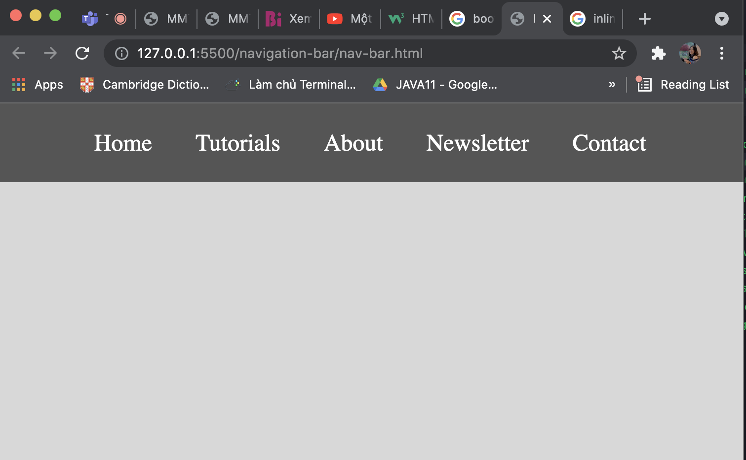

Create two files: **"nav-bar.html"** and **"nav-bar.css"**.

***1.1.1       Constraints***

·         **<nav>**tag as container

·        **<body>**

o   Margin: **0px;**

o   Padding: **0px;**

o   Background Color: **#CCCCCC;**

·        **<ul>** tag for unordered list

o   Background Color: **#444;**

o   Center the text

o   Padding: **0px;**

o   Margin: **0px;**

o   **list-style:none;**

·        **<li>** tag for list item

o   Text size: **24px;**

o   Line Height: **40px;**

o   Height: **40px;**

o   Padding: **20px;**

·        **<a>** tag for hyperlink

o   **text-decoration:** **none;**

o   Text-Color: **#ffffff;**

***1.1.2       Hints***

Use:

·        **<li>** with **display: inline-block;**

**Code:**

<!DOCTYPE *html*>

<html *lang*="en">

<head>

<title>Nav</title>

<link *rel*="stylesheet" *href*="nav-bar.css" />

</head>

<body>

<nav>

<ul>

<li><a *href*="#">Home</a></li>

<li><a *href*="#">Tutorials</a></li>

<li><a *href*="#">About</a></li>

<li><a *href*="#">Newsletter</a></li>

<li><a *href*="#">Contact</a></li>

</ul>

</nav>

</body>

CSS:

body {

background-color: lightgray;

margin: 0px;

padding: 0px;

}

nav {

background-color: #444;

}

nav ul {

text-align: center;

list-style: none;

margin: 0px;

padding: 0px;

}

nav ul li {

font-size: 24px;

line-height: 40px;

height: 40px;

padding: 20px;

display: inline-block;

}

nav ul li a {

text-decoration: none;

color: white;

}

**1.2         Page Content**

Create a Web Page like the following using**"page-content.html"**.

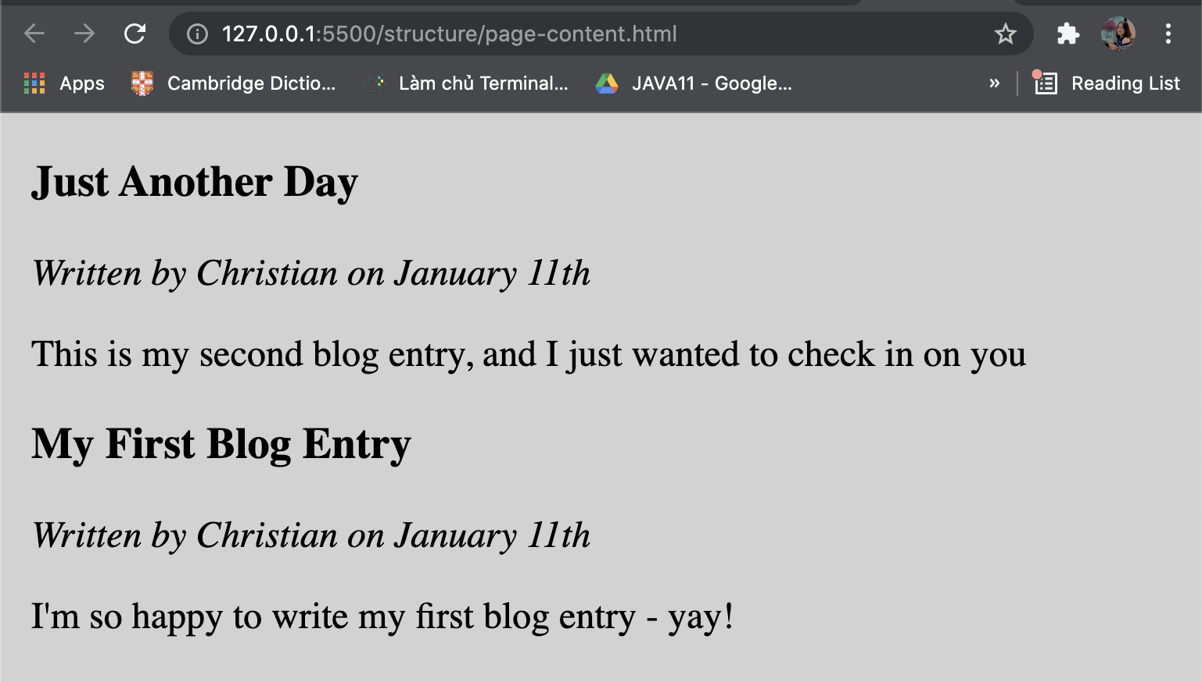

Create two files: **"page-content.html"**and**"page-content.css"**

***1.2.1       Constraints***

·        **<section>**as a container

·        **<article>**tag for content

o   **<header>**with:

§  **<h1>**Text size:**28px;**

§  **<p>**Font Style: **italic;**

·         **Paragraph**

o   Text size:**24px;**

·        **<body>**

o   Margin: **0px;**

o   Padding:**0px;**

o   Background color: **#CCCCCC;**

·        **<section>**

* Margin Left: **20px;**

Code:

HTML

<!DOCTYPE *html*>

<html *lang*="en">

<head>

<link *rel*="stylesheet" *href*="page-content.css" />

<title>Document</title>

</head>

<body>

<section>

<article>

<h1>Just Another Day</h1>

<p>Written by Christian on January 11th</p>

</article>

<p>This is my second blog entry, and I just wanted to check in on you</p>

</section>

<section>

<article>

<h1>My First Blog Entry</h1>

<p>Written by Christian on January 11th</p>

</article>

<p>I'm so happy to write my first blog entry - yay!</p>

</section>

</body>

</html>

CSS:

body {

margin: 0;

padding: 0;

background-color: #cccccc;

}

section {

margin-left: 20px;

}

section article h1 {

font-size: 28px;

}

section article p {

font-style: italic;

}

section p {

font-size: 24px;

}

**1.3         Simple Website**

Create a Web Page like the following

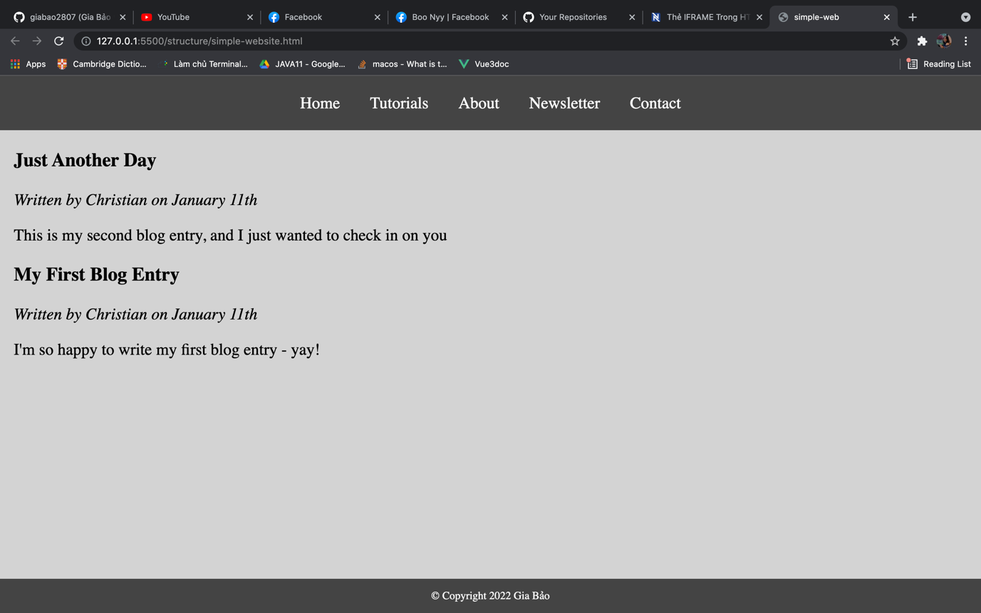

Create two files: "**simple-website.html**"and"**simple-website.css**".

***1.3.1       Constrains***

·        **Use the html and css from previous two problems**

·        **<footer>**tag

o   Background color: **#444;**

o   **<p>** tag for text

o   **Text Color: #fff;**

o   **Center the text**

***1.3.2       Hints***

Use:

·        **&copy;**for copyright symbol

Code:

HTML

<!DOCTYPE *html*>

<html *lang*="en">

<head>

<title>simple-web</title>

<link *rel*="stylesheet" *href*="simple-websit.css" />

</head>

<body>

<nav>

<ul>

<li><a *href*="#">Home</a></li>

<li><a *href*="#">Tutorials</a></li>

<li><a *href*="#">About</a></li>

<li><a *href*="#">Newsletter</a></li>

<li><a *href*="#">Contact</a></li>

</ul>

</nav>

<section>

<article>

<h1>Just Another Day</h1>

<p>Written by Christian on January 11th</p>

</article>

<p>This is my second blog entry, and I just wanted to check in on you</p>

</section>

<section>

<article>

<h1>My First Blog Entry</h1>

<p>Written by Christian on January 11th</p>

</article>

<p>I'm so happy to write my first blog entry - yay!</p>

</section>

<footer>

<p>&copy; Copyright 2022 Gia Bảo</p>

</footer>

</body>

</html>

CSS

body {

background-color: lightgray;

margin: 0px;

padding: 0px;

}

nav {

background-color: #444;

}

nav ul {

text-align: center;

list-style: none;

margin: 0px;

padding: 0px;

}

nav ul li {

font-size: 24px;

line-height: 40px;

height: 40px;

padding: 20px;

display: inline-block;

}

nav ul li a {

text-decoration: none;

color: white;

}

section {

margin-left: 20px;

}

section article h1 {

font-size: 28px;

}

section article p {

font-style: italic;

}

section p {

font-size: 24px;

}

footer {

background-color: #444;

color: white;

position: fixed;

bottom: 0;

width: 100%;

text-align: center;

}

**1.4         Exam Results**

Create a Web Page like the following using**exam-results.txt**.

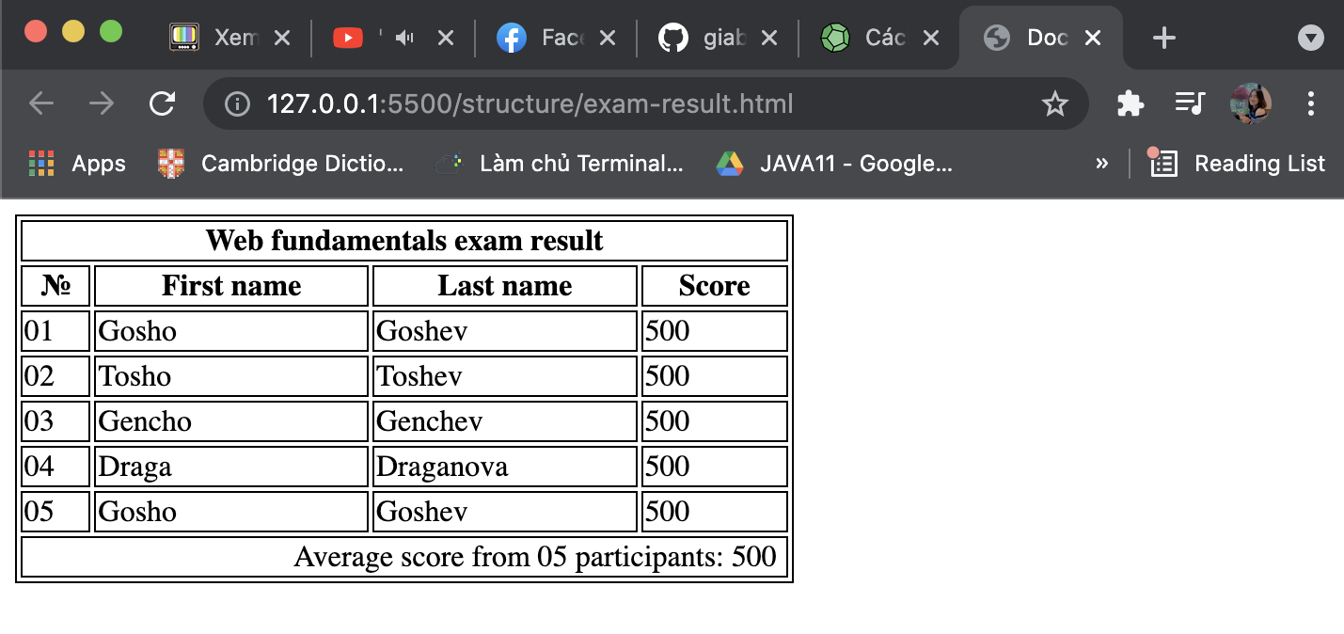

Create two files: "**exam-results.html**" and "**exam-results.css**"

***1.4.1       Constrains***

·         Border for **<table>, <td>, <tr>, <th>**

o   **1px solid #000000;**

·        **<thead>** with **<th colspan="4">** for Table Heading

·        **<td class="bold">**for bold text

o   Font Weight:**bold;**

o   Center the text

·        **<td class="result" colspan="4">**for text in the footer

o   Width:**400px;**

o   Text Align:**right;**

o   Padding Right:**5px;**

·         Table data

o   Padding Left:**5px;**

***1.4.2       Hints***

Use:

·        **&#8470;**for number sign

Code:

HTML:

<!DOCTYPE *html*>

<html *lang*="en">

<head>

<title>Document</title>

<link *rel*="stylesheet" *href*="exam-result.css" />

</head>

<body>

<table>

<tr>

<th *colspan*="4">Web fundamentals exam result</th>

</tr>

<tr>

<th>&#8470;</th>

<th>First name</th>

<th>Last name</th>

<th>Score</th>

</tr>

<tr>

<td>01</td>

<td>Gosho</td>

<td>Goshev</td>

<td>500</td>

</tr>

<tr>

<td>02</td>

<td>Tosho</td>

<td>Toshev</td>

<td>500</td>

</tr>

<tr>

<td>03</td>

<td>Gencho</td>

<td>Genchev</td>

<td>500</td>

</tr>

<tr>

<td>04</td>

<td>Draga</td>

<td>Draganova</td>

<td>500</td>

</tr>

<tr>

<td>05</td>

<td>Gosho</td>

<td>Goshev</td>

<td>500</td>

</tr>

<tr>

<td *class*="result" *colspan*="4">

Average score from 05 participants: 500

</td>

</tr>

</table>

</body>

</html>

CSS:

body {

margin: 5;

padding: 0;

}

table data {

padding-left: 5px;

}

table th {

text-align: center;

}

table,

td,

tr,

th {

border: 1px solid #000000;

}

*.result* {

width: 400px;

text-align: right;

padding-right: 5px;

}