**1.    Lab: CSS Selectors and Rules**

**1.1         Photo Shoot Effect**

Create a Web Page like the following using "**photo-shoot-effect.html**"

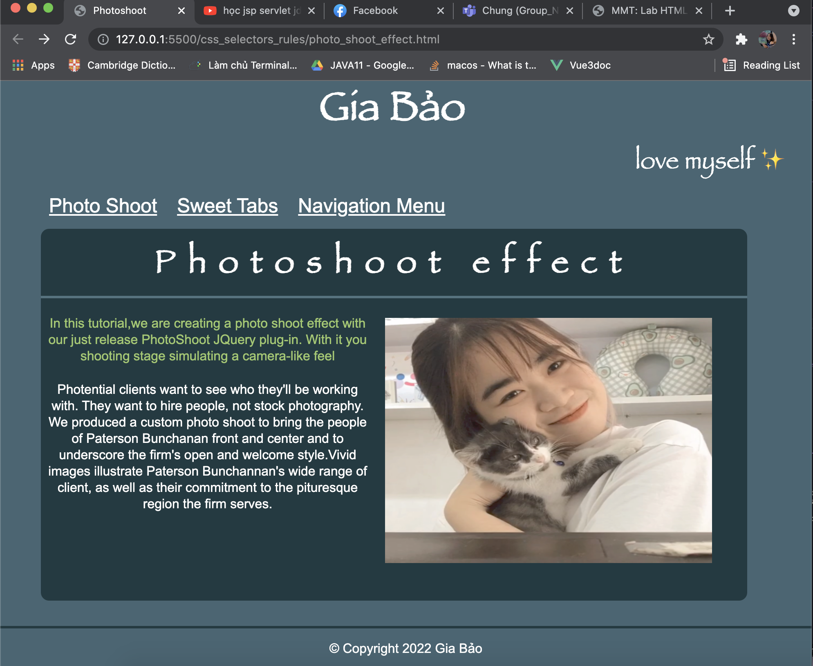

Create file: "**photo-shoot-effect.css**"

You are **NOT** allowed to change the HTML file.

***1.1.1       Constrains***

·         <body>

o   Width:**960px;**

o   Center the body

o   font-family:**Arial, sans-serif;**

o   Text Color:**#fcfcfc;**

o   Background:**#355664;**

·        **Headings**

o   Font-family: **forte, Arial, sans-serif;**

·        **<h1>**

o   Text size: **50px;**

o   Padding: **10px 0 0;**

o   Center the text

·        **<h2>**

o   Text size: **40px;**

o   Letter spacing: **15px;**

o   Center the text

o   Border at the bottom: **3px solid #416371;**

o   Padding at the bottom: **20px;**

·        **<h3>**

o   Text Align: **right;**

o   Text size: **30px;**

o   Font-weight: **normal;**

o   Margin: **0 0 10px;**

·        **Paragraphs**

o   Line height: **20px;**

o   Padding bottom: **5px;**

o   Text Color: **#94c258;**

·        **Images**

o   Width: **500px;**

o   Height: **300px;**

o   Border: **None;**

·        Div with class = "**article-content**"

o   Margin:**15px 0;**

·        **Navigation**

o   Background: **#355664;**

o   Padding-right and Left: **5px;**

o   Padding-top and Bottom:**0px;**

·        **Hyperlinks**

o   Text Color:**#ffffff;**

o   Text Color:**#7CB3E9;**

o   Text Color:**#8EC45B;**

o   Margin:**5px 2px;**

o   Padding:**7px 10px 4px;**

o   Text Size:**30px;**

·        **Article**

o   Height:**390px;**

o   Background: **#213E4A;**

o   Padding:**20px;**

o   Margin:**0 0 10px;**

·        **Figure**

o   Border:**3px solid #142830;**

o   Float:**right;**

o   Height: **300px;**

o   Width:**500px;**

o   Marginleft:**15px;**

·        **Footer**

o   Border at top: **3px solid #142830;**

o   PaddingTop:**15px;**

o   MarginBottom:**30px;**

o   Centerthetext

o   Textsize:**20px;**

Code:

HTML:

<!DOCTYPE *html*>

<html *lang*="en">

<head>

<title>Photoshoot</title>

<link *rel*="stylesheet" *href*="photo_shoot_effect.css" />

</head>

<body>

<h1>Gia Bảo</h1>

<h3>love myself ✨</h3>

<nav>

<ul>

<li><a *href*="#">Photo Shoot</a></li>

<li><a *href*="#">Sweet Tabs</a></li>

<li><a *href*="#">Navigation Menu</a></li>

</ul>

</nav>

<div *class*="article-content">

<article>

<h2>Photoshoot effect</h2>

<div *class*="content">

<div>

<p>

In this tutorial,we are creating a photo shoot effect with our

just release PhotoShoot JQuery plug-in. With it you shooting stage

simulating a camera-like feel

</p>

<p *style*="color: white">

Photential clients want to see who they'll be working with. They

want to hire people, not stock photography. We produced a custom

photo shoot to bring the people of Paterson Bunchanan front and

center and to underscore the firm's open and welcome style.Vivid

images illustrate Paterson Bunchannan's wide range of client, as

well as their commitment to the pituresque region the firm serves.

</p>

</div>

<figure *style*="float: right">

<img *src*="./images/giabao.JPG" *alt*="" />

</figure>

</div>

</article>

</div>

<footer>

<p>&copy; Copyright 2022 Gia Bảo</p>

</footer>

</body>

</html>

CSS:

body {

font-family: Arial, Helvetica, sans-serif;

width: 960px;

text-align: center;

counter-reset: #fcfcfc;

background: #355664;

color: white;

margin: 0;

padding: 0;

}

h1,

h2,

h3 {

font-family: Blippo, fantasy;

}

h1 {

font-size: 50px;

align-items: center;

margin: 0;

}

h2 {

font-size: 40px;

letter-spacing: 15px;

text-align: center;

border-bottom: 3px solid #416371;

padding-bottom: 5px;

margin: 0;

padding-top: 10px;

}

h3 {

text-align: right;

font-size: 30px;

font-weight: normal;

margin: 0;

}

*.article-content* {

margin: 15px 0px 15px 50px;

width: 100%;

height: 450px;

width: 90%;

padding-top: 5px;

border-radius: 10px;

background-color: #142830;

}

img {

width: 400px;

height: 300px;

border: none;

}

figure {

border: 3px solid #142830;

height: 300px;

width: 500px;

margin-left: 15px;

}

*.content* {

margin-top: 5px;

padding-left: 5px;

display: flex;

}

*.content* p {

color: #94c258;

line-height: 20px;

padding-bottom: 5px;

}

nav {

background-color: none;

margin: 0;

}

nav ul {

text-align: left;

list-style: none;

}

nav ul li {

font-size: 24px;

line-height: 24px;

padding-left: 20px;

display: inline-block;

}

nav ul li a {

color: white;

}

footer {

border-top: 3px solid #142830;

background-color: none;

color: white;

position: fixed;

bottom: 0;

width: 100%;

text-align: center;

}

**1.2         Ancient Architecture**

Create a Web Page like the following using"**ancient-architecture.html**".

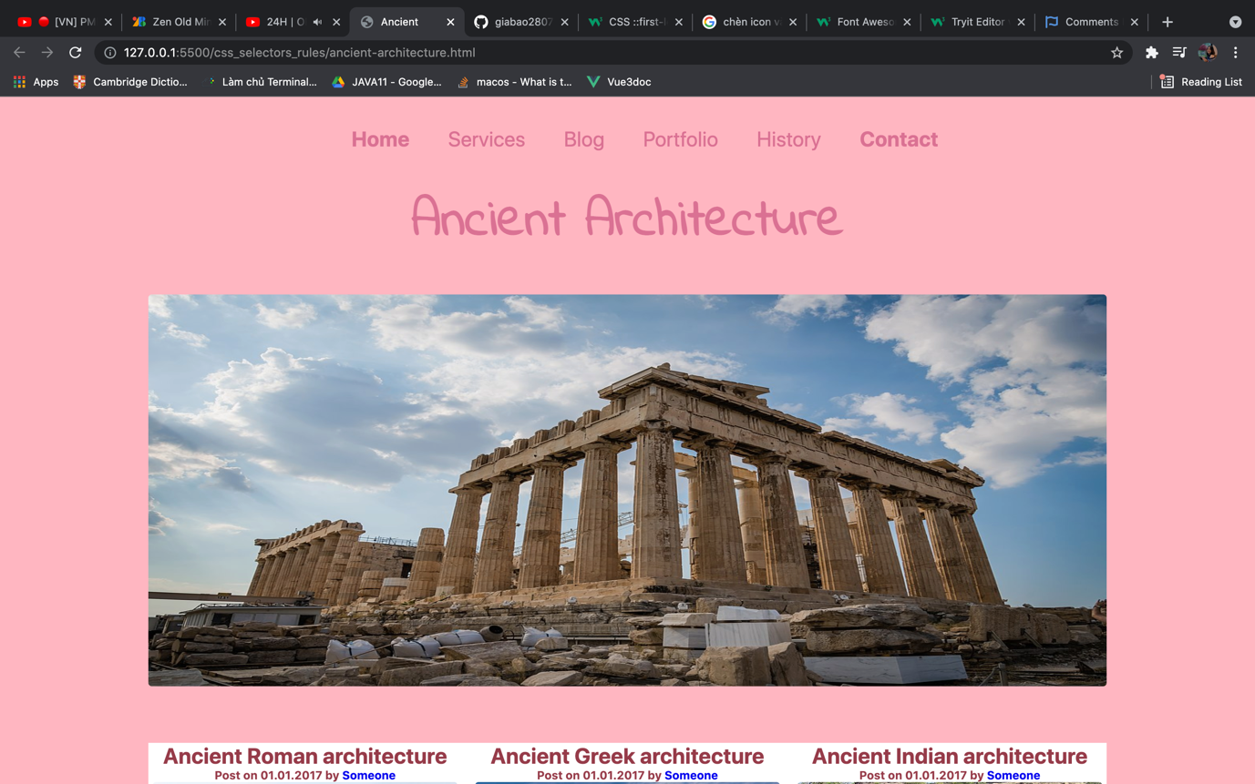

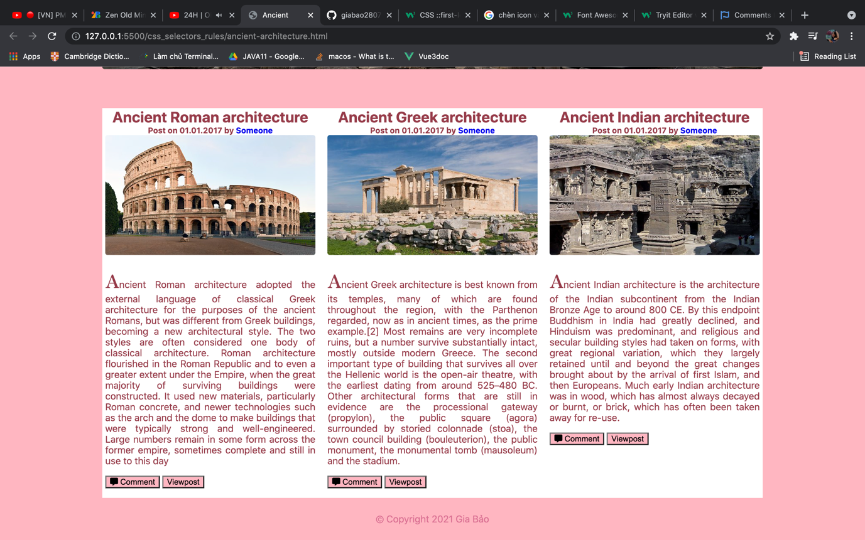

Create file: "**ancient-architecture.css**"

You are **NOT** allowed to change the HTML file.

Font Family:**Roboto, sans-serif; 'Indie Flower', cursive; EucrosiaUPC sans-serif;**

***1.2.1       Constrains***

·        **Body**

o   Font Family:**Roboto, sans-serif;**

o   Background:**#e2d7aa;**

o   Text Color:**#000000**

o   Text size: **16px**

o   Width:**1180px;**

o   Center the **container**

·        **Image**

o   Width:**1100px;**

o   Height:**450px;**

·        **Image-container**

o   Width: **1600px;**

o   Height: **450px;**

o   Margin at Top: **65px;**

·        **<h1>**

o   Text size: **60px;**

o   Center the text

o   Margin at the top: **65px;**

o   Font Family: **‘Indie Flower’, cursive;**

·        **Navigation**

o   Margin:**30px;**

·        **Hyperlinks**

o   Text size: **28px;**

o   Text-color: **#000000;**

·        **Hyperlink**

o   Text-color:**#0a2d4a;**

o   Font Weight:**Bold;**

·        **Image**inArticle

o   Width:**350px;**

o   Height:**200px;**

o   Margin Bottom:**20px;**

·        **First Letter in paragraph**

o   font-family:**EucrosiaUPC, sans-serif;**

o   Text size: 40px;

·        **Hyperlink in span**

o   Background: **url(images/bg2.jpg)**

o   Textcolor:**#ffffff;**

o   **Padding: 10px;**

o   **Margin-top: 10px;**

·        **Footer**

o   Margin: **0px;**

o   Padding: **10px 0 10px 0;**

o   Center the text

Code:

HTML:

<!DOCTYPE *html*>

<html *lang*="en">

<head>

<link *rel*="stylesheet" *href*="ancient-architecture.css" />

<script

*src*="https://kit.fontawesome.com/1939b78ca2.js"

*crossorigin*="anonymous"

></script>

<title>Ancient</title>

</head>

<body>

<nav>

<ul>

<li>

<a *href*="#"><b>Home</b></a>

</li>

<li><a *href*="#">Services</a></li>

<li><a *href*="#">Blog</a></li>

<li><a *href*="#">Portfolio</a></li>

<li><a *href*="#">History</a></li>

<li>

<a *href*="#"><b>Contact</b></a>

</li>

</ul>

</nav>

<h1>Ancient Architecture</h1>

<img *src*="./images/ancient1.JPG" *alt*="" />

<div *class*="image-container">

<article>

<h3>Ancient Roman architecture</h3>

<h5>

Post on 01.01.2017 by

<a *href*="#">Someone</a>

</h5>

<img *class*="img-content" *src*="./images/ancient2.JPG" *alt*="" />

<p>

Ancient Roman architecture adopted the external language of classical

Greek architecture for the purposes of the ancient Romans, but was

different from Greek buildings, becoming a new architectural style.

The two styles are often considered one body of classical

architecture. Roman architecture flourished in the Roman Republic and

to even a greater extent under the Empire, when the great majority of

surviving buildings were constructed. It used new materials,

particularly Roman concrete, and newer technologies such as the arch

and the dome to make buildings that were typically strong and

well-engineered. Large numbers remain in some form across the former

empire, sometimes complete and still in use to this day

</p>

<button><i *class*="fas fa-comment-alt"></i> Comment</button>

<button>Viewpost</button>

</article>

<article>

<h3>Ancient Greek architecture</h3>

<h5>

Post on 01.01.2017 by

<a *href*="#">Someone</a>

</h5>

<img *class*="img-content" *src*="./images/ancient3.JPG" *alt*="" />

<p>

Ancient Greek architecture is best known from its temples, many of

which are found throughout the region, with the Parthenon regarded,

now as in ancient times, as the prime example.[2] Most remains are

very incomplete ruins, but a number survive substantially intact,

mostly outside modern Greece. The second important type of building

that survives all over the Hellenic world is the open-air theatre,

with the earliest dating from around 525–480 BC. Other architectural

forms that are still in evidence are the processional gateway

(propylon), the public square (agora) surrounded by storied colonnade

(stoa), the town council building (bouleuterion), the public monument,

the monumental tomb (mausoleum) and the stadium.

</p>

<button><i *class*="fas fa-comment-alt"></i> Comment</button>

<button>Viewpost</button>

</article>

<article>

<h3>Ancient Indian architecture</h3>

<h5>

Post on 01.01.2017 by

<a *href*="#">Someone</a>

</h5>

<img *class*="img-content" *src*="./images/ancient4.JPG" *alt*="" />

<p>

Ancient Indian architecture is the architecture of the Indian

subcontinent from the Indian Bronze Age to around 800 CE. By this

endpoint Buddhism in India had greatly declined, and Hinduism was

predominant, and religious and secular building styles had taken on

forms, with great regional variation, which they largely retained

until and beyond the great changes brought about by the arrival of

first Islam, and then Europeans. Much early Indian architecture was in

wood, which has almost always decayed or burnt, or brick, which has

often been taken away for re-use.

</p>

<button><i *class*="fas fa-comment-alt"></i> Comment</button>

<button>Viewpost</button>

</article>

</div>

<footer>

<p>&copy; Copyright 2021 Gia Bảo</p>

</footer>

</body>

</html>

CSS:

@import url("https://fonts.googleapis.com/css2?family=Indie+Flower&display=swap");

@import url("https://fonts.googleapis.com/css2?family=Indie+Flower&family=Zen+Antique&display=swap");

body {

background-color: lightpink;

font-family: -apple-system, BlinkMacSystemFont, "Segoe UI", Roboto, Oxygen,

Ubuntu, Cantarell, "Open Sans", "Helvetica Neue", sans-serif;

color: palevioletred;

font-size: 16px;

width: 100%;

align-items: center;

padding: 0;

margin: 0;

}

nav {

text-align: center;

background-color: none;

margin: 0;

}

nav ul {

text-align: center;

list-style: none;

}

nav ul li {

font-size: 24px;

line-height: 24px;

padding: 20px;

display: inline-block;

}

nav ul li a {

text-decoration: none;

color: palevioletred;

}

h1 {

font-size: 60px;

text-align: center;

margin-top: 20px;

font-family: "Indie Flower", cursive;

}

img {

width: 1100px;

height: 450px;

display: block;

margin-left: auto;

margin-right: auto;

border-radius: 4px;

}

*.image-container* {

width: 1100px;

height: 650px;

background-color: #fff;

margin-top: 65px;

display: flex;

text-align: justify;

margin-left: auto;

margin-right: auto;

}

*.image-container* article {

color: rgb(150, 58, 73);

width: 350px;

margin-left: 5px;

margin-right: 15px;

}

*.image-container* article h3 {

font-size: 25px;

text-align: center;

margin: 0;

padding: 0;

}

*.image-container* article p {

text-align: justify;

}

*.image-container* article p*::first-letter* {

font-family: "Zen Antique", serif;

font-size: 30px;

}

*.image-container* article h5 {

text-align: center;

margin: 0;

padding: 0;

}

*.image-container* article h5 a {

font-weight: bold;

text-decoration: none;

}

*.img-content* {

width: 350px;

height: 200px;

margin-bottom: 20px;

}

*.image-container* article button {

background-color: lightpink;

border: 1 solid palevioletred;

}

footer {

background-color: none;

color: palevioletred;

width: 100%;

margin: 0;

padding: 10px 0 10px 0;

text-align: center;

}