**1.    Lab: CSS Selectors and Rules**

**Plan Page**

You are given the HTML for the Web page shown below. Write the missing CSS:

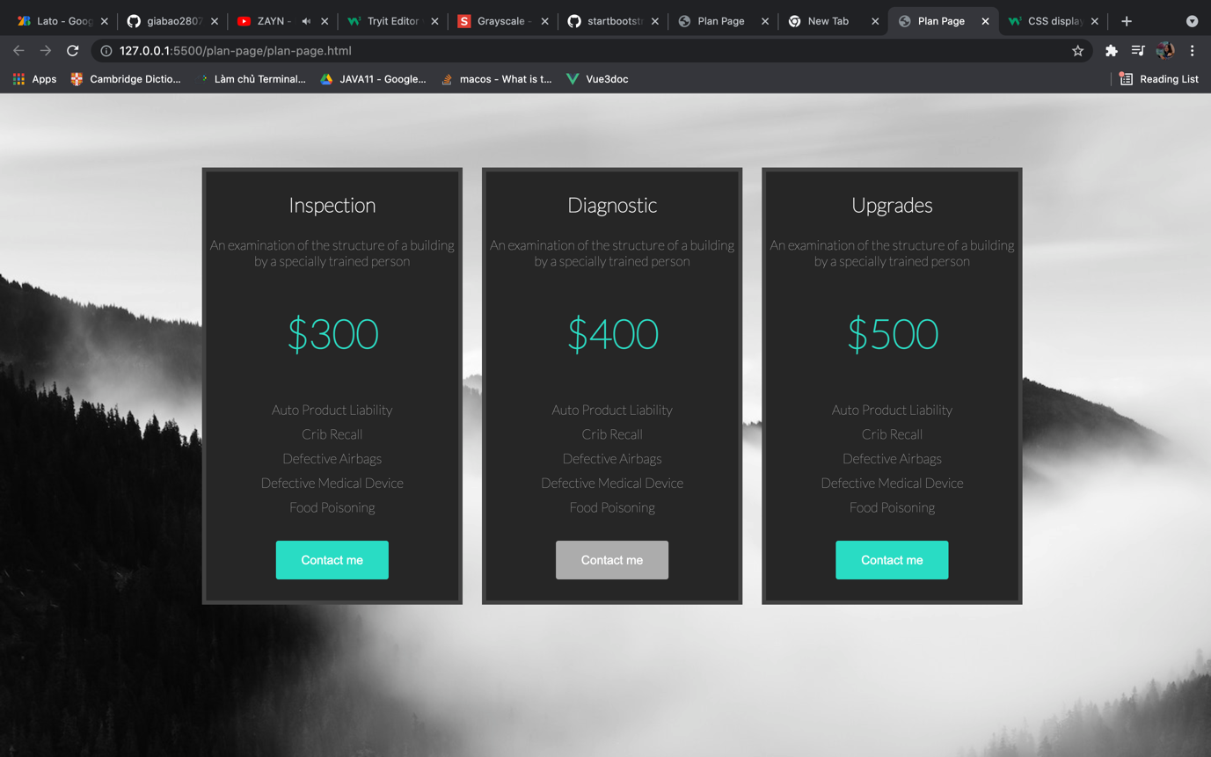

·        Use the following HTML file: "**plan-page.html**".

o   You are **NOT** allowed to change the HTML code.

·        Write the missing CSS file: "**plan-page.css**".

***1.1.1       Constrains***

·        **Body**

o   Font Family:**Lato, sans-serif;**

o   Background:**url(plan-page.jpg);**

o   Text size: **16px**

o   Width:**1180px;**

·        **Section**

o   Center the **container**

·        **Article**

o   Background:**#262626;**

o   Display:**inline-block;**

o   Margin: **80px 20px 0 20px;**

o   Border: **5px solid #424242;**

o   Color: **#a1a1a1;**

·        **Article <h1>**

o   Text size: **1.5em;**

o   Color: **#FFF;**

·        **<p> with class="price"**

o   Text size: **3em;**

o   Text weight: **bold;**

o   Color: **#27dcc4;**

·        **<ul>**

o   Padding:**0;**

·        **<button>**

o   Background: **#27dcc4;**

o   Color: **#FFF;**

o   Padding: **15px 30px;**

o   Margin: **10px 0;**

o   Text size: **0.9em;**

o   Cursor: **pointer;**

o   Border: **none;**

·        **<button> on hover**

o   Background: **#ACACAC;**

·        **<li>**

o   List-style-type: **none;**

o   Padding: **5px 0;**

Code:

HTML

<!DOCTYPE *html*>

<html *lang*="en">

<head>

<title>Plan Page</title>

<link *rel*="stylesheet" *href*="plan-page.css" />

</head>

<body>

<section>

<article>

<h1>Inspection</h1>

<p>

An examination of the structure of a building by a specially trained

person

</p>

<p *class*="price">$300</p>

<ul>

<li>Auto Product Liability</li>

<li>Crib Recall</li>

<li>Defective Airbags</li>

<li>Defective Medical Device</li>

<li>Food Poisoning</li>

</ul>

<button>Contact me</button>

</article>

<article>

<h1>Diagnostic</h1>

<p>

An examination of the structure of a building by a specially trained

person

</p>

<p *class*="price">$400</p>

<ul>

<li>Auto Product Liability</li>

<li>Crib Recall</li>

<li>Defective Airbags</li>

<li>Defective Medical Device</li>

<li>Food Poisoning</li>

</ul>

<button>Contact me</button>

</article>

<article>

<h1>Upgrades</h1>

<p>

An examination of the structure of a building by a specially trained

person

</p>

<p *class*="price">$500</p>

<ul>

<li>Auto Product Liability</li>

<li>Crib Recall</li>

<li>Defective Airbags</li>

<li>Defective Medical Device</li>

<li>Food Poisoning</li>

</ul>

<button>Contact me</button>

</article>

</section>

</body>

</html>

CSS:

@import url("https://fonts.googleapis.com/css2?family=Lato:wght@100&display=swap");

body {

font-family: "Lato", sans-serif;

background: url("./images/plan-page.jpg");

width: 100%;

font-size: 16px;

}

section {

text-align: center;

}

section article {

background-color: #262626;

height: 510px;

width: 300px;

position: relative;

display: inline-block;

margin: 80px 10px 0 10px;

border: 5px solid #424242;

color: #a1a1a1;

text-align: center;

}

section article h1 {

font-size: 1.5em;

color: #fff;

font-weight: bold;

}

section article *.price* {

font-size: 3em;

font-weight: bold;

color: #27dcc4;

}

section article button {

background-color: #27dcc4;

color: white;

padding: 15px 30px;

margin: 10px 0;

font-size: 0.9em;

cursor: pointer;

border: none;

border-radius: 3px;

}

section article button*:hover* {

background-color: #acacac;

}

section article ul {

padding: 0;

}

section article ul li {

list-style-type: none;

padding: 5px 0;

}