**1.    Lab: CSS Presentation and Positioning**

**1.1         Briard History**

Create a Web Page like the following.

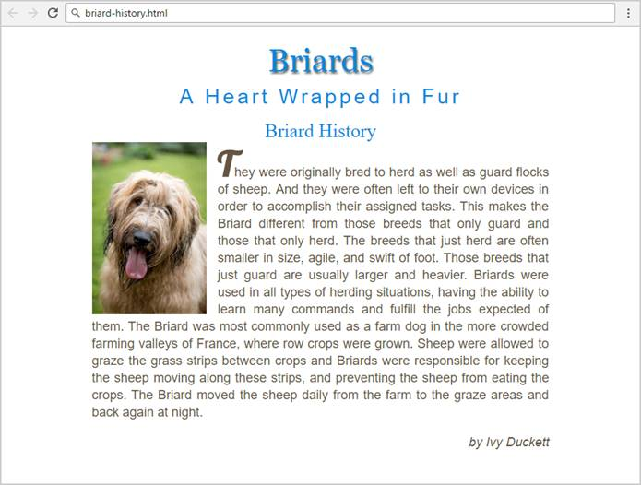

Result:

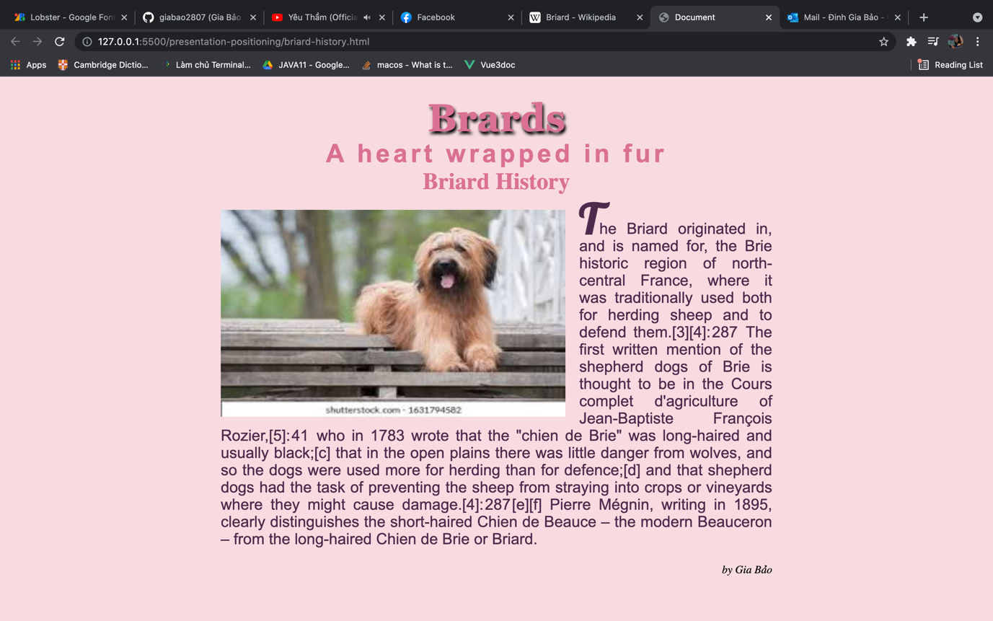

Create files: "**briard-history.css**" and "**briard-history.html**"

***1.1.1       Steps to Follow***

Start with the **site header**:

·        Copy the CSS **@import** for the ‘**Lobster**’**font** from Google Fonts: [**https://fonts.googleapis.com/css?family=Lobster**](https://fonts.googleapis.com/css?family=Lobster)

·        **<html>**

o   Text size:  **16px**;

·         **Main site**

o   Center the main

o   Width:**800px;**

o   Padding:**20px;**

·         **Format the image:** **<img>**

o   Width: **200px;**

o   Float: **Left;**

o   Margin-right: **20px;**

**Now style the all headings and the hyperlink:**

·        **<h1>, <h2>, <h3>, a**

o   Font Style: **Normal;**

o   Text color: **#0088dd;**

o   Margin: **0;**

o   Center the text

o   Text Size: **2.1rem;**

o   Remove **underline;**

·        **<h1>**

o   Font Family: **Georgia, Times, serif;**

o   Text Size: **3.5rem;**

o   Shadow for Text: **2px 4px 4px #666666;**

o   Padding at the bottom: **10px;**

o   Transform the text

·        **<h2>**

o   Font Family: **Arial, sans-serif;**

o   Text Size: **2.3rem;**

o   Transform the text

o   Spacing between letter: **0.3rem;**

·        **<h2> <span>**

o   Transform the text to **none**

**Now style the site content (article):**

·        **Article**

o   Margin at the top: **20px;**

o   Align Text: **Justify;**

·        **Paragraphs in the article**

o   Font Family: **Arial, Verdana, sans-serif;**

o   Text Size: **1.4rem;**

o   Line Height: **30px;**

o   Text Color:**#665544;**

·        **<p> for site author**

o   Text Style: **Italic;**

o   Align the text to the **right;**

·        **First letter in the first article’s paragraph**

o   Text Site: **3.8rem;**

o   Font Family**: 'Lobster', cursive;**

o   Text Style: **bold;**

o   Make the text **UPPERCASE;**

o   **Hint**: use the pseudo-selector **:first-of-type:first-letter**

**Code:**

**HTML:**

<!DOCTYPE *html*>

<html *lang*="en">

<head>

<title>Document</title>

<link *rel*="stylesheet" *href*="briard-history.css" />

</head>

<body>

<h1>Brards</h1>

<h2>A heart wrapped in fur</h2>

<h3><a *href*="#">Briard History</a></h3>

<article>

<img *src*="./briard.jpg" *alt*="" />

<p>

The Briard originated in, and is named for, the Brie historic region of

north-central France, where it was traditionally used both for herding

sheep and to defend them.[3][4]: 287  The first written mention of the

shepherd dogs of Brie is thought to be in the Cours complet

d'agriculture of Jean-Baptiste François Rozier,[5]: 41  who in 1783

wrote that the "chien de Brie" was long-haired and usually black;[c]

that in the open plains there was little danger from wolves, and so the

dogs were used more for herding than for defence;[d] and that shepherd

dogs had the task of preventing the sheep from straying into crops or

vineyards where they might cause damage.[4]: 287 [e][f] Pierre Mégnin,

writing in 1895, clearly distinguishes the short-haired Chien de Beauce

– the modern Beauceron – from the long-haired Chien de Brie or Briard.

</p>

</article>

<p *class*="author">by Gia Bảo</p>

</body>

</html>

CSS:

@import url("https://fonts.googleapis.com/css2?family=Lato:wght@100&family=Lobster&display=swap");

body {

background-color: rgb(247, 219, 224);

width: 800px;

text-align: center;

padding: 20px;

font-size: 16px;

margin-left: auto;

margin-right: auto;

}

img {

width: 500px;

height: 300px;

float: left;

margin-right: 20px;

}

h1,

h2,

h3,

a {

font-style: normal;

color: palevioletred;

margin: 0;

text-align: center;

font-size: 2.1rem;

}

h1 {

font-family: Georgia, Times, serif;

font-size: 3.5rem;

text-shadow: 2px 4px 4px #000000;

}

h2 {

font-family: Arial, Helvetica, sans-serif;

font-size: 2.3rem;

letter-spacing: 0.3rem;

}

a {

transform: none;

text-decoration: none;

}

article {

margin-top: 20px;

text-align: justify;

}

article p {

font-style: normal;

font-family: Arial, Helvetica, sans-serif;

font-size: 1.4rem;

line-height: 25px;

color: rgb(78, 43, 77);

}

article p*::first-letter* {

font-size: 3.8rem;

font-weight: bold;

font-family: "Lobster", cursive;

}

*.author* {

font-style: italic;

text-align: right;

}

**1.2         Autumn**

Create a Web Page like the following using "**Golden-Autumn.html**"

Top part:

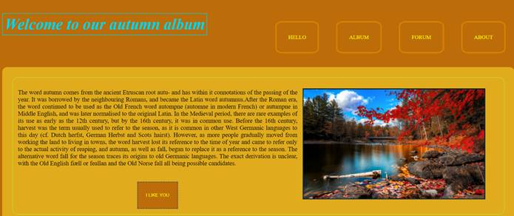

Bottom part:

Result:

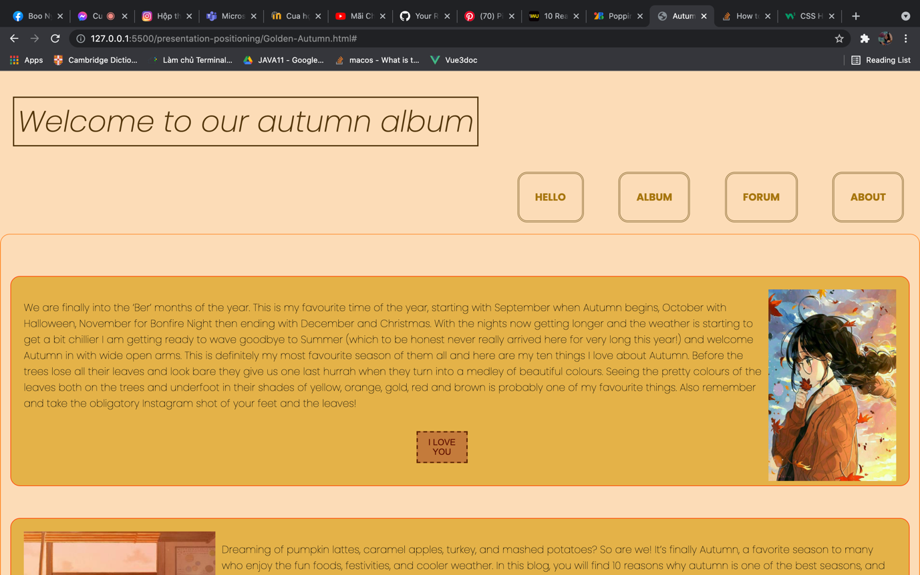

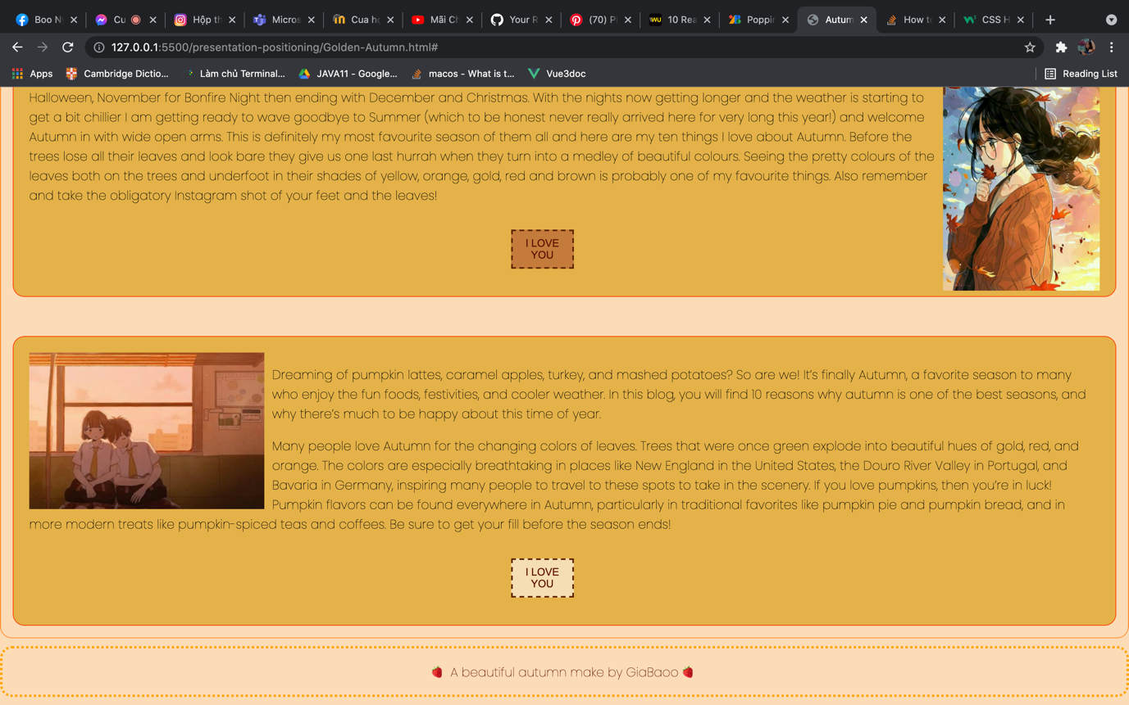

Create file: "**Golden-Autumn.css**"

You are **NOT** allowed to change the HTML file.

***1.2.1       Constrains***

·         <body>

o   Background:**#bc6c09;**

·         <header>

o   Margin top: **45px;**

·        **<li>**

o   Display : **block and inline;**

o   Float : **right**;

o   Paddin Top **: 55px;**

·        **<a>**

o   Without text decoration;

o   Padding : **35px**;

o   Border: **3px double orange**;

o   Margin: **25px**;

o   Color:**Yellow**;

o   Without background;

o   Radius on border:**15%**;

o   **Uppercase text**;

·        **<img>**

o   Width : **100%**;

o   Height: **100%**;

·        **<p>**

o   Color : **black**;

o   Font-size : **18px**;

·        **Main article div**

o   Border : **double 1px greenyellow**;

o   Radius on border: **15px**;

o   Padding:**15px**;

o   Margin:**10px**;

o   

·        **<h1>**

o   **Double border;**

o   **Inline display**;

o   Padding:**5px**;

o   Font-size:**46px**;

o   Margin-top: **10px**;

o   Color: **#00d5f2**;

o   Italic

·        **<article>**

o   Height: **900px**;

o   Padding: **20px**;

o   Margin on top : **100px**;

o   Background**: #e0ac1d**;

o   Radius on border: **15px**;

o   Text-align**: justify**;

o   Text-justify: **inter-word**;

·        **Article div figure**

o   Border: **3px solid #142830**;

o   Float: **right**;

o   Height**: 320px**;

o   Width: **530px**;

o   Margin on left: **15px**;

·        **<figure>**

o   Float: **right**;

o   Height: **320px**;

o   Width: **530px**;

·        **Button**

o   Border: **2px dashed**;

o   Border-Color: **#685d50**;

o   Background: **#bcbc09**;

o   Color :**yellow**;

o   Width: **120px**;

o   Height: **80px**;

o   Left margin: **350px**;

o   Top margin: **25px**;

o   Uppercase the text

·        **Make hover on <a> and <button>**

o   Color: **red**;

o   Background: **#e8f3f4**;

o   Italic

·        **<footer>**

o   Border: **dotted greenyellow**;

o   Radius on border: **10px**;

o   Color: **yellow**;

o   Center the text

o   Margin: **10px**;

o   Uppercase the text

HTML:

<!DOCTYPE *html*>

<html *lang*="en">

<head>

<title>Autumn</title>

<link *rel*="stylesheet" *href*="Golden-Autumn.css" />

<meta *name*="viewport" *content*="width=device-width, initial-scale=1" />

</head>

<body>

<header *class*="header">

<h1>Welcome to our autumn album</h1>

</header>

<div *class*="nav">

<ul>

<li><a *href*="#">Hello</a></li>

<li><a *href*="#">Album</a></li>

<li><a *href*="#">Forum</a></li>

<li><a *href*="#">About</a></li>

</ul>

</div>

<div *class*="main-article-div">

<article>

<img *class*="img1" *src*="./autumn1.jpg" *alt*="" />

<p>

We are finally into the ‘Ber’ months of the year. This is my favourite

time of the year, starting with September when Autumn begins, October

with Halloween, November for Bonfire Night then ending with December

and Christmas. With the nights now getting longer and the weather is

starting to get a bit chillier I am getting ready to wave goodbye to

Summer (which to be honest never really arrived here for very long

this year!) and welcome Autumn in with wide open arms. This is

definitely my most favourite season of them all and here are my ten

things I love about Autumn. Before the trees lose all their leaves and

look bare they give us one last hurrah when they turn into a medley of

beautiful colours. Seeing the pretty colours of the leaves both on the

trees and underfoot in their shades of yellow, orange, gold, red and

brown is probably one of my favourite things. Also remember and take

the obligatory Instagram shot of your feet and the leaves!

</p>

<button>I love you</button>

</article>

<article>

<img *class*="img2" *src*="./autumn2.jpg" *alt*="" />

<p>

Dreaming of pumpkin lattes, caramel apples, turkey, and mashed

potatoes? So are we! It’s finally Autumn, a favorite season to many

who enjoy the fun foods, festivities, and cooler weather. In this

blog, you will find 10 reasons why autumn is one of the best seasons,

and why there’s much to be happy about this time of year.

</p>

<p>

Many people love Autumn for the changing colors of leaves. Trees that

were once green explode into beautiful hues of gold, red, and orange.

The colors are especially breathtaking in places like New England in

the United States, the Douro River Valley in Portugal, and Bavaria in

Germany, inspiring many people to travel to these spots to take in the

scenery. If you love pumpkins, then you’re in luck! Pumpkin flavors

can be found everywhere in Autumn, particularly in traditional

favorites like pumpkin pie and pumpkin bread, and in more modern

treats like pumpkin-spiced teas and coffees. Be sure to get your fill

before the season ends!

</p>

<button>I love you</button>

</article>

</div>

<footer>

<p>🍓 A beautiful autumn make by GiaBaoo 🍓</p>

</footer>

</body>

</html>

CSS:

@import url("https://fonts.googleapis.com/css2?family=Poppins:ital,wght@0,100;0,700;1,200;1,700&display=swap");

body {

font-family: "Poppins", sans-serif;

font-size: 100;

background-color: rgb(252, 220, 182);

margin: 0;

padding: 0;

}

header {

margin-left: 20px;

margin-top: 45px;

}

h1 {

font-weight: 400;

border: double 2px rgb(82, 53, 10);

display: inline;

padding: 5px;

font-size: 46px;

margin-top: 10px;

color: rgb(82, 53, 10);

font-style: italic;

}

*.nav* {

text-align: right;

background-color: none;

}

*.nav* ul {

text-decoration: none;

margin-bottom: 10px;

}

*.nav* ul li {

display: inline-block;

padding-top: 55px;

padding-bottom: 35px;

}

*.nav* ul li a {

text-decoration: none;

padding: 25px;

border: 3px double rgb(155, 125, 70);

margin: 25px;

color: rgb(167, 118, 12);

background: none;

border-radius: 15px;

text-transform: uppercase;

font-weight: bolder;

}

*.img1* {

height: 300px;

width: 200px;

float: right;

margin-left: 10px;

}

*.img2* {

height: 200px;

width: 300px;

float: left;

margin-right: 10px;

}

*.main-article-div* {

border: double 1px rgb(255, 141, 47);

padding: 15px;

border-radius: 15px;

}

article {

height: 40%;

padding: 20px;

margin-top: 50px;

background-color: rgb(228, 178, 72);

border-radius: 15px;

border: 1px solid orangered;

}

button {

border: 2px dashed;

border-color: rgb(95, 37, 3);

background-color: rgb(196, 124, 58);

color: rgb(94, 14, 0);

width: 80px;

height: 50px;

margin-left: 45%;

margin-top: 15px;

margin-bottom: 15px;

text-transform: uppercase;

}

button*:hover* {

background-color: wheat;

}

footer {

border: dotted orange;

border-radius: 15px;

color: rgb(94, 14, 0);

text-align: center;

margin: 10px 0 10px 0;

}