Name: Bao Nguyen

Course: CMSC 203

Pseudo Code

1.Declare double variables temperature, windspeed, and windchill

2. Display the name of this program “Wind Chill Calculator “

3. Ask users for temperature in Fahrenheit

4. Let users input number for the temperature

5. Ask users for wind speed

6. Let users input number for wind speed

7. Use the formula to calculate Wind Chill and print it out.

8. Print out the programmer name

Test Plan

|  |  |  |  |  |  |
| --- | --- | --- | --- | --- | --- |
| Test Case # | Input | Actual Input | Expected Output | Actual Output | Did the test pass? |
| 1 | Temp: 30  Wind chill: 20 | 30  20 | Wind Chill Temperature:  17.361783756466327 degrees Fahrenheit | 17.361783756466327 | Yes |
| 2 | Temp: 20  Wind chill: 30 | 20  30 | Wind Chill Temperature:  1.298559080003507 degrees Fahrenheit | 1.298559080003507 | Yes |
| 3 | Temp: 10  Wind Chill:  23 | 10  23 | Wind Chill Temperature:  -10.025708246137688  degrees Fahrenheit | -10.025708246137688 | Yes |

Screenshot

Test case #1

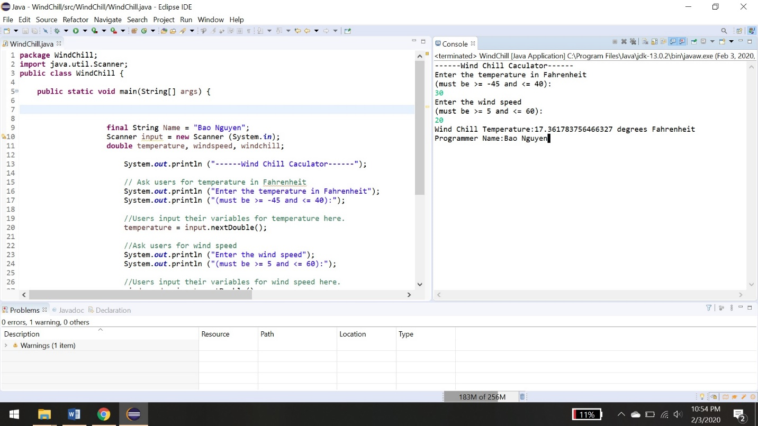

Test case #2

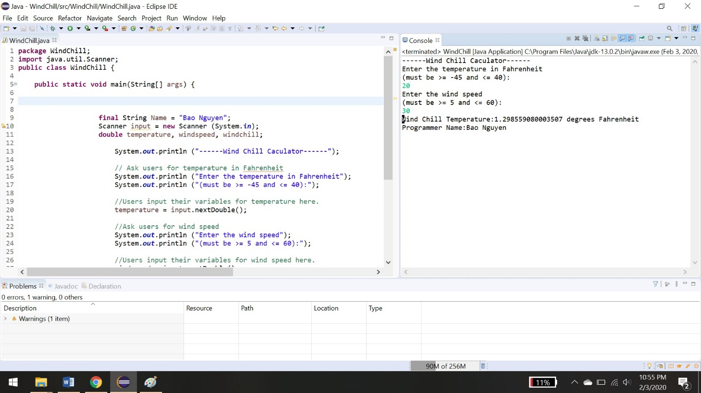

Test case #3

