Standard form:
maximise
subject to

and
In more detail:

Where:
- N is the number of different parts that I need and are available on the BrickLink market.
- M is the number of UK sellers, shipping to UK customers, who offer the full quantity of at least one of the above parts, plus any quantity of any other part.
- p_{i,j} is the i-th seller's worst price for the j-th part, and x_{i,j} is the quantity of the j-th part I am buying from the i-th seller.
A is the expression of several conditions:
- First, I need to satisfy my requirements
- Second, I can't order from a supplier more pieces than they got:
where m_{i,j} is the i-th seller's availability of the j-th part (“max” number of pieces) .
- Third, the i-th seller has the faculty not to accept orders whose value is smaller than v_{i}:
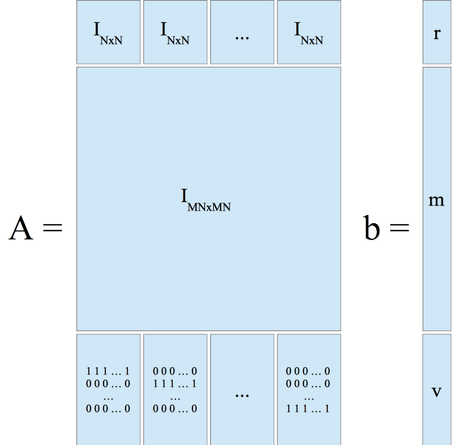
Where:

…
The total size of A is (MN + M + N) x (2MN + M). This number can quickly grow beyond conventional programming languages' capacity unless you use dedicated memory structures, e.g. for sparse matrices. At the moment of writing this I am working on a LEGO model with 166 potential sellers and 59 missing pieces. The early code my script used to build in memory the necessary 10,019 x 19,754 matrix soon failed, running out of memory.

The same seller can offer the same part at different prices. For simplicity, I am considering their worst price only.

