**Introduction to basic GIS concepts – Instruction sheet**

**Setting up the environment in ArcGIS**

1. Create a folder on your Desktop named OnSSET_model
2. Open ArcGIS and create a new map
3. Right click to layers → Properties → Coordinate system → Geographic Coordinate Systems → World → WGS 1984
4. Go to Catalog → Connect to folder

**Data Acquisition**

**Polygons**

1. GADM is a comprehensive dataset providing administrative boundary layers for all countries in various formats. Access the website using the following link and download the administrative boundaries layers (level 0 and level 1) for the demo country (e.g. Ethiopia).

Source: <http://www.gadm.org/country>

1. Place the downloaded file in the OnSSET_model folder under a subfolder with a name “Administrative_Boundaries”.
2. Insert the administrative boundaries as layers into your open map in ArcGIS. You can do that by simply dragging the files with the shapefile extension (.shp) into your map.

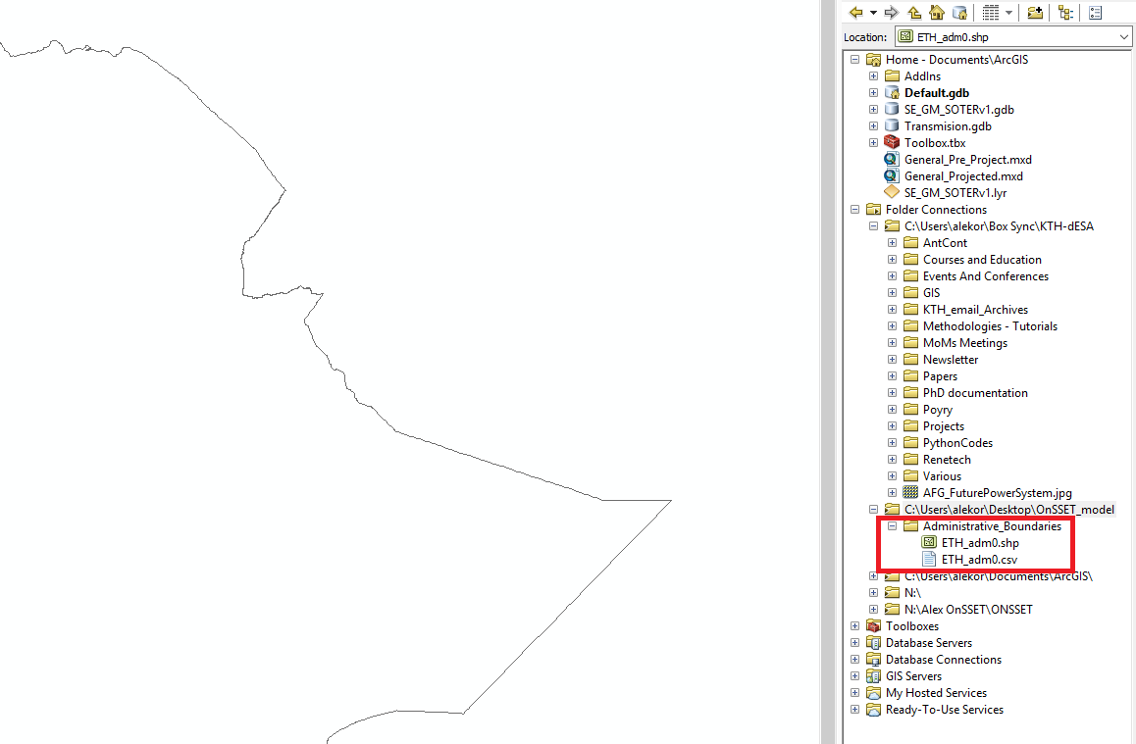

1. Convert the feature layer into a raster using the features to raster functions. You can find the function by simply typing its name in the search window.
2. The new raster layer will be automatically saved in your Default geodatabase with a suggested name. You can change the name to your preference in the output raster cell, that you see within the function.

**Lines**

1. Energydata.info is an initiative of the World Bank aiming to serve as an online repository of energy related geospatial data. KTH dESA has actively contributing to this initiative by providing a number of GIS related datasets. Access the website and use the search box to identify data related to your country (e.g. Ethiopia) or the type of data you are looking for.
2. Download the “Africa Road Network” (latest version available). In the option **Explore** click on **Download.** The pop-up window contains the data in geojson format. Right click and save the data as such in the OnSSET_model forder. Converting a geojson file into shapefile can be achieved in two ways:
   1. By using the Interoperability toolbox and the **Quick Import** command in ArcGIS (if this extension was included in your initial installation settings).
   2. By using online available tools (e.g. <http://mapshaper.org/>) that will convert and export the input geojson file into various outputs (e.g. Topojson, csv, shapefile).

In both cases the final shapefile should be saved under the name “Africa_Road_Network” in the OnSSET_model forder.

1. Insert the road network dataset as a new layer into your map.

**Note!** Depending on the source, data may be in different projection systems. If this is the case, bring the data onto the same coordinate/projection system as your reference (e.g. WGS 1984) by using the command **Project** (Data Management).

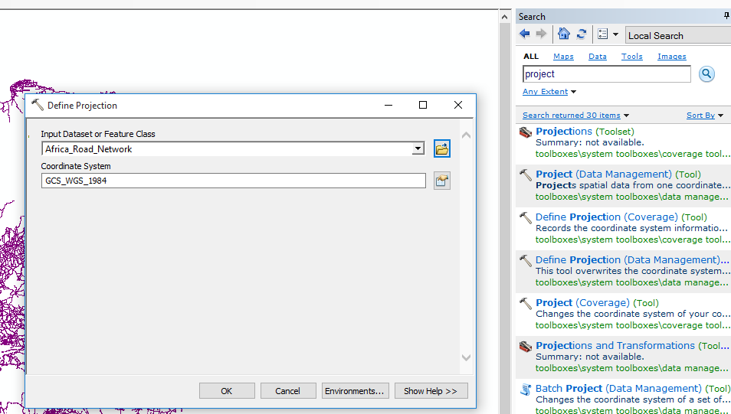

1. Use the **clip (analysis)** function in order to select and keep only the line data (roads) that lay within your county’s borders. You can find the function by simply typing its name in the search window.

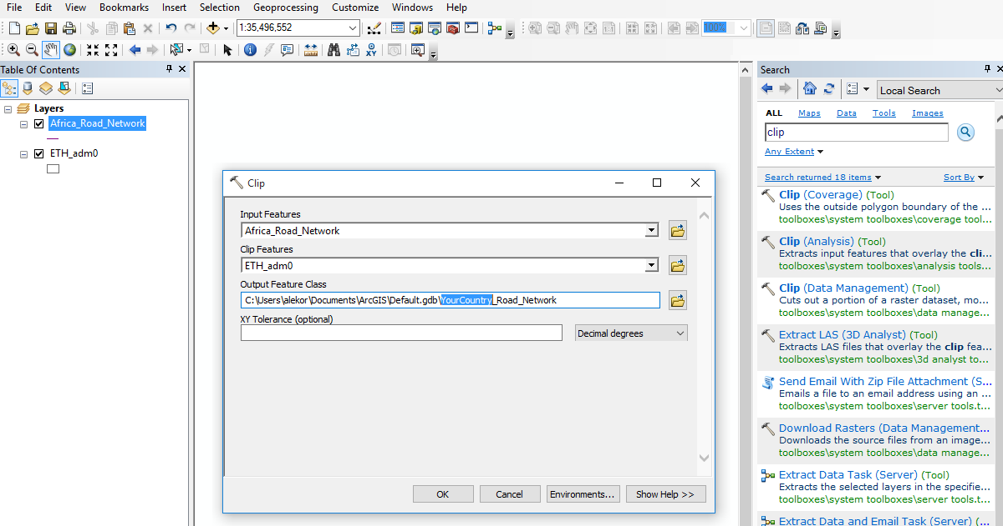

**Note!** The output will appear directly onto your data view screen in ArcGIS. Unless specified differently, this layer is saved in your Default database (see within your Catalog). It is a good habit to save it onto your designated folder (OnSSET_model) by using the Export Data function.

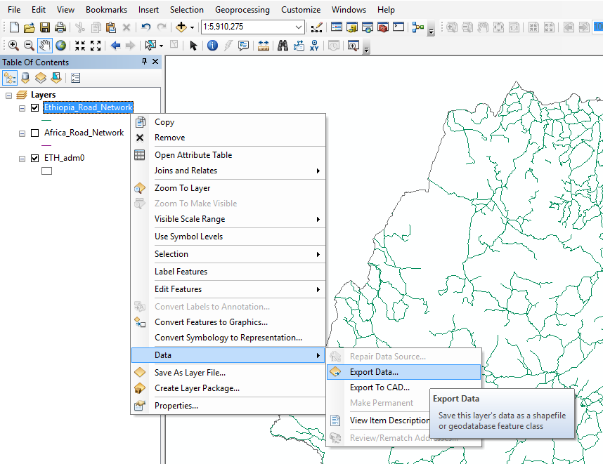

**Points**

1. Download the world mineral resources dataset from <https://mrdata.usgs.gov/general/global.html> (the USGS website) as csv file.
2. Place the downladed file into your OnSSET_model folder.
3. Insert the dataset into your map as a layer using the Add XY data function and by selecting X as longitude and Y as latitude. Define the coordinate system as WGS 1984.

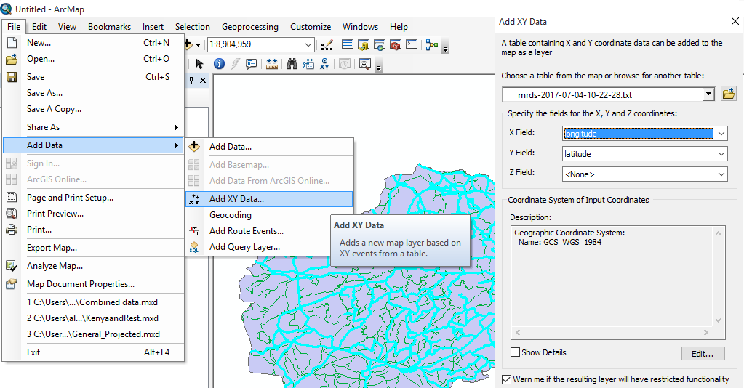

1. Use the clip (analysis) function in order to select and keep only the point data that lay within your country’s borders.
2. Export the “events” layer as shapefile in the OnSSET_model folder under the name “YourCountry_Mineral_Resources) similar to previous examples. Then import the layer into GIS again from your OnSSET_model folder.
3. Open the attribute table by right clicking on the road network layer in the table of contents, which is located on the left part of your screen.

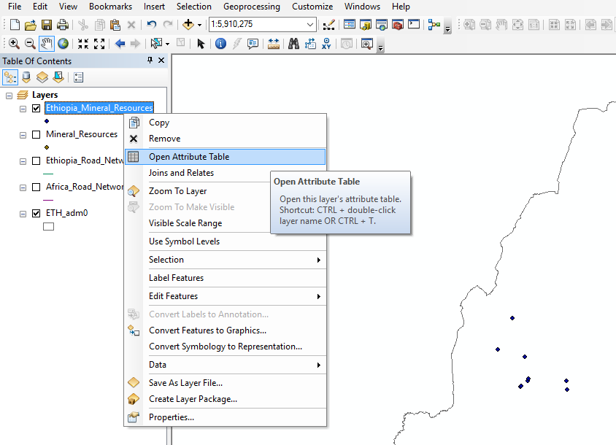

1. Use the function select by attribute in order to identify what is the type of mines that this dataset contains for your country.

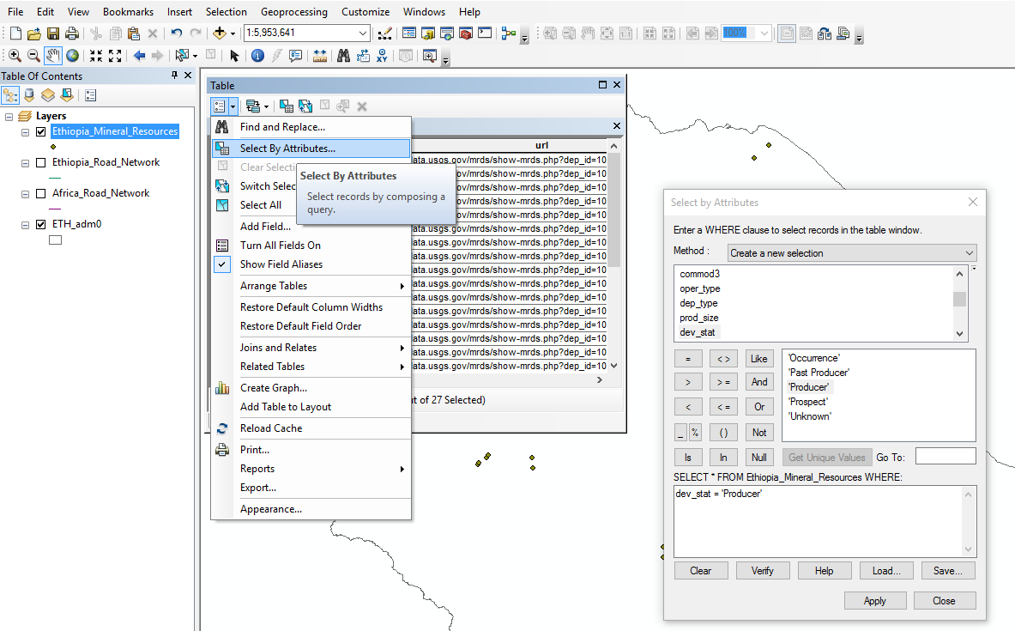

1. Use the selection in order to create two separate layers based on the variable “dev_stat” representing Producers and other mining activities in your country.

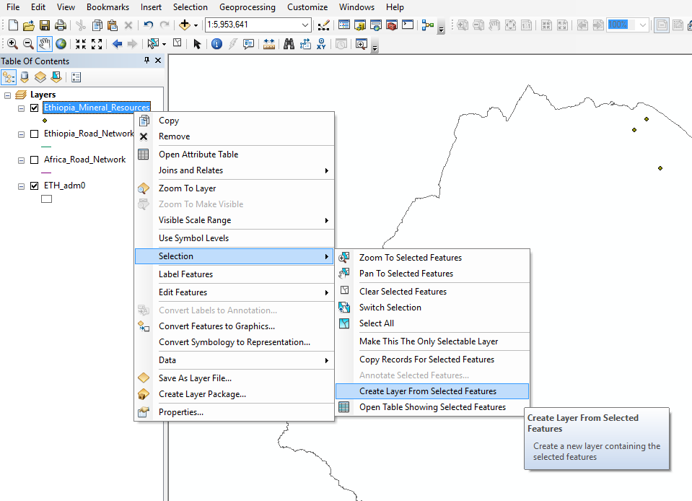

Project the feature layer (resourses) using the project (data management) function. You can find the function by simply typing its name in the search window. Please use WGS 1984 World Mercator projected coordinate system.

**Raster**

1. The population dataset is the basis of the OnSSET analysis. Population datasets are available both in raster and vector formats. Its resolution defines later on the resolution of the OnSSET analysis. In this example we will work with a raster dataset provided in 1 km spatial resolution. Please, access <http://www.worldpop.org.uk/> and download the regional population dataset for Africa.
2. Insert the dataset into the map as layer.
3. Clip the population dataset using the administrative boundaries of your country so as to reduce the volume of the dataset and to lower the processing time of the electrification analysis on the following stages. **Note!** The clipping function for raster layers is called Extract by mask.
4. Project the raster population for your country using the project raster (data management) function. You can find the function by simply typing its name in the search window. Please use WGS 1984 World Mercator projected coordinate system.

**Data creation and processing**

**Digitization process**

1. Create a new GIS file by going to File → New → Blank map
2. Right click to layers → Properties → Coordinate system → Geographic Coordinate Systems → World → WGS 1984
3. Insert the Administrative boundaries (level 0) for your country (e.g. Ethiopia) and set the color as No fill (basically no color selected).

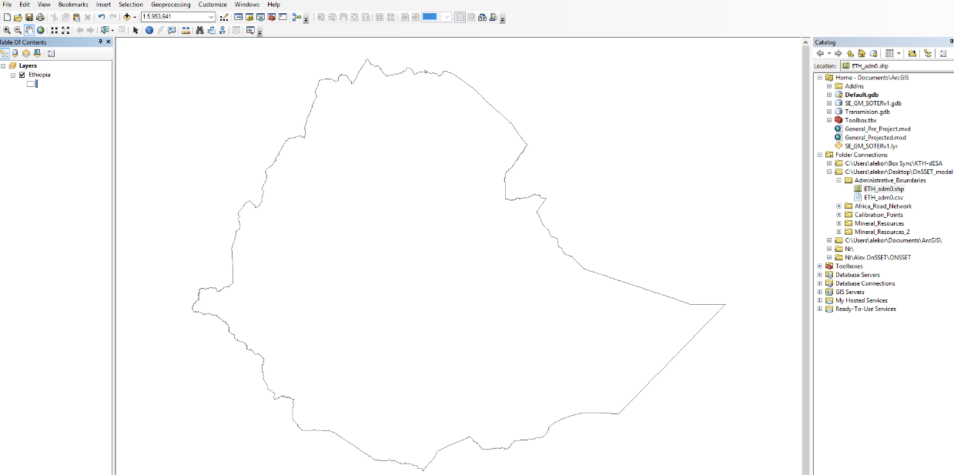

1. Go to Catalog → your new folder (e.g. OnSSET_model) → right click → new → shapefile. Provide name as Calibration_Points, select feature types as point and define the Geographic Coordinate Systems as WGS 1984 (Under the category World).

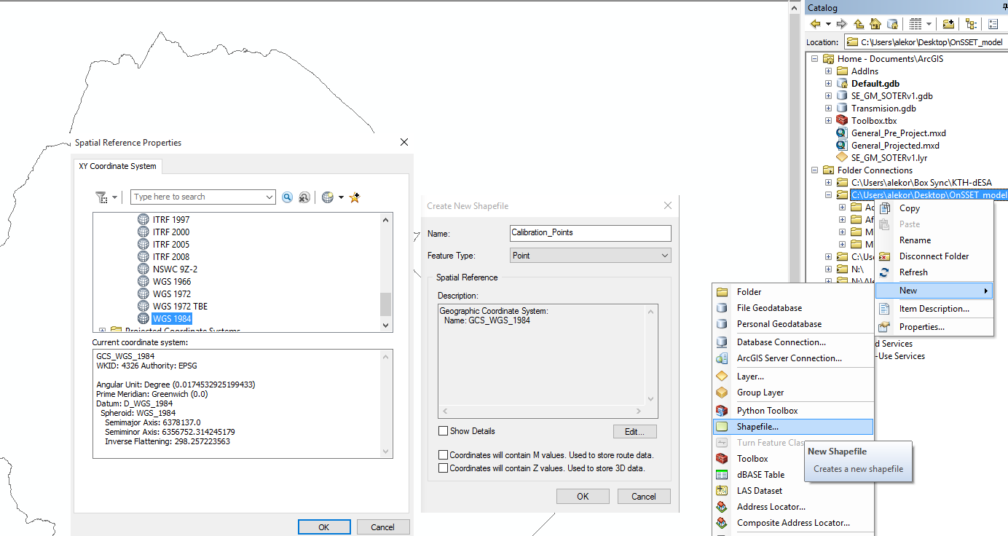

1. Make sure that the Georeferencing module is active on your ArcGIS. You do that by right clicking on the main upper ribbon, and ticking on the relevant module.

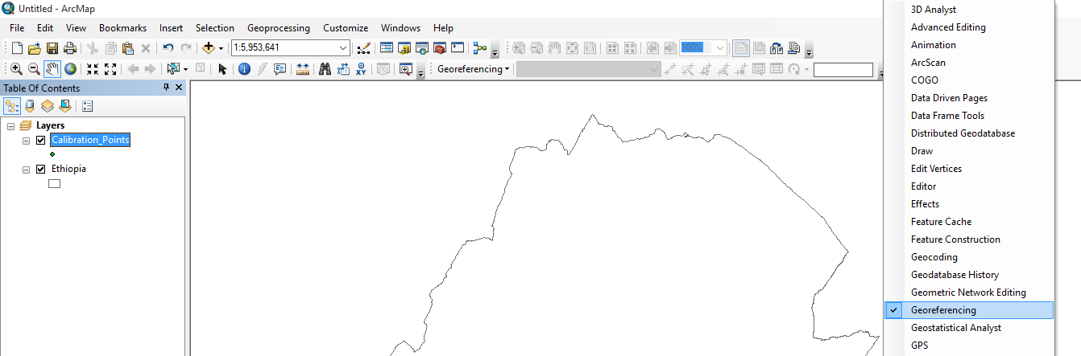

1. Now on editor (upper ribbon), select start editing. Select the points layer and click ok.

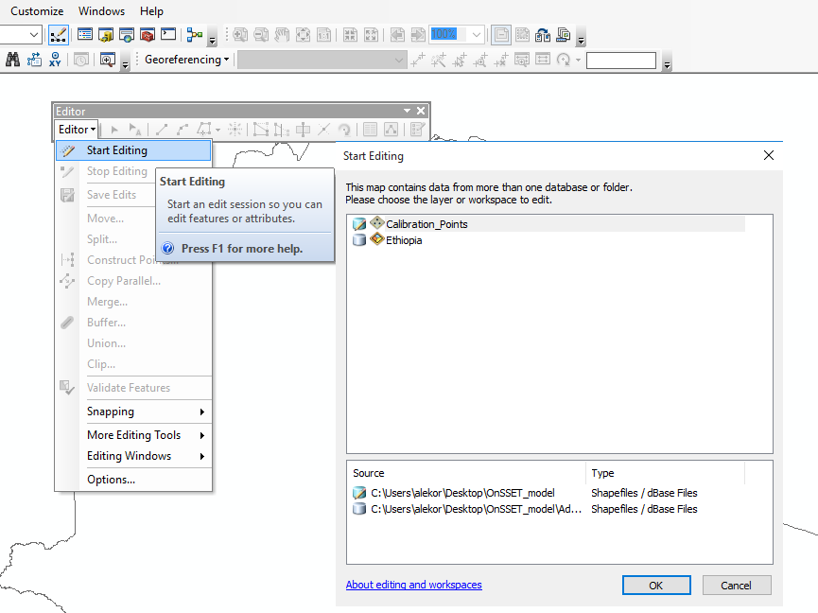

You should be able to add new points onto the map. Please add 6-10 new points on the edges of the country’s area equally distributed around the periphery. Save edits and click on stop editing. After finishing, save the edits and press stop editing (at the editor ribbon). You should be able to have something like this:

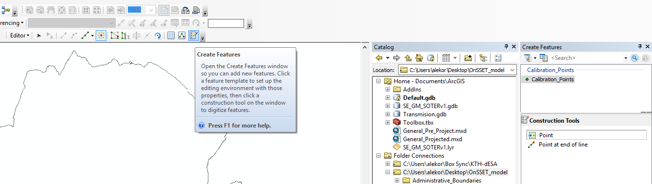

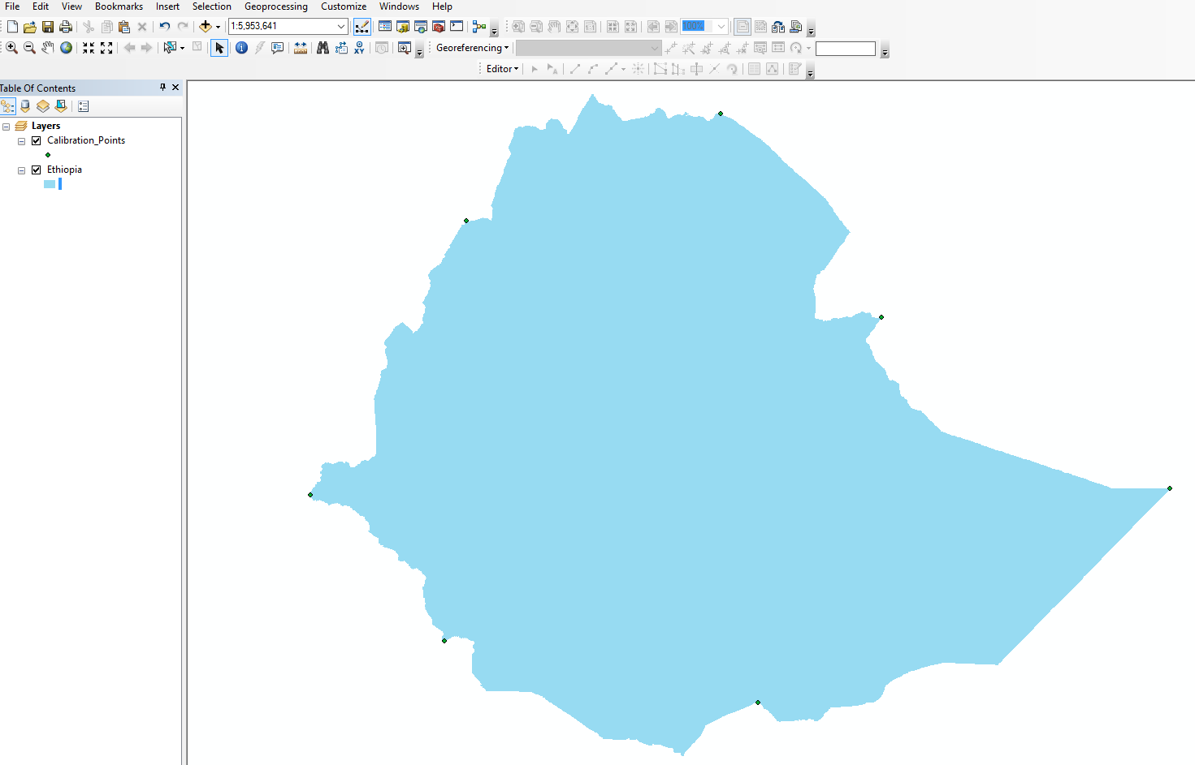

1. From the upper ribbon select add data, and then import the image of the Afghan Transmission network existing in your OnSSET_model folder. On the windows appearing click No and Ok.

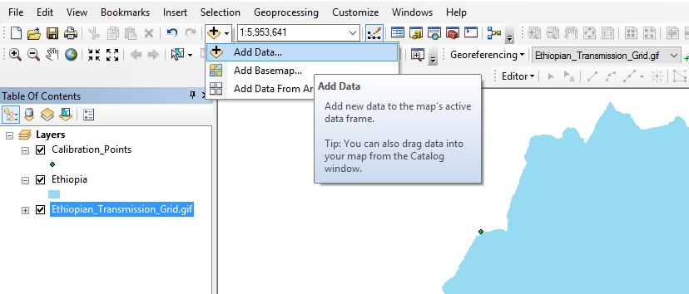

1. On the Georeferencing tab (upper ribbon) click fit to display (make sure that the image is selected for this process). Now you should be able to see the following:

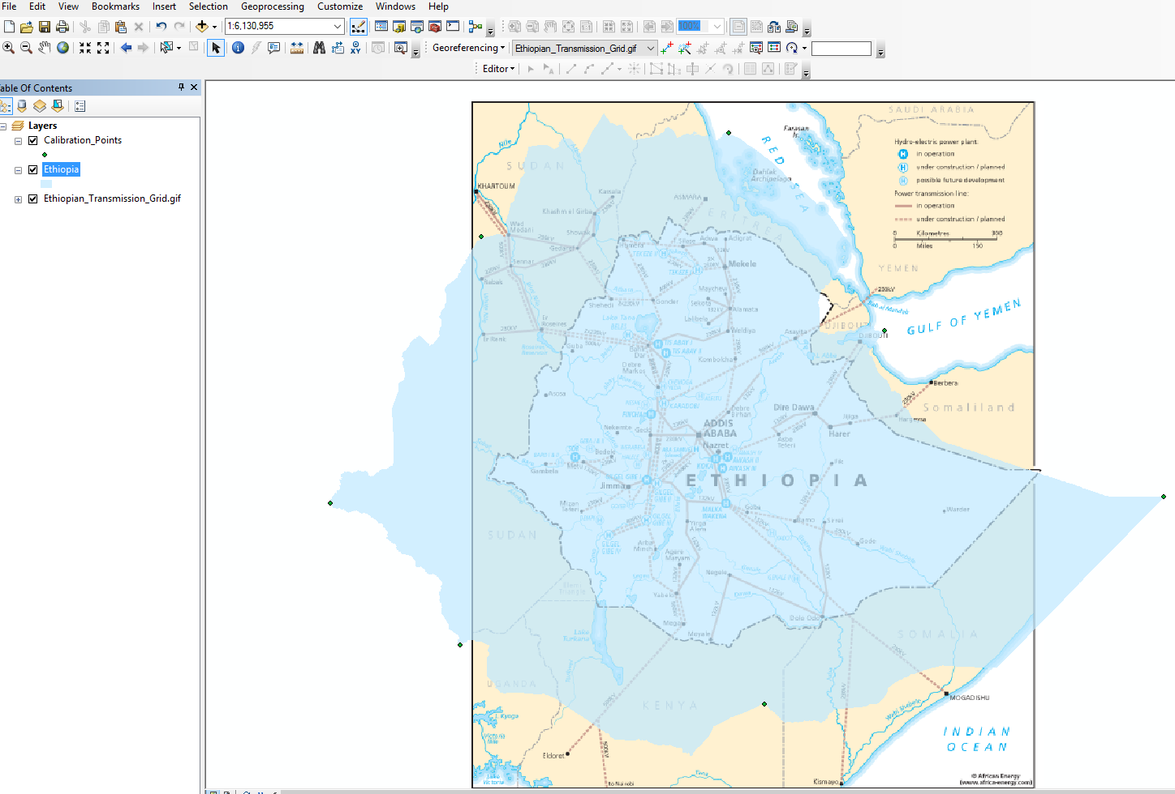

On the Georeferencing tab, click Add Control Points and one by one try to match the points on the image map to the calibration points that you have created. You can have a look at the Link table in the Georeferencing tab and more specifically on the residuals. The lower the residual the better the fit. You can delete the residuals that have high values. The result will look like this:

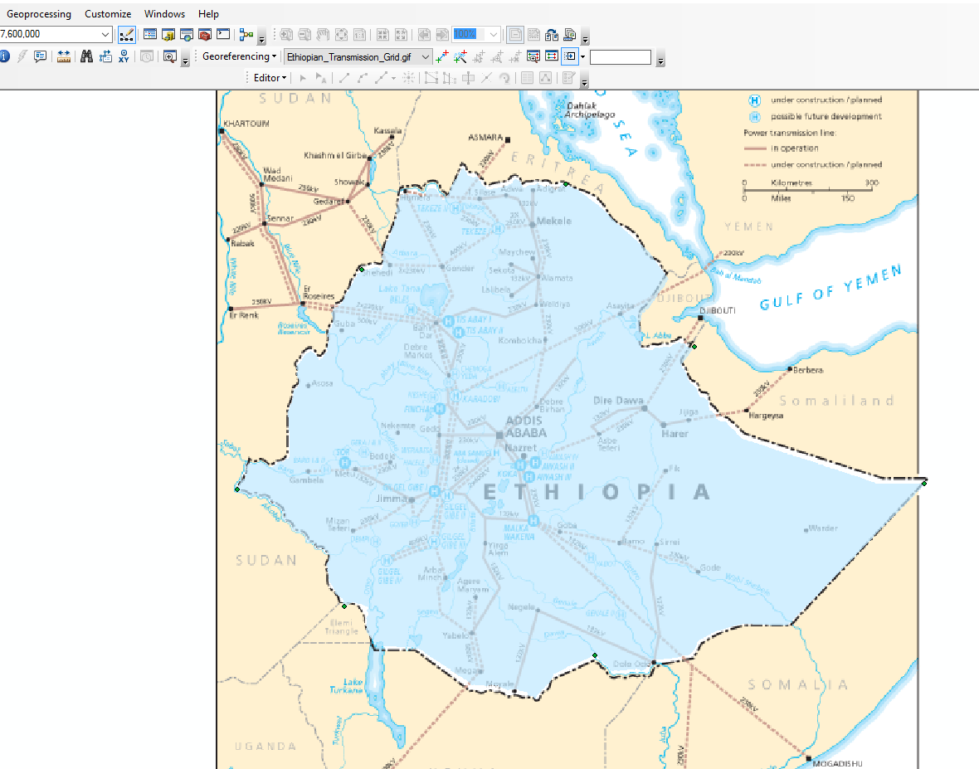

1. Finally, when you feel comfortable with the result, click Rectify and save the layer in the OnSSET_model folder under the name “YourCountry_Power_Infrastructure”.

**Creating new power infrastructure Layers (power plants – transmission lines)**

1. In the OnSSET_model folder, create a sub-folder called Existing_Infrastructure.
2. Go to Catalog → your new folder (e.g. Existing_Infrastructure) → right click → new → shapefile. Provide name as Existing_Grid, select feature types as **Polyline** and define the Geographic Coordinate Systems as WGS 1984 (Under the category World).
3. Add the Existing_Grid layer into your map. In the table of contents, right click on the Existing_Grid layer and open attribute table.

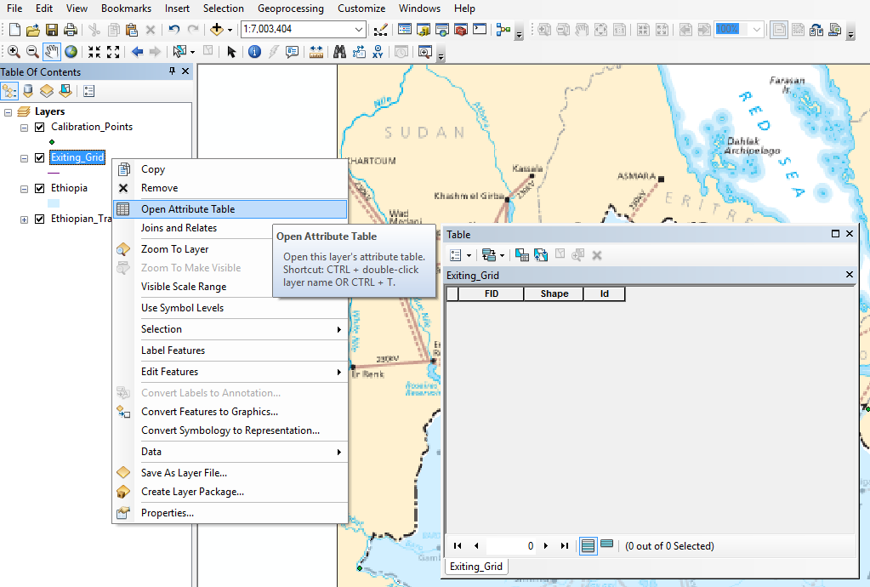

1. The table is empty, so we have to provide fields that correspond to the attributes that power lines might have (e.g. type, year of construction, Voltage, operating status etc.). Please make sure that every variable is defined properly. For example, **Voltage** should be defined as float while **Type** as text.

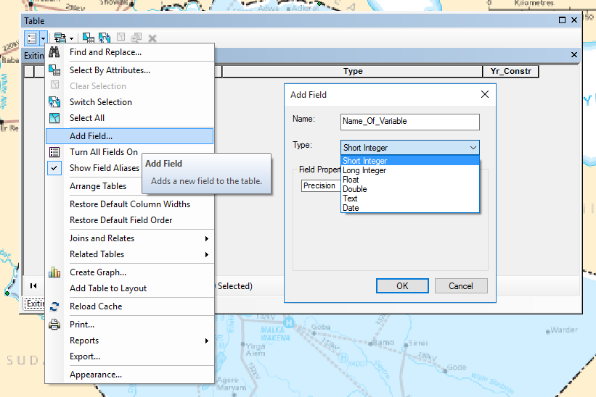

1. Using the digitized map from the previous process insert all the power lines that you see on the map along with their corresponding attributes, using the editor tab as shown before. Note, that this time you can select particular lines and provide attributes to them.

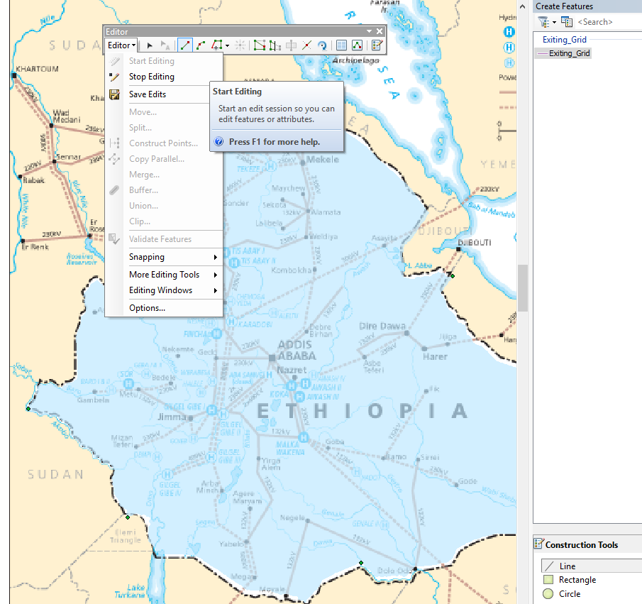

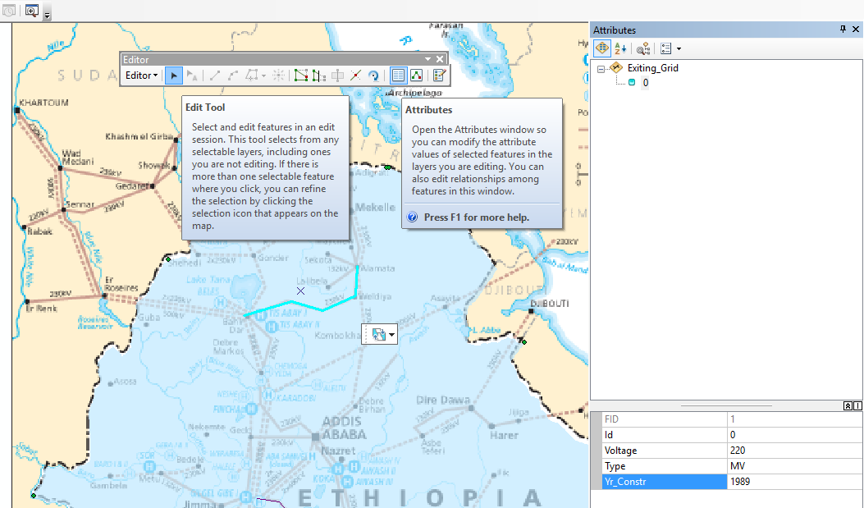

After the you have added all the elements, save the edits and stop editing. The new layer is ready to use and/or share.

1. Follow a similar process for the other power components (power plants, substations etc.). Note that in this case the new shapefile should be **Points** instead. Same process shall be followed for the planned infrastructure. After this exercise you should be able to create new vector files or process existing ones.

**Creating and populating a geodatabase**

**Setting up the projected environment in ArcGIS**

1. Open ArcGIS and create a new map named “YourCountry_Projected” (e.g. Ethiopia_Projected)
2. Right click to layers → Properties → Coordinate system → Projected Coordinate Systems → World → WGS 1984 World Mercator
3. Go to Catalog → Connect the “OnSSET_YourCountry” folder containing all the 16 projected GIS layers needed for an OnSSET analysis. KTH has prepared this folder for you and will be distributed during the worlshop.
4. Insert one by one the layers required for the analysis into your map. **Note**! Names of layers are set up by KTH in such way that will facilitate the following steps. It is recommended that they remain as set. In case alternative names are selected please be aware that changes in the python code (in next steps) are necessary.
5. On catalog tab, Right click on the newly created sub-folder and create within it a new **File Geodatabase** with the name of your country (e.g. Ethiopia).

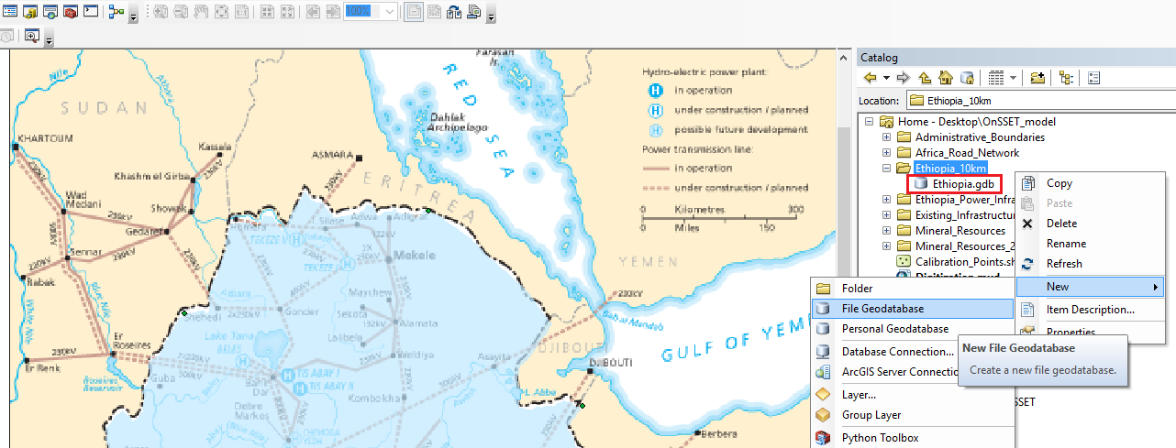

1. Right clicking on Ethiopia.gdb you will be able to import data. You can use multiple import for feature classes and raster datasets should be imported one by one.

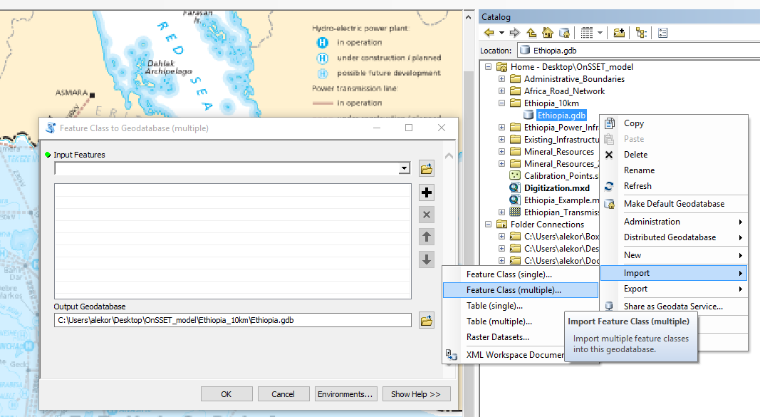

1. Once the geodatabase is populated you can start building the file to be used as input to the OnSSET model (or what we call the settlement file). Please use the txt file called “GIS commands for processing” that will guide you through all the GIS processes and the use of python.

**IMPORTANT!** When using the GIS commands for processing guide, you should ensure that

a) the paths demanded in the first lines of the code are clearly defined in the beginning and

b) the naming of the variables in the commands are the same as in the geodatabase

*path = r"C:\... \YourCountry.gdb"*

*path1 = r"C:\... \Assistingfolder" # Add this folder manually in the directory*

*outpath = r"C:\...\OnSSET_model "*

Please ask the workshop coordinators for any help if needed.

1. Once naming and paths are set up in a correct manner, you can start running the commands using the python command window in ArcGIS. The commands can run all together or in batches based on the intended goal and the capabilities of the computer the analysis is ran on.

