Setting up security token
- Log into SalesForce
- Click on Your name, then choose >> My Settings
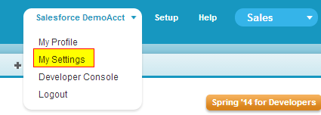
- On the left navigation bar, click Personal >> then Reset My Security Token >> then click the Reset Security Token button. The token will then be emailed to you.
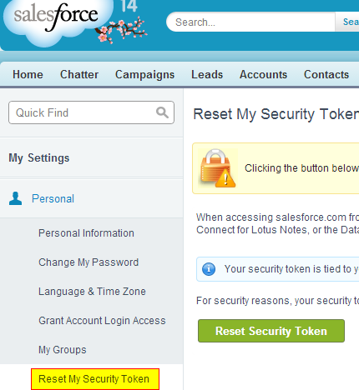

Setting up Connected App credentials
- Choose click setup

- Click Create >> Apps from the left navigation bar. Then the New button in the Connected Apps section at the bottom.
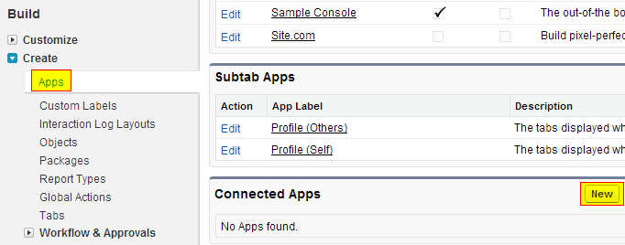
- Set your app information and click Save
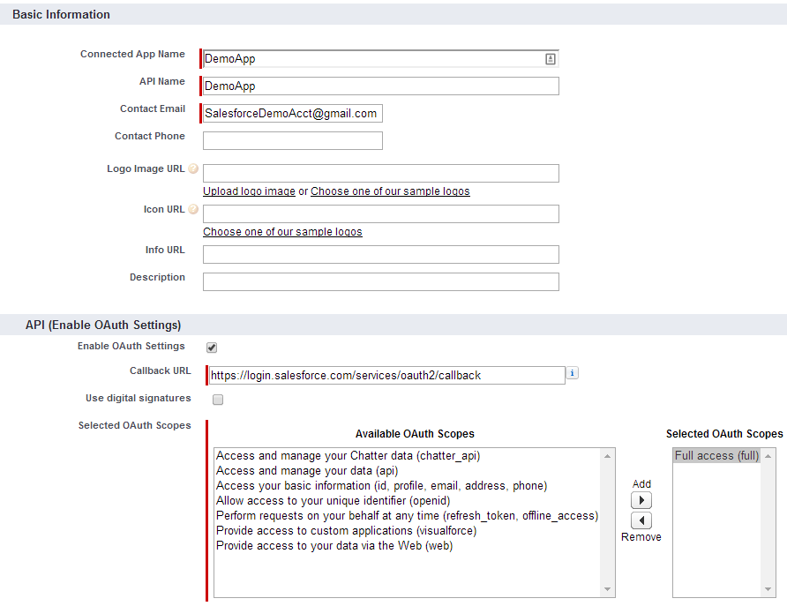
- You’ll see your consumer key and consumer secret – you’ll need those for your program.

Questions?
Scott VandenElzen
Email: scott@vandenelzen.com
Twitter: @scottvelzen

