# Introduction

As global change continues to increase impacts on global ecosystems, carbon emissions reinforce climate change negatively impacting biodiversity and ecosystem services. Land degradation accounts for 15 - 20% of all anthropogenic GHG emissions (van der Werf et al., 2009; Keith et al., 2009). Land protecion can support climate change mitigation by slowing down carbon loss (Scharlemann et al., 2010; Munang et al., 2013). The Sustainable Development Goals (SDGs), the United Nations Framework Convention on Climate Change (UNFCCC) and the CBD emphasize the necessity to integrate climate and conservation agendas. CC, carbon, storage vs sequestration, PAs, Paris Agreement, CBD, SDGs…

Terrestrial protected areas cover X% of the land surface (Delli et al., 2021). They represent an effective tool to reduce land degradation and provide several ecosystem services (de la Fuente et al., 2020). Carbon storage in vegetation and soil is an important service which has gained interest in the climate-policy agenda. However, protected areas as a mechanism in climate change mitigation policies have mainly targeted above ground carbon-dense forests (Venter & Kohl, 2012), not considering for the most part other regions with relevant carbon pools (for example soils and root systems).

This study presents an multi-scale assessment of carbon stocks across the “vertical pools” (of forests) in PAs showing their total contribution to the global carbon storage. We examine the contribution of protected carbon stocks by country and ecoregion, and in different PA management categories, ranging from strict nature reserves to sustainable use areas. This exercise provides a global overview of which regions and countries contribute most to mitigate climate change through reducing emissions from deforestation and forest degradation (REDD). Overarching policy question: How do protected areas contribute to carbon storage and hence to offset the impacts of fossil fuel emissions and to climate change mitigation?

How important are PAs for C stock conservation relative to their total % coverage?

# Materials & methods

Since our approach in carbon stocks doesn’t account for grasslands or cropland (negligible in PAs?) maybe we could try to only include SOC pixels where there is AGB? So only forests?

**Protected areas and buffer zones**

Using the spatial extent of PAs at the global scale using the public version of the World Database on Protected Areas (WDPA) for [WDPA version] from Protected Planet (UNEP-WCMC, [year]). The WDPA is managed by the World Conservation Monitoring Centre (WCMC) of the United Nations Environment Programme (UNEP) in collaboration with the International Union for Conservation of Nature (IUCN), and is collated from national and regional datasets. This dataset consists of [n] protected areas (PAs), of which those of [X] km2 or larger ([n] PAs) are documented in detail in the Digital Observatory for Protected Areas (DOPA) developed by the Joint Research Centre of the European Commission (Dubois et al., 2016, Bastin et al., 2017). The DOPA, accessible at http://dopa.jrc.ec.europa.eu, provides a broad range of consistent and comparable indicators on PAs at country, ecoregion and protected area level (Dubois et al., 2016). These indicators are particularly relevant for Aichi Biodiversity Target 11 (Protected Areas) of the CBD, for which DOPA provides several official indicators (PA connectivity as a measure of how well connected terrestrial PA systems are, and PA coverage of terrestrial and marine ecoregions as a measure of PA representativeness), and the UN Sustainable Development Goals 14 (Life below Water) and 15 (Life on Land).

In this study, we excluded from the original dataset the following PAs. First, we excluded [n] PAs with undefined boundaries, so-called point PAs that are reported by national authorities with only a single geographic reference for the centre of the PA. Second, we excluded [n] polygon PAs with status 'Not reported' or 'Proposed', in line with common practice for global PA analyses (e.g., UNEP-WCMC, 2016 Saura et al., 2018). Third, we excluded the UNESCO-MAB and the Biosphere Reserves, as their buffer areas and transition zones may not meet the IUCN protected area definition (Dudley, 2011), and because most of their core areas overlap with other protected areas (UNEP-WCMC, 2016). Fourth, we excluded [n] marine PAs, i.e. we only considered PAs classified in the WDPA as terrestrial and coastal (the latter comprised both terrestrial and marine portions. Since the land productivity dynamics has null values for water areas, marine portions are not considered in our analyses). Last, we retained only PAs larger than [X] km2. This led to a subset of [n] PAs, object of this study, covering a total of [n] km2 and representing [n]% of the [n] km2 of protected land area at global level.

**Total carbon**

Three datasets are included for the calculation of the total organic carbon stocks inside PAs.

(i) Soil organic carbon (SOC) is derived from the information provided by the global soil organic carbon (GSOC) map (version 1.2.0) (Brus et. al., 2017), a global dataset which quantifies the amount of organic carbon in the first 30 cm of soil with a spatial resolution of 1 km. This dataset was produced through the efforts of the Global Soil Partnership was produced in a collaborative effort in which countries developed their capacities to collect and compile national available data. The data is available at <http://www.fao.org/global-soil-partnership/pillars-action/4-information-and-data-new/global-soil-organic-carbon-gsoc-map/en/.> The data compiled independently and generated a single SOC map in each country continuous SOC map through predictions or extrapolations, involving covariates that were shown to be related to SOC levels in the sampled locations and hence useful to provide SOC estimates in the unsampled locations, similar to other soil mapping efforts (Hengl et al., 2017; Hengl et al., 2021). The national SOC maps were then combined into a continuous global dataset.

(ii) Aboveground biomass carbon (ABC) is itself an approximation derived from aboveground biomass data. Biomass is considered as the oven-dry mass of the woody parts (stem, bark, branches and twigs) of all living trees. Shrubs, low bushes, grasslands and cropland are not considered. Carbon stocks from trees were obtained by applying a conversion factor of 0.5 to the total biomass. This value represents a good approximation of the typical carbon content in the biomass of terrestrial vegetation, and is consistent with the Good Practice Guidance in LULUCF by the IPCC (2003) and with other related assessments (Baccini et al., 2017; Zarin et al., 2016; Achard et al., 2014). As biomass reference data, this study uses the global terrestrial biomass map derived from Earth Observation data and based on 2010 data. The dataset was developed in the framework of the GlobBiomass project and is a global dataset is derived from several missions (Envisat, Landsat, ICESAT) and different sensors (SAR, LiDAR, optical) at 100 m spatial resolution (Santoro et al., 2018). Overall, the GlobBiomass dataset performs appropriately in estimating AGB in all biomes, as assessed over a significant set of locations with independent in situ reference data (Santoro et al., 2021). It is available at <http://globbiomass.org>.

(iii) Belowground biomass carbon (BBC) is derived from the ABC and expresses an estimation of the carbon stored in roots of living trees. This carbon pool is calculated as a fraction of the ABC stocks using root-to-shoot ratios (R) from two main data sources: the ABC data and ratios of below-ground biomass to above-ground biomass (IPCC, 2019). Root systems are a long-term stable carbon pool which can account for up to 40% of the total aboveground biomass (Reich et al., 2014). The IPCC Root-to-shoot ratios depend on the biogeographic conditions (ecozone), forest type, forest origin (natural or planted) and aboveground biomass density (Table 4.4 of IPCC, 2019). However, while the aboveground biomass data has a global coverage, the IPCC ratios are not available for all existing combinations of the parameters necessary to calculate them. In order to estimate the root-to-shoot ratios in the classes not represented in the IPCC table the following assumptions were made: (i) in missing ecozones use the ratio for the most similar ecozone included in the IPCC table, considering physiological allocation of biomass (i.e., higher ratios for dry ecozones); (ii) in case of missing continents in the IPCC table, use the average ratio available for other continents located in the same ecozone and same biomass class; (iii) for missing origin, use the ratio for the same forest type (broadleaf or conifer) but different forest origin; (iv) for missing forest type use the closest forest type; (v) in case of missing aboveground biomass range use an available range. Ancillary datasets necessary to map root-to-shoot ratios are: (a) Spatial dataset of the ecological zones from FAO (2012); (b) Land cover map for the year 2017 (ESA Land Cover CCI, 2017); (c) Spatial Database of Planted Trees used to identify the forest origin (Harris et al., 2019); and (d) Statistical mapping of tree species over Europe (Brus et al., 2011). Similarly, as for the ABC, a 0.5 biomass to carbon conversion factor was applied, in line with good practices and recommendations from the scientific community (IPCC, 2003; Baccini et al., 2017; Zarin et al., 2016; Achard et al., 2014).

For this analysis, the total carbon stocks in the three mentioned pools are considered. All three carbon datasets (SOC, ABC and BBC) were brought to the same spatial definitions (resolution and extent). To avoid oversampling artifacts, ABC and BBC were brought to the SOC spatial resolution and summed to calculate the total carbon in each 1km x 1km pixel, resulting in a density measure of carbon (Mg C/km2) in forested areas. Although soil data from GSOC map has not reference date and is compiled from national soil carbon inventories collected at different times, it is recommended to be used as a baseline dataset (FAO & ITPS, 2020). Given that organic soil carbon a relatively stable stock, it is assumed that the reference year for the total carbon stocks presented in this study is the year 2010.

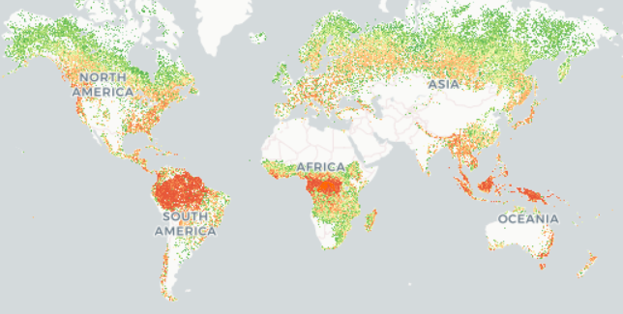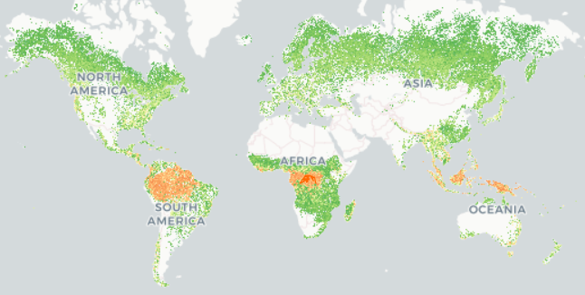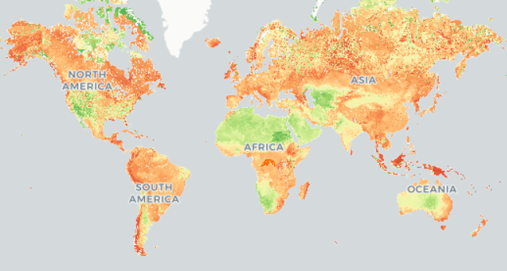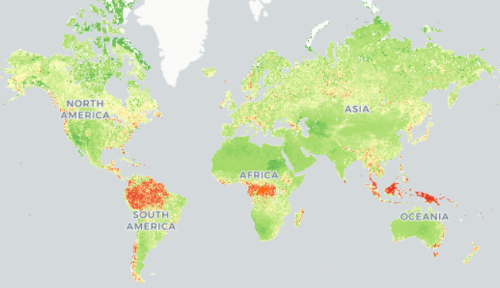

Figure X: Carbon maps. In clockwise order starting from top left: Aboveground Biomass Carbon, Belowground Biomass Carbon, Total Carbon and Soil Organic Carbon.

The harmonized dataset of the total carbon stocks was aggregated at PA, country and ecoregion levels. The WDPA was used to define only terrestrial protected areas as mentioned above. Country boundaries were obtained from the Global Administrative Unit Layers for the year 2015, developed by the Food and Agricultural Organization (FAO) of the United Nations. Only terrestrial ecoregions (TEOW) were included as defined by Olson et al. (2001). Summary statistics (min, max, mean and sum) of each protected area, country and ecoregion were produced.

# Results

Results 1: Global assessment of the C distribution between the three pools considered and ho much of each pool is protected. In terms of the distribution of carbon in the three pools considered, 61% is stored in SOC, 29% in ABC and 10% in BBC.

Results 2: Country assessment of the major countries with carbon stocks, how it is distributed in the three pools and how much carbon is protected in each country x pool. The largest stocks of protected carbon are located in Brazil (54 Pg), followed by the Russian Federation (22 Pg) and the United States of America (18 Pg), which are also the three countries with the largest stocks of protected SOC (13 Pg, 17 Pg and 13 Pg, respectively). In absolute terms, the largest stocks of carbon are located in the Russian Federation (198 Pg), Canada (109 Pg) and Brazil (103 Pg), most of the carbon corresponding to SOC stocks.

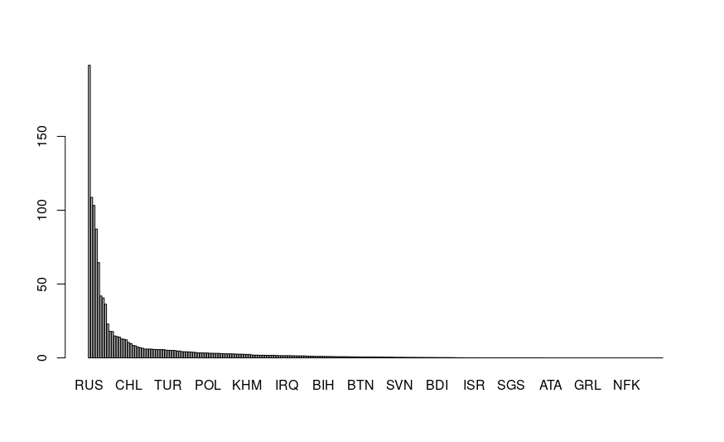

Results 3: Ecoregion assessment of the major ecoregions storing carbon, how it is distributed in the three pools and how much carbon is protected in each ecoregion x pool. The ecoregions with the largest carbon stocks are the East Siberian taiga, Scandinavian and Russian taiga and West Siberian taiga (43, 27 and 25 Pg respectively).

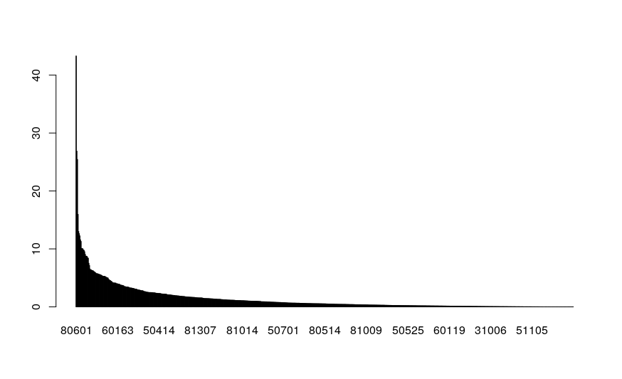

Results 4: PA assessment of the most important PAs in terms of carbon, how is distributed in the three pools and which IUCN category shows the most relevance in storing carbon (this analysis may be flawed, as areas might have several designations overlapping).

In terms of countries

Show the countries which protect the highest share of their carbon stocks

# Discussion

Compare with

# Conclusions

# References

Achard, F., Beuchle, R., Mayaux, P., Stibig, H. J., Bodart, C., Brink, A., ... & Lupi, A. (2014). Determination of tropical deforestation rates and related carbon losses from 1990 to 2010. Global change biology, 20(8): 2540-2554. https://doi.org/10.1111/gcb.12605

Baccini, A., Walker, W., Carvalho, L., Farina, M., Sulla-Menashe, D., & Houghton, R. A. (2017). Tropical forests are a net carbon source based on aboveground measurements of gain and loss. Science, 358(6360): 230-234. DOI:10.1126/science.aam5962

Bastin, L., Mandrici, A., Battistella, L., Dubois, G., 2017. Processing Conservation Indicators with Open Source Tools: Lessons Learned from the Digital Observatory for Protected Areas. In Free and Open Source Software for Geospatial (FOSS4G) Conference Proceedings (Vol. 17, No. 1, p. 14).

Brus, D.J., G.M. Hengeveld, D.J.J. Walvoort, P.W. Goedhart, A.H. Heidema, G.J. Nabuurs, K. Gunia, 2011. Statistical mapping of tree species over Europe. Special Issue European Journal of Forest Research. https://doi.org/10.1007/s10342- 011-0513-5

Brus, D., Hengl, T., Heuvelink, G., Kempen, B., Mulder, T. V. L., Olmedo, G. F., ... & Vargas, R. (2017). Soil organic carbon mapping: GSOC map cookbook manual.

Dubois G., et al., 2016. Integrating multiple spatial datasets to assess protected areas: lessons learnt from the Digital Observatory for Protected Areas (DOPA). ISPRS International Journal of Geo-Information, 5, 242

Dudley, N. (Editor), 2008. Guidelines for Applying Protected Area Management Categories. Gland, Switzerland: IUCN.

FAO & ITPS. 2020. Global Soil Organic Carbon Map V1.5: Technical Report. Rome. FAO. https://doi.org/10.4060/ca7597en

Hengl, T., Mendes de Jesus, J., Heuvelink, G. B., Ruiperez Gonzalez, M., Kilibarda, M., Blagotić, A., ... & Kempen, B. (2017). SoilGrids250m: Global gridded soil information based on machine learning. PLoS one, 12(2), e0169748.

Hengl, T., Miller, M. A., Križan, J., Shepherd, K. D., Sila, A., Kilibarda, M., ... & Crouch, J. (2021). African soil properties and nutrients mapped at 30 m spatial resolution using two-scale ensemble machine learning. Scientific Reports, 11(1), 1-18.

IPCC, 2019. Chapter4. Refinement to the 2006 IPCC Guidelines for National Greenhouse Gas Inventories, Calvo Buendia, E., Tanabe, K., Kranjc, A., Baasansuren, J., Fukuda, M., Ngarize, S., Osako, A., Pyrozhenko, Y., Shermanau, P. and Federici, S. (eds). Published: IPCC, Switzerland

Keith, H., Mackey, B. G., & Lindenmayer, D. B. (2009). Re-evaluation of forest biomass carbon stocks and lessons from the world's most carbon-dense forests. Proceedings of the National Academy of Sciences, 106(28), 11635-11640.

Munang, R., Thiaw, I., Alverson, K., Mumba, M., Liu, J., & Rivington, M. (2013). Climate change and Ecosystem-based Adaptation: a new pragmatic approach to buffering climate change impacts. Current Opinion in Environmental Sustainability, 5(1), 67-71.

Reich, P. B., Luo, Y., Bradford, J. B., Poorter, H., Perry, C. H., & Oleksyn, J. (2014). Temperature drives global patterns in forest biomass distribution in leaves, stems, and roots. Proceedings of the National Academy of Sciences, 111(38), 13721-13726. https://doi.org/10.1073/pnas.1216053111

Santoro, M., Cartus, O., Carvalhais, N., Rozendaal, D., Avitabile, V., Araza, A., ... & Willcock, S. (2021). The global forest above-ground biomass pool for 2010 estimated from high-resolution satellite observations. Earth System Science Data, 13(8), 3927-3950.

Santoro, M., Cartus, O., Mermoz, S., Bouvet, A., Le Toan, T., Carvalhais, N., Rozendaal, D., Herold, M., Avitabile, V., Quegan, S., Carreiras, J., Rauste, Y., Balzter, H., Schmullius, C., Seifert, F.M., 2018, GlobBiomass global above-ground biomass and growing stock volume datasets, available on-line at http://globbiomass.org/products/global-mapping

Saura S., Bertzky B., Bastin L., Battistella L., Mandrici A., Dubois G., 2018. Protected area connectivity: Shortfalls in global targets and country-level priorities. Biological Conservation, 219, 53–67. pmid:29503460

Scharlemann, J. P., Kapos, V., Campbell, A., Lysenko, I., Burgess, N. D., Hansen, M. C., ... & Miles, L. (2010). Securing tropical forest carbon: the contribution of protected areas to REDD. Oryx, 44(3), 352-357.

UNEP-WCMC and IUCN, [year]. Protected Planet: The World Database on Protected Areas (WDPA) [month, year], Cambridge, UK: UNEP-WCMC and IUCN. Available at: [www.protectedplanet.net](http://www.protectedplanet.net).

UNEP-WCMC and IUCN, 2016. Protected Planet Report 2016. UNEP-WCMC and IUCN: Cambridge UK and Gland, Switzerland.

VAN DER WERF , G.R., MORTON , D.C., DE F RIES , R.S., OLIVIER, J.G.J., KASIBHATLA, P.S., JACKSON , R.B. et al. (2009) CO2 emissions from forest loss. Nature Geoscience, 2, 737–738.

Venter, O., & Koh, L. P. (2012). Reducing emissions from deforestation and forest degradation (REDD+): game changer or just another quick fix?. Annals of the New York Academy of Sciences, 1249(1), 137-150.

Zarin, D. J., Harris, N. L., Baccini, A., Aksenov, D., Hansen, M. C., Azevedo‐Ramos, C., ... & Allegretti, A. (2016). Can carbon emissions from tropical deforestation drop by 50% in 5 years? Global change biology, 22(4): 1336-1347. https://doi.org/10.1111/gcb.13153