10/09/2018 – Giacomo De Liberali, 580595

Advanced SOftware Engineering – Homework 1

# Github repository

### The repository is published on github.com at this link:

### <https://github.com/giacomodeliberali/adv-software-engineering/tree/master/Homework_1>

### It is placed in a common repository containing also all the lab sections.

# pytest result

The pytest completes successfully, even if a warning is raised into one app’s dependency.

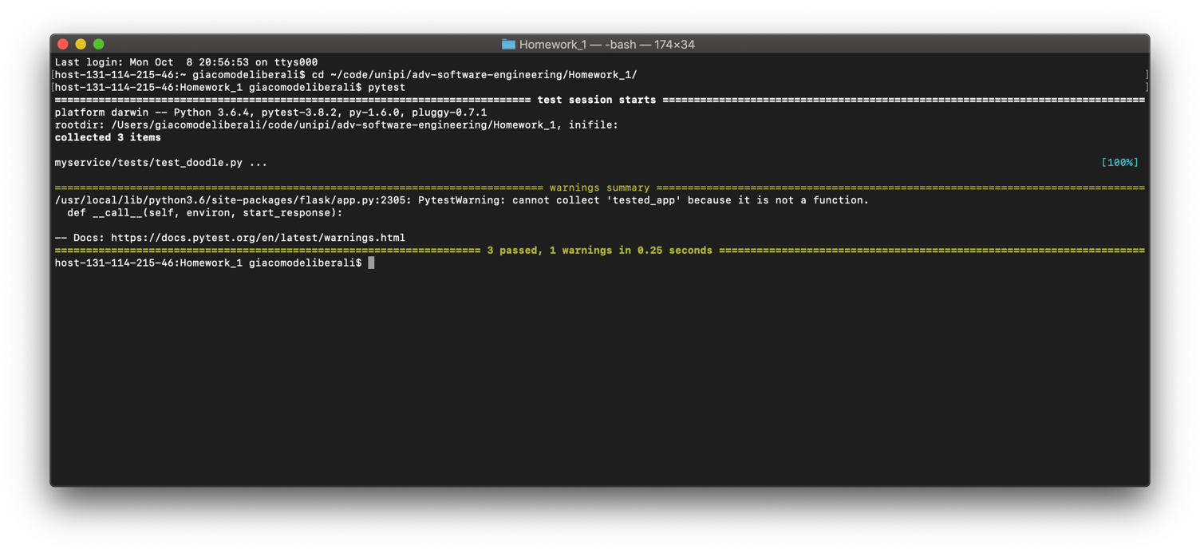

# Postman tests

# I created a Postman collection containing all the request included in the “tests/test_doodle.py”. The exported collection can be found in the root of the repository, it’s a JSON file named “*Homework1-Test.postman_collection.json*”

# For every request I also have included Postman tests following the expectations of the python test cases, verifying both response status code and optional body response.

# The Postman test results file is exported in the root of the repository in a file named “*Homework1-Test.postman_test_run.json*”.

# An example of Postman test case is the following, which is executed automatically by Postman after the request has been completed:

1. pm.test("Winners should be 2", **function** () {
2. **var** jsonData = pm.response.json();
3. pm.expect(jsonData.winners.length).to.eql(2);
4. });
6. pm.test("Winners[0] = 1", **function** () {
7. **var** jsonData = pm.response.json();
8. pm.expect(jsonData.winners[0]).to.eql("1");
9. });
11. pm.test("Status code is 200", **function** () {
12. pm.response.to.have.status(200);
13. });

# The following images represent the result of the collection run: each line is an http request and all the indented squares are the postman tests per request.

