Exploring the Shakespeare Theatre Knowledge Graph

- Exploration exercises (guided queries)

- Group mini-challenge
In this exercise we will explore a graph containing information about:
- authors
- plays
- theatre productions
- performances
- venues
- reviews
- geographic locations
Your task is to explore the graph using Cypher queries.

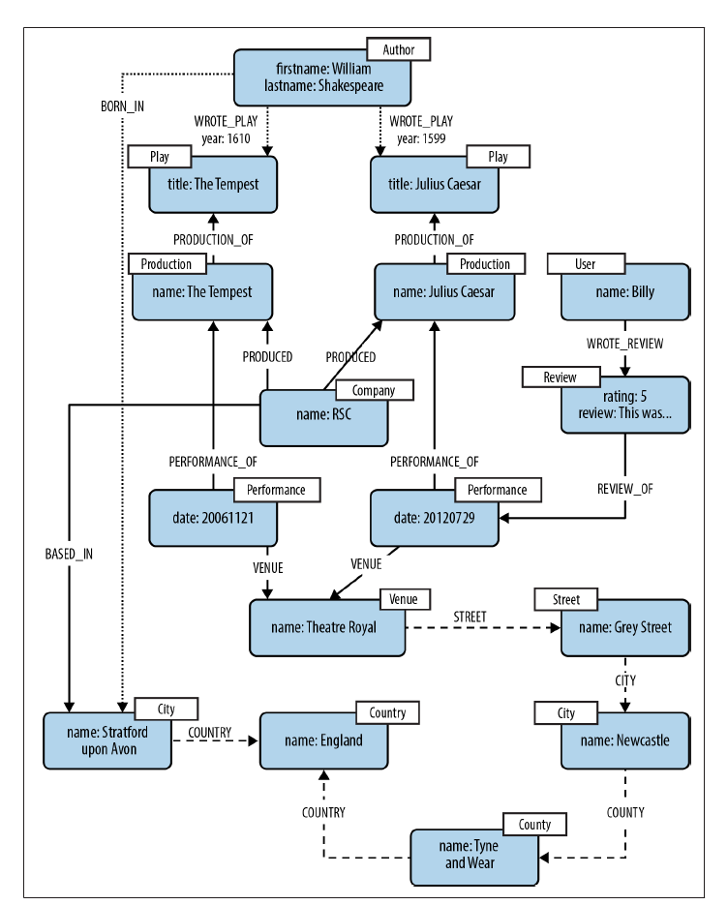
The Shakespeare graph
The data is available as a script you can run on Neo4j:
MATCH (n) DETACH DELETE n;
CREATE (shakespeare:Author {firstname:'William', lastname:'Shakespeare'}),
(juliusCaesar:Play {title:'Julius Caesar'}),
(shakespeare)-[:WROTE_PLAY {year:1599}]->(juliusCaesar),
(theTempest:Play {title:'The Tempest'}),
(shakespeare)-[:WROTE_PLAY {year:1610}]->(theTempest),
(rsc:Company {name:'RSC'}),
(production1:Production {name:'Julius Caesar'}),
(rsc)-[:PRODUCED]->(production1),
(production1)-[:PRODUCTION_OF]->(juliusCaesar),
(performance1:Performance {date:20120729}),
(performance1)-[:PERFORMANCE_OF]->(production1),
(production2:Production {name:'The Tempest'}),
(rsc)-[:PRODUCED]->(production2),
(production2)-[:PRODUCTION_OF]->(theTempest),
(performance2:Performance {date:20061121}),
(performance2)-[:PERFORMANCE_OF]->(production2),
(performance3:Performance {date:20120730}),
(performance3)-[:PERFORMANCE_OF]->(production1),
(billy:User {name:'Billy'}),
(review:Review {rating:5, review:'This was awesome!'}),
(billy)-[:WROTE_REVIEW]->(review),
(review)-[:RATED]->(performance1),
(theatreRoyal:Venue {name:'Theatre Royal'}),
(performance1)-[:VENUE]->(theatreRoyal),
(performance2)-[:VENUE]->(theatreRoyal),
(performance3)-[:VENUE]->(theatreRoyal),
(greyStreet:Street {name:'Grey Street'}),
(theatreRoyal)-[:STREET]->(greyStreet),
(newcastle:City {name:'Newcastle'}),
(greyStreet)-[:CITY]->(newcastle),
(tyneAndWear:County {name:'Tyne and Wear'}),
(newcastle)-[:COUNTY]->(tyneAndWear),
(england:Country {name:'England'}),
(tyneAndWear)-[:COUNTRY]->(england),
(stratford:City {name:'Stratford upon Avon'}),
(stratford)-[:COUNTRY]->(england),
(rsc)-[:BASED_IN]->(stratford),
(shakespeare)-[:BORN_IN]->(stratford)

Step 1 — Explore the Graph Structure
Start by visualizing the graph.
MATCH (n)
RETURN n
Look at the visualization and answer:
Questions
- What different types of nodes exist?
- What different types of relationships exist?

Step 2 — Find the Author
Find all authors in the database.
MATCH (a:Author)
RETURN a
Questions:
- Who is the author in this dataset?
- Which properties describe the author?

Step 3 — Which Plays Did the Author Write?
Retrieve the plays written by the author.
MATCH (a:Author)-[:WROTE_PLAY]->(p:Play)
RETURN a,p
Questions:
- How many plays did the author write?
- What are their titles?

Step 4 — When Were the Plays Written?
Retrieve the year when each play was written.
MATCH (a:Author)-[r:WROTE_PLAY]->(p:Play)
RETURN p.title, r.year
Questions:
- Which play is older?
- What is the time difference between the two plays?

Step 5 — Explore Productions
Find which theatre company produced the plays.
MATCH (c:Company)-[:PRODUCED]->(prod:Production)
RETURN c, prod
Questions:
- What company produced the plays?
- How many productions exist?

Step 6 — Explore Performances
Find all performances.
MATCH (perf:Performance)
RETURN perf
Now connect performances to productions.
MATCH (perf:Performance)-[:PERFORMANCE_OF]->(prod:Production)
RETURN perf, prod
Questions:
- How many performances are recorded?
- Which production has more performances?

Step 7 — Where Did the Performances Take Place?
Find the venues.
MATCH (perf:Performance)-[:VENUE]->(v:Venue)
RETURN perf, v
Questions:
- Where did the performances take place?
- Are all performances in the same venue?

Step 8 — Explore the Location Hierarchy
Follow the geographic chain.
MATCH (v:Venue)-[:STREET]->(s:Street)-[:CITY]->(c:City)
RETURN v,s,c
Try to go further.
MATCH (v:Venue)-[:STREET]->()-[:CITY]->()-[:COUNTY]->()-[:COUNTRY]->(country)
RETURN v, country
Questions:
- In which city is the venue located?
- In which country?

Step 9 — Explore Reviews
Find reviews written by users.
MATCH (u:User)-[:WROTE_REVIEW]->(r:Review)
RETURN u,r
Questions:
- Who wrote a review?
- What rating did they give?

Step 10 — Which Performance Was Reviewed?
MATCH (u:User)-[:WROTE_REVIEW]->(r:Review)-[:RATED]->(p:Performance)
RETURN u,r,p
Questions:
- Which performance was reviewed?
- What was the rating?

Step 11 — Connect Everything
Try to retrieve a complete story:
Author → Play → Production → Performance → Venue
MATCH (a:Author)-[:WROTE_PLAY]->(p:Play)
<-[:PRODUCTION_OF]-(prod:Production)
<-[:PERFORMANCE_OF]-(perf:Performance)
-[:VENUE]->(v:Venue)
RETURN a,p,prod,perf,v
Observe how graphs make multi-hop queries intuitive.

Mini-Challenge (Group Activity)
Small groups (3–4 students).
Each group must write Cypher queries to answer the following questions.
Learning Goal
By facing these challenges you should learn:
- how to explore a graph database
- how to write Cypher pattern queries
- how to follow multi-hop relationships
- how graph databases naturally represent complex connected data

Challenge 1
Find all performances of the play "Julius Caesar". The query should return play title, performance date, production name.
Challenge 2
Find the city and country where the theatre company is based. The query should return company name, city, country

Challenge 3
Find a user who wrote a review, report review text and rating of the review, name of the user and date of the performance

Challenge 4
Find all plays that have at least one performance. If you can return play title and number of performances
Challenge 5 (Harder)
Write a query that returns:
- Play title
- Production name
- Performance date
- Venue
- City
- Country
This requires combining many parts of the graph.
Explain the meaning of your query

Submission of the Group Challenge
Would you like to receive feedback on your solutions to the challenges?
- Send your answers following the format below.
Create a .txt file containing the Cypher queries you used to solve each challenge.
Example format:
// challenge 1
[Cypher query]
// challenge 2
[Cypher query]
….
- Save the file as: groupname.txt
- Then send the file to laura.po@unimore.it by Monday 9th March, 2:00 PM.

