Name: Gia Dao

Student ID: 1001747062

**Self-Portrait**

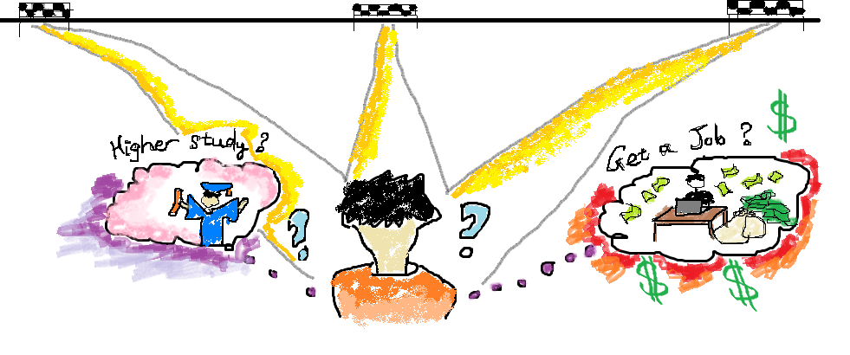

The topic for this assignment is self-portrait, therefore, the use of **proportion** in this picture is greatly important. I’ve depicted a version of myself standing in the middle of the picture so the viewers can shift their attention to the main object, which fits with the topic. Also, the position of myself acted as a **focal point** in the center created a **balance** as a whole for the picture. The feature that I used in the picture is **atmospheric perspective** that represented by the road. At the end of the **horizontal line**, there are some finish lines. In this case, I depicted myself as an ambitious person but also confusing which path I should follow. I’ve set out many goals but remaining indecisive which one I would achieve first in the future. The **organic shapes** used to draw my dreams help the viewers visualize what targets that I’m having in my mind. I’m inspired to draw this picture since I’ve found many students are having the same issues like me. We are young, passionate in what we are doing but still, there are many things to complete. I drew this picture with a hope that I could find for myself a right track to pursue.