Name: Gia Dao

Student ID: 1001747062

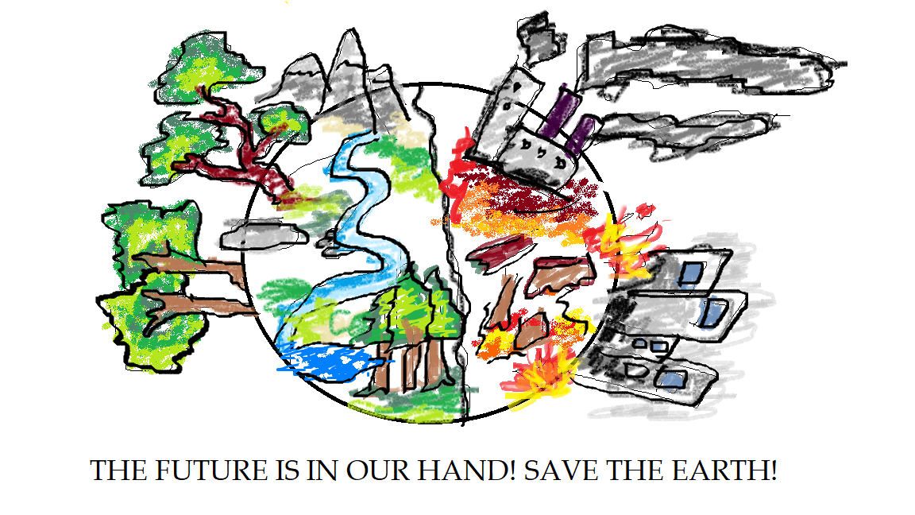

The topic of my social protest artwork relates to climate change, one of the most urgent issues that has not yet been resolved. In this picture, I used **symmetrical balance** to depict visual equilibrium between two sides of the earth, as if they are confronting each other. The effect of this balance creates a sense of urgency that our world is being consumed by pollution and also capture the intensity of our fights to maintain the earth’s cleanness. The left-handed side represents the nature, while the right-handed is the industrialized world that jeopardizes our environment. The **color** that I used for my artwork is the **contradiction** between **temperature**. Nature consists of cooler colors, while industry used hotter and stronger ones. Lastly, the only **geometric shape** in my artwork is the earth drawn by circular shapes at the center. The use of geometric shape as background and the **proportion** to be almost two-third of the painting captures the viewer’s attention. Lastly, the objects such as trees, fires, and rivers depicted on both sides of our earth is drawn using **organic shapes**. Curve and irregular lines help viewers to better percept the message conveys in the painting.