**Name**: Gia Dao.

**UTA student ID**: 1001747062.

**Class**: CSE_1310_007.

**Task 1.**

public class WhileB

{

public static void main(String[] args)

{

int a = 24;

int b = 42;

while (b != 0)

{

int t = b;

b = a % b;

a = t;

System.out.printf("a = %3d, b = %3d\n", a, b);

}

}

}

If I execute this program, it will print out

a = 42, b = 24

a = 24, b = 18

a = 18, b = 6

a = 6, b = 0

**Task 2.**

public class WhileLimit

{

public static void main(String[] args)

{

int a = 65;

int limit = 50;

while (a != limit)

{

a = limit - (limit-a)/2;

System.out.printf("a = %2d\n", a);

}

}

}

If I execute this program, it will print out

a = 57

a = 53

a = 51

a = 50

I pledge, on my honor, to uphold UT Arlington's tradition of academic integrity, a tradition that values hard work and honest effort in the pursuit of academic excellence.

I promise that I will submit only work that I personally create or that I contribute to group collaborations, and I will appropriately reference any work from other sources. I will follow the highest standards of integrity and uphold the spirit of the Honor Code.

Student’s signature.

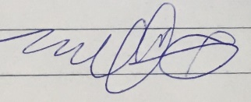

Gia Dao