**CSE 3310 – Fundamentals of Software Engineering**

**Fall 2021 – Term Project**

**Project 1: University Food System (UFS)**

**Team 3**

**Cameron Chilcoat**

**Ja’Lun Morris**

**Sumaita Sabaha**

**Gia Dao**

**Table of Contents**

**Project Summary ---------------------------------------------------- Page 3**

**Project Context Diagram -------------------------------------------Page 4**

**UML – Class Diagram – University Food System -------------Page 5**

**UML – State Transition Diagram – Login ----------------------Page 6**

**UML – State Transition Diagram – Registration --------------Page 7**

**UML – Activity Diagram – Search --------------------------------Page 8**

**UML –Class Diagram – Restaurant and Advertisement -----Page 9**

**UML – State Transition Diagram – Order ----------------------Page 10**

**UML – State Transition Diagram – Ratings --------------------Page 11**

**UML – Activity Diagram – Communication --------------------Page 12**

**UML – State Transition Diagram – Payment--------------------Page 13**

**UML – State Transition Diagram – Delivery --------------------Page 14**

**Project Summary**

Develop an android application to help university students order food and provide information about on-campus and near-campus restaurants and food providers (e.g. restaurant review and comments). The system should have an appealing home screen and minimally include the following functionality (you may modify or add additional functionality after receiving approval from your client):

* Registration: Students must register before they can use the system. University ID can be used as member Id.
* Login: Members must login to use the system after initial registration.
* Payments: System should be able to handle payments (Meal plan and Credit cards only; You do not need to validate credit cards for this project, just make them 16 digits long, have an expiration date, and a 3-digit security code)
* Restaurants: System should allow vendors to add their restaurants and their menu (e.g. subway, Panda express, connection café and other on campus restaurants).
* Orders: Place food order (e.g. Sandwich and coke with chips etc.). System should also allow for modifying your order after the initial placement within 5 minutes of your initial order time (i.e. cancel an order to modify existing order by adding new items).
* Communication: System should allow for sending text messages/e-mails to a single, subgroup or all members (e.g. Your order has been placed, your order is on its way etc.)
* Delivery: System should allow students to track their order and get their food delivered or select an option for pick up.
* Favorites list: Allow creating a favorite list of restaurants (you must have ordered at least once from a restaurant before you can add it to your favorite’s list)
* Search: You should be able to search for different food items or restaurants
* Review and Rating: Use Stars (one to five stars) to rate the service received, and allow to enter for a short comment to help future users
* Advertisements: System should provide advertising space (e.g. Local subway store offers specials or coupons to members). This could be a source of revenue from the app.

**Project Context Diagram**

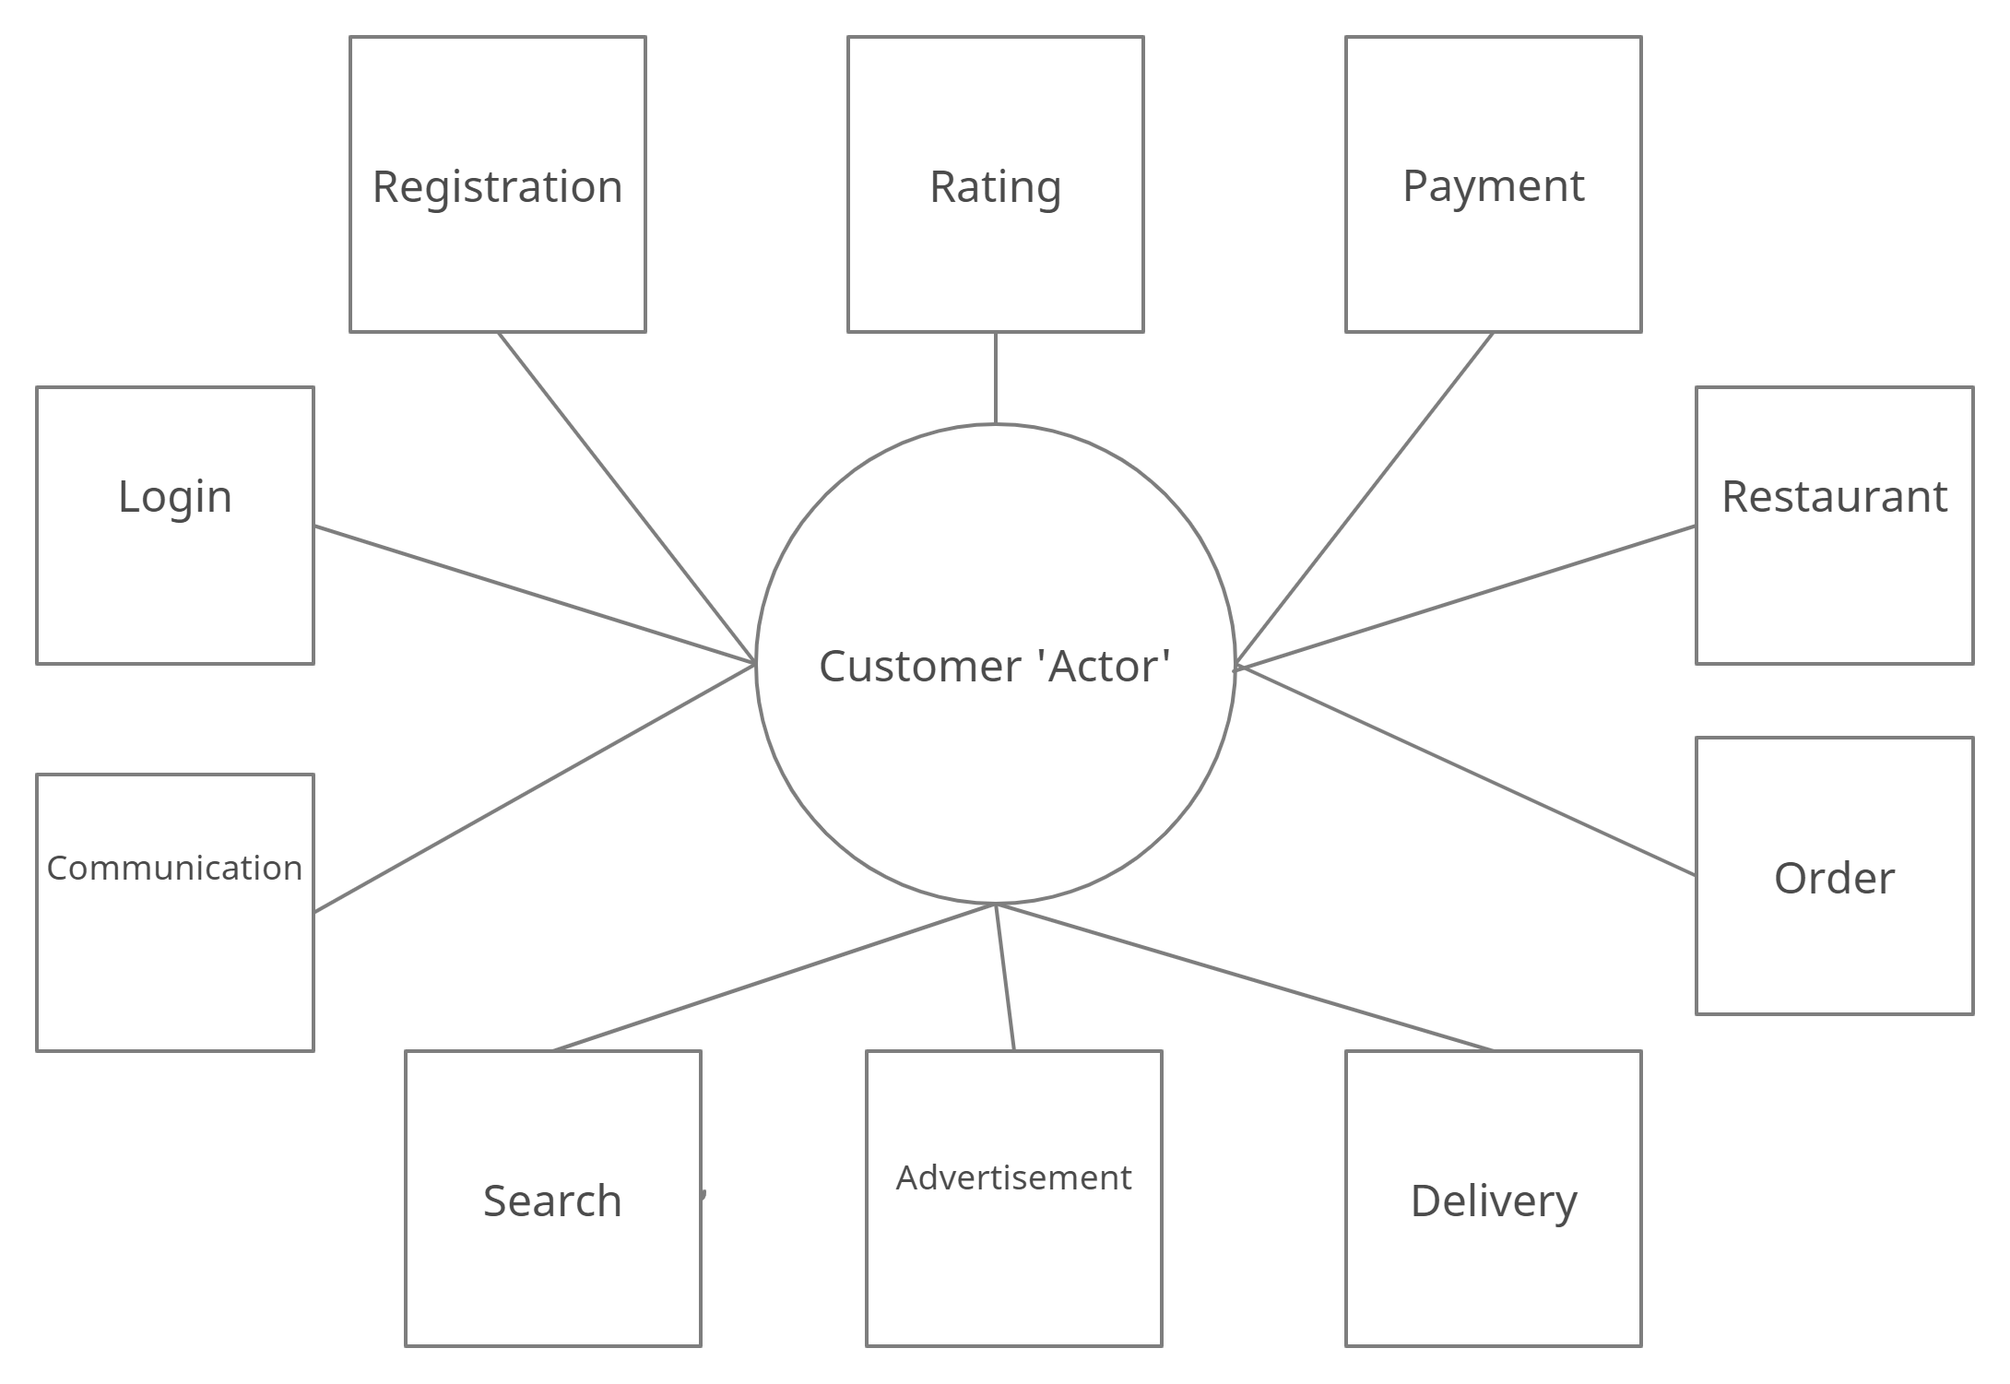

**UML – Class Diagram – University Food System**

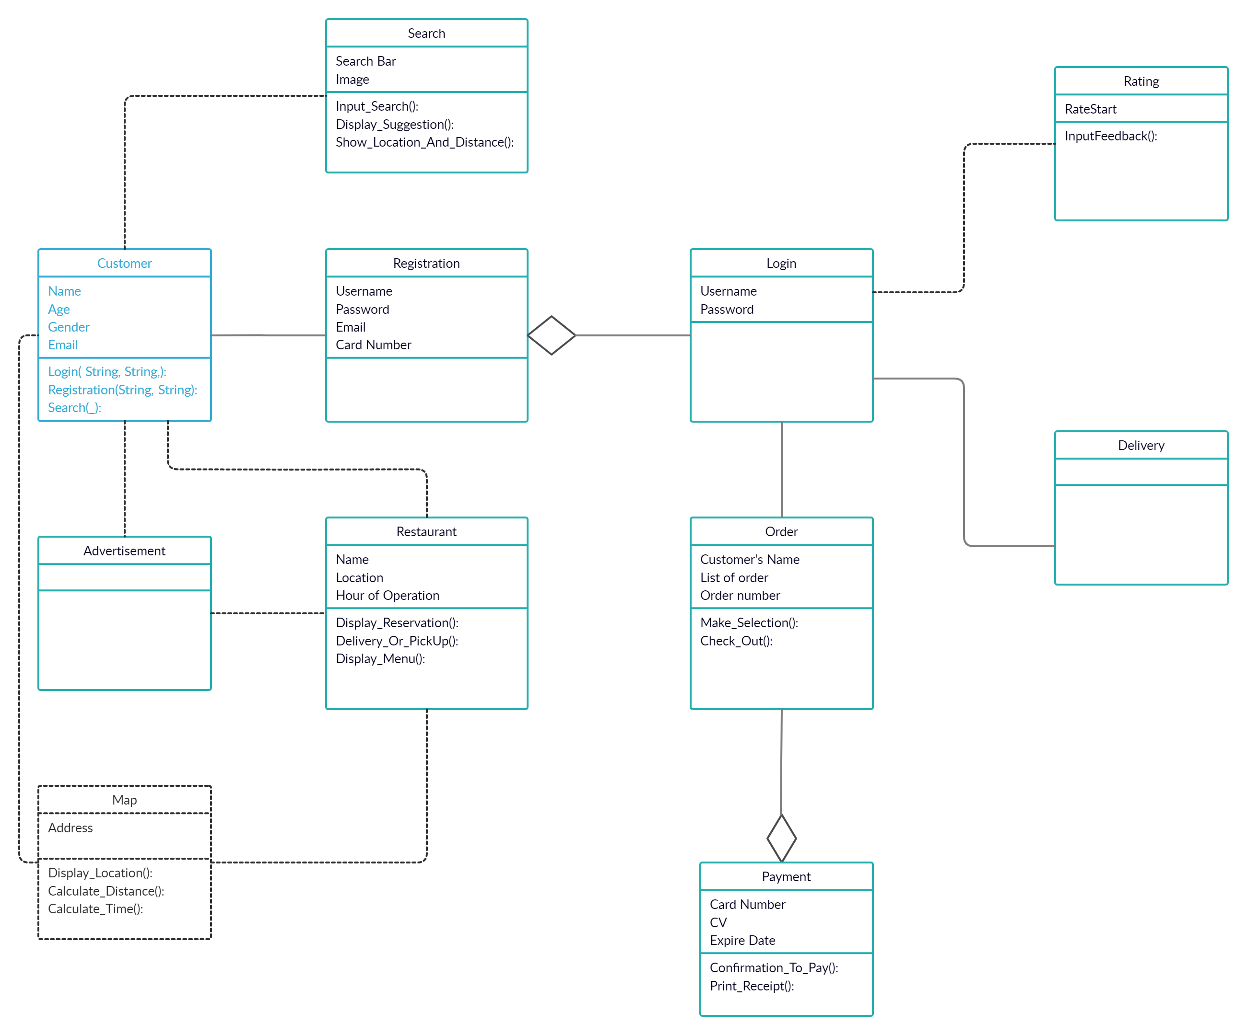

**UML – State Transition Diagram – Login**

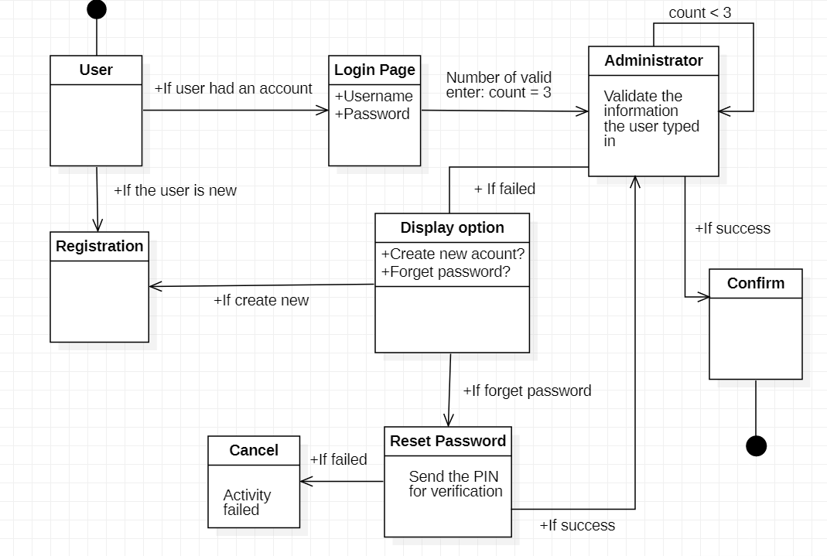

**UML – State Transition Diagram – Registration**

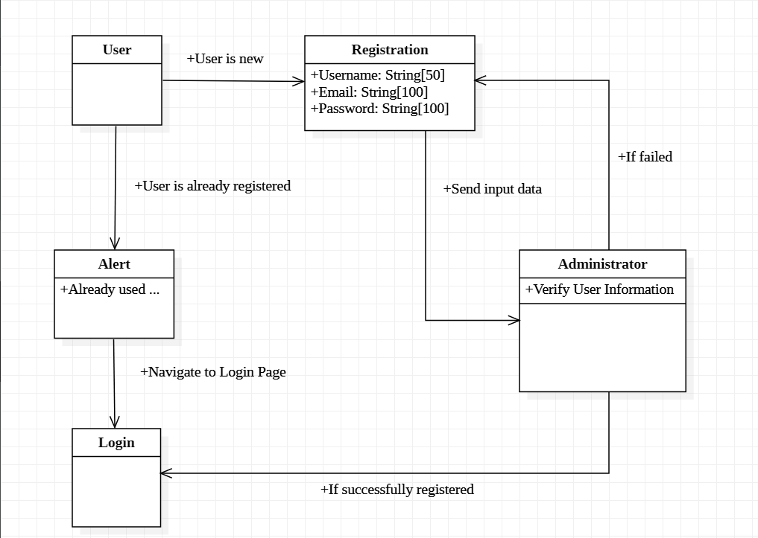

**UML – Activity Diagram – Search**

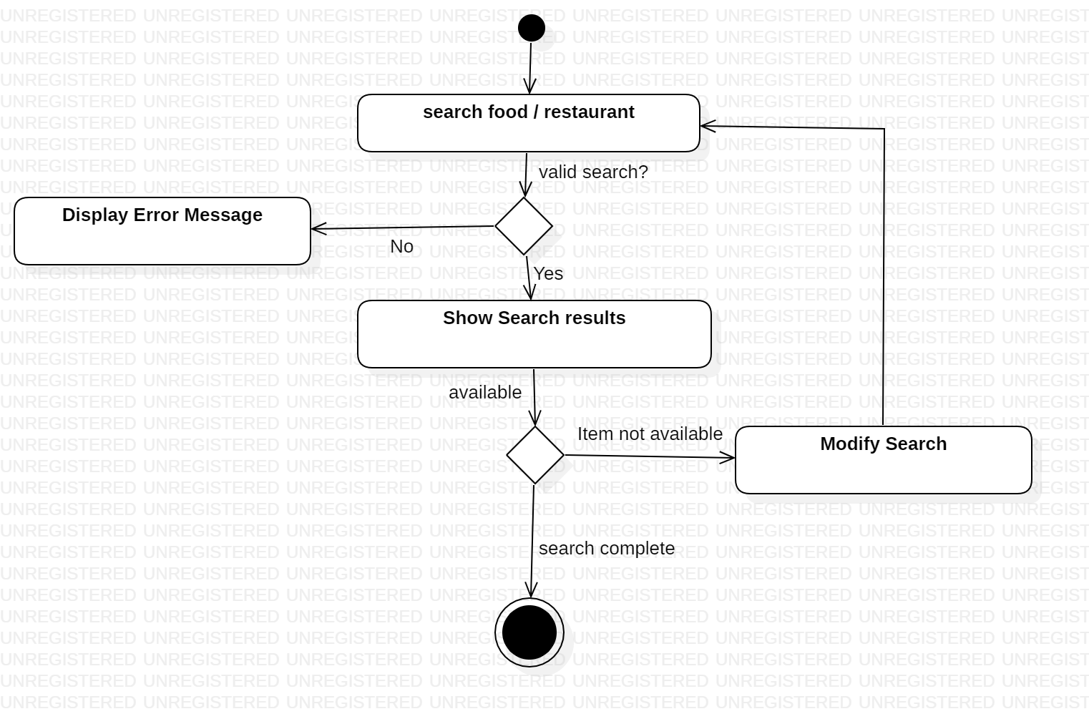

**UML –Class Diagram – Restaurant and Advertisement**

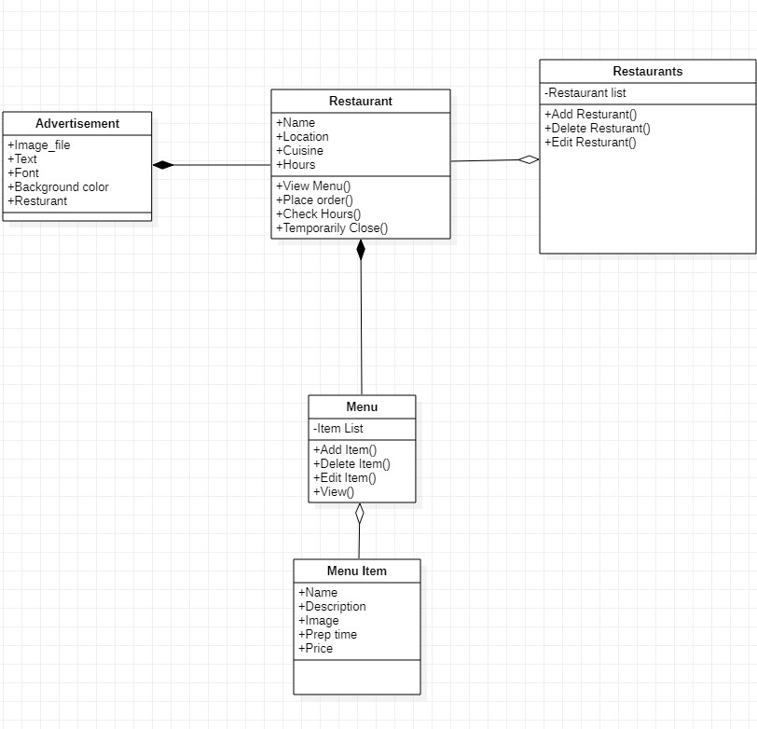

**UML – State Transition Diagram – Order**

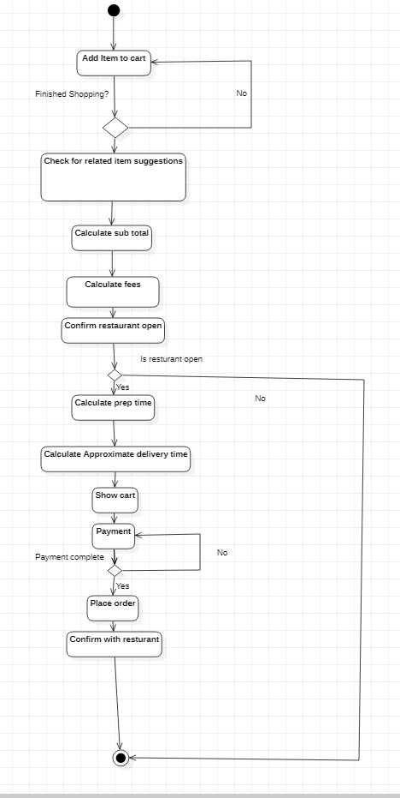

**UML – State Transition Diagram – Ratings**

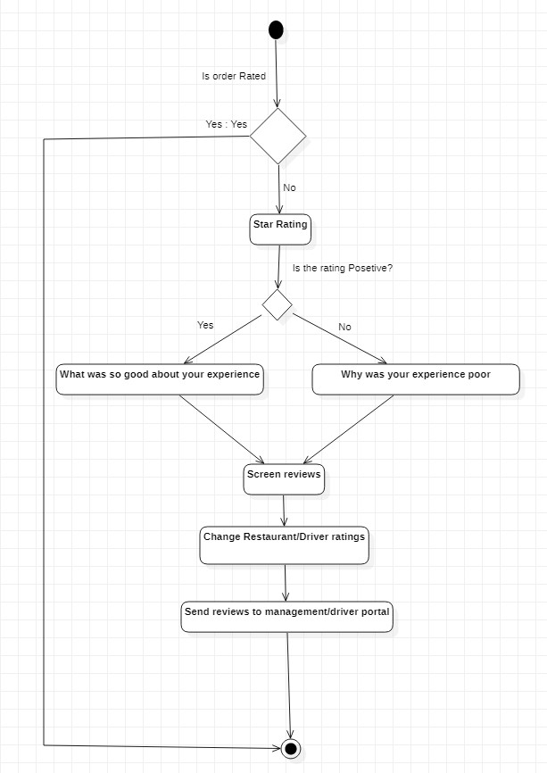

**UML – Activity Diagram – Communication**

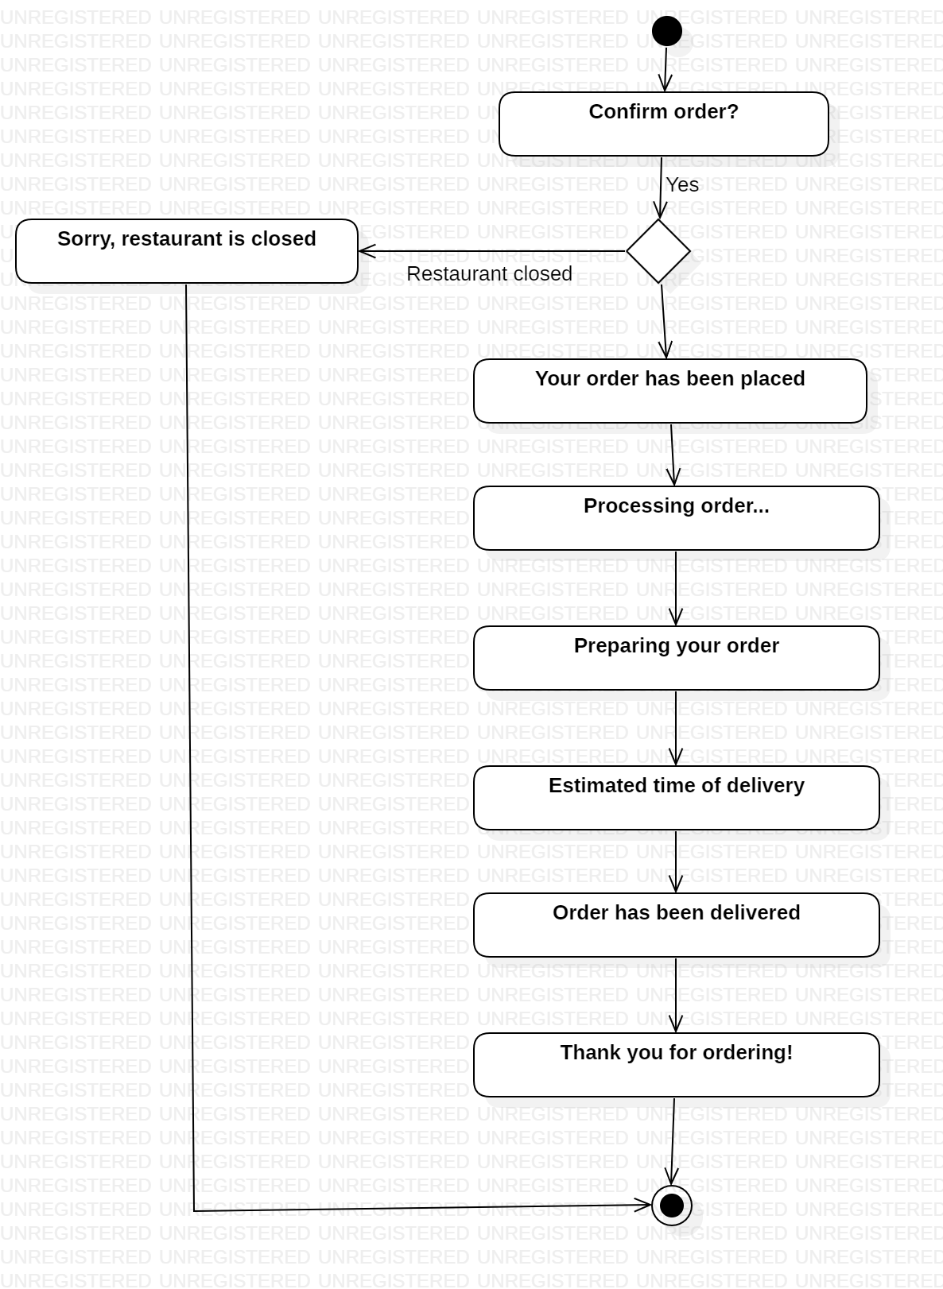

**UML – State Transition Diagram – Payment**

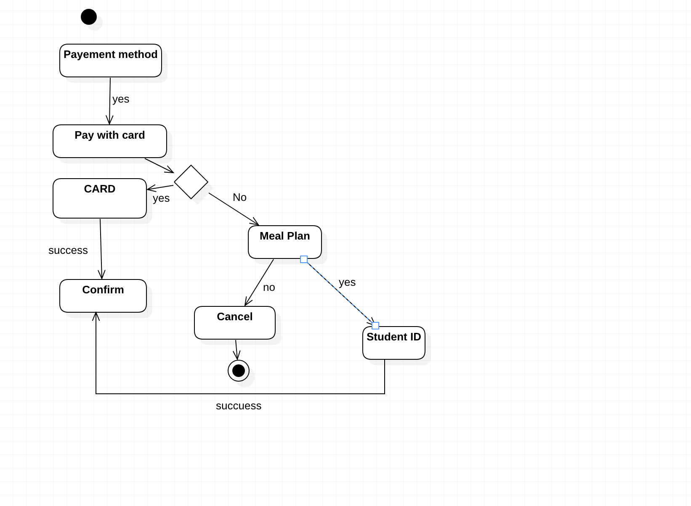

**UML – State Transition Diagram – Delivery**

