|  |  |  |  |  |
| --- | --- | --- | --- | --- |
|  |  | | | |
|  | |  | | |
| Project: | | MAV DASH | | |
| Team No.: | | Team 4 | | |
| Class: | | CSE 3310; Spring 2021 | | |
| Module: | | System Requirements Analysis (SRA) | | |
| Deliverable: | | SRA Document | | |
| Version: | | [1.0] | Date: | [04/01/2021] |

Contributors:

AAYUSH ADHIKARI

AASHISH MAHARJAN

ANKIT JHA

SRI AKASH BALU

Revision History

| Version number | Date | Originator | Reason for change | High level description of changes |
| --- | --- | --- | --- | --- |
| 1.0 | 04/01/2021 | Team4 | Initial draft |  |
|  |  |  |  |  |
|  |  |  |  |  |
|  |  |  |  |  |

TABLE OF CONTENTS

1. Introduction and Project Overview 3

2. Objectives 4

2.1 BUSINESS Objectives 4

2.2 SYSTEM Objectives 5

3. Project Context Diagram 6

4. Systems Requirements 7

4.1 “Login And Registration” Requirements 7

4.2 “Distance Check” Requirements 9

4.3 “Restaurant Selection” Requirements 10

4.4 “Placing An Order” Requirements 12

4.5 “Payment” Requirements 13

5. Software Processes and Infrastructure 14

5.1 Hardware and Infrastructure 14

5.2 UML Diagrams 14

5.3 Conceptual Data Model – Database 20

5.4 Screen Shots 20

5.5 Test Plan 20

6. Assumptions and Constraints 21

6.1 ASSUMPTIONS 21

6.2 CONSTRAINTS 21

6.3 Out of Scope material 21

7. Delivery and Schedule 22

8. Stakeholder Approval Form 23

Appendix: 24

# 1. Introduction and Project Overview

Android application to facilitate university students order food from the university center and get it delivered to them. The system will have following elements:

1) Registration: Students must register before they can use the system. University ID can be used as member ID.

2) Login: Members must login to use the system after initial registration.

3) Payments: System should be able to handle payments (credit cards, 16-digit number on the UTA ID card (to use the dining dollars), cash)

4) Food delivery: System should allow members to order food from the menu from different restaurants in the University center like Starbucks, Subway, Chic-fil-A, Panda Express, UTA market and Einstein bagels from the library etc.

5) Search: System will allow students to search for the restaurants on campus and then the menu of the chosen place will be displayed. Students can choose from the menu and add food items into the cart.

6) Delivery: The location to be delivered should be on campus. The apartment/residence hall name will be requested from the user before ordering and verified if it is on campus.

# 2. Objectives

## 2.1 Business Objectives

The following is a list of business objectives:

**Objective 1**: Login/Registration: All members must provide the following information prior to using the system:

* If the user is not registered, the user must give:
* First Name, Middle Name {Optional}, Last Name
* Student/Faculty/Staff ID number
* UTA email ID
* If the user is registered, the user just has to login using the email ID and password.

**Objective 2: Distance** Check: After login/registration, the user will be asked of the apartment name or resident hall name from a drop-down menu.

* If the user selects from one of on campus housing from the drop-down menu, they can proceed further with choosing the restaurant.
* If the user does not live in on-campus or any option from the drop-down, then the food cannot be delivered.

**Objective 3**: Restaurant information: Users will be able to choose restaurants/cafes on campus from the various options. The various options are:

* Subway.
* Chick-Fil-A
* Panda Express
* Starbucks
* Kalachandji’s or Market
* Boba Tea shop

**Objective 4**: Shopping Cart:

* Once the user chooses the restaurant, they can access the menu of the restaurant and order the items.
* After they pick an item, they can choose the quantity and add to order.

**Objective 5**: Payment: Once the order is complete, the user can proceed to check out and do the payment.

* The payment can be done with their 16-digit credit/debit card number. They have to type the number and it is validated.
* They can also use the 16-digit number on their UTA ID to be validated for the payment.

## 2.2 System Objectives

The following is a list of system objectives:

**Objective 1**: System will be an android application made on android studio with most of the coding done on Java.

**Objective 2**: The system will have dropdown menus and a feature of adding to the cart using a single click of the button.

**Objective 3:** Firebase will be used to store the limited amount of data.

# 3. Project Context Diagram

**CONTEXT-DIAGRAM**

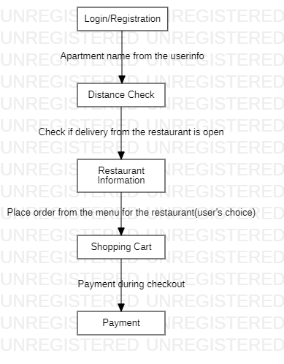

# 4. Systems Requirements

## 4.1 “Login And Registration” Requirements

|  |  |
| --- | --- |
| **Requirement Title:** | Login and Registration |
| **Sequence No:** | 001 |
| **Short description:** | Register new user |
| **Description:** | New users must register before accessing the application. The following information will be collected:   * Name {First, Last name} * Email address * Phone number * Select an ID {at least 8 character long, alphanumeric, wild characters not allowed} * Select a password {Must include, letters, at least one number, at least Capital letter, wild characters allowed) * Select a security question/answer (to be Used for password forgot/reset)   User can press:   * Submit * Cancel (i.e., discard changes) * Exit screen (or close) |
| **Pre-Conditions**: | * Application must be loaded already * Duplicate registration is not allowed |
| **Post Conditions:** | * All “Saved” changes will be kept permanently |
| **Other attributes:** | * None |

|  |  |
| --- | --- |
| **Requirement Title:** | Login and Registration |
| **Sequence No:** | 002 |
| **Short description:** | Login Existing User |
| **Description:** | Enter User Id and Password (already established during Registration) and Press Submit  User can press:   * Submit * Forgot ID or Password * Cancel (i.e. discard changes) * Exit screen (or close) |
| **Pre-Conditions**: | * User must have already registered |
| **Post Conditions:** | * Keep a log of the date and time of login |
| **Other attributes:** | * Allow a maximum of three tries, then recommend to use “Forgot Password” |

## 4.2 “Distance Check” Requirements

|  |  |
| --- | --- |
| **Requirement Title:** | Distance Check |
| **Sequence No:** | 010 |
| **Short description:** | Select the apartments from the given option |
| **Description:** | * User must select the apartment before accessing the dashboard. * Application can only be used between the apartments that are given in the options. * User can enter apartment number. * If the user does not select the apartment from the given options, user must exit. * The user can press the exit button. |
| **Pre-Conditions**: | * User credentials must be verified |
| **Post Conditions:** | * Dashboard can be viewed |
| **Other attributes:** | * None |

## 4.3 “Restaurant Selection” Requirements

|  |  |
| --- | --- |
| **Requirement Title:** | Restaurant selection |
| **Sequence No:** | 011 |
| **Short description:** | Selecting the restaurants |
| **Description:** | * Restaurants are shown in the cardboard view. * Cart items are displayed * User can press the button for favorite to make the particular restaurant his/her favorite |
| **Pre-Conditions**: | * The user must verify their address |
| **Post Conditions:** | * The user can view the options from the selected restaurant |
| **Other attributes:** | * None |

|  |  |
| --- | --- |
| **Requirement Title:** | Restaurant selection |
| **Sequence No:** | 012 |
| **Short description:** | Viewing the options from the restaurant |
| **Description:** | * The menu from the restaurant is shown. * The prices of the items are listed with the item. * Small description of the item is shown. * User can add dish to the cart. * User can increase/decrease the number of the order. * User can search desired item. * User can exit the particular restaurant page |
| **Pre-Conditions**: | * User must select particular restaurant |
| **Post Conditions:** | * User can view the cart for placing a order |
| **Other attributes:** | * Allow a maximum of fifteen items |

## 4.4 “Placing An Order” Requirements

|  |  |
| --- | --- |
| **Requirement Title:** | Placing the order |
| **Sequence No:** | 100 |
| **Short description:** | Add/Update the cart |
| **Description:** | * User can see order summary of the items they select. * User can increase/decrease the number of items they have selected * User can see the total price of the order * User can add new item to the order * User can check out the order * User can cancel the order * User can add favorite to the item. |
| **Pre-Conditions**: | * User must have selected a item. |
| **Post Conditions:** | * User can go to the payment option |
| **Other attributes:** | * None |

## 4.5 “Payment” Requirements

|  |  |
| --- | --- |
| **Requirement Title:** | Payment |
| **Sequence No:** | 101 |
| **Short description:** | Paying for the order |
| **Description:** | * User can see the total cost of the order * User can view the order. * User can see the address for the item to be delivered * User can choose the payment option * User has to validate the credentials * User can select the delivery options for the order to be delivered. * User can see the estimated time for the delivery of their item |
| **Pre-Conditions**: | * Checkout option must be selected |
| **Post Conditions:** | * Users receive payment invoice |
| **Other attributes:** | * None |

# 5. Software Processes and Infrastructure

## 5.1 Hardware and Infrastructure

This project will use Android version KitKat.

## 5.2 UML Diagrams

**UML-CLASSDIAGRAM-SYSTEM**

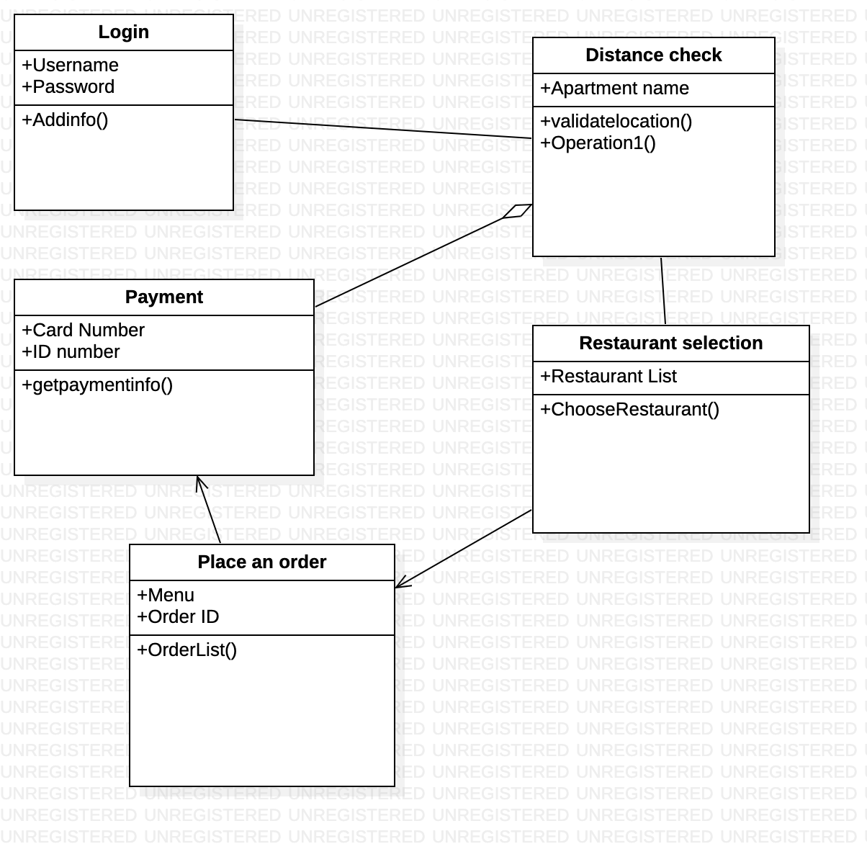

**UML-STD-LOGIN/REGISTRATION** 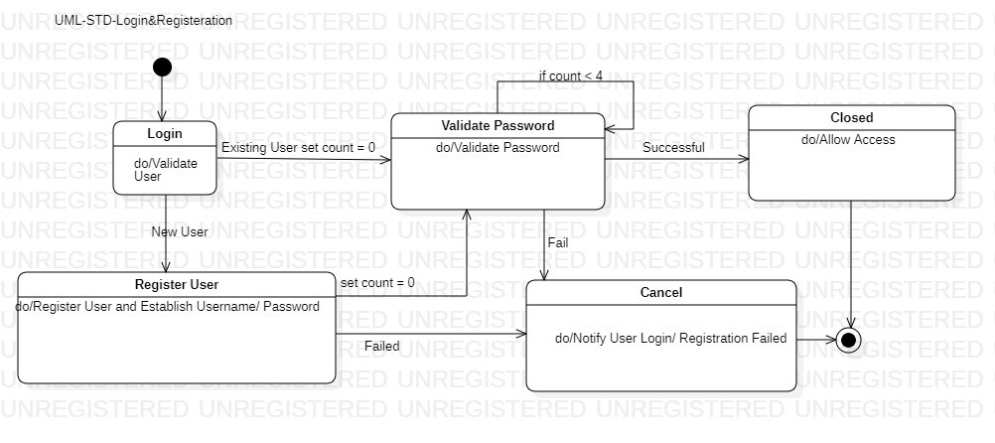

**UML-ACTIVITY-DISTANCE CHECK**  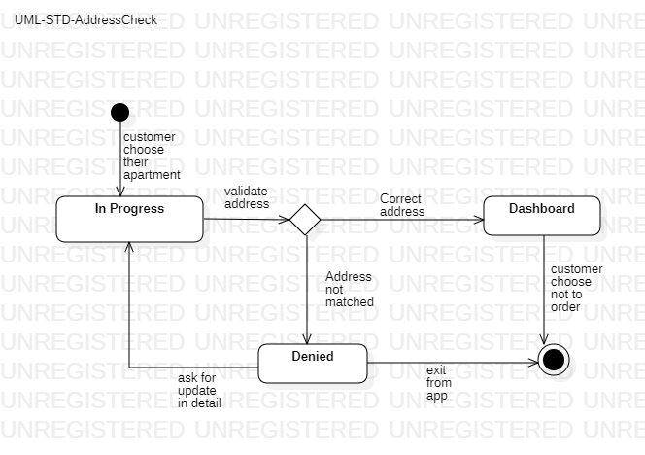

**UML-ACTIVITY-RESTAURANTSELECTION**

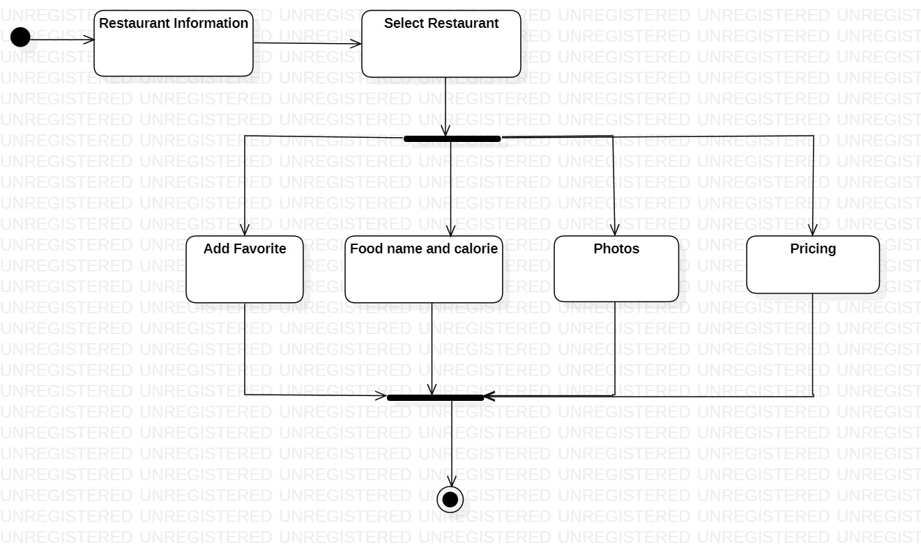

**UML-SEQUENCE-PLACETHEORDER**

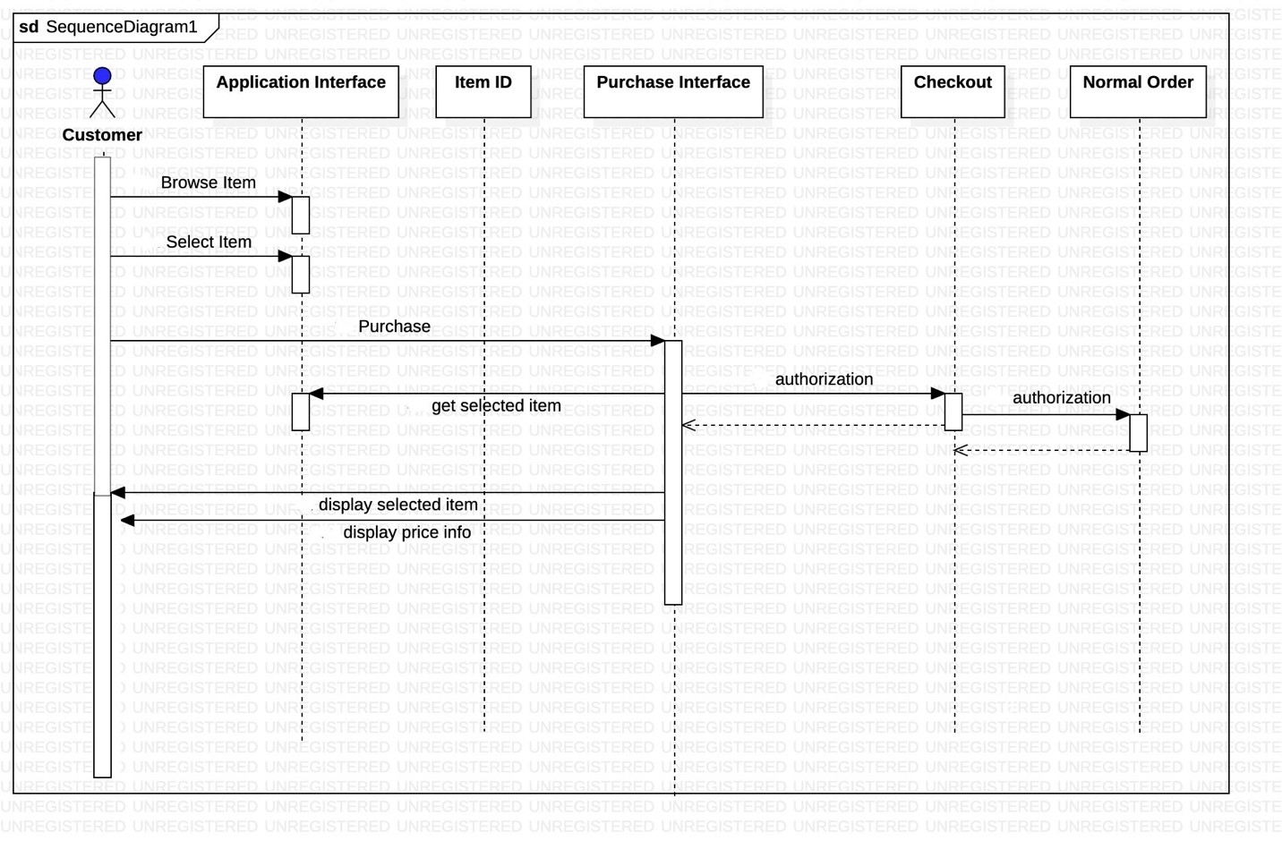

**UML-ACTIVITY-PAYMENT**

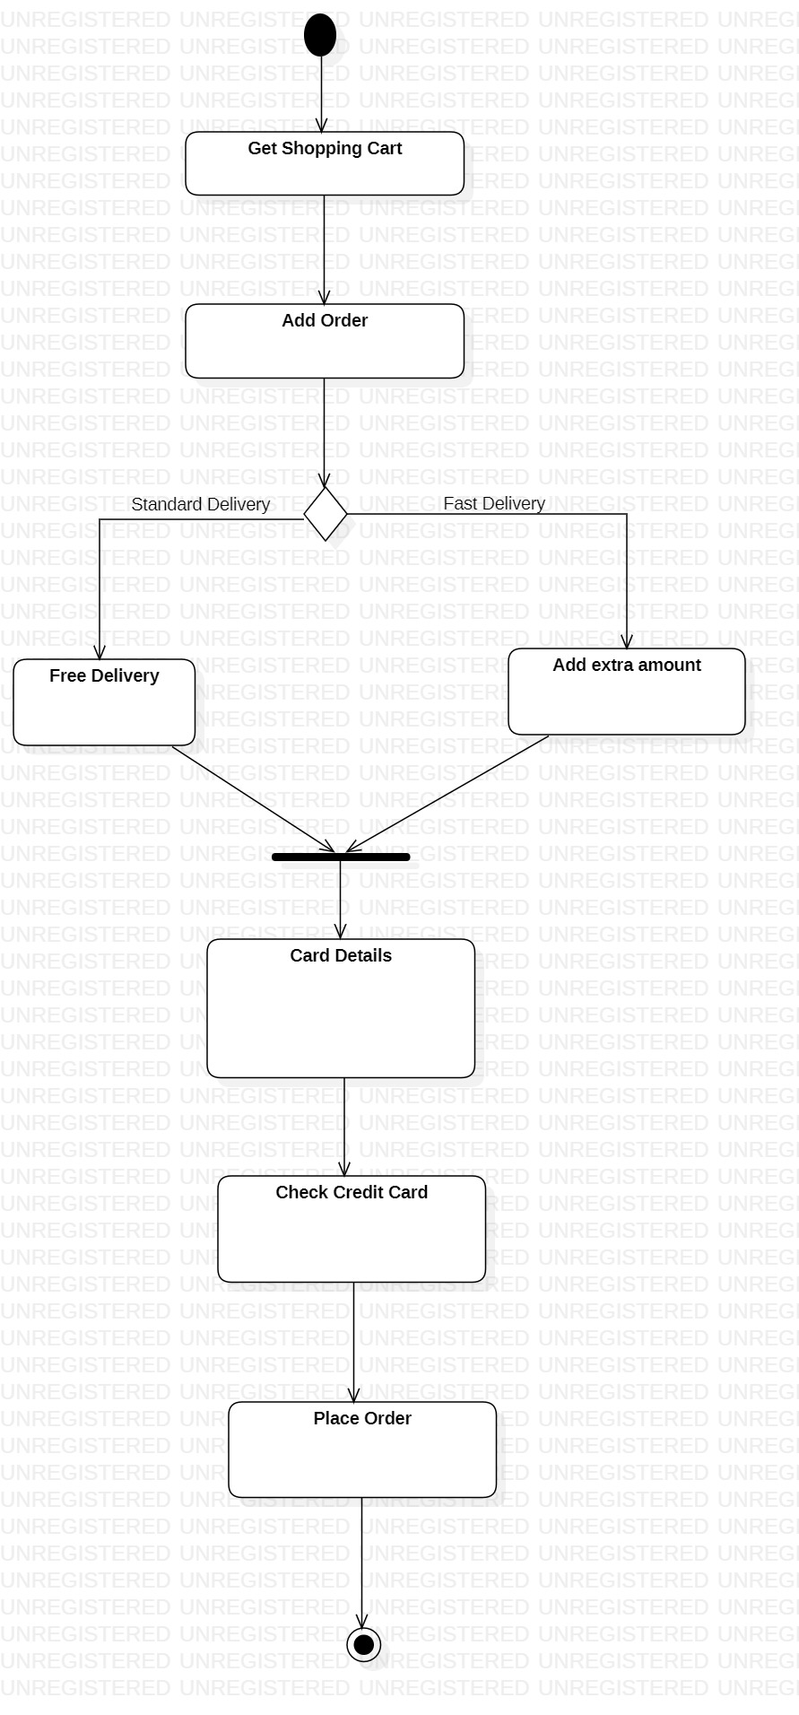

## 5.3 Conceptual Data Model – Database

None available at this time

## 5.4 Screen Shots

None available at this time

## 5.5 Test Plan

The test plan will be provided at a later stage of the project.

# 6. Assumptions and Constraints

## 6.1 Assumptions

The following is a list of assumptions:

* The user must be on campus and select options from on campus dorm or apartment.
* The user can use their dining dollar to purchase from any restaurant.

## 6.2 Constraints

The following is a list of constraints:

* Team lacks android experience
* Schedule very aggressive
* Team hasn’t used database for any application before

## 6.3 Out of Scope material

The following is a list of “out of scope” material:

* Post Project maintenance is not covered

# 7. Delivery And Schedule

|  |  |  |  |  |
| --- | --- | --- | --- | --- |
| Task/Milestone Description | Anticipated Start Date | Anticipated End Date | Status | Comments |
| Prepare Requirements and UML diagram | 2/4/2021 | 3/4/2021 | Complete | Deliverable UML document. Increment 1 Deliverable |
| SRA document (Includes project objectives, Requirements and UML diagrams) | 3/16/2021 | 4/1/2021 | In Progress | Deliverable will be the SRA document. All stakeholders agree on the content of the SRA by signing in section 8.  Increment 2 Deliverable |
| Home screen design and implementation | 3/20/2021 | 3/20/2021 | To Be Completed (TBC) |  |
| Login and Registeration | 4/06/2021 | 4/20/2021 | To be Completed(TBC) |  |
| Distance | 4/06/2021 | 4/28/2021 | To be Completed(TBC) |  |
| Restaurant Information | 4/10/2021 | 4/28/2021 | To be Completed(TBC) |  |
| Shopping Cart | 4/10/2021 | 4/28/2021 | To be Completed(TBC) |  |
| Payment | 4/14/2021 | 4/28/2021 | To be Completed(TBC) |  |
| Test case design | 4/6/2021 | 4/22/2021 | To be Completed(TBC) | Increment 3 Deliverable |
| External Documentation (i.e. User Manual) | 4/23/2021 | 5/4/2021 | To be Completed(TBC) |  |
| Project presentation | 4/27//2021 | 5/4/2021 | To be Completed(TBC) |  |
| Final Milestone: project delivery | 4/28/2021 | 5/4/2021 | To be Completed(TBC) | Increment 4 Deliverable |

# 8. Stakeholder Approval Form

|  |  |  |  |
| --- | --- | --- | --- |
| Stakeholder Name | Stakeholder Role | Stakeholder Comments | Stakeholder Approval Signature and Date |
| Bahram Khalili | Development Mgr |  |  |
| Akshit Singhal | Project Assistant |  |  |
| Aayush Adhikari | Developer | Adhikari, Aayush | AA  03/31/21 |
| Aashish Maharjan | Developer | Maharjan, Aashish | AM  03/31/21 |
| Ankit Jha | Developer | Jha, Ankit | AJ  03/31/21 |
| Sri Akash Balu | Developer | Balu, Sri Akash | SAB  03/31/21 |

# Appendix:

None