**PROJECT 1 CSE_3330_004**

**GROUP MEMBER: CHERRYL MARIA BIBIN, NINAD PANDIT, GIA DAO.**

Explain the method to load the data to the tables:

Modify the csv by removing the title of each column in Player, Game, Team, Injury Record, and remove the quote from the string and character values in all csv files.

Step 1: Use the command ‘.mode csv’

Step 2: ‘ .import Game.csv Game ‘

Step 3: ‘ .import Player.csv Player ’

Step 4: ‘ .import Team.csv Team ‘

Step 5: ‘ .import InjuryRecord.csv InjuryRecord ‘

Step 6: (Optional) .mode column to modify the format of the output

QUERY 3:

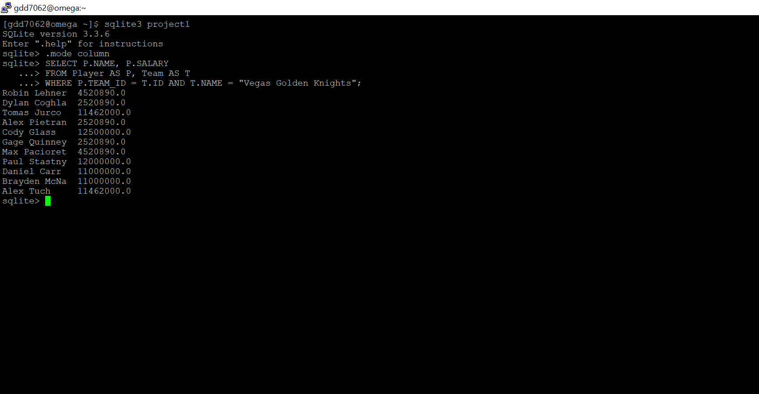

QUERY 4:

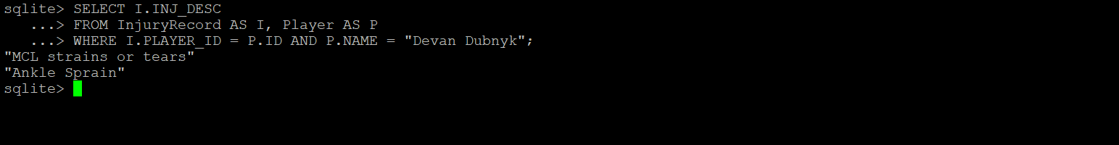

QUERY 5:

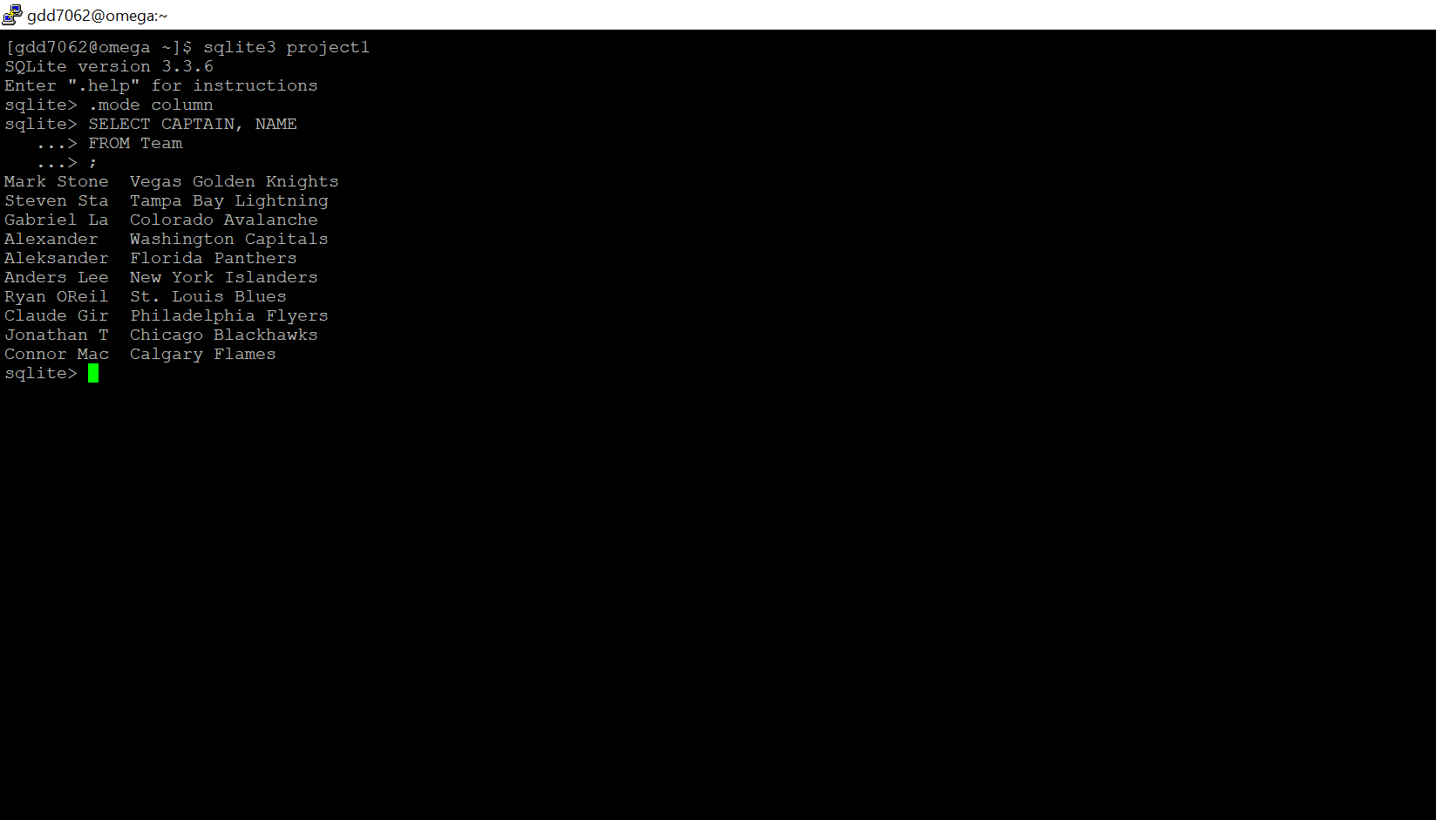

QUERY 6:

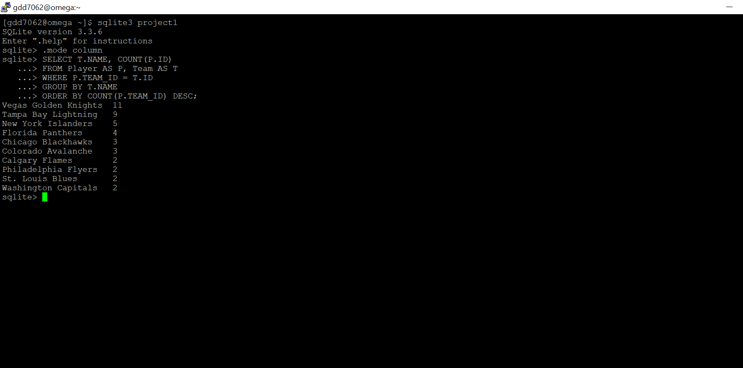

QUERY 7:

