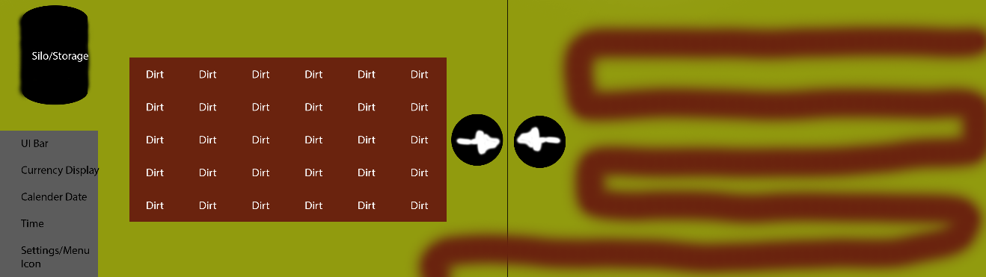



[REPLACE THE KITTEN WITH AN IMAGE REPRESENTING YOUR GAME] no

*Green Thumb*

by

**Team Boyd**

Table of Contents

**Version History** **3**

**Game Overview** **4**

**Win/Lose Conditions** **4**

**Game Controls** **4**

**Game Mechanics** **4**

Coffee Cups 4

**HUD Layout** **4**

**Level Layouts** **5**

**Asset List** **5**

Programming 5

Art 5

Audio 5

Level Design 5

# Version History

|  |  |
| --- | --- |
| **Version** | **Change log** |
| V1.0 | * Initial Draft |
| V2.0 | * Beta Build, hud layout, ipm char |
|  |  |
|  |  |

# Game Overview

***Green Thumb*** is a garden simulation game, in which you learn to grow better crops while defending your garden from bugs, stray animals, and neighbors. In this fast-paced chaotic game, follow the various upgrade paths to get better defense systems, better crops and fertilizers, and bigger space in your backyard. If you lose all your money and cannot afford seeds for the next day, the game is over and you lose.

# Win/Lose Conditions

Survival – Waves will get more and more difficult as time goes on.

Lose – Player runs out of money and cannot buy anymore seeds.

# Game Controls

WASD – Basic Movement

Left Click – Fire Weapon

E – Interact: Plant seeds, water plants, harvest plants, place tower, interact with shop

# Game Mechanic

## Toolbar

* **Watering Can**
  + Watering Can will be an item in the toolbar which the Player will use to tend their crop and make sure it will grow fast.
  + The Watering Can will have its own sound and animation when interacting with the plants
* **Hoe**
  + The Hoe will be an item in the toolbar which the Player will use to prepare the soil for a seed to be planted
  + The Hoe will have its own sound and animation when interacting with the plants
* **Weapon**
  + The Weapon will be the players secondary method for defending themselves against enemies
  + The Weapon will have its own sound and animation when being used

## Plants

* Plants will start of as seeds and will grow during the daytime and a progress bar attached to the plant will be used to track plant growth
* Plants will need to be tended by the Player to keep growing and produce a successful crop
* Plants will be the main target for enemies as they will try to destroy the Players plants

## Shop

* The Shop will be where the Player will be able to interact with and purchase and sell items
* The Player will be able to sell crops, buy seeds, upgrade items, and buy new items
  + These items will be used to either help plant growth or help the player fight against the enemy

## Structures

* **Turrets**
  + Turrets will be able to be purchased in the shop and will be the Players best defense against enemies
  + Turrets will automatically target the enemy and depending on the turret will have different attacks
* **Silos**
  + Silos will be the Players method of storage for any extra seeds.
  + Since the lose condition is the Player losing all the seeds in the game the Silo will be a key structure that should also be protected at all times.

# HUD Layout and Level Layouts

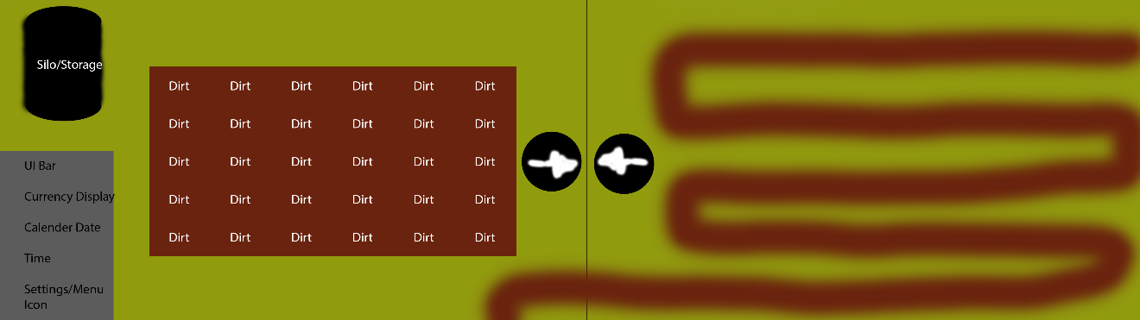

# IPM Chart

|  |  |  |  |  |  |  |
| --- | --- | --- | --- | --- | --- | --- |
| Mechanics | Level |  |  |  |  |  |
|  | 1 Day | 1 Night | 2 | 2 Night | 3 | 4 |
| Moving | P |  | M |  |  |  |
| Plant | P |  | M |  |  |  |
| Water | P |  | M |  |  |  |
| Harvest | P |  | M |  |  |  |
| Silo |  |  | P |  | M |  |
| Turret |  |  |  |  | P | M |
| Shop |  | P |  | M |  |  |
| Melee |  |  |  |  | P | M |
| Enemies |  |  |  |  | P | M |

# Asset List

## Programming

* Shop System: Buy and Sell
* Plant Interaction
  + Plant
  + Harvest
  + Water
* Plant Growth Progress Bar
* Enemy Controller
* Player Controller
* Turret Controller
* Item Mechanics
  + Watering Can
  + Hoe
  + Weapon

## Art

* Plant
* Items
* Farm
* Enemies
* Player
* Structures

## Audio

* Shop Interactions
* Player Actions
* Turret Actions
* Enemy Actions

## Level Design

* Tile Placement for Plants
* Farm Rows
* Silo
* House