**Skin Disease Diagnosis Expert System using PROLOG**

|  |  |
| --- | --- |
| Nico T. Solitana  *nico_solitana@dlsu.edu.ph*  *Master of Science in Computer Science*  *De La Salle University* | Gian Marco Te  *gian_te@dlsu.edu.ph*  *Master of Science in Computer Science*  *De La Salle University* |

1. **Introduction** Skin diseases such as acne, common rash and allergies are sometimes downplayed to be a simple dermatological problem compared to other diseases that causes significant mortality. However, WHO has found that skin diseases rank 32nd in the leading causes of deaths in the Philippines. In one study of Villanueva et al (2019), they have found that 80% of PNP members suffers from skin diseases. In line with this, the proponents opted to develop an Expert System that identifies patient’s skin disease based on the current symptoms such as red spots, white spots on mouth, vomiting, etc. However, the expert system is limited only to the ten diseases selected by the proponents: (1) Measles, (2) Chickenpox, (3) Skin allergies due to food or medication, (4) Dengue, (5) Coronavirus Rash, (6) Heat Rash, (7) Shingles, (8) Common Rash, (9) Acne, and (10) Atopic Dermatitis.  
     
   These tasks of differentiating and diagnosing these skin diseases require expertise since some of these skin diseases has two or more common symptoms but can be differentiated only by specific factors. The commonality of some diseases can easily confuse the patient with having another disease without undergoing proper diagnosis that the expert system aims to resolve. To supply the necessary knowledge base on the expert system, the proponents performed researches about the similarities and differences of selected skin diseases. These were organized into symptoms in the development of the knowledge base. Villanueva et al specified in their 2019 study that skin diseases are significant health concern often overlooked but its impact can affect the performance of oneself. The output of this study aims to address this issue. It will be a valuable tool most specially to underserved communities in determining the skin diseases they are suffering from.
2. **Knowledge Base**
3. *Knowledge Base*

* *Gender*

This tells the biological sexual identity of the patient by stating either male or female.

* *Patient’s Symptoms*

This is composed of the current symptoms of the patient. These symptoms get added on the fly as the questions get asked and as the user answers a “y”, indicative of a “yes” – meaning that they have the specific symptom being asked in the question.

* *Symptom Description*

This is composed of the set of queries to be asked on the patient based on symptoms. Each query describes a specific symptom.

* *Hypothesis*

This determines the skin disease of the patient based on matching symptoms to its assigned disease. A disease will be diagnosed only if all of its associated symptoms were asserted as facts during the question-and-answer portion.

1. Easiest Part to finalize

The easiest part to develop is the hypothesis. After differentiating common-like symptoms, it has been easy to differentiate the diseases with one another. For instance, since rash and blisters are no longer confusing, the we are no able to list which diseases that has rash only, has blisters or both.

1. Hardest Part to finalize

The hardest part to develop is the Symptom Description since most of it are similar with one another, the proponent needed to be cautious with words to prevent misinterpretation. See example diagram below:

round

bump

red

watery

*Blister*

*Rash*

…

*Figure 1.0. Differentiating symptoms*

This part is hard because we need to further search for “unique” symptoms that will differentiate diseases from one another. For instance, in the figure above both rashes and blisters are round and has bumps. Knowing this is not enough since the hypothesis will be inconclusive when diagnosing between those two diseases if both round and bumps are asserted as facts.

The way that this was fixed was to conduct a bit more research to add more facts to the knowledge base to make each disease have symptoms that are “unique” for the expert system to be able to properly differentiate between similar-looking symptoms.

1. **Evaluation and Analysis**
2. *Evaluating Symptoms and Diseases*

The following diagram describes the behavior of the expert system:

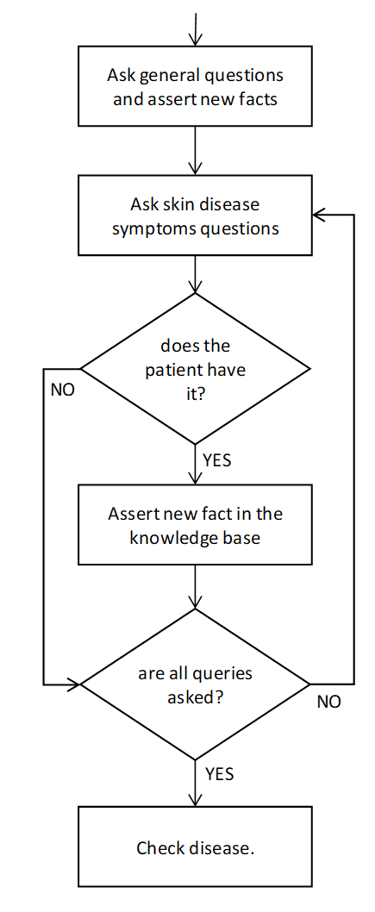

*Figure 2.0. Expert System Flowchart*

After all facts have been included in the knowledge base, a concrete diagnosis about the patient’s disease will be displayed by asserting which diseases the patient using the symptoms that were added as facts. We do this by utilizing Prolog’s ability to check

By following the logic described in the flowchart, the expert system is able to exclude diseases that does not match the patient’s current symptoms.

1. *Strengths*

The following describes the strengths of the expert system:

* The expert system has the capability to differentiate similar-like symptoms to come-up with accurate diagnosis.
* The expert system can diagnose multiple possible diseases as long as the patient has the symptoms of those diseases.
* The system runs through all of the questions, and for each question asserted as “yes” by the user, adds that symptom as a fact on the fly. It waits until the end to hypothesize on the diagnosis that it will give because a patient can potentially have multiple diseases.
* The system does not repeat questions for symptoms that are shared between diseases. For instance, fevers are common between some of the diseases – it is already added to the knowledge base during runtime when the fever question is asked so there is no need to repeat it.

1. *Weakness*

The following describes the weaknesses of the expert system:

* In the event that there’s no matching symptoms based on the user’s current condition; it will not be able to provide any diagnosis.
* All symptoms of a disease must be asserted as “yes” to diagnose that disease. It does not consider symptoms that are optional.
* The system does not immediately eliminate diseases with unique symptoms that were asserted as “no”.

1. **Summary and Lessons Learned**

The output expert system is able to sufficiently address its goal by asking concrete questions and providing accurate diagnosis based on the gathered data. It is able to assert new facts on its patient symptoms’ knowledge based accordingly and was able to display correct queries from its knowledge based of symptom descriptions. With this, it would be of great help for patients to understand and identify the skin disease they are going through.

The proponents of the expert system were able to learn how to imitate human experts, in this case, dermatologist, and apply their thought-process in the tool. They were able to learn how to extract and systematically organized data for form as knowledge bases that can provide conclusive diagnosis.

The proponents also appreciate the skills and knowledge required by medical practitioners in order to just diagnose a disease. Doing this expert system and learning about 10 diseases and their corresponding symptoms is already a challenging tasks. It is not as simple as knowing just 10 diseases and all of their symptoms – they have to learn the side effects and potential medication to the diseases, and they have to do it without logic tools such as Prolog.

At the same time, the proponents also now have a better understanding on why some doctors “misdiagnose” because there are diseases that have overlapping symptoms and not having all of the facts for the diagnosing a patient of a disease with multiple and complicated symptoms might be a reason for why this happens. It is also possible that these complicated symptoms overlap with other diseases, which may be a further add to why a patient can be misdiagnosed.