USER PERSPECTIVE(WITHOUT ACCOUNT)
Home page:
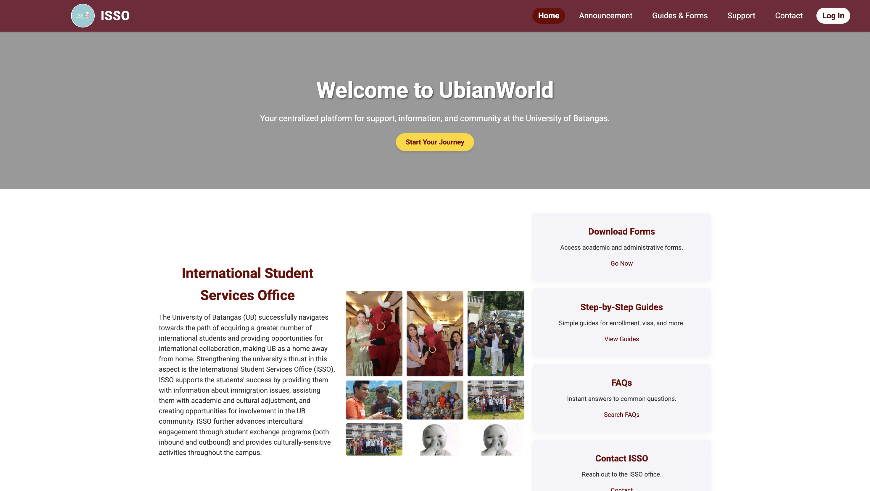
Announcement & events page:
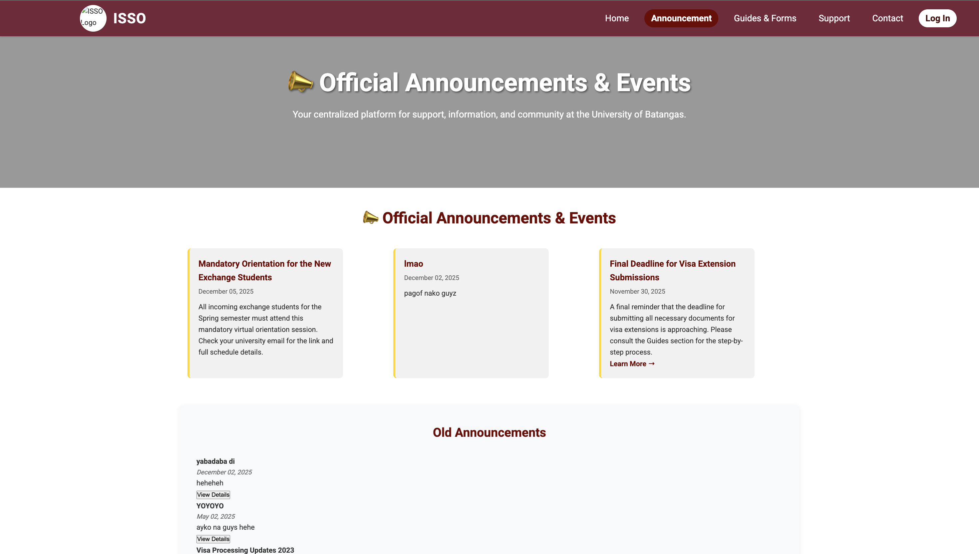
Guides and forms:
Sample docs

