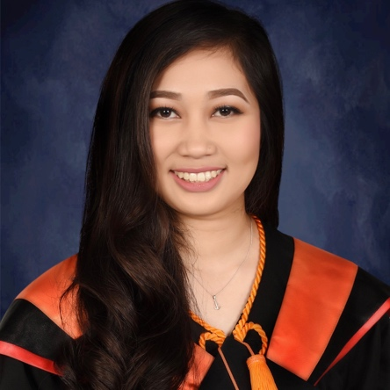

**Sacay, Gian Frances C.**

Blk.4, Kaimito St., Tirso Babiera,

Ipil, Zamboanga Sibugay

Mobile No.: (+63) 977 805 9908

Email: gianfrancescincosacay@gmail.com

**OBJECTIVES**

To gain knowledge and skills to complement those that I have learned from school in an actual job environment and to challenge myself to any position that fits my qualification.



**PERSONAL INFORMATION**

Date of Birth

Age

Place of Birth

Father’s Name

Mother’s Name

Religion

Gender

Civil Status

Language known

Citizenship

: May 23, 1995

: 23 y.o.

: Zamboanga City

: Eduardo Y. Sacay

: Mercy C. Sacay

: Roman Catholic

: Female

: Single

: English, Tagalog and Visayan dialect

: Filipino

**EDUCATIONAL ATTAINMENT**

***Tertiary Education***

***: Bachelor of Science in Computer Engineering***

***Silliman University (SU)***

Dumaguete City, Negros Oriental

S.Y. 2011 - 2018

***Secondary Education***

***: Marcelo Spinola School (MSS)***

Ipil, Zamboanga Sibugay

S.Y. 2007-2011

***Primary Education***

***: Marian College Elementary Department***

Ipil, Zamboanga Sibugay

S.Y. 2005-2007

**SKILLS**

* Database Software Programming and Management (mysql/sqlite/db)
* C++ Programming
* GUI/Electronic Graphic Designing (xml)
* Web Designing (html/php/css/javascript)
* Assembly Language Programming/Hardware Programming (nasm)
* Microprocessors Programming (xc8)
* Technical hardware tinkering
* Electronics and Electrical skills
* Technical data entry (spreadsheet/ppt/docs)
* Good communication and social skills
* Technical researching skills

**EXPERIENCE**

***On-the-Job Training***

**Tallant Asia, Inc. (April 2018 – May 2018)**

**SEMINARS ATTENDED**

* ***Job Basic Entry Skills Seminar (JBESS) 2017*** Multimedia Room, Silliman University, Dumaguete City
* ***Google I/O Extended Dumaguete 2017***

Claire Isabel McGill Luce Auditorium, Silliman University, Dumaguete City

* ***Occupational Safety and Health Seminar (OSHNET) 2018***

Engineering Building, Silliman University, Dumaguete City

* ***1st Philippine Artificial Intelligence and Emerging Technologies Caravan***

Claire Isabel McGill Luce Auditorium, Silliman University, Dumaguete City

**ORGANIZATIONS**

* ***Philippine Institute of Computer Engineering Students (PHICES)*** Silliman University

Dumaguete City