**TABLE OF CONTENTS**

* **PROJECT DOCUMENTATION**

Project Abstract

Keywords

Scope and Delimitation

Software Development Requirements

Minimum Hardware Requirements

* **PROGRESS REPORT**

Summary of Activities and Achievements

Photo Booth

* **APPENDIX**

Database Tables

Plates

Sitemap

Video Demo

Repository

Enrollment Form

Communication Letter

Curriculum Vitae

**PROJECT DOCUMENTATION**

**Project Abstract**

The Absolute Mind Library System is an application for a librarian to manage a book in the university. The system provides the basic set of features to add/update, home/delete, add/ books, return books, issue books, search etc. It helps both students and library manager to keep a constant track of all the books available in the library. It allows the admin and the student to search for the book they are looking.

**Keywords**

* Absolute Mind Library System, Resource Sharing, Internet, Electronic Mail, E-mail, Document Delivery, Library Management Information System, Digital Images, New Generation Information System, OPAC, Online Public Access Catalog, Databases, Medical Library, Rosales National High School Department of Education - College Library Technology and Cooperation Grants Program.

**Scope and Delimitation**

Absolute Mind Library system is a resource planning and enterprise management software, used to operate and manage the huge amount of data generated from libraries. It is also used to track bills, books, and customers who have borrowed books from the library.

Researching which new books are required by users becomes very difficult, and again, labor intensive. Librarians must be consulted directly to find out the availability of a book since it may already be issued to some other library user.

**Software Development Requirements**

|  |  |
| --- | --- |
| Description | Specification |
| Android Studio | Xml-font end |
|  | Firebase- back end |
|  |  |

**Minimum Hardware Requirements**

Mobile Application

|  |  |
| --- | --- |
| Description | Specification |
| Android vrs | Android 5.0 Lollipop 3.0 |
| RAM | Minimum of 3GB |
| Core Speed | 1.5 GHz or higher |
| Processor modes | Samsung |

**PROGRESS REPORT**

**Summary of Activities and Achievements**

Itemize the 15 major activities and achievements you have brought to the development of the project during the subject.

1. John Kenneth E. Mina
2. Julie Ann C. Basa
3. Ralph Danmark P. Aquino
4. Gian Greco M.Alberto
5. Justine Joel M. Angeles

|  |  |  |  |  |  |
| --- | --- | --- | --- | --- | --- |
|  | A | B | C | D | E |
| 1. Created the presentation for title proposal | ✔ |  | ✔ |  | ✔ |
| 1. Created the design of logo | ✔ | ✔ |  | ✔ |  |
| 1. Conduct data gathering and interview to the client | ✔ | ✔ | ✔ |  | ✔ |
| 1. Created, edited and upload the video demo | ✔ |  | ✔ |  |  |
| 1. Edited graphical icons on the mobile app | ✔ |  |  |  | ✔ |
| 1. Fix the error of the system | ✔ |  | ✔ |  | ✔ |
| 1. Finish the recommendation of the teacher on the system | ✔ |  | ✔ |  | ✔ |
| 1. Process and finish the communication letter | ✔ |  |  |  | ✔ |
| 1. Uploaded on the github |  |  |  |  |  |
| 1. Participated in documentation | ✔ | ✔ | ✔ |  | ✔ |
| 1. Researcher for image/icons | ✔ |  | ✔ |  | ✔ |
| 1. Improve the design (user interface) | ✔ |  |  |  | ✔ |
| 1. Adding features (Login with google) | ✔ |  | ✔ |  | ✔ |
| 1. Created the documentation | ✔ |  |  |  | ✔ |

**Photo Booth**

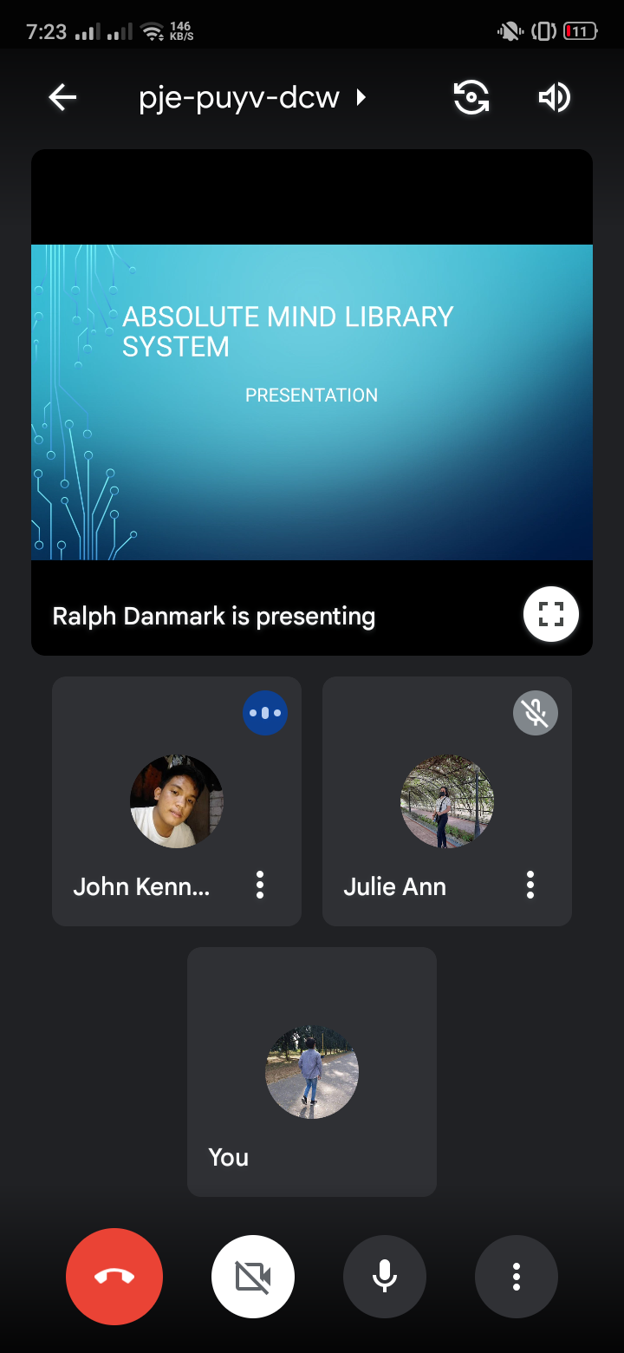

These are the some documents and screenshots of our meetings when we started making our system and this also includes testing our system and fixing errors etc.

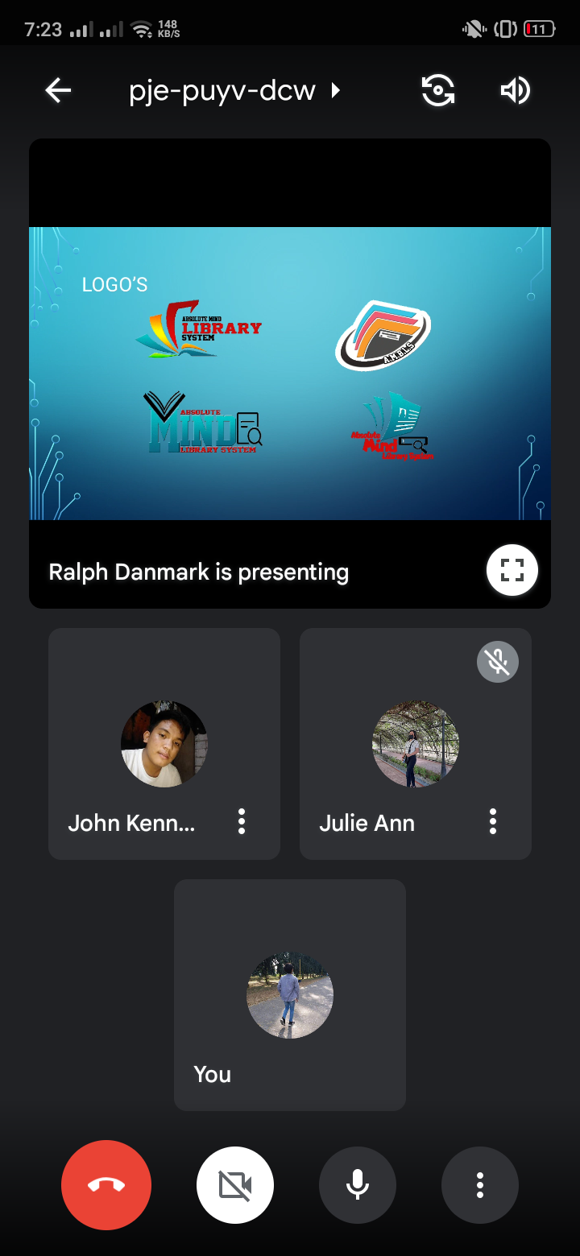

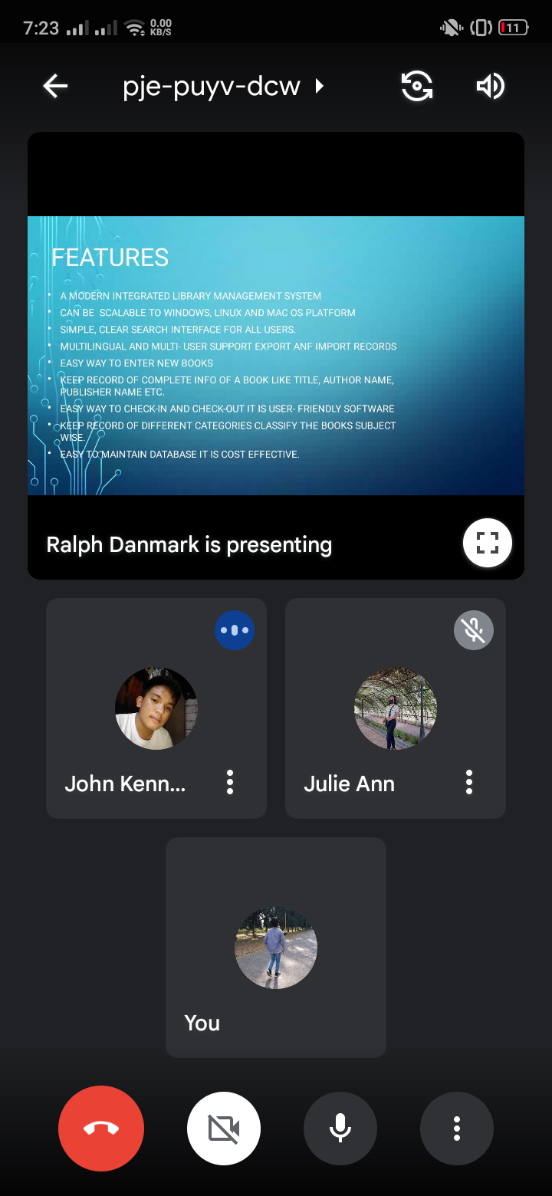

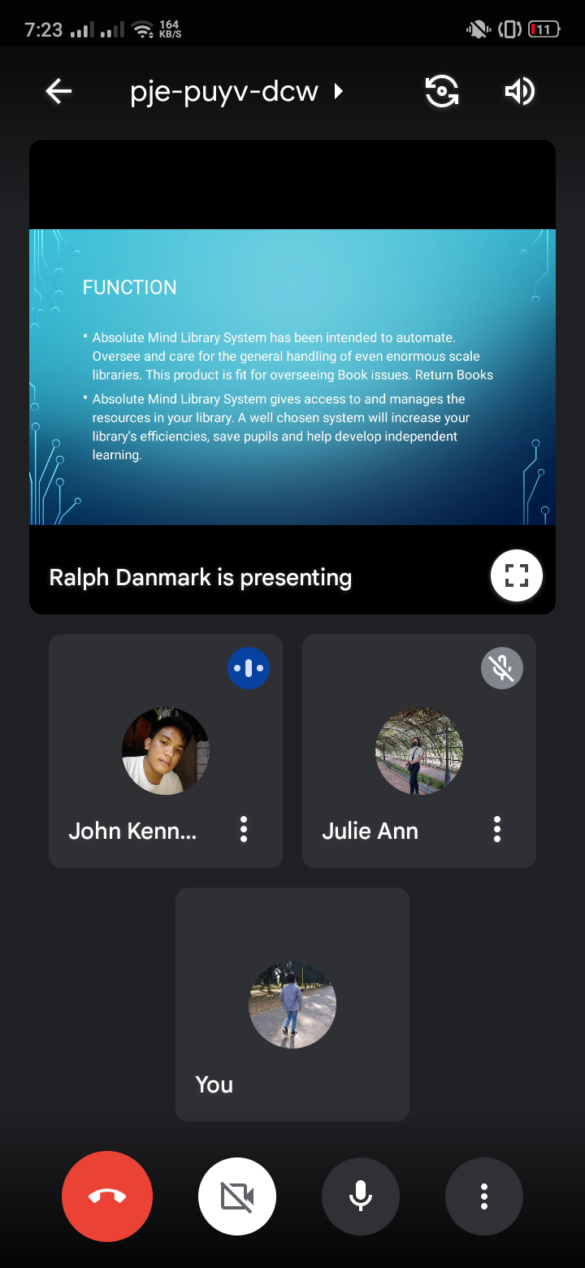

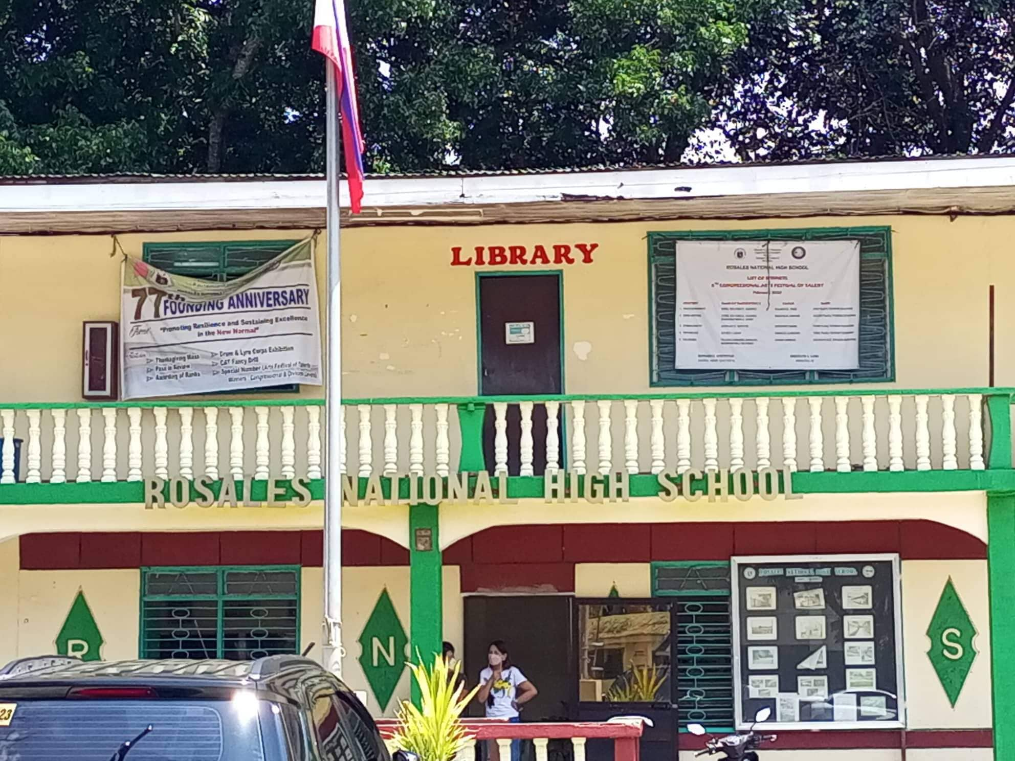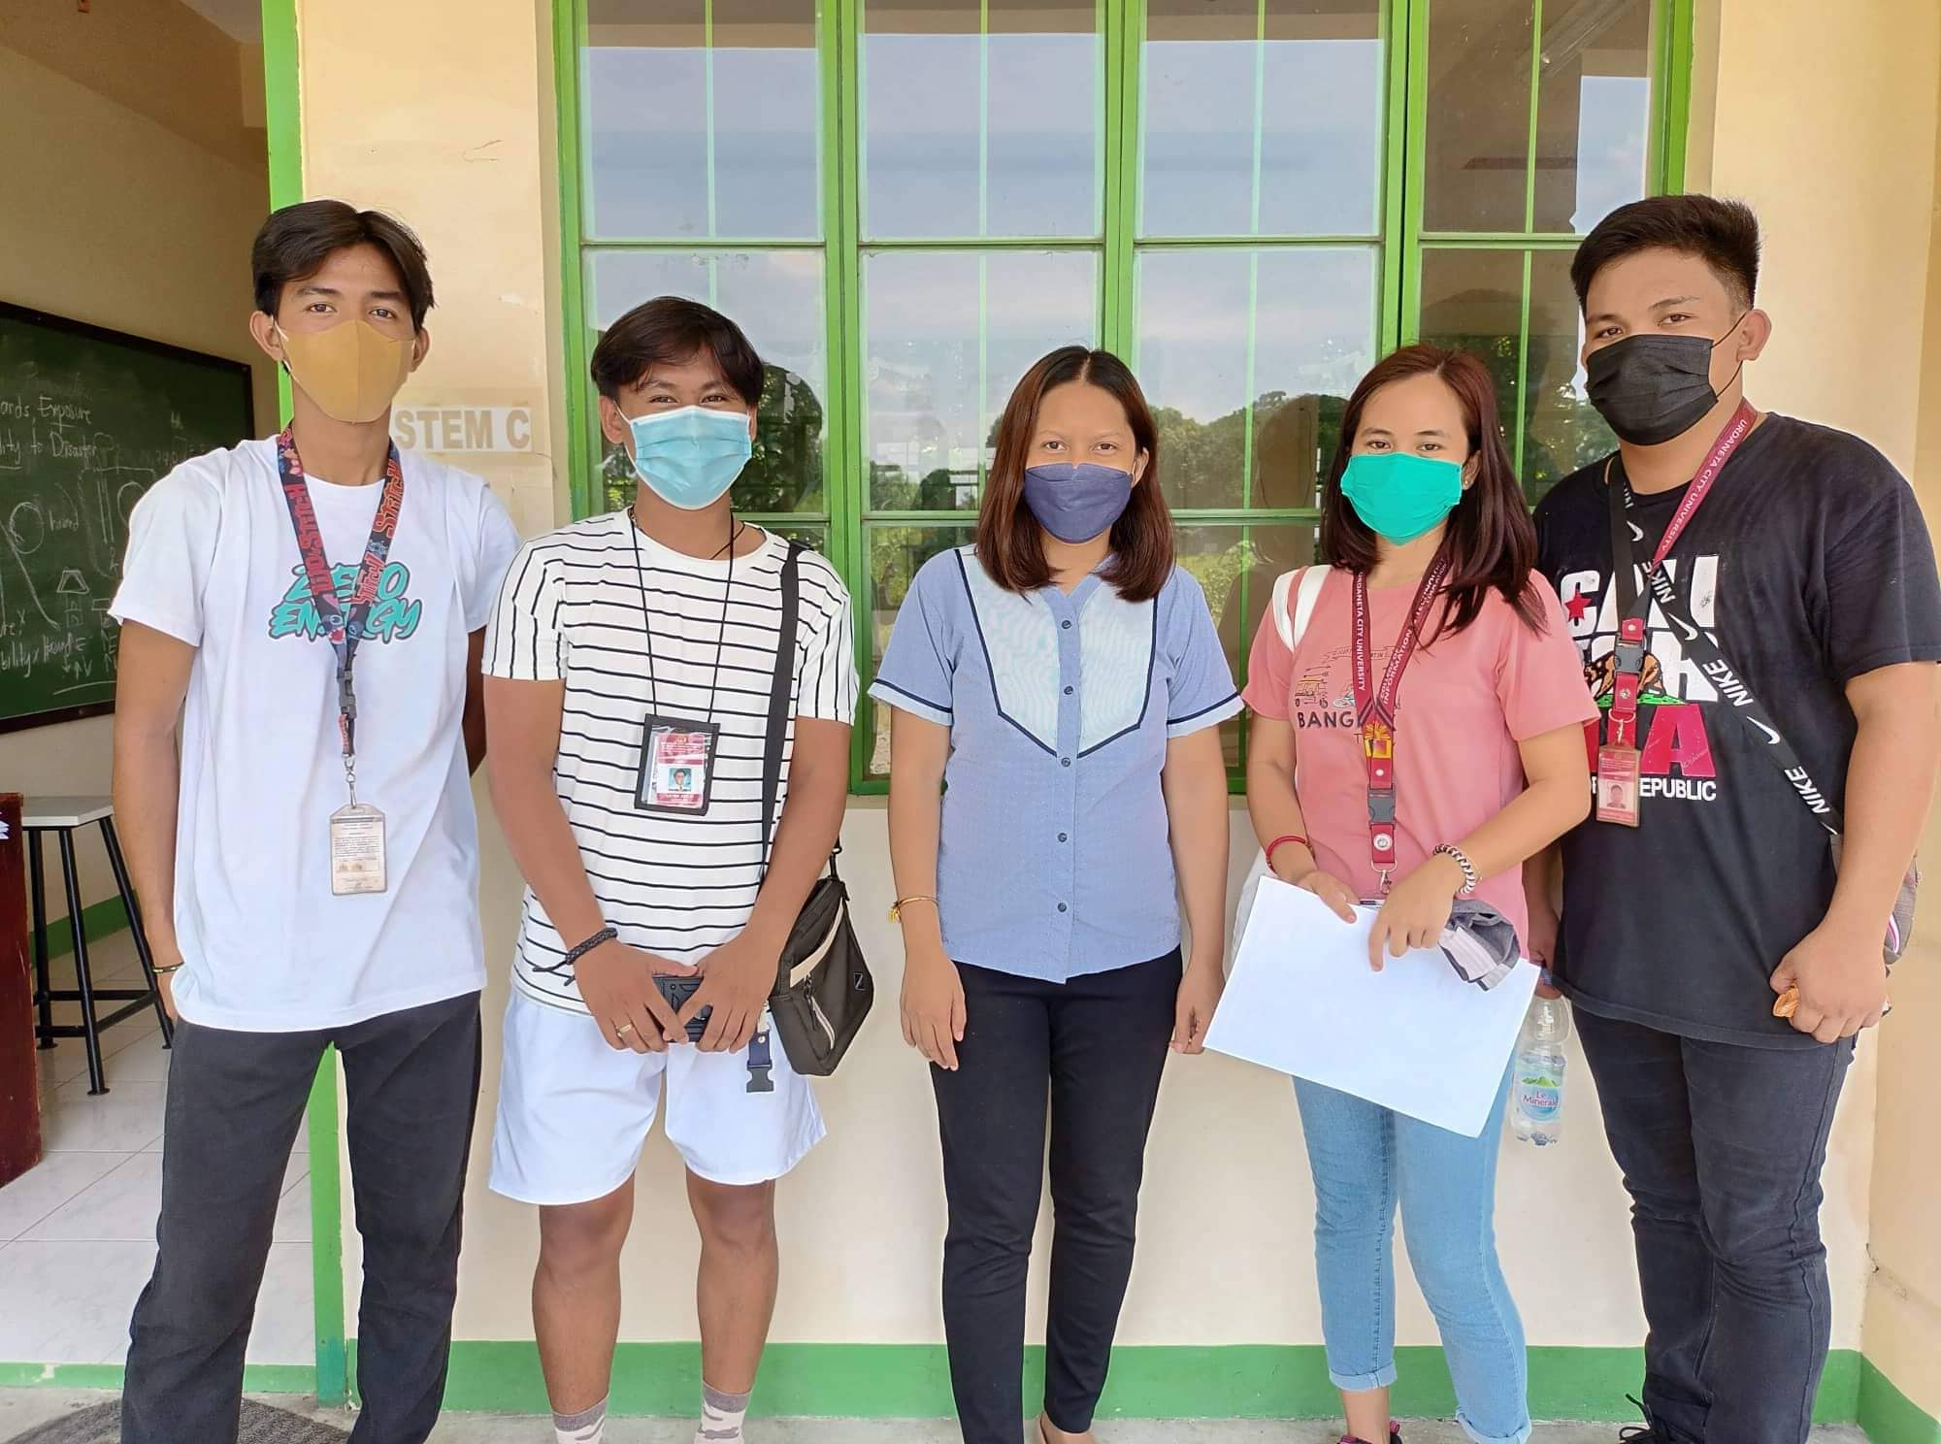

These are the photos we took when we were gathering and approval of our system to our Client at Rosales National Highschool. What we did in rosales national highschool was we showed our system to our client and explain the system we made. Then we went to their library and we took a picture of it.

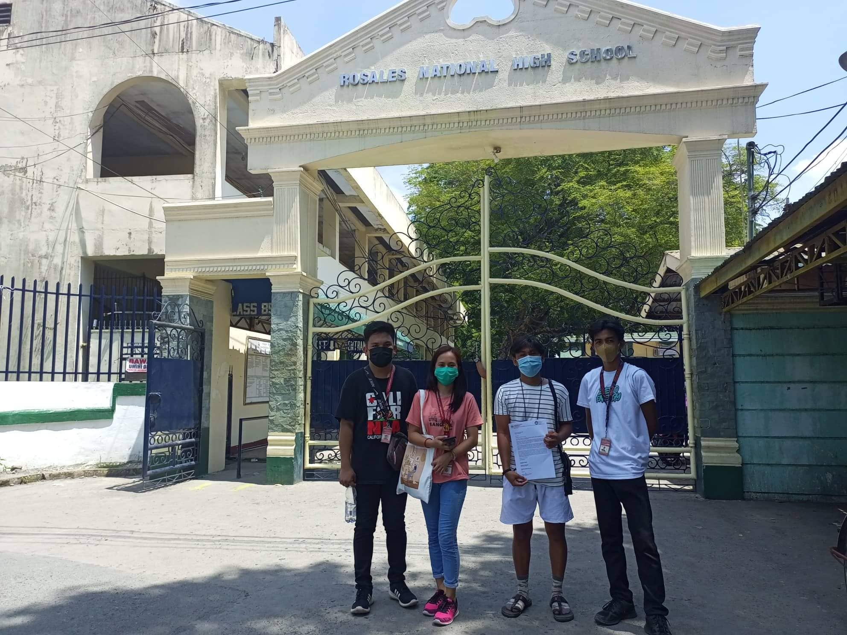

**APPENDIX**

**Database Tables**

update_information_tbl

|  |  |  |
| --- | --- | --- |
| stud_id | int | 22 |
| stud_fname | char | 155 |
| Stud_contact | varchar | 155 |
|  |  |  |

Issue_book_tbl

|  |  |  |
| --- | --- | --- |
| stud_rnumber | int | 22 |
| stud_id | int | 22 |
| stud_fname | char | 255 |
| stud_dptmnt | char | 255 |
| stud_contact | int | 22 |
| stud_books | varchar | 255 |
| stud_date | int | 22 |

Update_information_tbl

|  |  |  |
| --- | --- | --- |
| stud_id | int | 22 |
| Stud_fname | varchar | 255 |
| Stud_dprtmnt | varchar | 255 |
| semester | int | 22 |
| Stud_contact | int | 22 |

admin_account_tbl

|  |  |  |
| --- | --- | --- |
| username | varchar | 11 |
| password | varchar | 255 |

**Plates**

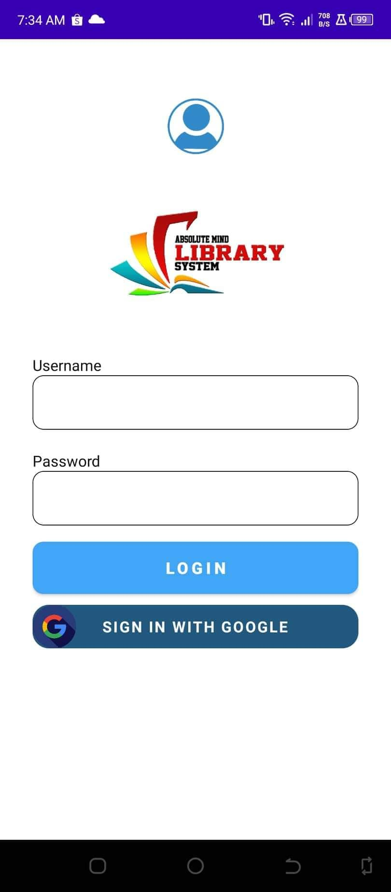

The students who want to access library materials, need to do registration first. The registration allows for maintaining records accurately. After registering, they can check out and check in the library material

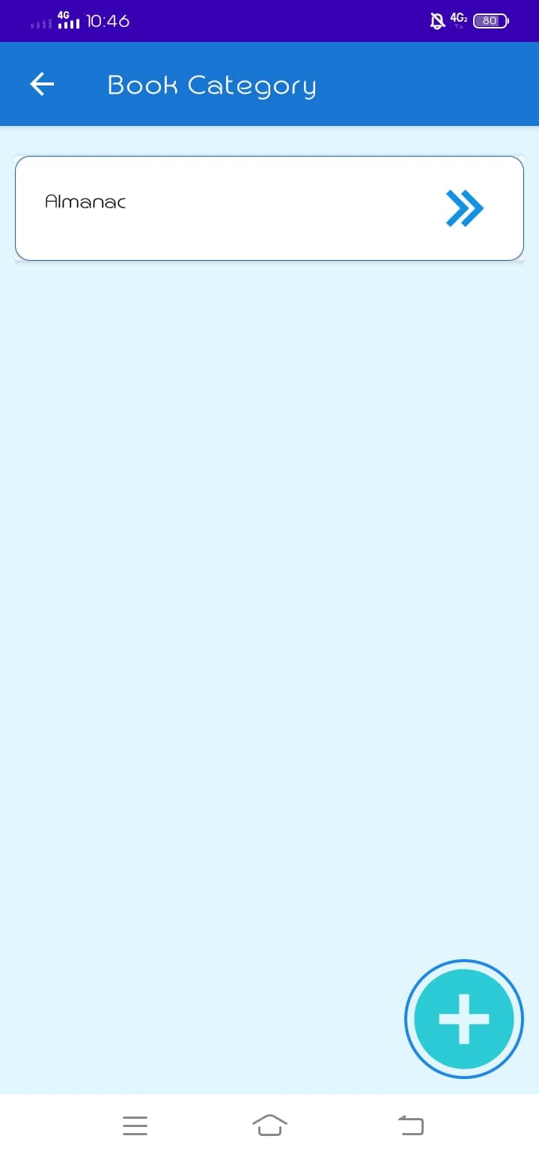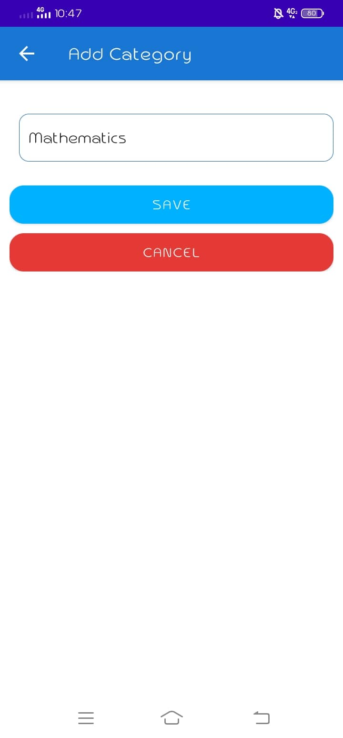

Add and update book: The admin can add new books or other materials to the system with the essential details. Thus. the librarian can maintain the system effectively.

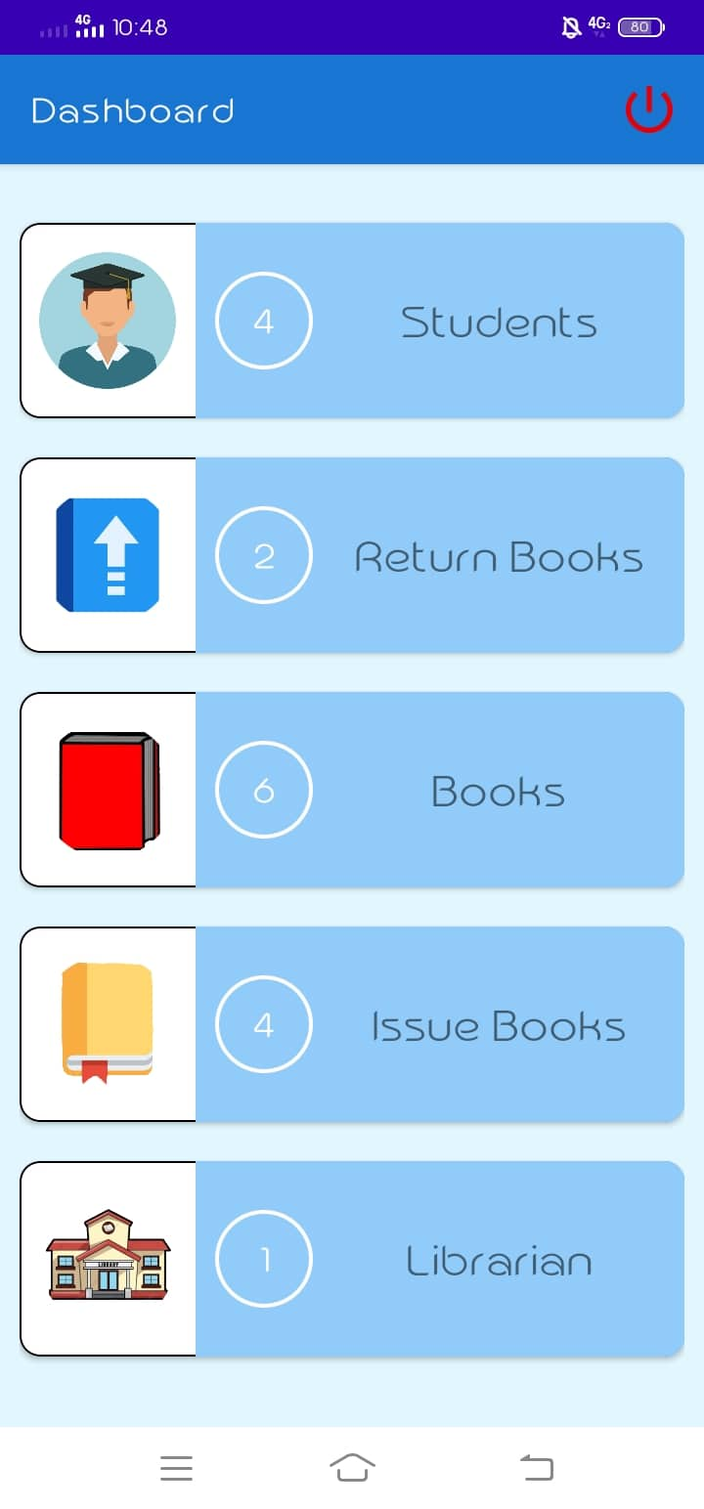

Add and update book: The admin can add new books or other materials to the system with the essential details. Thus. the librarian can maintain the system effectively.



Check in and check out: This is the distinct component of a library management system where a student can check in and check out. the library souvenirs electronically this facility helps to save the time both; students and the librarian

**Sitemap**

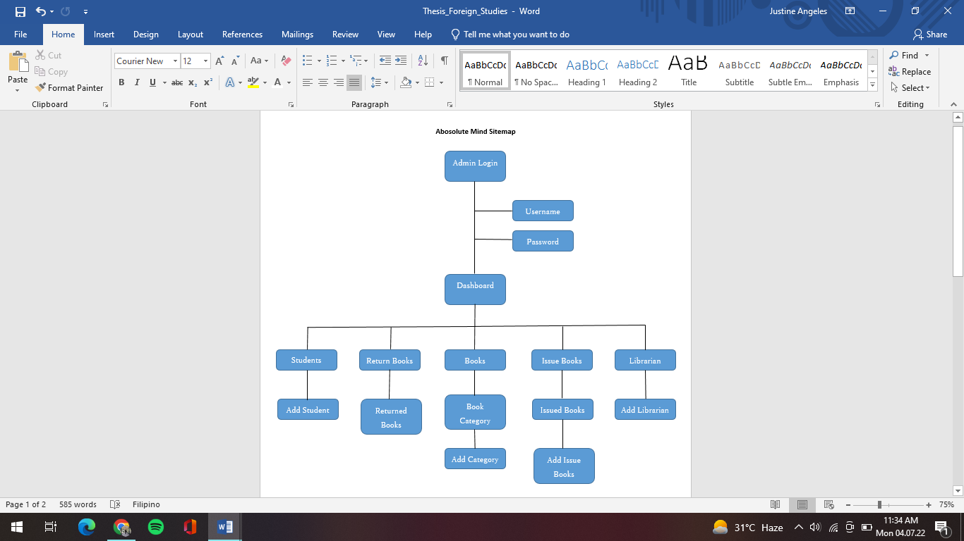

Admin sitemap - The admin sitemap access the following features inside the system:

Admin Login – describe the subsection and how it works

Students – describe the subsection and how it works…

Return Books – describe the subsection and how it works

Books – describe the subsection and how it work  
Issue Book - describe the subsection and how it works  
Librarian - describe the subsection and how it works

**Video Demo**

|  |  |
| --- | --- |
| Use this template the QR code image size is 1.9x1.9 don’t make resize it.  The QR code should contain video link from YouTube demonstrating how the developed system/ application works and how to use it link here for manual typing:  https://www.youtube.com/watch?v=fjSVEd3gBHE |  |

**Repository**

|  |  |
| --- | --- |
| Use this template the QR code image size is 1.9x1.9 don’t make resize it.  The QR code should contain system/ application link uploaded from Github also add the link here for manual typing:  https://github.com/ sampleLink |  |

**Enrollment Form**

*Clear photo of registration form…*

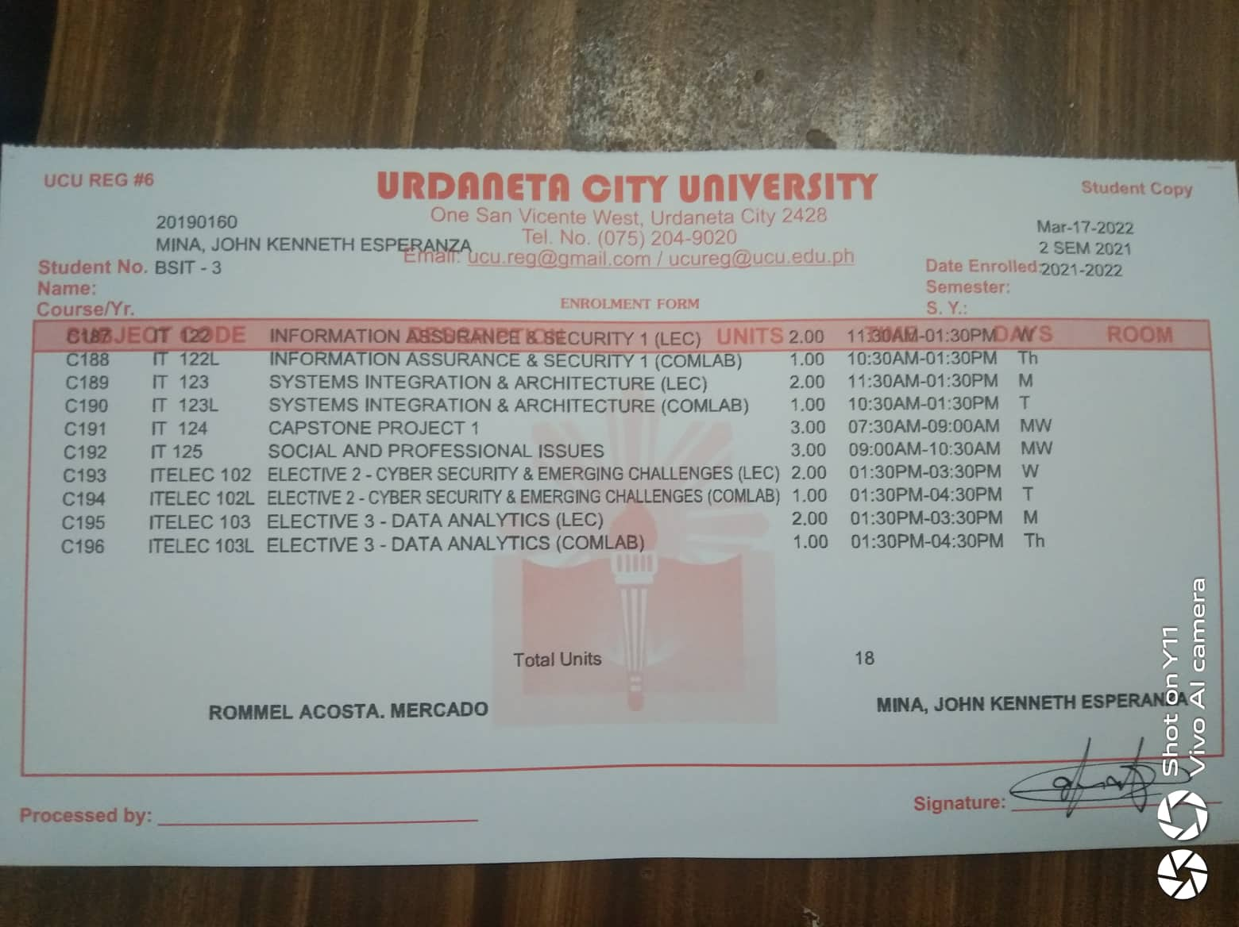

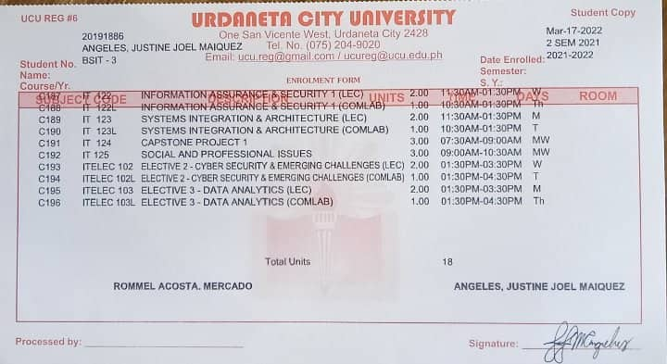

**Communication Letter**

Clear photo of communication letter…

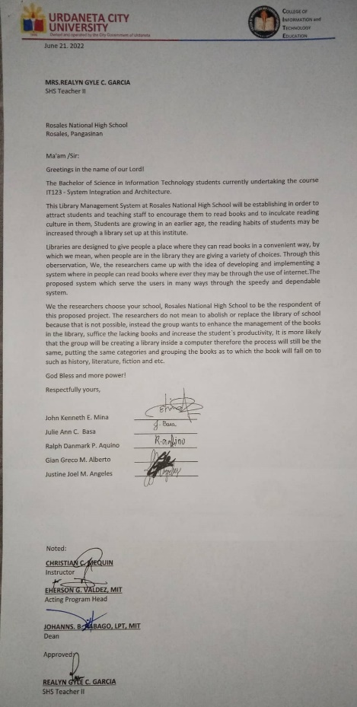

**Curriculum Vitae**

Personal Information

Name : John Kenneth E. Mina

Birth Date : March 15,2001

Birth Place : Paniqui, Tarlac

Age : 21

Gender : Male

Civil Status : Single

Address : Brgy. Baloy, Cuyapo, Nueva Ecija

Mother’s Name : Myla E. Mina

Father’s Name : Edison B. Mina

Educational Attainment

Elementary : Baloy Elementary School

Year Graduated : 2012-2013

Secondary : Baloy National High School

Year Graduated : 2018-2019

Motto

“Never stop learning, because life never stop teaching”

**Curriculum Vitae**

Personal Information

Name : Justine Joel M. Angeles

Birth Date : October 6,2000

Birth Place : Urdaneta City, Pangasinan

Age : 21

Gender : Male

Civil Status : Single

Address : Brgy. 27 Bayaoas, Urdaneta City, Pangasinan

Mother’s Name : Estrella M. Angeles

Father’s Name : Jose C. Angeles Jr

Educational Attainment

Elementary : Urdaneta I Central School

Year Graduated : 2012-2013

Secondary : Divine Word College of Urdaneta

Year Graduated : 2018-2019

Motto

"Success is not final; failure is not fatal: It is the courage to continue that counts."

**Curriculum Vitae**

Personal Information

Name : Ralph Danmark Aquino

Birth Date : June 11,2001

Birth Place : Asingan, Panasinan

Age : 21

Gender : Male

Civil Status : Single

Address : Brgy 147 Toboy, Asingan Pangasinan

Mother’s Name : Racquel P. Aquino

Father’s Name : Roldan M. Aquino

Educational Attainment

Elementary : Toboy Elementary School

Year Graduated : 2012-2013

Secondary : Toboy National High school

Year Graduated : 2018-2019

Motto

“Tomorrow is another day”

**Curriculum Vitae**

Personal Information

Place your photo here

1.5x.15

DO NOT RESIZE

Name : Gian Greco M. Alberto

Birth Date : August 1,2001

Birth Place : Rosario, La Union

Age : 21

Gender : Male

Civil Status : Single

Address : Brgy Imabalbalatong, Pozorrubio, Pangasinan

Mother’s Name : Kathlyn Alberto

Father’s Name : Joehonson Alberto

Educational Attainment

Elementary : Mary Help of Christians Learning Center

Year Graduated : 2012-2013

Secondary : Benigno V. Aldana National High school

Year Graduated : 2018-2019

Motto

“Anything is Possible”

**Curriculum Vitae**

Personal Information

Name : Julie Ann C. Basa

Birth Date : Daraga, Albay

Birth Place : July 22, 2001

Age : 20

Gender : Female

Civil Status : Single

Address : San Bartolome, Rosales, Pangasinan

Mother’s Name : Rosie C. Basa

Father’s Name : Robert M. Lopos

Educational Attainment

Elementary : San Bartolome Elementary School

Year Graduated : 2012-2013

Secondary : Rosales National High School

Year Graduated : 2018-2019

Motto

“Enjoy the little things”