National College of Ireland
H6WD – Web Design and Development 2025/2026
CA2 | Local Business Website
CA2 Project Report Template (Maximum 5 Pages)

Complete this template and submit it as a PDF or DOCX. Keep the report concise (maximum 5 pages excluding cover page if used).
Project Title
Project Topic (SDG) | Smart Hime Sustainability-Water and Energy(SDG 6 and 7)
Group Number | B
Student 1 (Name & ID) | CATHERINE WANJIRU NJARO 25113674
Student 2 (Name & ID) | GIAN MAQUILING 24285285
GitHub Repository | https://github.com/gianbryce/H6WAD_CA2_Project
Live Website URL (GitHub Pages) | https://gianbryce.github.io/H6WAD_CA2_Project/
Presentation Video URL

1. Project Overview
Smart Home Sustain is an educational website designed to promote sustainable living be encouraging households to reduce energy and water consumption website provides practical advice,interactive content and an energy savings calculator to help users understand the financial and environmental benefits for adopting sustainable practices. Target audience include home owners,families and students who intend to make their homes water and energy efficient. The projects supports United Nations Sustainable Development Goal 6(Clean water and Sanitation) by promoting water conservation and Sustainable Development Goal 7(Affordable clean Energy)by encouraging efficient energy use. The website was developed using HTML5,CSS,Bootstrap and JavaScript to create a responsive and user friendly experience.

2. Planning and Design
- Insert screenshots of desktop and mobile wire frames for all six pages.
- Insert your mood board and briefly explain your color palette, typography, and design choices.
A green color was selected to represent sustainability and environmental protection,while blue was used to reflect water conservation. Yellow highlights energy saving feature and important buttons..Cambria was chosen for its readability across devices. Bootstrap responsive grid system ensures the website adapts well to desktop,tablet and mobile screens.

3. Website Implementation
Summary of six webpage
Webpage | Main Features
Home | Introduce website and SDGs with navigation and call to action buttons
Energy | Explains methods for improving household energy efficiency
Calculator | Estimates annual savings from LED lighting and smart heating controls
Water | Provides practical water conservation advice
Tips | Share simple sustainability tips for everyday life.
Contact | Allows users to submit feedback through a contact form

Work Allocation
Catherine
- Homepage
- Energy page
- Calculator
- JavaScript
- DOM manipulation
- Validation
GIAN
- Water page
- Tips page
- Contact Page
- YouTube embed
- Google form
Implementation
HTML5 semantic elements such as <header>,<nav>,<main>,<section> and <footer> were used to structure the website. CSS provided consistent colors,typography,spacing and layout through an external style sheet. Bootstrap's grid system created a responsive layout that adjusts to different screen sizes, ensuring a consistent user experience on desktop and mobile devices.

4. JavaScript Calculator
Purpose
The calculator estimates potential annual savings achieved by replacing traditional lighting with LED bulbs and by using smart heating controls.
DOM Manipulation
JavaScript retrieves values entered by the user performs the calculations and updates the results dynamically without refreshing the webpage.
Input validation
Calculator validates user input by checking whether all values are numeric and greater than or equal to zero before calculations are performed.
Contribution to Project
Calculator provides users with an interactive way to understand the financial benefit of improving households energy efficiency,supporting the sustainability goals of the website.
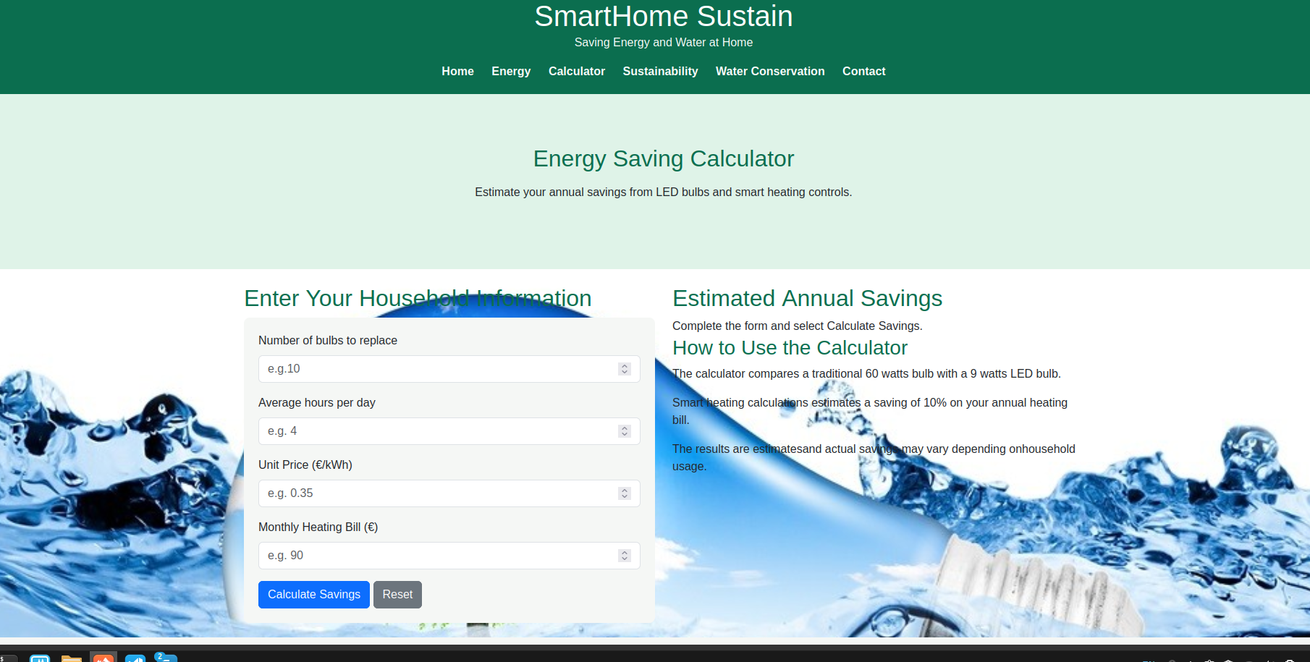
Calculator before values
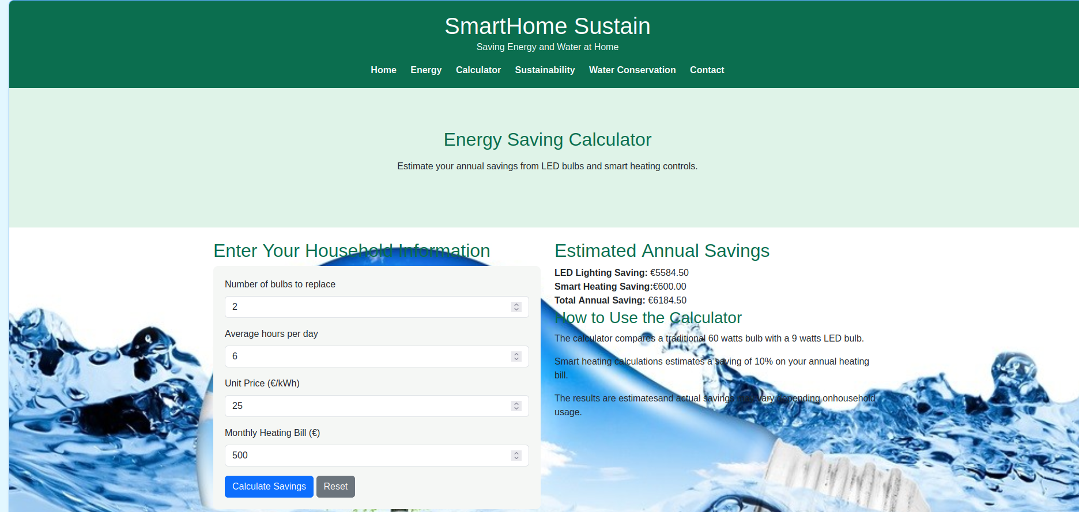

Calculator after values

5. Web Standards, Testing and Optimization
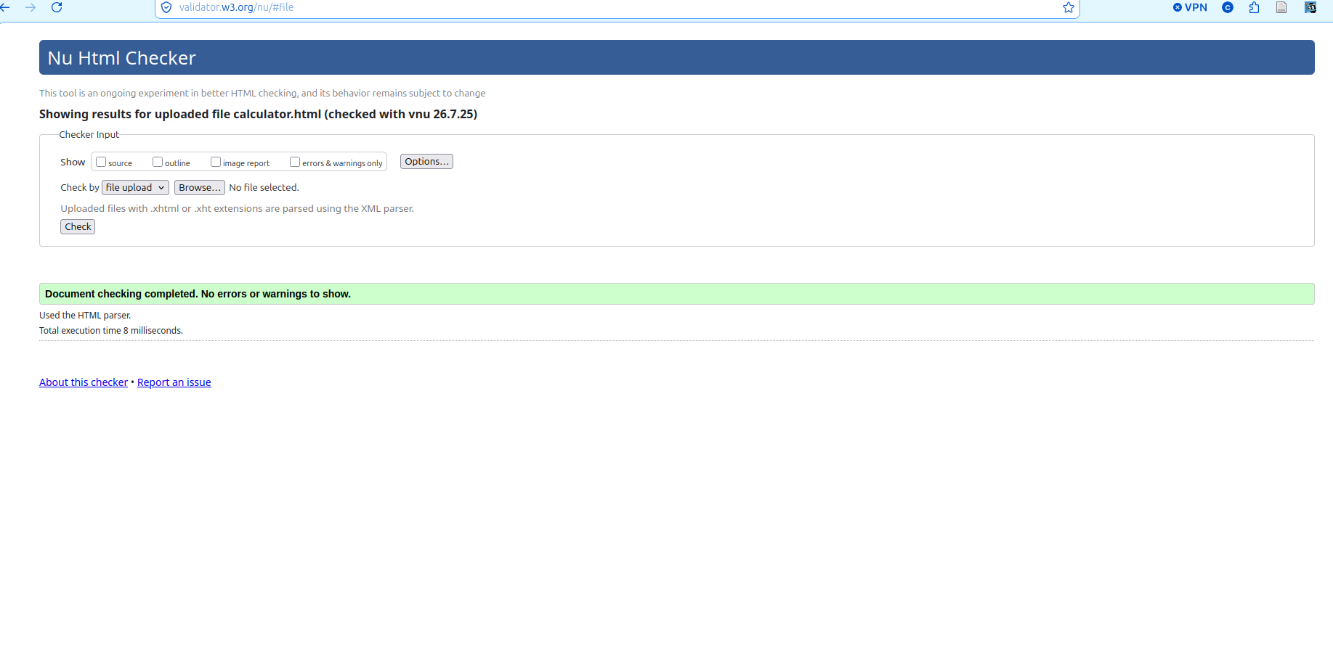

Calculator-w3c.png
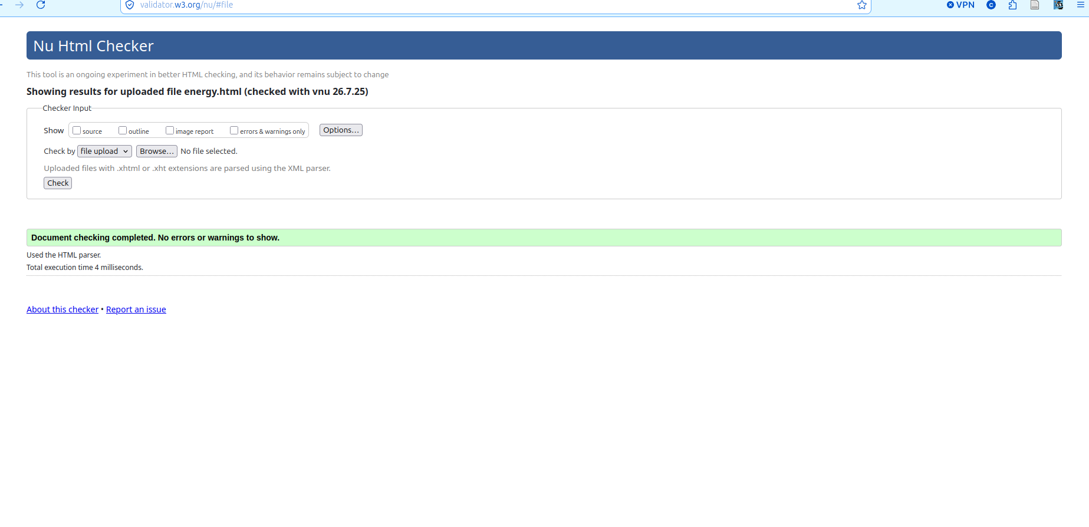
energy-w3c.png

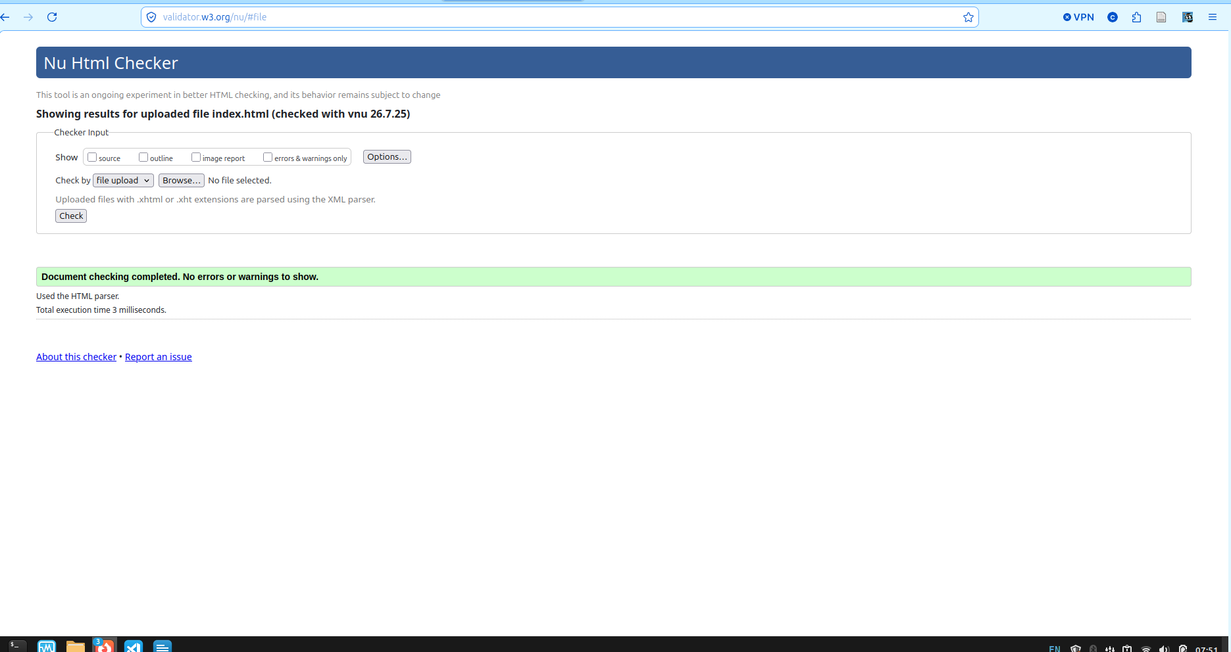

index-w3c.png

• W3C HTML validation screenshots
• W3C CSS validation results (if used)

• Google PageSpeed Insights screenshots

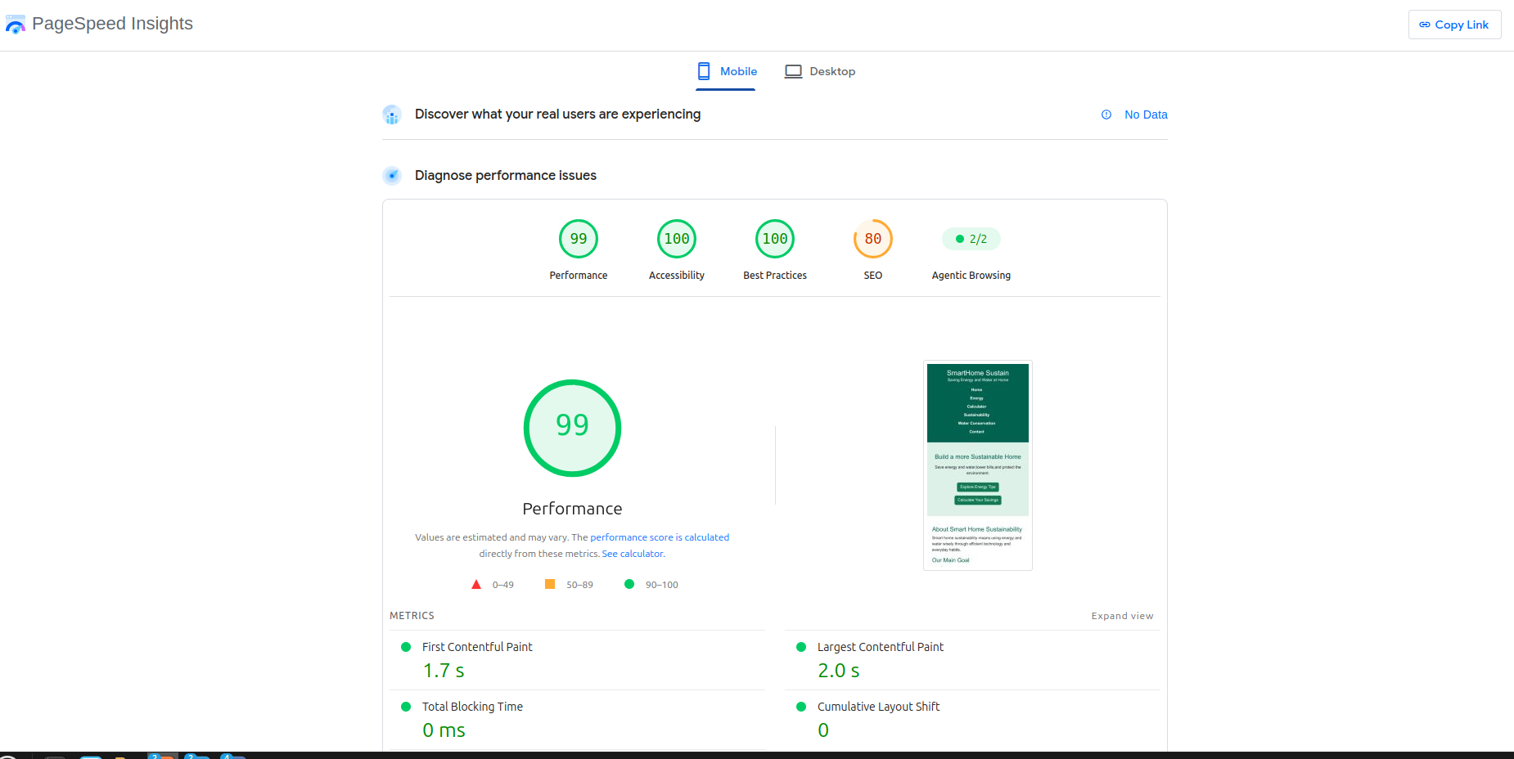
mobile_pagespeed.png

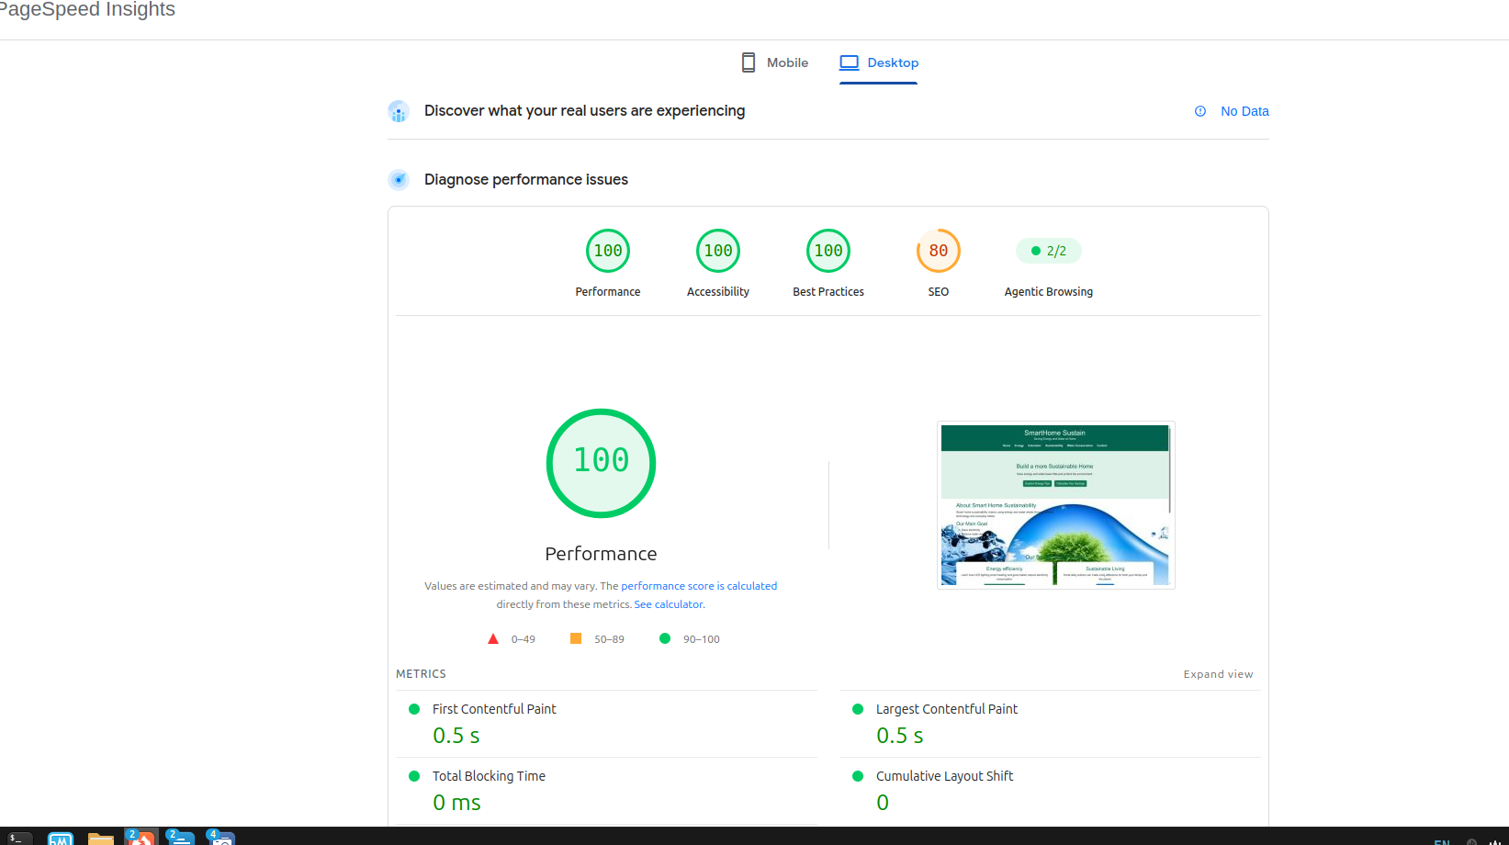
desktop_pagespeed.png

Evidence of responsive testing
• Image optimisation techniques
• Accessibility features (alt text, semantic HTML etc.)

6. Team Contributions
Provide a table listing the tasks completed by each student and summarise the GitHub contributions (minimum 5 commits per student).

7. References
Google(2025) PageSpeed Insights. Available at:https://pagespeed.web.dev/
W3Schools(2025)CSS Tutorial. Available at:https://www.w3schools.com/css/
W3Schools(2025)Bootstrap Tutorial. Available at:https://www.w3schools.com/bootstrap5/
United Nations(2025)Sustainable Development Goals. Available at:https://sdgs.un.org/goals

