Giancarlo Barillas

Android Development

Lab 3

**XML Code:**

*<?***xml version="1.0" encoding="utf-8"***?>*<**android.support.constraint.ConstraintLayout xmlns:android="http://schemas.android.com/apk/res/android"  
 xmlns:app="http://schemas.android.com/apk/res-auto"  
 xmlns:tools="http://schemas.android.com/tools"  
 android:layout_width="match_parent"  
 android:layout_height="match_parent"  
 android:background="#FFCB33 "  
 tools:context="org.example.lab3.MainActivity"**>  
  
 <**TextView  
 android:id="@+id/textView"  
 android:layout_width="match_parent"  
 android:layout_height="wrap_content"  
 android:layout_marginEnd="8dp"  
 android:layout_marginStart="8dp"  
 android:layout_marginTop="8dp"  
 android:text="Tempeture Converter"  
 android:textColor="@android:color/black"  
 android:textSize="24sp"  
 app:layout_constraintEnd_toEndOf="parent"  
 app:layout_constraintHorizontal_bias="0.503"  
 app:layout_constraintStart_toStartOf="parent"  
 app:layout_constraintTop_toTopOf="parent"** />  
  
 <**TextView  
 android:id="@+id/textView5"  
 android:layout_width="wrap_content"  
 android:layout_height="wrap_content"  
 android:layout_marginTop="32dp"  
 android:text="0F"  
 app:layout_constraintStart_toStartOf="@+id/textView"  
 app:layout_constraintTop_toBottomOf="@+id/textView"** />  
  
 <**SeekBar  
 android:id="@+id/seekBar3"  
 android:layout_width="0dp"  
 android:layout_height="wrap_content"  
 android:layout_marginEnd="8dp"  
 android:layout_marginStart="8dp"  
 app:layout_constraintEnd_toStartOf="@+id/textView6"  
 app:layout_constraintStart_toEndOf="@+id/textView5"  
 app:layout_constraintTop_toTopOf="@+id/textView5"** />  
  
 <**TextView  
 android:id="@+id/textView6"  
 android:layout_width="wrap_content"  
 android:layout_height="wrap_content"  
 android:layout_marginTop="32dp"  
 android:text="200F"  
 app:layout_constraintEnd_toEndOf="@+id/textView"  
 app:layout_constraintTop_toBottomOf="@+id/textView"** />  
  
 <**TextView  
 android:id="@+id/textView7"  
 android:layout_width="wrap_content"  
 android:layout_height="wrap_content"  
 android:layout_marginTop="32dp"  
 android:text="Fahrenheit:"  
 android:textColor="@android:color/black"  
 app:layout_constraintStart_toStartOf="@+id/textView5"  
 app:layout_constraintTop_toBottomOf="@+id/seekBar3"** />  
  
 <**TextView  
 android:id="@+id/farenheitValue"  
 android:layout_width="wrap_content"  
 android:layout_height="wrap_content"  
 android:layout_marginTop="32dp"  
 android:textColor="@android:color/black"  
 app:layout_constraintEnd_toEndOf="@+id/textView6"  
 app:layout_constraintTop_toBottomOf="@+id/seekBar3"** />  
  
 <**TextView  
 android:id="@+id/textView9"  
 android:layout_width="wrap_content"  
 android:layout_height="wrap_content"  
 android:layout_marginTop="32dp"  
 android:text="Celsius:"  
 android:textColor="@android:color/black"  
 app:layout_constraintStart_toStartOf="@+id/textView7"  
 app:layout_constraintTop_toBottomOf="@+id/textView7"** />  
  
 <**TextView  
 android:id="@+id/celsiusValue"  
 android:layout_width="wrap_content"  
 android:layout_height="wrap_content"  
 android:textColor="@android:color/black"  
 app:layout_constraintEnd_toEndOf="@+id/textView6"  
 app:layout_constraintTop_toTopOf="@+id/textView9"** />  
  
 <**TextView  
 android:id="@+id/feeling"  
 android:layout_width="0dp"  
 android:layout_height="wrap_content"  
 android:layout_marginEnd="8dp"  
 android:layout_marginStart="8dp"  
 android:layout_marginTop="32dp"  
 android:textAlignment="center"  
 android:textColor="@android:color/black"  
 app:layout_constraintEnd_toEndOf="parent"  
 app:layout_constraintStart_toStartOf="parent"  
 app:layout_constraintTop_toBottomOf="@+id/textView9"** />  
  
 <**ImageView  
 android:id="@+id/chicagoImage"  
 android:layout_width="0dp"  
 android:layout_height="200dp"  
 android:layout_marginBottom="8dp"  
 android:layout_marginEnd="8dp"  
 android:layout_marginStart="8dp"  
 app:layout_constraintBottom_toBottomOf="parent"  
 app:layout_constraintEnd_toEndOf="parent"  
 app:layout_constraintStart_toStartOf="parent"** />  
  
</**android.support.constraint.ConstraintLayout**>

**Java Code:**

**package** org.example.lab3;  
  
**import** android.graphics.Color;  
**import** android.support.v7.app.AppCompatActivity;  
**import** android.os.Bundle;  
**import** android.widget.ImageView;  
**import** android.widget.SeekBar;  
**import** android.widget.TextView;  
**import** java.text.DecimalFormat;  
  
**public class** MainActivity **extends** AppCompatActivity {  
  
 SeekBar **seekbar**;  
 TextView **textView**;*//for farenheit* TextView **textView2**;*//for celsius* TextView **textView3**;*//for feeling* ImageView **imageView**;  
 **int progress**;  
 **double dProgress**;  
 **double converstion**;  
  
 @Override  
 **protected void** onCreate(Bundle savedInstanceState) {  
 **super**.onCreate(savedInstanceState);  
 setContentView(R.layout.***activity_main***);  
  
 **seekbar**=(SeekBar)findViewById(R.id.***seekBar3***);  
 **seekbar**.setMax(200);  
 **seekbar**.setProgress(**progress**);  
  
  
  
  
 **seekbar**.setOnSeekBarChangeListener(**new** SeekBar.OnSeekBarChangeListener() {  
 @Override  
 **public void** onProgressChanged(SeekBar seekBar, **int** i, **boolean** b) {  
 **progress**=i;  
 **dProgress**=i;*//needed a double to make celsius double calulation* **converstion**=(5)*(**dProgress**-32)/9;  
 DecimalFormat format=**new** DecimalFormat(**"0.00"**);  
 **textView**=(TextView)findViewById(R.id.***farenheitValue***);  
 **textView**.setText(**""**+**progress**);  
 **textView2**=(TextView) findViewById(R.id.***celsiusValue***);  
 **textView2**.setText(**""**+format.format(**converstion**));  
 **textView3**=(TextView)findViewById(R.id.***feeling***);  
 **imageView**=(ImageView)findViewById(R.id.***chicagoImage***);  
 **if**(i<=40)  
 {  
 **textView3**.setText(**"Too Cold"**);  
 **textView3**.setBackgroundColor(Color.***BLUE***);  
 **imageView**.setImageResource(R.drawable.***winter***);  
 }  
 **else if**(i>40&&i<=90)  
 {  
 **textView3**.setText(**"Just Right"**);  
 **textView3**.setBackgroundColor(Color.***GREEN***);  
 **imageView**.setImageResource(R.drawable.***spring***);  
 }  
 **else if**(i>90)  
 {  
 **textView3**.setText(**"Hot!"**);  
 **textView3**.setBackgroundColor(Color.***RED***);  
 **imageView**.setImageResource(R.drawable.***summer***);  
 }  
 }  
  
 @Override  
 **public void** onStartTrackingTouch(SeekBar seekBar) {  
  
 }  
  
 @Override  
 **public void** onStopTrackingTouch(SeekBar seekBar) {  
  
 }  
 });  
  
 }  
}

**Screenshots:**

3 Images used in this app

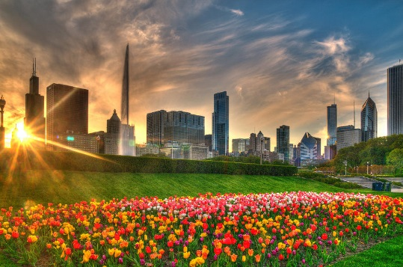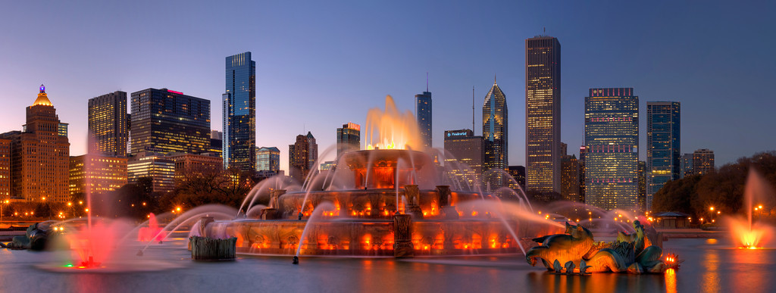

Images of app working on my phone:

