Giancarlo Barillas

Homework 7 and 8

ITM 455

Screenshot:

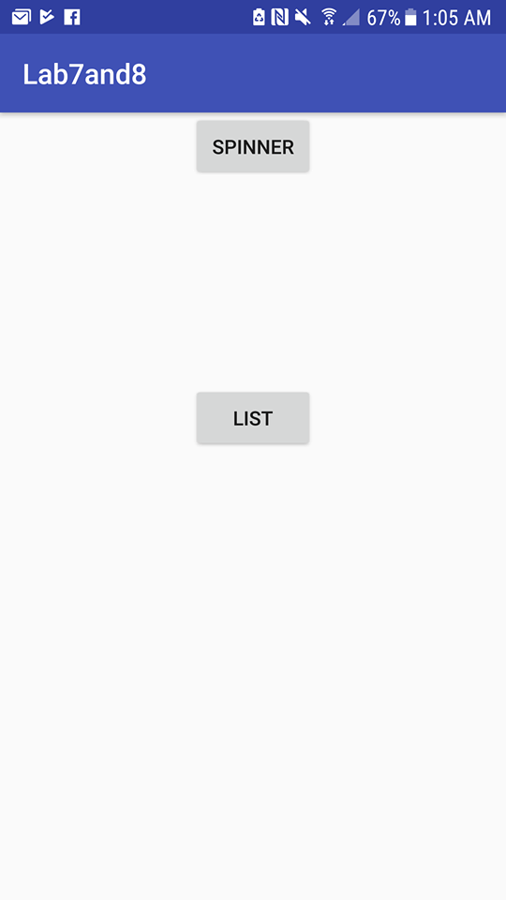

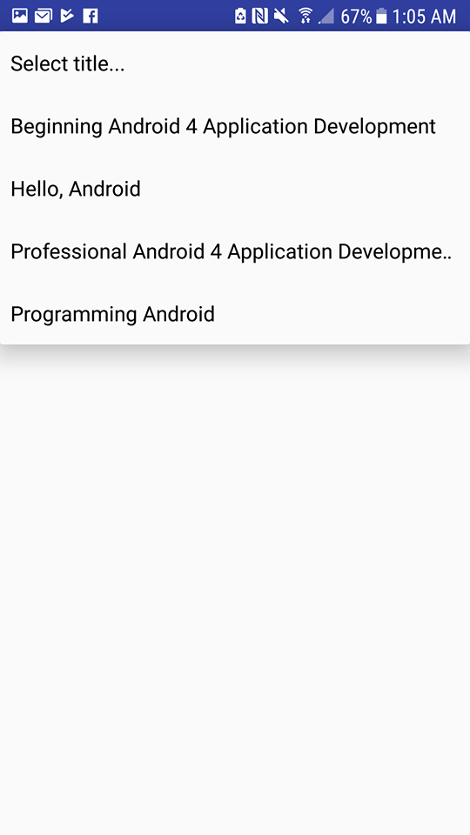

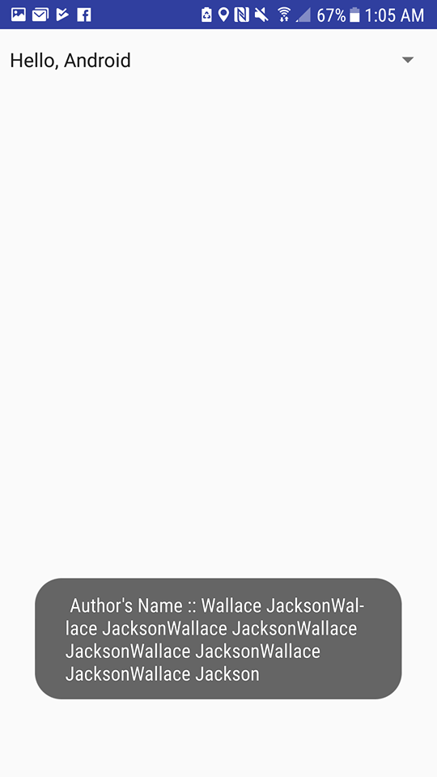

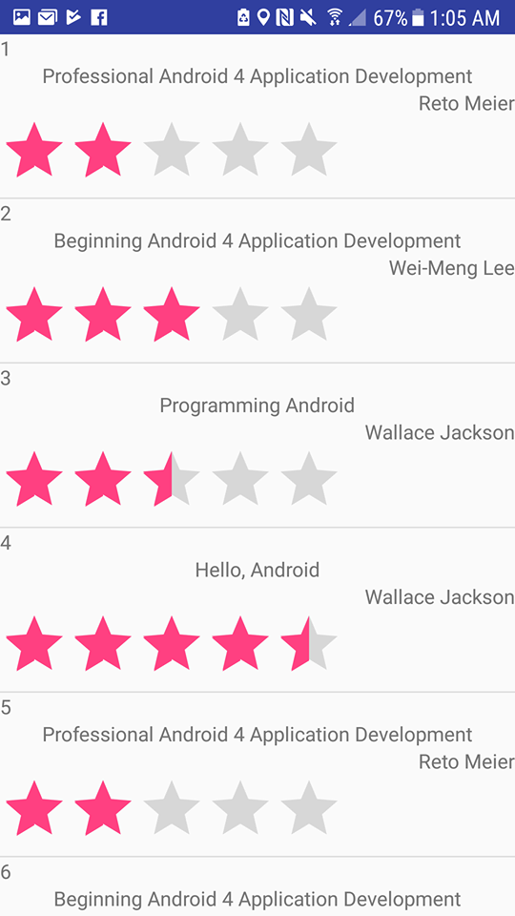

**XML CODES:**

**Activity_main.XML**

*<?***xml version="1.0" encoding="utf-8"***?>*<**RelativeLayout xmlns:android="http://schemas.android.com/apk/res/android"  
 xmlns:app="http://schemas.android.com/apk/res-auto"  
 xmlns:tools="http://schemas.android.com/tools"  
 android:layout_width="match_parent"  
 android:layout_height="match_parent"  
 tools:context="org.example.lab7and8.MainActivity"**>  
  
 <**Button  
 android:id="@+id/spinner"  
 android:layout_width="wrap_content"  
 android:layout_height="wrap_content"  
 android:layout_alignParentTop="true"  
 android:layout_centerHorizontal="true"  
 android:text="Spinner"** />  
  
 <**Button  
 android:id="@+id/list"  
 android:layout_width="wrap_content"  
 android:layout_height="wrap_content"  
 android:layout_alignLeft="@+id/spinner"  
 android:layout_alignStart="@+id/spinner"  
 android:layout_below="@+id/spinner"  
 android:layout_marginTop="145dp"  
 android:text="List"** />  
  
</**RelativeLayout**>

**Customlayout.XML**

*<?***xml version="1.0" encoding="utf-8"***?>*<**RelativeLayout xmlns:android="http://schemas.android.com/apk/res/android"  
 android:layout_width="match_parent"  
 android:layout_height="match_parent"**>  
  
 <**TextView  
 android:id="@+id/id"  
 android:layout_width="wrap_content"  
 android:layout_height="wrap_content"  
 android:layout_alignParentLeft="true"  
 android:layout_alignParentStart="true"  
 android:layout_alignParentTop="true"  
 android:text="TextView"** />  
  
 <**TextView  
 android:id="@+id/title"  
 android:layout_width="wrap_content"  
 android:layout_height="wrap_content"  
 android:layout_below="@+id/id"  
 android:layout_centerHorizontal="true"  
 android:text="TextView"** />  
  
 <**TextView  
 android:id="@+id/author"  
 android:layout_width="wrap_content"  
 android:layout_height="wrap_content"  
 android:layout_alignParentEnd="true"  
 android:layout_alignParentRight="true"  
 android:layout_below="@+id/title"  
 android:text="TextView"** />  
  
 <**RatingBar  
 android:id="@+id/ratingBar"  
 android:layout_width="wrap_content"  
 android:layout_height="wrap_content"  
 android:layout_alignParentLeft="true"  
 android:layout_alignParentStart="true"  
 android:layout_below="@+id/author"** />  
</**RelativeLayout**>

**List.XML**

*<?***xml version="1.0" encoding="utf-8"***?>*<**RelativeLayout xmlns:android="http://schemas.android.com/apk/res/android"  
 android:layout_width="match_parent"  
 android:layout_height="match_parent"**>  
  
 <**ListView  
 android:id="@+id/list"  
 android:layout_width="match_parent"  
 android:layout_height="match_parent"  
 android:layout_alignParentLeft="true"  
 android:layout_alignParentStart="true"  
 android:layout_alignParentTop="true"** />  
</**RelativeLayout**>

**Spinner.XML**

*<?***xml version="1.0" encoding="utf-8"***?>*<**LinearLayout xmlns:android="http://schemas.android.com/apk/res/android"  
 android:layout_width="match_parent"  
 android:layout_height="match_parent"**>  
  
 <**Spinner  
 android:id="@+id/spinner1"  
 android:layout_width="match_parent"  
 android:layout_height="50dp"  
 android:drawSelectorOnTop="true"** />  
</**LinearLayout**>

**JAVA CODES:**

**MainActivity.java**

**package** org.example.lab7and8;  
  
**import** android.content.Intent;  
**import** android.support.v7.app.AppCompatActivity;  
**import** android.os.Bundle;  
**import** android.view.View;  
**import** android.widget.Button;  
  
**public class** MainActivity **extends** AppCompatActivity {  
  
 @Override  
 **protected void** onCreate(Bundle savedInstanceState) {  
 **super**.onCreate(savedInstanceState);  
 setContentView(R.layout.***activity_main***);  
  
 Button spinButton=(Button) findViewById(R.id.***spinner***);  
 spinButton.setOnClickListener(**new** View.OnClickListener() {  
 @Override  
 **public void** onClick(View view) {  
 Intent intent=**new** Intent(getApplicationContext(),spinner.**class**);  
 startActivity(intent);  
 }  
 });  
  
 Button listButton=(Button) findViewById(R.id.***list***);  
 listButton.setOnClickListener(**new** View.OnClickListener() {  
 @Override  
 **public void** onClick(View view) {  
 Intent intent2=**new** Intent(getApplicationContext(),list.**class**);  
 startActivity(intent2);  
 }  
 });  
 }  
}

**CustomListAdapter.java**

**package** org.example.lab7and8;  
  
**import** android.content.Context;  
**import** android.support.annotation.NonNull;  
**import** android.view.LayoutInflater;  
**import** android.view.View;  
**import** android.view.ViewGroup;  
**import** android.widget.ArrayAdapter;  
**import** android.widget.RatingBar;  
**import** android.widget.TextView;  
  
**import** java.util.List;  
  
*/**  
 * Created by GiancarloDesktop on 4/8/2018.  
 */***public class** CustomListAdapter **extends** ArrayAdapter<Books>{  
  
 **private** List<Books>**listElements**;  
  
 **public** CustomListAdapter(@NonNull Context context, **int** resource) {  
 **super**(context, resource);  
 }  
 **public** CustomListAdapter(@NonNull Context context, **int** resource, @NonNull List<Books> objects) {  
 **super**(context, resource, objects);  
 **this**.**listElements**=objects;  
 }  
 **public** View getView(**int** index, View changeView, ViewGroup parent)  
 {  
 View v=changeView;  
 **if**(v==**null**){  
 LayoutInflater layoutInflater;  
 layoutInflater=LayoutInflater.*from*(getContext());  
 v=layoutInflater.inflate(R.layout.***customlayout***,**null**);  
 }  
 Books books=getItem(index);  
 **if**(books!=**null**){  
 TextView tid=(TextView) v.findViewById(R.id.***id***);  
 TextView ttitle=(TextView) v.findViewById(R.id.***title***);  
 TextView tauthor=(TextView) v.findViewById(R.id.***author***);  
 RatingBar rate=(RatingBar) v.findViewById(R.id.***ratingBar***);  
  
 **if**(tid!=**null**){  
 tid.setText(**""**+books.getId());  
 }  
 **if**(ttitle!=**null**){  
 ttitle.setText(**""**+books.getTitle());  
 }  
 **if**(tauthor!=**null**){  
 tauthor .setText(**""**+books.getAuthor());  
 }  
 **if**(rate!=**null**){  
 **float** rating=Float.*parseFloat*(books.getRating());  
 rate.setRating(rating);  
 }  
 }  
 **return** v;  
 }  
}

**SqlHelper.java**

**package** org.example.lab7and8;  
  
**import** android.content.ContentValues;  
**import** android.content.Context;  
**import** android.database.Cursor;  
**import** android.database.DatabaseErrorHandler;  
**import** android.database.sqlite.SQLiteDatabase;  
**import** android.database.sqlite.SQLiteOpenHelper;  
**import** android.util.Log;  
  
**import** java.util.HashSet;  
**import** java.util.LinkedList;  
**import** java.util.List;  
**import** java.util.Set;  
  
*/**  
 * Created by GiancarloDesktop on 4/8/2018.  
 */***public class** SqlHelper **extends** SQLiteOpenHelper {  
 **private static final** String ***DATABASE_NAME*** = **"Books.db"**;  
 **private static final** String ***TABLE_NAME*** = **"book_table"**;  
 **private static final** String ***COL_1*** = **"id"**;  
 **private static final** String ***COL_2*** = **"title"**;  
 **private static final** String ***COL_3*** = **"author"**;  
 **private static final** String ***COL_4*** = **"rating"**;  
 **public** SqlHelper(Context context){  
 **super**(context,***DATABASE_NAME***,**null**,2);  
 }  
  
 @Override  
 **public void** onCreate(SQLiteDatabase db) {  
 db.execSQL(**" create table "** + ***TABLE_NAME*** + **" (ID INTEGER PRIMARY KEY AUTOINCREMENT, TITLE TEXT NOT NULL, AUTHOR TEXT NOT NULL, RATING TEXT NOT NULL)"**);  
 }  
  
 @Override  
 **public void** onUpgrade(SQLiteDatabase sqLiteDatabase, **int** i, **int** i1) {  
 sqLiteDatabase.execSQL(**"DROP TABLE IF EXISTS "** + ***TABLE_NAME***);  
 }  
  
 **public void** addBook(Books book){  
  
 Log.*d*(**"addBook"**,book.toString());  
 SQLiteDatabase db=**this**.getWritableDatabase();  
 ContentValues values=**new** ContentValues();  
 values.put(***COL_2***,book.getTitle());  
 values.put(***COL_3***,book.getAuthor());  
 values.put(***COL_4***,book.getRating());  
 db.insert(***TABLE_NAME***,**null**,values);  
 db.close();  
 }  
  
 **public** List<Books> getAllBooks(){  
 List<Books> books=**new** LinkedList<Books>();  
 String tablequery=**" SELECT * FROM "**+***TABLE_NAME***;  
 SQLiteDatabase db=**this**.getWritableDatabase();  
 Cursor cursor=db.rawQuery(tablequery,**null**);  
 Books bookObject=**null**;  
 **if**(cursor.moveToFirst()){  
 **do** {  
 bookObject=**new** Books();  
 bookObject.setId(Integer.*parseInt*(cursor.getString(0)));  
 bookObject.setTitle(cursor.getString(1));  
 bookObject.setAuthor(cursor.getString(2));  
 bookObject.setRating(cursor.getString(3));  
 books.add(bookObject);  
 }**while** (cursor.moveToNext());  
 }  
 Log.*d*(**"getAllBooks()"**, books.toString());  
 **return** books;  
 }  
  
 **public** Set<String> getTitle(){  
 Set<String> set = **new** HashSet<String>();  
 String tablequery=**" SELECT * FROM "**+***TABLE_NAME***;  
 SQLiteDatabase db=**this**.getReadableDatabase();  
 Cursor cursor = db.rawQuery(tablequery,**null**);  
 **if**(cursor.moveToFirst()){  
 **do** {  
 set.add(cursor.getString(1));  
 }**while**(cursor.moveToNext());  
 }  
 cursor.close();  
 db.close();  
 **return** set;  
 }  
  
 **public** String getAuthor(String tabletitle){  
 StringBuilder stringBuilder=**new** StringBuilder();  
 String tablequery=**"SELECT * FROM "**+***TABLE_NAME***+**" where title=?"**;  
 SQLiteDatabase db=**this**.getReadableDatabase();  
 Cursor cursor=db.rawQuery(tablequery,**new** String[]{tabletitle});  
 **if**(cursor.moveToFirst()){  
 **do**{  
 stringBuilder.append(cursor.getString(2));  
 }**while**(cursor.moveToNext());  
 }  
 cursor.close();  
 db.close();  
 **return** stringBuilder.toString();  
 }  
 **public int** updateBook(Books book, String updateTitle, String updateAuthor){  
 SQLiteDatabase db=**this**.getWritableDatabase();  
 ContentValues values=**new** ContentValues();  
 values.put(**"title"**,updateTitle);  
 values.put(**"autor"**,updateAuthor);  
 **int** index=db.update(***TABLE_NAME***,values,***COL_1***+**" =?"**,**new** String[]{String.*valueOf*(book.getId())});  
 db.close();  
 Log.*d*(**"Book Updated"**,book.toString());  
 **return** index;  
 }  
 **public void** deleteBook(Books book){  
 SQLiteDatabase db=**this**.getWritableDatabase();  
 db.delete(***TABLE_NAME***,***COL_1***+**" =?"**,**new** String[]{String.*valueOf*(book.getId())});  
 db.close();  
 Log.*d*(**"Book Deleted"**, book.toString());  
 }  
}

**Books.java**

**package** org.example.lab7and8;  
  
*/**  
 * Created by GiancarloDesktop on 4/9/2018.  
 */***public class** Books {  
 **private int id**;  
 **private** String **title**;  
 **private** String **author**;  
 **private** String **rating**;  
  
 **public** String getRating() {  
 **return rating**;  
 }  
  
 **public int** getId() {  
 **return id**;  
 }  
  
 **public void** setId(**int** id) {  
 **this**.**id** = id;  
 }  
  
 **public** String getTitle() {  
 **return title**;  
 }  
  
 **public void** setTitle(String title) {  
 **this**.**title** = title;  
 }  
  
 **public** String getAuthor() {  
 **return author**;  
 }  
  
 **public void** setAuthor(String author) {  
 **this**.**author** = author;  
 }  
  
 **public void** setRating(String rating) {  
 **this**.**rating** = rating;  
  
 }  
  
 **public** Books(){  
  
 }  
 **public** Books(String title,String author,String rating){  
 **super**();  
 **this**.**title**=title;  
 **this**.**author**=author;  
 **this**.**rating**=rating;  
 }  
  
 **public** String toString(){  
 **return "Book id: "**+**id**+**" title: "**+**title**+**" author: "**+**author**+**" rating: "**+**rating**;  
 }  
}

**List.java**

**package** org.example.lab7and8;  
  
**import** android.app.Activity;  
**import** android.content.Intent;  
**import** android.os.Bundle;  
**import** android.widget.ListAdapter;  
**import** android.widget.ListView;  
  
**import** java.util.ArrayList;  
**import** java.util.List;  
  
*/**  
 * Created by GiancarloDesktop on 4/10/2018.  
 */***public class** list **extends** Activity {  
 @Override  
 **protected void** onCreate(Bundle savedInstanceState){  
 **super**.onCreate(savedInstanceState);  
 setContentView(R.layout.***list***);  
 Intent intent=getIntent();  
 SqlHelper db=**new** SqlHelper(**this**);  
  
 List<Books> list=db.getAllBooks();  
 ListView bookList=(ListView) findViewById(R.id.***list***);  
 List<Books> books=**new** ArrayList<Books>();  
 books=db.getAllBooks();  
 ListAdapter customAdapter = **new** CustomListAdapter(**this**,R.layout.***customlayout***, books);  
 bookList.setAdapter(customAdapter);  
 }  
}

**Spinner.java**

**package** org.example.lab7and8;  
  
**import** android.app.Activity;  
**import** android.content.Intent;  
**import** android.os.Bundle;  
**import** android.view.View;  
**import** android.widget.Adapter;  
**import** android.widget.AdapterView;  
**import** android.widget.ArrayAdapter;  
**import** android.widget.Spinner;  
**import** android.widget.Toast;  
  
**import** java.util.ArrayList;  
**import** java.util.Collections;  
**import** java.util.Comparator;  
**import** java.util.List;  
**import** java.util.Set;  
  
*/**  
 * Created by GiancarloDesktop on 4/10/2018.  
 */***public class** spinner **extends** Activity **implements** View.OnClickListener, AdapterView.OnItemSelectedListener {  
 Set<String> **set**;  
 SqlHelper **db**;  
 **boolean flag**=**false**;  
  
 @Override  
 **public void** onCreate(Bundle savedInstanceState) {  
 **super**.onCreate(savedInstanceState);  
 setContentView(R.layout.***spinner***);  
 Intent intent=getIntent();  
 **db**=**new** SqlHelper(**this**);  
  
 **db**.addBook(**new** Books(**"Professional Android 4 Application Development"**,**"Reto Meier"**,**"2.0"**));  
 **db**.addBook(**new** Books(**"Beginning Android 4 Application Development"**,**"Wei-Meng Lee"**,**"3.0"**));  
 **db**.addBook(**new** Books(**"Programming Android"**, **"Wallace Jackson"**,**"2.5"**));  
 **db**.addBook(**new** Books(**"Hello, Android"**, **"Wallace Jackson"**,**"4.5"**));  
  
 Spinner spin;  
 spin=(Spinner)findViewById(R.id.***spinner1***);  
 **set**=**db**.getTitle();  
 List<String> bookList=**new** ArrayList<String>(**set**);  
 Collections.*sort*(bookList, **new** Comparator<String>() {  
 @Override  
 **public int** compare(String s, String t1) {  
 **return** s.compareTo(t1);  
 }  
 });  
 bookList.add(0,**"Select title..."**);  
 ArrayAdapter<String> adapter = **new** ArrayAdapter<String>(**this**,android.R.layout.***simple_spinner_item***,bookList);  
 adapter.setDropDownViewResource(android.R.layout.***simple_spinner_dropdown_item***);  
  
 spin.setAdapter(adapter);  
 spin.setWillNotDraw(**false**);  
 spin.setOnItemSelectedListener(**this**);  
 }  
  
 @Override  
 **public void** onItemSelected(AdapterView<?> adapterView, View view, **int** i, **long** l) {  
 **if**(**flag**){  
 **if**(i>0){  
 String title=adapterView.getItemAtPosition(i).toString();  
 Toast.*makeText*(**this**,**" Author's Name :: "** + **db**.getAuthor(title),Toast.***LENGTH_LONG***).show();  
 }  
 }  
 **flag**=**true**;  
 }  
  
 @Override  
 **public void** onNothingSelected(AdapterView<?> adapterView) {  
  
 }  
  
 @Override  
 **public void** onClick(View view) {  
  
 }  
}

**AndroidManifest.XML**

*<?***xml version="1.0" encoding="utf-8"***?>*<**manifest xmlns:android="http://schemas.android.com/apk/res/android"  
 package="org.example.lab7and8"**>  
  
 <**application  
 android:allowBackup="true"  
 android:icon="@mipmap/ic_launcher"  
 android:label="@string/app_name"  
 android:roundIcon="@mipmap/ic_launcher_round"  
 android:supportsRtl="true"  
 android:theme="@style/AppTheme"**>  
 <**activity android:name=".MainActivity"**>  
 <**intent-filter**>  
 <**action android:name="android.intent.action.MAIN"** />  
  
 <**category android:name="android.intent.category.LAUNCHER"** />  
 </**intent-filter**>  
 </**activity**>  
 <**activity android:name=".spinner" android:label="@string/app_name"**></**activity**>  
 <**activity android:name=".list" android:label="@string/app_name"**></**activity**>  
 </**application**>  
  
</**manifest**>