Giancarlo Barillas

Report Assignment 2

Introduction:

The purpose of this assignment is to locate is to locate fault lines in Utah that are in areas of high liquefaction and to locate tracts in Utah that are 250 meters away from fault lines. The two map outputs reflect these results. The first map shows in red the fault lines that are in areas of high liquefaction. The second map shows in red the tracts that have fault that are 250m in destructive areas.

Data Sources:

The data sources are the following: Liquefaction_Potential_Albers, Fault_Lines_Albers, and Tracts_2000.

Analysis section:

1. Import all three shapefiles
2. Project the shapefiles into the same coordinate system by doing the following:
   1. 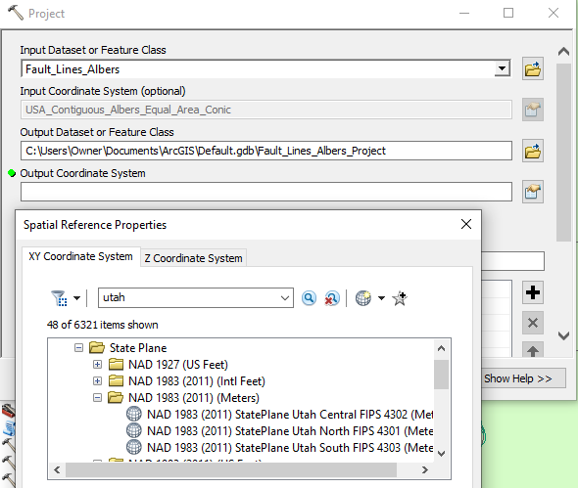
   2. 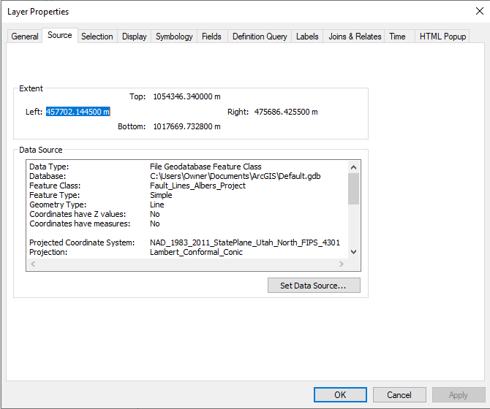
      1. These two images show the projection process and the verification that the new feature has the proper Coordinate system
3. Repeat step 2 for the other 2 shapefiles
4. The selection by attribute was used to get the high potential areas and then those selection were created into their own layer as shown below
   1. 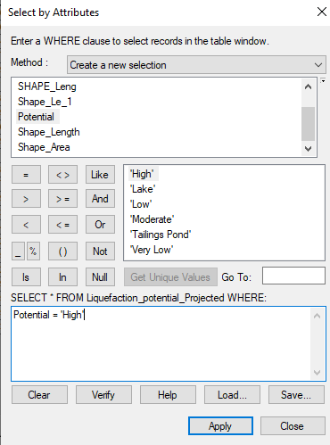
5. The selection by location was used to find the areas that overlap with high potential as shown below
   1. 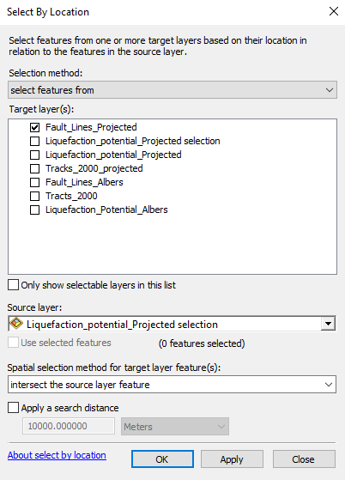
6. Once these selections were made I was able to display the result for part 1.
7. The buffer was created with 250 from the fault lines shown below
   1. 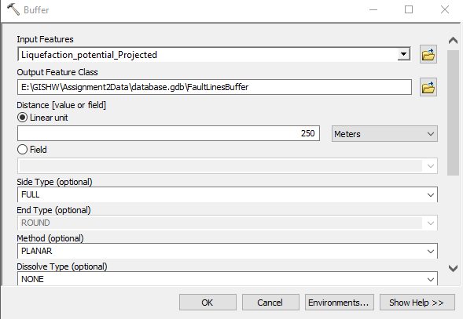
8. Step 5 was repeated to get the selection of tracks that were intersecting with fault lines of buffer 250

Conclusion:

There are few fault lines that are in areas of high liquefaction as shown in map 1. There tracts that will be affected most by earthquakes are on the west side of Utah and they are all 250m away from fault lines.