Giancarlo Barillas

Report Assignment 3

Introduction:

The purpose of this assignment is to create a central location to store features in arcmaps. This problem using buildings to store them into a geodatabase and to create feature datasets to store groups of data.

Data Sources:

The data provides is raster data of Douglas_dem, Table data of ChicagoGroveryStores, Shapefiles of buildings, Coverage of roads, and CAD of IIT Buildings. These are found from the United States Geological Survey (USGS) National Elevation Dataset (NED) and City of Chicago Data Portal

Analysis section:

1. Create a new geodatabase. This was done by right click the folder in the catalog and select create new geodatabase.
2. 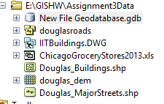
3. This was followed by importing the raster data into the folder. This was done by importing raster data by right clicking the new database.
4. 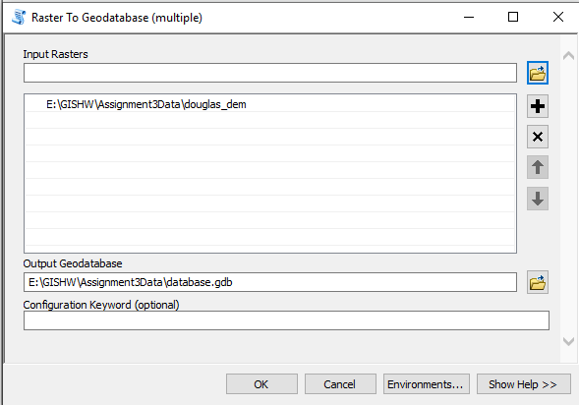
5. The following image shows the new imported raster data and the renaming of the database
6. 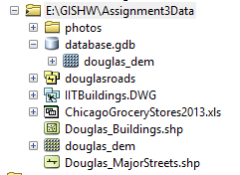
7. Table was imported using the import table from the geodatabase.
8. 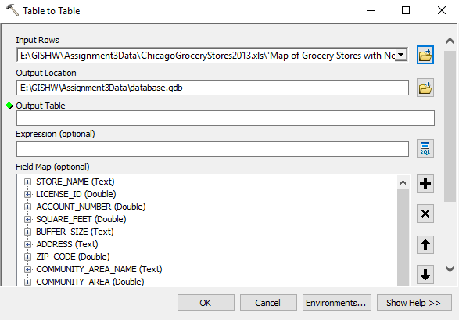
9. The following image shows the result of this
10. 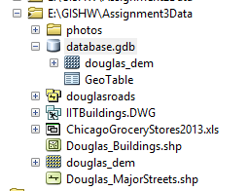
11. The creation of a new feature dataset allows multiple features to be stored. The new feature dataset was used by right clicking the folder and new, feature dataset.
12. 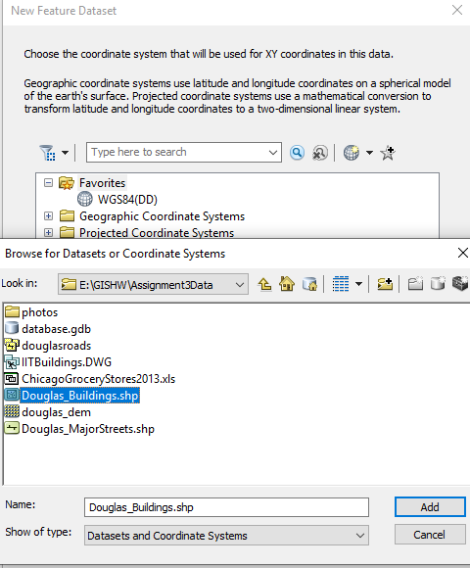
13. This is the output of the feature dataset
14. 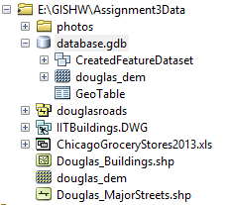
15. The following screenshot are importing multiple features as feature classes into the dataset
16. 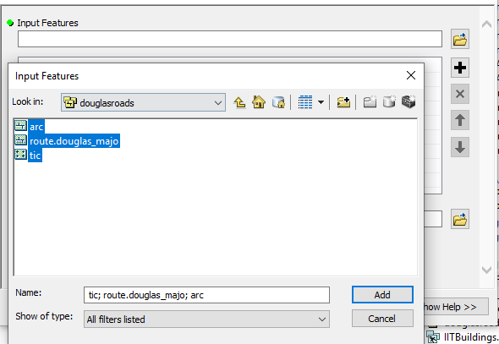
17. 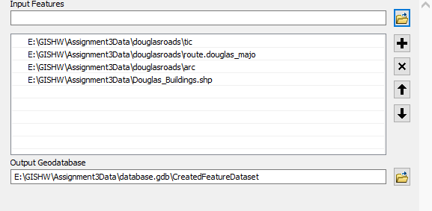
18. 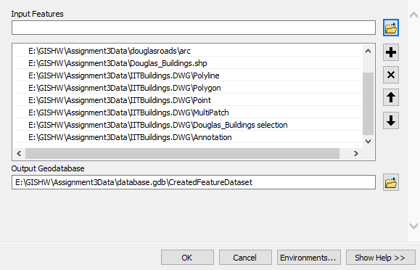
19. Once this was completed all the shapefiles were now able to be used to create the maps

Conclusion:

The reason why you would want to store all this information in a geodatabase is to have a central folder where you can access and manipulate the files. This allows the creation of new outputs from models to be store in this folder even if they are raster outputs.