Giancarlo Barillas

Report Assignment 5

Introduction:

The purpose of this assignment is to become familiar with data in arcmaps. This assignment is broken into three parts. The first part is understanding how to create new fields in a map and then populate those fields with information from another data set. This is important since this allows you to quickly look up information from another dataset. The second part of this lab is joining tables with shapefiles. This allows you have more information in your maps. The last step is projecting data onto a map and then extracting information from this data.

Data Sources:

The data sources used throughout the assignment are the following: CensusTract_Population table, CensusTracts2010, CityNeighborhoods, EnterpriseZones, Final_Ike table, USStates, and WorldCountries. These are from United States Census 2010, City of Chicago Data Portal and ESRI Inc.

Analysis section:

Task 1:

1. Import the information about enterprise and neighborhoods.
   1. 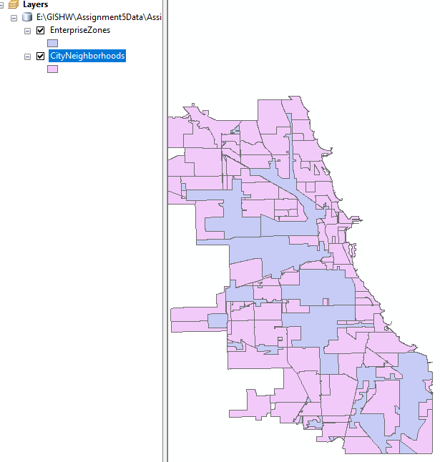
2. Create a new field in the attributes table of Neighborhoods. This new field will hold the Zone information
   1. 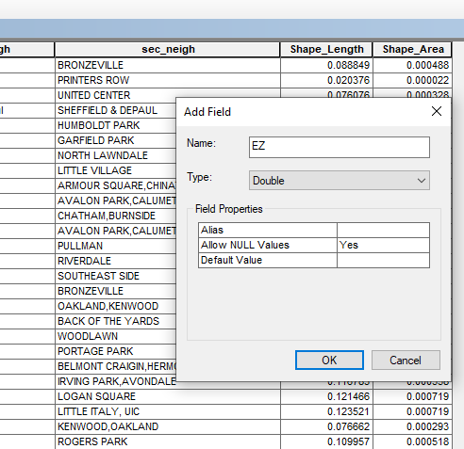
3. Create a select by location that would take the zone information and find the neighborhoods that have a centroid in that zone.
   1. 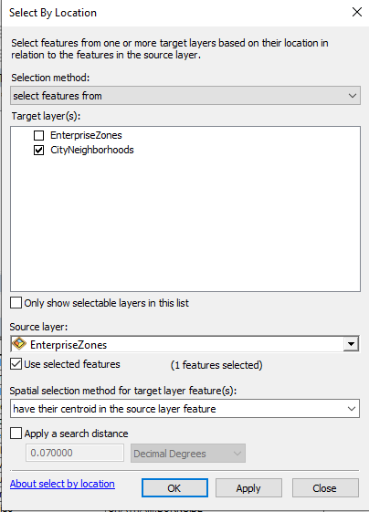
4. Once the selection was made then the field calculator was used to input the zone of the selected areas.
   1. 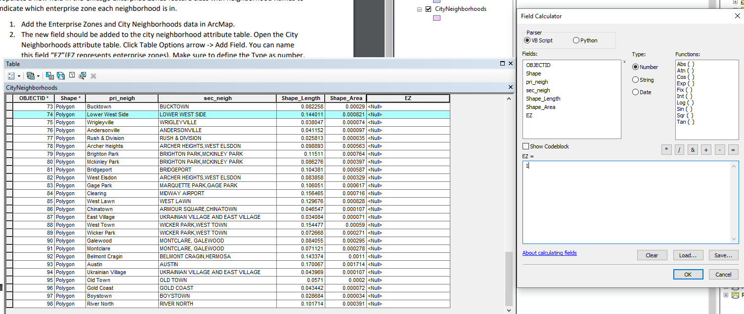
5. This step was repeated for each zone. The following images show the process for each step
   1. 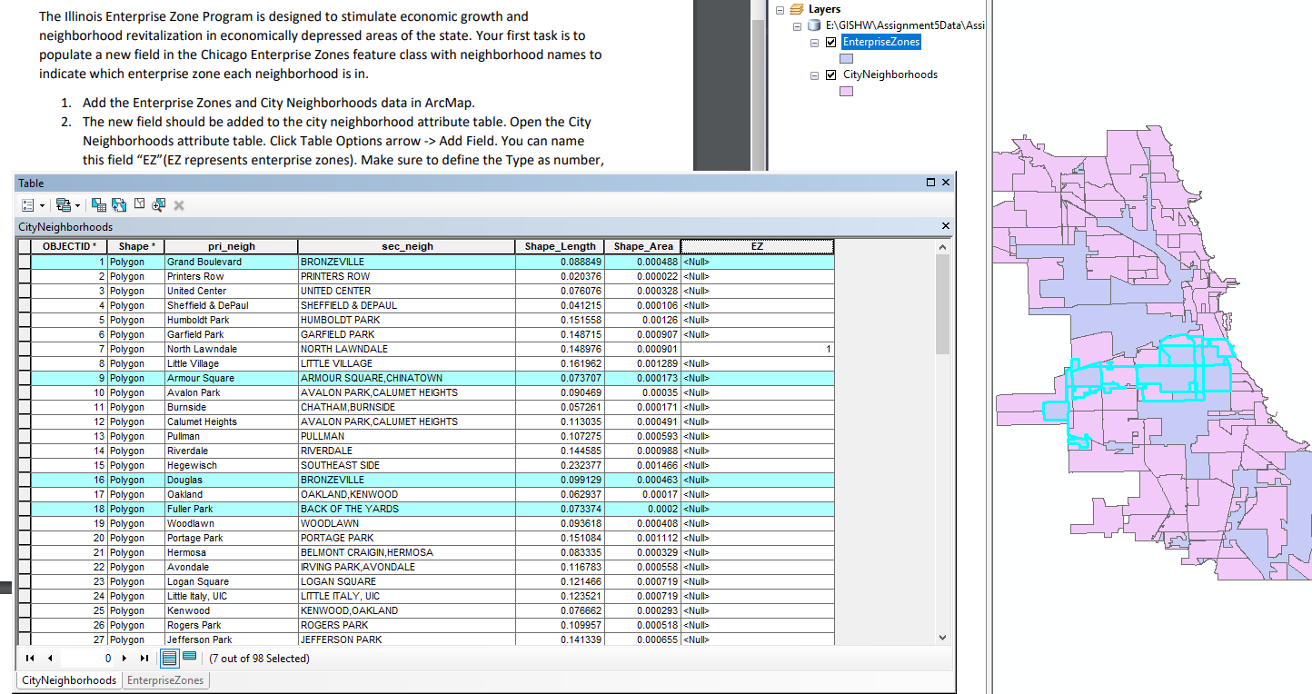
   2. 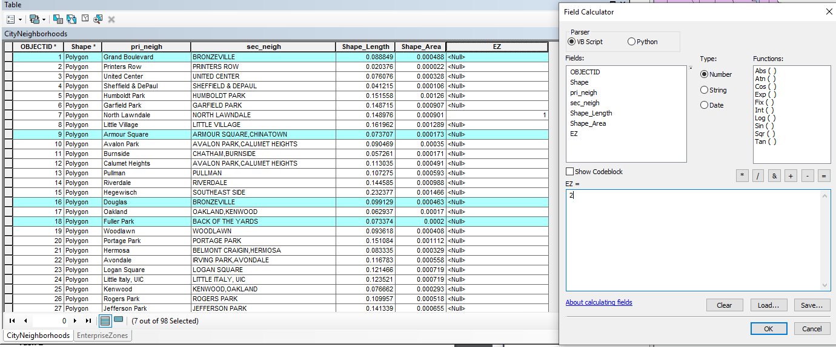
   3. 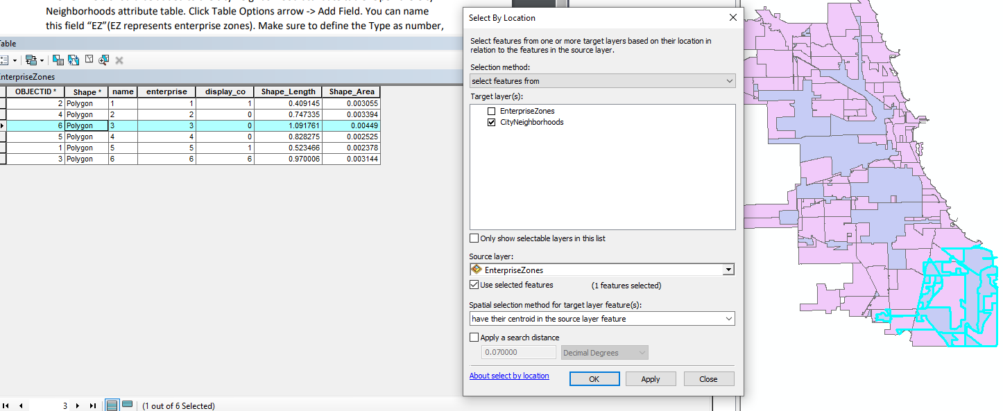
   4. 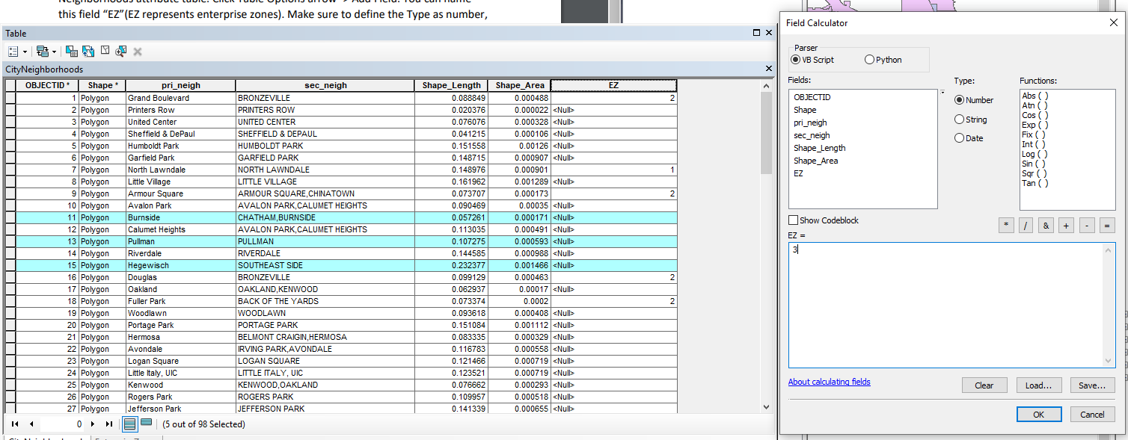
   5. 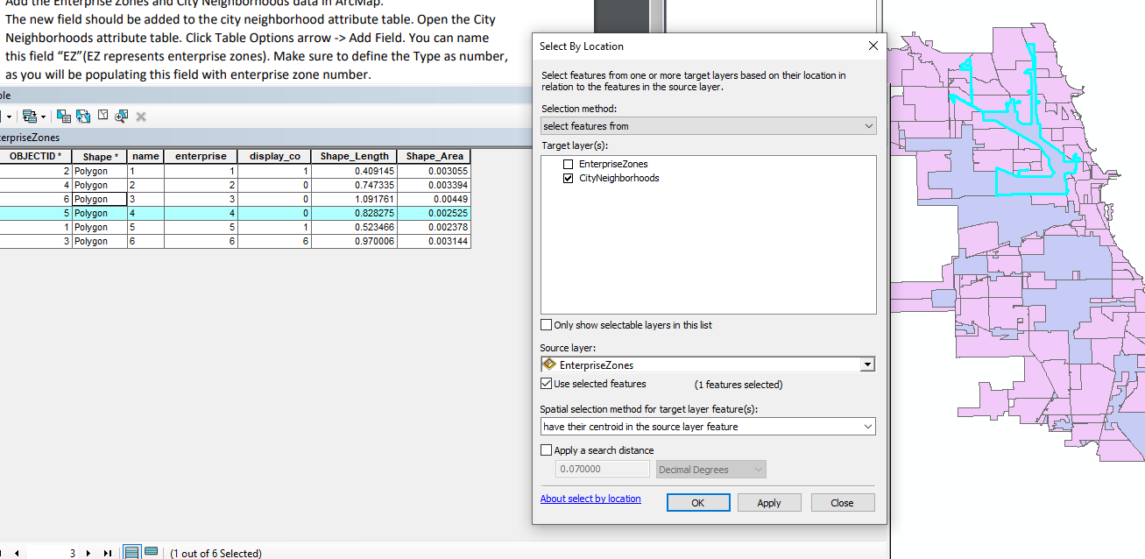
   6. 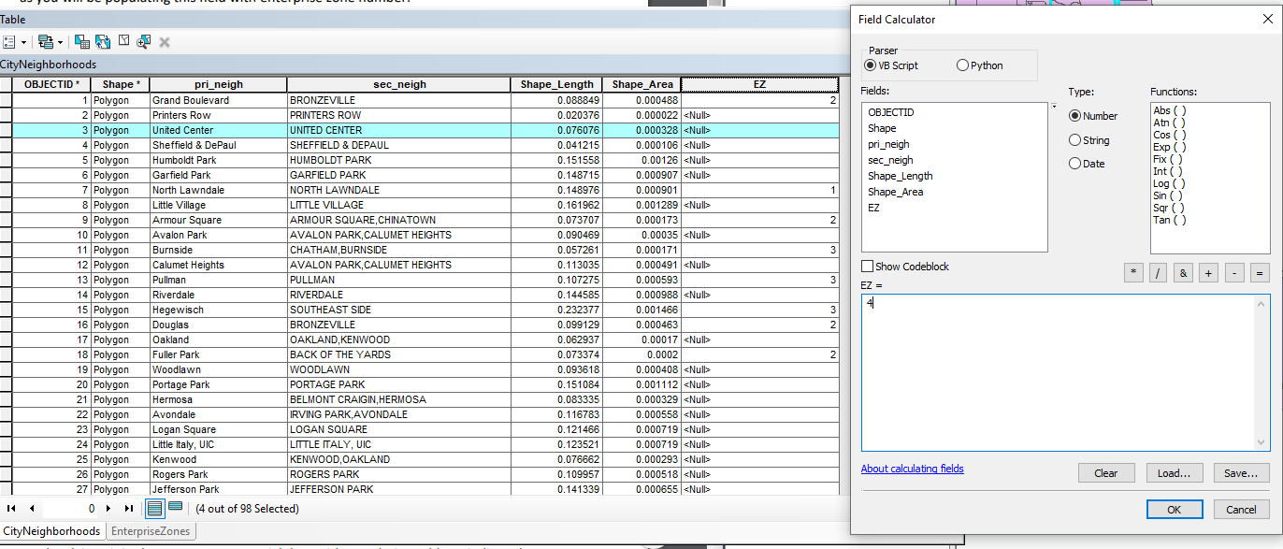
   7. 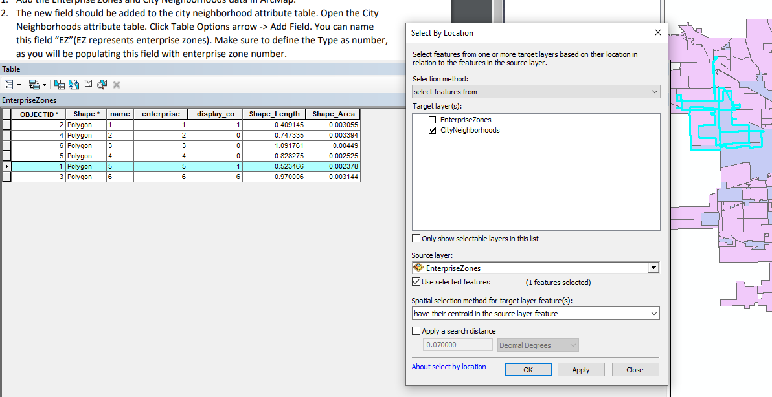
   8. 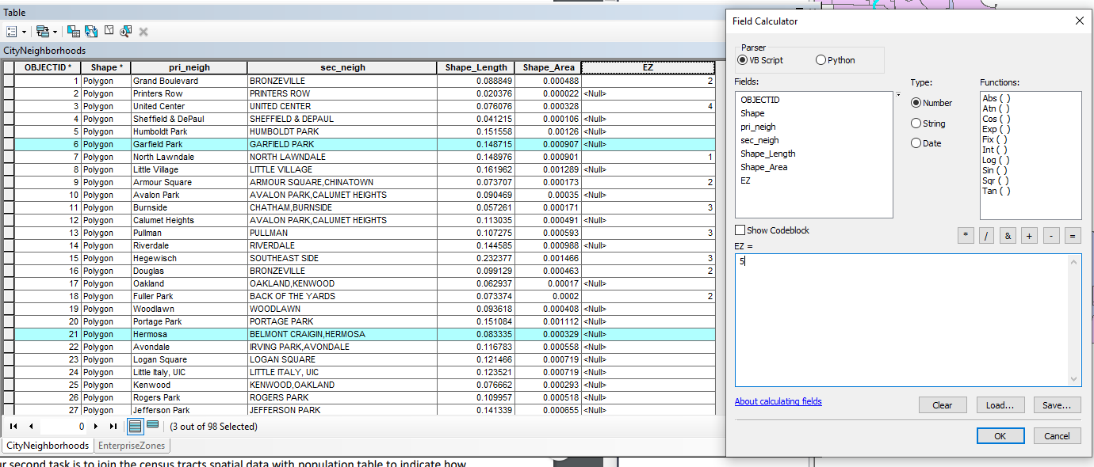
   9. 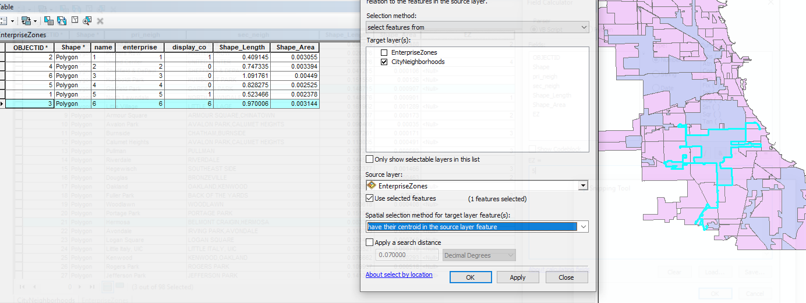
   10. 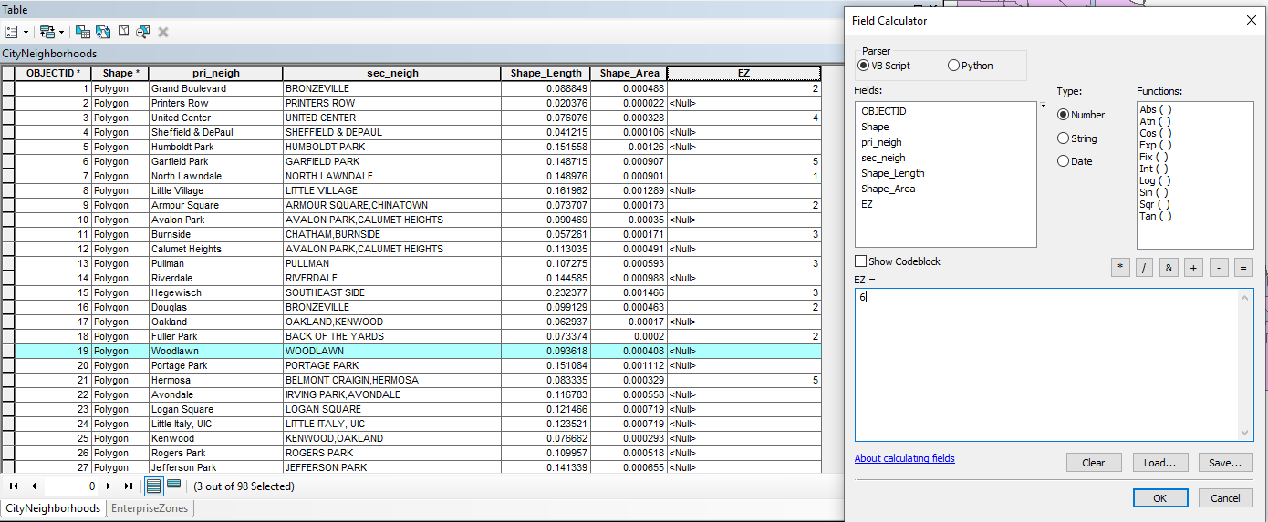
6. Once all the fields in those zones were completed the final output looked like the following by ascending order.
7. 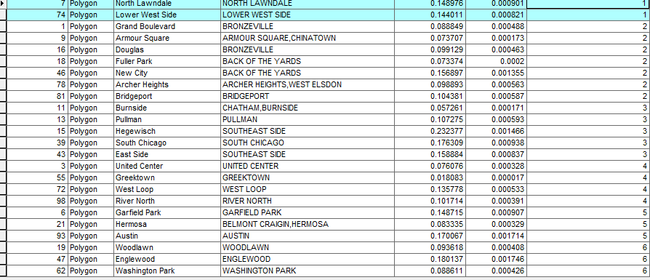

Task 2

1. The join of the two tables was done by using the same information for both tables. This was done by using the join feature by GEOID.
   1. 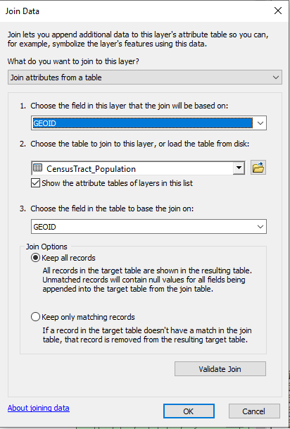
2. Once the two sets of data were merged into the shapefile. The population was able to be used to display a map of population. Null Values were selected and made as a layer to show them in the map and legend. The final output looked like the following image.
   1. 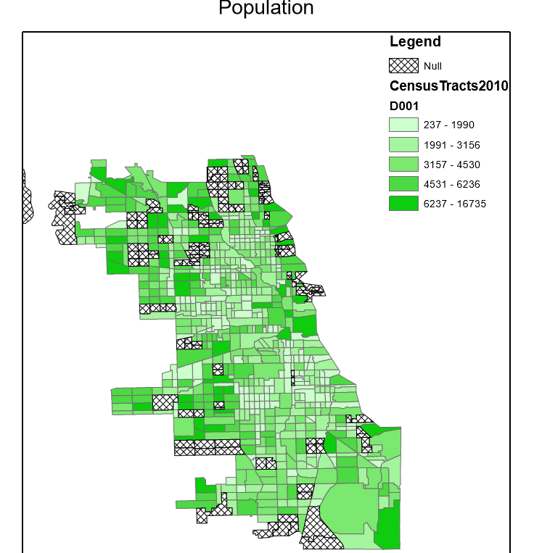

Task 3

1. All features were imported into arcmaps
   1. 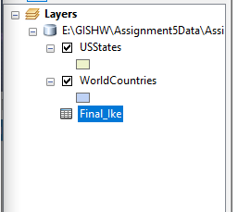
2. The new feature was created based on the XY coordinates as shown below
   1. 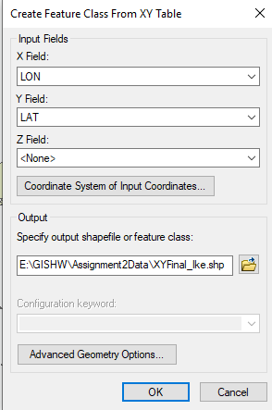
3. Once this was completed the output of the display was shown as this:
   1. 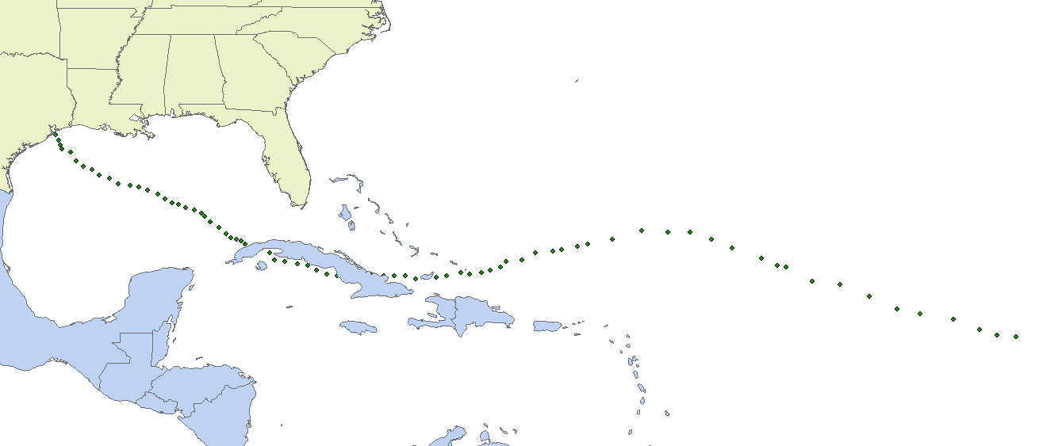
4. The graph was made by going into the attributes table and then the graph was made to show wind on the Y axis and Time in the X axis.
   1. 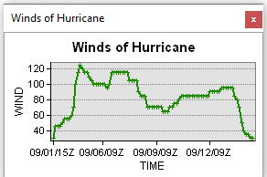
5. The final map looked like this:
   1. 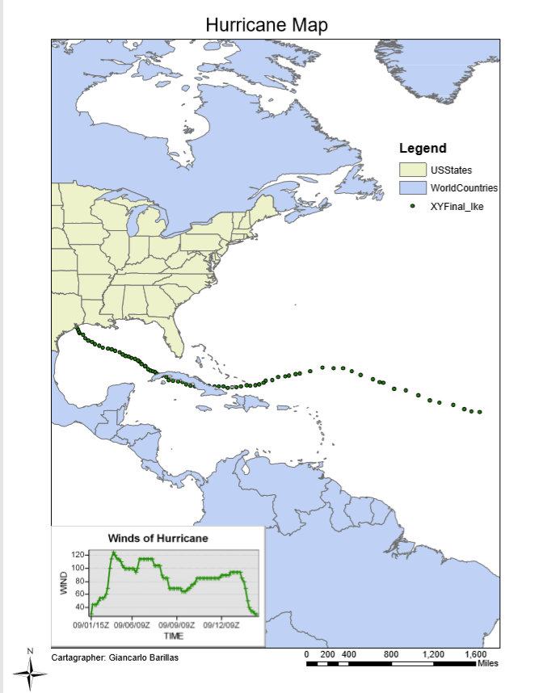

Conclusion:

The outputs of this assignment are three maps. The first map has new information to the relationship between Enterprise Zones and City Neighborhoods. The second map shows the join between population information and census tracts. The map also shows that not all data can be joined and that null values might appear. The last map is of a hurricanes path. This map also has a graph of the wind speeds in relation to time.