Giancarlo Barillas

Report Assignment 6

Introduction:

The purpose of this assignment is to create a suitability map for a new farmers market. This is done by creating raster data. The benefit of raster data is that it is possible to combine raster data to get more detailed maps. This can be accomplished by using reclassification which can standardize raster information so that they can be merged.

Data Sources:

The data sources used throughout the assignment are the following: Chicago City census block group boundaries, Chicago farmers market, and Chicago major streets.

Analysis section:

1. Import all shp files into arcmaps
   1. 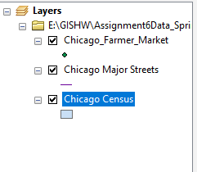
2. The new field for the Chicago census was created. This new field would hold the double information for population
   1. 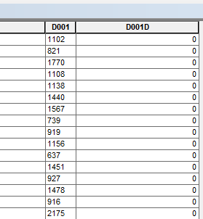
3. Field calculator was used to populate this information
   1. 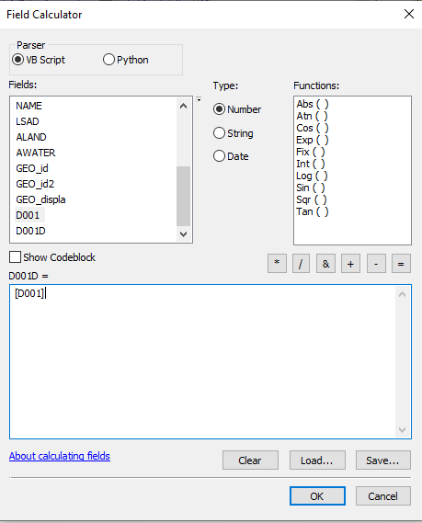
4. The sum of these values was given by using the statistics tool. This was used to calculate the percentage of population in that area.
   1. 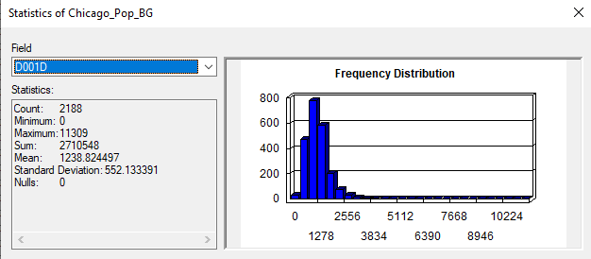
   2. 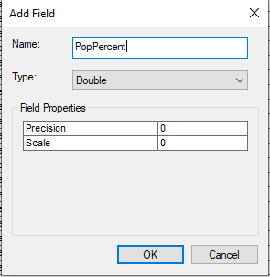
   3. 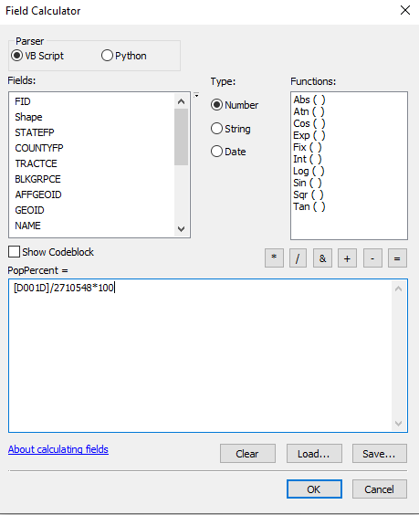
5. A mask was created to make the raster information outputs in the same map locations.
   1. 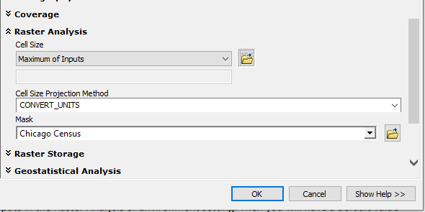
6. A toolbox and geodatabase was created to store models and outputs in a central folder
   1. 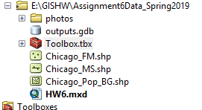
7. The rasters need to be created now. The first raster completed was for population percentage.
   1. 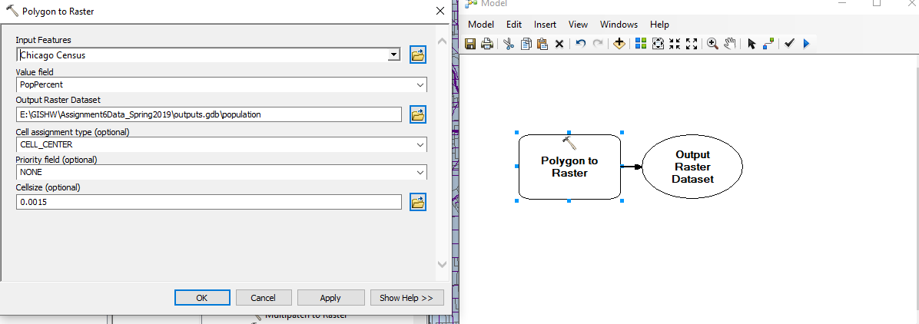
8. The second raster made was for density of famers market
   1. 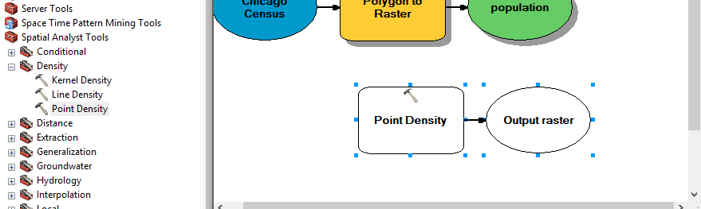
   2. 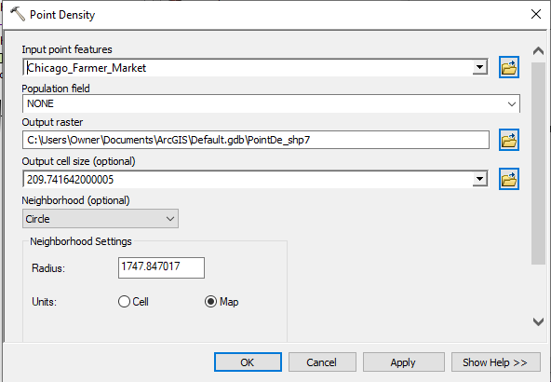
9. After that the street raster was made using Euclidian Distance
   1. 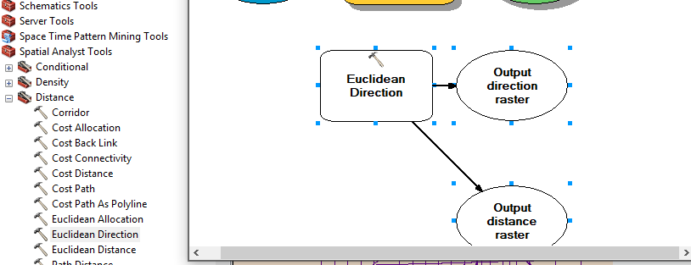
      1. In this image I accidently used direction but I changed that in the model to be distance
10. Once all the rasters were created I had to reclassify them so that I can add them
    1. 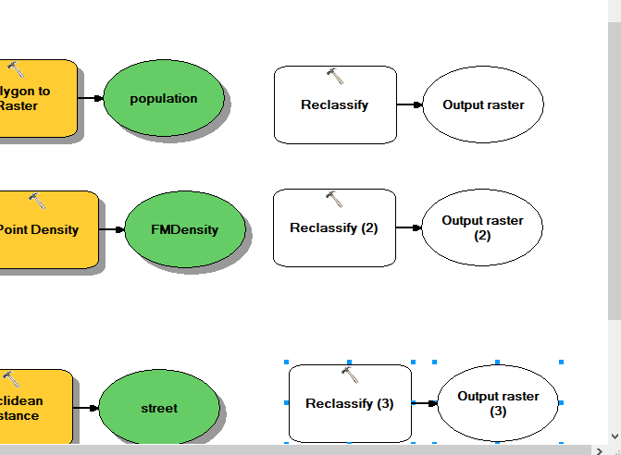
    2. 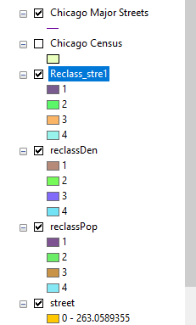
11. Once all the rasters were reclassified into comparable breaks I was able to calculate them together
    1. 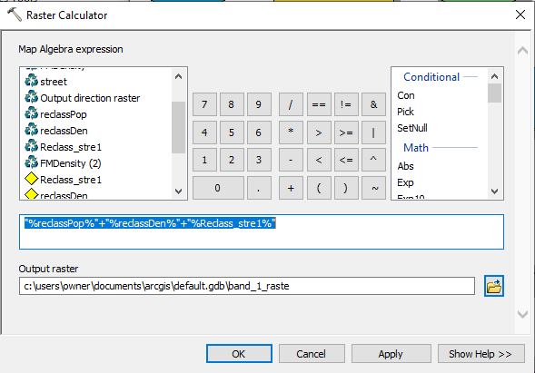
12. This would give me the final output needed

Conclusion:

The output of this assignment is 5 maps. Three of these maps are the raster outputs for the inputs for the raster calculation. The first map to discuss is the population percent. The new farmers market needs to be in a highly populated area. This was done by calculating the percentage and creating a raster based off population percent. Areas of high population percent are downtown, west of Chicago and down south. The second map is famers market density. This point density shows areas of high farmers markets. These areas are avoided for the newest farmers market. The third map is the major street. Euclidian Distance was used to create a raster map of areas near the major streets. These 3 rasters were combined to create a final output that shows potential locations for new farmers market. The biggest area to focus on is down south. These map shows that areas on the edge of downtown and down south are good potential location for new farmers markets.