Chicago Crime in Relation to Energy Consumption and Public Transportation

Giancarlo Barillas

SSCI 225 Introduction to GIS

# 

# Introduction

“Darkness cannot drive out darkness; only light can do that” Martin Luther King Jr. Most people believe that crime happens in the darkest of alleys within a city. Chicago is one of the brightest cities in Illinois, yet it is on the list of most dangerous cities to live in. People that live in Chicago rely on public transportation to get them to their destination within Chicago. Some of those CTA stops are hubs for criminal activity such as assault and theft. All these areas have energy usage. Some of these areas use more than others.

This paper will discuss if there is a relationship between energy consumption and criminal activity in Chicago. This research is focused around CTA stops and bike paths since people who work in Chicago rely on public transportation to get around the city. This paper will see if there is a relationship between crime and energy consumptions since new research done this year in New York show that having more lights that consume more energy can reduce criminal activity.

The hypothesis for this research is that there is a relationship between energy consumption and criminal activity. This relationship will show that CTA stops of high energy consumption will have lower instances of criminal activity since there is more electricity being used in the form of lights or buildings. This paper looks that the kilowatt per hour of a specific boundary in Chicago for a specific month. It will also look at that same month crime data from the city of Chicago data portal and see if there is a relationship between crime and energy consumption. The final maps will have public transportation to see hot spots of crime activity that have energy consumption.

The significance of this research is to find out if there is an update in the relationship between crime and energy consumption. If there is a correlation between energy consumption and criminal activity, then the city can understand how crime reacts to lights in a specific area. In this paper it will discuss the negative or positive relationship between energy consumption and crime

# Literature Review

There are a lot of articles and papers about crime in Chicago. Across those papers it is consistent that Chicago has areas that have more instances of crime than others. In one of the papers by northwestern it was said that “Skogan said 50 percent of all shootings in 2016 occurred in just a handful of neighborhoods, including Austin, Garfield Park, North and South Lawndale, Englewood, and West Pullman”(4,Northwestern). These areas are near the following CTA stops: Central(Green Line), Kenzie(Green Line), Pulaski(Green Line), 63rd Street(Red Line), and 95th Street(Red Line). An even more interesting part of that article is that a small block in Humboldt Park has been in the top 5 percent of shootings for the past 27 years. This articles stressed that social connection and interpersonal issues are the cause of crimes. Another article recently investigated the ACLU effect. “2016 agreement between Chicago police and American civil liberties to reform unconstitutional stop and frisk practices leading to a drop of 82 percent of street stops”(4,Wheeling). This drop has an inverse relationship to crime. Crimes have spiked in the most recent years while street stops have gone down. There are two research papers that have conflicting information about the relationship between energy consumption and crime. These two papers are by Chalfin and Morrow.

Morrow research is based in Chicago. This was an experiment conducted in 2000. The purpose of this paper is to see if crime reports would go down if areas had more lighting. These lights took up considerable energy consumption since these would be running all night. This experiment was broken into three parts. The first part was to upgrade or improve 175,000 streetlights around residential streets. The second part was to fix or repair lighting near CTA Stations. The final part was to boost lighting in alleys across the city. They wanted to have a controlled model and an experimental model. They decided to pick two areas in Chicago that have high crime rates. They chose West Garfield Park to be their experimental area. This area would have improved lighting in alleys. Their controlled area was Englewood.

Their expectation was the lighting would help reduce crime in Chicago while also reducing reports of crime. They found out that improved lighting could increase reports of crimes in a certain area. Crime reports in Garfield Park were higher post lighting than pre-lighting. They attributed this due to the visibility. People around that area can see criminal activity better, but this could also mean that criminals are able to find more victims at night due to better visibility. This was true for all crime except for non-index crime. Non-index crimes were crimes such as prostitution, narcotics, and gambling. There was a decrease in these types of crimes. So, it is conclusive that if an area has high levels of prostitution then a way to reduce that crime is by implementing more lighting which means that in that area it will have higher energy consumption.

The second paper that experimented with lighting in a city is by Chalfin. This experiment was conducted in New York. This report is more recent and was published in April 24,2019. This paper is about the effect of distributed lights across New York and to see if they decrease crime. This experiment was conducted by randomly distributing lights across New York. They then took the number of reports in that areas after the lights were installed and tested to see if there was a correlation between crimes and lighting during the day. These lights were the extreme version of normal street light and offered much higher brightness. They were able to conclude that there was a decrease of 36% in criminal activity around the areas where new lights were installed. They calculated this by comparing values before installation and prior. They also go through a cost base analysis of the light installations in these areas. They concluded it is better to install the lights in high crime areas and pay for the energy consumption in those areas than deal with the expensive of a crime and law informant.

Both papers addressed the energy costs of these light and how much they would cost. This means that both papers have found a relationship between energy consumption and criminal activity. Both concluded that areas of higher energy consumption are brighter and have more lights than areas of low energy consumption since installing more lights will increase energy consumption.

# Data

The data indicators that were used for this research are: CTA L Paths, CTA Bus Paths, CTA Stops, Bike Paths, and Chicago boundaries. Two types of Chicago boundaries were used in this research paper. The two boundaries that were used are Chicago boundaries by neighborhoods and Chicago boundaries by GeolocationID and census block. These indicators were used so that a map of Chicago could accurately reflect the location of these areas of interest. This paper also used crime data and energy consumption in Chicago from the City of Chicago Data Portal. The crime data from the City of Chicago Data Portal has records from 2001 to present. In this experiment, only the crimes from April of 2019 and April of 2010 were used. The energy data from the City of Chicago Data Portal has data from 2010. This data has the census block and the monthly KWH on that area in a month.

The shapefiles used for this research paper are the shapefiles for the following: CTA-Bus Stops-Shapefile, CTA-Bus Routes-Shapefile, CTA-‘L’(Rail) Lines- Shapefile, and Bike Routes. These can all be located at the City of Chicago Data Portal.

The data was collected by crime data from 2001 to present and only the data from April 2010 and April 2019. This was done by exporting the csv file from the City of Chicago Data Portal filtered between those months. This data already has latitude and longitude. The energy usage data does not have latitude and longitude, but it does have census block. To make this usable in ArcMaps it was necessary to find a boundary shapefile of Chicago that had census blocks. This shapefile was found in the City of Chicago Data Portal. This boundary shapefile had the census blocks for every boundary.

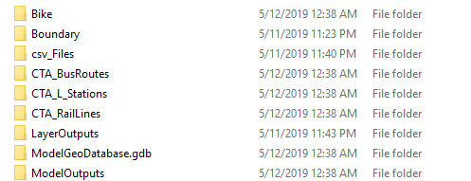

Figure 1: Storage of all data sources.

As you can see in the Figure above each shapefile has its own folder. The purpose of this was to store all versions of a specific shapefile or csv file. The name of each folder corresponds to the name of the specific shapefile that is inside that folder. The bottom 3 folder are reserved for analysis layers and model outputs.

# Methods

All the data from the City of Chicago Data Portal was imported into ArcMaps. Both boundaries maps were in the same Geographic Coordinate System of WGS84(DD). The bike shapefile was in WGS84(DD). All the CTA shapefiles were in a different Geographic Coordinate System. These maps were projected to the right Geographic Coordinate System by using the projection tool in ArcMaps. The new projected shapefiles were then imported into the maps.

The energy and crime data were imported into ArcMaps. The crime data was able to be displayed into the map by using the display XY option after right clicking the csv file. The longitude was used for X Field and the latitude was used for the Y Field. This layer was saved into the layer outputs folder and imported into ArcMaps. Spatial analysis was able to be conducted on the crime layer once the points were imported. The model began with using the point density tool. The input for the point density was the Crime layer. This raster data was saved in the geodatabase. The new layer was created once the model ran and the output was displayed to the map. This created a heatmap of crime in Chicago during the month of April as shown in the figure below:

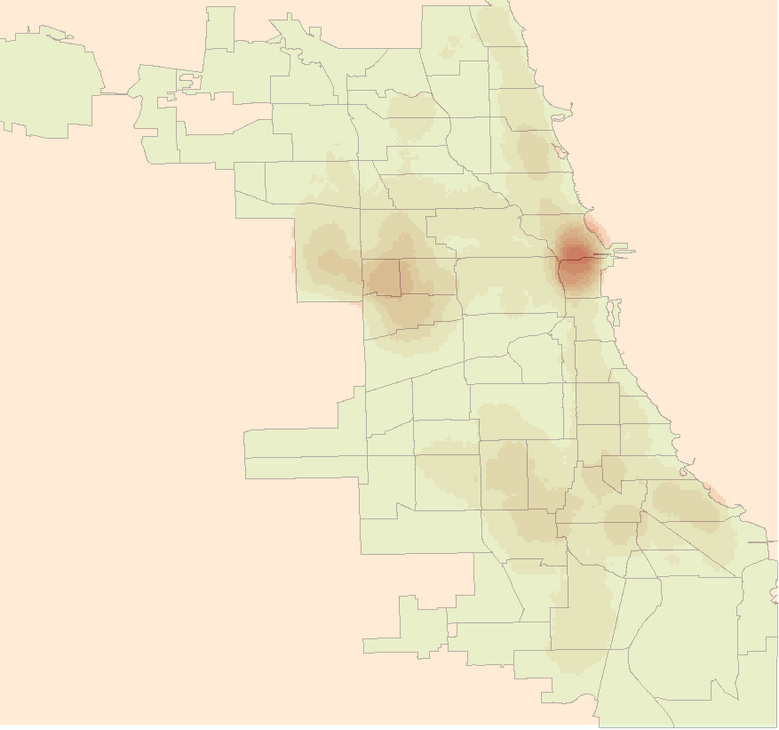

Figure 2: Point Density Output where redder areas have more crime

The energy usage data does not have latitude and longitude, instead it has census block id. This field in the table is a double which means that this can be used for a join without any manipulation. The community boundaries shapefile has a field called GeoID10 which correspond to the census block ID. This field is a string. A new field needs to be created to convert the string value into a double. This new field is shown in the image below:

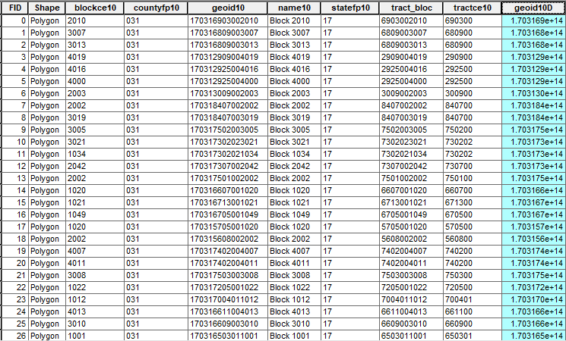

Figure 3: GeoId10D field created of type double

A join was able to be done once both fields were of type double. The energy usage data was joined with the boundaries by census block ID. Now all the data related to a boundary had the information of energy usage of 2010. This new layer was then saved into the model outputs and then imported into ArcMaps. Since a point density spatial analysis can only be done on a point, the boundaries needed to be converted into a point. The model builder was used to create a feature to point conversion. The input for this conversion was the layer of boundaries with the energy usage information. The point output looked like the figure below:

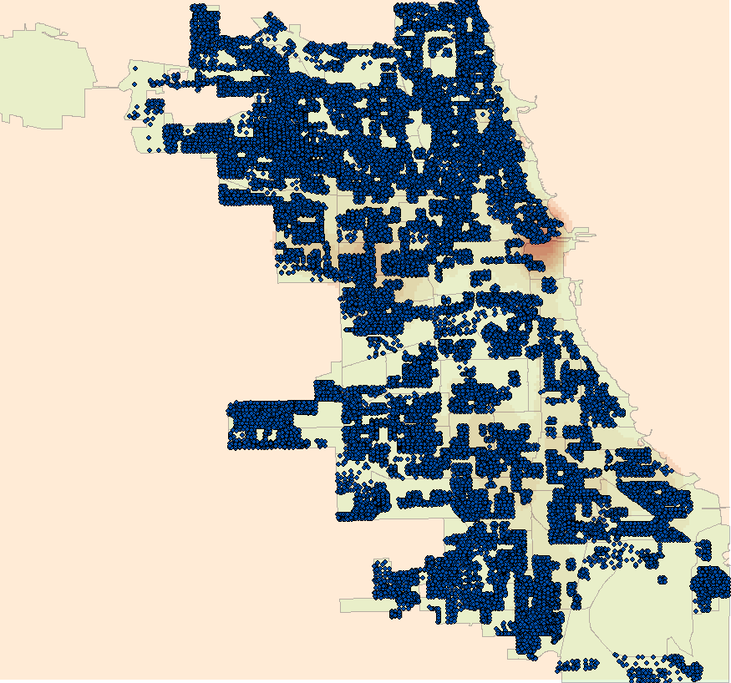

Figure 4: Points of Energy in Chicago

If a regular point density was conducted on this layer, then there would be a cluster of hotspots northwest of Chicago. This would not reflect the energy usage in Chicago since each point contains all the information of energy throughout a year. There is a field in the attributes table which is for Kilowatts per hour (KWH) for a specific month. These fields are all Strings and must be converted into a double before a point density spatial analysis can be done.

A new field was created for each of the months for the analysis. These new fields would be of type double and would contain the information of the KWH for a month in 2010. Then within the model builder, the point density tool was used to get the energy usage for a specific month. This step was repeated for any month that was relevant to test. The output for the model was then displayed into the map. This new layer was saved into the model output folder and imported into the ArcMap to be viewed with the crime data. The output for the energy consumption point density maps are shown below in the following two figures.

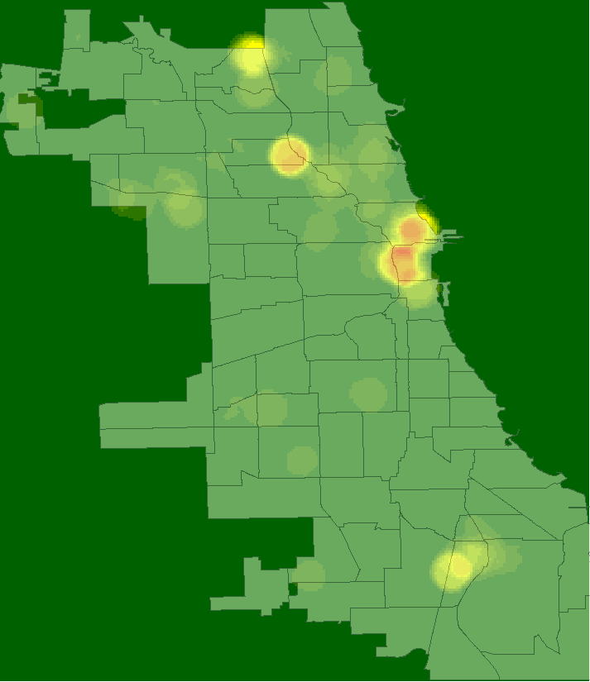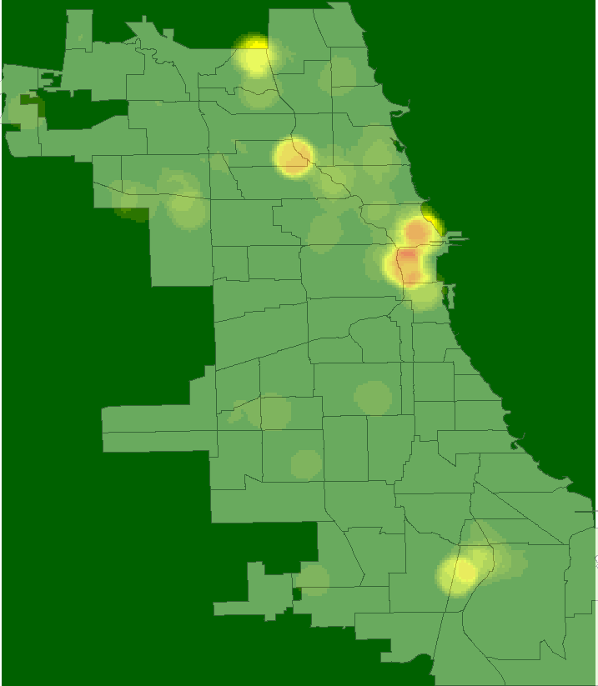

Figure 5: Energy April 2010 Figure 6: Energy May 2010

# Results

There are three main map outputs from this research project. Those outputs are shown below:

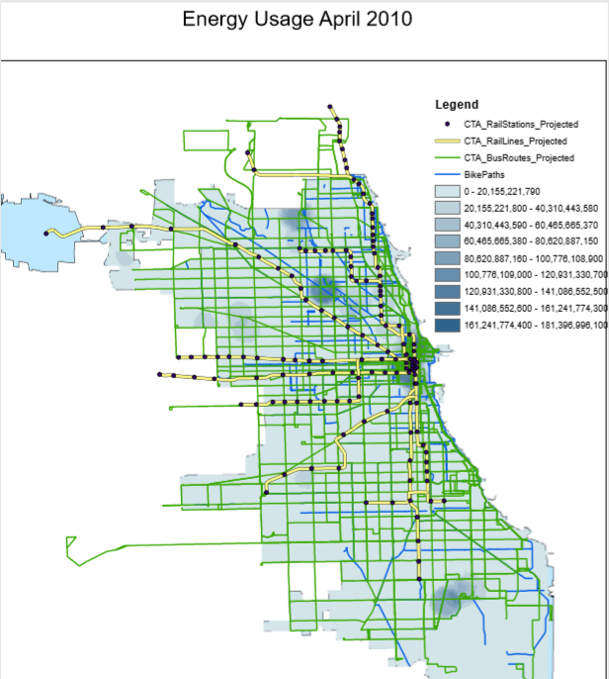

Figure 7: Energy Usage of April 2010

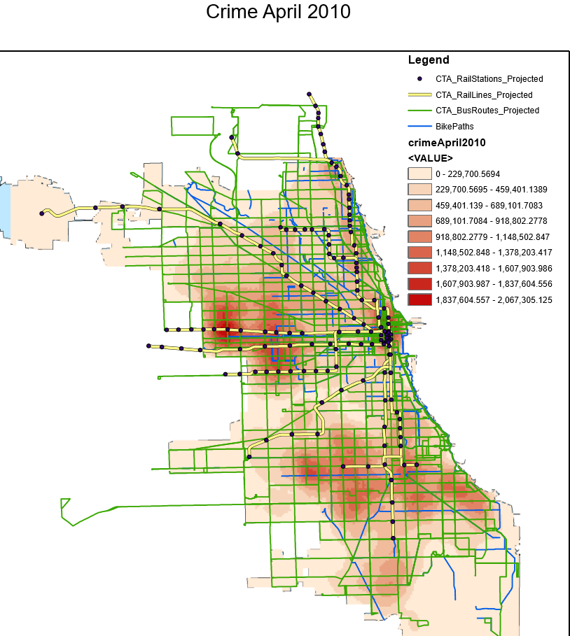

Figure 8: Crime in April of 2010

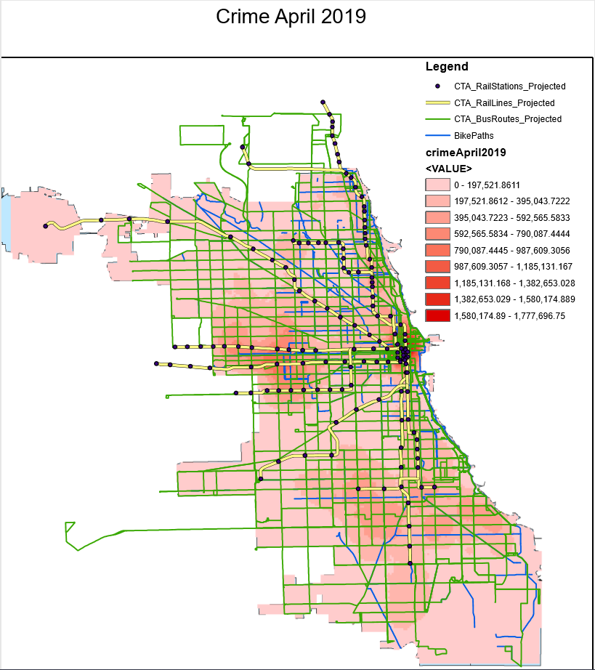

Figure 9: Crime in April of 2019

The three maps are used to get an understanding of energy consumption and crime. As shown in Figure 7 and Figure 8 you can see that areas of lower energy consumption have higher instances of crimes. Some of the areas that support this are shown in the following table. Each of these areas have lower energy consumption and high criminal activity.

|  |  |
| --- | --- |
| Crime | Energy Usage |
| Figure 10: Crime in April 2010 South | Figure 11: Energy in April 2010 South |
| Figure 12: Crime in April 2010 West | Figure 12: Crime in April 2010 West |

As you can see from the following comparisons in the same year these areas had low energy usage and high instance of crime. The CTA stops that are most affected by this are the Green line heading towards Ashland 63 and the Green line heading towards Harlem-Lake.

Since this data is taken from 2010 the same can be said about these areas currently, by comparing the maps of 2010 and 2019 of crime in April you can see that these areas stay consistent. This is shown below in the following table.

|  |  |
| --- | --- |
| April 2010 | April 2019 |
|  |  |

The maps of both areas show that crime has stayed in these areas for the past years. Another area that supports the hypothesis is up south by Logan Square. This area shows that higher energy consumption in that area has low instances of crime. This can be shown below,

|  |  |
| --- | --- |
| Crime | Energy |
|  |  |

# Conclusion

The research shows that there is a relationship between crime and energy usage. The only area that does not relate these two is downtown since downtown is a hub for criminal activity and light pollution. The CTA stops that need to have better energy usage are those at the end of the green line heading southbound and westbound. The end of those lines have low energy consumption and high criminal activity. Areas that have good energy usage such as the stops on Logan square have lower criminal activity. Energy related projects can help combat the number of crimes in those areas. Some of those projects can be Solar powered energy lights or LED lights to increase the energy usage in those areas. This could help reduce criminal activity like the results found in New York. Some future work that can be conducted on this research is seeing what energy usage in these areas might be more beneficial than other and how solar energy impact the usage of energy. This project shows that there is a relationship between energy usage and crime. New research needs to be conducted since prior research may be outdated.

### References

Allaham, M., & Marx, R. (2017, August 23). Does a hot summer mean more crime? Here's what the data show. Retrieved from https://www.chicagotribune.com/news/data/ct-crime-heat-analysis-htmlstory.html

Brinson, J. R. (2017, June 27). Chicago violence: Why the dramatic increases in shootings, homicides? Retrieved from https://www.chicagotribune.com/news/91748847-132.html

Chalfin, A. (april 24, 2019). Reducing Crime Through Environmental Design. *Evidence from a Randomized Experiment of Street Lighting in New York City,*1-45. Retrieved from https://urbanlabs.uchicago.edu/attachments/e95d751f7d91d0bcfeb209ddf6adcb4296868c12/store/cca92342e666b1ffb1c15be63b484e9b9687b57249dce44ad55ea92b1ec0/lights_04242016.pdf.

N. (n.d.). Crime in Chicago: What Does the Research Tell Us? Retrieved from https://www.ipr.northwestern.edu/about/news/2018/crime-in-chicago-research.html

Dark Sky Association, I. (2015, October 05). Lighting, Crime and Safety. Retrieved from https://www.darksky.org/light-pollution/lighting-crime-and-safety/

Morrow, E. N., & Hutton, S. A. (april 2000). The Chicago Alley Lighting Project:. *Final Evaluation Report,*1-60. Retrieved from https://www.darksky.org/wp-content/uploads/2014/09/Chicago-Alley-Lighting-Project.pdf.

Wheeling, K. (2018, March 30). What Caused Chicago's Spike in Violent Crime? Retrieved from https://psmag.com/social-justice/chicago-spike-in-violent-crime