FLASK API BUILD STEPS
-----------------------------------------

0. To delete everything deployed on Docker/Kubernetes:
→ docker system prune -a –volumes

1. Start creating docker image using the command:
→ cd “/home/group-18/images/citizen_registration_flask”
→ docker build -t flaskapi .

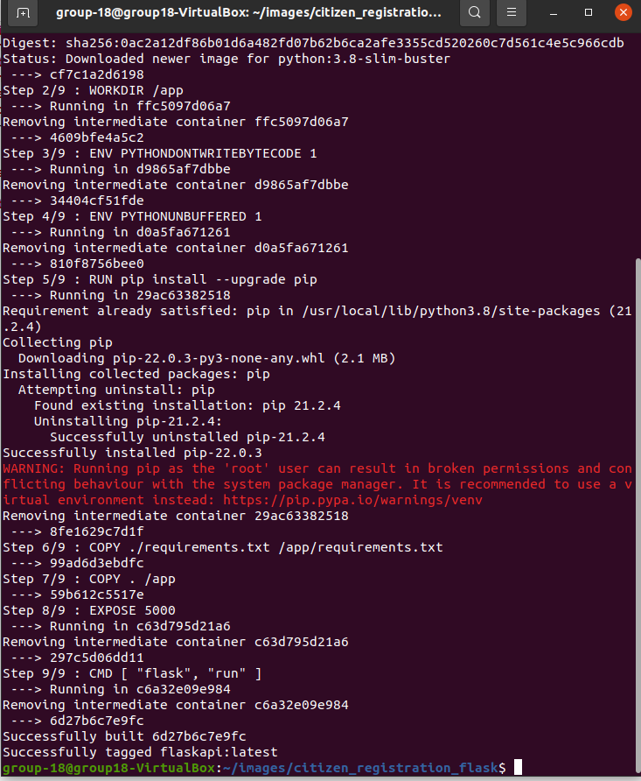
2. List docker image to verify that the image is correctly available:
→ docker images

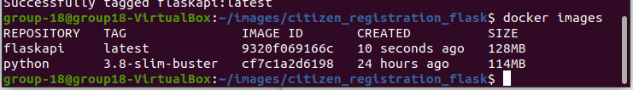
3. Please note that the image is tagged as ‘latest’
4. Since microk8s doesn’t use the dockerd daemon, we need to manually push it to the microk8s registry add-on.
→ docker push localhost:32000/flaskapi

