REACT Client-side Web Application BUILD STEPS
-----------------------------------------------------------------------

0. To delete everything deployed on Docker/Kubernetes:
→ docker system prune -a –volumes

1. Start creating docker image using the command:
→ cd “/home/group-18/images/citizen_registration_react”
→ docker build -t react .
→ docker build . -t 10.0.2.15:32000/react:registry (check point 4 note for the explanation)

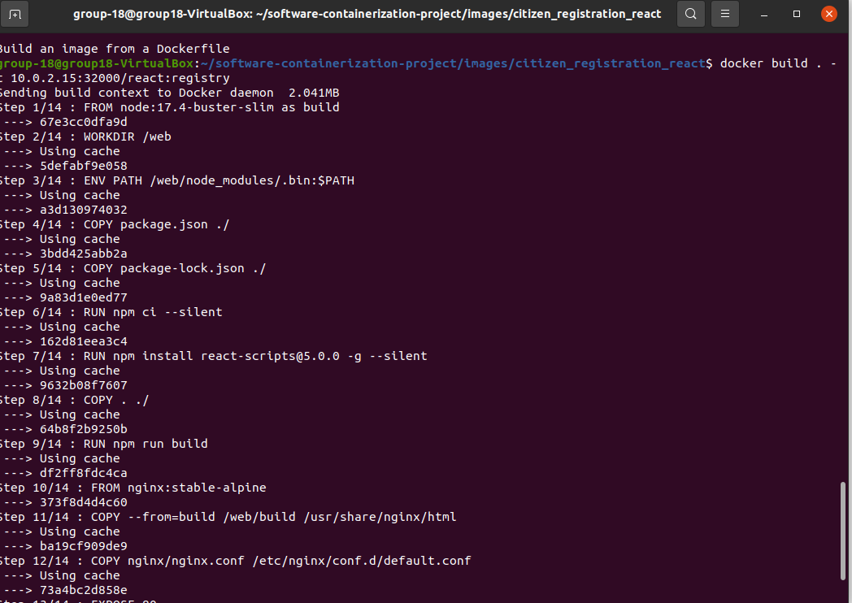

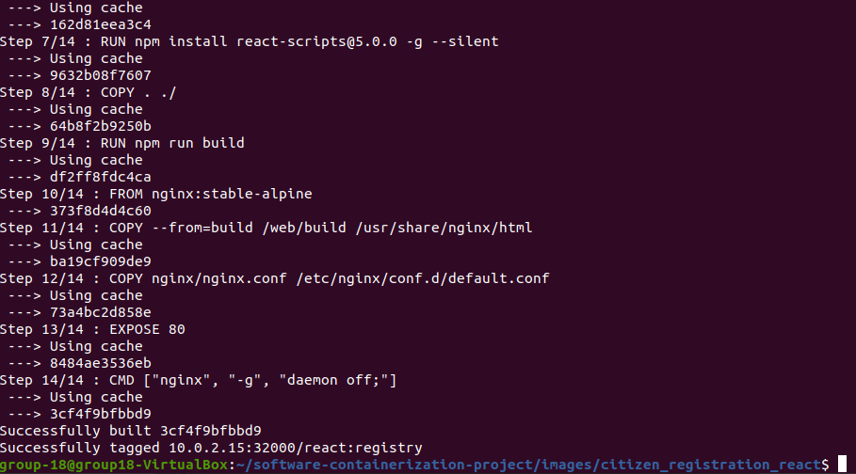

2. List docker image to verify that the image is correctly available:
→ docker images

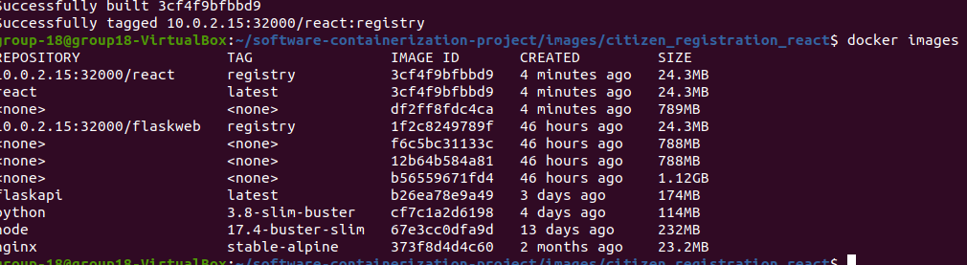
3. Please note that the image ‘react’ is tagged as ‘latest’.
4. Since microk8s doesn’t use the dockerd daemon, we need to manually push it to the microk8s registry add-on.

*NOTE: We need to identify the IP-address of the Kubernetes node running in the VM using below command:
→ microk8s.kubectl describe node $(microk8s.kubectl get nodes --no-headers | cut -f 1 -d " ")
→ It gives the IP-address as “10.0.2.15”, so we need to use the same while accessing kubernetes registry.

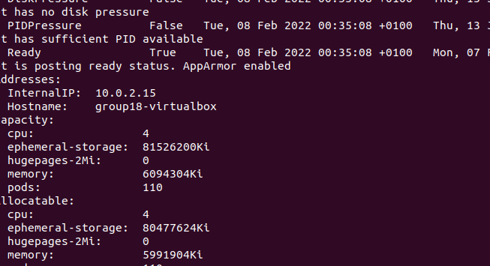
The containerd daemon used by MicroK8s is configured to trust this insecure registry. To upload images we have to tag them with 10.0.2.15:32000/our-image before pushing them. We can tag an already existing image using the image ID. Obtain the ID by running:
-> docker images
→ docker build . -t 10.0.2.15:32000/react:registry
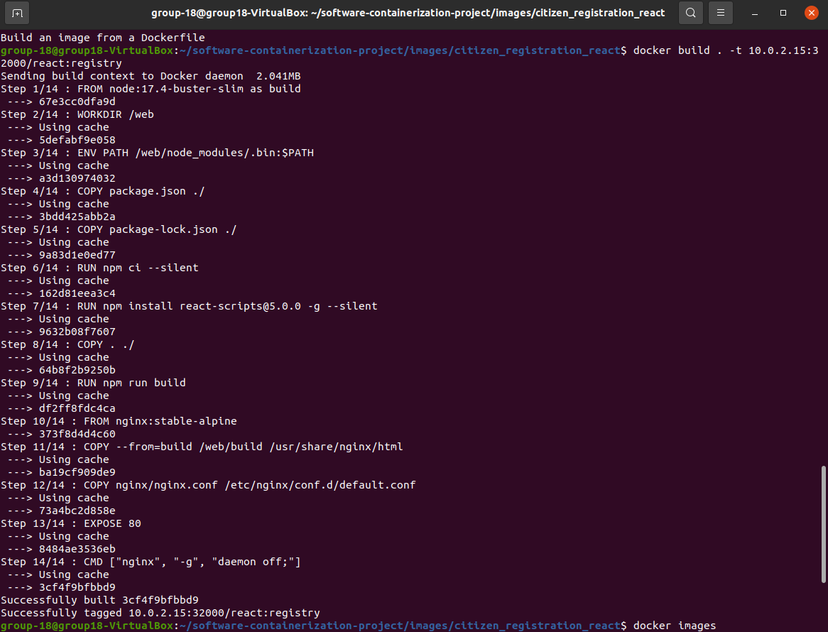
→ docker push 10.0.2.15:32000/react

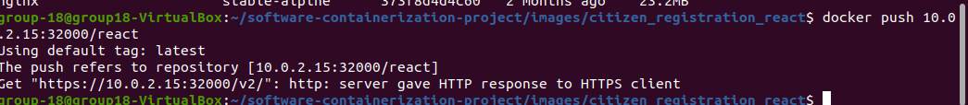
5. Deploy React app using the yaml file as shown below:
→ kubectl create -f react-deployment.yaml
→ kubectl create -f react-service.yaml

