PostgreSQL image download and configuration STEPS
-----------------------------------------------------------------------

0. To delete everything deployed on Docker/Kubernetes:
→ docker system prune -a –volumes

1. Before proceeding with the database configuration, it is important to highlight that since containers are ephemeral, we need to configure a volume, via a PersistentVolume and a PersistentVolumeClaim, to store the Postgres data outside of the Pod.
→ cd “/home/group-18/images/database”
→ kubectl get pvc –all-namespaces (get PVC from all namespaces)
→ kubectl delete pvc -n default postgres-pv-claim –force // (to delete existing PVC)

Then, once the cleanup has been performed, please start the volume mount steps detailed below.
→ kubectl apply -f ./postgres-persistent-volume.yml
→ kubectl apply -f ./postgres-persistent-volume-claim.yml
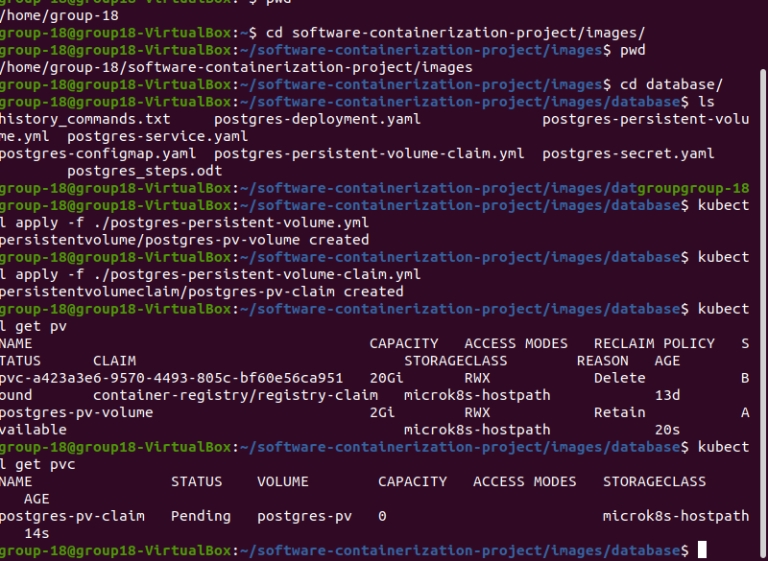

2. Similarly, keep following the next steps as detailed:
→ kubectl apply -f ./postgres-configmap.yaml
→ kubectl apply -f ./postgres-secret.yaml
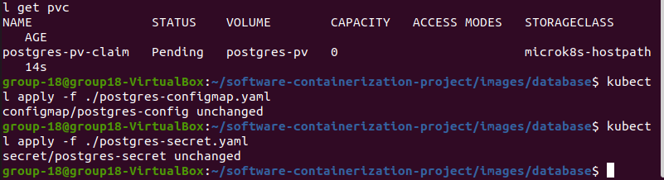

3. Now, proceed for the postgres database image deployment.
→ kubectl apply -f ./postgres-deployment.yaml
→ kubectl get deployments

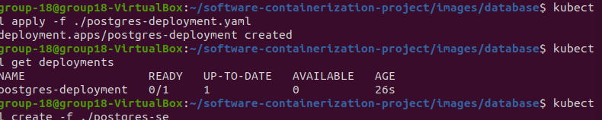
4. Lastly, create the network connection using services:
→ kubectl create -f ./postgres-service.yaml
→ kubectl get pods

