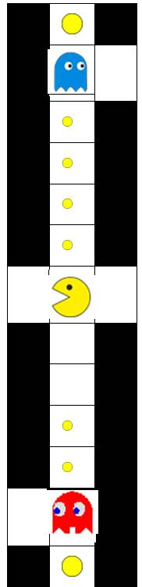
Input
 | : Active ghost
 | : Eldible ghost
 | : pills
 | : power pills

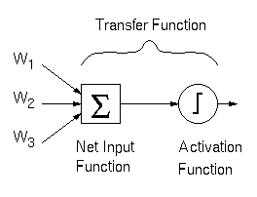
Take the pacman as a center, take 13 positions in horizotal and vertical ( 6 front and 6 back )
Shift left or right incase the position is out of board
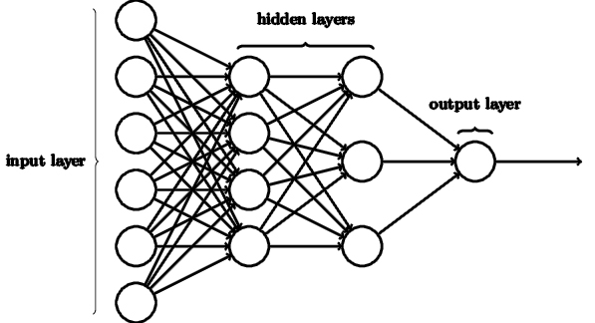

Name | Example Encode
Pills | (0011000111100)₂
Power pill | (1000000000001)₂
Pacman position | (0000010000000)₂
Active ghosts position | (0100000000000)₂
Edible ghosts position | (0100000000010)₂
Junction (intersection) | (0100003000020)₄
Last position of ghosts
Actual position of position
Current maze

Value of current state

Training
Use neural network to estimate value of a state
Use reinforcement learning to train the weights of network (the same as 2048) base on reward value after each move
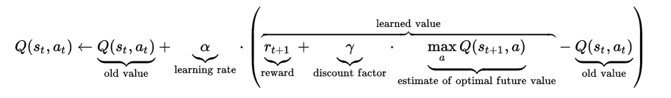 ϒ = 0

Neural network with MCTS

Use value that be canculated by neural network as the return value of play-out phase from MCTS. Using for backpropagation, and UCT in selection
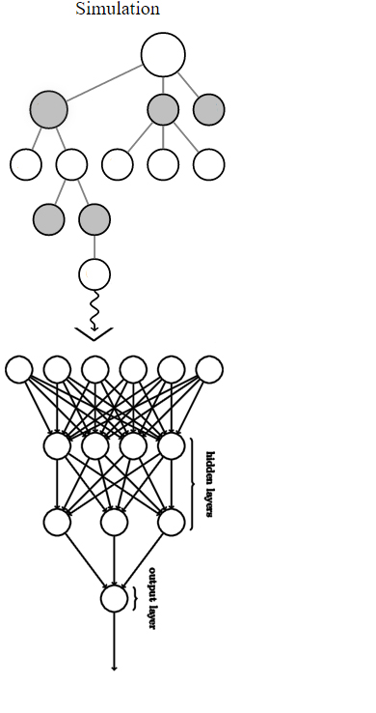

Laking of information => no much information about the pill => moving around when there is no much pills left
Run a map too long, can not finnish
Survival threshold = 0.6
Time of running MCTS Tree is fixed : 100 times
Playout : random or using strategy?

