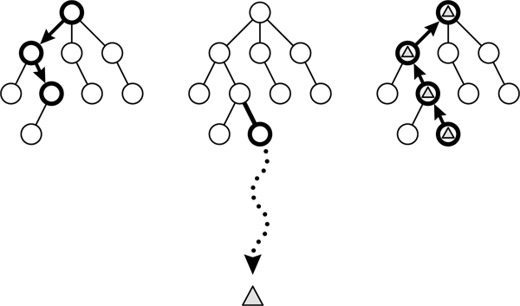
Update maxViValue[tactic]
Update sumReward
Increase visitedCount

Playout return 3 reward : survival rate, pill, ghosts ( value is nomolized [0,1] )

Each node keeps
- Sum reward from over child
- maximun reward over child

Sum of reward
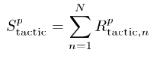
Avarage reward (canculate at leaf)
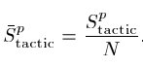
Maximun value of earch node
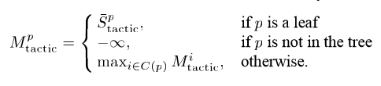
Vi for UCT value
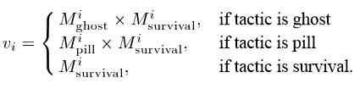
UCT Value
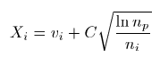
public static void runMCTS (MCTSNode currentNode){
if currentNode.isLeaf() {
reward = playOutPhase();
Play Out

currentNode.updatStats(reward);
for earch reward i
currentNode.maxViValue[i] = currentNode.sumReward[i] / currentNode.visitedCount;

return;
}
else {
for child : currentNode.listChild {
if (child.visitedCount < MIN_VISITED)
chose random one of child
else
Selection

chose the child that maximize UCT equation
}

boolean isReachChild =treePhase(currentBestChild); // try to reach the child

if (!isReachChild) { // if can not reach the child, we assume that currentNode is a leaf

reward =playOutPhase();
Play Out
currentNode.updatStats(reward);
for earch reward i
currentNode.maxViValue[i] = currentNode.sumReward[i] / currentNode.visitedCount;
return;

}
else {
runMCTS(currentBestChild);

for each child
Backpropagation
for each reward i
update maxViValue for currentNode

currentNode.updatStats(currentBestChild .rewardPlayout);
return;
}
}
}

void updatStats (double reward[]) {
for each reaward i
sumReward[i] += reward[i];
visitedCount++;
rewardPlayout = reward;
}

Select move :
THRESHOLD = 0.6
Default : tactic = pill
If (maxViValue[survival] < THRESHOLD_SURVIVAL) tactic = survival ;
If ( has just eatten Power Pill ) tactic = ghosts

Chose the move that leads to the child which maximize the maxViValue[tactic]

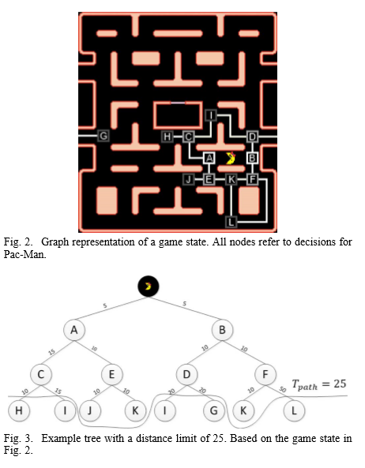
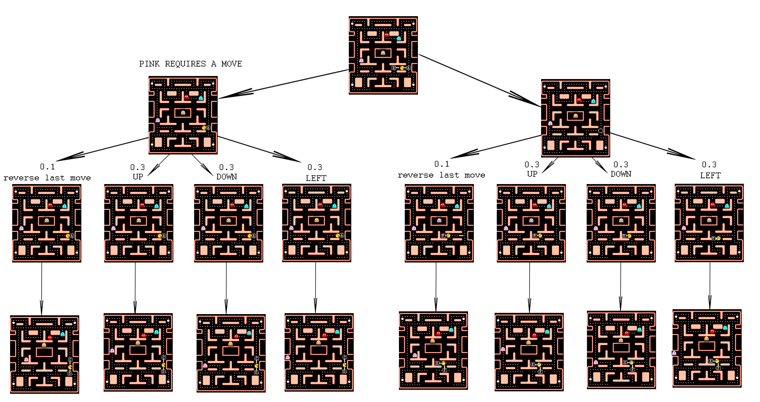

-Ghosts require a move at every junction. 10% chance of reversing it’s last move for non-edible ghost. Edible ghost : the chance is the same for each choice
- More than one ghost can require move before Pacman reach the child. Multi Min-layer node
- No simulation at leaf ?
- Depth of tree ? Using MCTS, can run ~ 100 times ( travel 100 paths) . How many leaf we could create on tree without runing simulation ?

