Lab report :3

Exercise 1:

1. Go to the root directory and see the current permission of /home

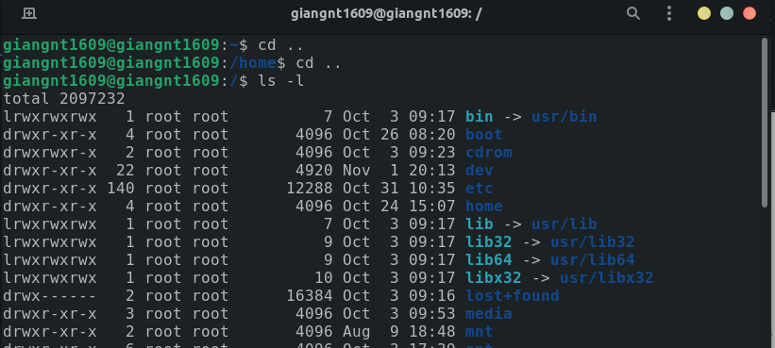we could see the permission is rwx r-x r-x. Now, using chmod with sudo to change the permission of home directory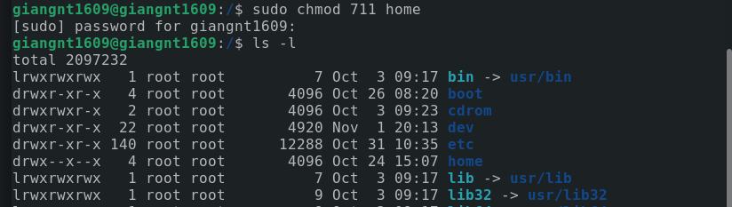. After that, list all file to see the new permission, we get rwx –x--x.

2. By default, when we create new files, they are given rw-rw-r– permissions. The r, w, and x signify the read, write, and execute permissions, respectively.

For example, create a file vanban.txt in ~/ directory

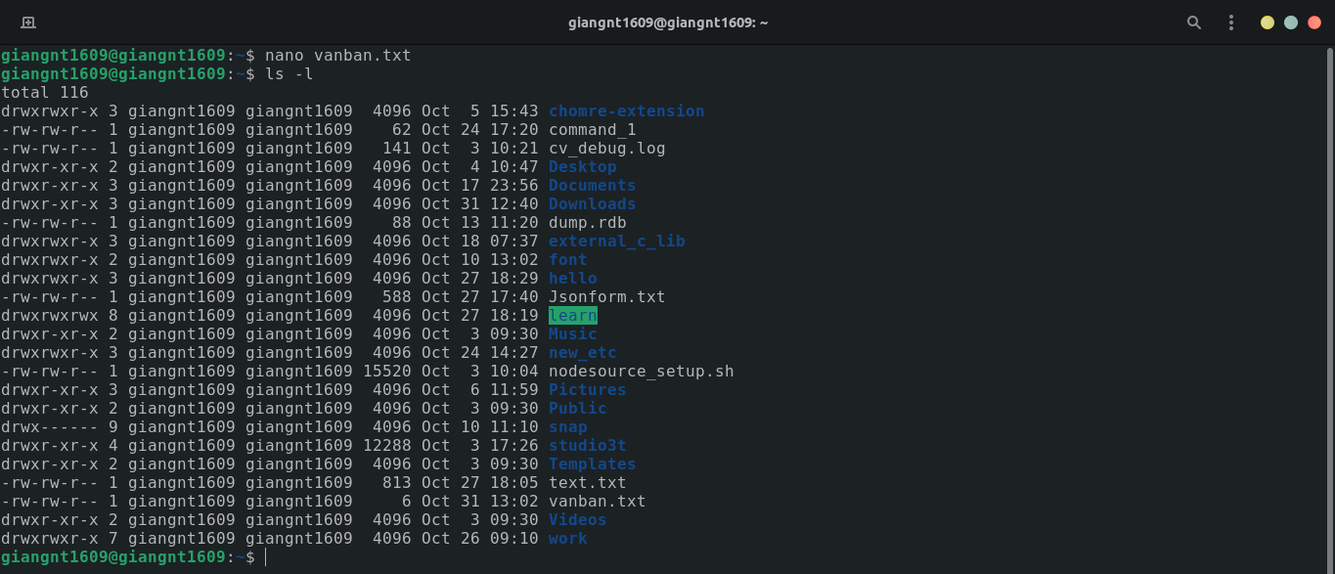we could see the default permission is rw-rw-r-- while using ls -l to see all files and directories in ~/

3. Move to root directory and list everything

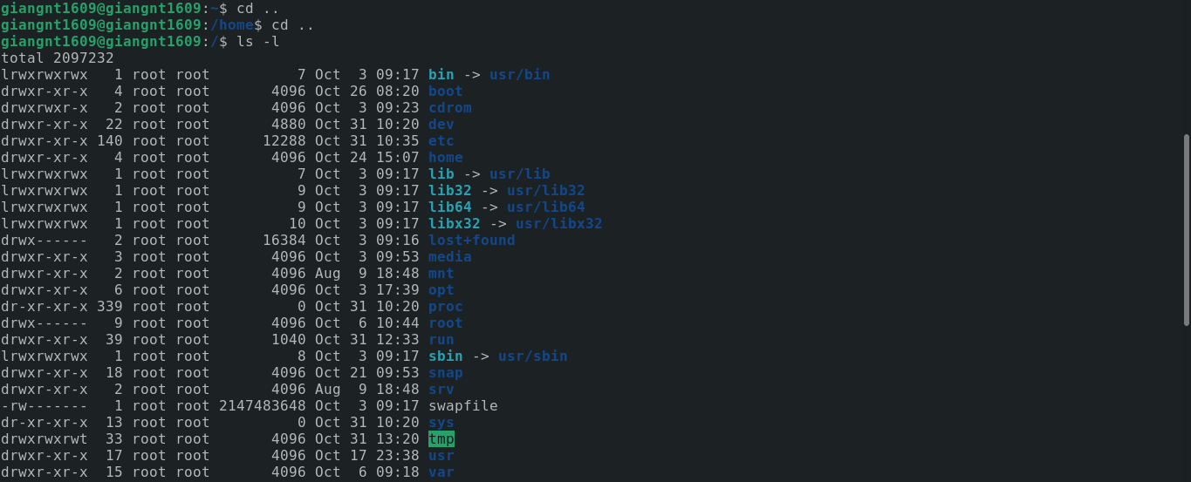

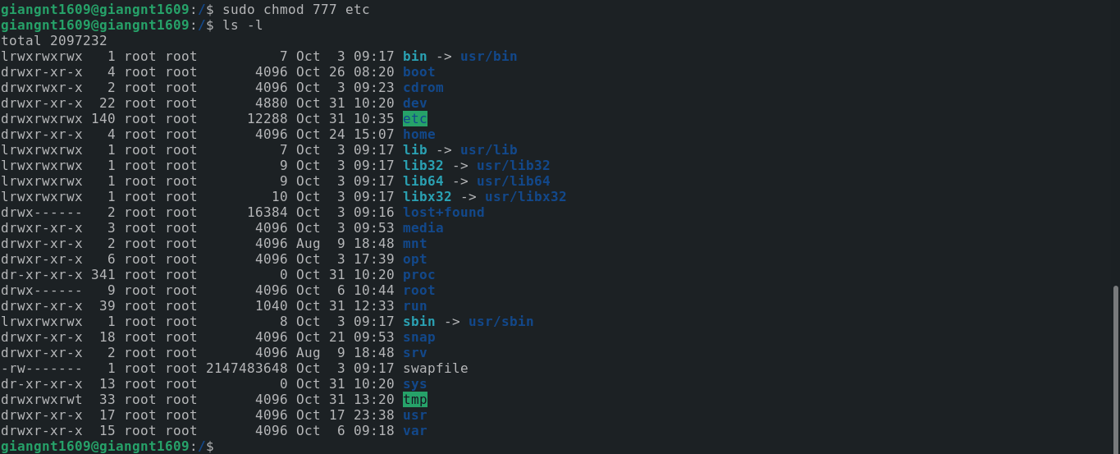we see the permission of etc is rwx r-x r-x, to change the permission using chmod command by administrator’s permisson with sudo. Set all permission read, write, execute for all and we have the result.

4.

See that the permissions of .bashrc is rw- r-- r--

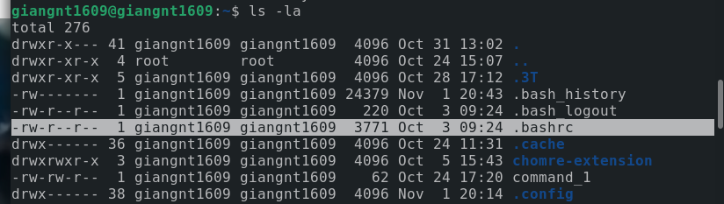 using chmod to change the permissions

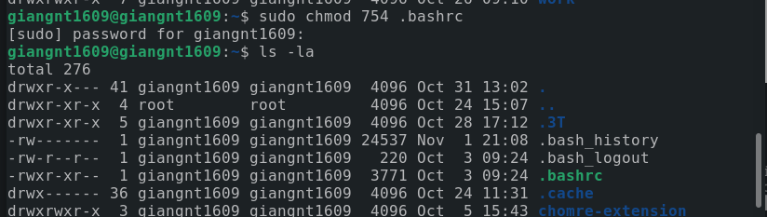5.

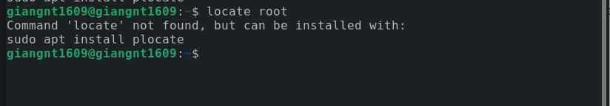The system can’t find the command locate.

6.

We can use a symbol link because the symbol link will create with all permission of diretory.

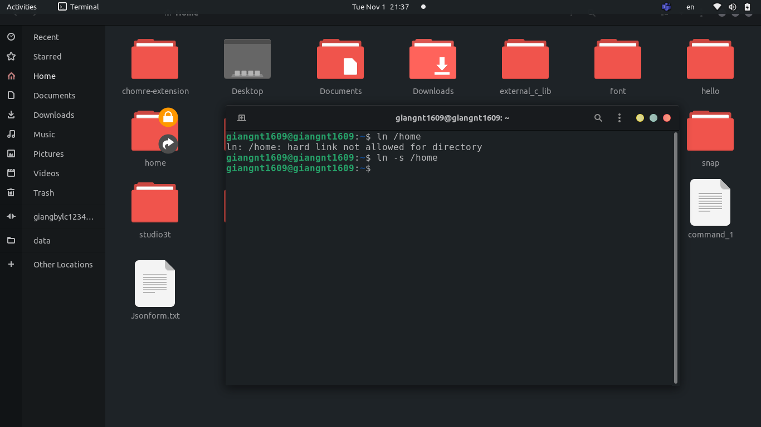

Exercise 2:

1. Create the file test.txt and try use 3 ways:

+ Using chmod commands:

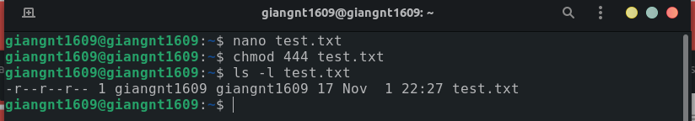

+ Using bitmask:

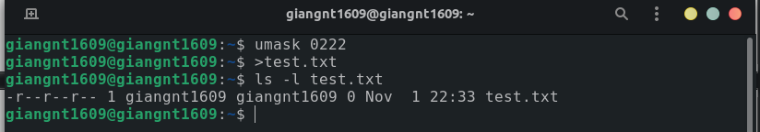+ Using GUI: right-click on the file and choose property after that we can set the permissions for the file.

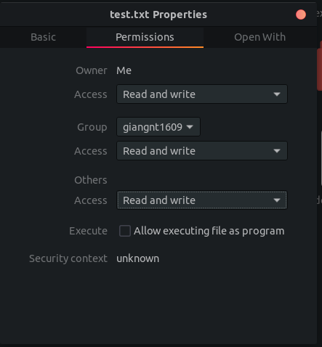

2.