lab repoort 09:
StudentName: Nguyen Truong Giang
StudentID: 20194751

Exercise 1:
1. Both tar and cpio have a single purpose: concatenate many separate files to a single stream. They don't compress data. (These days tar is more popular due to its relative simplicity – it can take input files as arguments instead of having to be coupled with find as cpio has.)
In your case, you do not need either of these tools; they would have no useful effect, because you don't have many separate files. zfs send already did the same thing that tar would have done. So you don't have any files, only a nameless stream.
2, 3
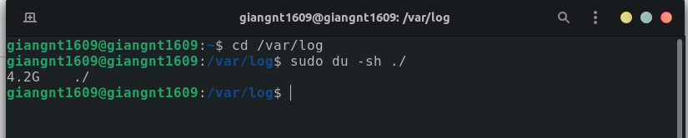
4.
create a taz file compress all files in the folder

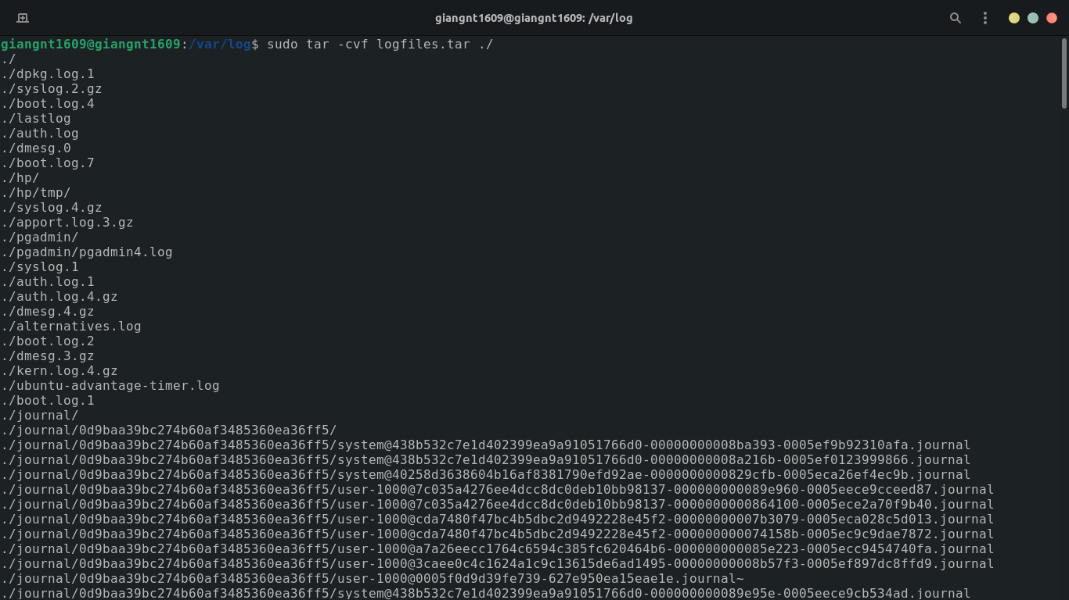
next, move that taz file to home directory
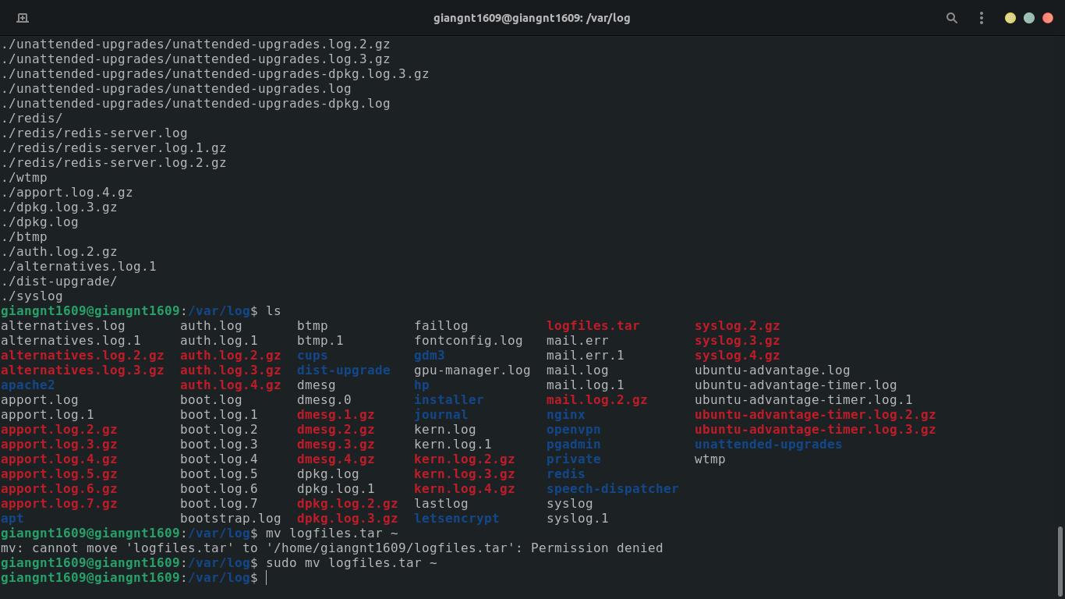
5.
This tar file is appear in home directory.
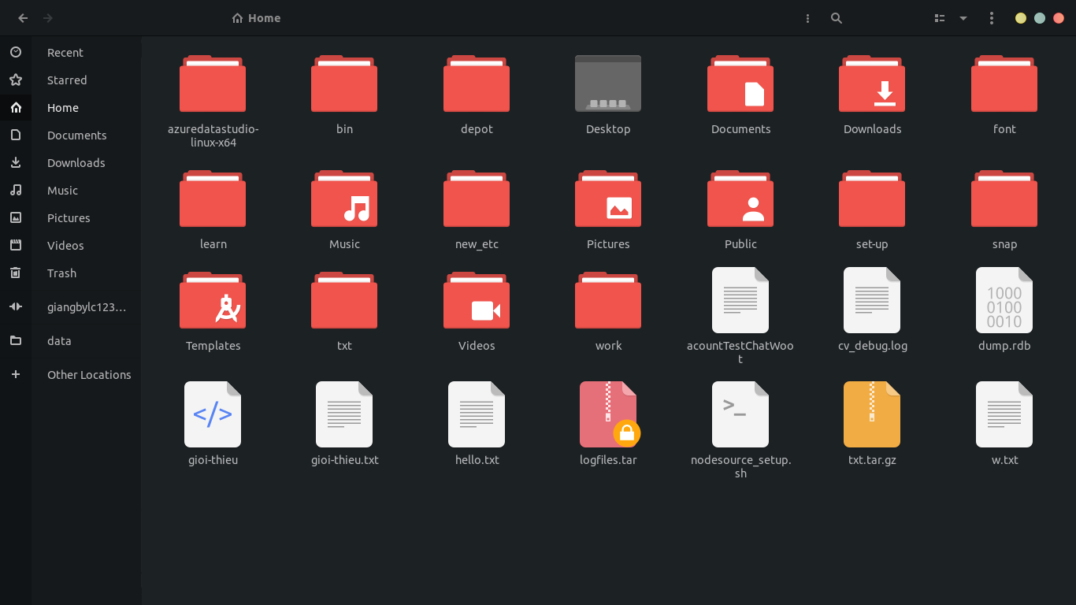
6. The filename of tar file is absolute name.
7.
Check the size of tar file
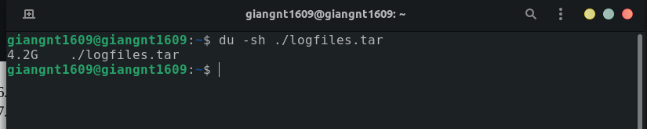
As the result in previous part, the size of archive file is have the same size with the folder in address /var/log

8.
Using command “tar xvf logfiles.tar messages” the result is not found.
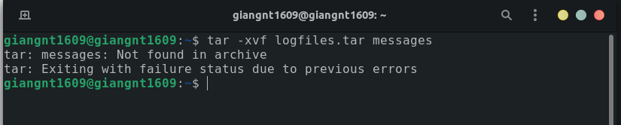
9.
The content of file doesn’t have so having the first line and maybe make notification in the second line when missing permission for reading some files.

10.

Try the command with root permission “sudo tar -cvf logfile2.tar /var/log”
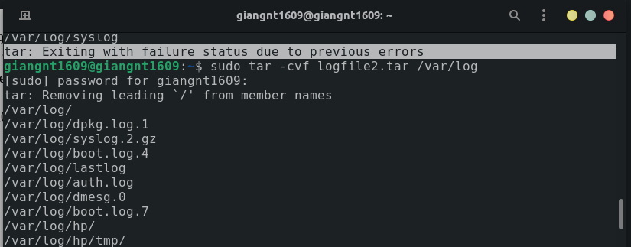
11.
the permission of content in new tar file is the same with permissions in the /var/log .
13.
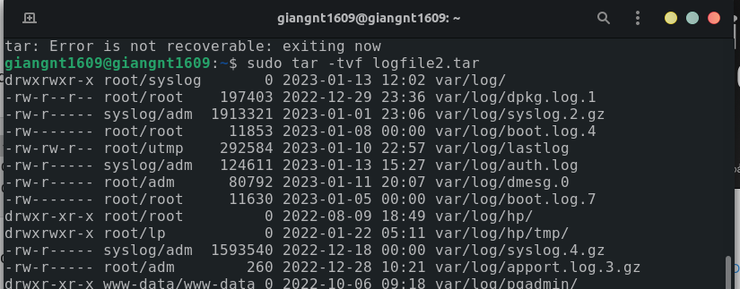
14.
Can’t extract with message because message is not exist.
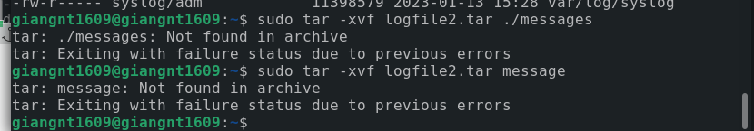
15.
the extracted file will be appear in the current work directory.

Exercise 2:
1.
Both tar and cpio have a single purpose: concatenate many separate files to a single stream. They don't compress data. (These days tar is more popular due to its relative simplicity – it can take input files as arguments instead of having to be coupled with find as cpio has.)
In your case, you do not need either of these tools; they would have no useful effect, because you don't have many separate files. zfs send already did the same thing that tar would have done. So you don't have any files, only a nameless stream.
2,3
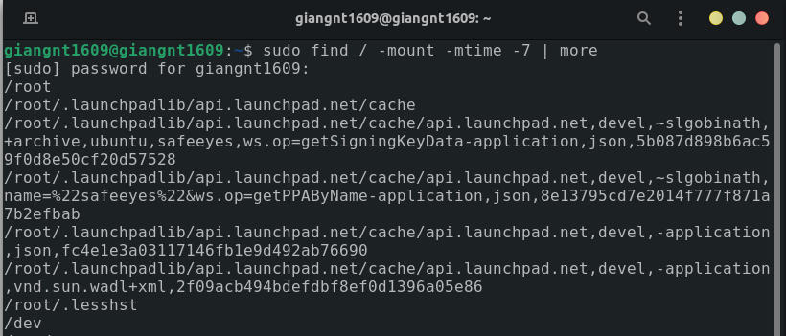
4.
find with option –mount is meaning:
don't descend directories on other filesystems. An alternate name for -xdev, for compatibility with some other versions of find.

5.

