Laporan Test Automation Login
Tanggal Run: 2026-01-26
Target URL: http://localhost:8000
Screenshots Folder: Test Automation Evidence\screenshots_20260126_104658
--------------------------------------------------
Scenario: 1. Login Sukses (Valid/Valid)
Input: User='admin' | Pass='admin123'
Expect: Success | Actual: Fail
Status: Failed
Step 1: Empty Form
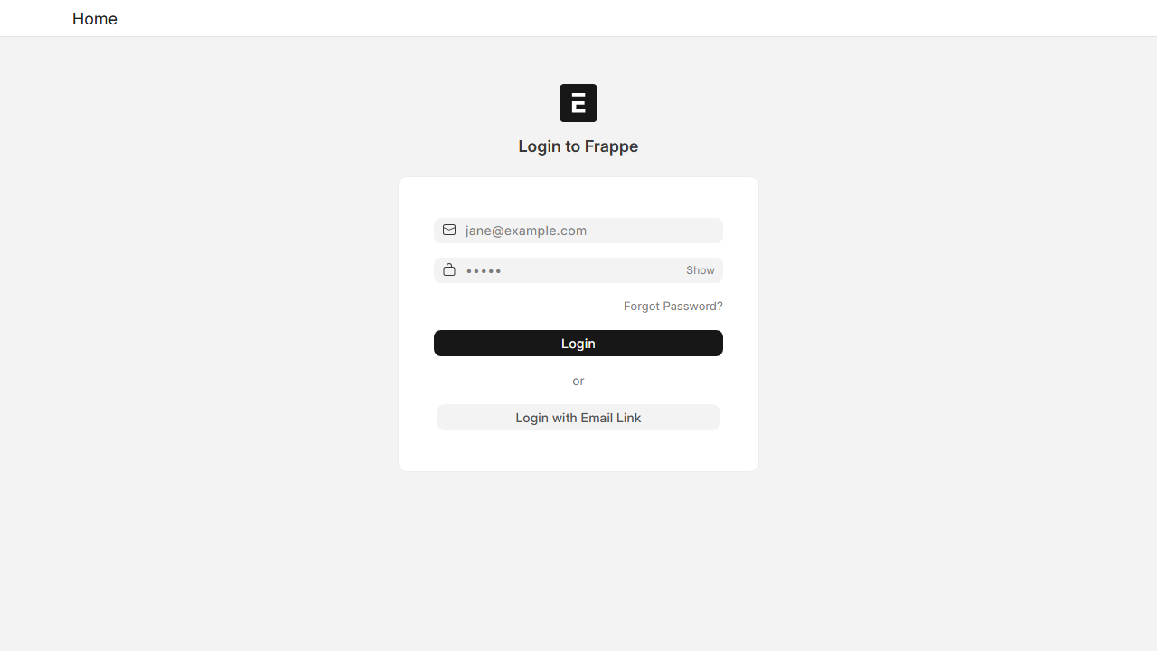
Step 2: Filled Inputs
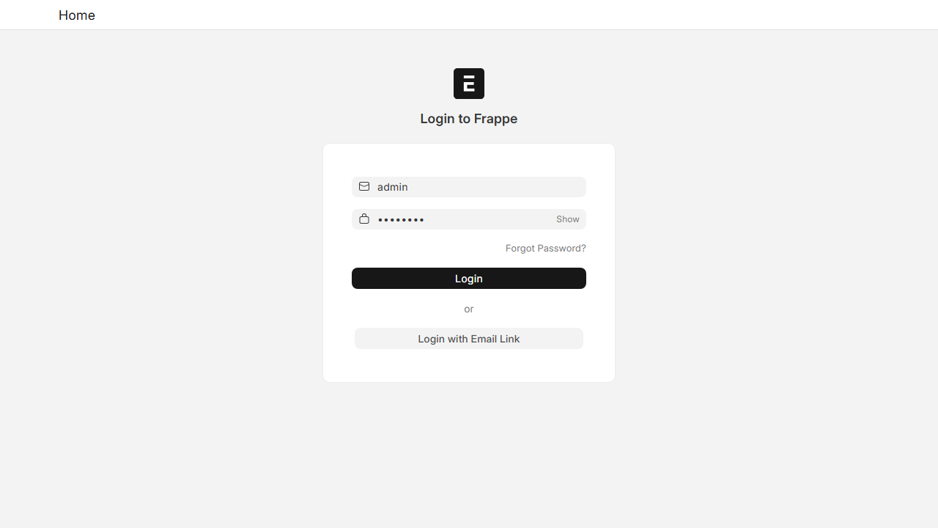
Step 3: Result
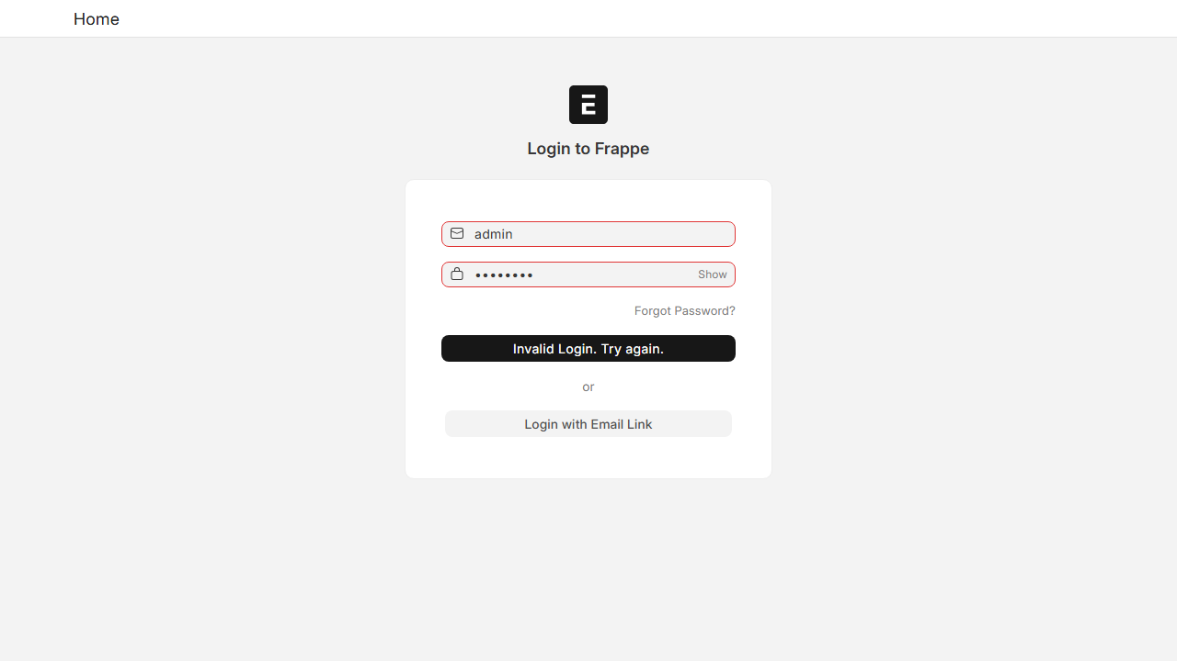
------------------------------
Scenario: 2. Login Gagal (Invalid/Invalid)
Input: User='wronguser' | Pass='wrongpass'
Expect: Fail | Actual: Fail
Status: Passed
Step 1: Empty Form
Step 2: Filled Inputs
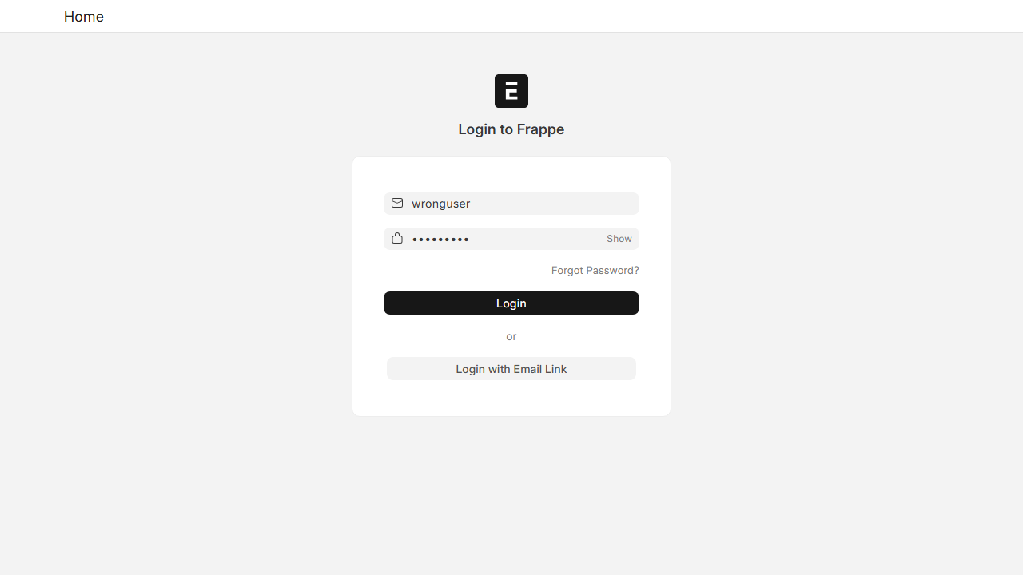
Step 3: Result
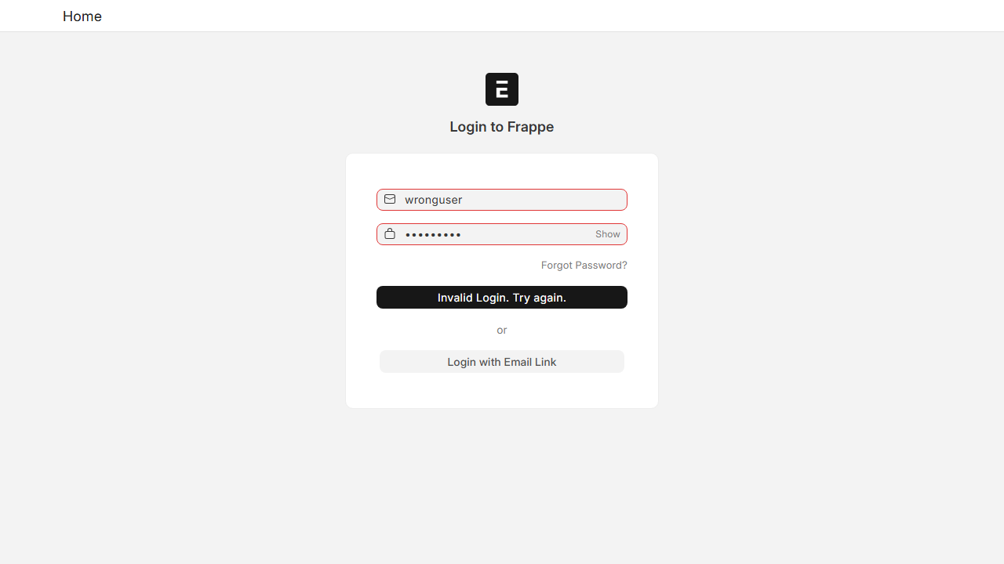
------------------------------
Scenario: 3. Login Gagal (Valid/Invalid)
Input: User='admin' | Pass='wrongpass'
Expect: Fail | Actual: Fail
Status: Passed
Step 1: Empty Form
Step 2: Filled Inputs
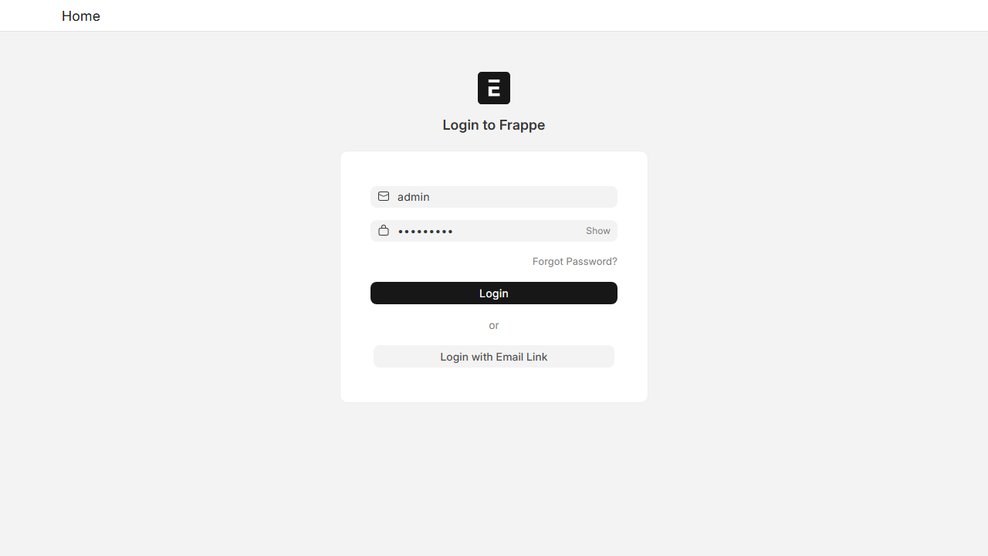
Step 3: Result
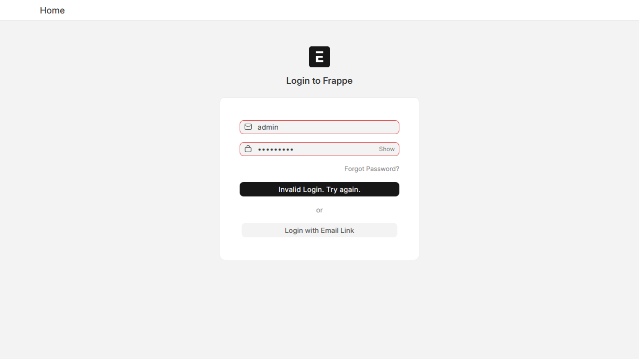
------------------------------
Scenario: 4. Login Gagal (Invalid/Valid)
Input: User='wronguser' | Pass='admin123'
Expect: Fail | Actual: Fail
Status: Passed
Step 1: Empty Form
Step 2: Filled Inputs
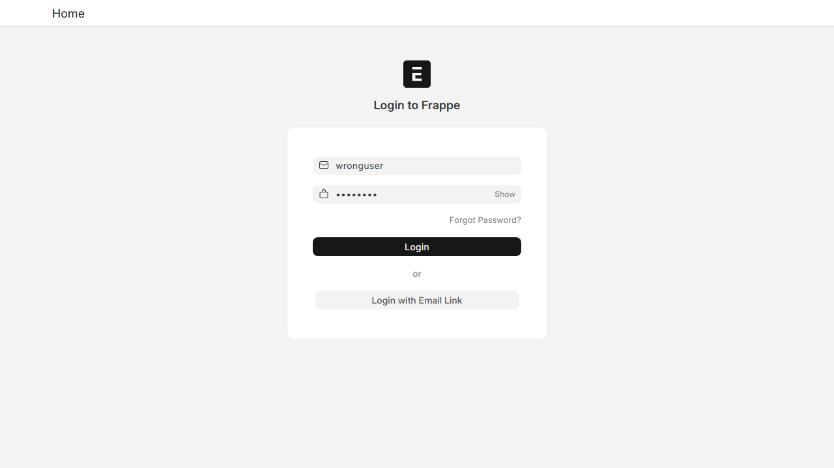
Step 3: Result
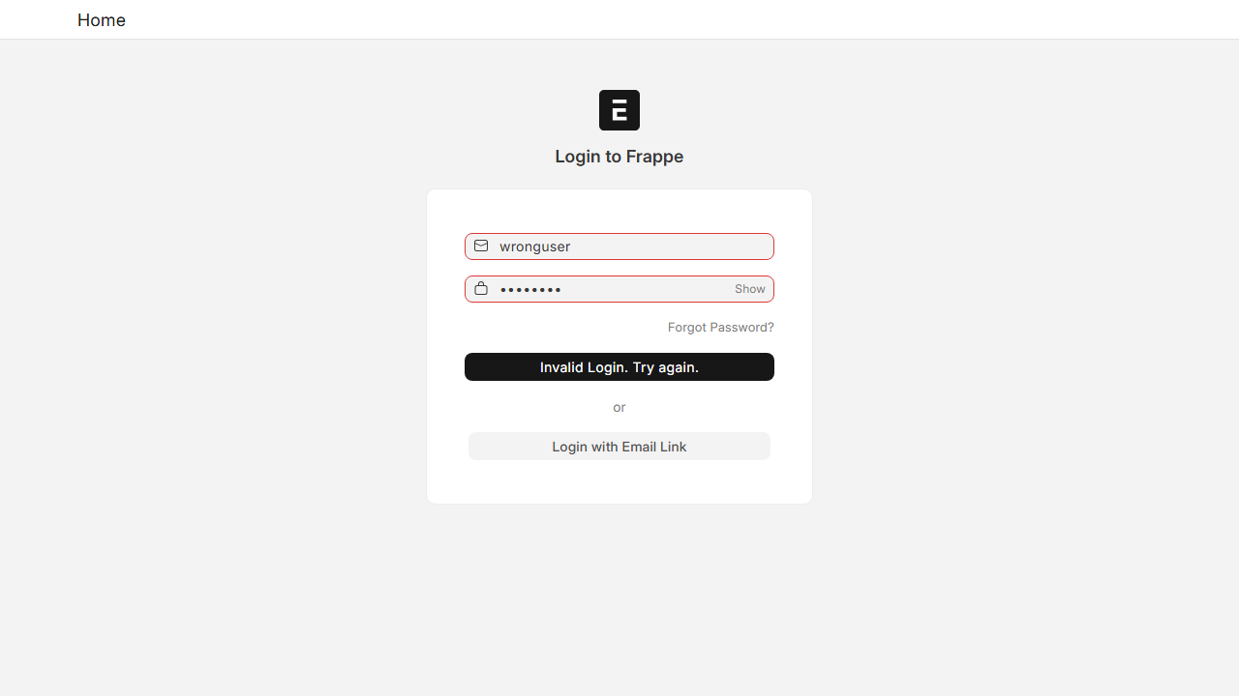
------------------------------
Scenario: 5. Login Gagal (Empty/Empty)
Input: User='' | Pass=''
Expect: Fail | Actual: Fail
Status: Passed
Step 1: Empty Form
Step 2: Filled Inputs
Step 3: Result
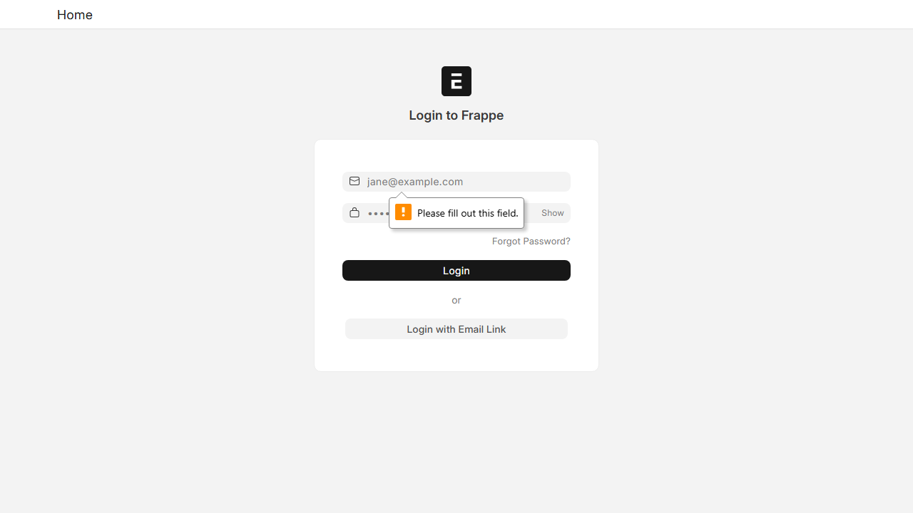
------------------------------
Scenario: 6. Login Gagal (Valid/Empty)
Input: User='admin' | Pass=''
Expect: Fail | Actual: Fail
Status: Passed
Step 1: Empty Form
Step 2: Filled Inputs
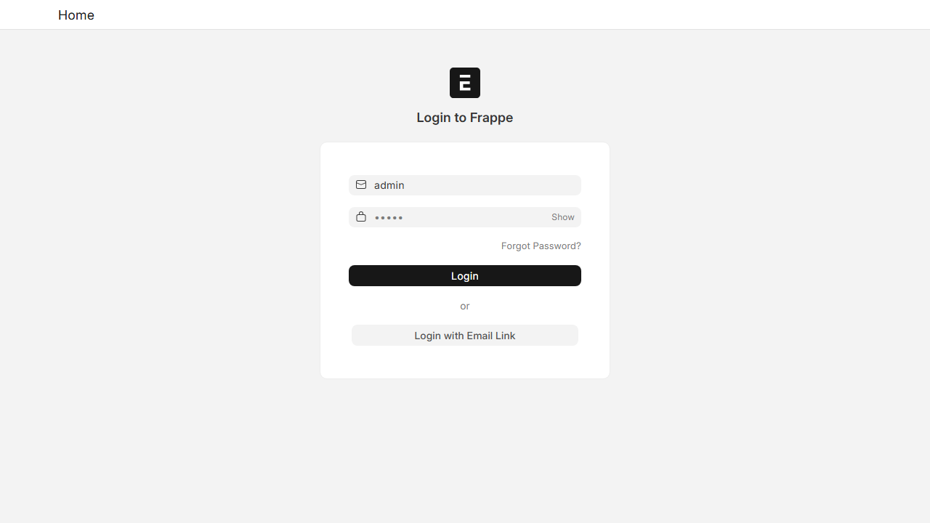
Step 3: Result
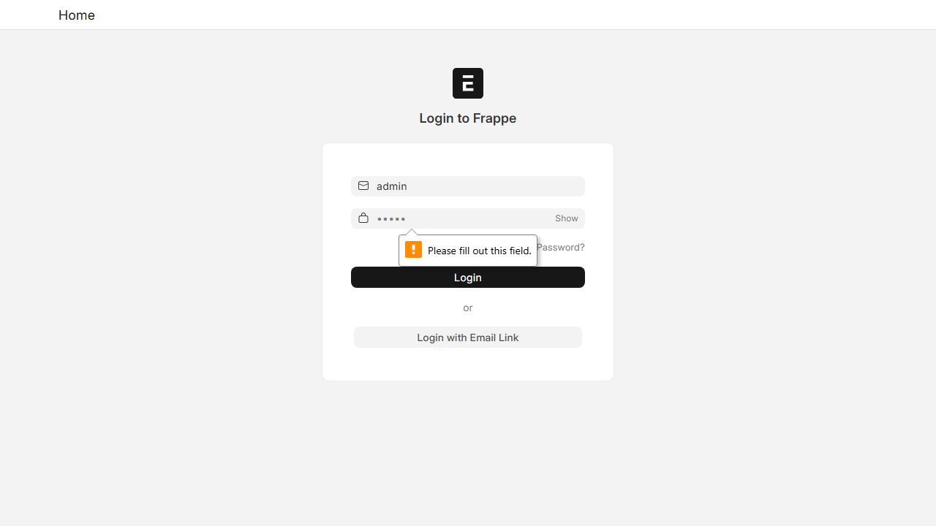
------------------------------
Scenario: 7. Login Gagal (Invalid/Empty)
Input: User='wronguser' | Pass=''
Expect: Fail | Actual: Fail
Status: Passed
Step 1: Empty Form
Step 2: Filled Inputs
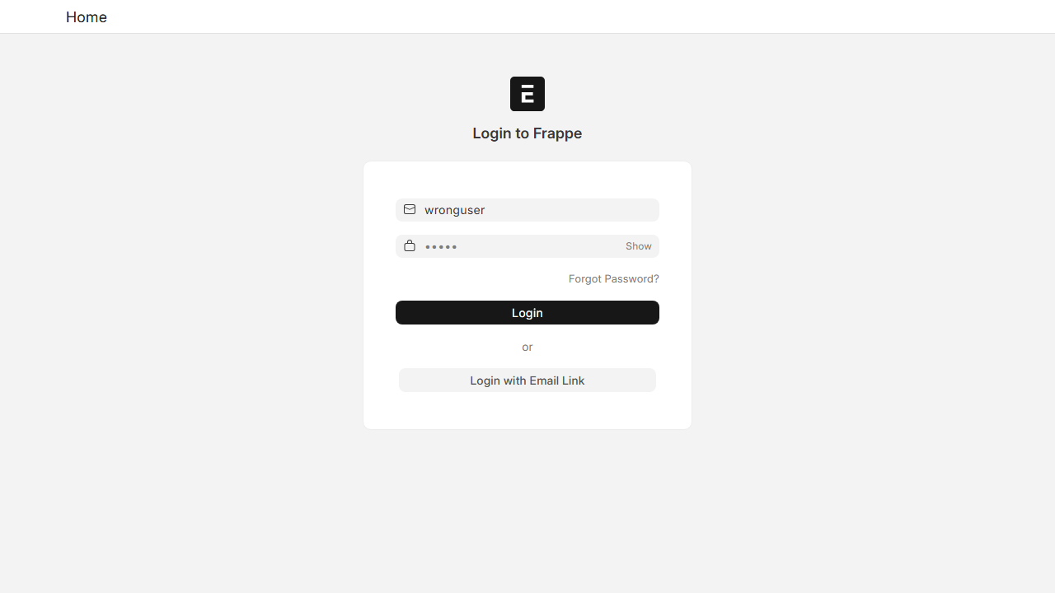
Step 3: Result
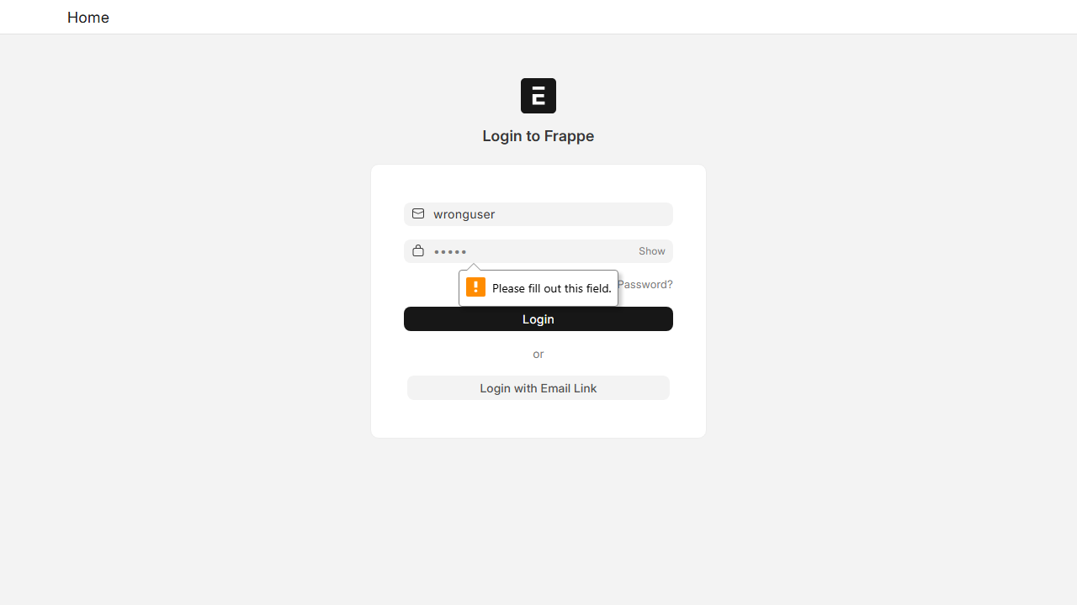
------------------------------
Scenario: 8. Login Gagal (Empty/Valid)
Input: User='' | Pass='admin123'
Expect: Fail | Actual: Fail
Status: Passed
Step 1: Empty Form
Step 2: Filled Inputs
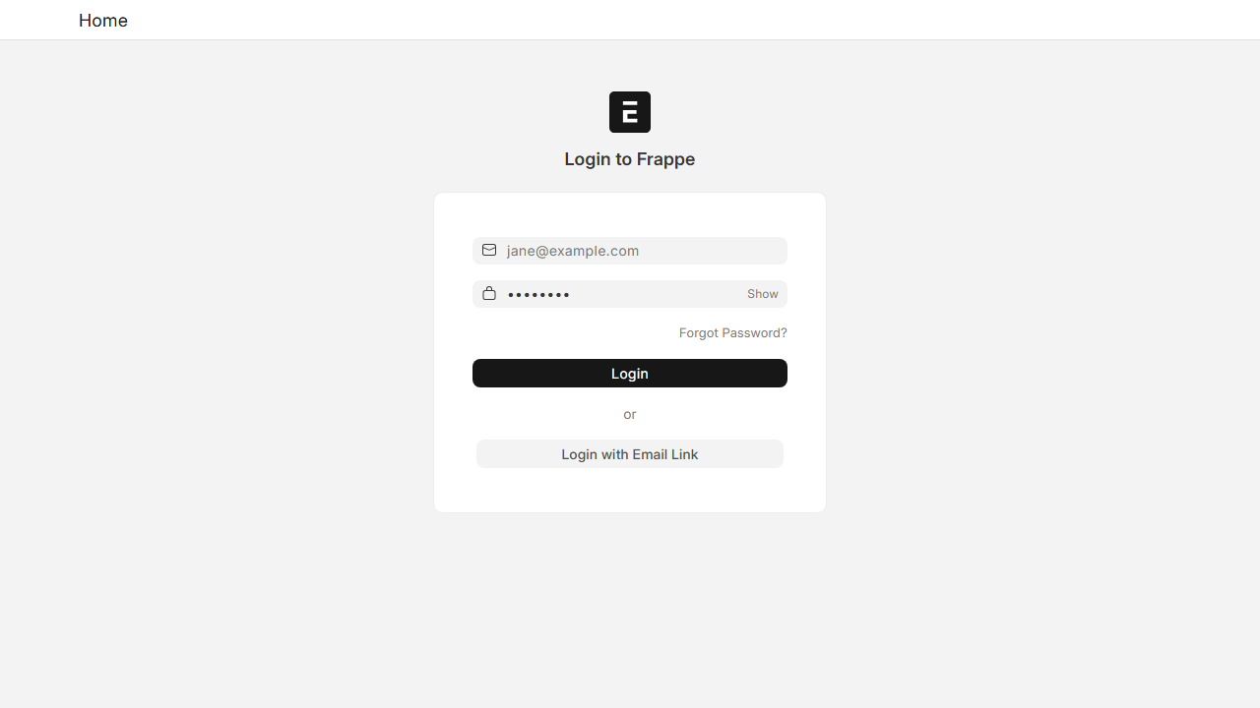
Step 3: Result
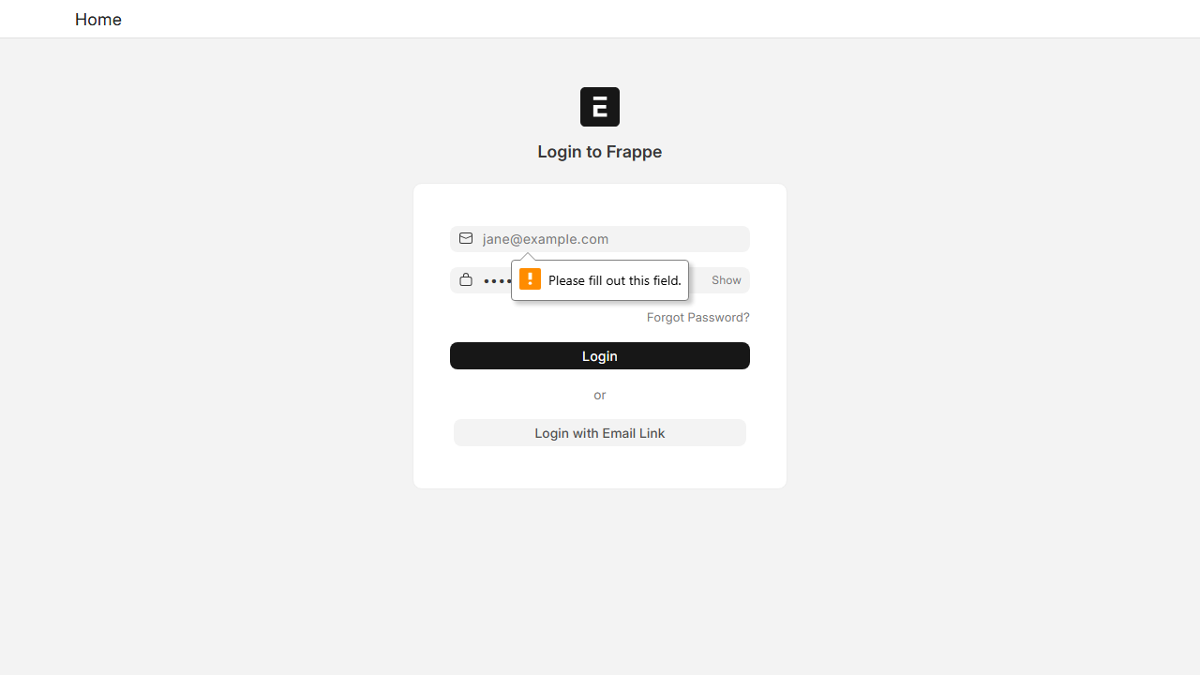
------------------------------
Scenario: 9. Login Gagal (Empty/Invalid)
Input: User='' | Pass='wrongpass'
Expect: Fail | Actual: Fail
Status: Passed
Step 1: Empty Form
Step 2: Filled Inputs
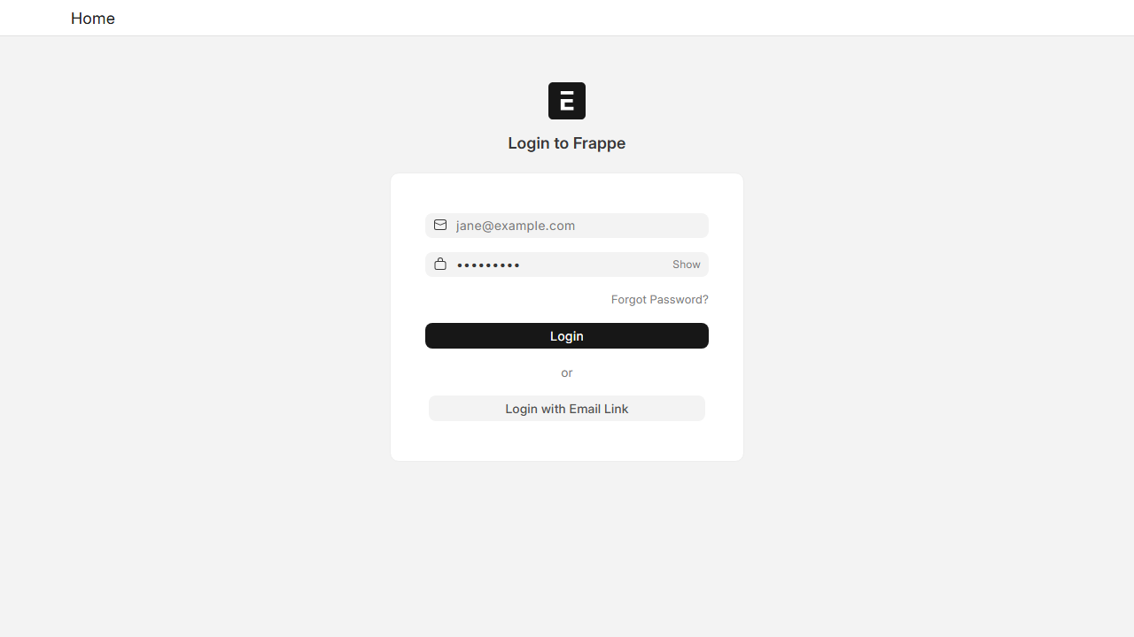
Step 3: Result
------------------------------

