Laporan Test Automation Queue
Date: 2026-01-26
Environment: http://localhost:59690
Data Seeded: Yes
--------------------------------------------------
1. Check Fungsi Call Patient (Kiri)
Button not visible/enabled.
Result: FAILED
4. Check Tampilan (Kiri)
Layout Verified.
Result: PASSED
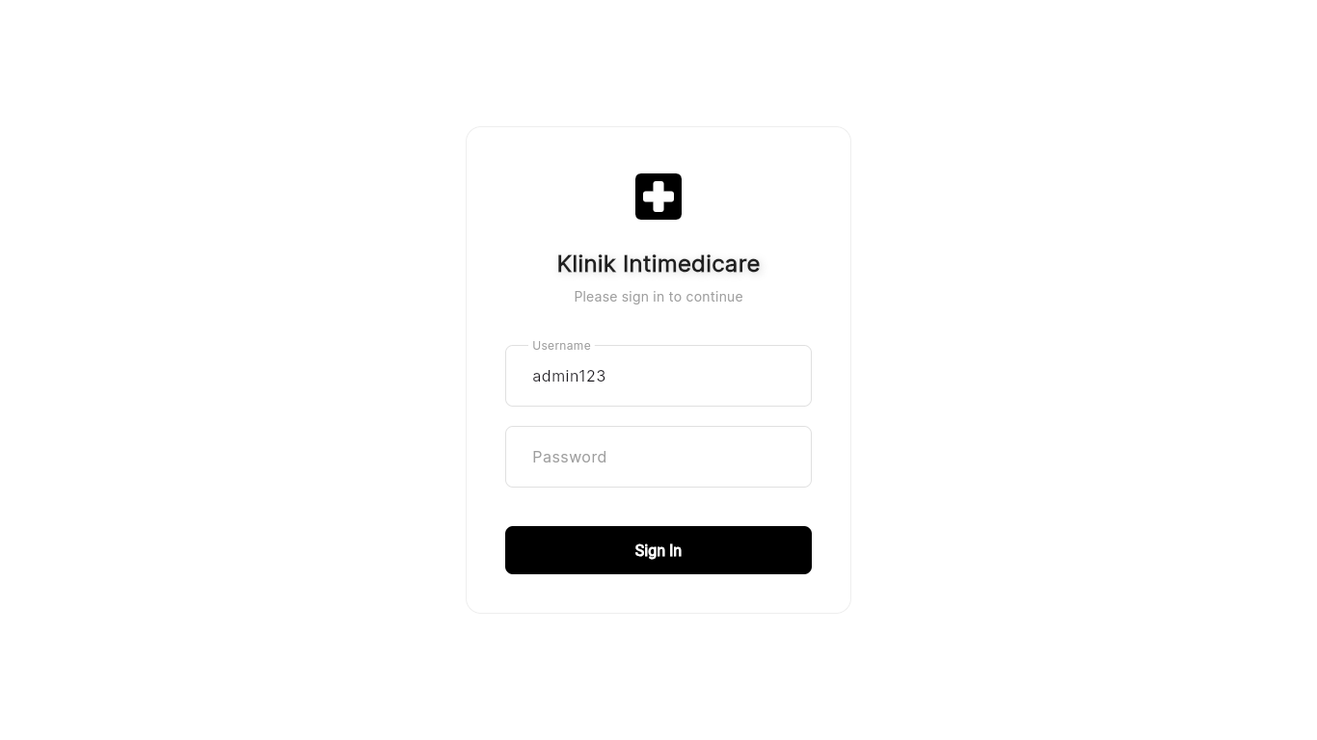
FATAL ERROR: Locator.is_enabled: Timeout 30000ms exceeded.
Call log:
- waiting for locator("text=Completed").first

