1util_trace/TouTiao_Trace_NO_EVENTS_UTIL/TouTiao_VIDEO_FRAME_TRACE3_NO_TimeStamp

|  |  |  |  |  |  |  |  |  |  |
| --- | --- | --- | --- | --- | --- | --- | --- | --- | --- |
| 绝对误差值平均x = （∑abs(real[i] – predict[i])） / (real数组的长度) | N = 1 | N = 2 | N =3 | N =4 | N =5 | N =6 | N = 7 | N = 8 | N = 9 |
| WMA | 70.3 | 79.92 | 86 | 90 | 92 | 95 | 97 | 98 | 100 |
| AVERAGE | 70.3 | 85.63 | 93.52 | 97.67 | 100.95 | 103.46 | 105．62 | 106.89 | 107．99 |
| WALT | 70.3 | 81 | 87 | 91 | 94 | 95.9 | 96 | 97.24 | 97.76 |
| MAX | 70.3 | 95.35 | 112.7 | 130.67 | 148.66 | 165.85 | 181.14 | 196.23 | 210.9 |

|  |  |  |  |  |  |  |  |  |  |
| --- | --- | --- | --- | --- | --- | --- | --- | --- | --- |
| 相对误差率平均x =(∑（predict[i] – real[i]）/ real[i])/ (real数组长度) | N = 1 | N = 2 | N =3 | N =4 | N =5 | N =6 | N = 7 | N = 8 | N = 9 |
| WMA | 6.91 | 7.9 | 8.64 | 9.15 | 9.78 | 10．28 | 10.65 | 10.92 | 11.10 |
| AVERAGE | 6.91 | 8.45 | 9.34 | 9.93 | 11.03 | 11.52 | 11.76 | 11.89 | 11.80 |
| WALT | 6.91 | 9.67 | 11.53 | 12.68 | 13.88 | 14.66 | 14.799 | 14.854 | 14.84 |
| MAX | 6.91 | 12.43 | 16．71 | 19.97 | 23.72 | 25.17 | 28.82 | 31.48 | 33.15 |

|  |  |  |  |  |  |  |  |  |  |
| --- | --- | --- | --- | --- | --- | --- | --- | --- | --- |
| 相对误差率绝对平均x =(∑（（abs(predict[i] – real[i])）/ real[i])/ (real数组长度) | N = 1 | N = 2 | N =3 | N =4 | N =5 | N =6 | N = 7 | N = 8 | N = 9 |
| WMA | 7.3 | 8.31 | 9.01 | 9.52 | 10.13 | 10.63 | 10.99 | 11.26 | 11.44 |
| AVERAGE | 7.3 | 8.84 | 9.74 | 10.31 | 11.41 | 11.90 | 12.13 | 12.25 | 12.16 |
| WALT | 7.3 | 9.98 | 11.80 | 12.92 | 14.10 | 14.87 | 14.99 | 15.03 | 15.02 |
| MAX | 7.3 | 12.70 | 16.91 | 20.13 | 23.85 | 25.28 | 28.91 | 31.56 | 33.23 |

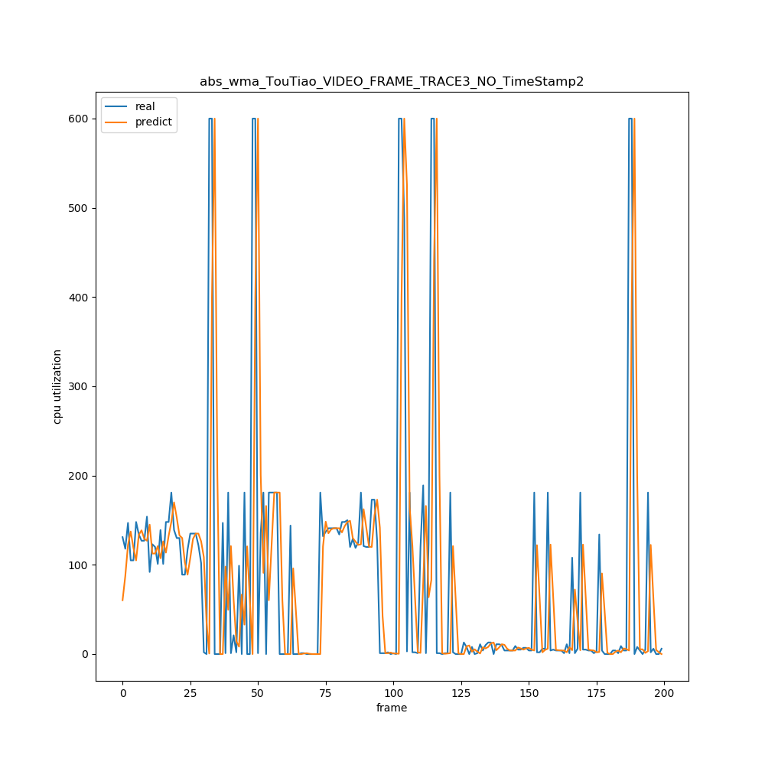

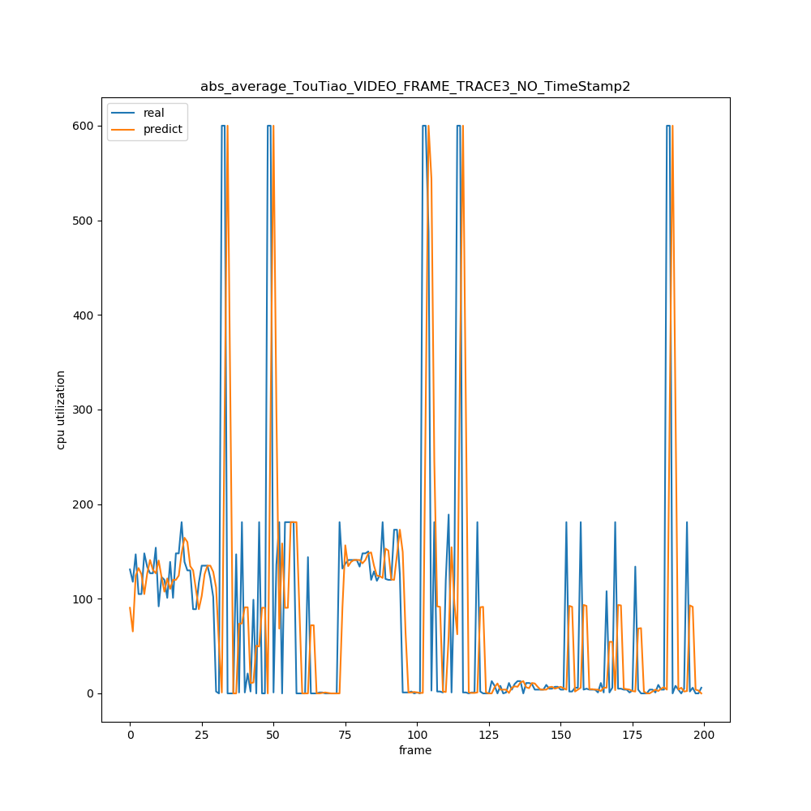

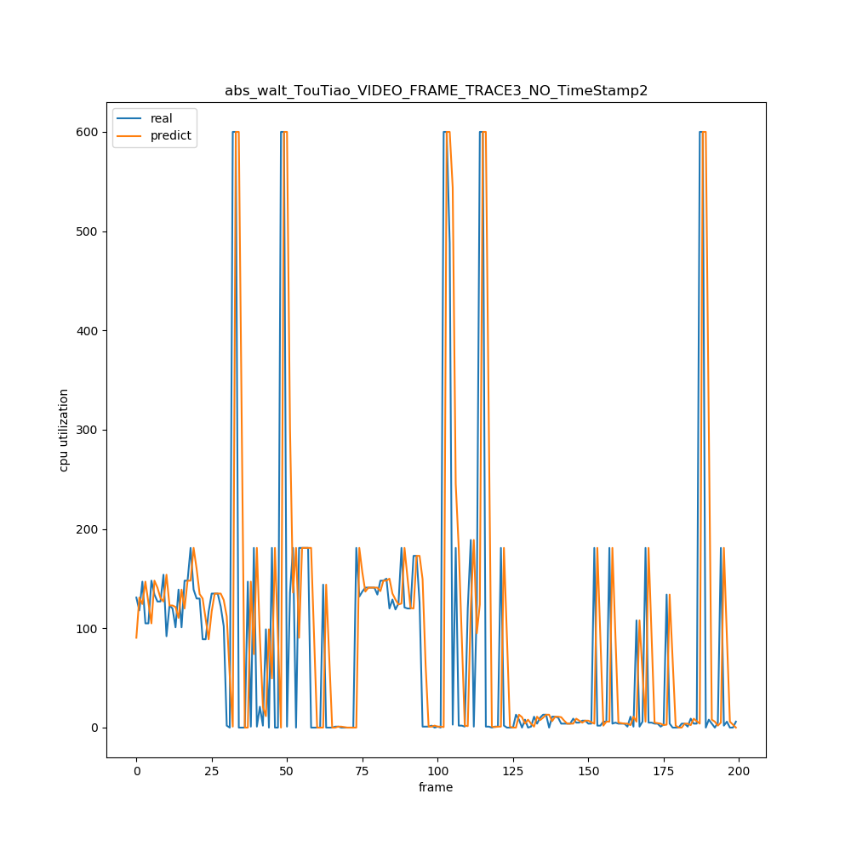

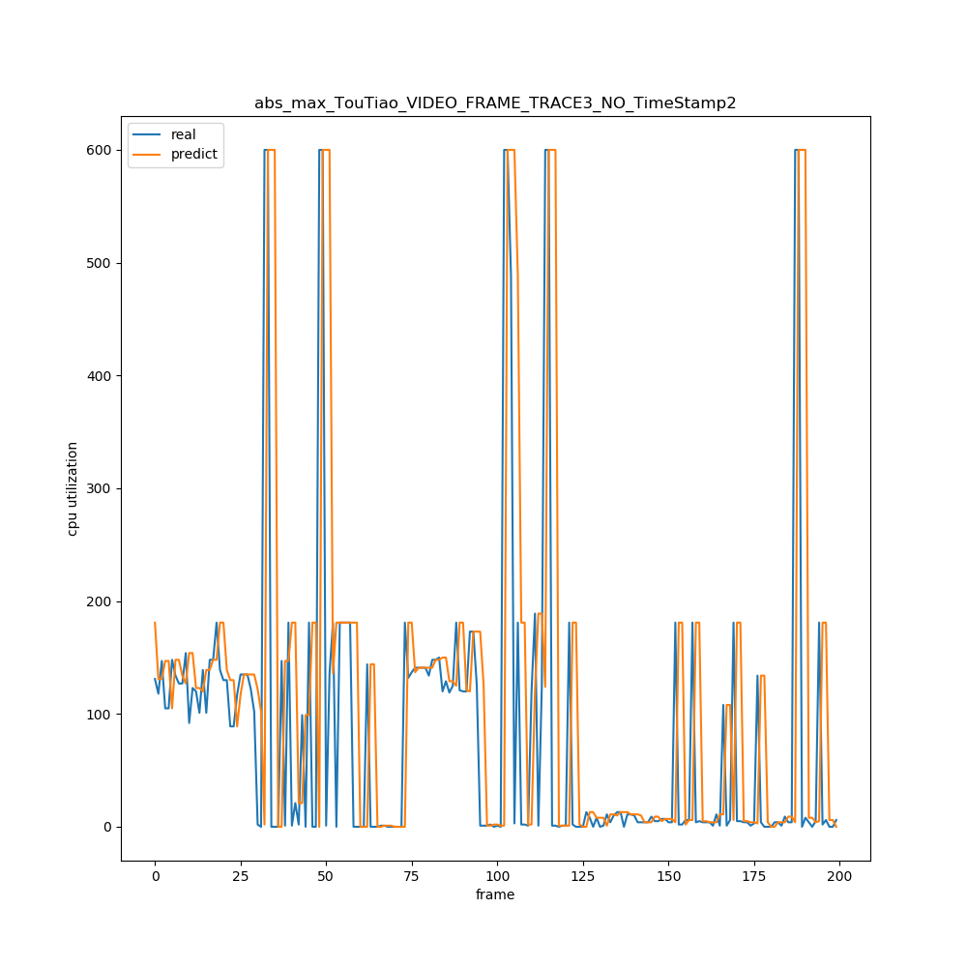

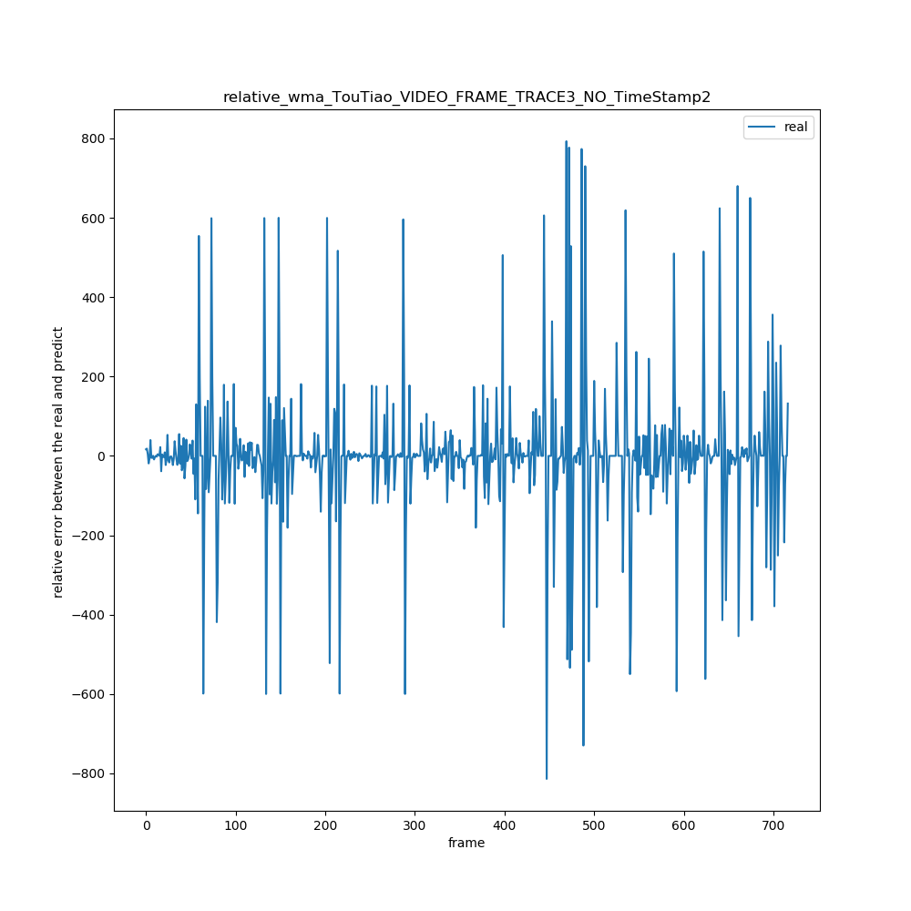

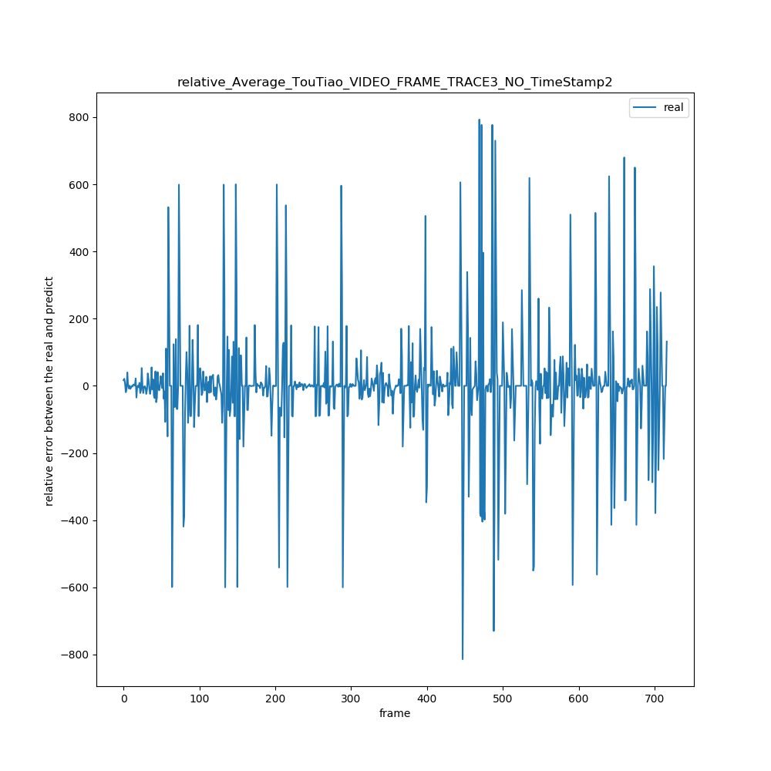

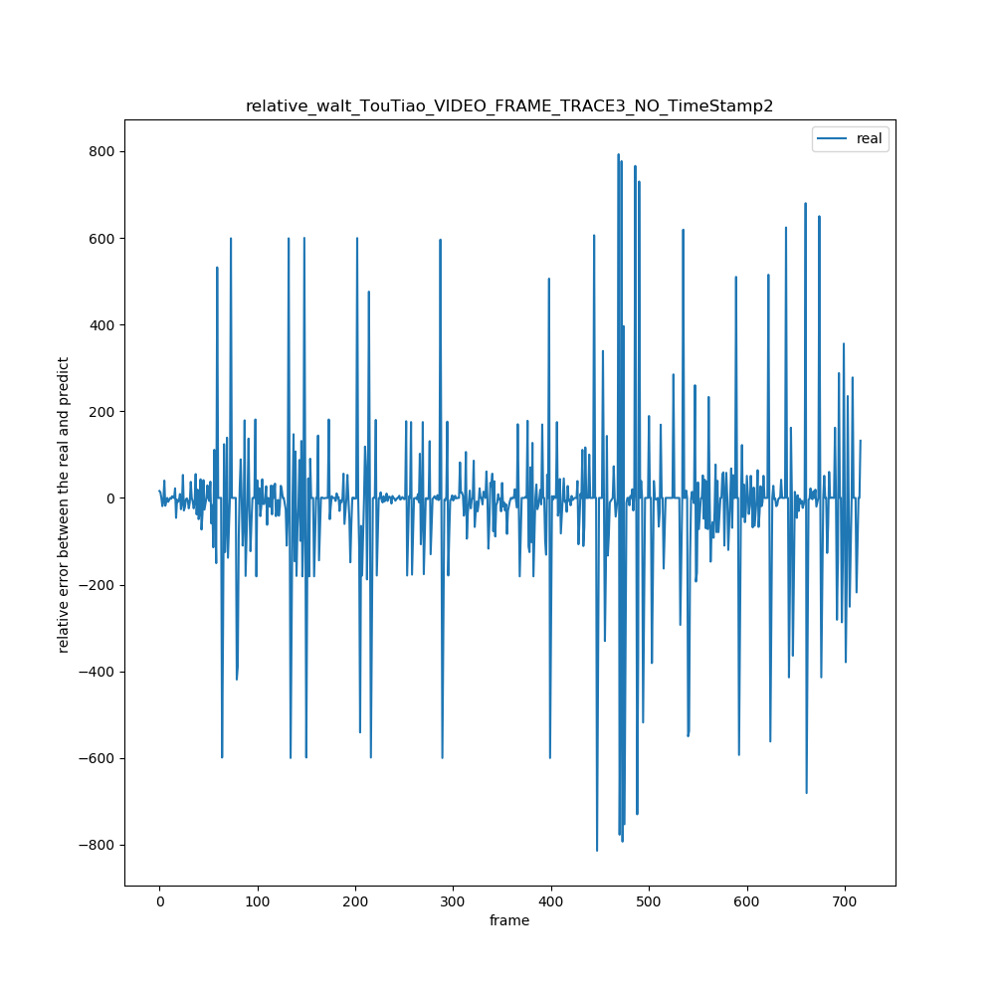

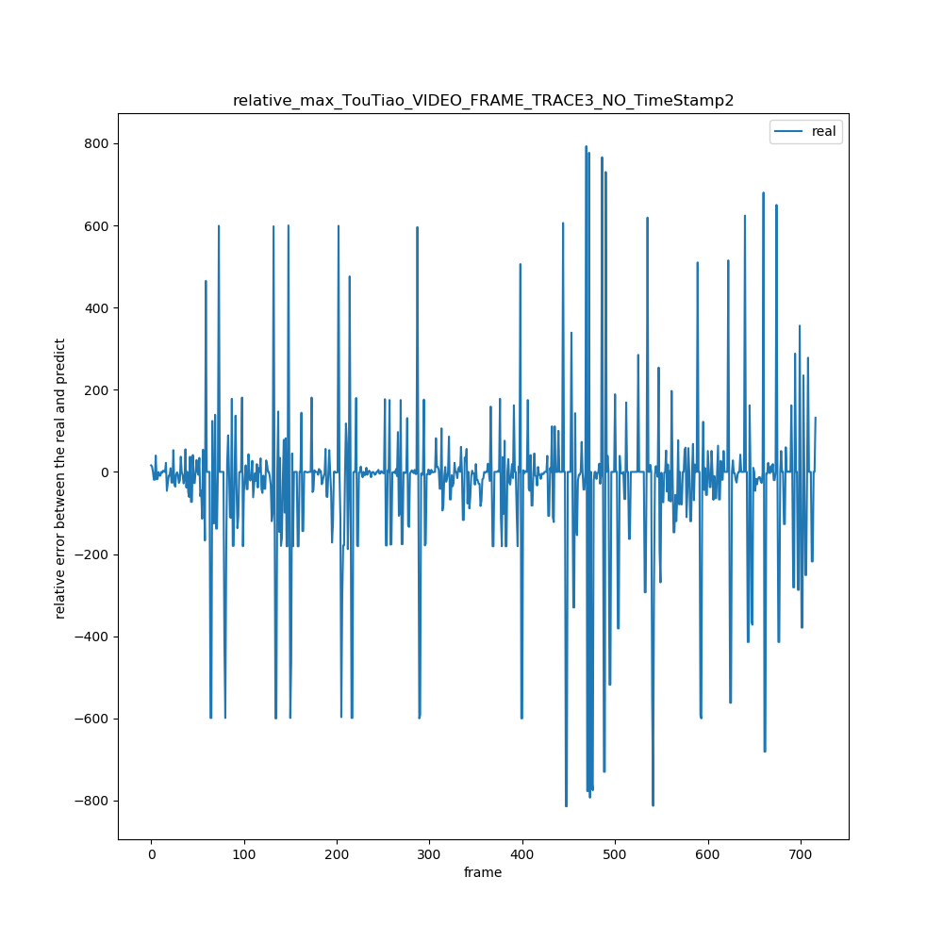

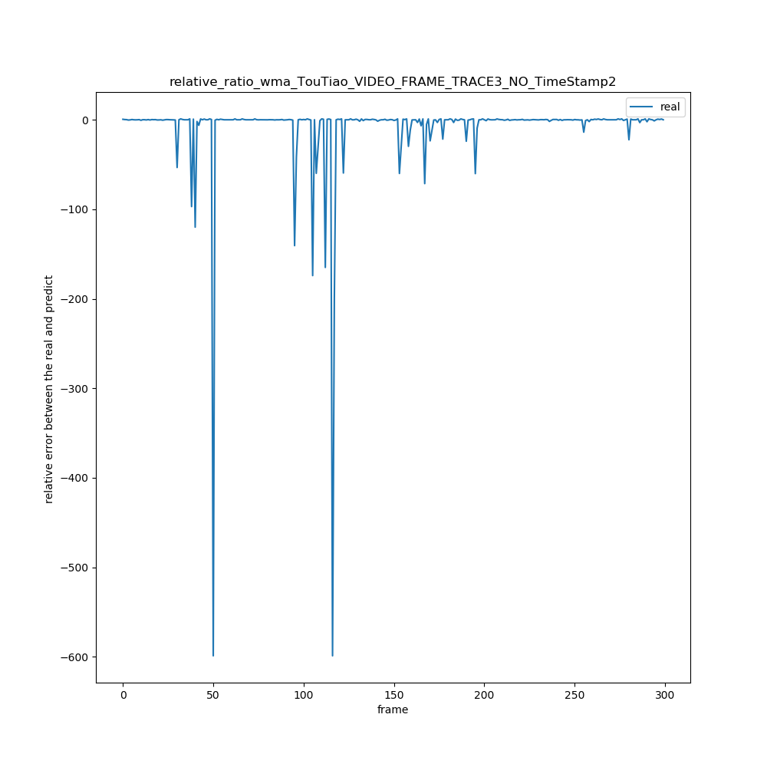

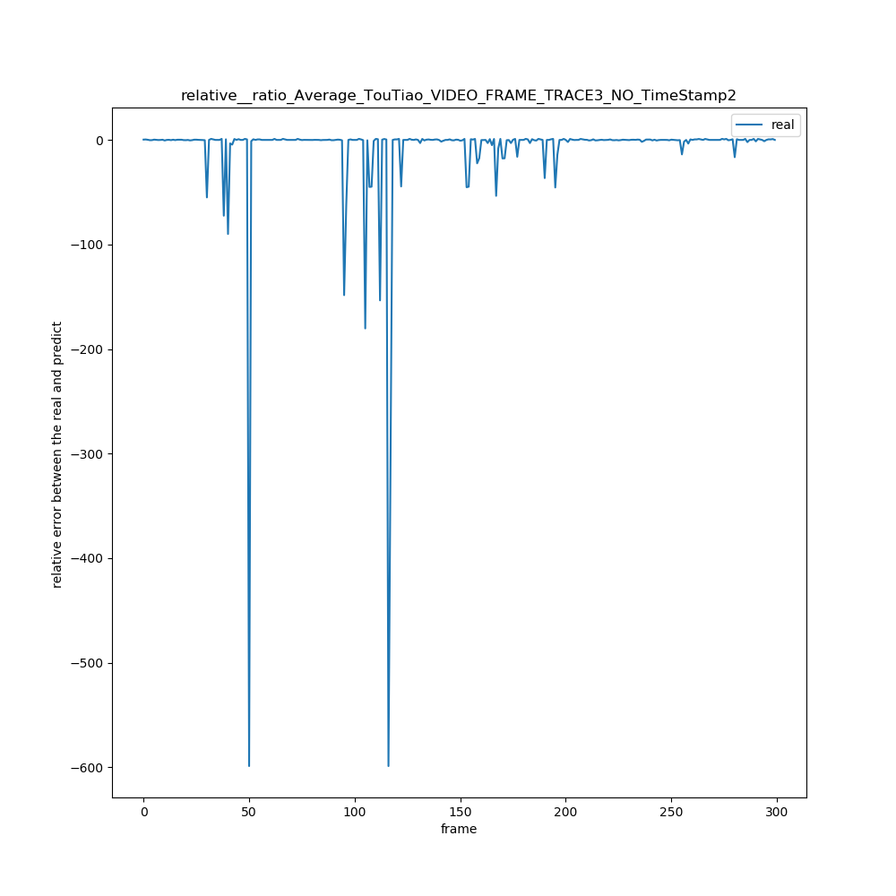

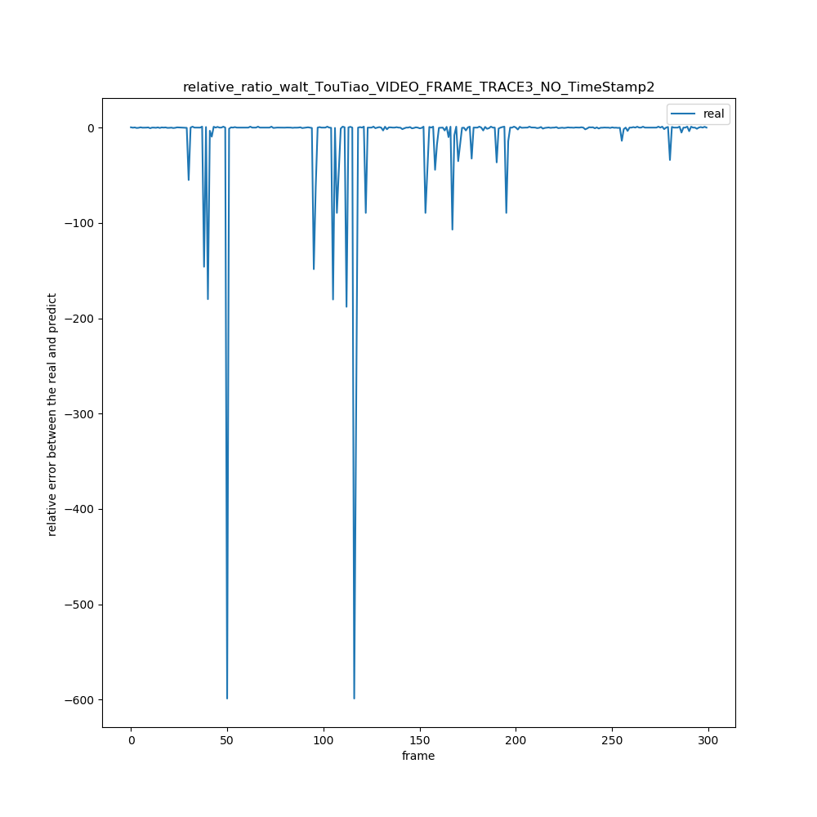

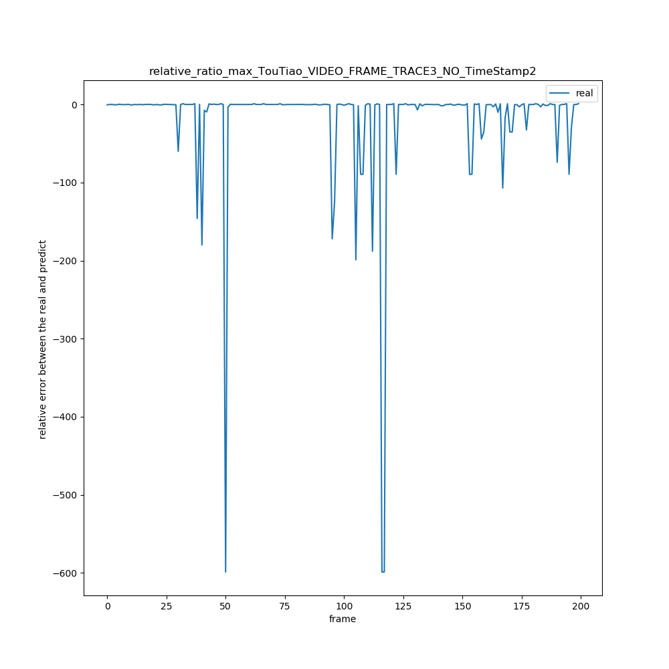

2 util_trace/TouTiao_VIDEO_FRAME_TRACE_NO_TimeStamp

|  |  |  |  |  |  |  |  |  |  |
| --- | --- | --- | --- | --- | --- | --- | --- | --- | --- |
| 绝对误差值平均x = ∑abs(real[i] – predict[i]) / (real数组的长度) | N = 1 | N = 2 | N =3 | N =4 | N =5 | N =6 | N = 7 | N = 8 | N = 9 |
| WMA | 12.9 | 17.26 | 20.68 | 22.98 | 24.57 | 25.70 | 26.61 | 27.34 | 27.96 |
| AVERAGE | 12.9 | 19.41 | 24.21 | 26.89 | 28.53 | 29.60 | 30.33 | 30.88 | 31.41 |
| WALT | 12.9 | 16.18 | 18.39 | 19.93 | 20.86 | 21.40 | 21.72 | 22.00 | 22.30 |
| MAX | 12.9 | 19.41 | 23.86 | 27.44 | 30.90 | 33.76 | 26.41 | 39.02 | 41.52 |

|  |  |  |  |  |  |  |  |  |  |
| --- | --- | --- | --- | --- | --- | --- | --- | --- | --- |
| 相对误差率平均x =(∑（predict[i] – real[i]）/ real[i])/ (real数组长度) | N = 1 | N = 2 | N =3 | N =4 | N =5 | N =6 | N = 7 | N = 8 | N = 9 |
| MAX | 0.001 | 0.05 | 0.11 | 0.17 | 0.23 | 0.27 | 0.32 | 0.355 | 0.3895 |
| AVERAGE | 0.001 | 0.0028 | 0.0049 | 0.0083 | 0.012 | 0.016 | 0.020 | 0.023 | 0.026 |
| WALT | 0.001 | 0.029 | 0.059 | 0.084 | 0.102 | 0.115 | 0.124 | 0.131 | 0.137 |
| WMA | 0.001 | 0.0025 | 0.0037 | 0.0056 | 0.0077 | 0.010 | 0.012 | 0.015 | 0,017 |

|  |  |  |  |  |  |  |  |  |  |
| --- | --- | --- | --- | --- | --- | --- | --- | --- | --- |
| 相对误差率绝对平均x =(∑（（abs(predict[i] – real[i])）/ real[i])/ (real数组长度) | N = 1 | N = 2 | N =3 | N =4 | N =5 | N =6 | N = 7 | N = 8 | N = 9 |
| WMA | 0.10 | 0.14 | 0.17 | 0.192 | 0.20 | 0.21 | 0.221 | 0.227 | 0.232 |
| AVERAGE | 0.10 | 0.16 | 0.20 | 0.225 | 0.239 | 0.248 | 0.255 | 0.259 | 0.264 |
| WALT | 0.10 | 0.13 | 0.15 | 0.17 | 0.18 | 0.186 | 0.190 | 0.194 | 0.198 |
| Max | 0.10 | 0.165 | 0.207 | 0.247 | 0.289 | 0.325 | 0.359 | 0.39 | 0.42 |

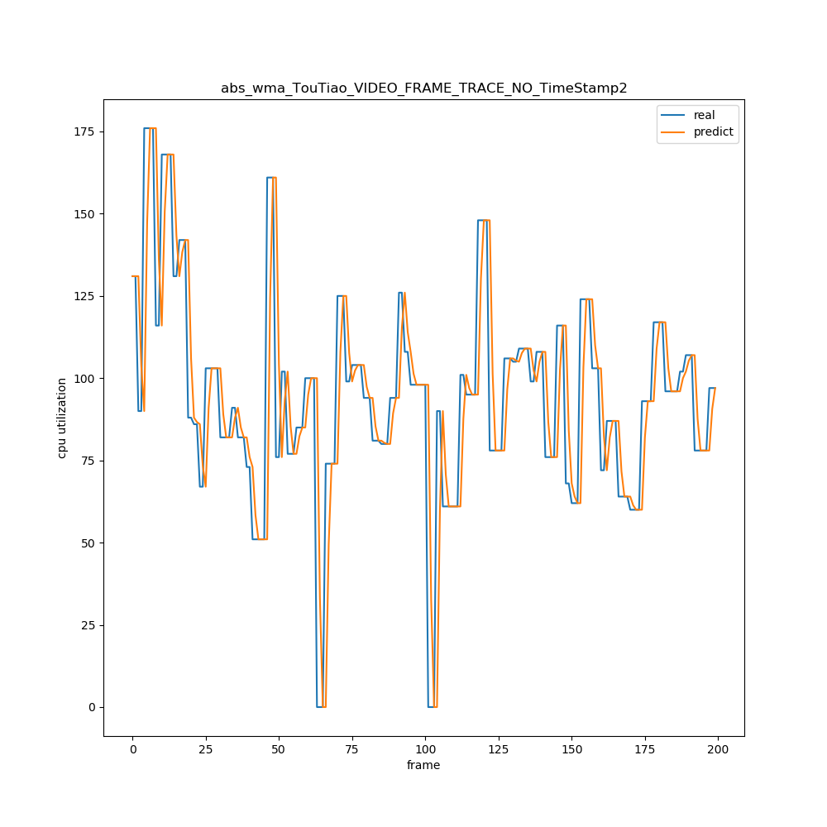

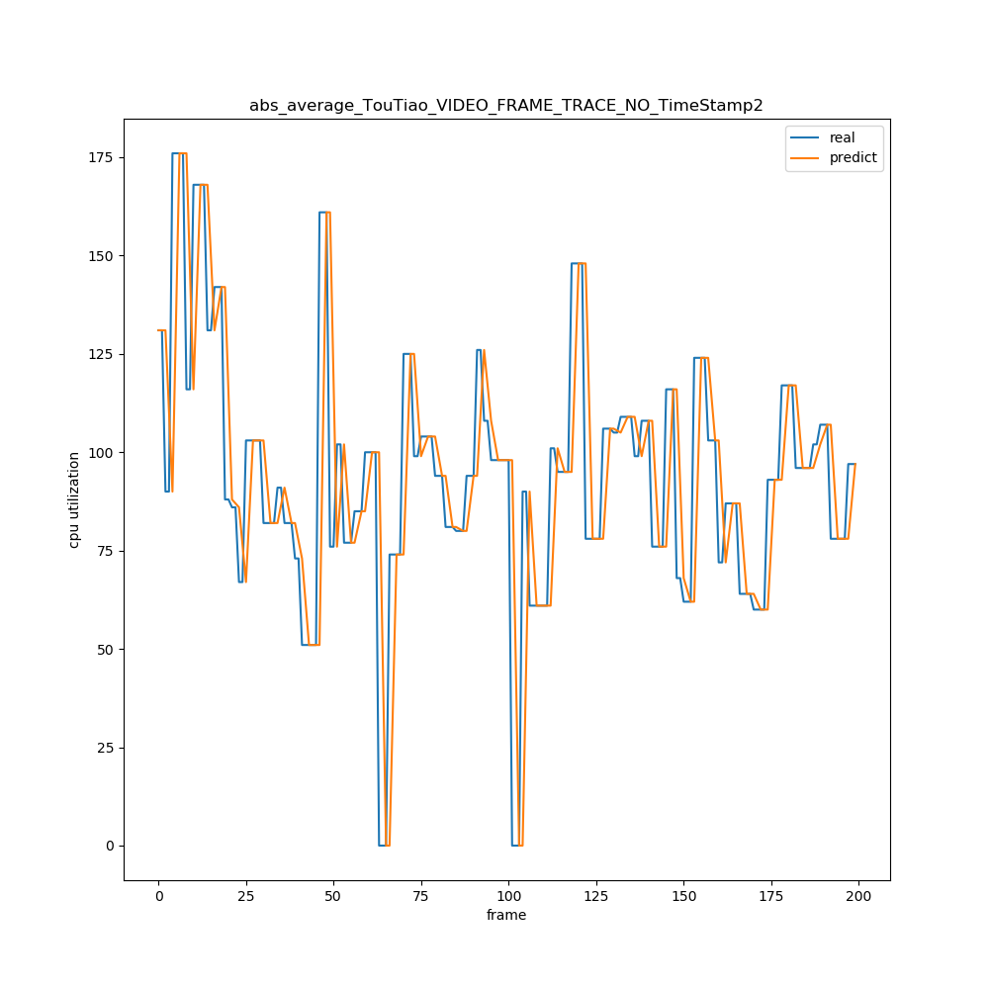

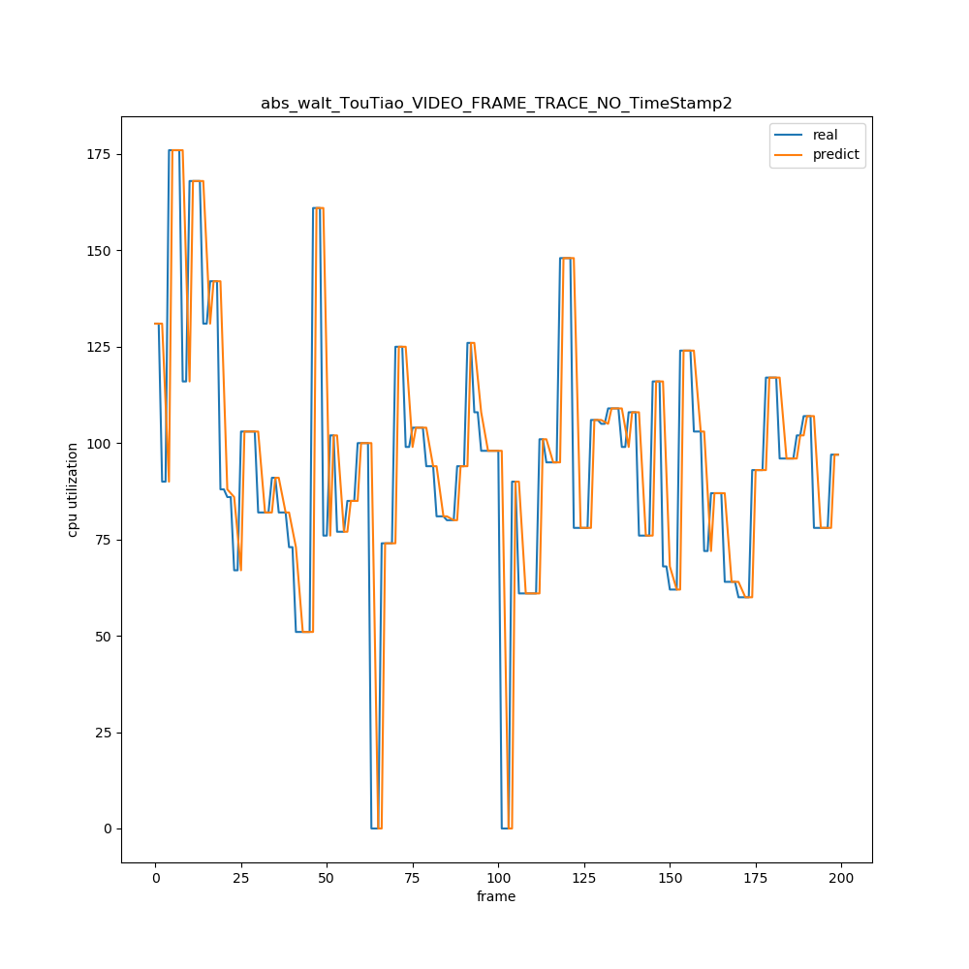

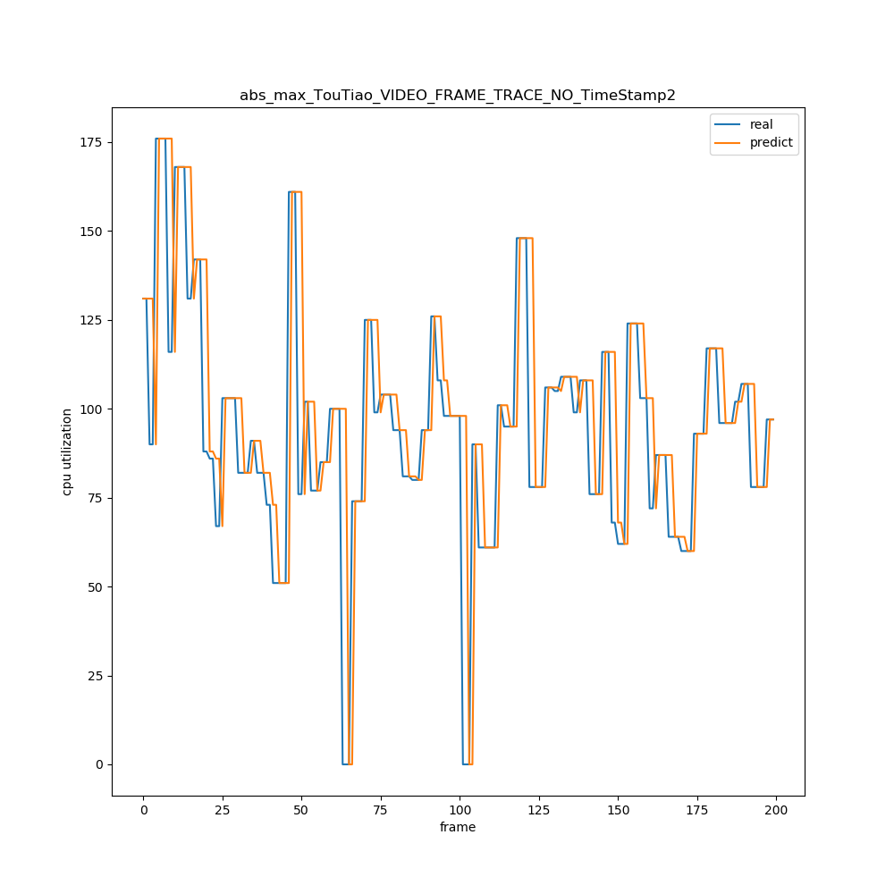

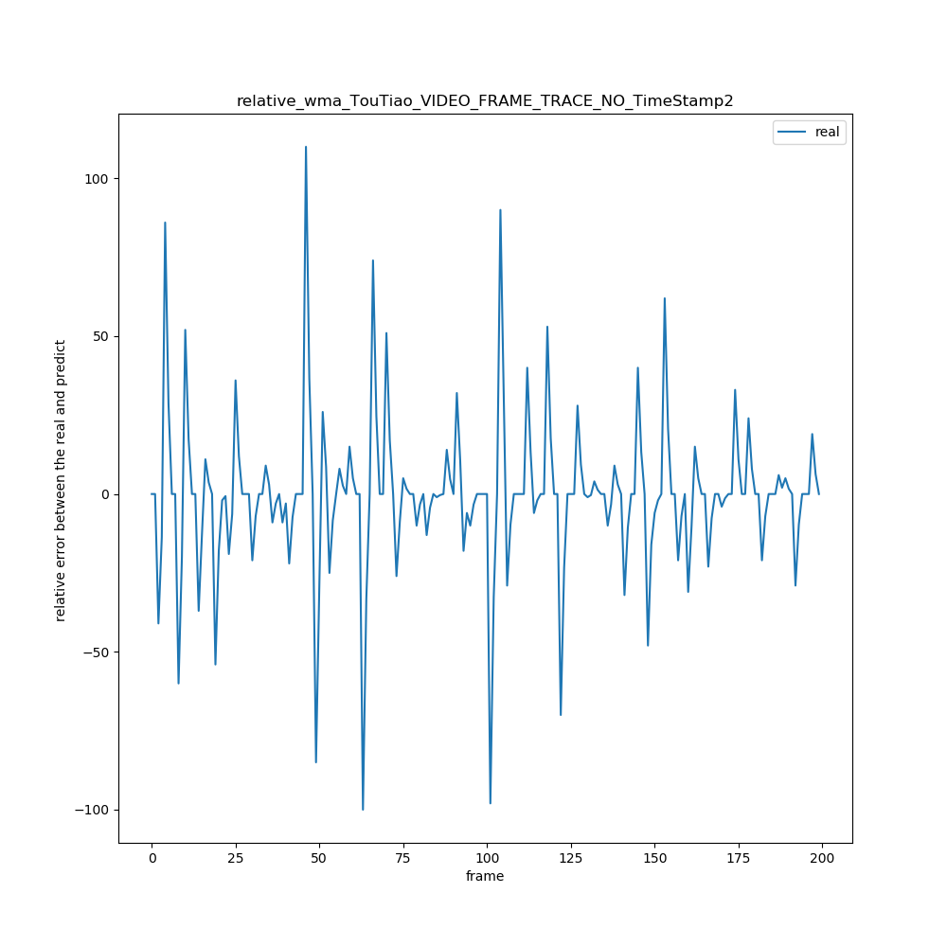

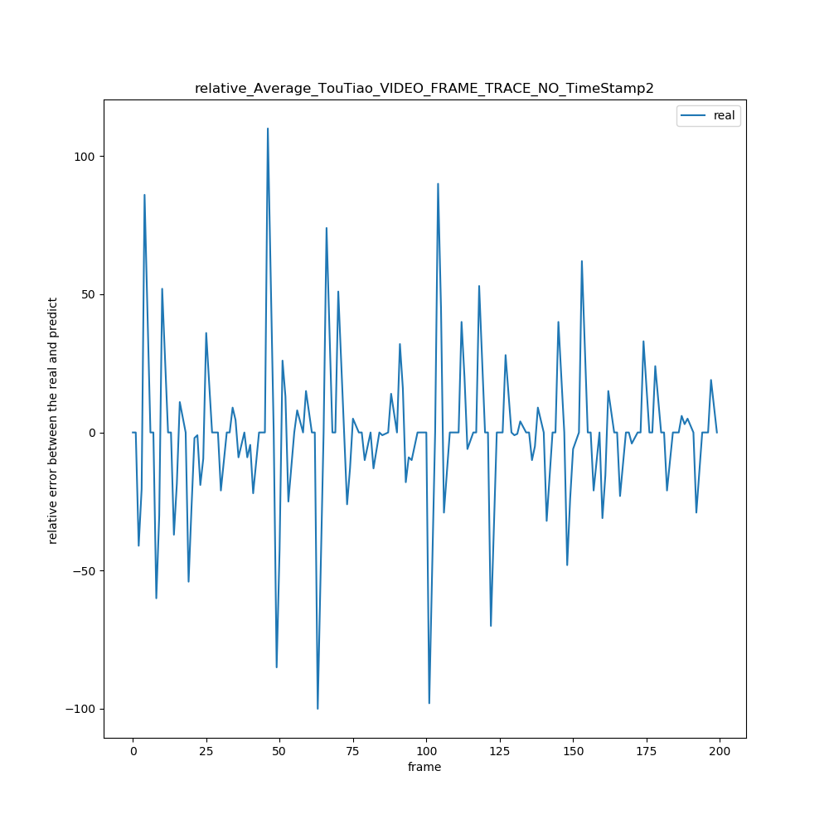

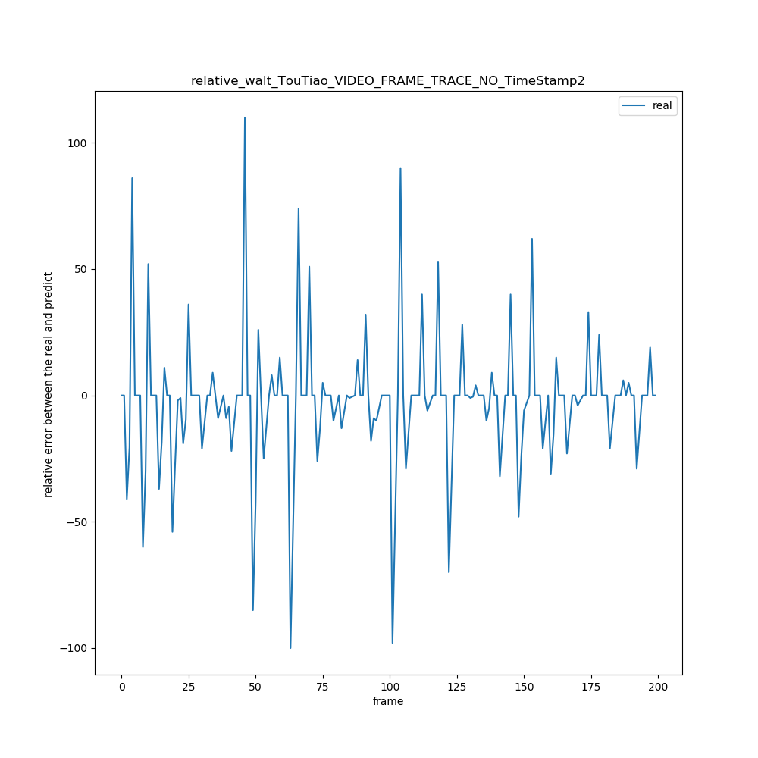

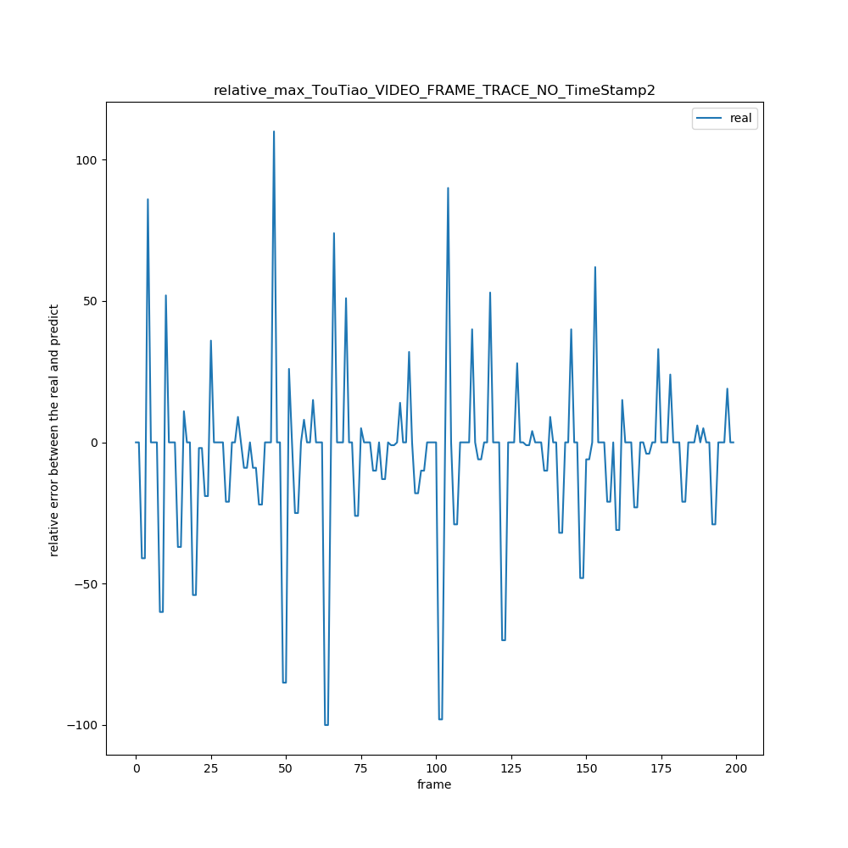

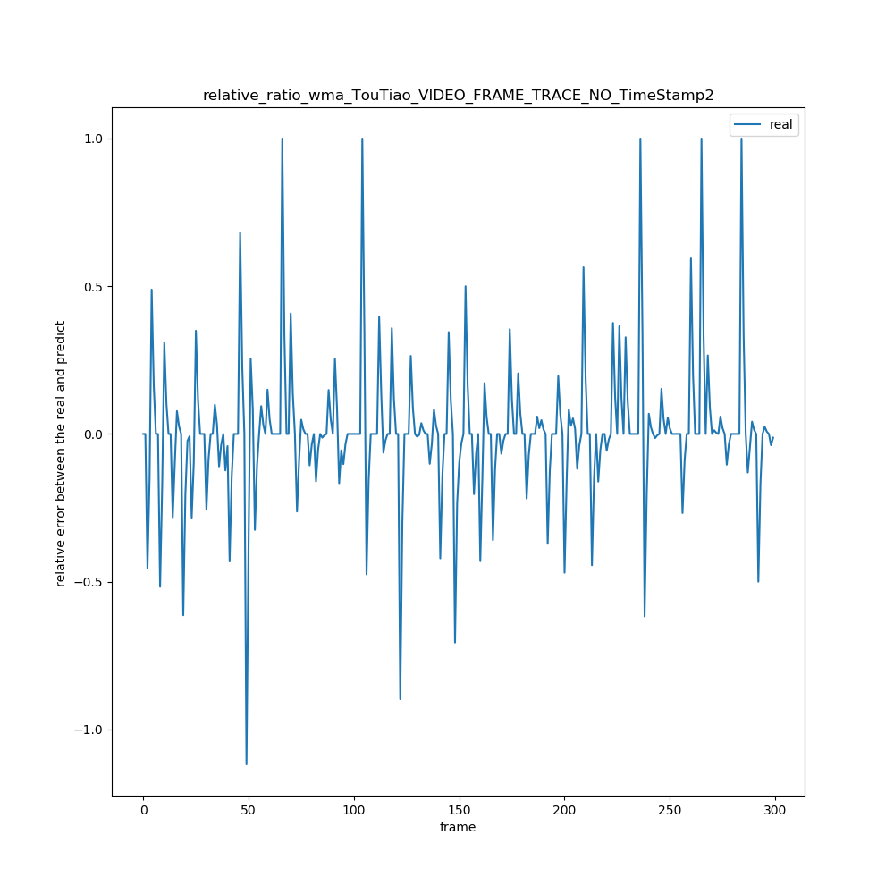

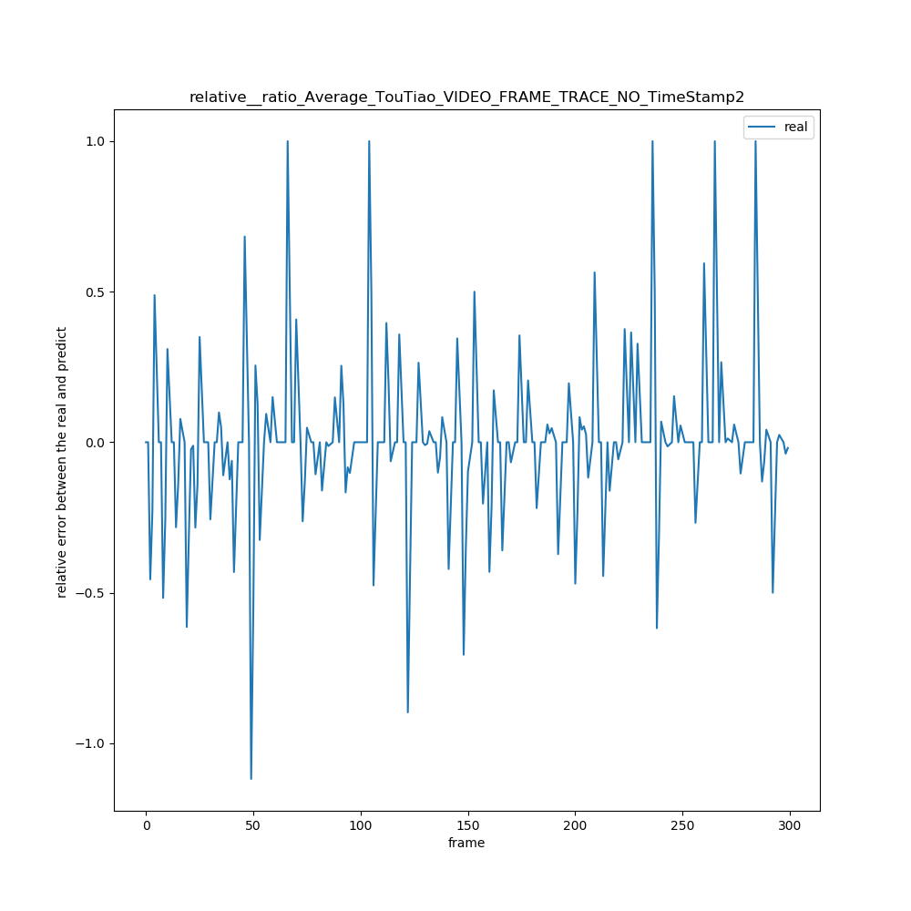

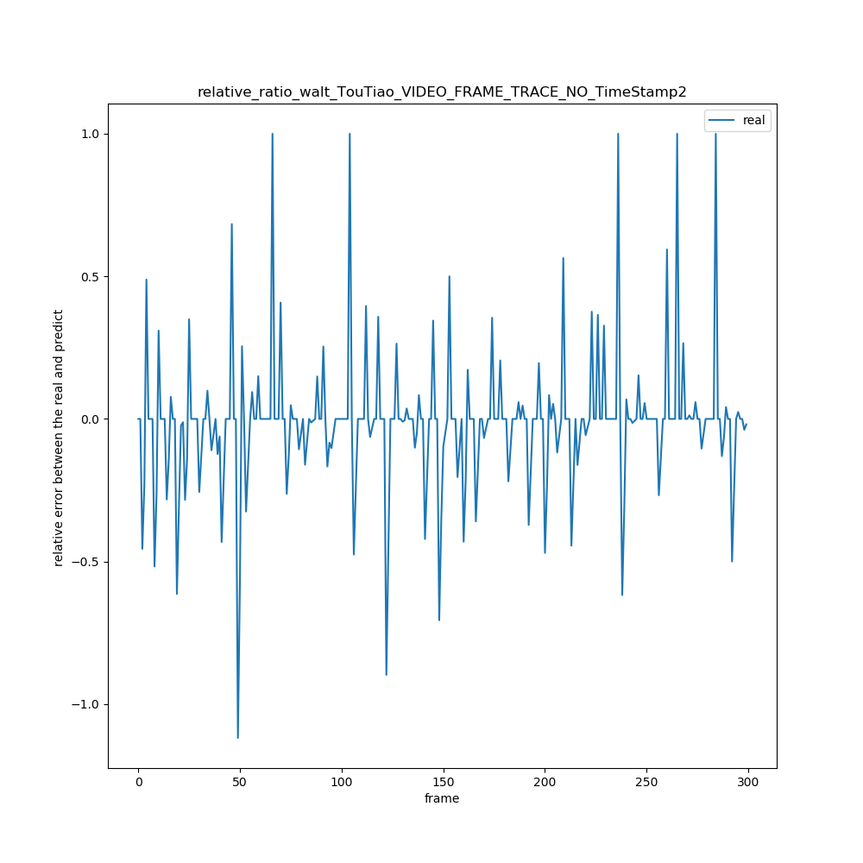

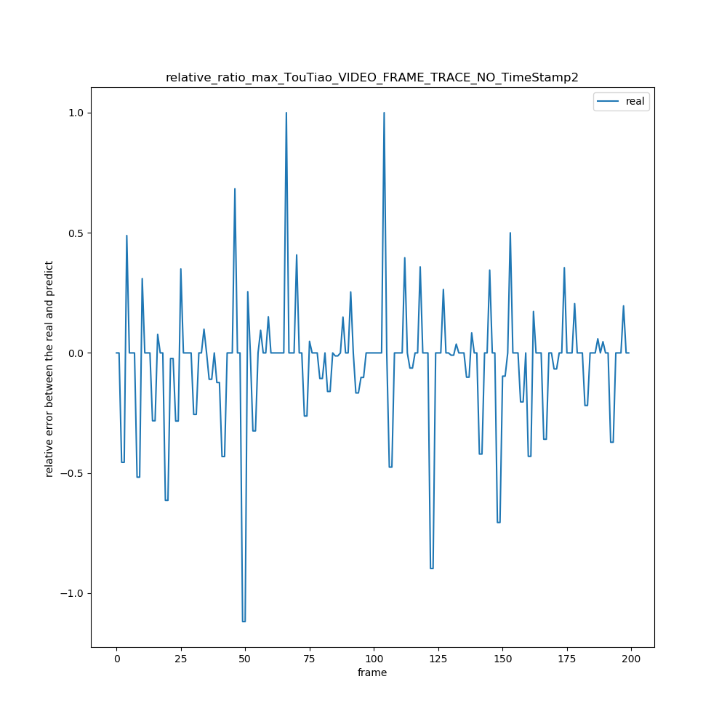

3 util_trace\UC_TRACE_NO_EVENTS_UTIL\UC_ROLL_FRAME_TRACE3_NO_TimeStamp

|  |  |  |  |  |  |  |  |  |  |
| --- | --- | --- | --- | --- | --- | --- | --- | --- | --- |
| 绝对误差值平均x = ∑abs(real[i] – predict[i]) / (real数组的长度) | N =1 | N = 2 | N =3 | N =4 | N =5 | N =6 | N = 7 | N = 8 | N = 9 |
| WMA | 102.6 | 110.13 | 114.59 | 117.8 | 119.9 | 121.58 | 122.9 | 124.3 | 126.1 |
| AVERAGE | 102.6 | 114.6 | 120.2 | 123.9 | 125.1 | 126.9 | 128.4 | 130.7 | 135.0 |
| WALT | 102.6 | 117.8 | 121.60 | 123.91 | 124.64 | 124.67 | 125.7 | 127.4 | 130.0 |
| MAX | 102.6 | 136.5 | 157.9 | 180.6 | 201.7 | 217.7 | 235.5 | 251.3 | 268.4 |

|  |  |  |  |  |  |  |  |  |  |
| --- | --- | --- | --- | --- | --- | --- | --- | --- | --- |
| 相对误差率平均x =(∑（predict[i] – real[i]）/ real[i])/ (real数组长度) | N = 1 | N = 2 | N =3 | N =4 | N =5 | N =6 | N = 7 | N = 8 | N = 9 |
| MAX | 15.9 | 27.09 | 34.3 | 43.7 | 51.9 | 58.0 | 65.9 | 71.7 | 78.3 |
| AVERAGE | 15.9 | 18.1 | 18.6 | 19.9 | 21.4 | 22.5 | 23.4 | 23.9 | 24.8 |
| WALT | 15.9 | 21.5 | 23.9 | 25.7 | 27.4 | 28.2 | 29.2 | 29.8 | 30.6 |
| WMA | 15.9 | 17.3 | 18.0 | 18.7 | 19.6 | 20.4 | 21.2 | 21.8 | 22.4 |

|  |  |  |  |  |  |  |  |  |  |
| --- | --- | --- | --- | --- | --- | --- | --- | --- | --- |
| 相对误差率绝对平均x =(∑（（abs(predict[i] – real[i])）/ real[i])/ (real数组长度) | N =1 | N = 2 | N =3 | N =4 | N =5 | N =6 | N = 7 | N = 8 | N = 9 |
| WMA | 16.3 | 17.8 | 18.4 | 19.1 | 20.0 | 20.88 | 21.6 | 22.2 | 22.8 |
| AVERAGE | 16.3 | 18.5 | 19.1 | 20.3 | 21.8 | 22.9 | 23.8 | 24.3 | 25.2 |
| WALT | 16.3 | 21.8 | 24.2 | 25.9 | 27.7 | 28.5 | 29.4 | 30.0 | 30.8 |
| MAX | 16.3 | 27.4 | 34.6 | 43.8 | 52.0 | 58.1 | 66.0 | 71.8 | 78.4 |

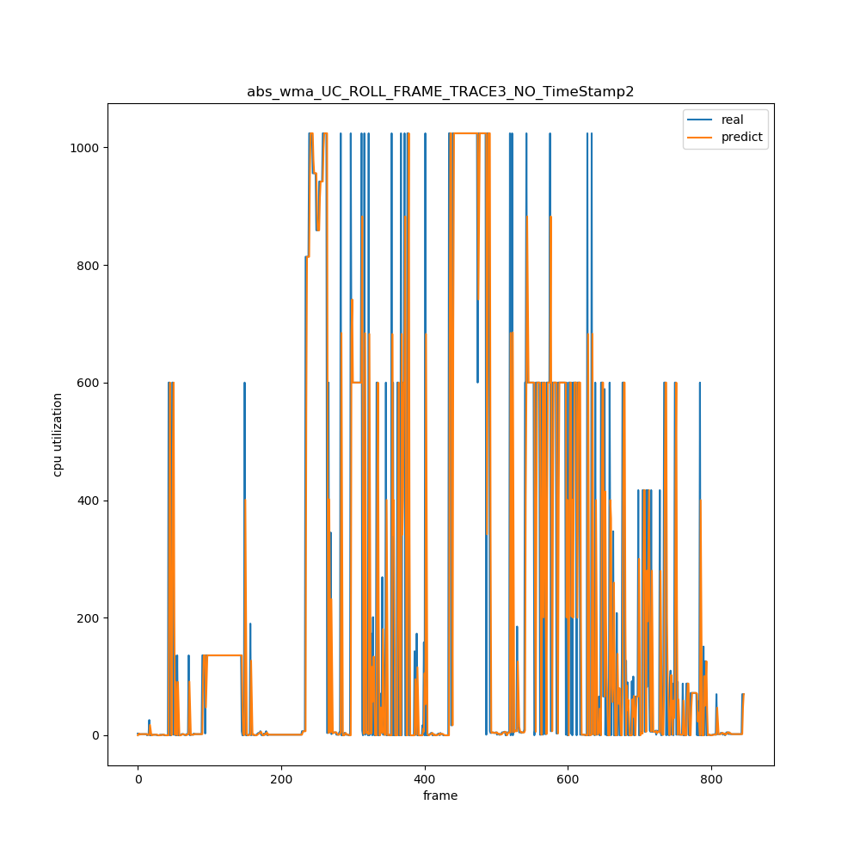

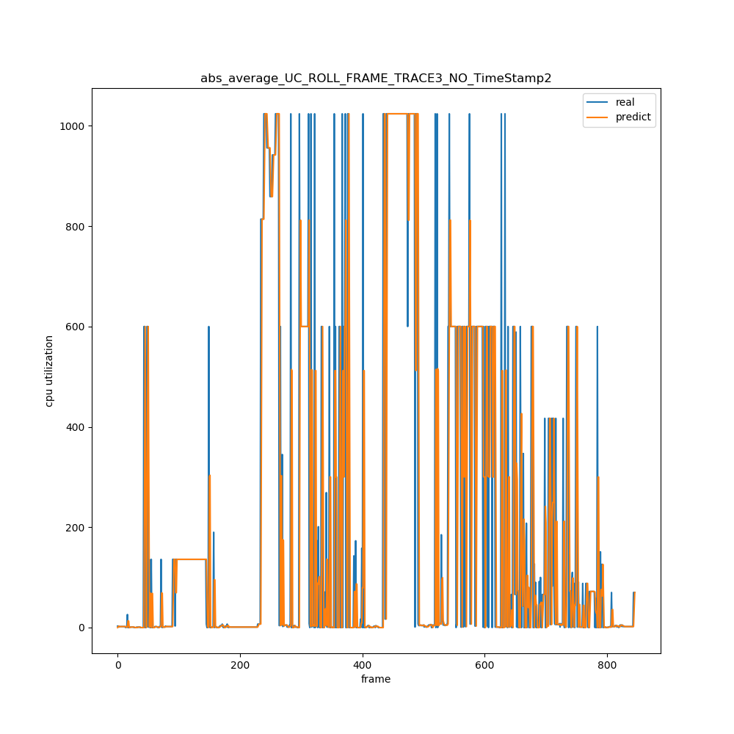

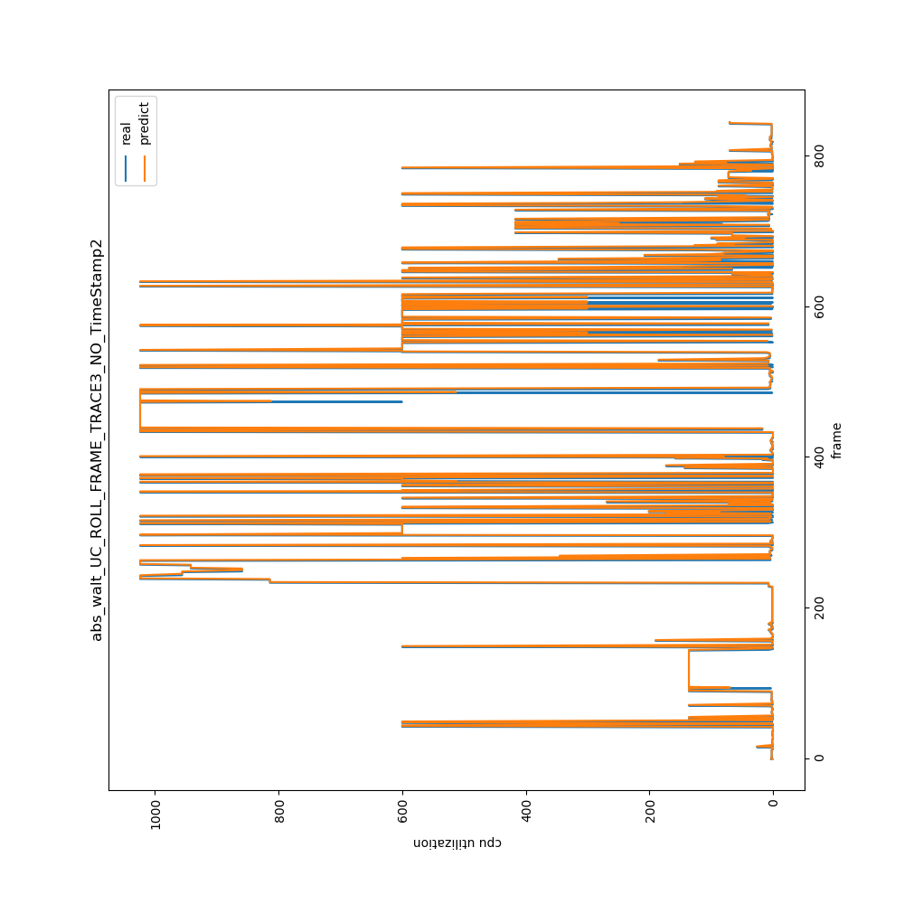

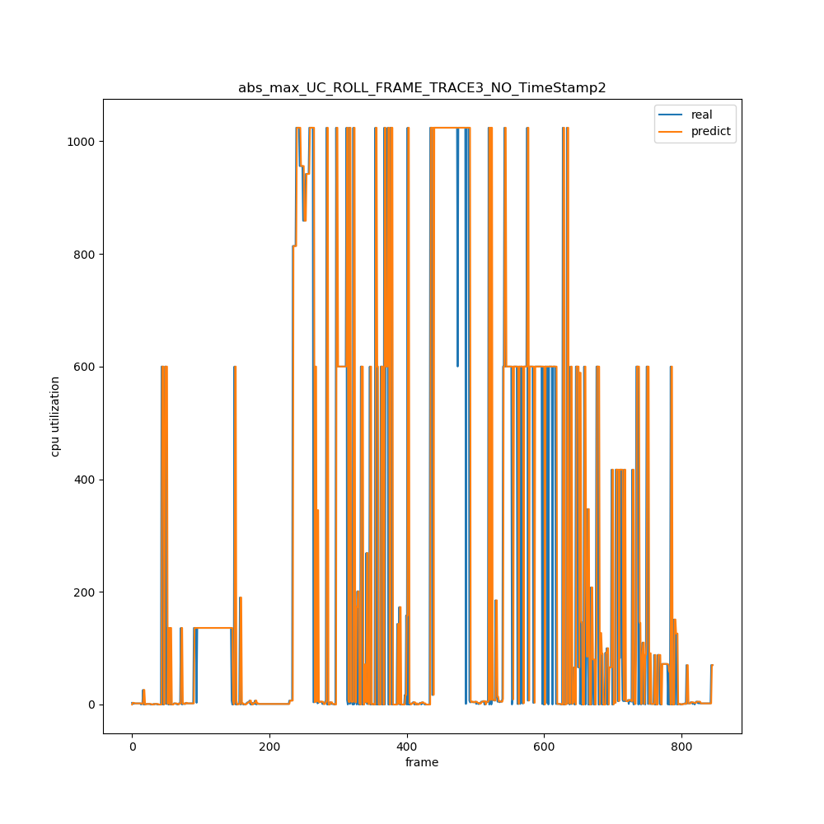

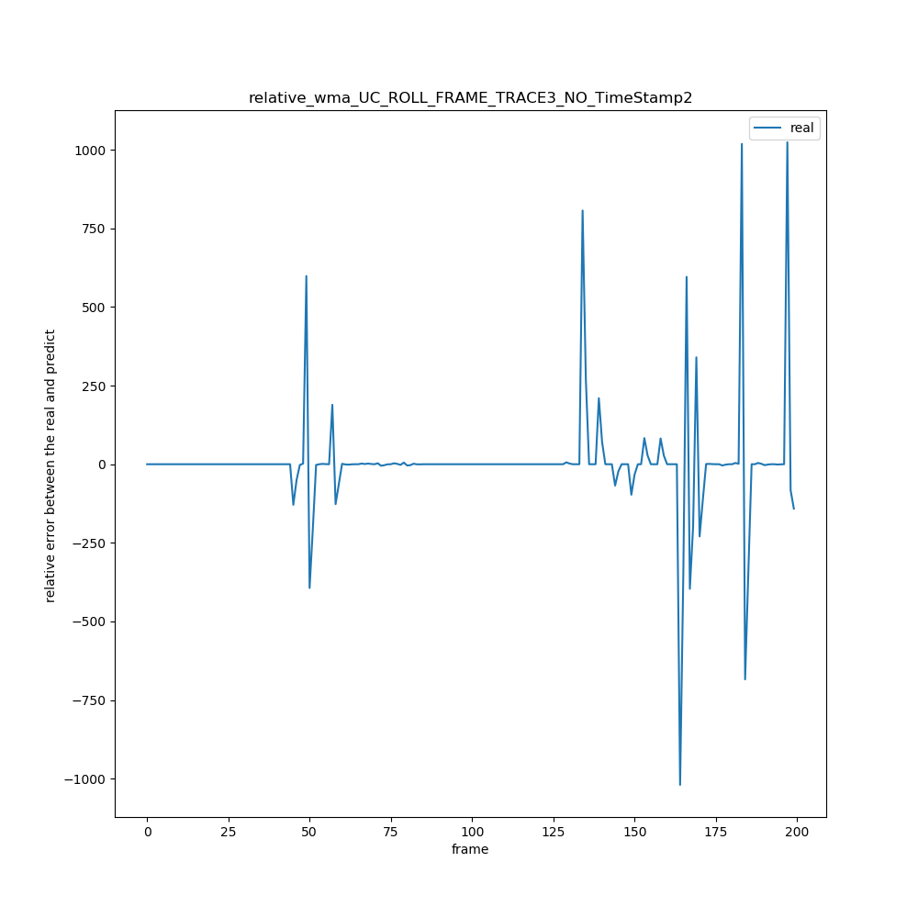

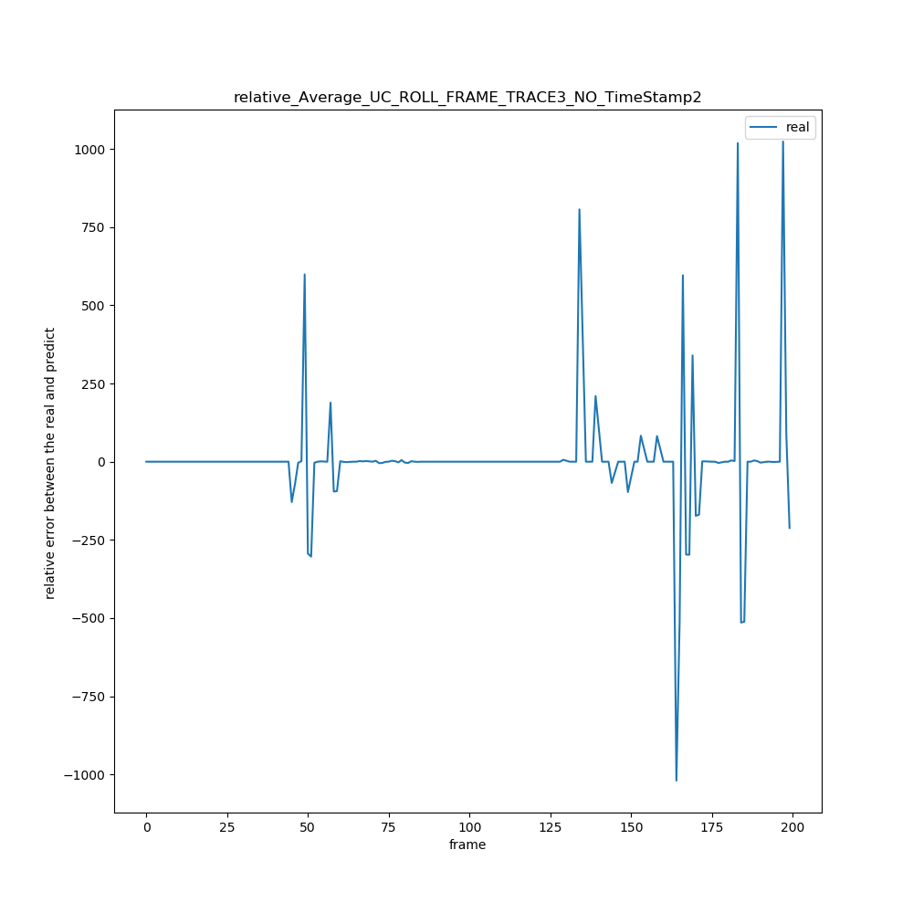

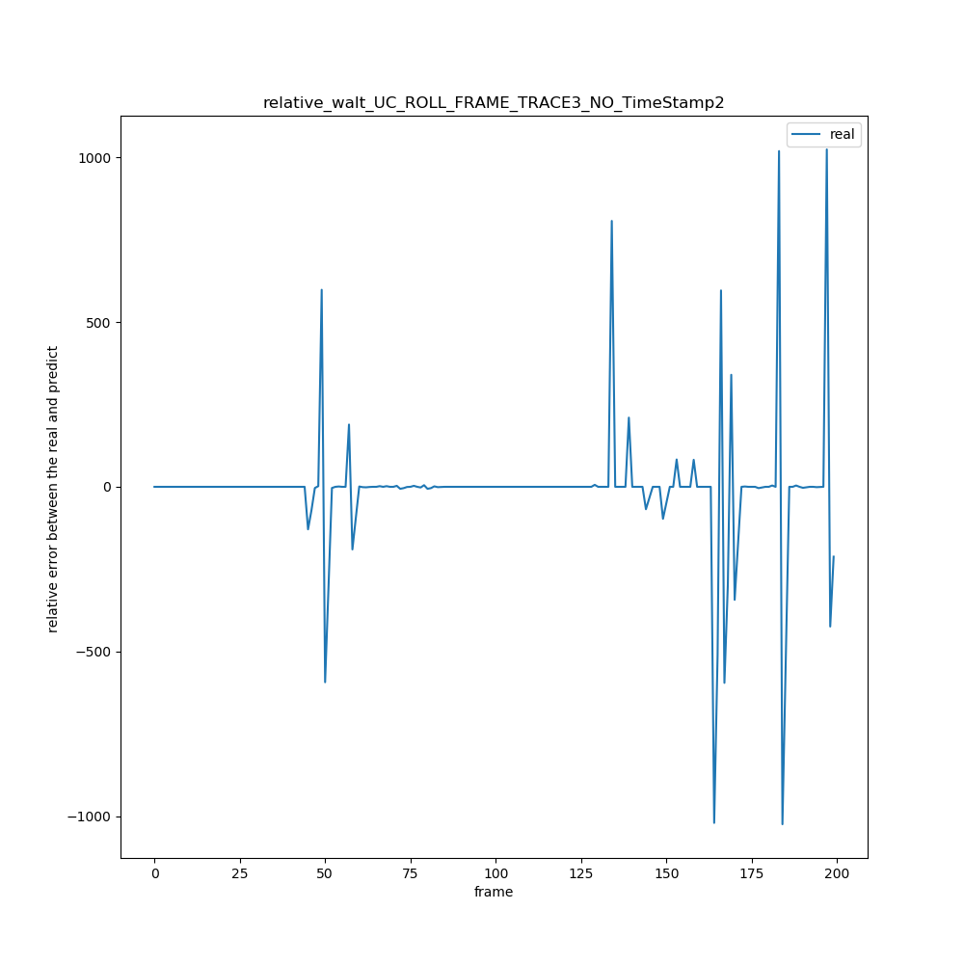

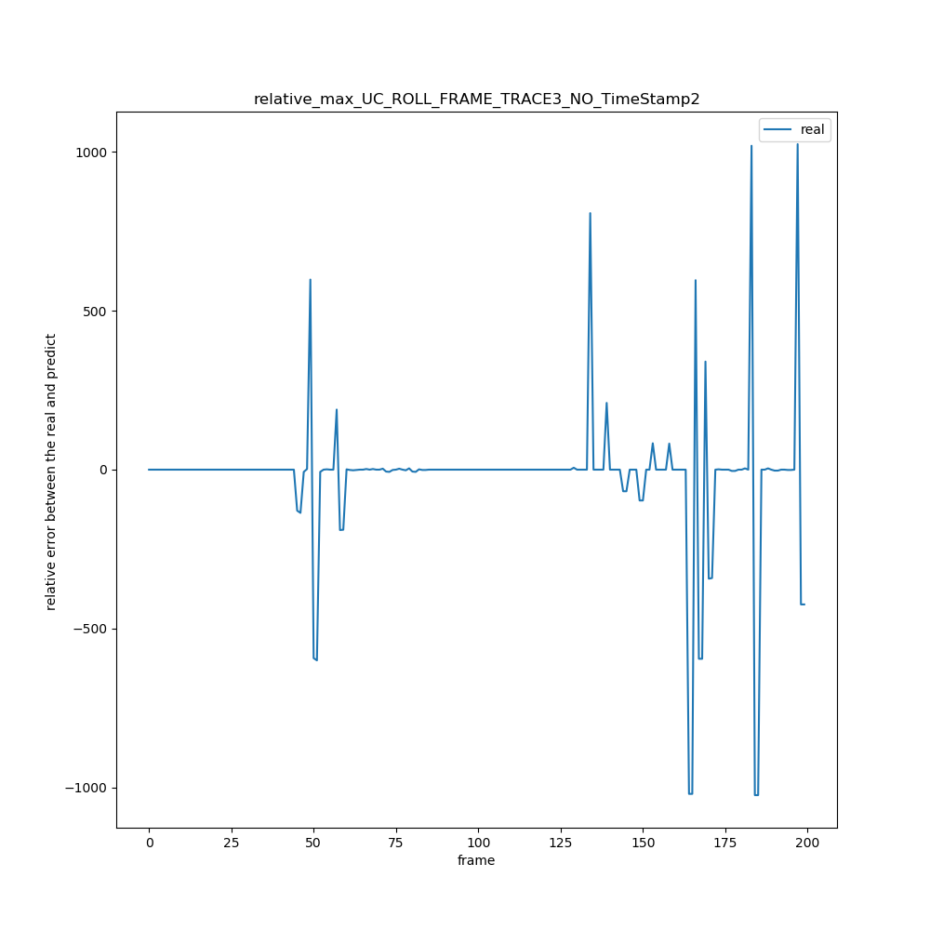

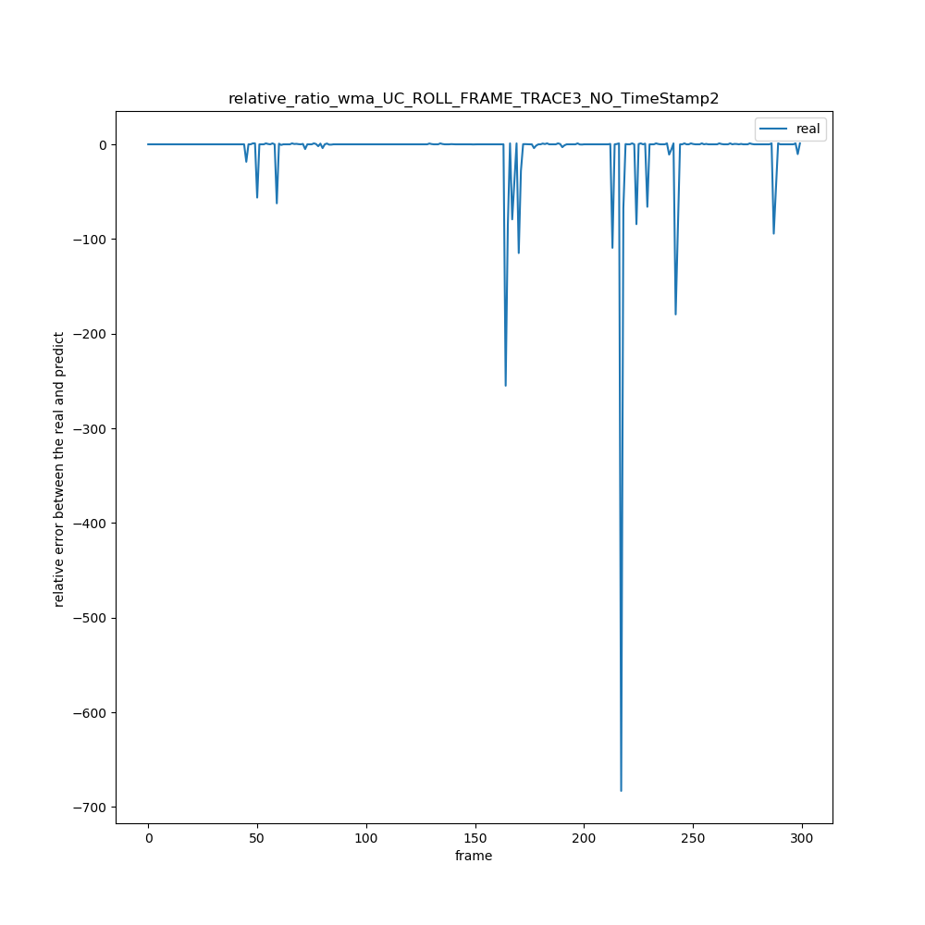

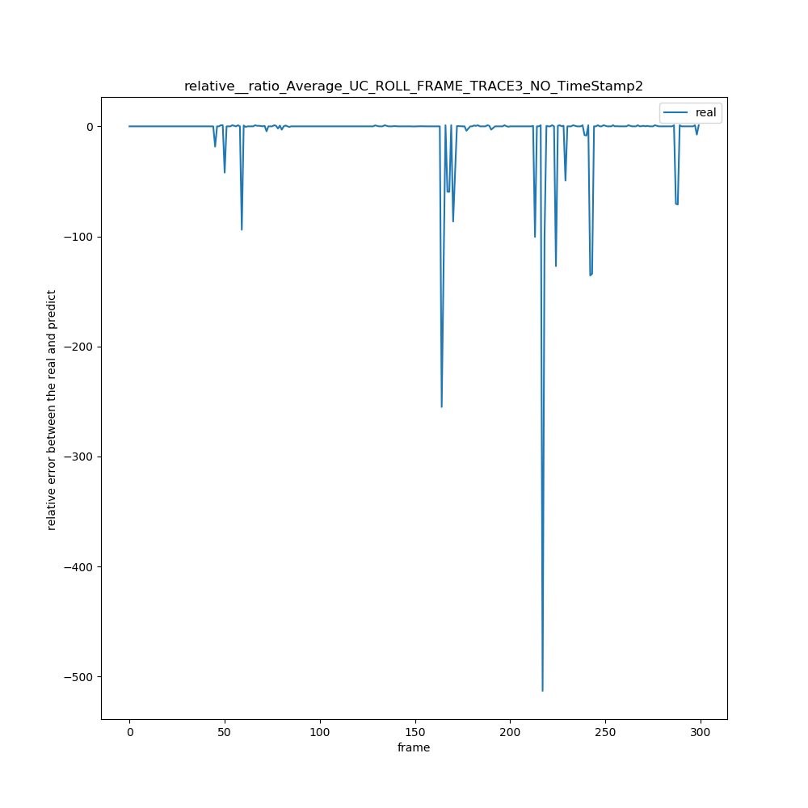

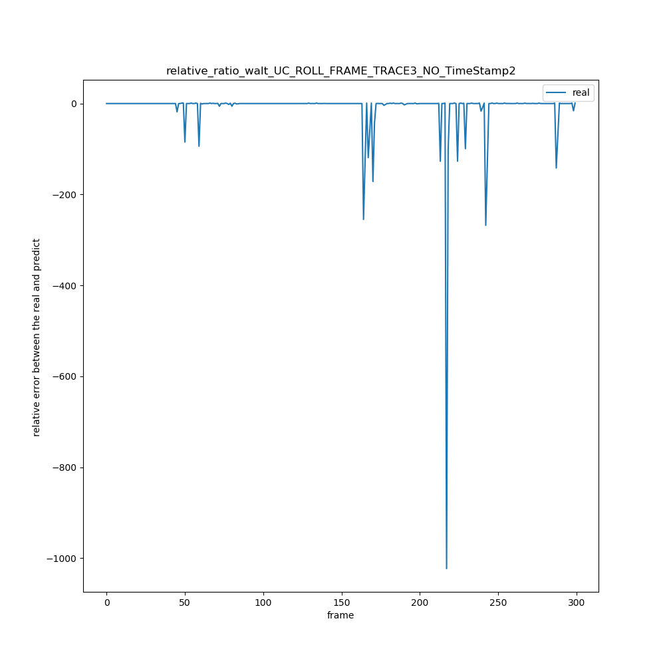

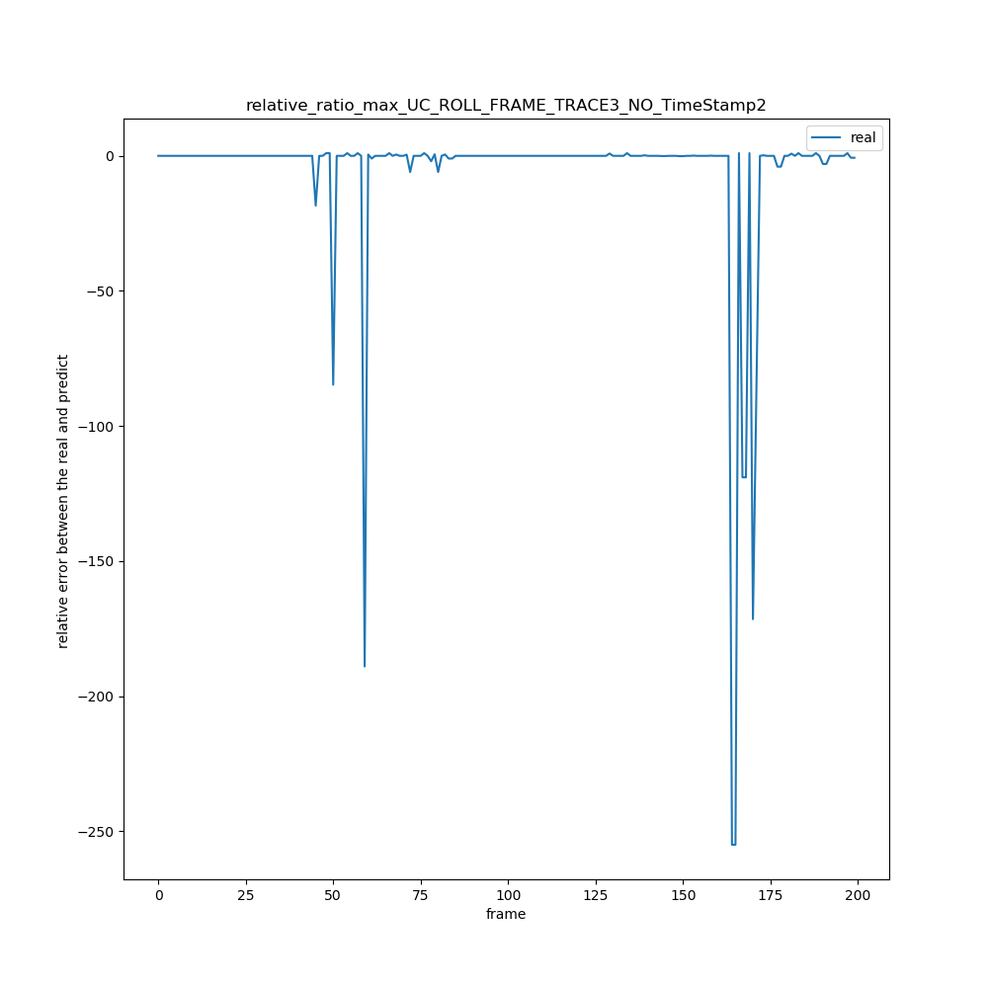

4 WeiBo_TRACE_NO_EVENTS_UTIL\WeiBo_Pic_SLIDE_FRAME_TRACE_NO_TimeStamp

|  |  |  |  |  |  |  |  |  |  |
| --- | --- | --- | --- | --- | --- | --- | --- | --- | --- |
| 绝对误差值平均x = ∑abs(real[i] – predict[i]) / (real数组的长度) | N =1 | N = 2 | N =3 | N =4 | N =5 | N =6 | N = 7 | N = 8 | N = 9 |
| WMA | 33.7 | 39.6 | 43.0 | 45.3 | 47.4 | 49.0 | 50.3 | 51.5 | 52.6 |
| AVERAGE | 33.7 | 43.0 | 47.4 | 50.0 | 52.3 | 54.2 | 55.4 | 56.9 | 58.4 |
| WALT | 33.7 | 41.1 | 45.3 | 47.7 | 49.6 | 51.5 | 53.5 | 55.1 | 56.62.0 |
| MAX | 33.7 | 49.3 | 61.0 | 73.0 | 84.8 | 94.3 | 104.8 | 115.4 | 125.5 |

|  |  |  |  |  |  |  |  |  |  |
| --- | --- | --- | --- | --- | --- | --- | --- | --- | --- |
| 相对误差率平均x =(∑（predict[i] – real[i]）/ real[i])/ (real数组长度) | N =1 | N = 2 | N =3 | N =4 | N =5 | N =6 | N = 7 | N = 8 | N = 9 |
| WMA | 1.59 | 2.0 | 2.1 | 2.2 | 2.3 | 2.4 | 2.4 | 2.4 | 2.4 |
| AVERAGE | 1.59 | 2.2 | 2.2 | 2.4 | 2.6 | 2.4 | 2.4 | 2.3 | 2.4 |
| WALT | 1.59 | 2.4 | 2.9 | 3.3 | 3.6 | 3.5 | 3.5 | 3.5 | 3.6 |
| MAX | 1.59 | 3.4 | 4.4 | 6.5 | 7.1 | 7.6 | 8.1 | 8.8 | 9.9 |

|  |  |  |  |  |  |  |  |  |  |  |
| --- | --- | --- | --- | --- | --- | --- | --- | --- | --- | --- |
|  | 相对误差率绝对平均x =(∑（（abs(predict[i] – real[i])）/ real[i])/ (real数组长度) | N =1 | N = 2 | N =3 | N =4 | N =5 | N =6 | N = 7 | N = 8 | N = 9 |
|  | WMA | 1.86 | 2.2 | 2.3 | 2.52 | 2.63 | 2.6 | 2.6 | 2.6 | 2.6 |
|  | AVERAGE | 1.86 | 2.5 | 2.5 | 2.7 | 2.8 | 2.7 | 2.6 | 2.6 | 2.7 |
|  | WALT | 1.86 | 2.7 | 3.1 | 3.5 | 3.7 | 3.7 | 3.6 | 3.6 | 3.8 |
|  | MAX | 1.86 | 3.5 | 4.5 | 6.6 | 7.2 | 7.6 | 8.2 | 8.8 | 10.0 |

