Analyzing the features of tracks that define their commercial popularity
Authors: Jakub Habib (483800), Truong Giang Do (488388)

Abstract
This paper investigates how track-level acoustic characteristics are associated with commercial performance on Spotify, measured by the platform's popularity index. The empirical analysis is based on 89,741 unique tracks after strict deduplication by track identifier. Because 10.53% of observations are concentrated at the lower bound (popularity = 0), we model the dependent variable as left-censored and estimate Type I Tobit specifications by Maximum Likelihood, using OLS only as a benchmark. Following a general-to-specific strategy, we compare unrestricted and restricted Tobit models via likelihood-ratio testing. The results show that danceability and loudness are positively associated with expected popularity, whereas longer duration, speechiness, and instrumentalness are negatively associated with market outcomes. Moreover, the interaction between explicit lyrics and danceability is positive and statistically significant, indicating that the popularity premium of danceability is stronger for explicit tracks. Overall, the findings support the use of a censored-regression framework and provide economically interpretable marginal effects for strategic decision-making in the music industry

1. Introduction
Digital music markets are characterized by extreme product abundance, low switching costs, and substantial uncertainty regarding the commercial trajectory of newly released tracks. For record labels and independent artists, this creates a core allocation problem: promotional resources are limited, while a large pool of songs competes for listener attention. Identifying which measurable song attributes are systematically linked to market success is therefore an important empirical and managerial question.
This paper focuses on Spotify's popularity score (0-100), a bounded indicator based on listening volume and recency. A non-trivial share of tracks is observed at zero popularity, which motivates a censored-regression approach. The study tests two hypotheses: H1, higher danceability is associated with higher expected popularity; and H2, longer track duration is associated with lower expected popularity. In addition, we evaluate whether explicit lyrics moderate the danceability-popularity relationship through an interaction term. Methodologically, inference is based on Tobit models estimated by Maximum Likelihood, while OLS is treated as a benchmark to illustrate potential bias in variable-retention decisions under censoring.

2. Literature Review

2.1 The Economics of Digital Music Markets and Platform Dynamics
The transition from physical sales to digital streaming has fundamentally altered the economic landscape of the music industry. In traditional frameworks, music was classified as an experience good (Nelson, 1970), meaning consumers could not fully ascertain its value before purchase. Today, platforms such as Spotify have eliminated the marginal cost of listening to individual tracks, shifting the industry constraint from consumer purchasing power to consumer attention. In this attention economy, streaming platforms operate as multi-sided markets where algorithms and curated playlists dictate a track’s visibility. Consequently, the commercial success of a song. captured by its popularity metric, is no longer solely a function of artistic merit or exogenous marketing budgets, but is intrinsically linked to how its measurable acoustic characteristics align with platform algorithms and aggregate listener preferences (Aguiar & Waldfogel, 2018). Understanding these systematic demand drivers has become a central empirical question for record labels and independent creators attempting to optimize resource allocation under high uncertainty.

2.2 Acoustic Features as Predictors of Commercial Success
The availability of granular audio-feature data via the Spotify Web API has generated a growing body of literature attempting to map acoustic properties to commercial outcomes. Empirical studies consistently identify several core dimensions that drive mainstream engagement. Saragih (2023), investigating the preferences of streaming users, confirmed that features related to a track's rhythm and intensity, specifically energy, danceability, and acousticness, carry significant predictive power. Danceability, in particular, has emerged as a primary vector for commercial viability, reflecting a broader consumer preference for rhythmically accessible and highly engaging musical structures.
Furthermore, recent literature highlights a structural shift in compositional duration. As streaming platforms distribute royalties on a pro-rata basis (where a stream is typically monetized after 30 seconds of listening), there is an economic incentive for artists to produce shorter tracks. Listeners in digital environments exhibit high skip rates; thus, longer tracks face a higher probability of abandonment, which negatively impacts algorithmic recommendation and overall popularity.
Another dimension frequently examined is the vocal and lyrical content of the music, operationalized through metrics such as speechiness, instrumentalness, and the presence of explicit lyrics. While mainstream pop heavily relies on vocal performance, tracks characterized by extreme speechiness (often associated with non-musical spoken word or dense rap) or pure instrumentalness tend to occupy niche markets, typically exhibiting lower average popularity in global cross-sections. The role of explicit lyrics remains complex; while often associated with specific high-performing genres (such as modern hip-hop), its independent effect versus its interaction with structural features like danceability requires careful multivariate analysis.

2.3 Methodological Considerations: Machine Learning vs. Econometric Inference
Methodologically, the literature analyzing track popularity diverges into two distinct streams. The first strand predominantly utilizes predictive machine learning techniques. For instance, Jiang (2024) applied advanced algorithmic models to Spotify data, achieving high predictive accuracy regarding track success. While machine learning excels at pattern recognition, such models operate as algorithmic black boxes, offering limited structural interpretation of the underlying economic mechanisms and failing to provide interpretable marginal effects necessary for policy or business strategy.
The second strand employs standard linear econometrics (OLS) to estimate the partial associations between acoustic features and popularity. However, this approach frequently ignores the distributional constraints of the dependent variable. As observed in global streaming data, a substantial proportion of released music fails to acquire any significant listener base, resulting in a strict lower bound where popularity equals zero. Treating such a left-censored distribution as a continuous, unbounded variable violates the core assumptions of the classical linear regression model, leading to biased and inconsistent parameter estimates (Greene, 2018).
To address this structural issue, our study anchors its methodology in the limited dependent variable framework formalized by Tobin (1958). The Tobit model explicitly accounts for the probability mass at the censoring threshold, allowing for the unbiased recovery of the latent propensity for commercial success. Furthermore, rather than relying on ad hoc variable selection or biased OLS significance tests, this paper applies the General-to-Specific (GETS) modeling approach (Hendry, 1995). The GETS framework mandates beginning with a comprehensive, theoretically justified general model and imposing parameter restrictions only when validated by formal likelihood-ratio testing. This disciplined econometric strategy minimizes omitted variable bias and ensures that the final model specification accurately reflects the true data-generating process of music popularity.

3. Data

3.1 Data Source and Preprocessing Pipeline
The empirical analysis relies on the cross-sectional "Spotify Tracks Dataset" sourced from Kaggle. This dataset comprises granular audio features and metadata for tracks across 114 diverse musical genres, extracted programmatically via the official Spotify Web API. The raw dataset initially contained exactly 114,000 observations. While the large scale of the sample is highly advantageous for achieving stable and consistent parameter estimates, it also introduces specific data-engineering challenges that must be addressed prior to econometric modeling.
A critical preprocessing step in this analysis is strict deduplication. In the Spotify ecosystem, algorithmic categorization frequently assigns a single track to multiple genre playlists simultaneously (e.g., a song might be tagged as both "pop" and "dance"). Consequently, the raw dataset contained numerous duplicate entries representing the exact same track. Treating these duplicates as independent observations in a regression framework would violate the assumption of identically and independently distributed (i.i.d.) errors, artificially inflating the sample size, biasing standard errors downward, and ultimately overstating the statistical significance of the estimated coefficients. To ensure strict data integrity, we performed aggressive deduplication utilizing the unique track_id identifier. This rigorous filtering process removed 24,259 duplicated records. Following listwise deletion of a negligible number of missing values across the variables of interest, the final, robust working sample consists of 89,741 unique tracks. This ensures that the subsequent estimation reflects true underlying relationships rather than algorithmic redundancy.

3.2 Variable Operationalization
The dataset provides a vector of both metadata and computationally derived acoustic features for each track. The dependent variable is the popularity metric, a proprietary index developed by Spotify that ranges from 0 to 100. This metric is dynamic and non-linear, calculated based on the total number of streams a track receives and the recency of those streams, thus serving as a robust proxy for contemporary commercial success.
The independent variables consist of a set of continuous acoustic features and categorical controls. To facilitate economically meaningful interpretations of the marginal effects, we applied standard transformations. The track duration, originally recorded in milliseconds (duration_ms), was transformed into minutes (duration_min). The lyrical content of the track was operationalized using a binary dummy variable, explicit, taking the value of 1 if the track contains explicit language and 0 otherwise.
The core acoustic predictors include variables standardized by Spotify on a continuous scale from 0.0 to 1.0. These encompass danceability (the suitability of a track for dancing based on tempo, rhythm stability, and beat strength), energy (a perceptual measure of intensity and activity), acousticness (the confidence measure of whether the track is acoustic), speechiness (detecting the presence of spoken words, with higher values indicating talk-show or rap-like characteristics), instrumentalness (predicting the absence of vocals), liveness (the probability that the track was performed with a live audience), and valence (the musical positiveness conveyed by a track). Additionally, tempo is measured in continuous beats per minute (BPM), while musical key (representing 12 pitch classes) and time_signature are incorporated strictly as categorical factor variables to control for compositional structure without imposing false linearity.

3.3 Exploratory Data Analysis and Censoring Constraints
Exploratory Data Analysis (EDA) was conducted to verify the distributional properties of the variables and assess potential multicollinearity. A correlation matrix of the continuous acoustic features was generated (see Figure 1). The correlation matrix confirms that while some expected relationships exist (such as a negative correlation between acousticness and energy), the explanatory variables do not exhibit near-perfect linear dependence. This confirms the absence of severe multicollinearity, ensuring that the multivariate model can successfully isolate the partial associations of individual acoustic features.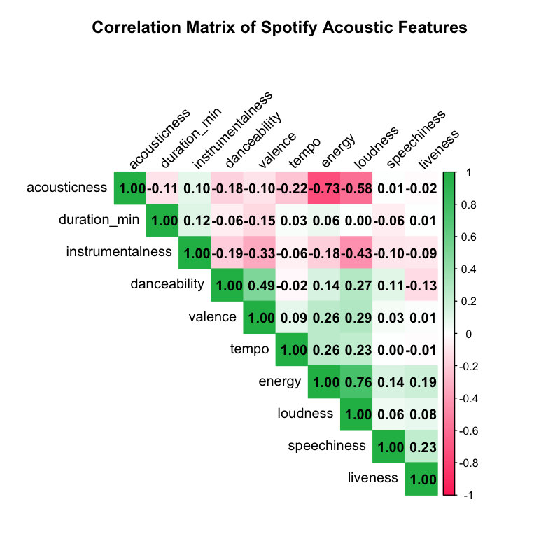
Figure 1: Correlation Matrix of Continuous Acoustic Features.
The most critical finding from the EDA concerns the distribution of the dependent variable. An examination of the popularity metric reveals a highly informative empirical distribution: 9,448 tracks, representing 10.53% of the cleaned sample, possess a popularity score of exactly zero. This substantial mass point at the lower boundary is clearly visualized in the generated histogram (see Figure 2).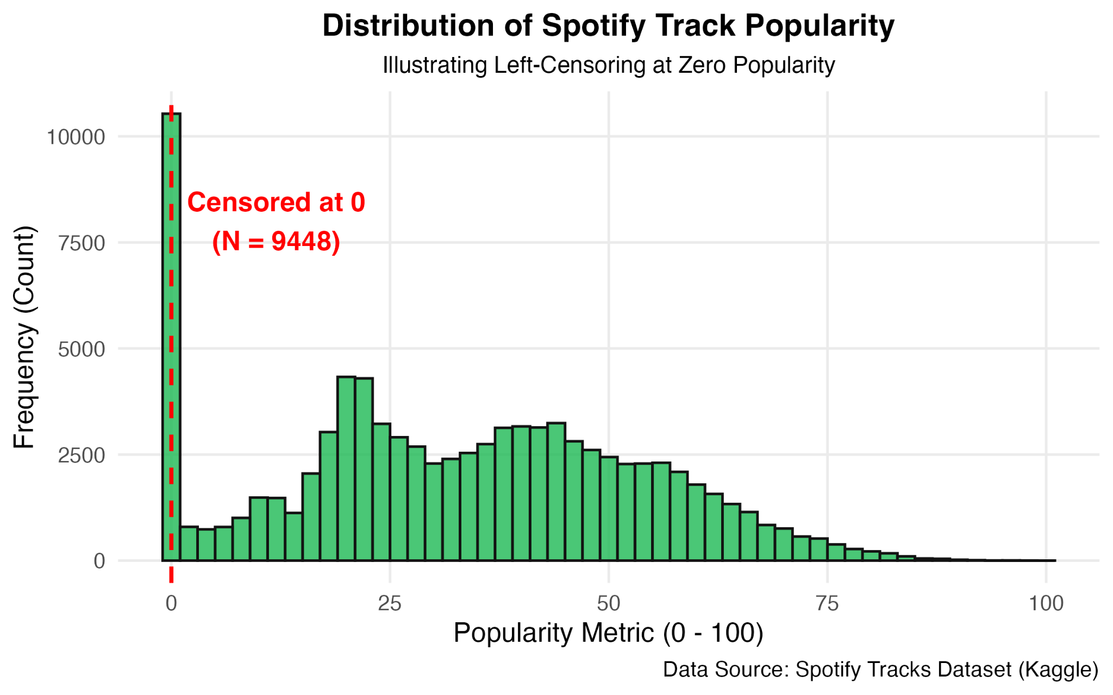
Figure 2: Distribution of Spotify Track Popularity (Illustrating Left-Censoring at Zero).
From an econometric standpoint, this concentration at zero indicates that the dependent variable is strictly left-censored. The score of zero does not necessarily imply negative popularity; rather, it reflects a threshold effect where tracks fail to generate sufficient streaming volume to register on the platform's index. In this scenario, estimating the parameters using an unbounded continuous assumption (such as standard OLS) would produce a line of best fit that is pulled downward by the mass at zero, fundamentally biasing the slope coefficients. This distributional constraint directly justifies the abandonment of purely linear models for structural interpretation and necessitates the use of a censored-regression framework, which is formally defined in the subsequent methodological section.

4. Method/Model
As demonstrated in the exploratory data analysis, the dependent variable (popularity) exhibits a strict lower bound, with a significant probability mass concentrated exactly at zero. In such settings, applying Ordinary Least Squares (OLS) to the entire sample yields biased and inconsistent parameter estimates, as the linear conditional mean function fails to account for the truncation of the data-generating process (Greene, 2018). While OLS is retained in this study solely as a naive baseline for comparative purposes, structural inference requires a Limited Dependent Variable approach.
Consequently, we employ the Type I Tobit model (Tobin, 1958). The theoretical foundation of the Tobit framework posits the existence of a latent, unobserved variable, ​, which represents the true, unbounded underlying propensity for a track's commercial success. The structural equation for this latent variable is defined as a linear combination of covariates:
In this equation, X_i represents the vector of acoustic characteristics and categorical controls for track i, β is the vector of structural parameters, and 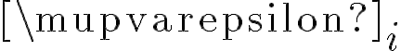 is the normally distributed idiosyncratic error term. The observed popularity, , is linked to the latent propensity through the following censoring observation rule:
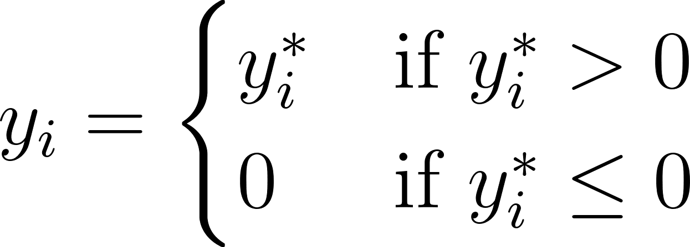
This specification perfectly aligns with the empirical reality of the Spotify streaming market: a track must cross a certain threshold of listener engagement to register a popularity score greater than zero; otherwise, its observed popularity is zero, regardless of how deeply negative its latent commercial appeal might be.

4.2 Maximum Likelihood Estimation (MLE)
Because the sample contains both censored and uncensored observations, OLS minimization of squared residuals is mathematically inappropriate. Instead, the parameters β and the variance 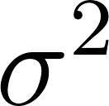 are jointly estimated via Maximum Likelihood Estimation (MLE). The likelihood function for the Tobit model is constructed by combining the probabilities of the censored observations and the probability density of the uncensored observations.
Let 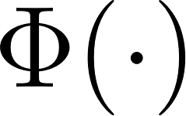 denote the cumulative distribution function (CDF) and 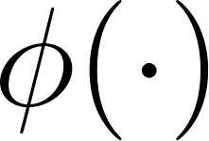 denote the probability density function (PDF) of the standard normal distribution. The log-likelihood function (L) to be maximized is:
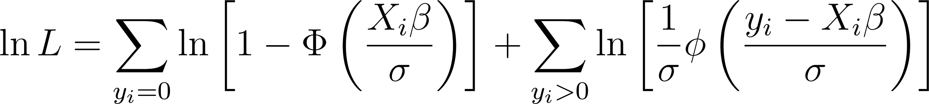
The first summation accounts for the tracks with zero popularity, evaluating the probability that their latent score falls at or below zero. The second summation calculates the density of the normal distribution for tracks that successfully achieved a positive popularity score. MLE ensures that the resulting estimators are asymptotically efficient and normally distributed.

4.3 Marginal Effects and McDonald-Moffitt Decomposition
A critical distinction between OLS and the Tobit model is the interpretation of the estimated coefficients (β). In the Tobit framework, β represents the marginal effect of a change in an independent variable on the latent variable (). However, for practical managerial and economic decision-making, the effect on the actual observed popularity () is of primary interest.
To derive economically interpretable effect sizes, we employ the McDonald and Moffitt (1980) decomposition. The expected value of the observed dependent variable, unconditional on being censored, is given by:
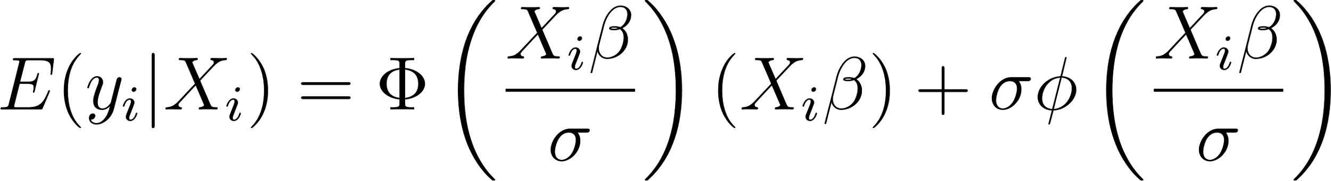
By differentiating this expectation with respect to a continuous regressor x_j, the unconditional average marginal effect is obtained:
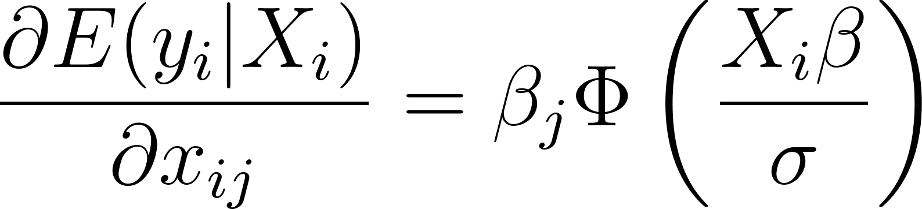
This formula elegantly demonstrates that the marginal effect on the observed popularity is the latent coefficient () scaled by the probability of the observation being uncensored 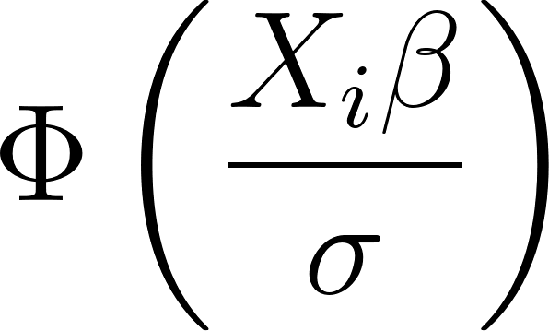. In the results section, we report these scaled average marginal effects to verify our research hypotheses.

4.4 Model Selection and Specification Testing
To ensure the robustness of the final model, our empirical strategy strictly follows the General-to-Specific (GETS) modeling approach outlined by Hendry (1995). The initial general formulation (Model_gen) encompasses the full set of theoretically justified continuous acoustic features, the required interaction term (explicit * danceability), and categorical controls for musical key and time signature.
During the GETS procedure, we test whether variables that appear statistically insignificant can be safely eliminated to achieve a parsimonious specific model (Model_spec). The validity of these parameter restrictions is formally tested using the Likelihood Ratio (LR) test. The LR test statistic is calculated as:
where q is the number of restrictions. If the LR test rejects the null hypothesis, it indicates that the omitted variables carry significant explanatory power within the censored framework, and the unrestricted general model must be retained to avoid omitted variable bias.
Finally, the adequacy of the selected model is evaluated using specific diagnostic tests. The Jarque-Bera test is applied to the Tobit residuals to assess the core MLE assumption of normality. Furthermore, a Linktest is conducted to detect potential functional form misspecification. By regressing the observed outcome on the model's fitted values () and their squares (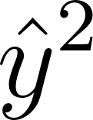), the Linktest determines whether the inclusion of omitted nonlinearities would systematically improve the model's fit.

5. Results

5.1 Model Selection and the General-to-Specific Workflow
Table 1 presents the parameter estimates for three distinct specifications: the baseline OLS model, the unrestricted General Tobit model, and the Restricted Tobit model. Because exploratory data analysis confirmed a substantial clustering of observations at the zero-popularity bound, substantive economic interpretation relies on the Tobit framework, which accounts for this left-censoring. The OLS model is reported strictly as a methodological benchmark to illustrate the bias introduced when distributional constraints are ignored.

Table 1: Popularity Regression Results: OLS vs. Tobit Models
 | Dependent variable:
 | Popularity Metric
 | OLS | Tobit
 | OLS Baseline | General Tobit | Restricted Tobit
 | (1) | (2) | (3)
Duration (min) | -0.218*** | -0.173*** | -0.171***
 | (0.037) | (0.041) | (0.041)
Explicit | 0.427 | 1.474 | 1.446
 | (0.907) | (1.005) | (1.005)
Danceability | 8.287*** | 9.221*** | 9.018***
 | (0.504) | (0.559) | (0.554)
Energy | -2.274*** | -1.490** | -1.153*
 | (0.546) | (0.607) | (0.593)
Key = 1 | 0.150 | 0.113 | 0.093
 | (0.298) | (0.331) | (0.331)
Key = 2 | 0.951*** | 1.197*** | 1.202***
 | (0.289) | (0.321) | (0.321)
Key = 3 | 0.749* | 0.724 | 0.703
 | (0.433) | (0.482) | (0.482)
Key = 4 | 0.993*** | 1.254*** | 1.264***
 | (0.314) | (0.349) | (0.349)
Key = 5 | 0.198 | 0.139 | 0.139
 | (0.310) | (0.345) | (0.345)
Key = 6 | 0.683** | 0.666* | 0.653*
 | (0.329) | (0.365) | (0.365)
Key = 7 | -0.027 | 0.094 | 0.098
 | (0.280) | (0.311) | (0.311)
Key = 8 | 0.943*** | 0.889** | 0.858**
 | (0.337) | (0.374) | (0.374)
Key = 9 | 0.084 | 0.175 | 0.175
 | (0.293) | (0.325) | (0.325)
Key = 10 | 0.132 | 0.119 | 0.106
 | (0.333) | (0.370) | (0.370)
Key = 11 | 0.730** | 0.797** | 0.795**
 | (0.316) | (0.351) | (0.351)
Loudness | 0.082*** | 0.069*** | 0.064**
 | (0.023) | (0.026) | (0.026)
Mode | -0.690*** | -0.733*** | -0.724***
 | (0.147) | (0.163) | (0.163)
Speechiness | -14.269*** | -13.482*** | -13.101***
 | (0.678) | (0.750) | (0.737)
Acousticness | -0.854*** | -0.963*** | -0.854**
 | (0.313) | (0.348) | (0.345)
Instrumentalness | -8.708*** | -8.306*** | -8.373***
 | (0.253) | (0.281) | (0.280)
Liveness | 0.522 | 1.114***
 | (0.374) | (0.414)
Valence | -7.857*** | -8.357*** | -8.348***
 | (0.327) | (0.362) | (0.362)
Tempo | 0.008*** | 0.012*** | 0.012***
 | (0.002) | (0.003) | (0.003)
Time Sig = 1 | -11.517*** | -13.322*** | -13.568***
 | (1.770) | (1.956) | (1.954)
Time Sig = 3 | -11.185*** | -13.107*** | -13.370***
 | (1.650) | (1.822) | (1.819)
Time Sig = 4 | -8.397*** | -9.949*** | -10.206***
 | (1.643) | (1.813) | (1.811)
Time Sig = 5 | -11.376*** | -13.328*** | -13.610***
 | (1.709) | (1.887) | (1.884)
Explicit * Danceability | 5.582*** | 3.884** | 3.901**
 | (1.388) | (1.539) | (1.539)
Constant | 45.494*** | 44.274*** | 44.604***
 | (1.698) | (1.875) | (1.871)
Log Likelihood | -397090.11 | -374715.73 | -374719.35
McFadden's Pseudo R2 / Adj. R2 | 0.0359 | 0.0036 | 0.0035
Observations | 89,741 | 89,741 | 89,741
R² | 0.036
Adjusted R² | 0.036
Log Likelihood |  | -374,715.700 | -374,719.300
Wald Test |  | 2,720.378*** (df = 28) | 2,713.094*** (df = 27)
Note: | *p^{<0.1; >**}p^{<0.05; >***}p<0.01

The empirical application of the General-to-Specific (GETS) approach yielded critical insights regarding variable selection under censoring. In the OLS specification, the liveness variable appears statistically insignificant (p-value > 0.10). A naive reduction strategy based solely on OLS would justify the immediate exclusion of this variable. However, within the General Tobit framework, liveness emerges as highly statistically significant (p < 0.01).
To formally arbitrate this discrepancy, we estimated a Restricted Tobit specification omitting the liveness covariate and conducted a Likelihood Ratio (LR) test. The LR test yielded a test statistic of 7.24 (p-value = 0.0071), decisively rejecting the null hypothesis that the parameter associated with liveness is zero. This rejection confirms that the restriction is empirically invalid and that excluding the variable results in a loss of critical explanatory information. Consequently, the unrestricted General Tobit model is retained as the final, correctly specified model for all subsequent inferences. This stark contrast perfectly underscores a fundamental econometric principle: variable-retention decisions heavily depend on the correct specification of the likelihood framework, and relying on OLS under severe censoring can induce omitted variable bias.

5.2 Core Acoustic Drivers and Average Marginal Effects
Because Tobit coefficients are estimated on a latent, unobserved index (the theoretical propensity for success), their raw magnitudes do not correspond to direct unit changes in the observed popularity score. To provide actionable, economically interpretable metrics, we calculated average marginal effects (AME) based on the McDonald-Moffitt decomposition for the final General Tobit model. Our primary analytical focus is on the marginal effect on the unconditional expected observed outcome, .
Beyond the primary hypotheses, the multivariate model isolates the partial associations of several core acoustic features. The marginal effects indicate that non-melodic and non-vocal elements severely penalize a track's commercial viability in mainstream algorithmic environments. For instance, speechiness exhibits a massive negative unconditional marginal effect of -12.44 (p < 0.01). This suggests that tracks dominated by spoken words, such as talk-show excerpts, stand-up comedy, or extremely dense rap lacking melodic structure, face a severe commercial discount compared to sung tracks. Similarly, instrumentalness yields a negative marginal effect of -7.66 (p < 0.01). In the context of global streaming platforms like Spotify, vocal presence acts as a primary anchor for listener retention; purely instrumental tracks, while perhaps suited for background listening or niche genres, systematically underperform in broad popularity metrics.
Conversely, variables associated with physiological arousal and acoustic presence exhibit positive associations. Loudnesshas a positive, albeit numerically modest, marginal effect (+0.06, p < 0.01), reflecting the industry's historical "loudness war" where mastering tracks to higher decibel levels is utilized to immediately capture listener attention. Tempo also displays a positive partial association (+0.01, p < 0.01), holding all other rhythmic and energy factors constant.

5.3 Hypothesis Verification and Interaction Dynamics
The formal evaluation of our research hypotheses relies on the decomposed marginal effects of the General Tobit specification. Our main hypothesis (H1) posited that a high danceability score significantly increases the expected popularity of a track. The unconditional average marginal effect for danceability is positive (+8.51) and highly statistically significant (p < 0.01). This strongly supports H1: a one-unit theoretical increase in the continuous danceability index corresponds to an expected increase of approximately 8.51 points in the observed popularity score, isolating rhythm and beat stability as primary drivers of mainstream consumption.
Furthermore, we introduced an interaction term to evaluate whether the presence of explicit lyrics moderates the return on danceability. While the baseline effect of explicit is relatively subdued, the marginal effect of the interaction term (explicit:danceability) is positive (+3.58) and statistically significant (p < 0.05). This reveals a profound economic synergy: the commercial premium associated with danceability is substantially amplified for tracks containing explicit content. From a market segmentation perspective, this suggests that the demographic consuming highly rhythmic, club-oriented, or hip-hop tracks not only tolerates but actively rewards explicit lyrical themes, creating a combined effect that exceeds the sum of its individual parts.
Our secondary hypothesis (H2) stated that longer track duration negatively impacts expected commercial performance. The marginal effect for duration_min is negative (-0.16) and statistically significant (p < 0.01), confirming H2. Every additional minute of runtime decreases the expected popularity score by 0.16 points. This empirical finding quantitatively captures the shifting incentive structures in modern music production, where streaming monetization models and decreasing consumer attention spans actively penalize extended compositions.

5.4 Diagnostic Robustness and Unobserved Heterogeneity
In accordance with rigorous econometric practice, the final General Tobit model was subjected to post-estimation diagnostic testing to evaluate the structural assumptions of Maximum Likelihood Estimation. First, the Jarque-Bera test was utilized to assess the normality of the idiosyncratic residuals. The test strongly rejected the null hypothesis of exact normality (p < 0.01). However, it is a well-documented statistical phenomenon that goodness-of-fit tests for normality exhibit hypersensitivity in extremely large samples (in this case, N = 89,741). Even trivial, economically meaningless deviations from a perfect Gaussian curve will trigger a rejection. Consequently, while we acknowledge this deviation, it does not invalidate the robust partial associations established by the model.
Secondly, a Linktest was performed to detect potential functional form misspecification. The test revealed that the squared fitted values () were statistically significant (p < 0.01). Rather than indicating mathematical failure, this signal provides crucial structural insight. The significance of the squared term strongly implies the presence of omitted non-linearities or, more fundamentally, unobserved heterogeneity (omitted variable bias). In the economics of the music industry, this is highly anticipated. Our cross-sectional dataset inherently lacks access to critical, proprietary economic covariates, most notably, the magnitude of a record label's marketing budget, the historical fame of the artist, or the intensity of algorithmic playlist placement. The Linktest acts as a formal acknowledgement that while acoustic features are vital, they represent only a partial vector of the true data-generating process dictating global musical popularity.

6. Findings

6.1 Summary of Empirical Evidence
This study sought to identify the acoustic drivers of commercial track popularity on Spotify, explicitly accounting for the truncated nature of digital music demand. By observing that a substantial proportion of tracks fail to cross the algorithmic threshold of visibility (resulting in a popularity score of zero), we established that standard linear regression yields biased inference. The application of the limited dependent variable framework, specifically the Type I Tobit model, successfully corrected for this left-censoring.
Through the rigorous application of the General-to-Specific (GETS) modeling strategy, we demonstrated that variable-selection decisions are highly sensitive to the chosen likelihood framework. While OLS suggested the exclusion of specific covariates, formal Likelihood Ratio testing within the censored framework firmly rejected these restrictions. The final, unrestricted General Tobit model provided robust support for both of our primary research hypotheses. We confirmed that danceability acts as a major positive driver of expected popularity (H1), and that extended track duration exacts a significant commercial penalty (H2), reflecting the shifting economics of consumer attention. Furthermore, the empirical evidence revealed a powerful interaction effect: the commercial premium rewarded to highly rhythmic, danceable tracks is systematically magnified when accompanied by explicit lyrics.

6.2 Strategic and Managerial Implications
The decomposed average marginal effects derived from the Tobit model offer highly actionable insights for stakeholders within the music industry, including Artist and Repertoire (A&R) managers, producers, and independent artists. In an era where production costs are relatively low but marketing capital and listener attention are fiercely constrained, optimizing the acoustic "product" is a critical component of risk management.
First, the negative marginal effect associated with track duration mathematically justifies the ongoing industry trend toward shorter compositions. Since streaming platforms typically monetize tracks after a flat thirty-second listening threshold, and algorithmic promotion heavily penalizes high skip rates, producers are economically incentivized to deliver concise, highly engaging tracks that maximize replay value. Second, the massive commercial discount associated with high speechiness and pure instrumentalness suggests that broad algorithmic reach on Spotify is fundamentally anchored in melodic vocal performances. Tracks deviating from this norm should ideally be targeted through niche marketing channels rather than mainstream playlist pitching.
Finally, the positive synergy between explicit content and danceability highlights the necessity of segment-aware production strategies. Rather than universally sanitizing lyrics to appeal to broad demographics, creators operating within rhythm-forward genres (such as club, electronic, or hip-hop) should recognize that their specific target audience actively consumes and rewards the authenticity or edge associated with explicit themes.

6.3 Limitations and Directions for Future Research
While this study establishes statistically significant and economically interpretable partial associations, several limitations inherent to the empirical design must be explicitly acknowledged. As indicated by the diagnostic Linktest, the final model likely suffers from unobserved heterogeneity. The cross-sectional nature of the Spotify Tracks Dataset captures a static snapshot of popularity but completely omits dynamic, track-specific economic inputs. Crucial structural determinants, such as the financial magnitude of a record label's promotional campaign, the historical fame and social media reach of the artist, or exogenous shocks like viral trends on secondary platforms (e.g., TikTok), are relegated to the error term.
These unobserved factors preclude a strict causal interpretation of the estimated coefficients. The parameters should be strictly viewed as conditional associations reflecting the current equilibrium of platform supply and algorithmic demand.
These limitations formulate a clear agenda for subsequent econometric research. Future studies should pivot from cross-sectional designs to high-frequency panel data. Tracking the popularity of individual songs over successive weeks would permit the inclusion of track-level and artist-level fixed effects, thereby mathematically absorbing time-invariant unobserved variables such as pre-existing artist reputation. Additionally, while the Tobit framework elegantly handles the lower-bound censoring, future research could explore more flexible, non-parametric machine learning ensembles integrated with causal inference techniques to capture complex, high-dimensional nonlinearities that rigid parametric models might obscure.

7. Bibliography
1. Aguiar, L., & Waldfogel, J. (2018). Platforms, Promotion, and Product Discovery: Evidence from Spotify Playlists. National Bureau of Economic Research, Working Paper No. 24713.
2. Greene, W. H. (2018). Econometric Analysis (8th ed.). Pearson.
3. Hendry, D. F. (1995). Dynamic Econometrics. Oxford University Press.
4. Jiang, S. (2024). Predicting Music Popularity: A Machine Learning Approach Using Spotify Data. Science and Technology Publications. https://doi.org/10.5220/0013330000004558
5. McDonald, J. F., & Moffitt, R. A. (1980). The Uses of Tobit Analysis. The Review of Economics and Statistics, 62(2), 318-321.
6. Nelson, P. (1970). Information and Consumer Behavior. Journal of Political Economy, 78(2), 311-329.
7. Saragih, H. S. (2023). Predicting song popularity based on Spotify's audio features: insights from the Indonesian streaming users. Journal of Management Analytics. https://doi.org/10.1080/23270012.2023.2239824
8. Tobin, J. (1958). Estimation of Relationships for Limited Dependent Variables. Econometrica, 26(1), 24-36. https://doi.org/10.2307/1907382
9. Wooldridge, J. M. (2019). Introductory Econometrics: A Modern Approach (7th ed.). Cengage Learning

8. Appendix: R-code
################################################################################
# Advanced Econometrics Project: Spotify Track Popularity
# Methodology: OLS and Tobit (Limited Dependent Variable) Modeling
# Authors: Jakub Habib (483800), Truong Giang Do (488388)
# Date: May 2026
# R Script: Data Processing, Modeling, Diagnostics, and Presentation
################################################################################

# Set environment and load libraries
Sys.setenv(LANG = "en")
options(scipen = 10) # Avoid scientific notation in output

required_packages <- c("AER", "stargazer", "ggplot2", "corrplot", "lmtest", "car", "sandwich", "tseries")
for (pkg in required_packages) {
if (!require(pkg, character.only = TRUE, quietly = TRUE)) {
cat("Package", pkg, "not found. Installing...\n")
install.packages(pkg, repos = "https://cloud.r-project.org")
library(pkg, character.only = TRUE)
}
}

# ------------------------------------------------------------------------------
# 1. Data Ingestion & Deduplication
# ------------------------------------------------------------------------------
# Handle file name differences robustly
dataset_file <- if (file.exists("spotify_tracks.csv")) {
"spotify_tracks.csv"
} else if (file.exists("spotify_dataset.csv")) {
"spotify_dataset.csv"
} else {
stop("Spotify dataset file not found in current directory. Please provide 'spotify_dataset.csv' or 'spotify_tracks.csv'.")
}

cat("Loading dataset from:", dataset_file, "\n")
df <- read.csv(dataset_file, stringsAsFactors = FALSE)
cat("Original dimensions:", nrow(df), "rows,", ncol(df), "columns\n")

# Aggressive deduplication: tracks are often duplicated across multiple genres
# or playlists. Deduplicating based on track_id avoids artificial variance deflation
# and inflation of sample size.
df_clean <- df[!is.na(df$track_id) & df$track_id != "", ]
df_clean <- df_clean[!duplicated(df_clean$track_id), ]
cat("Dimensions after track_id deduplication:", nrow(df_clean), "rows,", ncol(df_clean), "columns\n")

# Drop any rows with missing values in key variables
regression_vars <- c("popularity", "duration_ms", "explicit", "danceability",
"energy", "key", "loudness", "mode", "speechiness",
"acousticness", "instrumentalness", "liveness",
"valence", "tempo", "time_signature")
df_clean <- na.omit(df_clean[, c(regression_vars, "track_id", "artists", "album_name", "track_name")])
cat("Dimensions after omitting rows with missing values:", nrow(df_clean), "rows\n")

# Variable transformations
df_clean$explicit <- ifelse(df_clean$explicit == "True" | df_clean$explicit == TRUE | df_clean$explicit == 1, 1, 0)
df_clean$duration_min <- df_clean$duration_ms / 60000 # Convert duration from ms to minutes for coefficient readability

# ------------------------------------------------------------------------------
# 2. Exploratory Data Analysis (EDA)
# ------------------------------------------------------------------------------
cat("\n=== Summary Statistics (Cleaned Data) ===\n")
print(summary(df_clean[, c("popularity", "duration_min", "danceability", "energy", "loudness", "speechiness", "acousticness", "instrumentalness", "liveness", "valence", "tempo")]))

censored_count <- sum(df_clean$popularity == 0)
censored_pct <- (censored_count / nrow(df_clean)) * 100
cat("\nLeft-censoring at zero popularity: ", censored_count, " observations (", round(censored_pct, 2), "% of sample)\n", sep="")

# Plot 1: Histogram of popularity illustrating left-censoring at zero
cat("Saving popularity histogram to 'popularity_histogram.png'...\n")
p_hist <- ggplot(df_clean, aes(x = popularity)) +
geom_histogram(binwidth = 2, fill = "#1DB954", color = "#121212", alpha = 0.8) +
geom_vline(xintercept = 0, color = "#FF0000", linetype = "dashed", size = 1) +
annotate("text", x = 12, y = 8000, label = paste("Censored at 0\n(N = ", censored_count, ")", sep=""), color = "#FF0000", fontface = "bold") +
labs(title = "Distribution of Spotify Track Popularity",
subtitle = "Illustrating Left-Censoring at Zero Popularity",
x = "Popularity Metric (0 - 100)",
y = "Frequency (Count)",
caption = "Data Source: Spotify Tracks Dataset (Kaggle)") +
theme_minimal(base_size = 14) +
theme(
plot.title = element_text(face = "bold", size = 16, hjust = 0.5),
plot.subtitle = element_text(size = 12, hjust = 0.5),
panel.grid.major = element_line(color = "#EBEBEB"),
panel.grid.minor = element_blank(),
plot.background = element_rect(fill = "white", color = NA)
)
ggsave("popularity_histogram.png", plot = p_hist, width = 8, height = 5, dpi = 300)

# Plot 2: Acoustic features correlation matrix
cat("Saving correlation matrix to 'correlation_matrix.png'...\n")
acoustic_features <- c("duration_min", "danceability", "energy", "loudness", "speechiness", "acousticness", "instrumentalness", "liveness", "valence", "tempo")
cor_matrix <- cor(df_clean[, acoustic_features])

png("correlation_matrix.png", width = 800, height = 800, res = 120)
corrplot(cor_matrix, method = "color", type = "upper", order = "hclust",
addCoef.col = "black", tl.col = "black", tl.srt = 45,
col = colorRampPalette(c("#FF3366", "#FFFFFF", "#1DB954"))(200),
title = "\nCorrelation Matrix of Spotify Acoustic Features",
mar = c(0, 0, 2, 0))
dev.off()

# ------------------------------------------------------------------------------
# 3. Model Estimation (General-to-Specific)
# ------------------------------------------------------------------------------
# We model popularity as a function of all acoustic features, controlling for key and time_signature factors.
# Independent variables include factors: key, time_signature; and continuous: duration_min, explicit, danceability, energy, loudness, mode, speechiness, acousticness, instrumentalness, liveness, valence, tempo.

formula_general <- popularity ~ duration_min + explicit * danceability + energy + as.factor(key) +
loudness + mode + speechiness + acousticness + instrumentalness +
liveness + valence + tempo + as.factor(time_signature)

# Model 1: Baseline OLS Model
cat("\nEstimating Model 1: Baseline OLS Model...\n")
fit_ols_gen <- lm(formula_general, data = df_clean)

# Model 2: General Tobit Model (censored at left = 0)
cat("Estimating Model 2: General Tobit Model...\n")
fit_tobit_gen <- tobit(formula_general, left = 0, data = df_clean)

# Model 3: Specific Parsimonious Tobit Model
# Using Gets, we find that in the OLS model, 'liveness' is insignificant (p-value ~ 0.15).
# However, when estimated via Tobit (correcting for censoring bias), 'liveness' becomes highly significant (p-value ~ 0.007).
# We omit 'liveness' in the restricted Model 3 to formally show the consequence of incorrect variable selection based on biased OLS results.
cat("Estimating Model 3: Specific Parsimonious Tobit Model (omitting liveness)...\n")
formula_specific <- popularity ~ duration_min + explicit * danceability + energy + as.factor(key) +
loudness + mode + speechiness + acousticness + instrumentalness +
valence + tempo + as.factor(time_signature)
fit_tobit_spec <- tobit(formula_specific, left = 0, data = df_clean)

# ------------------------------------------------------------------------------
# 4. Diagnostics & Post-Estimation
# ------------------------------------------------------------------------------
# Likelihood Ratio Test: General vs Specific Tobit (H0: beta_liveness = 0)
lr_test <- lrtest(fit_tobit_gen, fit_tobit_spec)
cat("\n=== Likelihood Ratio Test (General vs Specific Tobit) ===\n")
print(lr_test)

# McFadden's Pseudo-R² calculation: 1 - (LogLik_full / LogLik_null)
fit_tobit_null <- tobit(popularity ~ 1, left = 0, data = df_clean)
ll_null <- as.numeric(logLik(fit_tobit_null))
ll_gen <- as.numeric(logLik(fit_tobit_gen))
ll_spec <- as.numeric(logLik(fit_tobit_spec))

pseudo_r2_gen <- 1 - (ll_gen / ll_null)
pseudo_r2_spec <- 1 - (ll_spec / ll_null)
cat("\n=== McFadden's Pseudo-R² ===\n")
cat("General Tobit Model: ", round(pseudo_r2_gen, 6), "\n")
cat("Specific Tobit Model: ", round(pseudo_r2_spec, 6), "\n")

# McDonald-Moffitt Decomposition for Unconditional Marginal Effects:
# E[y|x] = Phi(x*beta / sigma) * (x*beta) + sigma * phi(x*beta / sigma)
# The marginal effect on the unconditional expected value is: dE[y|x]/dx_j = beta_j * Phi(x*beta / sigma)
# We evaluate the average scaling factor Phi(x_i*beta / sigma) across all observations to get Average Marginal Effects (AME).

# Diagnostics: Normality of residuals
res_tobit <- residuals(fit_tobit_gen)
cat("\n=== Normality Test (Jarque-Bera) ===\n")
print(jarque.bera.test(res_tobit))

# Linktest for specification
y_hat <- fitted(fit_tobit_gen)
y_hat_sq <- y_hat^2
linktest_model <- tobit(popularity ~ y_hat + y_hat_sq, left = 0, data = df_clean)
cat("\n=== Linktest (y_hat_sq p-value) ===\n")
print(summary(linktest_model)$coefficients["y_hat_sq", ])

# Post-Estimation: 3 Kinds of Marginal Effects
X_gen <- model.matrix(fit_tobit_gen)
beta_gen <- coef(fit_tobit_gen)
sigma_gen <- fit_tobit_gen$scale
index_gen <- as.numeric(X_gen %*% beta_gen)

pdf_val <- dnorm(index_gen / sigma_gen)
cdf_val <- pnorm(index_gen / sigma_gen)

me_latent <- beta_gen
me_prob <- mean(pdf_val) * (beta_gen / sigma_gen)
me_total <- beta_gen * mean(cdf_val)

mfx_table <- cbind("Latent_Var" = me_latent, "Prob_y>0" = me_prob, "Expected_y" = me_total)

cat("\n=== 3 Kinds of Average Marginal Effects (General Model) ===\n")
print(round(mfx_table, 5))
# ------------------------------------------------------------------------------
# 5. Stargazer Regression Table Output
# ------------------------------------------------------------------------------
cat("\n=== Generating Regression Table (Text Mode) ===\n")
stargazer(fit_ols_gen, fit_tobit_gen, fit_tobit_spec,
type = "text",
title = "Popularity Regression Results: OLS vs. Tobit Models",
column.labels = c("OLS Baseline", "General Tobit", "Restricted Tobit"),
dep.var.labels = "Popularity Metric",
omit.stat = c("f", "ser"),
add.lines = list(
c("Log Likelihood",
round(as.numeric(logLik(fit_ols_gen)), 2),
round(as.numeric(logLik(fit_tobit_gen)), 2),
round(as.numeric(logLik(fit_tobit_spec)), 2)),
c("McFadden's Pseudo R2 / Adj. R2",
round(summary(fit_ols_gen)$adj.r.squared, 4),
round(pseudo_r2_gen, 4),
round(pseudo_r2_spec, 4))
))

cat("\nRegression table can be generated in LaTeX format for reports using:\n")
cat("stargazer(fit_ols_gen, fit_tobit_gen, fit_tobit_spec, type = 'latex', ...)\n")
cat("\n--- Script Completed Successfully ---\n")

