Name: Hoang Truong Giang

Student ID: 20161171

Class: ICT.01-K61

**LAB WORK**

**CHAPTER1: INTRODUCTION**

**Question 1:**

The path of the html file that contains the content of the default website apache is

“/var/www/html/index.html”

**Question 2:**

The default port that the webserver is listening is 80

**Question 3:**

Permission 755 means that everyone can read and execute access, but only root has the write access

**Question 4:**

We can see the content of the 2 html files rendered on the browser because these 2 sites are enabled in the apache webserver.

**Question 5:**

In order to make other machins in the same LAN access to these 2 websites, we need to add to that machine host file the ip of the webserver machine and the URL of the website.

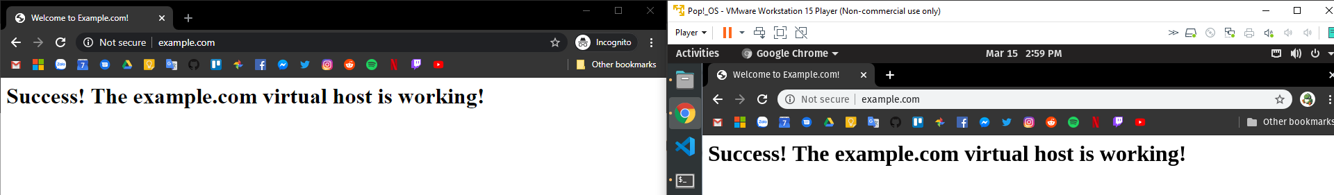

**Question 6:**

Code of the while loop:

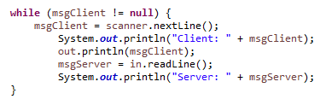

This while loop serves the purpose of listening to the message of the client and send it to the server and listen to server message until the client input nothing.

**Question 7:**

The role of method run is to wait for input from client side and then execute the sort function then print out the sorted array to client side.

The run method is run after class Sorter is initialized when a client is connected.