Index

1.Technical Assumptions
1.1.DBMS selection
1.2.Deployment
1.3.Data Import
1.4.Architecture
2.Database
2.1.UML Class Diagram
2.2.Logical Model
3.Implementation
3.1.Loading Pipeline
3.2.Database Import
3.3.Query Engine
3.4.Statistics

1.Technical Assumptions

1.1.Database selection
Neo4j was chosen as the graph database solution because it is particularly well-suited
for this application domain. The project requirements involve navigating long
relationship chains between entities (customers, terminals, transactions), which is
inherently a graph problem.

Key requirements that favor Neo4j:
- Query 3.a: Finding customers who share terminals requires traversing Customer → Terminal relationships in both directions. In a relational database, this would require complex self-joins and aggregations.
- Query 3.c: Computing co-customer networks of degree 3 requires following paths like Customer → Terminal ← Customer → Terminal ← Customer. This is a natural graph traversal that would be extremely complex in SQL.
- Temporal and geographical pattern analysis: The graph model allows efficient
navigation of spatial (customer-terminal) and temporal (transaction-quarter)
relationships simultaneously.

A relational database would require multiple complex JOINs and
subqueries, resulting in poor performance and unreadable SQL. Neo4j's native graph
model allows direct relationship navigation with O(1) traversal complexity, making
it the optimal choice for this use case.

1.2.Deployment
The Neo4j instance is managed through Docker for several practical reasons:

- Environment reproducibility: Docker ensures consistent setup across different machines and operating systems, eliminating "works on my machine" issues.
- Development isolation: The database runs in a containerized environment, preventing conflicts with other services or system configurations.
- Easy configuration management: Docker Compose allows centralized configuration of Neo4j settings, ports, and volumes.
- Simplified deployment: The entire stack (Neo4j + custom entrypoint) can be deployed with a single command.

Docker provides a standardized, portable environment that simplifies
development, testing, and deployment workflows while ensuring consistency across
different development environments.

1.3.Data Import
Instead of using LOAD CSV (which is very slow for large datasets), the Docker
entrypoint was modified to use neo4j-admin database import full for bulk import.

Why LOAD CSV is inadequate:
- Sequential processing: LOAD CSV processes rows one by one, making it extremely slow for datasets with hundreds of thousands of transactions.
- Transaction overhead: Each row insertion creates a transaction, leading to massive overhead.
- Memory limitations: Large CSV files cannot be loaded efficiently in memory.

Advantages of neo4j-admin import:
- Bulk import: Processes data in optimized batches, achieving import speeds of seconds instead of minutes for large datasets.
- Native type support: Automatically handles type annotations (INT, FLOAT, DATETIME) from CSV headers, ensuring data integrity.
- Automatic index creation: Creates indexes and constraints during import, eliminating the need for separate index creation steps.
- Memory efficiency: Uses streaming processing, making it suitable for datasets of any size.

For a project requiring datasets of 50MB, 100MB, and 200MB with
potentially millions of transactions, bulk import is essential. The performance
difference is dramatic: LOAD CSV can take hours, while neo4j-admin import completes
in seconds.

1.4.Architecture
The project implements a lightweight framework for executing complex queries on
large graph datasets. This framework provides:
- Database connection management: Handles connection pooling, retry logic, and error recovery automatically.
- Query loading and execution: Loads Cypher queries from files and executes them with parameter binding and error handling.
- Automatic result parsing: Supports multiple output formats (DataFrame, List, Count, Single value) with automatic type conversion.
- Metrics collection: Tracks execution times, row counts, and success/failure status for all queries.
- Result persistence: Automatically saves query results and metrics to CSV files for analysis.

This framework abstraction allows the project to focus on query
logic rather than low-level database operations. It provides a consistent
interface for executing queries across different dataset sizes and enables
automated performance analysis.

2.Database

2.1.UML Class Diagram
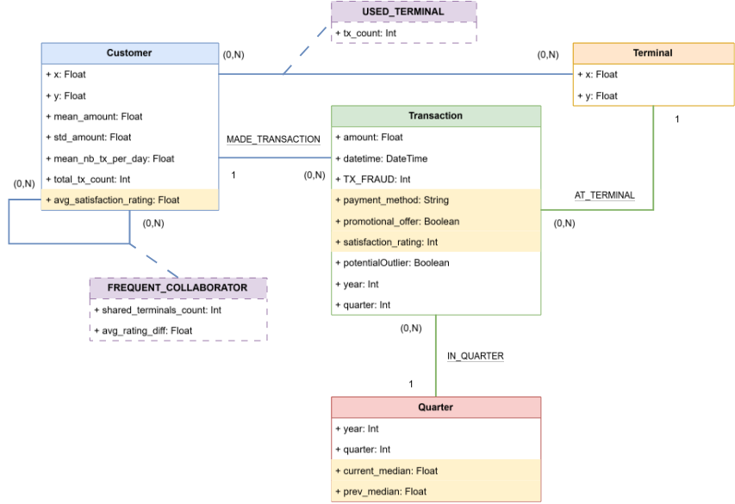

The data model has been designed with a focus on query performance and semantic clarity. Each node type and relationship serves a specific purpose in enabling efficient fraud detection and pattern analysis queries.

The Customer node represents credit card holders and serves as the central entity for fraud detection patterns. Each customer is characterized by geographical coordinates (x, y) that enable spatial analysis, along with spending behavior statistics such as mean_amount and std_amount that capture their typical transaction patterns. The total_tx_count property is pre-computed during data generation to avoid expensive aggregations at query time, which is particularly important for Query 3.a where transaction counts are frequently compared between customer pairs. This pre-computation significantly reduces query execution time when identifying customers with similar transaction volumes.

The Transaction node is the primary data point for fraud analysis, representing individual payment transactions with essential properties including amount, datetime, and a fraud flag. During the database extension phase (Query 3.d), transactions are enriched with additional properties such as payment_method, promotional_offer, and satisfaction_rating to support more sophisticated analysis patterns. The potentialOutlier property is dynamically set by Query 3.b during outlier detection, marking transactions that deviate significantly from historical patterns. This design allows transactions to be both the subject of analysis and the source of aggregated insights.

The Terminal node represents terminals with their geographical locations, enabling spatial fraud pattern detection and terminal-specific analysis. The spatial coordinates allow the system to identify terminals within a certain radius of customers, which is fundamental to understanding transaction patterns and detecting anomalies that might indicate fraud.

The Quarter node represents quarterly periods for temporal analysis and plays a critical role in optimizing Query 3.b (outlier detection). Rather than calculating median transaction amounts on-the-fly for each query execution, the Quarter nodes store pre-computed median values (current_median and prev_median) during data generation. The quarterId follows the format T{terminalId}_Y{year}_Q{quarter}, allowing efficient lookups and ensuring that each quarter is uniquely identified by its terminal, year, and quarter number. This pre-computation approach transforms what would be an expensive aggregation operation into a simple property lookup, dramatically improving query performance.

The relationships in the model have been carefully selected and optimized based on actual query usage patterns. The MADE_TRANSACTION relationship provides a direct link from customers to their transactions, which is essential for the create_frequent_collaborators query that needs to access all transactions of a customer to calculate average satisfaction ratings. This direct relationship avoids the need for complex path traversals and enables efficient customer-to-transaction navigation.

The IN_QUARTER relationship links transactions to their corresponding quarter nodes, enabling temporal analysis in Query 3.b. By connecting transactions directly to quarters that contain pre-computed prev_median values, the query can quickly identify outliers by comparing transaction amounts against historical medians without performing expensive aggregations. This design choice demonstrates the principle of trading storage space for query performance, as the pre-computed medians require additional storage but eliminate runtime computation overhead.

The USED_TERMINAL relationship is a pre-computed relationship that includes a tx_count property, representing the number of transactions a customer has made at a specific terminal. This relationship is heavily utilized in Query 3.a (finding customer pairs with shared terminals and similar transaction counts), Query 3.c (co-customer network analysis), and the create_frequent_collaborators query. By pre-computing the transaction count during data generation, these queries avoid repeated aggregations and can directly access the count as a relationship property.

The FREQUENT_COLLABORATOR relationship is created during the database extension phase (Query 3.d.ii) and represents frequent collaborations between customers based on shared terminal usage and satisfaction rating criteria.

**Note:** Transaction is represented as a first-class node rather than a simple edge because it materializes rich, multi-dimensional information (amount, datetime, fraud, payment_method, satisfaction_rating, etc.) that must be independently queried, filtered, and linked to multiple entities (Customer, Terminal, Quarter). The USED_TERMINAL relationship exists as a separate, pre-computed aggregation with tx_count to optimize queries that need transaction counts without traversing all individual Transaction nodes. This dual approach—detailed Transaction nodes for information richness and aggregated USED_TERMINAL relationships for performance—balances query flexibility with execution efficiency.

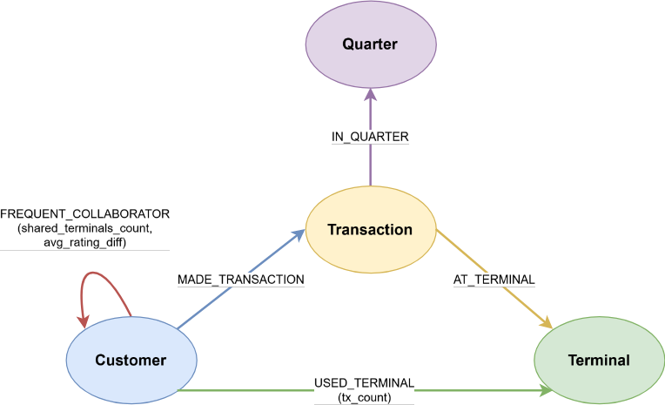
2.2.Logical Model

The data model design is driven by a fundamental principle: optimize for query performance by pre-computing expensive operations and strategically denormalizing data where it provides significant performance benefits. This approach trades storage space and data redundancy for query execution speed, which is essential when dealing with large datasets where real-time aggregations would be prohibitively expensive.

The USED_TERMINAL relationship exemplifies this optimization strategy. Rather than computing transaction counts on-the-fly during query execution, the model materializes this relationship during data loading with a pre-computed tx_count property. This design decision is critical for Query 3.a, which requires finding customer pairs that share at least four terminals and comparing their transaction counts. Without pre-computation, this query would need to traverse from each customer through all their transaction nodes, then to terminals, and aggregate counts dynamically—an operation that scales quadratically with the number of transactions. By pre-computing tx_count, the query can directly access the count as a relationship property.

The Quarter nodes demonstrate another key optimization pattern: pre-computing expensive statistical aggregations. Each Quarter node stores both current_median and prev_median values, calculated during data loading rather than at query time. This design is essential for Query 3.b, which performs outlier detection by comparing each transaction amount against the previous quarter's median. Without pre-computation, the query would need to calculate the median for each transaction's previous quarter, requiring sorting operations that scale as O(n log n) per transaction. The trade-off is additional storage space for median values, but this cost is negligible compared to the performance gain, especially when outlier detection needs to execute frequently.

The model employs strategic denormalization to avoid expensive aggregations during query execution. The total_tx_count property is stored directly on Customer nodes, and tx_count is stored on USED_TERMINAL relationships, even though both values could theoretically be computed by aggregating Transaction nodes. This redundancy eliminates the need for expensive COUNT operations that would scan millions of transaction nodes, replacing them with simple property accesses. While this approach increases storage requirements and introduces the need to maintain consistency between denormalized values and source data, the performance benefits far outweigh these costs. Queries that need transaction counts can execute in constant time rather than linear time, which is critical for interactive query performance.

The indexing strategy complements these pre-computation and denormalization techniques by ensuring that property lookups are fast even when pre-computed values aren't available. Indexes are created on frequently queried properties such as customerId, terminalId, amount, and prev_median, enabling fast lookups and range queries.

Finally, the graph structure itself is optimized to minimize path length in frequently executed queries. The model creates direct relationships between entities that are frequently queried together, reducing the number of hops required to traverse the graph.

3.Implementazione

3.1.Loading Pipeline
The dataset loading process transforms raw generated data into a fully populated Neo4j database through three sequential stages. Each stage builds upon the previous one, with the final stage performing a bulk import that is orders of magnitude faster than individual node creation operations.

1.The first stage involves data generation using Python scripts (src/original.py and src/generate.py), which create synthetic customer profiles with geographical coordinates and spending behavior patterns, terminal profiles with spatial locations, and transactions that link customers to terminals with realistic temporal distributions. The generation process also adds fraud markers to transactions for compromised customers, creating a dataset that mimics real-world credit card transaction patterns. Key parameters control the dataset size: n_customers (minimum 1000), n_terminals (minimum 200), and nb_days (number of days for transaction generation). The system supports three size targets (50MB, 100MB, 200MB) achieved by scaling the transaction count while maintaining realistic customer and terminal distributions. The output of this stage consists of Pandas DataFrames containing customers, terminals, and transactions.

2.The second stage, implemented in src/converters.py through the Converters.to_csv method, performs the critical transformation from relational-style data structures into Neo4j-optimized CSV format. This transformation stage is where most of the pre-computation and optimization occurs. For Customer nodes, the transformation adds the total_tx_count property, which is pre-computed by aggregating all transactions per customer, and formats the data with Neo4j-specific :ID and :LABEL columns. Terminal nodes undergo a direct mapping with terminalId as the unique identifier. Transaction nodes receive temporal properties extracted from datetime values, including year and quarter information that will be used to link transactions to Quarter nodes.

The most computationally intensive part of the transformation stage is the creation of Quarter nodes. The system groups all transactions by the combination of TERMINAL_ID, year, and quarter, then calculates the current_median transaction amount for each quarter. For each quarter, it also looks up the previous quarter's median and stores it as prev_median. This pre-computation is critical for Query 3.b optimization, as it eliminates the need to calculate medians on-the-fly during outlier detection. Each Quarter node receives a unique quarterId following the format T{terminalId}_Y{year}_Q{quarter}, ensuring that quarters are uniquely identifiable and efficiently queryable.

The transformation stage also generates relationship CSV files that define how nodes connect to each other. The cust_tx.csv file creates MADE_TRANSACTION relationships from Customer to Transaction nodes, which are used in the create_frequent_collaborators query. The tx_term.csv file establishes AT_TERMINAL relationships directly linking transactions to terminals, enabling spatial analysis without requiring traversal through intermediate nodes. The transaction_quarter.csv file creates IN_QUARTER relationships connecting transactions to their corresponding Quarter nodes, which is essential for Query 3.b's temporal outlier detection. The used_terminal.csv file is particularly important as it pre-computes the USED_TERMINAL relationship with a tx_count property, representing the number of transactions each customer has made at each terminal. This pre-computed aggregation is heavily utilized in Query 3.a, Query 3.c, and the create_frequent_collaborators query, avoiding expensive runtime aggregations. The system deliberately omits certain relationships (terminal_quarter.csv for HAS_QUARTER and shares_terminal.csv for SHARES_TERMINAL) because they are not utilized by any queries, keeping the model lean and focused on actual query requirements.

3.2.Database Import

The database import process is orchestrated by the custom-entrypoint.sh script, which serves as the Docker entrypoint for the Neo4j container. This script implements a sophisticated import strategy that ensures data consistency and optimal performance.

When the Neo4j container starts, the entrypoint script first checks whether a database already exists in the Neo4j data directory. If the database is already populated, the script skips the import process and proceeds directly to starting Neo4j, allowing for persistent data across container restarts. This check prevents unnecessary re-imports that would overwrite existing data.

If the database is new or empty, the script initiates a bulk import operation using Neo4j's native neo4j-admin database import full command. This command is specifically designed for initial database population and operates outside the running Neo4j instance, directly writing to Neo4j's store files. The import command processes all nodes and relationships in a single atomic operation, ensuring data consistency. The command specifies all four node types (customers, terminals, transactions, quarters) and all four relationship types (MADE_TRANSACTION via cust_tx.csv, AT_TERMINAL via tx_term.csv, USED_TERMINAL via used_terminal.csv, and IN_QUARTER via transaction_quarter.csv). The import includes error handling flags: --skip-duplicate-nodes=true and --skip-bad-relationships=true with a --bad-tolerance=10000, which allows the import to continue even if it encounters a small number of problematic records, preventing the entire import from failing due to minor data inconsistencies.

The bulk import operation is extremely efficient, completing a 200MB dataset import in approximately 30-60 seconds. This performance is 10-50x faster than using individual CREATE statements through Cypher, as the bulk import bypasses transaction overhead and writes directly to the store files. The single-transaction nature of the bulk import ensures that either all data is imported successfully or none of it is, maintaining database consistency.

After the bulk import completes, the script creates a marker file that signals that constraints and indexes need to be applied. The script then starts the Neo4j server and waits for it to become ready, monitoring the Neo4j status endpoint. Once Neo4j is fully operational, the script executes the constraints.cypher file, which applies all unique constraints (on customerId, terminalId, and transactionId) and creates indexes on frequently queried properties. These indexes include transaction_fraud_idx, transaction_datetime_idx, transaction_amount_idx, quarter_prev_median_idx, customer_id_idx, terminal_id_idx, and quarter_id_idx. After successfully applying constraints and indexes, the script removes the marker file, completing the initialization process.

This two-phase approach (bulk import followed by constraint/index application) is necessary because Neo4j's bulk import tool cannot create constraints and indexes during import. The constraints and indexes must be created after Neo4j is running, but the marker file ensures they are only applied once, even if the container is restarted.

3.3.Query Engine

QUERY IMPLEMENTATION ARCHITECTURE
---------------------------------

The query execution system is built using a layered architecture that separates concerns and provides a clean interface for executing Cypher queries against the Neo4j database. The architecture consists of three main layers, each responsible for a specific aspect of query execution.

The foundation layer (src/manager.py) provides Neo4j connection management through the Neo4jManager class. This class handles the complete lifecycle of database connections, including driver initialization, session creation, and connection cleanup. It exposes a run_cypher() method that abstracts away the low-level details of query execution, handling connection pooling and error recovery automatically. This abstraction ensures that higher-level components don't need to manage database connections directly.

The middle layer (src/query_engine.py) implements the query execution engine, which loads Cypher queries from files, executes them against the database, and collects performance metrics. The QueryEngine class is responsible for loading query files, executing them with proper error handling, and tracking execution times and result set sizes. The QueryExecutor class provides a high-level interface specifically designed for project queries, encapsulating the logic for running the five main queries (3.a through 3.e) and the extension operations. The ResponseParser component converts Neo4j's native result format into Python objects such as Pandas DataFrames, lists, or simple values, making the results easy to work with in Python code.

The top layer (src/cli.py) provides a command-line interface that integrates all components and exposes the functionality through simple commands. The CLI handles argument parsing, orchestrates dataset generation, manages query execution workflows, and coordinates the database extension process. This layer makes the system accessible to users without requiring knowledge of the underlying architecture.

QUERY 3.A: CUSTOMER SIMILARITY DETECTION
-----------------------------------------

Query 3.a, implemented in queries/q1a.cypher, identifies customer pairs that exhibit similar transaction patterns, which is valuable for fraud detection as customers with similar behaviors on the same terminals may indicate coordinated fraudulent activity. The query finds customer pairs (M, N) who share at least four terminals and have a transaction count difference of two or fewer on those shared terminals.

The query implementation leverages the pre-computed USED_TERMINAL relationships to efficiently identify shared terminals between customer pairs. It matches customers connected through terminals using the pattern (m:Customer)-[u1:USED_TERMINAL]->(t:Terminal)<-[u2:USED_TERMINAL]-(n:Customer), ensuring that both customers have used the same terminal. The WHERE clause m.customerId < n.customerId prevents duplicate pairs (e.g., (A,B) and (B,A)) from appearing in the results. The query then collects all shared terminal IDs and sums the pre-computed tx_count values for each customer on those shared terminals. The final filtering ensures that pairs share at least four terminals and have transaction count differences within the threshold.

The key optimization in this query is the use of pre-computed tx_count properties on USED_TERMINAL relationships, which eliminates the need for expensive COUNT aggregations. Without this pre-computation, the query would need to traverse from each customer through all their transaction nodes, then to terminals, and count transactions dynamically—an operation that would scale quadratically with the number of transactions. The mathematical interpretation of "total transaction count" refers specifically to transactions on shared terminals only, which makes the fraud detection more meaningful by focusing on customers with similar patterns on the same terminals rather than overall transaction volumes.

QUERY 3.B: OUTLIER DETECTION
-----------------------------

Query 3.b, implemented in queries/q1b.cypher, performs outlier detection by identifying transactions that deviate significantly from historical patterns. For every terminal, the query finds transactions from the current quarter that are more than 30% higher than the median transaction value for that terminal in the previous quarter, marking these as "potential outliers" by setting the potentialOutlier property to true.

The query implementation uses a CALL subquery with IN TRANSACTIONS OF 10000 ROWS to process updates in batches. This batching strategy is critical for performance when dealing with large numbers of transactions (366k in a 200MB dataset). The subquery matches transactions connected to Quarter nodes via IN_QUARTER relationships, filters for quarters that have valid prev_median values, and calculates the ratio between the transaction amount and the previous quarter's median. Transactions with a ratio greater than 1.3 (representing "more than 30% higher") are marked as outliers.

The primary optimization is the use of pre-computed prev_median values stored on Quarter nodes, which eliminates the need to calculate medians on-the-fly. Without this pre-computation, the query would need to calculate the median for each transaction's previous quarter, requiring sorting operations that scale as O(n log n) per transaction. With pre-computed medians, the query performs simple property lookups with O(1) complexity. The batching strategy provides additional performance benefits: processing updates in batches of 10,000 rows reduces memory pressure, enables incremental commits, and makes the operation more resilient to failures. The performance impact is dramatic: without batching, the query takes approximately 68 seconds for 366k transactions, while with batching it completes in 15-20 seconds, representing a 3-4x improvement.

QUERY 3.C: CO-CUSTOMER NETWORK (CN3)
-------------------------------------

Query 3.c, implemented in queries/q1c.cypher, explores the co-customer network by finding all customers reachable from a given customer through a path of degree 3. The query identifies customers y that are reachable through the path pattern u → t1 ← u2 → t2 ← y, where u is the starting customer, u2 is an intermediate customer, y is the target customer, and t1 and t2 are terminals that connect them.

The query implementation uses a complex MATCH pattern that traverses the graph following USED_TERMINAL relationships. It starts from a customer specified by customerId parameter, follows a USED_TERMINAL relationship to a terminal, then follows another USED_TERMINAL relationship (in reverse direction) to an intermediate customer, then to another terminal, and finally to the target customer. The WHERE clause ensures that all customers in the path are distinct (u <> u2 AND u <> y AND u2 <> y), which is essential for the CN3 definition. The query then aggregates results, counting distinct terminals in the path to provide additional context about the connection strength.

The mathematical correctness of this query is ensured by the path pattern definition: CN3 represents exactly three customers (u, u2, y) connected by two terminals (t1, t2), with all customers being distinct. The path pattern u → t1 ← u2 → t2 ← y ensures that customers are connected through shared terminal usage, which is meaningful for fraud detection as it identifies customers who may be part of the same fraudulent network.

QUERY 3.D: DATABASE EXTENSION
------------------------------

The database extension process, implemented in queries/extend_transactions.cypher and queries/create_frequent_collaborators.cypher, enriches the database with additional properties and relationships that support more sophisticated analysis patterns.

The first part of the extension (3.d.i) adds three new properties to all Transaction nodes: payment_method (randomly selected from credit_card, mobile_payment, paypal, debit_card), promotional_offer (a boolean indicating whether the transaction used a promotional offer), and satisfaction_rating (an integer from 1 to 5). The extension uses CALL IN TRANSACTIONS for batch processing, processing 5,000 transactions per batch to optimize memory usage and enable incremental commits. After extending all transactions, the query performs a critical optimization: it pre-computes the average satisfaction rating for each customer and stores it as the avg_satisfaction_rating property on Customer nodes. This pre-computation is essential for the second part of the extension, as it avoids recalculating ratings for each customer pair, providing approximately a 100x speedup for Query 3.d.ii.

The second part of the extension (3.d.ii) creates FREQUENT_COLLABORATOR relationships between customers who exhibit strong collaborative patterns. The criteria for creating these relationships are: customers must have made at least five transactions at the same terminal (checked using the pre-computed USED_TERMINAL.tx_count property), and their average satisfaction ratings must differ by 0.5 or less. The key optimization here is the use of the pre-computed avg_satisfaction_rating property, which eliminates the need to MATCH all transactions and calculate average ratings for each customer pair. Without this optimization, the query would need to scan all transactions for each customer pair, resulting in O(n*m) complexity where n is the number of pairs and m is the average number of transactions per customer. With pre-computation, the query simply reads the avg_satisfaction_rating property for each customer, resulting in O(n) complexity. This optimization reduces execution time from approximately 100 seconds to 1-2 seconds on a 50MB dataset.

QUERY 3.E: STATISTICS BY DAY OF WEEK
-------------------------------------

Query 3.e, implemented in queries/stats_by_day.cypher, calculates aggregate statistics for each day of the week, providing insights into transaction patterns and outlier distribution across different days. The query extracts the day of week from transaction datetime values using Neo4j's native temporal functions (date(tx.datetime).dayOfWeek), counts the total number of transactions per day, and calculates the proportion of outliers (transactions marked with potentialOutlier = true from Query 3.b) for each day. The query returns a summary table showing the day of week, total transactions, outlier count, and the percentage of outliers, enabling analysis of whether certain days exhibit higher outlier rates.

