w_i=w_i^{-\alpha*\Delta t_i }+1

p_i=\frac{p_i*w_i*e^{-\alpha\Delta t_i }+request}{w_i*e^{-\alpha\Delta t_i }+1}

If new request overlap exited group i



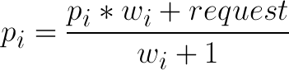

else create new group i with





update new weight of all group



check all group if group i overlap group j

remove group i and j

create new group



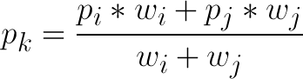

sort list group with w

find max group

|  |  |
| --- | --- |
| If new request overlap exited group i      else create new group i with      update new weight of all group | check all group if group i overlap group j  remove group i and j  create new group      sort list group with w  find max group |