c. R1 = XCdX R2 = XCHjCdX

Q1 = CHjC Q2 = djicd

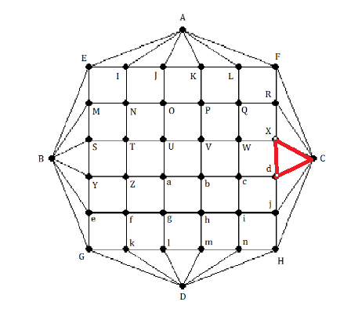 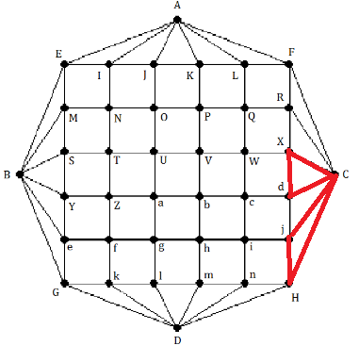

R3 = XCHjCdjicdX R4 = XCHjCdjinHDnmhicdX

Q3 = inHDnmhi Q4 = DmlD

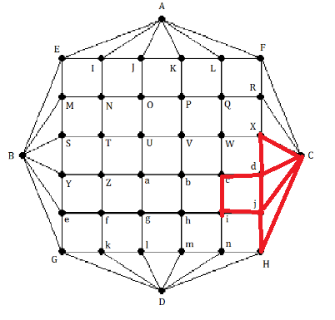 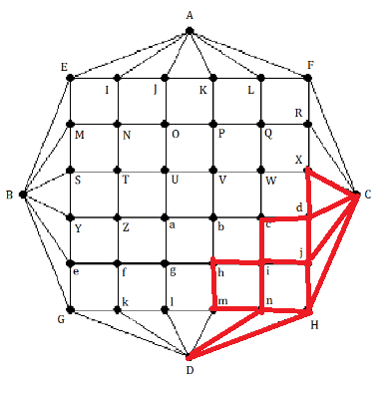

R5 = XCHjCdjinHDmlDnmhicdX R6 = XCHjCdjinHDmlkDGkfglDnmhicdX

Q5 = lkDGkfgl Q6 = feGBeYZf

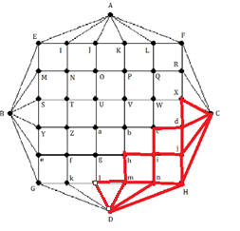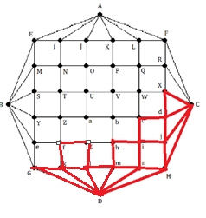

R7 = XCHjCdjinHDmlkDGkfeGBeYZfglDnmhicdX

Q7 = hgabh

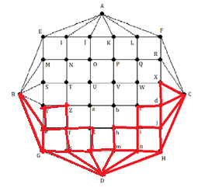

R8 = XCHjCdjinHDmlkDGkfeGBeYZfglDnmhgabhicdX

Q8 = YBSY

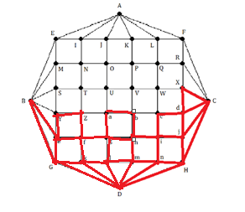

R9 = XCHjCdjinHDmlkDGkfeGBeYBSYZfglDnmhgabhicdX

Q9 = aZTUa

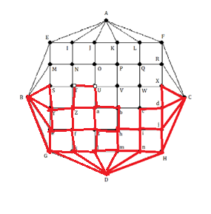

R10 = XCHjCdjinHDmlkDGkfeGBeYBSYZfglDnmhgaZTUabhicdX

Q10 = TSMNT

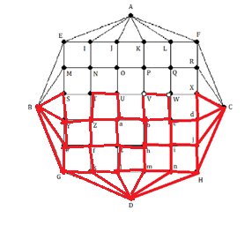

R11 = XCHjCdjinHDmlkDGkfeGBeYBSYZfglDnmhgaZTSMNTUabhicbVWcdX

Q11= MBEM

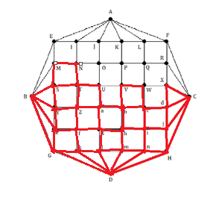

R12 = XCHjCdjinHDmlkDGkfeGBeYBSYZfglDnmhgaZTSMNTUabhicbVWcdX

Q12 = NIEAIJON

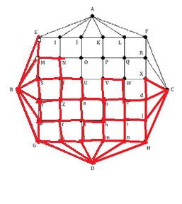

R13 = XCHjCdjinHDmlkDGkfeGBeYBSYZfglDnmhgaZTSMBEMNIEAIJONTUabhicbVWcdX

Q13 = VUOPV

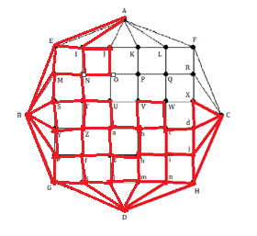

R14 = XCHjCdjinHDmlkDGkfeGBeYBSYZfglDnmhgaZTSMBEMNIEAIJONTUabhicbVUOPVWcdX

Q14 = PKJSKLQP

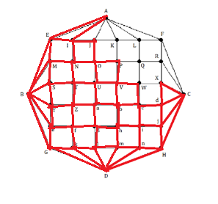

R15 = XCHjCdjinHDmlkDGkfeGBeYBSYZfglDnmhgaZTSMBEMNIEAIJONTUabhicbVUOPKJAKLQPVWcdX

Q15 = LAFL

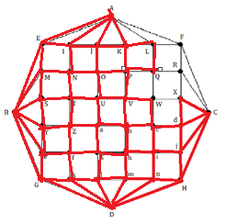

R16 = XCHjCdjinHDmlkDGkfeGBeYBSYZfglDnmhgaZTSMBEMNIEAIJONTUabhicbVUOPKJAKLAFLQPVWcdX

Q16 = FCRF

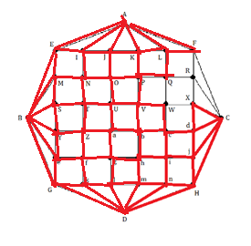

R17 = XCHjCdjinHDmlkDGkfeGBeYBSYZfglDnmhgaZTSMBEMNIEAIJONTUabhicbVUOPKJAKLAFCRFLQPVWcdX

Q17 = RQWXR

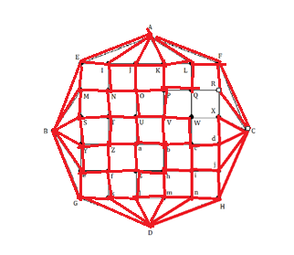

R18 =

XCHjCdjinHDmlkDGkfeGBeYBSYZfglDnmhgaZTSMBEMNIEAIJONTUabhicbVUOPKJAKLAFCRQWXRFLQPVWcdX

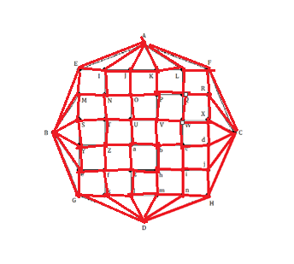

= > Chu trình Eulerian sử dụng thuật toán Hierholzer khi bắt đầu chu trình tại R1= XcdX là: R18 XCHjCdjinHDmlkDGkfeGBeYBSYZfglDnmhgaZTSMBEMNIEAIJONTUabhicbVUOPKJAKLAFCRQWXRFLQPVWcdX