Software Requirement Specification (SRS) SASUCare E-Commerce Platform
---
Document Information:
- Version: 1.0
- Date: January 28, 2025
- Authors: Business Analysis Team
- Status: To be continued
- Project: SASUCare E-Commerce Platform
---
Table of Contents

1. Overall Description

1.1 Functional Requirements Design

1.1.1 User Management Requirements
Requirement ID | Requirement Name | Description | Validation Rules
FR-001 | User Registration | Allows anonymous users to create  new accounts | Email uniqueness, password  strength
FR-002 | User Authentication | Allows registered users to authenticate and access their  dashboard | Valid credentials, account verification
FR-003 | Role Management | Allows administrators to assign and  manage user roles | Role assignment validation
FR-004 | Profile Management | Allows users to update their  personal profile information | Data validation, image upload

FR-005 | Password Reset | Allows users to reset their forgotten  passwords | Email verification, token  validation
FR-006 | User Account Management | Allows administrators to manage user  accounts | Admin role validation
FR-007 | User Session Management | Manages user sessions and  authentication state | Session timeout,  security validation

1.1.2 Product Management Requirements
Requirement ID | Requirement Name | Description | Validation Rules
FR-008 | Product Creation | Allows sellers to create new products in  their catalog | Required fields, price validation
FR-009 | Product Editing | Allows sellers to edit and update their  existing products | Owner validation, status check
FR-010 | Product Search | Allows customers to search for  products using various criteria | Search criteria validation
FR-011 | Product Display | Display product information to  users | Data formatting validation
FR-012 | Category Management | Allows administrators to create and organize  product categories | Admin role validation
FR-013 | Image Management | Allows sellers to upload and manage  product images | File type, size validation
FR-014 | Product Approval | Allows administrators to approve  pending products | Admin approval workflow

FR-015 | Product Inventory | Manage  product stock and availability | Stock level validation

1.1.3 Shopping and Order Requirements
Requirement ID | Requirement Name | Description | Validation Rules
FR-016 | Shopping Cart | Allows customers to add products to cart and manage  contents | Stock availability, quantity limits
FR-017 | Checkout Process | Allows customers to complete purchase and  finalize transactions | Address validation, payment info
FR-018 | Order Management | Allows sellers to view and process customer  orders | Order status validation
FR-019 | Order History | Allows customers to view their  complete order history | User ownership validation
FR-020 | Address Management | Allows users to manage their shipping  addresses | Address format validation
FR-021 | Order Tracking | Allows customers to track order  status | Order status updates
FR-022 | Order Administration | Allows administrators to oversee all  orders | Admin role validation
FR-023 | Payment Processing | Handle  payment transactions | Payment  validation, security

1.1.4 Booking System Requirements
Requirement ID | Requirement Name | Description | Validation Rules

FR-024 | Booking Creation | Allows customers to create service  bookings | Service availability, time validation
FR-025 | Booking Management | Allows sellers to manage their service  bookings | Seller ownership validation
FR-026 | Booking Status Update | Allows service providers to  update booking status | Status transition validation
FR-027 | Booking History | Allows customers to view their  booking history | User ownership validation
FR-028 | Booking Calendar | Display booking  schedules and availability | Date/time validation
FR-029 | Booking Notifications | Send notifications for booking  updates | Notification delivery validation

1.1.5 Content Management Requirements
Requirement ID | Requirement Name | Description | Validation Rules
FR-030 | Company Information Display | Display company  information and policies | Content validation
FR-031 | Contact  Information Management | Manage and  display contact information | Contact form validation
FR-032 | Partnership Information | Display collaboration and partnership  information | Content management validation
FR-033 | Site Navigation | Provide consistent navigation  across the platform | Navigation consistency
FR-034 | Search Functionality | Global search across products  and content | Search query validation

1.1.6 Administrative Requirements
Requirement ID | Requirement Name | Description | Validation Rules
FR-035 | Platform Dashboard | Provide administrative overview of  platform | Admin role validation
FR-036 | System Monitoring | Monitor system performance  and activities | System metrics validation
FR-037 | Sale Code Management | Create and manage promotional  codes | Code validation, expiry rules
FR-038 | Business Analytics | Provide business intelligence and  reporting | Data accuracy validation
FR-039 | System Configuration | Configure system settings  and parameters | Configuration validation
FR-040 | Data Export | Export system  data for reporting | Export format validation
FR-041 | Audit Trail | Track system changes and  user activities | Audit log validation

1.1.7 System and Security Requirements
Requirement ID | Requirement Name | Description | Validation Rules
FR-042 | Access Control | Enforce role- based access to system  functions | Permission validation
FR-043 | Error Handling | Handle system errors  gracefully | Error message validation
FR-044 | Data Security | Protect sensitive user and business  data | Encryption, data protection
FR-045 | Session Security | Secure user sessions and prevent  unauthorized access | Session validation
FR-046 | Input Validation | Validate all user inputs for | Input sanitization

 |  | security and data integrity
FR-047 | System Backup | Backup system  data and configurations | Backup validation

1.2 User Roles and Permissions
User Role | Primary Functions | Access Level
Anonymous User | FR-010, FR-011, FR-030,  FR-031, FR-032, FR-033, FR-034 | Public access only
Customer | FR-001, FR-002, FR-004, FR-005, FR-016, FR-017, FR-019, FR-020, FR-021,  FR-024, FR-027 | Authenticated user access
Seller | All Customer functions + FR-008, FR-009, FR-013, FR-015, FR-018, FR-025,  FR-026, FR-028, FR-038 | Seller-specific access + Customer access
Administrator | All system functions + FR- 003, FR-006, FR-012, FR-  014, FR-022, FR-035, FR-  036, FR-037, FR-039, FR-  040, FR-041 | Full system access

1.3 Use Case Design

1.3.1 Register
Table 1: Description of User Register (UC-101)

UC ID and Name | UC-101 - Register
Primary Actor | Anonymous User
Trigger: | This requirement allows anonymous users to create new accounts on the platform by providing personal information, selecting their role (Customer or Seller), and completing email verification to access  system features.
Description: | This use case allows an Anonymous User to register for a new account on the SASUCare platform by providing necessary details such as email, password, first name, last name, and optionally a shop name if registering as a Seller. The system validates  the input, creates a user record.
Preconditions: | The Anonymous User is not logged in.
Postconditions | A new user record is stored in the system database. The user is redirected to the  LoginPage upon successful registration.

Expected results | Upon submitting valid registration details and confirming the email verification, the system saves the new user record. The user  can then login and access their role-specific dashboard.
Normal Flow: | - Anonymous User navigates to the Homepage and clicks "Sign Up".  - The system displays the RegistrationPage with a form.  - Anonymous User enters email, password, confirms password, first name, last name, and optionally shop name, then clicks "Register".  - The system displays a success message and redirects to the LoginPage.
Alternative Flows: | Invalid Data  - Anonymous User submits the form with missing or incorrect data (e.g., duplicate email, invalid password).  - The system displays an error message next to the relevant field.  - Anonymous User corrects the data and resubmits.
Exceptions:
Business Rules Applied:
- BR-001: Email uniqueness validation
- Email must be unique across all user accounts
- Email format must follow RFC 5322 standard (e.g., user@domain.com)
- Email domain must have valid MX record
- BR-002: Password strength requirements
- Minimum 8 characters, maximum 128 characters
- Must contain at least 1 uppercase letter (A-Z)
- Must contain at least 1 lowercase letter (a-z)
- Must contain at least 1 number (0-9)
- Must contain at least 1 special character (!@#$%^&*)
- Cannot contain user's email or name
- BR-003: Email verification requirement
- Verification email must be sent within 30 seconds of registration
- Verification token expires after 24 hours
- Maximum 3 verification email resend attempts per day
- BR-004: Terms acceptance requirement
- Terms and Conditions checkbox must be checked (required)

- Privacy Policy acknowledgment required
- Marketing consent is optional

1.3.2 Login
Table 2: User Login use case description UC-102

UC ID and Name | UC-102 - Login
Primary Actor | Seller, Customer, Admin
Trigger: | This requirement allows registered users to authenticate themselves using email and password credentials to access their personalized dashboard and account- specific features based on their role  (Customer, Seller, or Admin).
Description: | This use case allows a Registered User to authenticate and access the SASUCare platform by providing their email and password. The system validates the credentials, creates a user session, and redirects the user to their role-specific  dashboard (Customer, Seller, or Admin).
Preconditions: | The user has a verified account with valid credentials. The user is not currently  logged in.
Postconditions | User session is created and authenticated. User is redirected to role-specific dashboard.
Expected results | Upon entering valid credentials, the system authenticates the user and redirects them  to their appropriate dashboard based on their role (Customer, Seller, or Admin).
Normal Flow: | - Registered User navigates to the Homepage and clicks "Login".  - The system displays the LoginPage with email and password fields.  - User enters email and password, then clicks "Login".  - The system validates credentials and redirects to role-specific dashboard.
Alternative Flows: | Invalid Credentials  - User enters incorrect email or password.  - System displays error message "Invalid email or password".  - User corrects credentials and resubmits.  Account Not Verified  - User attempts to login with unverified

account.
- System displays verification message.
- System offers to resend verification email.
Exceptions: | Account Suspended: System detects suspended account and displays suspension message with contact  information.

Business Rules Applied:
- BR-005: Account verification requirement
- Account must be email verified before login
- Unverified accounts blocked after 7 days of registration
- Account verification status checked on each login attempt
- BR-006: Login attempt limitations
- Maximum 5 failed login attempts per account per hour
- Account locked for 30 minutes after 5 failed attempts
- CAPTCHA required after 3 failed attempts
- IP-based rate limiting: 20 attempts per IP per hour
- BR-007: Session timeout configuration
- Session expires after 30 minutes of inactivity
- "Remember me" extends session to 30 days
- Session automatically renewed on user activity
- Maximum concurrent sessions per user: 3
- BR-008: Role-based redirection
- Customer role: Redirect to homepage or last visited product page
- Seller role: Redirect to seller dashboard
- Admin role: Redirect to admin panel
- Redirect URL stored in session for post-login navigation

1.3.3 Add Product to Cart
Table 3: Add Product to Cart use case description UC-203

UC ID and Name: | UC-203 - Add Product to Cart
Primary Actor: | Customer
Trigger: | This requirement allows customers to add selected products to their shopping cart by specifying quantity and product options,  enabling them to collect items for future purchase while browsing the marketplace.
Description: | This use case allows Customer to add a  selected product to their shopping cart. The system validates product availability,

 | checks stock quantity, and updates the cart with the selected item and quantity.
Preconditions: | Customer is viewing a product detail page.  Product is active and available.
Postconditions | Product is added to shopping cart. Cart  totals are updated. Cart item count is incremented.
Expected results | The selected product with specified quantity is successfully added to the cart. System displays confirmation message and  updates cart icon with new item count.
Normal Flow: | - Customer views product detail page and selects options (size, color, etc.).  - Customer specifies quantity and clicks "Add to Cart".  - System validates product availability and stock quantity.  - System adds item to cart and displays confirmation message.
Alternative Flows: | Insufficient Stock  - Customer selects quantity exceeding available stock.  - System displays stock limitation message.  - System suggests maximum available quantity.  Product Unavailable  - Customer attempts to add inactive product.  - System displays product unavailability message.
Exceptions: | Invalid Quantity: Customer enters invalid quantity (0 or negative). System displays  validation error.

Business Rules Applied:
- BR-009: Stock availability validation
- Real-time stock check before adding to cart
- Stock quantity must be > 0 for active products
- Reserved stock (in other carts) considered unavailable
- Stock validation timeout: 5 seconds maximum
- BR-010: Maximum quantity per item limits
- Maximum 99 units per product per cart

- Quantity must be positive integer (1-99)
- Cannot exceed available stock quantity
- Bulk purchase (>50 units) requires seller approval
- BR-011: Cart session persistence
- Guest cart expires after 24 hours of inactivity
- Registered user cart persists for 30 days
- Cart automatically saved every 30 seconds
- Maximum 50 different products per cart
- BR-012: Price consistency validation
- Price locked when item added to cart for 2 hours
- Price changes >10% require user confirmation
- Currency must match user's selected currency
- All prices displayed with 2 decimal places

1.3.4 View Shopping Cart
Table 4: View Shopping Cart use case description UC-204

UC ID and Name | UC-204 - View Shopping Cart
Primary Actor | Customer
Trigger: | This requirement allows customers to view all items currently in their shopping cart, modify quantities, remove unwanted items, and review total costs before proceeding to  checkout.
Description: | This use case allows Customer to view all items currently in their shopping cart, including product details, quantities, prices,  and total cost. Customer can also update quantities or remove items.
Preconditions: | Customer has items in cart or accessing empty cart.
Postconditions | Cart contents are displayed with current totals and available actions.
Expected results | Customer can see all cart items with details, update quantities, remove items,  and proceed to checkout if cart has items.
Normal Flow: | - Customer clicks on cart icon or navigates to cart page.  - System retrieves cart contents from session.  - System displays cart items with details and totals.  - Customer can update quantities, remove items, or proceed to checkout.
Alternative Flows: | Empty Cart

- Customer accesses cart with no items.
- System displays empty cart message.
- System provides 'Continue Shopping' link.
Price Changes

- System detects price changes since items were added.
- System displays price change notification.
- System updates cart with new prices.
Exceptions: | Cart synchronization issues: System handles concurrent cart modifications with  optimistic locking.

Business Rules Applied:
- BR-013: Cart session management
- Cart data refreshed every page load
- Session cart merged with database cart on login
- Cart synchronization timeout: 10 seconds maximum
- Concurrent cart modifications handled with optimistic locking
- BR-014: Price update notifications
- Price changes displayed with old vs new price comparison
- Notification shown for changes >5% or >$1.00
- User must acknowledge price changes before checkout
- Price change history maintained for 90 days
- BR-015: Cart expiration policies
- Guest cart: 24 hours from last activity
- Registered user cart: 30 days from last activity
- Expired items automatically removed from cart
- Email reminder sent 2 hours before cart expiration
- BR-016: Guest vs. registered user cart handling
- Guest cart limited to 10 items maximum
- Registered user cart allows up to 50 items
- Guest cart requires email for checkout
- Cart migration on registration preserves all items

1.3.5 Booking and Place Order
Table 5: Booking and Place Order use case description UC-207

UC ID and Name | UC-207 - Booking and Place Order

Primary Actor | Customer
Trigger: | This requirement allows customers to complete their purchase by providing shipping information, selecting payment methods, and confirming orders to finalize transactions and receive products or  services.
Description: | This use case allows Customer to complete their purchase by providing shipping information, selecting payment method, and confirming the order. The system processes the order and sends  confirmation.
Preconditions: | Customer has items in cart and is logged in.
Postconditions | Order is created, inventory is reserved, and confirmation email is sent.
Expected results | Order is successfully placed with order number generated. Customer receives  confirmation email and is redirected to order confirmation page.
Normal Flow: | - Customer navigates to checkout page from cart.  - Customer enters/confirms shipping information.  - Customer selects payment method and reviews order.  - Customer confirms order placement.  - System creates order and sends confirmation.
Alternative Flows: | Invalid Shipping Address  - Customer enters invalid address.  - System displays validation errors.  - Customer corrects address information.  Payment Processing Failed  - Payment gateway returns error.  - System displays payment error message.  - System releases reserved inventory.
Exceptions: | Insufficient Inventory: System detects  insufficient stock during checkout and updates cart with available quantities.

Business Rules Applied:
- BR-017: Address validation requirements
- Street address: 5-100 characters, alphanumeric and spaces

- City: 2-50 characters, letters and spaces only
- ZIP/Postal code: Format validated by country (e.g., 12345 or 12345-6789 for US)
- Phone number: 10-15 digits, international format supported
- BR-018: Inventory reservation during checkout
- Items reserved for 15 minutes during checkout process
- Reservation automatically released if checkout not completed
- Maximum 3 concurrent reservations per user
- Reservation extends by 5 minutes on each checkout step completion
- BR-019: Payment processing validation
- Credit card number: 13-19 digits, Luhn algorithm validation
- CVV: 3-4 digits depending on card type
- Expiry date: Must be future date, MM/YY format
- Payment processing timeout: 30 seconds maximum
- BR-020: Order confirmation email requirement
- Confirmation email sent within 60 seconds of order placement
- Email includes order number, items, total, and delivery estimate
- Email delivery retry: 3 attempts with exponential backoff
- Backup SMS notification if email fails after 3 attempts

1.3.6 View Order History
Table 6: View Order History use case description UC-208

UC ID and Name | UC-208 - View Order History
Primary Actor | Customer
Trigger: | This requirement allows customers to view their complete order history with current status information, track shipments, access order details, and reorder previous  purchases for convenience.
Description: | This use case allows Customer to view all their past orders with current status information, order details, tracking  information, and the ability to reorder or review products.
Preconditions: | Customer is logged in and has placed orders previously.
Postconditions | Order history is displayed with current status and available actions.
Expected results | Customer can view complete order history with status updates, track shipments, and access order details for reference or  reordering.
Normal Flow: | 1. Customer navigates to 'My Account' section.

- Customer clicks on 'Order History'.
- System retrieves customer's order history.
- System displays orders in reverse chronological order.
- Customer can view order details by
clicking on specific orders.
Alternative Flows: | No Orders Found  - System finds no orders for customer.  - System displays 'No orders found' message.  - System provides link to continue shopping.  Order Details Unavailable  - System cannot retrieve order details.  - System displays error message.  - System provides customer support contact.
Exceptions: | Data synchronization issues: System  handles order status updates with eventual consistency model.

Business Rules Applied:
- BR-021: Order history access restrictions
- Users can only view their own orders
- Order history limited to last 2 years for performance
- Guest orders accessible via email + order number for 90 days
- Admin can view all orders with audit logging
- BR-022: Order status display requirements
- Status updates in real-time with 5-second refresh interval
- Status history shows timestamps with timezone
- Estimated delivery date updated based on current status
- Status change notifications sent within 2 minutes
- BR-023: Order detail privacy protection
- Sensitive data (payment info) masked in order history
- Full order details require password re-authentication
- Order sharing limited to order number and basic status
- Personal information encrypted in database storage

1.3.7 Manage Seller Profile/Shop Information
Table 7: Manage Seller Profile use case description UC-301

UC ID and Name | UC-301 - Manage Seller Profile/Shop Information
Primary Actor | Seller
Trigger: | This requirement allows sellers to update their profile information and shop details including business name, description, contact information, and branding images  to present their business professionally to customers.
Description: | This use case allows a Seller to update their profile information and shop details  including shop name, description, contact information, and shop logo/banner images.
Preconditions: | Seller is logged in with active account.
Postconditions | Profile information is updated and saved in the system.
Expected results | Seller profile and shop information are successfully updated. Changes are reflected  across the platform.
Normal Flow: | - Seller navigates to shop settings or profile section.  - System displays current profile information.  - Seller updates desired information and uploads images.  - Seller saves changes and system validates information.  - System displays success confirmation.
Alternative Flows: | Invalid Shop Name  - Seller enters invalid or duplicate shop name.  - System displays validation error.  - Seller corrects shop name.  Image Upload Failed  - System fails to process uploaded image.  - System displays upload error message.  - Seller can retry or skip image upload.
Exceptions: | Required Fields Missing: System detects  missing required fields and highlights them for correction.

Business Rules Applied:
- BR-024: Shop name uniqueness validation
- Shop name: 3-50 characters, alphanumeric and spaces

- Must be unique across all sellers (case-insensitive)
- Cannot contain profanity or restricted words
- Name change allowed once every 30 days
- BR-025: Image file size and format restrictions
- Supported formats: JPEG, PNG, WebP only
- Maximum file size: 5MB per image
- Minimum dimensions: 200x200 pixels
- Maximum dimensions: 2048x2048 pixels
- Images automatically compressed to <1MB for web display
- BR-026: Required profile information validation
- Business name: 2-100 characters (required for sellers)
- Business description: 10-500 characters
- Contact phone: Valid phone number format
- Business address: Complete address required for tax purposes
- BR-027: Shop information approval process
- Profile changes reviewed within 24 hours
- Major changes (business name, category) require admin approval
- Seller notified via email within 2 hours of approval/rejection
- Rejected changes include specific reason and improvement suggestions

1.3.8 Manage Products
Table 8: Manage Products use case description UC-302

UC ID and Name | UC-302 - Manage Products
Primary Actor | Seller
Trigger: | This requirement allows sellers to perform complete product management including creating new products, editing existing ones, uploading images, setting prices, managing inventory, and removing  products from their catalog.
Description: | This use case allows a Seller to perform full CRUD operations on their products including creating new products, editing  existing ones, uploading images, setting prices, and managing inventory.
Preconditions: | Seller is logged in with active account.
Postconditions | Product is created/updated/deleted in the system database.
Expected results | Product operations are completed successfully. Product information is saved  and reflected in the marketplace.
Normal Flow: | 1. Seller navigates to product management page.

- Seller selects action (Add/Edit/Delete product).
- For Add/Edit: Seller enters product information and uploads images.
- Seller sets pricing and inventory details.
- System validates and saves product record.
Alternative Flows: | Invalid Product Data  - Seller submits form with invalid or missing data.  - System displays validation errors.  - Seller corrects data and resubmits.  Image Processing Failed  - System fails to process uploaded images.  - System displays image error message.  - Seller can retry image upload.
Exceptions: | Delete Confirmation: For delete action,  system displays confirmation dialog before permanent removal.

Business Rules Applied:
- BR-028: Product information completeness validation
- Product name: 5-100 characters, no special characters except hyphens
- Description: 20-2000 characters, rich text supported
- Price: $0.01 - $99,999.99, two decimal places
- SKU: 3-50 characters, alphanumeric, must be unique per seller
- BR-029: Image format and size restrictions
- Maximum 10 images per product
- First image becomes primary product image
- Same format restrictions as BR-025
- Image order can be changed via drag-and-drop interface
- BR-030: Pricing validation rules
- Price changes >20% require admin approval
- Sale price cannot be higher than regular price
- Bulk pricing tiers: 10+, 50+, 100+ units with minimum 5% discount
- Price history maintained for 1 year for analytics
- BR-031: Inventory management requirements
- Stock quantity: 0-9999 units
- Low stock alert when quantity ≤ 5 units

- Out of stock products automatically hidden from search
- Inventory updates reflected in real-time across all sessions

1.3.9 Manage Orders Received
Table 9: Manage Orders Received use case description UC-305

UC ID and Name | UC-305 - Manage Orders Received
Primary Actor | Seller
Trigger: | This requirement allows sellers to view and process customer orders containing their products, update order status, add tracking information, and communicate with customers throughout the fulfillment  process.
Description: | This use case allows a Seller to view and process orders containing their products, update order status, add tracking information, and communicate with  customers about order progress.
Preconditions: | Seller is logged in and has received orders for their products.
Postconditions | Order status is updated and customer is notified of changes.
Expected results | Orders are processed efficiently with proper status updates. Customers receive timely notifications about their order  progress.
Normal Flow: | - Seller navigates to order management page.  - System displays list of orders for seller's products.  - Seller selects order to process.  - System displays order details and current status.  - Seller updates order status and add tracking information.  - System saves changes and sends  customer notification.
Alternative Flows: | No Orders Found  - System finds no orders for seller.  - System displays 'No orders found' message.  Invalid Status Transition  - Seller attempts invalid status change.  - System displays validation error.  - Seller corrects status selection.

Tracking Information Required

- System requires tracking info for shipped status.
- System prompts seller to enter tracking
details.
Exceptions: | Communication failure: System handles notification delivery failures with retry  mechanism and fallback options.

Business Rules Applied:
- BR-032: Order status transition validation
- Valid transitions: Pending→Processing→Shipped→Delivered
- Cannot skip status levels (e.g., Pending→Shipped)
- Status change requires reason if reverting (e.g., Shipped→Processing)
- Delivered status cannot be changed after 7 days
- BR-033: Customer notification requirements
- Email notification sent within 5 minutes of status change
- SMS notification for Shipped and Delivered status (if opted in)
- Notification includes tracking number and estimated delivery
- Customer can opt-out of non-critical notifications
- BR-034: Tracking information requirements
- Tracking number: 8-50 characters, alphanumeric
- Carrier selection from predefined list (UPS, FedEx, USPS, DHL)
- Tracking URL automatically generated based on carrier
- Tracking info required within 24 hours of marking as Shipped
- BR-035: Seller order access restrictions
- Sellers can only view orders containing their products
- Order details filtered to show only seller's items
- Customer personal information limited to shipping address only
- Order access logged for audit purposes

1.3.10 Manage Categories
Table 10: Manage Categories use case description UC-404

UC ID and Name | UC-404 - Manage Categories
Primary Actor | Admin
Trigger: | This requirement allows administrators to create, edit, and organize the hierarchical  structure of product categories used throughout the platform, enabling proper

 | product classification and navigation for users.
Description: | This use case allows an Administrator to create, edit, and organize the hierarchical structure of product categories used  throughout the platform for product classification.
Preconditions: | Admin is logged in with appropriate permissions.
Postconditions | Category structure is updated and reflected across the platform.
Expected results | Category hierarchy is successfully managed. Changes are immediately visible  to sellers and customers.
Normal Flow: | - Admin navigates to category management page.  - System displays current category hierarchy.  - Admin selects action (Add/Edit/Delete category).  - Admin enters category information and sets properties.  - System validates and updates category structure.
Alternative Flows: | Duplicate Category Name  - Admin enters duplicate category name.  - System displays validation error.  - Admin corrects category name.  Category Has Products  - Admin attempts to delete category with products.  - System displays warning about existing products.  - Admin must reassign products or confirm deletion.
Exceptions: | Invalid Parent Category: System detects  circular reference in hierarchy and displays error message.

Business Rules Applied:
- BR-036: Category name uniqueness validation
- Category name: 2-50 characters, letters, numbers, spaces, hyphens
- Must be unique within the same parent category level

- Case-insensitive uniqueness check
- Reserved words (Admin, System, Test) not allowed
- BR-037: Category hierarchy validation
- Maximum 5 levels of category depth
- Cannot create circular references (category as its own parent)
- Parent category must be active to create subcategories
- Category path must be unique (e.g., Electronics/Phones/iPhone)
- BR-038: Product reassignment requirements
- Products must be reassigned before category deletion
- Bulk reassignment tool available for >10 products
- Reassignment requires confirmation from affected sellers
- Default "Uncategorized" category available as fallback
- BR-039: Category deletion restrictions
- Cannot delete categories with active products
- Cannot delete categories with subcategories
- Soft delete: Category marked inactive, not physically removed
- Deletion requires admin confirmation with reason

1.3.11 Manage All Products
Table 11: Manage All Products use case description UC-405

UC ID and Name | UC-405 - Manage All Products
Primary Actor | Admin
Trigger: | This requirement allows administrators to oversee and manage all products on the platform including approving, rejecting, editing, or removing products from any seller to maintain platform quality and  compliance standards.
Description: | This use case allows an Administrator to oversee and manage all products on the platform including approving, rejecting,  editing, or removing products from any seller.
Preconditions: | Admin is logged in with appropriate permissions.
Postconditions | Product oversight actions are completed and logged.
Expected results | Administrative actions on products are successfully executed. Affected sellers are  notified of changes.
Normal Flow: | - Admin navigates to product oversight page.  - System displays all products with  filtering options.

- Admin searches/filters products as needed.
- Admin selects product and performs action.
- System validates permissions and updates product status.
Alternative Flows: | Product Not Found  - Search/filter returns no results.  - System displays 'No products found' message.  Insufficient Permissions  - Admin lacks permission for selected action.  - System displays access denied message.  Product Has Active Orders  - Admin attempts to delete product with active orders.  - System displays warning about active orders.
Exceptions: | System logs all administrative actions with timestamp, admin ID, and reason for audit  purposes.

Business Rules Applied:
- BR-040: Admin permission validation
- Admin actions require role-based permissions (view, edit, delete)
- Sensitive actions require secondary authentication (password/2FA)
- Admin activity logged with timestamp, IP, and action details
- Super admin role required for system-wide changes
- BR-041: Product action logging requirements
- All product changes logged with before/after values
- Log retention: 2 years for compliance
- Logs include admin ID, timestamp, IP address, reason
- Critical actions (delete, suspend) require approval workflow
- BR-042: Seller notification requirements
- Seller notified within 1 hour of admin action on their products
- Notification includes specific reason and next steps
- Appeals process available for rejected/suspended products
- Notification delivery confirmed via email receipt

- BR-043: Product deletion restrictions
- Cannot delete products with pending/processing orders
- Cannot delete products with active bookings
- Soft delete preferred: product marked inactive instead
- Hard delete requires 30-day waiting period after soft delete

1.3.12 View Booking History & Status
Table 12: View Booking History use case description UC-211

UC ID and Name | UC-211 - View Booking History & Status
Primary Actor | Customer
Trigger: | This requirement allows customers to view their complete service booking history with real-time status information, manage upcoming appointments, and access  booking details for reference and planning purposes.
Description: | This use case allows Customer to view all their past and current service bookings with real-time status information, booking  details, and the ability to manage upcoming bookings.
Preconditions: | Customer is logged in and has made service bookings previously.
Postconditions | Booking history is displayed with current status and available management options.
Expected results | Customer can view complete booking history with status updates, manage upcoming bookings, and access booking  details for reference.
Normal Flow: | - Customer navigates to 'My Account' section.  - Customer clicks on 'Booking History'.  - System retrieves customer's booking history.  - System displays bookings with status information.  - Customer can view booking details by clicking on specific bookings.
Alternative Flows: | No Bookings Found  - System finds no bookings for customer.  - System displays 'No bookings found' message.  - System provides link to browse services.  Booking Details Unavailable  - System cannot retrieve booking details.

- System displays error message.
- System provides customer support contact.
Exceptions: | Real-time status synchronization issues: System handles booking status updates with eventual consistency and manual  refresh options.

Business Rules Applied:
- BR-044: Booking history access restrictions
- Users can only view their own bookings
- Booking history limited to last 3 years
- Guest bookings accessible via email + booking reference for 180 days
- Shared booking access requires explicit permission from booking owner
- BR-045: Booking status display requirements
- Status updates in real-time with 10-second refresh interval
- Status history includes timestamps and responsible party
- Booking progress indicator shows completion percentage
- Automated status updates based on service date/time
- BR-046: Booking detail privacy protection
- Personal information encrypted in database
- Payment details masked in booking history
- Service provider sees only necessary contact information
- Data retention: 7 years for tax/legal compliance

1.3.13 Cancel Booking
Table 13: Cancel Booking use case description UC-212

UC ID and Name | UC-212 - Cancel Booking
Primary Actor | Customer
Trigger: | This requirement allows customers to cancel existing service bookings according to the cancellation policy, with automatic refund processing and service provider notification to manage their appointments  effectively.
Description: | This use case allows Customer to cancel an existing service booking based on the cancellation policy, with automatic refund  processing and service provider notification.
Preconditions: | Customer has active booking that can be cancelled according to cancellation policy.

Postconditions | Booking is cancelled, seller is notified, and refund is processed according to policy.
Expected results | Booking is successfully cancelled with appropriate refund amount. Service  provider is immediately notified and calendar is updated.
Normal Flow: | - Customer accesses booking history and selects booking to cancel.  - System checks if booking can be cancelled based on policy.  - System displays cancellation confirmation with refund amount.  - Customer confirms cancellation.  - System updates booking status and processes refund.  - System sends notification to service  provider.
Alternative Flows: | Booking Cannot Be Cancelled  - System determines booking is not cancellable.  - System displays cancellation policy message.  - System provides customer support contact.  Cancellation Deadline Passed  - System detects cancellation deadline has passed.  - System displays deadline message.  - Customer can contact support for assistance.
Exceptions: | Refund processing failure: System handles payment gateway errors with retry  mechanism and manual processing fallback.

Business Rules Applied:
- BR-047: Booking cancellation policy validation
- Free cancellation up to 24 hours before service date
- 50% refund for cancellations 12-24 hours before
- No refund for cancellations <12 hours before service
- Emergency cancellations reviewed case-by-case
- BR-048: Cancellation deadline enforcement
- System automatically blocks cancellations after deadline

- Deadline calculated based on service date/time and timezone
- Grace period: 15 minutes for system processing delays
- Override available for admin with documented reason
- BR-049: Seller notification requirements
- Seller notified immediately via email and SMS (if enabled)
- Notification includes cancellation reason and refund amount
- Seller can dispute cancellation within 2 hours
- Automated calendar update sent to seller's booking system
- BR-050: Refund processing rules
- Refunds processed within 3-5 business days
- Refund amount calculated based on cancellation timing
- Processing fee: $2.99 for refunds <$50, 5% for refunds ≥$50
- Refund status tracking available in user account

1.3.14 Logout
Table 13: Logout use case description UC-103

UC ID and Name | UC-103 - Logout
Primary Actor | Seller, Customer, Admin
Trigger: | This requirement allows an authenticated user to securely end their session and log out of the platform.
Description: | This use case allows a Registered User who is logged into the SASUCare platform to securely log out of their account. The system terminates the user session, clears any sensitive session data, and redirects the user to the homepage or login page.
Preconditions: | The user is currently logged into the system.

Postconditions | The user session is terminated. The user is redirected to Home Page
Expected results | Upon clicking the logout button, the system securely terminates the user's session and redirects them to the homepage. The user will be unable to access any authenticated pages until they log in again.
Normal Flow: | 1. User clicks the "Logout" button, typically found in the user menu or page header.  2. The system receives the logout request.  3. The system invalidates the user session on the server-side.  4. The system clears any session-related cookies or tokens on the client-side.  5. The system redirects the user to the Home Page.
Alternative Flows: | Attempt to Access Protected Page After Logout  1. The user attempts to navigate back to a page requiring authentication (e.g., by using the browser's back button).  2. The system will deny access and redirect the user to the login page.
Exceptions: | Session Termination Failure  1. The system is unable to invalidate the user session due to a server error.  2. The system displays a generic error message and provides a link to retry or return to the homepage.

2. External Interface Requirements

2.1 User Interface Design

2.1.1 Screen Design Specifications

2.1.1.1 Screen Access Summary
Screen | Purpose | Access Level
Home Page | Main landing page, browse  featured products and navigate to other sections | Public
Product Detail Page | View detailed product information and  specifications | Public
Search Results Page | Browse and search through  available products with filtering options | Public
About Us Page | Display company information and mission | Public
Contact Page | Provide contact information and communication form | Public
Collaborations Page | Information about  partnerships and collaboration opportunities | Public
Login Page | Authenticate and access user accounts | Public
Customer Registration Page | Create customer accounts on the platform | Public
Seller Registration Page | Create seller accounts for shop owners | Public

Shopping Cart Page | Review and manage items before checkout | Customer
Customer Bookings Page | View and manage service  bookings | Customer
Booking Details Page | View detailed information about specific bookings | Customer
Create Booking Page | Create new service  bookings | Customer
User Profile Page | Manage personal information and settings | Authenticated
Edit Profile Page | Update personal profile information | Authenticated
Change Password Page | Update account password | Authenticated
User Orders Page | View past orders and track current ones | Authenticated
Dashboard Page | Monitor business  performance and activities | Seller + Admin
Seller Products Page | Create, edit, and manage seller product catalog | Seller
Edit Product Page | Edit and update existing products | Seller
Seller Order Details Page | View detailed information about specific orders | Seller
Admin Products Page | Manage all products in the system | Admin
Admin Pending Products Page | Review and approve pending product  submissions | Admin
Admin Categories Page | Organize and maintain product categories | Admin

Error Page | Handle errors of system | System

2.1.1.2 Screen Categories

2.1.1.2.1 Public Access Screens
These screens are accessible to all users without authentication:

Screen Category | Screen Name | Related Requirements | Primary Functions
Public Access | Home Page | FR-010, FR-011, FR- 033, FR-034 | Product browsing, search, navigation
Public Access | Product Detail Page | FR-011 | Product information display
Public Access | Search Results Page | FR-010, FR-034 | Product search and  filtering
Public Access | About Us Page | FR-030 | Company information display
Public Access | Contact Page | FR-031 | Customer  communication
Public Access | Collaborations Page | FR-032 | Partnership information
Public Access | Login Page | FR-002, FR-005 | User authentication
Public Access | Customer Registration Page | FR-001 | Customer account creation
Public Access | Seller Registration  Page | FR-001 | Seller account  creation

2.1.1.2.2 Customer Access Screens
These screens require customer-level authentication:

Screen Category | Screen Name | Related Requirements | Primary Functions
Customer Access | Shopping Cart Page | FR-016, FR-017 | Cart management, checkout
Customer Access | Customer Bookings Page | FR-027 | Service booking overview
Customer Access | Booking Details Page | FR-027 | Booking information display
Customer Access | Create Booking Page | FR-024 | New booking creation
Customer Access | User Orders Page | FR-019, FR-021 | Order history and tracking

2.1.1.2.3 Seller Access Screens
These screens require seller-level authentication:

Screen Category | Screen Name | Related Requirements | Primary Functions

Seller Access | Seller Dashboard | FR-038 | Business  performance monitoring
Seller Access | Seller Products Page | FR-008, FR-015 | Product catalog management
Seller Access | Edit Product Page | FR-008, FR-009, FR- 013 | Product editing and image management
Seller Access | Seller Orders Page | FR-018 | Order processing
Seller Access | Seller Order Details Page | FR-018 | Order detail management
Seller Access | Seller Bookings Page | FR-025, FR-028 | Service booking management
Seller Access | Seller Booking Details Page | FR-025, FR-026 | Booking detail management

2.1.1.2.4 Admin Access Screens
These screens require Admin-level authentication:

Screen Category | Screen Name | Related Requirements | Primary Functions
Admin Access | Admin Dashboard | FR-035, FR-036 | Platform oversight
Admin Access | Admin Products Page | FR-015, FR-039 | System-wide product  management
Admin Access | Admin Pending Products Page | FR-014 | Product approval workflow
Admin Access | Admin Categories  Page | FR-012 | Category  management
Admin Access | Admin Users Page | FR-003, FR-006 | User account management
Admin Access | Admin Orders Page | FR-022 | System-wide order management
Admin Access | Admin Order Details Page | FR-022 | Order detail oversight
Admin Access | Admin Sale Codes Page | FR-037 | Promotional code management

2.1.1.2.5 System Access Screens
These screens belong to System-level:

Screen Category | Screen Name | Related Requirements | Primary Functions
System | Access Denied Page | FR-042, FR-043 | Unauthorized access handling
System | Error Page | FR-043 | System error  handling

2.1.1.3 Common UI Components

2.1.1.3.1 Header Component
Figure 1. Navbar before authenticated
Figure 2. Navbar after authenticated
Table 1. Navbar elements description
Element | Type | Description | Access Level
Site Logo | Navigation | Navigate to Home Page | Public
SHOP button | Navigation | Navigate to Home Page | Public
COLLABS button | Navigation | If User is authenticated, navigate to Collaborations Page. Else navigate to Login Page | Public
CONTACT button | Navigation | Navigate to Contact Page | Public
ABOUT US button | Navigation | Navigate to About Us Page | Public
Search Bar | Input | Global product search functionality | Public
User Account Menu | Dropdown | User profile access, login/logout, account  Settings | Authenticated
Profile button | Navigation | The button is used for navigating to User Profile Page | Authenticated
Orders | Navigation | Navigate User to User Orders Page | Authenticated
Logout | Navigation | User logout system, navigate to defaut page (Homepage) | Authenticated
Seller Dashboard button | Navigation | Navigate to Dashboard | Seller
Admin Dashboard button | Navigation | Navigate to Dashboard | Admin
Shopping Cart Icon | Navigation | Cart access with item count indicator. If user is authenticated, navigate to Shopping Cart Page, else navigate to Login Page | Public
Login button | Navigation | Navigate user to Login Page | Public

2.1.1.3.2 Footer Component
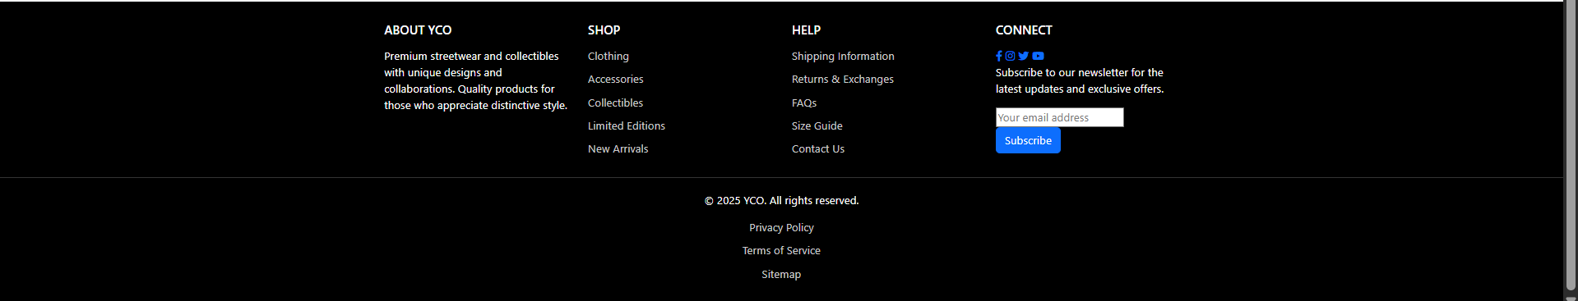
Figure 3. Footer Component Layout
Table 2. Description of Footer Component Elements
Element | Type | Description | Access Level
About YCO (Company Information) | Content | Brief brand intro (premium streetwear, collectibles, collaborations) | Public
Shop (Category Links) | Navigation | Links: Clothing, Accessories, Collectibles, Limited Editions, New Arrivals. Navigate to Error Page because there don’t have design for those page. | Public
Help | Navigation | Links: Shipping Information, Returns & Exchanges, FAQs, Size Guide, Contact Us. Navigate to Error Page because there don’t have design for those page. For the Contact Us link, it navigates user to Contact Page | Public
Connect (Social Media Links) | Content | Icons/links: Facebook, Instagram, Twitter, YouTube | Public
Newsletter Signup | Form | Email subscription form (email input + Subscribe button) | Public
Copyright Notice | Content | © {year} YCO. All rights reserved. | Public
Legal Links | Navigation | Privacy Policy, Terms of Service. Navigate to Error Page because there don’t have design for those page. | Public
Sitemap Link | Navigation | Link to Sitemap. Navigate to Error Page because there don’t have design for those page. | Public

2.1.1.3.3 User Profile Sidebar Component
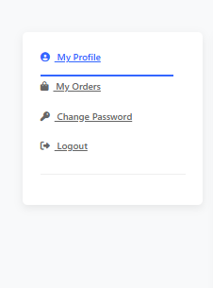
Figure 4. User Profile Sidebar
Table 3. User Profile Sidebar Elements
Element | Type | Description | Access Level
My Profile button | Navigation | Navigate to User Profile Page | Authenticated
My Orders button | Navigation | Navigate to User Orders Page | Authenticated
Change Password button | Navigation | Navigate to Change Password Page | Authenticated
Logout | Navigation | Navigate to Home Page | Authenticated

2.1.1.3.4 User Dashboard Sidebar Component
Table 4. User Dashboard Sidebar Elements
Element | Type | Description | Access Level
Home button | Navigation | Navigate to Home Page | Authenticated
My Profile button | Navigation | Navigate to User Profile Page | Authenticated
My Bookings button | Navigation | Navigate to Customer Booking Page | Customer
My Cart button | Navigation | Navigate to Shopping Cart Page | Customer
Wishlist | Navigation | Navigate to Error page because there doesn’t have design for that page | Customer

2.1.1.4 Detailed UI Elements by Screen

2.1.1.4.1 Public Pages

2.1.1.4.1.1 Home Page Elements
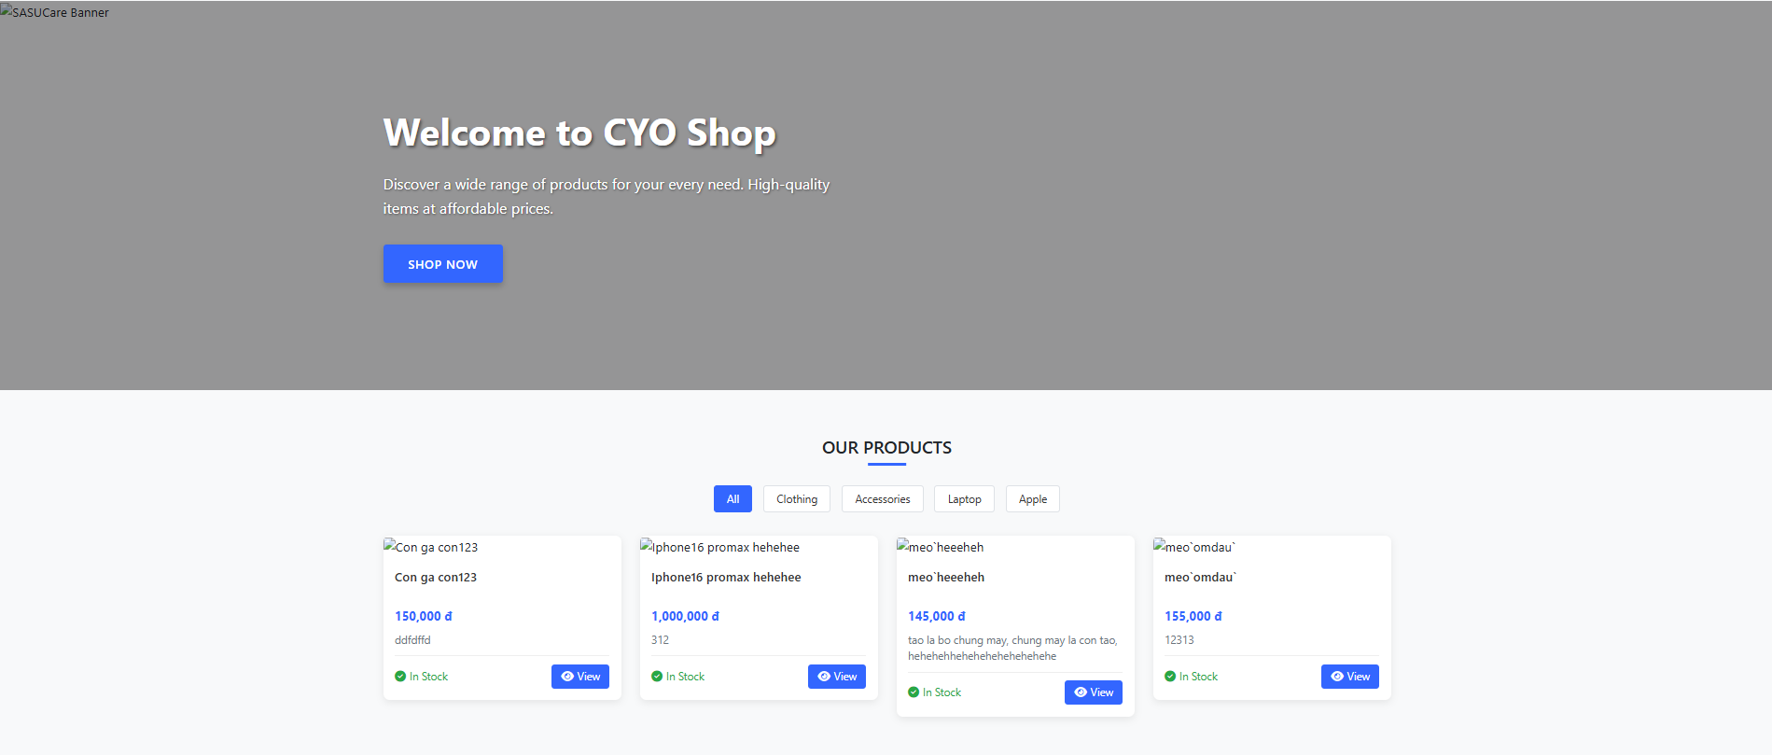
Figure 5. Home Page Layout
Table 5. Description of Home Page Elements
Element | Type | Description | Access Level
Hero Banner Image | Media | Full-width banner background | Public
Banner Title | Content | “Welcome to CYO Shop” | Public
Banner Text | Content | Short store intro | Public
Shop Now button | Button | Scrolls to products section | Public
OUR PRODUCTS Title | Content | Section header | Public
Category Pills: All | Button | Show all products | Public
Category Pills: By Category | Button | Filter products by category | Public
Empty State Card | Content | Shown when no products | Public
Product Card | Component | Card wrapper for each product | Public
- New Badge | Content | Optional product.badgeText | Public
- Product Image | Media | Product thumbnail | Public
- Product Title link | Navigation | Navigate to Product Detail Page | Public
- Product Price | Content | Formatted price (VND) | Public
- Product Description | Content | Short description or fallback | Public
- Stock Status | Content | “In Stock” or “Out of Stock” | Public
- View button | Navigation | Navigate to Product Detail Page | Public

2.1.1.4.1.2 Product Detail Page Elements
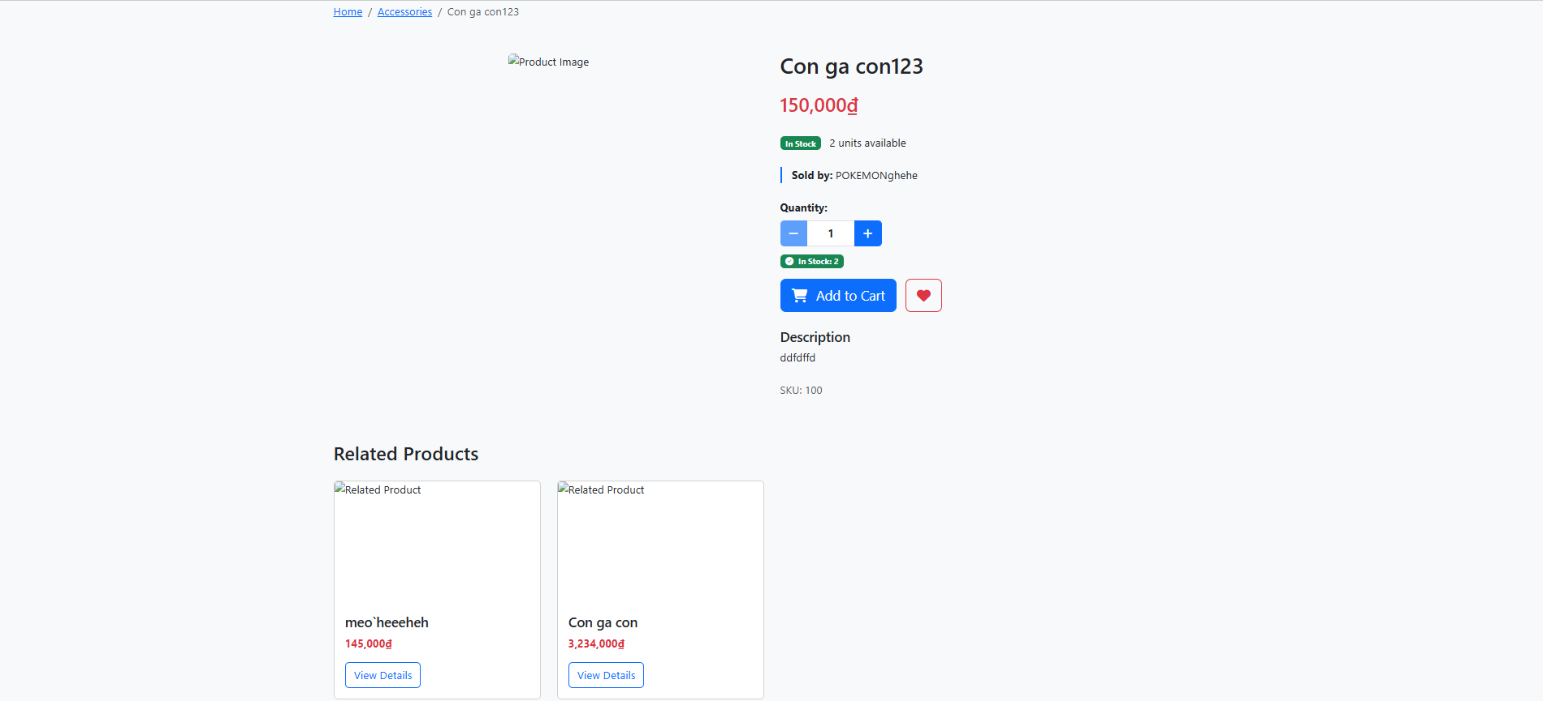
Figure 6. Product Detail Page Layout
Table 6. Description of Product Detail Page Elements
Element | Type | Description | Access Level
Breadcrumb | Navigation | Home → Category → Current product | Public
Main Product Image | Media | Large product image with thumbnails | Public
Thumbnails | Media | Click to swap main image | Public
Product Name | Content | Title of the product | Public
Price | Content | Formatted VND with red highlight | Public
Stock Status | Content | In Stock/Out of Stock + available units | Public
Seller Info | Content | Seller shop name or full name | Public
Quantity Selector | Control | Increment/decrement buttons and input with validation | Public
Add to Cart button | Action/Navigation | If User is authenticated, click the button will add product to cart. Else will navigate User to Login Page | Public
Wishlist (heart) | Action | Button placeholder to save item. This button is not have functionality yet | Authenticated to persist, viewable Public
Description | Content | Rich text (preserves line breaks) | Public
SKU | Content | Optional SKU display | Public
Related Products Section | Component | Grid of related products (image, name, price, View Details). Clickable, navigate to Product Detail Page | Public
- Product Image | Media | Product thumbnail or placeholder | Public
- Product Name | Content | Product title | Public
- Category Name | Content | Category label (if present) | Public
- Price | Content | Formatted VND | Public
- View Details button | Navigation | Navigate to Product Detail Page | Public

2.1.1.4.1.3 Search Results Page Elements
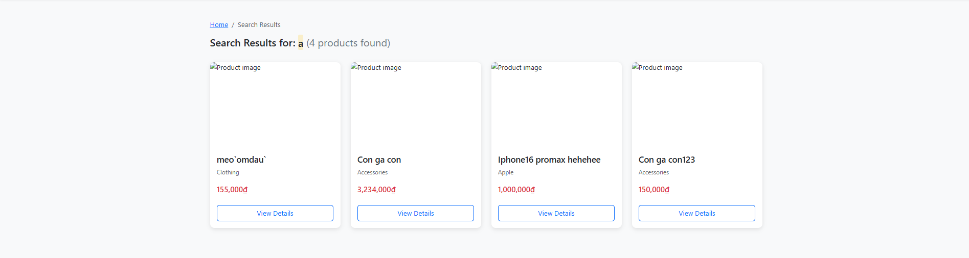
Figure 7. Search Results Page Layout
Table 7. Description of Search Results Page Elements
Element | Type | Description | Access Level
Breadcrumb | Navigation | Home → Search Results | Public
Search Query Heading | Content | Shows “Search Results for: {query}” with result count | Public
No Results Section | Content/CTA | Empty-state message and “Continue Shopping” button | Public
Product Card | Component | Grid of search results. Clickable, navigate to Product Detail Page | Public
- Product Image | Media | Product thumbnail or placeholder | Public
- Product Name | Content | Product title | Public
- Category Name | Content | Category label (if present) | Public
- Price | Content | Formatted VND | Public
- View Details button | Navigation | Navigate to Product Detail Page | Public

2.1.1.4.1.4 About Us Page Elements
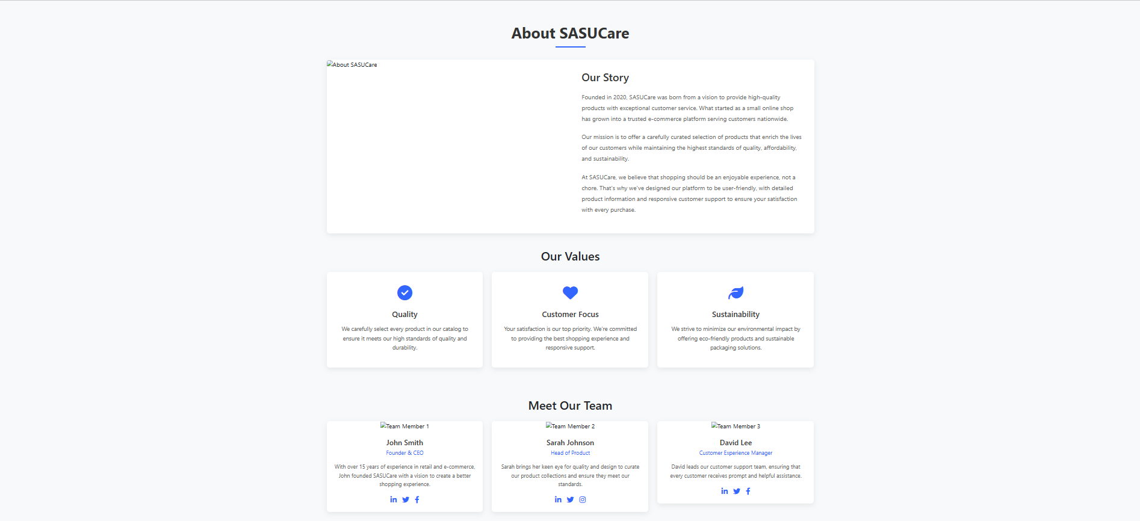
Figure 8. About Us Page Layout
Table 8. Description of About Us Page Elements
Element | Type | Description | Access Level
Page Title | Content | “About SASUCare” heading with underline | Public
About Section Image | Media | Banner/illustration for About section | Public
Our Story | Content | Company introduction and mission paragraphs | Public
Our Values: Quality | Card | Emphasizes rigorous product standards | Public
Our Values: Customer Focus | Card | Commitment to shopping experience and support | Public
Our Values: Sustainability | Card | Eco-friendly products and packaging | Public
Meet Our Team: John Smith | Card | Founder & CEO profile with social links | Public
Meet Our Team: Sarah Johnson | Card | Head of Product profile with social links | Public
Meet Our Team: David Lee | Card | Customer Experience Manager profile with social links | Public

2.1.1.4.1.5 Contact Page Elements
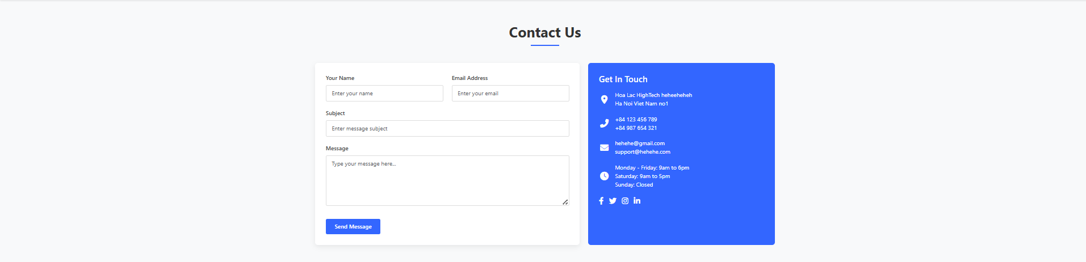
Figure 9. Contact Us Page Layout
Table 9. Description of Contact Us Page Elements
Element | Type | Description | Access Level
Page Title | Content | “Contact Us” heading with underline | Public
Contact Form: Your Name | Form field | Text input for sender name | Public
Contact Form: Email Address | Form field | Email input for sender email | Public
Contact Form: Subject | Form field | Text input for message subject | Public
Contact Form: Message | Form field | Textarea for message body | Public
Contact Form: Send Message button | Button | Submit form | Public
Get In Touch: Address | Content | Company address block | Public
Get In Touch: Phone | Content | Phone numbers | Public
Get In Touch: Email | Content | Support email addresses | Public
Get In Touch: Hours | Content | Business hours | Public
Social Links | Navigation | Facebook, Twitter, Instagram, LinkedIn icons. | Public

2.1.1.4.1.6 Collaborations Page Elements
Table 10. Description of Collaborations Page Elements
UI Element | Type | Description
Page Title | Content | Main heading for collaborations section
Partnership Information | Content | Details about collaboration opportunities and  partnerships
Partner Showcase | Visual | Display of current partners or collaboration examples
Contact for Partnerships | Content | Information on how to  initiate collaboration discussions

2.1.1.4.2 Authentication Pages

2.1.1.4.2.1 Login Page Elements
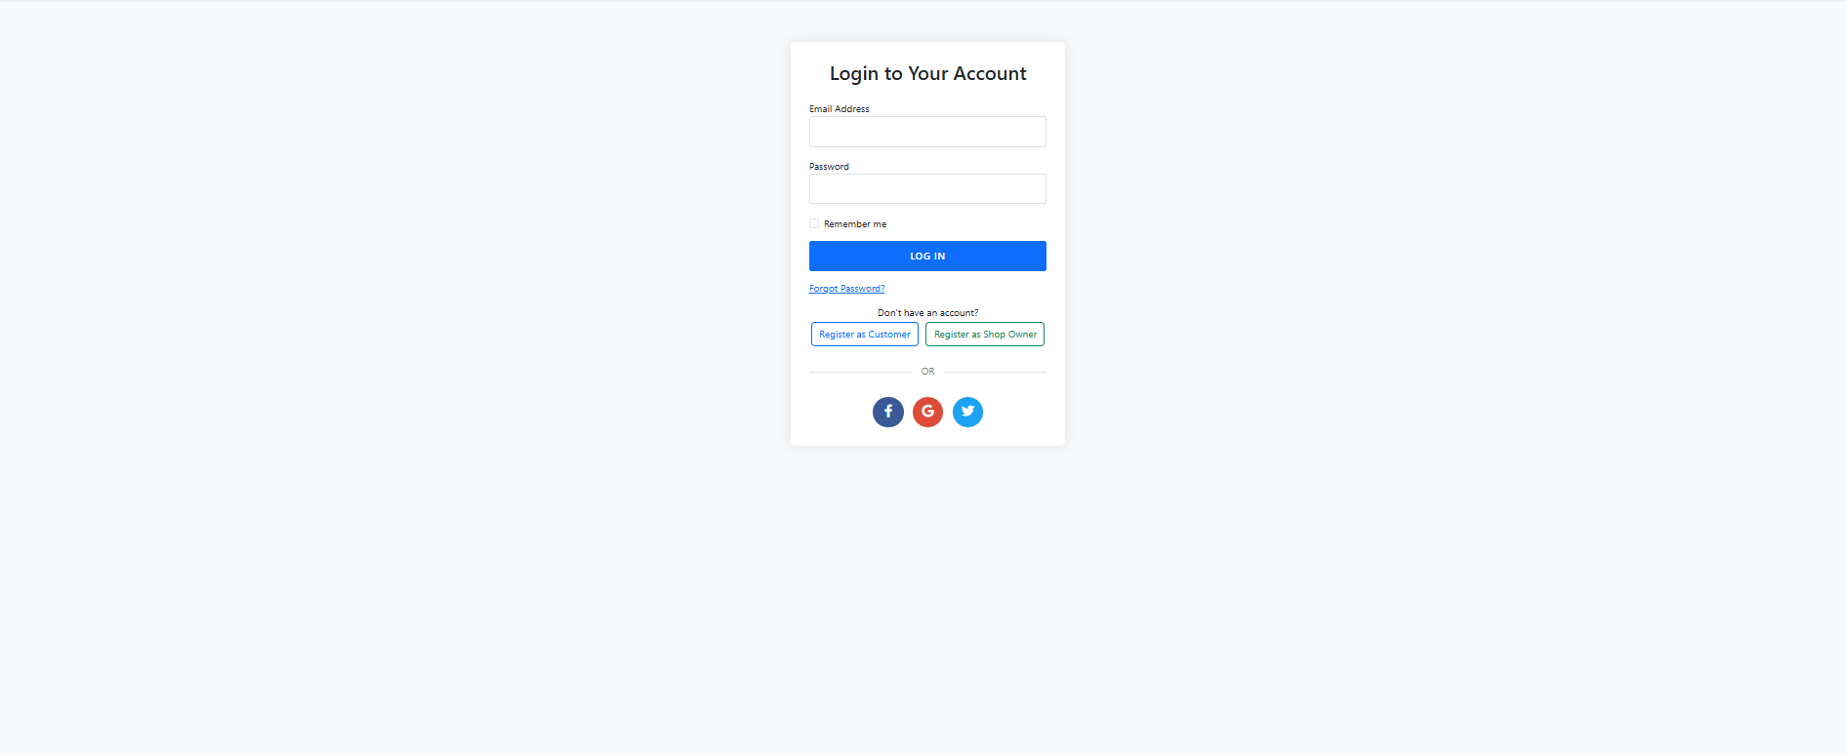
Figure 10. Login Page Layout
Table 11. Description of Login Page Elements
Element | Type | Description | Access Level
Page Title | Content | “Login to Your Account” | Public
Email Address | Form field | Input for username/email | Public
Password | Form field | Password input | Public
Remember me | Checkbox | Checkbox to remember session | Public
Login button | Button/Navigation | Submit credentials. If credentials valid, then navigate to Home Page | Public
Forgot Password link | Navigation | Navigation to password recovery | Public
Register as Customer button | Navigation | Navigation to Customer Registration Page | Public
Register as Shop Owner button | Navigation | Navigation to Seller Registration Page | Public
Social Login: Facebook | Icon Button | Placeholder social login | Public
Social Login: Google | Icon Button | Placeholder social login | Public
Social Login: Twitter | Icon Button | Placeholder social login | Public

2.1.1.4.2.2 Customer Registration Page Elements
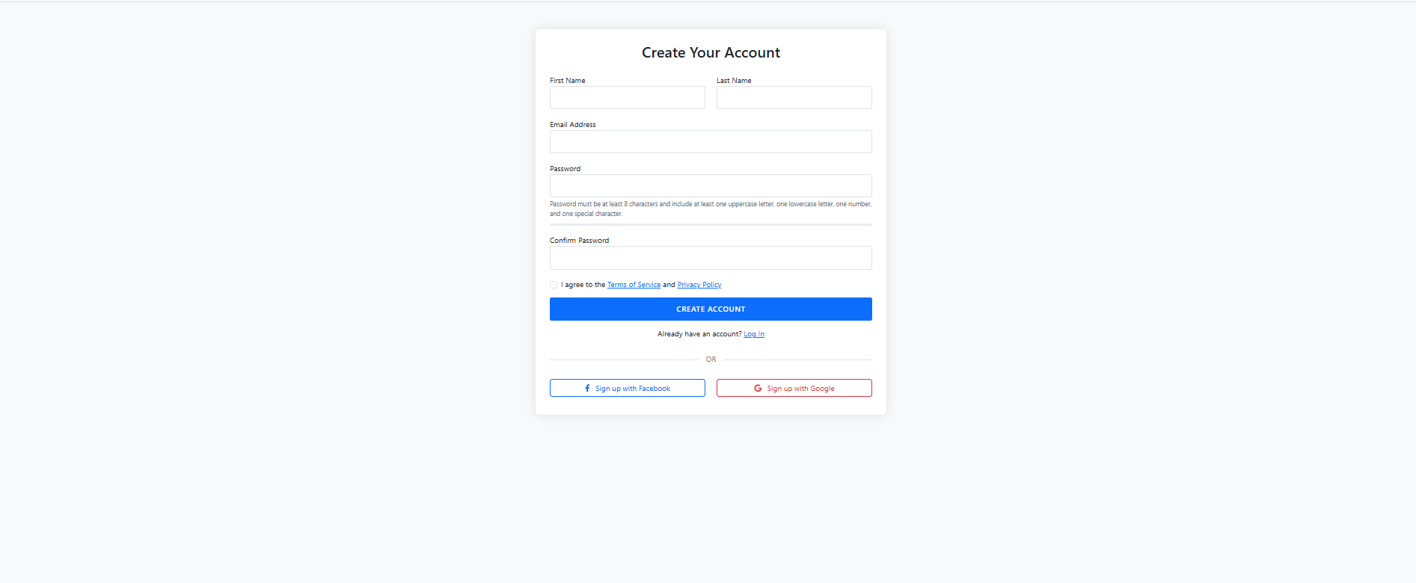
Figure 11. Customer Registration Page Layout
Table 12. Description of Customer Registration Page Elements
Element | Type | Description | Access Level
Page Title | Content | “Create Your Account” | Public
First Name | Form field | Text input | Public
Last Name | Form field | Text input | Public
Email Address | Form field | Email input with validation | Public
Password | Form field | Password input + requirements + strength bar | Public
Confirm Password | Form field | Password confirmation with mismatch validation | Public
Agree to Terms | Checkbox | Checkbox with modals for Terms and Privacy | Public
Create Account button | Button | Submit registration. If the form is submitted valid, navigate to Login Page | Public
Login link | Navigation | Navigate to Login Page | Public
Social Signup: Facebook | Button | Placeholder signup | Public
Social Signup: Google | Button | Placeholder signup | Public
Terms of Service Modal | Modal | Scrollable terms content | Public
Privacy Policy Modal | Modal | Scrollable privacy content | Public

2.1.1.4.2.3 Seller Registration Page Elements
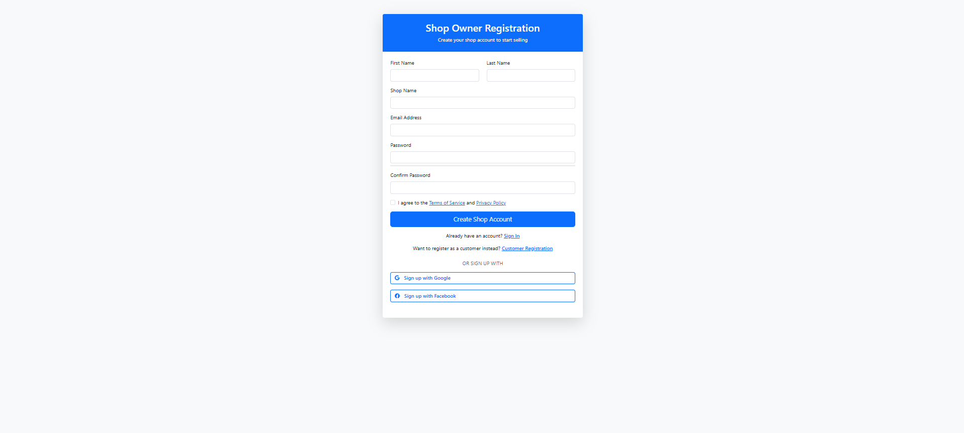
Figure 12. Seller Registration Page Layout
Table 13. Description of Seller Registration Page Elements
Element | Type | Description | Access Level
First Name | Form field | Text input | Public
Last Name | Form field | Text input | Public
Shop Name | Form field | Text input | Public
Email Address | Form field | Email input with validation | Public
Password | Form field | Password input + strength bar | Public
Confirm Password | Form field | Password confirmation with mismatch hint | Public
Agree to Terms | Checkbox | Checkbox with Terms and Privacy modals | Public
Create Shop Account button | Button | Submit seller registration. If the form is submitted valid, navigate to Login Page | Public
Signin link | Navigation | Navigate to Login Page | Public
Customer Registration link | Navigation | Navigate to Customer Registration Page | Public
Social Signup: Google | Button | Placeholder signup | Public
Social Signup: Facebook | Button | Placeholder signup | Public
Terms of Service Modal | Modal | Seller-specific terms | Public
Privacy Policy Modal | Modal | Seller privacy details | Public

2.1.1.4.3 Customer Pages

2.1.1.4.3.1 Shopping Cart Page Elements
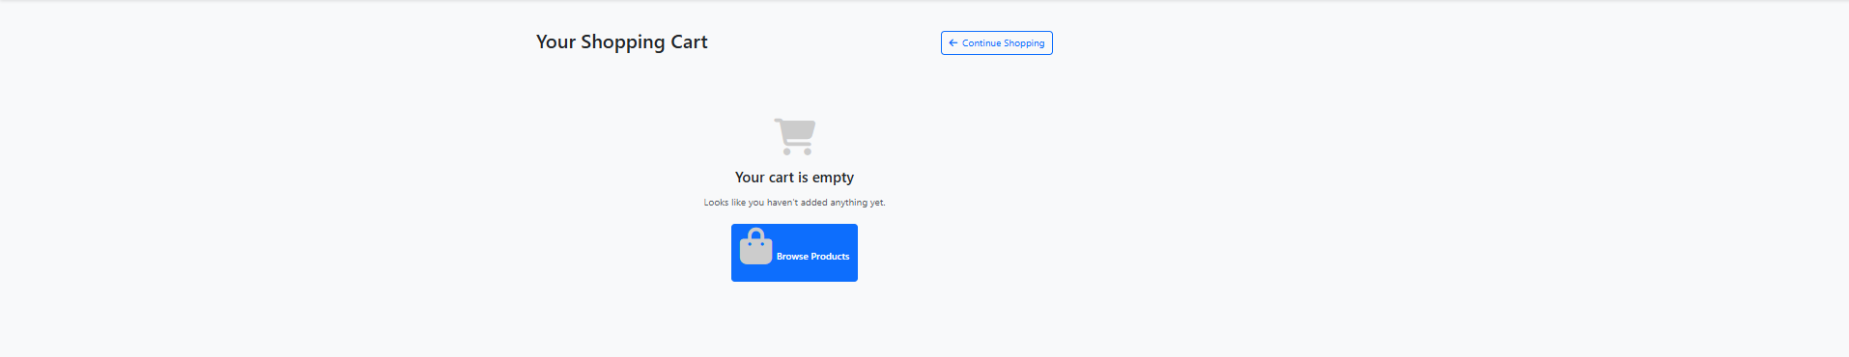
Figure 13. Shopping Cart Page (Empty State)
Table 14. Description of Empty Shopping Cart Elements
Element | Type | Description | Access Level
Page title | Content | A title “Your Shopping Cart” | Public
Continue Shopping button | Navigation | Navigate to Home Page | Public
Empty cart card | Content | Cart icon and “Your cart is empty” message | Public
Browse Products button | Navigation | Navigate to Home Page | Public
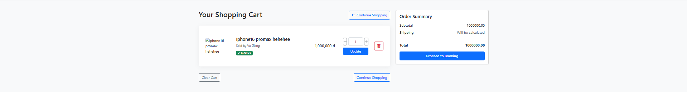
Figure 14. Shopping Cart Page (With Items)
Table 15. Description of Shopping Cart Elements with Items
Element | Type | Description | Access Level
Page title | Content | “Your Shopping Cart” | Authenticated
Continue Shopping button | Navigation | Navigate to Home Page | Authenticated
Product image | Media | Thumbnail of the item | Authenticated
Product info | Content | Name, seller, stock badge | Authenticated
Price | Content | Unit price (formatted) | Authenticated
Quantity control | Control | -/+ buttons and numeric input with validation | Authenticated
Update button | Action | Applies quantity changes | Authenticated
Remove item button | Action | Trash icon to remove the product | Authenticated
Clear Cart button | Action | Removes all items | Authenticated
Order Summary | Card | Subtotal, Shipping note, Total | Authenticated
Proceed to Booking button | Navigation | Navigate to Create Booking Page | Authenticated

2.1.1.4.3.2 Customer Bookings Page Elements
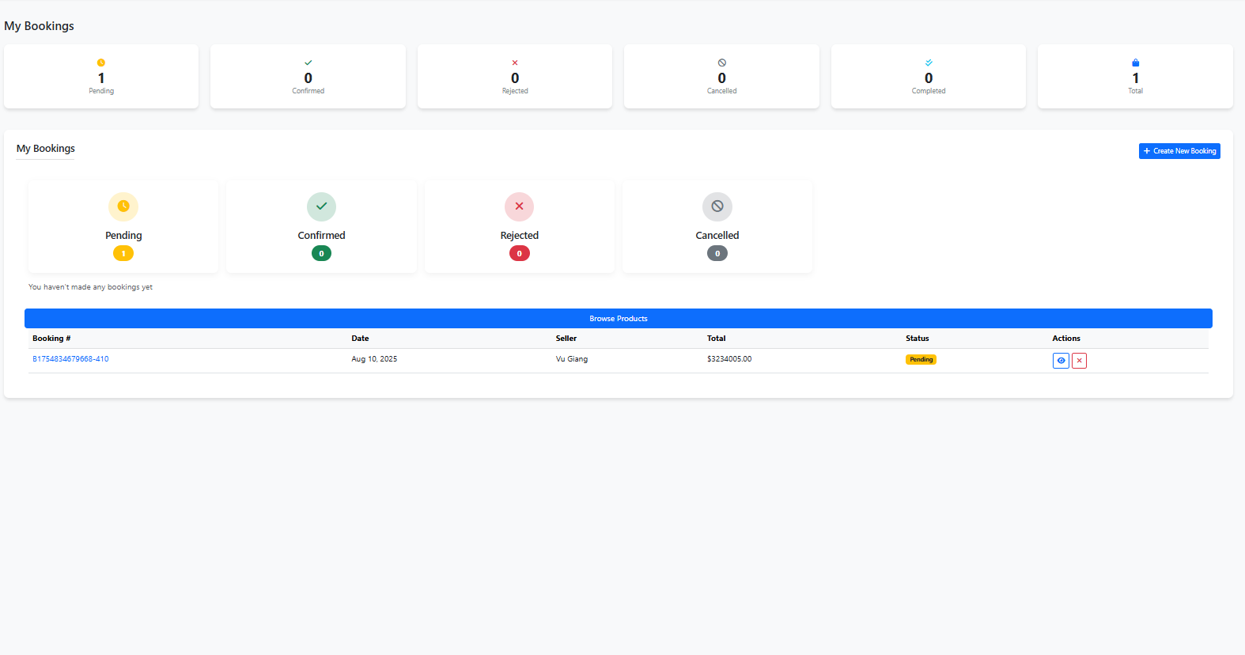
Figure 15. Customer Bookings Page Layout
Table 16. Description of Customer Bookings Page Elements
Element | Type | Description | Access Level
Summary counters | Stats | Pending, Confirmed, Rejected, Cancelled, Total | Authenticated
Create New Booking button | Navigation | Navigate to Create Booking Page | Customer
Status filters | Tabs/Cards | Quick filter by Pending/Confirmed/Rejected/Cancelled | Customer
Browse Products button | Navigation | Navigate to Home Page | Public
Bookings table | Table | Lists user bookings | Customer
- Booking # | Link/Navigation | Navigate to Booking Details Page | Customer
- Date | Content | Booking creation date | Customer
- Seller | Content | Seller name | Customer
- Total | Content | Total amount | Customer
- Status | Badge | Current booking status | Customer
- Actions | Buttons | Contain 2 buttons. The first is View Detail button, navigate to Booking Details Page when clicked. The second is Delete button, only appear when status is “pending”, delete product from booking when clicked. | Customer

2.1.1.4.3.3 Booking Details Page Elements
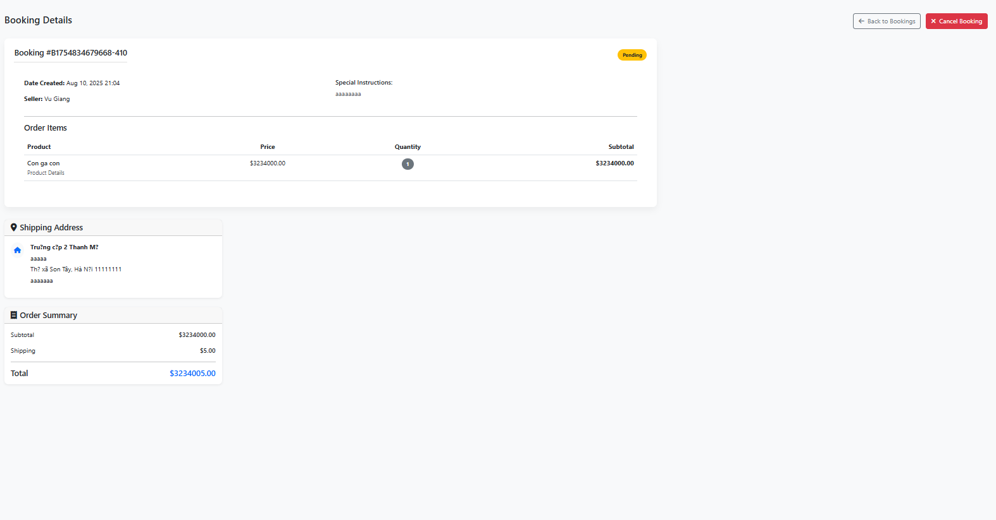
Figure 16. Booking Details Page Layout
Table 17. Description of Booking Details Page Elements
Element | Type | Description | Access Level
Back to Bookings button | Navigation | Navigate to Customer Bookings Page | Customer
Cancel Booking button | Action | Cancels the current booking (when allowed) | Customer
Booking header | Content | “Booking #{number}” and status badge (Pending/Confirmed/Rejected/Cancelled) | Customer
Date Created | Content | Booking creation timestamp | Customer
Seller | Content | Seller’s name | Customer
Special Instructions | Content | Optional notes provided by customer | Customer
Order Items table | Component | Lists items in the booking | Customer
- Product | Content | Product name | Customer
- Price | Content | Unit price | Customer
- Quantity | Content | Quantity ordered | Customer
- Subtotal | Content | Line total per item | Customer
Shipping Address card | Card | Recipient name and full address | Customer
Order Summary card | Card | Subtotal, Shipping, Total | Customer

2.1.1.4.3.4 Create Booking Page Elements
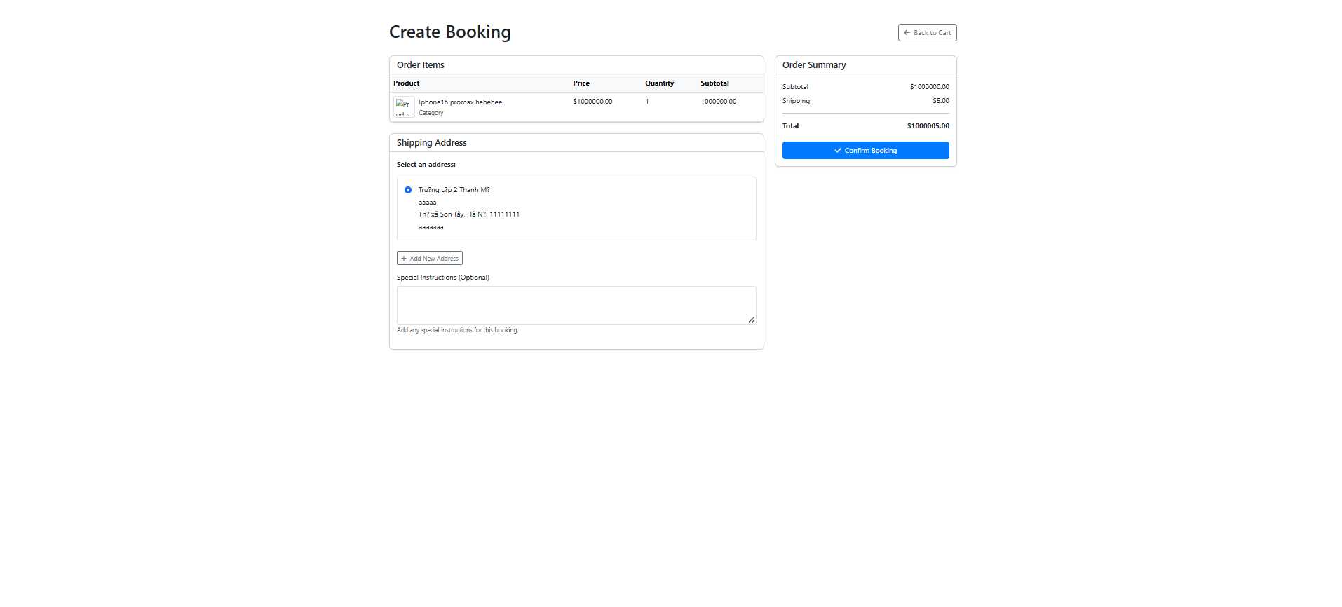
Figure 17. Create Booking Page Layout
Table 18. Description of Create Booking Page Elements
Element | Type | Description | Access Level
Back to Cart button | Navigation | Navigate to Shopping Cart Page | Customer
Alerts | Content | Error messages (param error, inline error) | Customer
Order Items table | Table | Product thumbnail, name, price, quantity, subtotal | Customer
Shipping Address section | Form | Select existing address (radio list) or add a new address | Customer
- Add New Address button | Action | Reveals new-address form, disables existing selection. Must click button first to show to form. | Customer
- New Address form | Fields | Street, Street Address, City, State/Province, Postal Code, Country | Customer
+ Street | Form input | Text input | Customer
+ Street Address | Form input | Text input (Optional) | Customer
+ City | Form input | Text input | Customer
+ State/Province | Form input | Text input | Customer
+ Postal Code | Form input | Text input | Customer
+ Country | Form input | Text input | Customer
+ Cancel button | Action | Close the New Address form without any save | Customer
Special Instructions | Textarea | Optional notes for the booking | Customer
Order Summary card | Card | Subtotal, Shipping, Total | Customer
Confirm Booking button | Button/Navigation | Submits bookingForm to create booking and navigate to Booking Details Page of that order | Customer

2.1.1.4.4 Account Management Pages

2.1.1.4.4.1 User Profile Page Elements
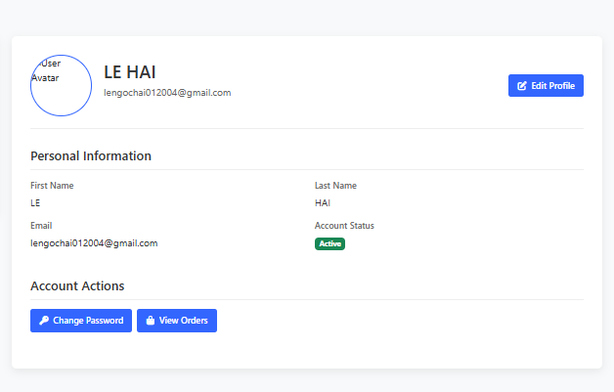
Figure 18. User Profile Page Layout
Table 19. Description of User Profile Page Elements
Element | Type | Description | Access Level
Avatar | Media | Circular user image | Authenticated
Full name | Content | firstName lastName | Authenticated
Email | Content | User email address | Authenticated
Role badges | Badge | One badge per role (e.g., Customer, Seller, Admin) | Authenticated
Edit Profile button | Navigation | Navigate to Edit Profile Page | Authenticated
First Name | Field (read-only) | Displays user’s first name | Authenticated
Last Name | Field (read-only) | Displays user’s last name | Authenticated
Email | Field (read-only) | Displays user’s email | Authenticated
Account Status | Badge | “Active” or “Inactive” | Authenticated
Shop Name | Field (read-only) | Seller’s shop name | SELLER
Seller Since | Field (read-only) | Date the seller account was created | SELLER
Manage Shop button | Navigation | Navigate to Dashboard Page | SELLER
Change Password button | Navigation | Navigate to Change Password Page | Authenticated
View Orders button | Navigation | Navigate to User Orders Page | Authenticated

2.1.1.4.4.2 Edit Profile Page Elements
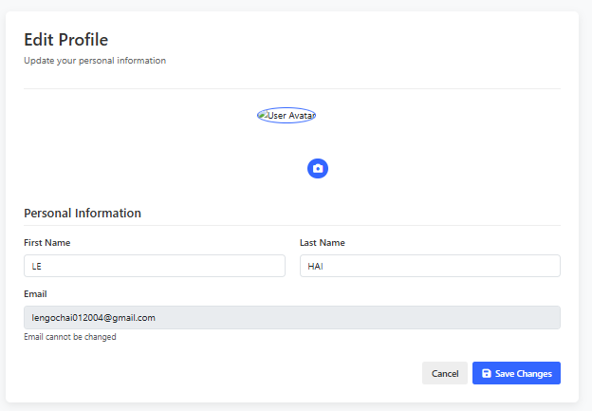
Figure 19. Edit Profile Page Layout
Table 20. Description of Edit Profile Page Elements
Element | Type | Description | Access Level
Page title | Content | “Edit Profile” and subtitle “Update your personal information” | Authenticated
Avatar preview | Media | Current avatar image | Authenticated
Upload avatar button | Action | Camera icon triggers file input profileImage (accepts images) | Authenticated
First Name | Input | Editable text field with validation | Authenticated
Last Name | Input | Editable text field with validation | Authenticated
Email | Input (read-only) | Disabled email field; cannot be changed | Authenticated
Shop Name | Input | Visible only for SELLER role | SELLER
Cancel button | Navigation | Navigate to User Profile Page without saving | Authenticated
Save Changes button | Navigation | Navigate to User Profile Page and save information | Authenticated

2.1.1.4.4.3 Change Password Page Elements
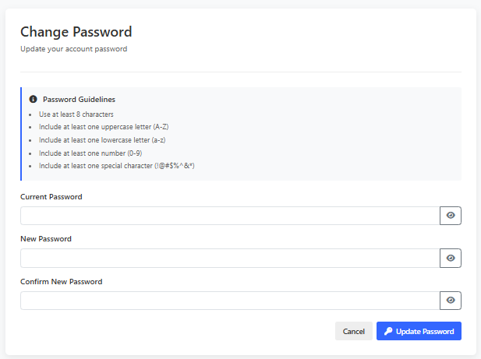
Figure 20. Change Password Page Layout
Table 21. Description of Change Password Page Elements
Element | Type | Description | Access Level
Page title | Content | “Change Password” with subtitle | Authenticated
Password Guidelines | Panel | List of strength requirements | Authenticated
Current Password | Input + toggle | Password field with eye icon to show/hide | Authenticated
New Password | Input + toggle | Password field with minlength 8 and eye icon | Authenticated
Confirm New Password | Input + toggle | Must match new password; mismatch shows error | Authenticated
Cancel button | Navigation | Navigate to User Profile Page without saving | Authenticated
Update Password button | Navigation | Navigate to User Profile Page and save information | Authenticated

2.1.1.4.4.4 User Orders Page Elements
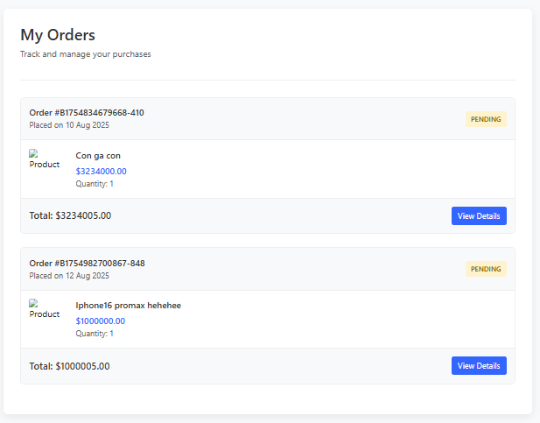
Figure 21. User Orders Page Layout
Table 22. Description of User Orders Page Elements
Element | Type | Description | Access Level
Page header | Content | Title “My Orders”, subtitle | Authenticated
Empty Orders state | Panel | Bag icon, message, “Shop Now” button | Authenticated
Order card | Card | One per order with header/body/footer | Authenticated
- Order ID | Content | “Order #<bookingNumber>” | Authenticated
- Placed on | Content | Formatted creation date | Authenticated
- Status badge | Badge | Pending/Confirmed/Completed/Cancelled | Authenticated
- Product item | Row | Image, name, price, quantity (for each booking item) | Authenticated
- Total | Content | Total amount | Authenticated
- View Details button | Navigation | Navigate to Booking Details Page | Authenticated

2.1.1.4.5 Seller Pages

2.1.1.4.5.1 Dashboard Page Elements
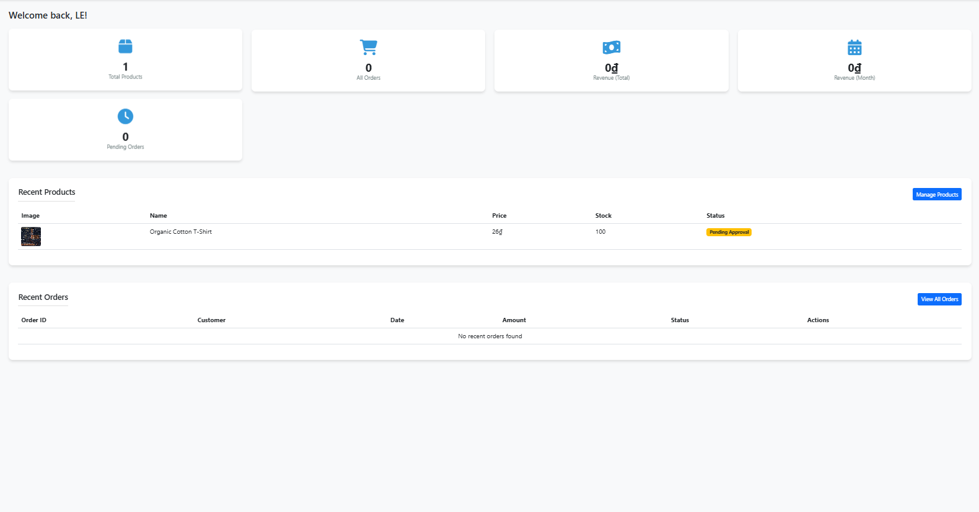
Figure 22. Seller Dashboard Layout
Table 23. Description of Seller Dashboard Elements
Element | Type | Description | Access Level
Flash messages | Alerts | Success, error, info banners | SELLER
Welcome text | Content | “Welcome back, {firstName}!” | SELLER
Stat card: Total Products | Card | Count of products | SELLER
Stat card: All Orders | Card | Count of recent orders list | SELLER
Stat card: Revenue (Total) | Card | Sum revenue formatted VND | SELLER
Stat card: Revenue (Month) | Card | Monthly revenue formatted VND | SELLER
Stat card: Pending Orders | Card | Number of pending orders | SELLER
Recent Products table | Table | Image, Name, Price, Stock, Status | SELLER
Manage Products button | Navigation | Navigate to Seller Products Page | SELLER
Product status badges | Badge | Active, Inactive, Out of Stock, Pending Approval, Rejected | SELLER
Recent Orders table | Table | Order ID, Customer, Date, Amount, Status, Actions; “View All Orders” button | SELLER
View All Orders button | Navigation | Navigate to Seller Orders Page | SELLER

2.1.1.4.5.2 Seller Products Page Elements
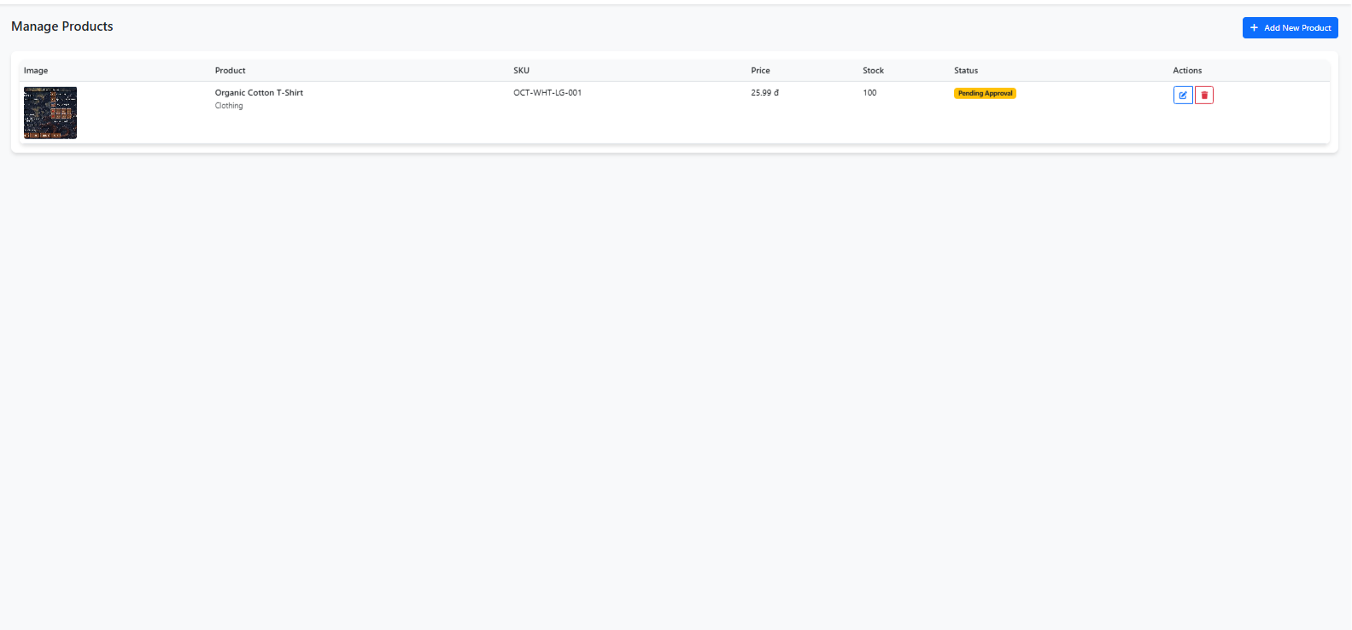
Figure 23. Seller Products Page Layout
Table 24. Description of Seller Products Page Elements
Element | Type | Description | Access Level
Page header | Content | “Manage Products” and Add New Product button (opens modal) | SELLER
Products table | Table | Image, Product, SKU, Price, Stock, Status, Actions | SELLER
Product status badges | Badge | Active, Inactive, Draft, Pending Approval, Rejected | SELLER
Action: Edit | Button/Navigation | Placeholder | SELLER
Action: Delete | Action | Opens Delete Product modal | SELLER
Delete Product modal | Modal | Confirms deletion; POST to /seller/products/delete/{id} | SELLER
- Title | Content | “Confirm Delete” | Title
- Message | Content | Confirms deletion of selected product by name; warns it cannot be undone | Message
- Close (X) button | Action | Dismisses the modal | Close (X)
- Cancel button | Action | Closes modal without action | Cancel
- Delete button | Action | Delete product | Delete
Add New Product button | Action | Open Add Product modal
Add Product modal | Modal + Form | Fields: Name, SKU, Description, Price, Stock, Category, Image upload; Save Product | SELLER
- Modal title | Content | “Add New Product” | SELLER
- Close (X) button | Action | Dismisses the modal | SELLER
- Product Name | Input (text) | Required | SELLER
- SKU | Input (text) | Optional | SELLER
- Description | Textarea | Optional | SELLER
- Price (VND) | Input (number) | Required | SELLER
- Stock Quantity | Input (number) | Required | SELLER
- Category | Dropdown | Optional | SELLER
- Product Image | Input (file) | Optional | SELLER
- Image Preview | Preview area | Shows selected image before submit | SELLER
- Cancel button | Action | Closes modal | SELLER
- Save Product button | Action | Submits the form to create the product and close modal | SELLER

2.1.1.4.5.3 Seller Orders Page Elements
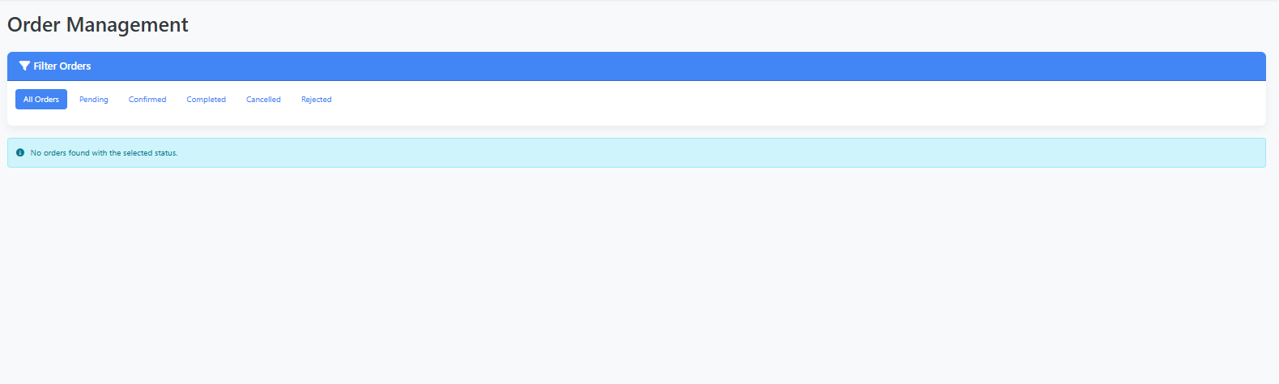
Figure 24. Seller Orders Page Layout (With Filters)
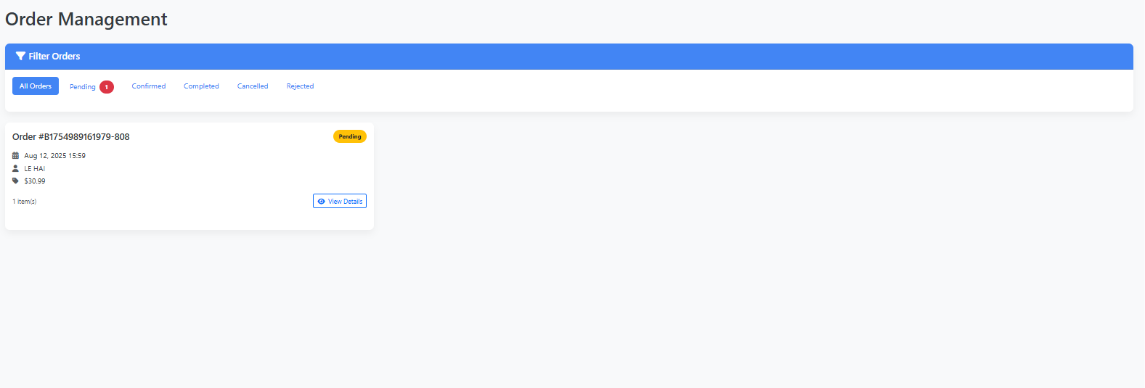
Figure 25. Seller Orders Page (Order List)
Table 25. Description of Seller Orders Page Elements
Element | Type | Description | Access Level
Page header | Content | “Order Management” | SELLER
Filters card | Card | Header “Filter Orders” | SELLER
- All Orders tab | Tab/Link | /seller/orders | SELLER
- Pending tab | Tab/Link + badge | /seller/orders?status=PENDING shows pendingCount | SELLER
- Confirmed tab | Tab/Link | /seller/orders?status=CONFIRMED | SELLER
- Completed tab | Tab/Link | /seller/orders?status=COMPLETED | SELLER
- Cancelled tab | Tab/Link | /seller/orders?status=CANCELLED | SELLER
- Rejected tab | Tab/Link | /seller/orders?status=REJECTED | SELLER
Empty state alert | Alert | “No orders found with the selected status.” | SELLER
Orders grid | Cards | One card per order with: Order #, Status badge, Placed date, Customer name, Total amount, Items count, View Details button | SELLER
View Details button | Navigation | Navigate to Seller Order Details Page | SELLER

2.1.1.4.5.4 Seller Order Details Page Elements
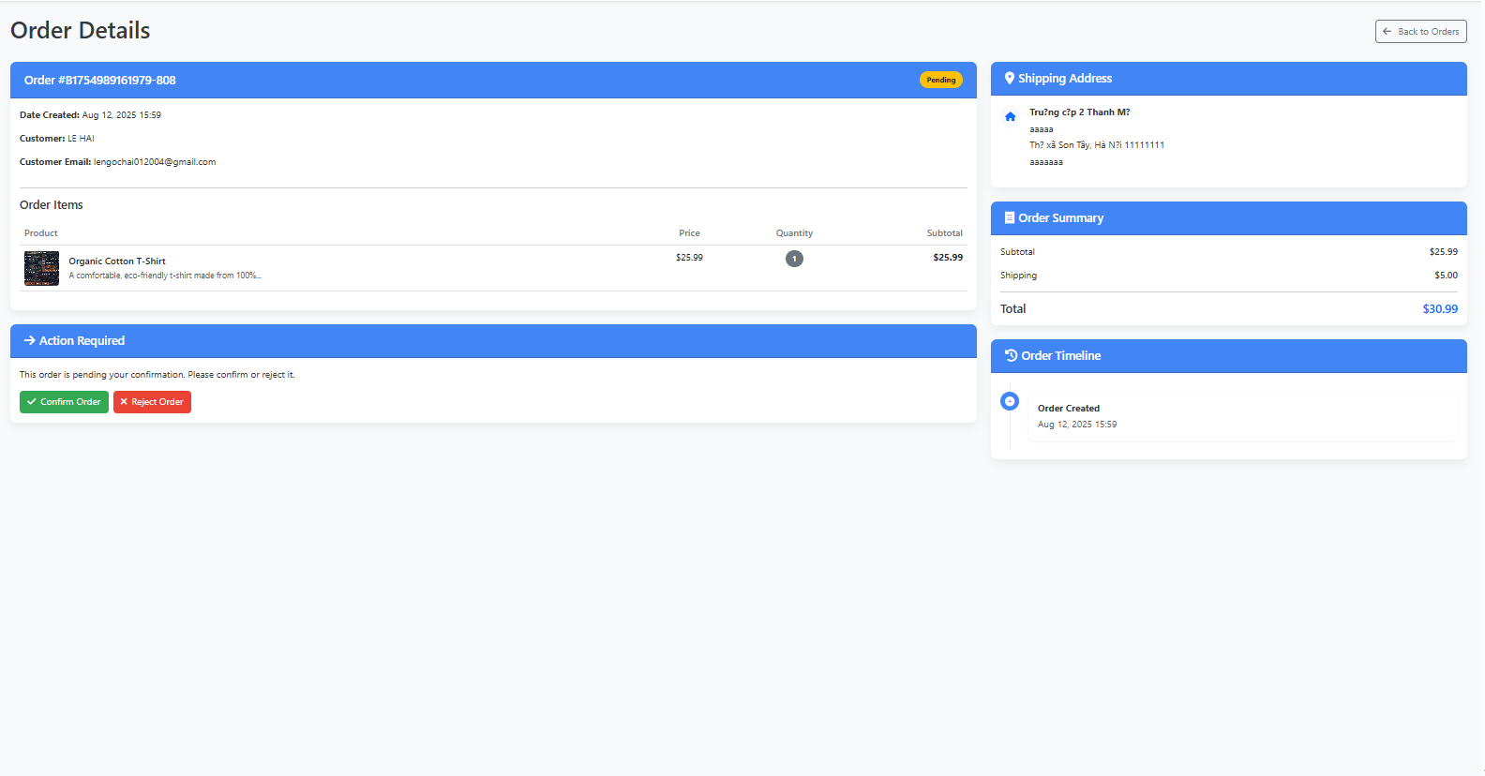
Figure 26. Seller Order Details Page Layout
Table 26. Description of Seller Order Details Page Elements
Element | Type | Description | Access Level
Back to Orders button | Navigation | Navigate to Seller Orders Page | SELLER
Order header | Card header | Order number and status badge (Pending/Confirmed/Rejected/Completed/Cancelled) | SELLER
Metadata (left) | Content | Date Created, Customer name, Customer email; conditional Confirmed On/Completed On; Special Instructions or Rejection Reason blocks | SELLER
Order Items table | Table | Product (image, name, details), Price, Quantity, Subtotal | SELLER
Confirm Order button | Action | Confirm order, set status to “Confirmed” | SELLER
Reject Order button | Action | Open Reject Order modal when clicked | SELLER
Reject Order modal | Modal + Form | Textarea reason (required); Cancel and Reject buttons; POST /seller/orders/{id}/reject | SELLER
Textarea reason | Textarea | Place to provide reason before reject | SELLER
Cancel button | Action | Close modal | SELLER
Reject Order button | Action | Close modal and set status to “Rejected” | SELLER
Mark as Complete | Action | Set status to “Completed” | SELLER
Shipping Address | Card | Street, optional Street Address, City/State/PostalCode, Country | SELLER
Order Summary | Card | Subtotal, Shipping, Total | SELLER
Order Timeline | Card | Created; Confirmed; Completed; Rejected; Cancelled (conditional entries) | SELLER

2.1.1.4.6 Admin Pages

2.1.1.4.6.1 Admin Products Page Elements
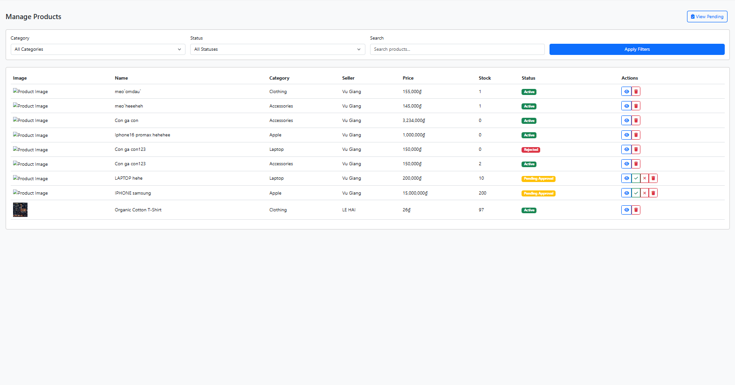
Figure 27. Admin Products Page Layout
Table 27. Description of Admin Products Page Elements
Element | Type | Description | Access Level
Manage Products | Content | Page title | Admin
View Pending button | Navigation | Navigate to Admin Pending Products Page | Admin
Success/Error alerts | Alert | Dismissible operation feedback | Admin
Filter form | Form
- Category | Dropdown | Filter by category (All + dynamic options) | Admin
- Status | Dropdown | Filter by status (All, Active, Inactive, Out of Stock, Pending Approval, Rejected) | Admin
- Search | Input | Free-text search box | Admin
- Apply Filters button | Action | Submits Filter form | Admin
Products table: Image | Media | 50x50 product thumbnail (placeholder if missing) | Admin
Products table: Name | Content | Product name | Admin
Products table: Category | Content | Category name or “Uncategorized” | Admin
Products table: Seller | Content | Seller full name or “Unknown” | Admin
Products table: Price | Content | Formatted VND | Admin
Products table: Stock | Content | Quantity in stock | Admin
Products table: Status | Badge | Active, Inactive, Out of Stock, Pending Approval, Rejected | Admin
Products table: Actions | Buttons | View, Approve (pending), Reject (pending), Delete | Admin
- Action: View button | Action/Navigation | Navigate to Product Detail Page | Admin
- Action: Approve button | Modal | Click to open Approve Product modal, contain 2 buttons: Cancel button and Approve button. Click Cancel button will close modal, otherwise click Approve button will set product status to “Active” and navigate to Admin Pending Products Page | Admin
- Action: Reject button | Modal | Click to open Reject Product modal, contain 2 buttons: Cancel button and Reject button. Click Cancel button will close modal, otherwise click Reject button will set product status to “Rejected” and navigate to Admin Pending Products Page | Admin
- Action: Delete button | Modal | Click to open Delete Product modal, contain 2 buttons: Cancel button and Delete button. Click Cancel button will close modal, otherwise click Delete button will navigate to Error Page because this functionality is not done yet | Admin

2.1.1.4.6.2 Admin Pending Products Page Elements
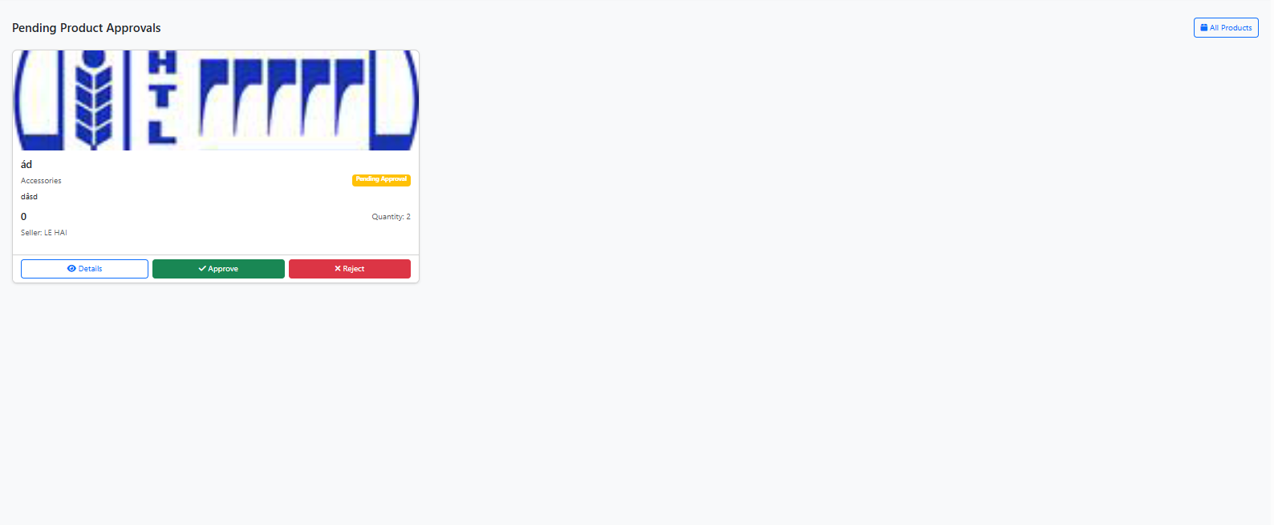
Figure 28. Admin Pending Products Page Layout
Table 28. Description of Admin Pending Products Page Elements
Element | Type | Description | Access Level
Pending Product Approvals | Content | Page heading | Admin
All Products button | Navigation | Navigate to Admin Products Page | Admin
Product card: Image | Media | Large product image | Admin
Product card: Name | Content | Product title | Admin
Product card: Category | Content | Category label | Admin
Product card: Status | Badge | “Pending Approval” | Admin
Product card: Description | Content | Short description | Admin
Product card: Price | Content | Formatted price | Admin
Product card: Quantity | Content | Stock quantity | Admin
Product card: Seller | Content | Seller full name | Admin
Details button | Action | Opens “Product Details” modal | Admin
Approve button | Action | Opens Approve modal; confirms approval | Admin
Reject button | Action | Opens Reject modal; requires reason | Admin
Modal: Product Details | Modal | Title, loading area, Open in New Tab CTA | Admin
Modal: Approve Product button | Modal | Hidden productId; Cancel/Approve buttons | Admin
Modal: Reject Product button | Modal | Hidden productId; Reason textarea (required); Cancel/Reject | Admin

2.1.1.4.6.3 Admin Categories Page Elements
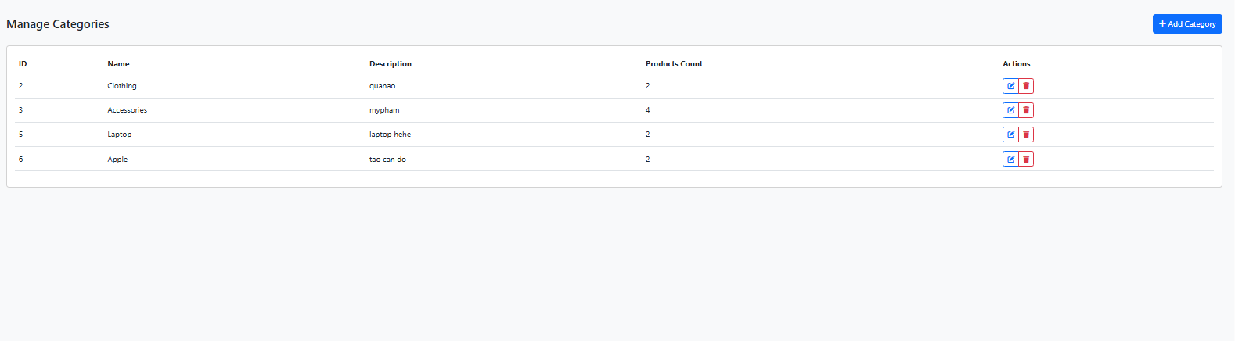
Figure 29. Admin Categories Page Layout
Table 29. Description of Admin Categories Page Elements
Element | Type | Description | Access Level
Manage Categories | Content | Page heading | Admin
Add Category button | Action | Opens Add New Category modal | Admin
- Category Name | Input | Text input | Admin
- Description | Input | Text input (optional) | Admin
- Cancel button | Action | Click to close modal | Admin
- Add category button | Action | Click to submit form | Admin
Categories table | Table | Lists existing categories | Admin
- ID | Column | Category identifier | Admin
- Name | Column | Category name | Admin
- Description | Column | Category description | Admin
- Products Count | Column | Number of products in category | Admin
- Actions | Column | Row controls | Admin
Action: Edit button | Action | Edit selected category | Admin
Action: Delete button | Action | Remove selected category | Admin

2.1.1.4.7 Error and System Pages

2.1.1.4.7.1 Error Page Elements
Table 30. Description of Error Page Elements
UI Element | Type | Description
Error Message | Content | User-friendly error message explaining the issue
Error Code | Content | HTTP error code (404, 500,  etc.)
Suggested Actions | Content | Recommendations for resolving the error
Home Page Link | Navigation | Link to return to the main  page
Search Functionality | Input | Search bar to help users  find what they were looking for
Contact Support | Navigation | Link to contact technical support

2.1.1.5 Common UI Components to Screens Mapping Table
Common UI Component | Screen/Page Name | User Role Access | Component Description
Header Component | Home Page | All Users | Main navigation, logo, search bar, user menu
Header Component | Product Detail | All Users | Navigation with breadcrumb, search, user account
Header Component | Login Page | All Users | Simplified header with logo and basic navigation
Header Component | Customer Cart | Customer | Header with cart indicator and customer menu
Header Component | Seller Dashboard | Seller | Header with seller-specific navigation and tools
Header Component | Admin Dashboard | Admin | Header with administrative controls and management tools
Footer Component | Home Page | All Users | Links, contact information, company details, social media
Footer Component | Product Detail | All Users | Standard footer with navigation and support links
Navigation Menu | All Pages | All Users | Primary navigation between main sections of the platform
Search Bar | Home, Search Results | All Users | Product and service search functionality with filters
User Authentication | Login, Register | All Users | Login forms, registration forms, authentication validation
Product Display | Home, Product Detail, Search Results | All Users | Product cards, product grids, product details, pricing display
Cart Components | Cart, Checkout | Customer | Shopping cart items, quantity controls, price calculations

Appendices
Document Version: 1.0
Last Updated: January 28, 2025 Document Status: To be continued

BUSINESS FLOW 1: A COMPLETE, INTERACTIVE LIFECYCLE BETWEEN CUSTOMER AND SELLER
This flow represents the end-to-end journey on the SASUCare platform, illustrating the direct cause-and-effect relationship between a Seller's actions and a Customer's experience. It is structured as a continuous narrative to serve as a foundation for integrated functional testing.
The lifecycle begins with a user intending to become a Seller. He navigates to the platform and initiates the registration process (UC-101), carefully selecting the 'Seller' role and providing all required information. After successfully verifying his email account according to the platform's rules (reflecting BR-003, BR-005), he logs in (UC-102) for the first time, landing on the Seller Dashboard. His initial priority is to establish his digital storefront. He navigates to the shop settings to manage his profile and shop information, uploading a logo, a banner, and writing a compelling business description (UC-301).
With his shop's identity established, the Seller proceeds to populate his product catalog. He accesses the product management interface to create a new product (UC-302). Here, he meticulously enters all product details, including its name, a rich-text description, price, a unique SKU, and, crucially, sets the available stock quantity by managing the product inventory (FR-015). He also uploads multiple high-quality product images (FR-013). This new product may be subject to an administrative approval process (reflecting UC-405) to ensure it meets platform quality standards before becoming visible to the public. Once his initial setup is complete, the Seller logs out of the system.
Now, a Customer enters the ecosystem. She either registers for a new 'Customer' account (UC-101) or logs in (UC-102) if she is a returning user. Once authenticated, she begins her shopping journey. She may browse through categories or use the global search functionality (FR-034, FR-010), where she discovers the very product the Seller just listed. Intrigued, she clicks on it to view the detailed product display page (FR-011), which shows all the information and images the Seller provided.
Satisfied with the product, the Customer decides to purchase it. She selects her desired quantity and adds the item to her shopping cart (UC-203); the system validates her request against the available stock set by the Seller. To review her selection, she navigates to the 'View Shopping Cart' page (UC-204), where she can modify item quantities or remove them. Ready to finalize, she proceeds with the checkout process (UC-207). During this critical step, she confirms her shipping address (FR-020) and selects a payment method, completing the transaction (FR-023). The system confirms the order, decrements the Seller's inventory, and sends a confirmation email. Her purchase now complete, the Customer logs out.
The system immediately notifies the Seller of the new sale. The Seller logs back into the platform (UC-102) and sees the new order on his dashboard. He navigates to the 'Manage Orders Received' section (UC-305) to process it. He reviews the order details and updates its status from 'Pending' to 'Processing'. After preparing the package for shipment, he updates the status again to 'Shipped' and adds the package's tracking number, which will allow the customer to track the order (FR-021). Having fulfilled his obligation, the Seller logs out.
To check on her order's progress, the Customer logs in again (UC-102). She navigates to her 'My Account' area and views her complete order history (UC-208). Here, she can see that the order status has been updated to 'Shipped' and can view the tracking details the Seller provided. Assured that her package is on its way, the Customer logs out.
Beyond the standard product flow, the platform also accommodates services. A Customer might log in (UC-102), find a service offered by the Seller, and create a service booking for a specific date and time (FR-024). He can later view his upcoming appointments in his booking history (UC-211). If his plans change, he can access this same screen to request a cancellation (UC-212). In response, the Seller would log in (UC-102), manage the booking from his dashboard (FR-025), see the cancellation, and have his availability calendar updated accordingly (FR-028) before logging out.
This entire ecosystem demonstrates a continuous loop. The Seller can log in at any time to edit existing products (FR-009) or update his personal information, just as the Customer can log in to manage her profile (FR-004) or addresses. Throughout these interactions, an Administrator has oversight, managing product categories (UC-404), user accounts (FR-006), and platform-wide settings to ensure a seamless experience for all parties.

BUSINESS FLOW 2: A PRODUCT'S JOURNEY: FROM CREATION TO CUSTOMER
A complete business flow begins when a Seller logs into the system with the goal of expanding their product catalog. After navigating to the product management page, they create a new item—for example, a "Premium Cotton T-Shirt"—meticulously filling in all the details, from the description and price to the stock quantity and illustrative images. Due to the platform's policy, this new product doesn't go live immediately but is instead placed into a "Pending Approval" status. Their task complete, the Seller logs out of the system.
Next, the Administrator's (Admin) role comes into play. The Admin logs into their account and navigates to the pending product approval queue. Here, they find the "Premium Cotton T-Shirt" and review the information provided by the Seller. Finding that the product meets the platform's quality standards and guidelines, the Admin clicks the "Approve" button. Instantly, the product's status updates to "Active," making it publicly visible and available for customers to discover. The Admin then logs out.
Now, a Customer enters the ecosystem. After logging in, they use the search function and quickly find the newly approved "Premium Cotton T-Shirt." Convinced by the detailed information and images, the customer adds the product to their cart and proceeds to the checkout process. They confirm their shipping address, select a payment method, and complete the purchase. The system successfully confirms the order, generates a unique order ID, and automatically decrements the product's stock quantity. Their shopping task complete, the Customer logs out.
The loop closes when the system notifies the Seller of the new order. The Seller logs back in, navigates to their order management page, and sees the new order from the customer. They review the details and click "Confirm Order" to begin the fulfillment process. The order status is updated, marking the completion of a seamless and successful interaction cycle between all three roles on the platform.

