E-Commerce Requirement Design Specification Documentation Contents

Contents

- Overview 2
  - User requirement 2
  - Overall Structure 3
    - Scope 3
    - Definitions and Acronyms 3
    - Actor 4
    - BusinessFlow 5
  - System High Level Design 7
    - Database Schema 7
    - Description 8
- Requirement Specifications 9
  - Functional Requirements 9
    - Anonymous User Flow 9
      - Diagram(s) Anonymous User 9
      - Descriptions 9
    - Customer Flows 14
      - Diagram(s) Customer 14
      - Description 14
    - Seller flow 25
    - Diagram(s) seller flow 25
    - Description 27
    - Admin flow 33
    - Diagram(s) admin 33
    - Description 34
- Design Specifications 38
  - Screen Flow 38
  - Customer 38
  - Seller 39
  - Admin 39
  - State Diagram 41
  - Screen Design 41
    - LoginPage 41
    - Screen: Homepage 43
    - ShoppingCartPage 46
    - ProductDetailPage 47
    - Screen: MyOrdersPage 50
    - Screen: BookingDetailsPage 51
    - Screen: ProfilePage 53
    - Screen: SellerDashboardPage 59
    - Screen: ProductManagementPage[Seller] 60
    - Screen: OrdersManagementPage 61
    - Screen: AdminDashboardPage 64
    - Screen: Admin ProductsManagePage 65
    - Screen: CreateBookingPage 68
    - Screen: RegistrationPage 70

Overview

User requirement
This Requirements Design Specification (RDS) document encompasses the design and detailed specification of the initial version of the SASUCare E-Commerce Platform. The platform aims to provide a comprehensive online marketplace enabling customers to browse products/services, manage shopping carts, place orders, and make service bookings. It will also empower Sellers/sellers to manage their virtual shops, list products/services, and process orders/bookings.

Overall Structure

2.1. Scope
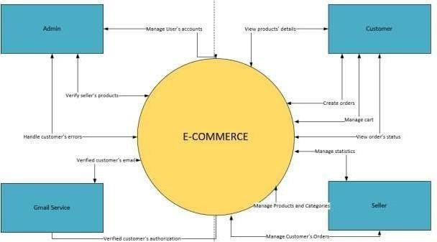

Figure 1: System Context diagram
The SASUCare E-Commerce Platform is a comprehensive online marketplace that enables:

2.2. Definitions and Acronyms

| Term/Acronym | Definition |

|---|---|
| API | Application Programming Interface |
| CRUD | Create, Read, Update, Delete |
| DTO | Data Transfer Object |
| JPA | Java Persistence API |
| JWT | JSON Web Token |
| MVC | Model-View-Controller |
| RBAC | Role-Based Access Control |
| REST | Representational State Transfer |
| SQL | Structured Query Language |
| UI | User Interface |
| UX | User Experience |

2.3. Actor
Table 1: Actors

# | Actor | Description | Key Input to the System | Key Output  from the System | Primary Responsibilities
1 | Customer | End user of the marketplace who browses products and places orders. | - Search terms,  filter/sort criteria- Registration & login credentials- Product  selections &  quantities- Shipping & payment details | - Product listings & details- Shopping cart contents- Order confirmation & status updates | - Register / authenticate- Browse/catalog navigation- Add/remove  items from cart- Booking & pay-  View order history & status
2 | Seller | Seller who  lists and manages their  own products, processes | - Product data (name, description, price,  inventory level,  images)- Order acceptance/rejection- | - Live  ProductListingP ages- Sales & inventory reports- Order notifications & | -  Create/update/delete product listings- Manage stock levels- Accept/process incoming orders-

 |  | orders, and tracks shipments. | Shipment info (tracking ID, carrier) | shipment confirmations | Provide shipment details
3 | Admin | Platform administrator who oversees users, content,  and overall system health. | - User management actions (create/disable accounts, assign roles)- Category/taxonomy changes- Platform settings adjustments- Report queries | - System health dashboards- User & seller activity  reports- Configuration confirmation messages- Audit logs | - Approve/reject seller registrations- Manage user roles & permissions- Configure  global  settings (tax, categories)- Monitor performance & security
4 | Gmail Service | External SMTP/email provider used to deliver transactional and notification emails. | - Email requests from app (recipient address, subject, template data: order ID, reset token, etc.) | - Delivery status callbacks/logs (sent, bounced, delivered)- Error responses for failed sends | - Send out registration confirmations, order & shipment notifications, password-reset emails-  Handle bounces and retries

2.4. BusinessFlow

2.4.1. Business Flows for Anonymous User

2.4.1.1. User Registration and Initial Login Flow

In the User Registration and Initial Login Flow, an anonymous user accesses the homepage to browse products without any authentication required. They then select the "Sign Up" option to initiate user registration (UC-101: User Registration), where the system prompts for details like email and password, followed by an email verification step. Upon successful registration, the user proceeds to log in (UC-102: User Login), transitioning into a customer or seller role based on their selection. This flow ensures seamless entry for new users, potentially handling hundreds of registrations daily.

2.4.1.2. Guest Product Browsing and Account Creation Prompt Flow
Another key flow is the Guest Product Browsing and Account Creation Prompt Flow, where the anonymous user views product details on the ProductDetailPage and attempts to add items to the cart, triggering a prompt to register (UC-101) or log in (UC-102). After completing these steps, they can continue shopping as an authenticated user.

2.4.1.3. Password Recovery and Access Restoration Flow
Additionally, the Password Recovery and Access Restoration Flow allows users with existing accounts to reset credentials: starting from the LoginPage, they enter their email to receive a reset link, update the password, and then log in (UC-102), restoring access without creating a new account.

2.4.2. Business Flows for Customer

2.4.2.1. End-to-End Product Purchasing and Checkout Flow
The End-to-End Product Purchasing and Checkout Flow begins with login (UC-102: User Login) on the LoginPage, followed by browsing products on the Homepage and viewing details on the ProductDetailPage. Users add items to the cart (UC-203: Add Product to Cart), review the cart contents (UC-204: View Shopping Cart), adjust quantities (UC-205: Update Cart Item Quantity), or remove items (UC-206: Remove Product from Cart). They then proceed to checkout (UC-207: Booking and Place Order) on the CreateBookingPage, finalizing payment and shipping, and later check order history (UC-208: View Order History) on the MyOrdersPage. This end-to-end process supports frequent shopping activities with high priority for cart management.

2.4.2.2. Service Booking Request and Status Tracking Flow
In the Service Booking Request and Status Tracking Flow, after logging in (UC-102), customers browse services, request bookings (UC-210: Request Booking for a Service/Product), view booking history and status (UC-211: View Booking History & Status), and cancel if needed (UC-212: Cancel Booking), with details accessible on the BookingDetailsPage.

2.4.2.3. Personal Account Profile and History Management Flow
The Personal Account Profile and History Management Flow involves logging in (UC-102), updating profile information (UC-201: Manage Account Profile) on the ProfilePage, reviewing orders (UC-208) and bookings (UC-211), and logging out (UC-103: User Logout), ensuring users maintain control over personal data.

2.4.2.4. Abandoned Cart Reminder and Purchase Completion Flow
Finally, the Abandoned Cart Reminder and Purchase Completion Flow handles incomplete sessions: after adding products (UC-203), if the user leaves, the system may send reminders; upon return and login (UC-102), they view the cart (UC-204) and complete the order (UC-207), reducing lost sales.

2.4.3. Business Flows for Seller

2.4.3.1. Product Inventory Creation and Maintenance Flow
The Product Inventory Creation and Maintenance Flow starts with login (UC-102: User Login) redirecting to the SellerDashboardPage, where sellers manage products (UC-302: Manage Products) on the ProductManagementPage, including creating, editing, or deleting listings. They conclude by reviewing dashboard reports (UC-310: View Seller Dashboard/Reports) to assess performance metrics like total products. This flow is essential for maintaining inventory with medium to high frequency.

2.4.3.2. Received Order Handling and Status Update Flow
In the Received Order Handling and Status Update Flow, after login (UC-102), sellers access the OrdersManagementPage to handle received orders (UC-305: Manage Orders Received), confirming, updating status, or canceling them, and then check reports (UC-310) for insights on pending orders.

2.4.3.3. Shop Information Editing and Profile Update Flow
The Shop Information Editing and Profile Update Flow involves logging in (UC-102), navigating to the ProfilePage to edit shop details (UC-301: Manage Shop Profile), such as name and logo, and verifying changes via the dashboard (UC-310), adhering to business rules like mandatory fields.

2.4.3.4. Booking Processing and Confirmation Flow
For the Incoming Booking Processing and Confirmation Flow, sellers log in (UC-102), review bookings on the dashboard, manage received bookings (UC-307: Manage Bookings Received) by confirming or canceling, update statuses with notifications to customers, and analyze data through reports (UC-310), supporting service-oriented operations.

2.4.4. Business Flows for Admin

2.4.4.1. User Account Creation and Role Assignment Flow
The User Account Creation and Role Assignment Flow commences with login (UC-102: User Login) to the AdminDashboardPage, followed by managing users (UC-401: Manage Users), such as creating accounts or assigning roles via RBAC, and reviewing summary metrics (UC-409: View Summary Dashboard Metrics) for system health. This ensures secure user governance.

2.4.4.2. Seller Product Review and Approval Decision Flow
In the Seller Product Review and Approval Decision Flow, after login (UC-102), admins access the Admin ProductsManagePage to oversee products (UC-406: Manage Products Oversight), approve or reject submissions (UC-407: Approve/Reject Products), updating statuses to ACTIVE or REJECTED, and monitor via the dashboard (UC-409).

2.4.4.3. Product Category Setup and Organization Flow
The Product Category Setup and Organization Flow involves logging in (UC-102), navigating to the CategoryManagementPage to create, edit, or delete categories (UC-404: Manage Categories), validating uniqueness, and checking impacts through metrics (UC-409).

2.4.4.4. Platform Performance Metrics Viewing and Oversight Flow
Lastly, the Platform Performance Metrics Viewing and Oversight Flow starts with login (UC-102) to view key metrics (UC-409) on the AdminDashboardPage, including revenue and pending items, cross-checking with approvals (UC-407) and user management (UC-401), facilitating proactive platform maintenance without altering state unless necessary.

3. System High Level Design

3.1. Database Schema

Key tables include:

users: id, email, password, first_name, last_name, shop_name, is_active, is_verified, etc.

roles: id, name (e.g., ROLE_USER), description.

products: id, name, price, stock_quantity, seller_id, category_id.

orders: id, customer_id, total_amount, order_status.

bookings: id, customer_id, seller_id, booking_status.

3.2. Description

SASUCare is a web-based e-commerce and service booking platform built with Spring Boot, utilizing Spring Security for authentication, JPA for data persistence, Thymeleaf for frontend rendering, and Microsoft SQL Server for data storage.

II. Requirement Specifications

1.1. Functional Requirements

1.1.1. Anonymous User Flow

1.1.1.1. Diagram(s) Anonymous User
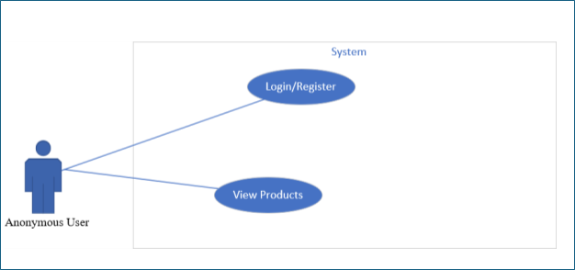
Figure 2: Anonymous User use case diagram

1.1.1.2. Descriptions
a, UC – 101 User Registration

Table 2: description of Anonymous User

# | Feature | Screen | Description
1 | Anonymo us User | Login | The Anonymous User login with a valid username, and valid password to log in to the system
2 |  | Register | The Anonymous User can create a new account(Customer or Seller)

3 |  | View  product s | The Anonymous User can view all products in Homepage

Table 3: User Registration use case description UC-101

UC ID and Name: | UC ID and Name: Use Case ID:  UC-101 Use Case Name: User Registration
Primary Actor: | Anonymous User | Secondary Actors:
Trigger: | The Anonymous User selects "Login" from the Homepage or navigation bar to create a new account.
Description: | This use case allows an Anonymous User to register for a new account on the SASUCare platform by providing necessary details such as email, password, first name, last name, and optionally a shop name if registering as a Seller. The system  validates the input, creates a user record, and sends a verification email. The user must verify their email to activate the account.
Preconditions: | The Anonymous User is not logged in. The user has access to a valid email address. (Screen: Homepage or direct access to RegistrationPage)
Postconditions  : | A new user record is stored in the system database. The user is redirected to  the LoginPage upon successful registration.
Expecte d results | Upon submitting valid registration details and confirming the email verification link, the system saves the new user record. The user can then login and access their  role-specific dashboard.
Normal Flow: | - Anonymous User navigates to the Homepage and clicks "Sign Up".  - The system displays the RegistrationPage with a form.  - Anonymous User enters email, password, confirms password, first name, last name, and optionally shop name, then clicks "Register".  - The system displays a success message and redirects to the LoginPage. |  | 3.1 The system validates the input data (e.g., email uniqueness, password strength, matching passwords).
Alternative Flows: | Invalid Data  - Anonymous User submits the form with missing or incorrect data (e.g., duplicate email, weak password).  - The system displays an error message next to the relevant field.  - Anonymous User corrects the data and resubmits.
Exceptions:

Priority: | High (Must Have)
Frequency of Use: | This action occurs once per user during initial account creation, potentially hundreds of times daily across all users.

Busines s Rules: | BR101, BR102, BR103, BR104
Use  Case related | "User Login" (UC-102)
Screen related | Screen: Homepage -> LoginPage -> RegistrationPage
Assumptions: | The system has a configured email service for sending verification emails. The user’s email client can receive and display the verification link correctly.

Table 4: Business Rule of UC-101

ID | Busines  s Rule | Business Rule Description
BR101 | Email Uniquenes s | The email address must be unique in the system. Constraint: The users.email field has a unique constraint in the database. Automated tests must verify that duplicate emails are rejected.
BR102 | Mandator y Fields | Email, password, confirm password, first name, and last name are mandatory. Constraint: Form submission is blocked if any field is empty, with visual indicators (e.g., asterisk) for required fields. Tests verify this behavior.
BR103 | Passwor d Strength | The password must be at least 8 characters long and include alphanumeric characters. Constraint: The system enforces this rule during validation, displaying an error if unmet. Test cases check for compliance.
BR104 | Passwor d Match | The password and confirm password fields must match. Constraint: Validation ensures matching entries, with an error message if they differ. Automated tests confirm this functionality.

b, UC-102 User Login
Table 5: Use case description of User Login UC-102

UC ID  and Name | Use Case ID: UC-102  Use Case Name: User Login
Primary Actor | Anonymous User (intending to become Customer, Seller, or Admin)

Secondar y Actors | System
Trigger | The Anonymous User selects "Sign In" from the Homepage or navigation bar to access authenticated features.
Description | This use case allows an Anonymous User to log in to the SASUCare platform by providing their email and password. The system validates the credentials using Spring Security, establishes a session, and redirects the user to their role-specific dashboard or the Homepage.
Preconditions | The user has a registered account.
Postcondition s | The user is logged in with their assigned role (Customer, Seller, Admin) is redirected to the homepage
Expecte d Results | Valid credentials result in authentication. A session is created.  Role-specific features become accessible.

Normal Flow | - Anonymous User navigates to the Homepage and clicks "Login".  - System displays the LoginPage (email and password fields).  - The user enters credentials and clicks "Login".  - The system validates credentials and establishes a session.  6. The system redirects the user to the Homepage.
Alternativ e Flows | Invalid Credentials:  The user enters an incorrect email or password. The system displays: "Invalid email or password". The user corrects and  resubmits.
Exceptions
Priority | High (Must Have)
Frequency of Use | Multiple times daily per user
Business Rules | BR201, BR204, BR205
Use Case Related | Related Use Cases: "User Registration" (UC-101), "User Logout" (UC-103)
Screen Related | Homepage → LoginPage → Homepage
Assumptions | The user has completed registration.

Table 6: Business Rule of UC-102

ID | Busines  s Rule | Business Rule Description

BR201 | Credential Validation | The system must validate the email and password against the users table. Constraint: Email must exist, and the password hash must match using BCrypt. Tests verify authentication logic.
BR204 | Sessio n Creatio n | A secure session must be created upon successful login. Constraint: The system uses Spring Security to manage sessions with secure cookies (HTTPS-only).  Tests confirm session establishment.
BR205 | Role-Base d Redirectio n | The system redirects the user based on their role (ROLE_USER to Homepage, ROLE_SELLER to Seller Dashboard, ROLE_ADMIN to Admin Dashboard). Constraint: Redirection logic must match role assignments.

1.1.2. Customer Flows

1.1.2.1. Diagram(s) Customer
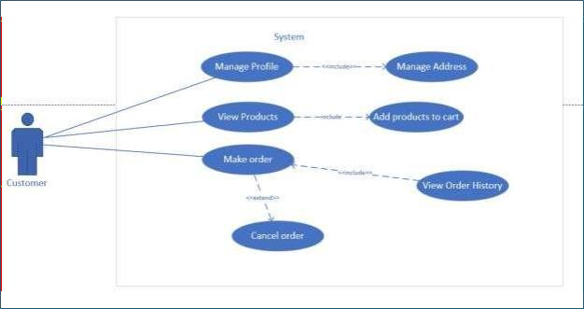

Figure 3: Customer use case diagram

1.1.2.2. Description
Table 7: Description of Customer use case diagram

ID | Use Case Name | Screen | Description
1 | User Login | LoginPage | Customer logs in with valid email and password to access authenticated features.
2 | Manage Account Profile | ProfilePage | Customer views and updates their profile information, such as name, contact, and password.
3 | Manage Addresses | ProfilePage | Customer adds, views, edits, and deletes their shipping addresses, setting a default.
4 | Add Product to Cart | ProductDetailPage | Customer adds products to their shopping cart with specified quantities.
5 | Booking and Place Order | Create Booking | Customer completes the purchase of cart items, selecting shipping and payment details.
6 | View Order History | Order History Page | Customer views a list of their past and current orders with statuses.
7 | View Booking History & Status | MyOrdersPag e | Customer views their past and current bookings with statuses.

8 | Cancel Booking | MyOrdersPag e | Customer cancels a pending or confirmed booking if allowed by status.

a, UC-203 Add Product to Cart
Table 8: Use case description of Add product to cart

UC ID  and Name | Use Case ID: UC-203  Use Case Name: Add Product to Cart
Primary Actor | Customer
Secondar y Actors | System
Trigger | The Customer clicks "Add to Cart" on the ProductDetailPage after selecting a product and quantity.
Description | This use case enables a Customer to add a product to their shopping cart by selecting a product and specifying the quantity. The system updates the cart, ensures availability and validity, and allows the Customer to proceed to Booking.
Preconditions | The Customer is authenticated with "ROLE_USER" privileges and has a valid session. Screen: LoginPage. The product is available (in stock) and has sufficient stock.
Postconditions | The selected product and quantity are added to the Customer’s session-based cart. The cart reflects the updated items, quantities, and total price, ready for Booking (UC-207).
Expecte d Results | After adding a product with a valid quantity, the system updates the cart, displays a confirmation message ("Product added to cart"), and allows the Customer to view the cart or continue shopping.
Normal Flow | - Customer navigates to the ProductDetailPage of a desired product  - System displays product details including name, price, stock status.  - Customer choose a quantity (default 1, adjustable) and clicks "Add to Cart"  - System adds the product and quantity to the Customer’s session-based cart (ShoppingCart bean)  - System displays a confirmation message ("Add [Number of product] [Name of the product] to cart") on the page or as a popup  - Customer can choose to continue shopping or navigate to the ShoppingCartPage
Alternativ e Flows
Exceptions
Priority | High (Must Have)
Frequency of Use | This action occurs frequently, potentially multiple times per session as Customers add items to their cart
Business Rules | BR801
Use Case Related | Related Use Cases: User Login (UC-102), View Shopping Cart (UC-204), Booking and Place Order (UC-207)

Screen Related | Screen: LoginPage → ProductDetailPage → ShoppingCartPage
Assumptions | The product is available for purchase.

Table 9: Business rule of Add Product to Cart

ID | Business Rule | Business Rule Description

BR80 1 | Stock Availability | The requested quantity can not exceed the product’s stock quantity

b, UC-204 View Shopping Cart
Table 10: Use case description of View Shopping Cart

UC ID  and Name | Use Case ID: UC-204  Use Case Name: View Shopping Cart
Primary Actor | Customer
Secondar y Actors | System
Trigger | The Customer clicks "View Cart" or the cart icon in the navigation bar to see their cart contents.
Description | Enables a Customer to view the items currently in their shopping cart, including product names, quantities, prices, and total cost. The system retrieves the session-based cart and displays the details, allowing modification or Booking.
Preconditions | The Customer is authenticated with "ROLE_USER" privileges and has a valid session. Screen: LoginPage. At least one item must have been added to the cart (UC-203).
Postconditions | The Customer sees an up-to-date cart with options to update quantities (UC-205), remove items (UC-206), or proceed to Booking (UC-207). The cart state remains unchanged unless modified.
Expecte d Results | The system displays the cart contents in a table format, showing product name, quantity, price per unit, subtotal, and total cost. Buttons allow the user to modify the cart or proceed to Booking.

Normal Flow | - Customer navigates to a page with a navigation bar  - Customer clicks "View Cart" or the cart icon  - System retrieves session-based cart (ShoppingCart bean)  - System displays cart contents in a table  - System shows buttons: "Update Quantities", "Remove Item", "Proceed to Booking"  - Customer reviews cart and decides on next action
Alternativ e Flows | Empty Cart: Cart has no items → System displays "Your cart is empty" with a link to continue shopping → Customer returns to product listings
Exceptions | Session Timeout: If the session expires, the system prompts login again.
Priority | High (Must Have)
Frequency  of Use | Frequent – typically multiple times per session as users review their cart
Business Rules
Use Case Related | UC-203 (Add Product to Cart), UC-205 (Update Cart Item Quantity), UC-206 (Remove Product from Cart), UC-207 (Booking and Place Order)
Screen Related | LoginPage → Homepage→ ShoppingCartPage
Assumptions | The Customer has items in their cart. The session-based cart persists across pages.

c, UC-205 Update Cart Item Quantity

Table 11: Use case description of Update Cart Item Quantity

UC ID  and Name | UC-205 – Update Cart Item Quantity
Primary Actor | Customer
Secondar y Actors | System
Trigger | The Customer modifies the quantity of an item on the ShoppingCartPage and clicks "Update Quantities"
Description | This use case allows the Customer to change the quantity of an item in their shopping cart. The system validates the new quantity, updates the session-based cart, and recalculates the total price to reflect the updated state for Booking
Preconditions | The Customer is authenticated with "ROLE_USER" privileges and has a valid session (already logged in). The Customer's cart contains at least one item from UC-203
Postcondition s | The session-based cart (ShoppingCart bean) is updated with the new quantity for the specified item. The total price is recalculated and the updated cart is displayed for review
Expecte d Results | After updating the quantity with a valid value, the system adjusts the cart, recalculates the total, and displays the updated cart with a confirmation message stating "Cart updated successfully". The Customer can proceed to Booking with the updated quantities
Normal Flow | Step 1: Customer navigates to the ShoppingCartPage (UC-204)  Step 2: System displays the cart with a table of items and editable quantity fields Step 3: Customer changes the quantity of an item using the input field Step 4: Customer clicks "Update Quantities"  Step 5: System validates the new quantity to ensure it is a positive integer and within available stock  Step 6: System displays a confirmation message and update the cart
Alternativ e Flow | Invalid Quantity:  - : Customer enters an invalid quantity such as zero or a value exceeding available stock  - : System displays an error message next to the item stating "Quantity must be positive and within stock"  - : Customer corrects the quantity and resubmits

Exceptions | If the product's status changes to INACTIVE, the system removes the item from the cart and shows a message stating "Product is no longer available". If the session expires, the Customer is prompted to log in again and the cart is  restored upon re-login
Priority | High (Must Have)
Frequency of Use | This action occurs frequently, typically multiple times per session as Customers adjust their cart before Booking

Business Rules | BR1001, BR1002
Use Case Related | UC-203 (Add Product to Cart), UC-204 (View Shopping Cart), UC-207 (Booking and Place Order)
Screen Related | LoginPage -> ShoppingCartPage
Assumptions | The Customer has items in their cart. The cart persists across page navigations

Table 12: Business of UC-205

ID | Busines  s Rule | Business Rule Description
BR100 1 | Quantity Validation | The new quantity must be a positive integer. Constraint: The system validates the input and displays an error if the value is invalid.
BR100 2 | Stock Availability | The new quantity must not exceed the product’s stock quantity. Constraint: The system checks the products table and rejects quantities that exceed available stock.

d, UC-207 Booking and Place Order
Table 13: Use case description of Booking and Place Order

UC ID and Name | Use Case ID: UC-207  Use Case Name: Booking and Place Order
Primary Actor | Customer
Secondar y Actors | System, Seller
Trigger | The Customer clicks "Proceed to Booking" on the ShoppingCartPage to complete their purchase.

Description | This use case enables a Customer to place an order for products in their cart by completing a multi-step Booking process. The Customer selects a shipping address, leaves a special instruction(optional), reviews the order, and confirms it. The system creates Order and OrderItem records, processes payment,  updates stock, and notifies the Seller.
Preconditions | The Customer is authenticated with "ROLE_USER" and has a valid session (already logged in).  The Customer’s cart contains at least one item (UC-203).  The Customer has at least one valid shipping address (UC-202).
Postcondition s | A new Order record is created with order_status set to PENDING or PAID. OrderItem records are created, linking to products and Sellers. Product stock quantities are updated, the cart is cleared, and the Seller is notified. The Customer is redirected to the MyOrdersPage.
Expecte d Results | After completing Booking with valid details, the system creates the order, updates stock, clears the cart, and displays a notice “Booking created successfully! Your booking number is: [ID of customer’s order]” and navigates to ‘My Booking’ page.The Customer can view the order in their Order History (UC-208), and the Seller sees it in their Order Management (UC-305).
Normal Flow | - Customer navigates to the ShoppingCartPage (UC-204).  - Customer clicks "Proceed to Booking".

- System displays the Create Booking with a multi-step process.
- Customer selects an existing address or adds a new one (street, city, postal code, country).
- Customer reviews the order summary, including items, quantities, prices, shipping cost, discounts, and total.
- Customer clicks "Confirm Booking".
- The system validates stock availability for all items in the cart.
- The system processes payment via the external gateway.
- System creates an Order record.
Alternative Flows
Exceptions | Session Timeout: If the Customer’s session expires, they are prompted to log in again before proceeding.
Priority | High (Must Have)
Frequency of Use | This action occurs frequently, typically once per shopping session when a Customer completes a purchase.
Busines s Rules | BR1201, BR1202, BR1205
Use Case Related | Add Product to Cart (UC-203), View Shopping Cart (UC-204), View Order History (UC- 208), Seller Manages Orders Received (UC-305)
Scree n Relate d | LoginPage → ShoppingCartPage → CreateBookingPage → MyOrdersPage

Assumptions | The Customer has a valid payment method. The payment gateway integration is functional and secure.

Table 14: Business of UC-207

ID | Busines s Rule | Business Rule Description
BR120 1 | Stock Availability | All cart items must have sufficient stock (stock_quantity). Constraint: The system checks the products table, rejecting orders if stock is insufficient. Tests verify this validation.
BR120 2 | Mandator y Address | A valid shipping address is required. Constraint: The system ensures a complete address is selected or added. Tests confirm this requirement.
BR120 5 | Stock Update | Product stock quantities must be decremented atomically. Constraint: The system uses database transactions to ensure consistency. Tests verify stock updates and rollback on failure.

e, UC-208 – View Order History

UC ID  and Name | UC-208 – View Order History
Primary Actor | Customer
Secondar y Actors | System

Trigger | The Customer navigates to the "My Account" section and selects "Order History" to view their orders.
Description | This use case allows a Customer to view a list of their past and current orders, including order IDs, dates, totals, and statuses. The system retrieves the orders from the orders table and displays them in a paginated list, with options to view details of specific orders.
Preconditions | The Customer is authenticated with "ROLE_USER" privileges and has a valid session (already logged in). The Customer has placed at least one order (UC-207).
Postcondition s | The Customer sees a list of their orders with key details. No changes are made to the orders or system state.

Expecte d Results | The system displays a table of orders with columns for order ID, date, total amount, status, and a details link. The Customer can navigate through pages of orders and select an order to view its details (UC-209).
Normal Flow | - Customer navigates to the "My Account" section from the Homepage or navigation bar.  - Customer clicks "Order History".  - System retrieves the Customer’s orders from the orders table, filtering by customer_id.  - System displays the Order History Page with a paginated table, showing order ID, date (created_at), total amount, status (e.g., PENDING, PAID, SHIPPED), and a "View Details" link for each order.  - Customer reviews the list and can navigate through pages or click "View Details" to see more information (UC-209).
Alternativ e Flows | If the Customer has no orders, the system displays a message ("You have no orders") with a link to start shopping. The Customer may then navigate back to  product listings.
Exceptions | Session Timeout: If the Customer’s session expires, they are prompted to log in again before proceeding.
Priority | Medium (Should Have)
Frequency of Use | This action occurs occasionally, typically after placing orders, potentially a few times per month per Customer.
Business Rules
Use Case Related | Related Use Cases: "Checkout and Place Order" (UC-207)
Screen Related | LoginPage → Homepage → MyOrdersPage
Assumptions | The Customer has placed orders in the system. The orders are stored in the orders table with associated order_items.

f, UC-211: View Booking History & Status
Table 15: Use case description of View Booking History & Status

UC ID  and Name | UC-211: View Booking History & Status
Primary Actor | Customer
Secondar y Actors
Trigger | Customer navigates to the "My Account" section and selects "My Bookings"

Description | Allows Customers to view their past and current bookings, including booking numbers, dates, services/products, and statuses. Bookings are retrieved from the database and shown in a paginated list. Customers can cancel eligible  bookings (via UC-212).
Preconditions | Customer is logged in with "ROLE_USER" privileges and has submitted at least one booking (UC-210).
Postcondition s | Customer sees a paginated list of their bookings. No updates occur unless the Customer cancels a booking.
Expecte d Results | The system displays bookings in a table format with columns: booking number, date, service/product name, status, and action link. The Customer can view and cancel eligible bookings.
Normal Flow | 1. Customer accesses "My Account". 2. Customer selects "My Bookings". 3. System filters bookings by customer_id. 4. System shows a paginated table with booking details.  5. Customer views or cancels bookings as applicable.
Alternativ e Flows | If no bookings exist, system displays "You have no bookings" and a link to browse services.
Exceptions | If session expires, Customer is prompted to log in again.
Priority | Medium (Should Have)
Frequency of Use | Occasional, typically a few times per month per Customer
Business Rules
Use Case Related | UC-208, UC-212: Cancel Booking
Screen Related | LoginPage → Homepage → MyOrdersPage
Assumptions | The Customer has made bookings. Relevant data exists in bookings and booking_items tables.

g, UC-212: Cancel Booking
Table 16: Use case description of Cancel Booking

UC ID  and Name | UC-212: Cancel Booking
Primary Actor | Customer
Secondar y Actors | System, Seller
Trigger | The customer clicks "Cancel" on a booking from the MyOrdersPage

Description | Allows Customers to cancel bookings with status PENDING or CONFIRMED. The system updates the booking’s status to CANCELLED, notifies the Seller, and reflects the update in the booking history.
Preconditions | Customer is logged in with "ROLE_USER" privileges. Customer has at least one booking with PENDING or CONFIRMED status from UC-210, visible on the MyOrdersPage (UC-211).
Postcondition s | Booking’s status is updated to CANCELLED. Seller is notified. Customer sees the updated status in their booking history.

Expecte d Results | Booking is updated to CANCELLED. Seller receives a notification ("Booking [number] has been cancelled"). Customer sees confirmation message and updated status in history.
Normal Flow | 1. Customer accesses MyOrdersPage (UC-211). 2. System shows cancel option for eligible bookings. 3. Customer clicks "Cancel". 4. System verifies eligibility. 5. System updates status to CANCELLED and notifies the Seller. 6. Confirmation is displayed to Customer. 7. Booking history is refreshed.
Alternativ e Flows | If booking has status COMPLETED or REJECTED, system displays an error ("Booking cannot be cancelled due to its status") and returns to the MyOrdersPage.
Exceptions | If session has expired, Customer is prompted to log in again
Priority | Medium (Should Have)
Frequency of Use | Occasional, typically when Customer changes plans; possibly a few times per month per user
Business Rules | BR1701, BR1702, BR1703
Use Case Related | UC-210: Request Booking for a Service/Product, UC-211: View Booking History & Status
Screen Related | LoginPage → MyOrdersPage
Assumptions | Booking exists and is in eligible status. Seller receives cancellation notifications via email or dashboard.

1.1.3. Seller flow

1.1.3.1. Diagram(s) seller flow

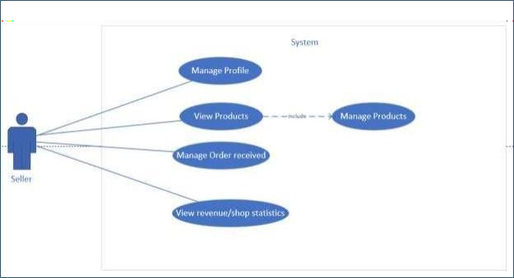

Figure 4: Seller use case diagram

1.1.3.2. Description
Table 17: Description of Seller

Feature | Screen | Description
Manage Profile | ProfilePage | Seller updates their name, details, etc.
Manage Products | ProductManageme ntPage | Seller views, adds, edits, or deletes products/services, including details and images.
Manage Orders Received | OrdersManagem entPage | Seller views and updates the status of orders containing their products.
View Order Item Details | OrderDetailsPage | Seller views details of specific order items related to their products.
View Dashboard/Reports | SellerDashboar dPage | Seller views sales summaries, popular products, and total received order statistics.

a, UC-301 Manage Seller Profile/Shop Information
Table 18: Use case description of Manage Seller Profile/Shop Information

UC ID  and Name | Use Case ID: UC-301  Use Case Name: Manage Seller Profile/Shop Information
Primary Actor | Seller
Secondar y Actors
Trigger | The Seller navigates to the "Profile" section from the Seller Dashboard to update their shop information.
Description | This use case enables a Seller to update their shop information, including the shop name. The system validates the updates, saves changes to the user table, and ensures the shop profile reflects the latest information for customers to see.
Preconditions | - Seller is authenticated with ROLE_SELLER privileges.  - Seller has a valid session (already logged in).  - Seller has an existing shop profile (shop_name field in the users table).
Postconditions | - Seller’s shop information is updated in the users table (e.g., shop_name, contact details).  - Updated shop profile is visible on customer-facing product listings.
Expecte d Results | - Valid updates are saved successfully.  - A success message is shown ("Shop profile updated successfully").  - ProfilePage and customer product views reflect updated info.

Normal Flow | - Seller logs into Seller Dashboard.  - Seller clicks "Profile".  - System displays the ProfilePage with current shop details.  - Seller updates fields (e.g., shop name, logo).  - Seller clicks "Save Changes".  - System validates data and saves to users table.  - System shows success message and refreshes profile view.
Alternativ e Flows | Invalid Data:  - Seller submits empty shop name or unsupported image.  - System displays relevant validation errors (e.g., "Shop name is required", "Logo must

be JPEG or PNG").
- Seller corrects input and retries.
Exceptions | - Image Upload Failure: System displays error, allowing retry or save without logo.  - Session Timeout: Seller must re-authenticate.
Priority | Medium (Should Have)
Frequency of Use | Occasionally – typically a few times per month per Seller.
Business Rules | BR1801, BR1802, BR1803
Use Case Related | UC-102: User Login  UC-310: View Seller Dashboard/Reports
Screen Related | LoginPage → SellerDashboardPage → ProfilePage
Assumptions | - Seller has an existing shop profile.

Table 19: Business of UC-301

ID | Business Rule | Business Rule Description
BR180 1 | Mandatory Shop Name | The shop name is a mandatory field.
BR180 2 | Description Length | The shop name must not exceed 255 characters.
BR180 3 | Image Constraints | The shop logo must be JPEG or PNG, and no larger than 3MB.

b, UC-302 Manage Products
Table 20: Use case description of Manage Products

Use Case ID | UC-302
Use Case Name | Manage Products
Primary Actor | Seller
Secondar y Actors | Admin
Trigger | Seller accesses “Manage Products” from the Seller Dashboard to perform CRUD operations.
Description | Enables Sellers to add, edit, or delete products/services, including fields like name, description, price, stock, category, and images. New products require Admin approval before being active.
Preconditions | The Seller is authenticated with ROLE_SELLER and has MANAGE_OWN_PRODUCTS permission. Product categories exist (UC-404).
Postconditions | For adding a product, a new Product record is created with status= PENDING_APPROVAL (awaiting Admin approval). Admin approval is required for new products before they become active or rejected (UC- 405)

Expecte d Results | On submission: product saved with status=PENDING, images uploaded, success message displayed. Seller sees products in their list but are not publicly visible until approved (UC-405).
Normal Flow (Add) | - Seller logs in and navigates to Seller Dashboard.  - Clicks "Manage Products" → "Add New Product".  - Fills in form: name, description, price, stock, SKU, category, images.  - Clicks "Save Product".  - System validates inputs.  - Product record created with status=PENDING, linked to seller_id and category_id.  - ProductImage records created; primary image marked.  - Success message displayed. Redirects to product list.
Alternative Flow – Edit | Seller selects a product → clicks "Edit" → updates info → system validates and saves.  Admin re-approval only needed if status changes.
Alternative Flow – Delete | Seller selects product → clicks "Delete" → confirms → system sets status=INACTIVE or deletes.
Exceptions | Image upload fails → error shown, retry allowed. Session timeout → login prompt displayed.
Priority | High (Must Have)
Frequency of Use | Regular (daily usage expected per Seller)
Business Rules | BR1901, BR1903

Related Use Cases | UC-102 (User Login), UC-303 (View Product Listings), UC-405 (Admin Product Approval)
Screen Flow | LoginPage → SellerDashboardPage→ ProductManagementPage
Assumptions | Product categories are defined; Admin approval process exists; file storage is configured.

Table 21: Business of UC-302

ID | Busines s Rule | Business Rule Description
BR190 1 | Mandator y Fields | Name, price, and stock quantity are mandatory for new products. Constraint: The system blocks submissions if any are empty, showing visual indicators. Tests: Confirm this behavior.
BR190 3 | Image Constraint s | Product images must be JPEG or PNG, and must not exceed 3MB. Constraint: The system validates format and size, rejecting invalid uploads. Tests: Validate enforcement.
c, UC-303 View Own Product Listings
Table 22: Use case description of View Own Product Listings

Use Case ID | UC-303
Use Case Name | View Own Product Listings

Primary Actor | Seller
Secondary Actors | System
Trigger | Seller navigates to "Manage Products" from the Seller Dashboard to view their listings.
Description | Enables the Seller to view all products/services they offer, with essential details such as name, price, stock quantity, and status (PENDING, ACTIVE, INACTIVE). Data is displayed in a paginated table with action links (Edit/Delete).
Preconditions | - Seller is authenticated with ROLE_SELLER and has a valid session.  - Seller has added at least one product (UC-302).
Postconditions | Seller sees a paginated list of their own products. No updates occur unless edit/delete is triggered.
Expected Results | System displays the product list table showing product name, price, stock quantity, status, and action links. Seller can page through results and click actions.

Normal Flow | - Seller logs in and navigates to Seller Dashboard.  - Seller selects "Manage Products".  - System loads and displays the paginated product list.  - Seller can review, edit, or delete products via action links (handled in UC-302).
Alternative Flow: No  Products | - If the Seller has no products, the system shows: "You have no products" and provides a link to add one (navigates to UC-302).
Exceptions | - Session Timeout: Seller session expires, system prompts login before proceeding.
Priority | Medium (Should Have)
Frequency of Use | Regular (typically multiple times per day per Seller)
Business Rules
Related Use Cases | - UC-302: Manage Products
Related Screens | - LoginPage → SellerDashboardPage → ProductListingPage
Assumptions | - Products exist in the database and are linked to the Seller.

d, UC-305 Manage Orders Received
Table 23: Use case description of Manage Orders Received

Use Case ID | UC-305
Use Case Name | Manage Orders Received
Primary Actor | Seller
Secondary Actors | System, Customer
Trigger | Seller navigates to the "Order Management" section from the Seller Dashboard.
Description | Allows the Seller to view and manage order items related to their products. Sellers can update the status of each item (e.g., PENDING → PROCESSING  → SHIPPED), triggering customer notifications.

Preconditions | - Seller is authenticated with ROLE_SELLER and has a valid session.  - Seller has MANAGE_OWN_ORDERS permission.  - Seller has received at least one order (UC-207).
Postconditions | - Status updates are saved in the order_items table.  - Customers are notified.  - Updated statuses are reflected in the Customer’s Order History (UC-208).
Expected | System shows the Seller’s orders. After status update, system saves the new status, notifies the Customer, and confirms the update to the Seller.

Results
Normal Flow | - Seller logs in and opens "Order Management".  - Orders are shown with details (ID, date, customer, item info, status dropdown).  - Seller updates item status by click ‘Confirm Order’ or ‘Reject Order’.  - System validates transition, updates order_items, and displays success message.
Alternative  Flow: No Orders | - If the Seller has no orders, the system displays: "You have no orders to manage" with a link to return to the Dashboard.
Exceptions | - Invalid Status Transition: System blocks illegal status changes and shows: "Invalid status transition".  - Session Timeout: System prompts login if session expired.
Priority | High (Must Have)
Frequency of Use | Regular – potentially multiple times per day per Seller.
Business Rules
Related Use Cases | UC-207: Checkout and Place Order
Related Screens | LoginPage → SellerDashboardPage → Manage Orders Page
Assumptions | - Seller has received at least one order.
e, UC-310 View Seller Dashboard/Reports
Table 24: Use case description of View Seller Dashboard/Reports

Use Case ID | UC-310
Use Case Name | View Seller Dashboard/Reports
Primary Actor | Seller
Secondary Actors
Trigger | Seller logs in or navigates to the "Seller Dashboard" section.
Description | Enables a Seller to view sales summaries, top products, booking statistics, and performance metrics. The dashboard aggregates data from orders, bookings, and products to offer business insights.
Preconditions | - Seller is authenticated with ROLE_SELLER and has a valid session.  - Seller has VIEW_SELLER_DASHBOARD permission.
Postconditions | Seller views dashboard data. No changes are made to the system state.
Expected Results | The Seller Dashboard displays:  - Revenue (Total and month)  - All Orders  - Total products  - Pending Orders

Normal Flow | - Seller logs in → redirected to Homepage  - Seller clicks on he/she’s name in nav menu to open user menu  - Seller click on Seller dashborad  - System displays all metrics on the SellerDashboardPage.  - Seller can click on links to:  - " Products" (UC-302)  - "Orders" (UC-305)
Alternative Flow: No Data
Exceptions | - Session Timeout: Seller is asked to log in again if the session expired.
Priority | Medium (Should Have)
Frequency of Use | Frequent – typically multiple times per day per Seller for performance monitoring.
Business Rules
Related Use Cases | UC-102 (User Login), UC-302 (Manage Products), UC-305 (Manage Orders Received), UC-307 (Manage Bookings Received)
Related Screens | LoginPage → SellerDashboardPage
Assumptions | - Seller has activity data (orders, products, bookings).  - System supports efficient data aggregation.

1.1.4. Admin flow

1.1.4.1. Diagram(s) admin
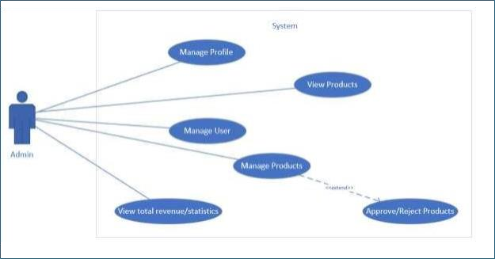

Figure 5: Admin use case diagram

1.1.4.2. Description
Table 25: Description of Admin use case diagram

Feature Name | Page / Module | Description
Manage Users | User Management Page | Admin creates, views, edits, and deletes user accounts, including role assignments.
Manage Categories | CategoryManage mentPage | Admin creates, views, edits, and deletes product/service categories.
Manage All Products | Product Oversight Page | Admin views, edits, and deletes all products, including approving new listings.
View System Reports  / Analytics | AdminDashboardPa ge | Admin views platform statistics, such as sales and user activity.

a, UC-404 Manage Categories
Table 26: Use case description of Manage Categories

Use Case ID | UC-404
Use Case Name | Manage Categories
Primary Actor | Admin
Secondary Actors | System
Trigger | Admin navigates to "Category Management" from the Admin Dashboard.
Description | Enables an Admin to create, view, edit, and delete categories used for organizing platform listings. The system validates inputs and persists category data in the categories table. This description focuses on the "Create Category" sub-flow.
Preconditions | - Admin is authenticated with ROLE_ADMIN and has a valid session.  - Admin has MANAGE_CATEGORIES permission.
Postconditions | - New Category record is created (on create).  - Existing record is updated (on edit).  - Category is removed if no product is assigned (on delete).
Expected Results | - On successful creation, system saves the new category, shows success message ("Category created successfully"), and displays it in the management list.  - Sellers can associate products with the category (UC-302).
Normal Flow (Create Category) | - Admin navigates to Admin Dashboard → selects "Category Management".  - Admin clicks "Create New Category".  - System displays Create Category Form with fields:  - Category Name  - Description  - Admin fills in data and clicks "Save".  - System validates input (e.g., name is unique).  - System creates Category record (with name, description, and optional parent_id).  - System shows success message and redirects to

 | CategoryManagementPage.
Alternative Flow: Edit Category | - Admin selects category → clicks "Edit".  - System shows form with current values.  - Admin updates fields and clicks "Save".  - System validates and updates record.

Alternative Flow: Delete Category | - Admin selects category → clicks "Delete".  - System checks for associated products:  - If assigned: shows error ("Cannot delete category with assigned products").  - If not: prompts confirmation, deletes record upon confirmation.
Exceptions | - Session Timeout: Admin is prompted to log in again.
Priority | High (Must Have)
Frequency of Use | Occasional – typically during initial setup or category updates, a few times per month.
Business Rules
Related Use Cases | UC-102 (User Login), UC-302 (Manage Products)
Related Screens | LoginPage → AdminDashboardPage → CategoryManagementPage
Assumptions

b, UC-405 Manage All Products
Table 27: Use case description of Manage All Products

Use Case ID | UC-405
Use Case Name | Manage All Products
Primary Actor | Admin
Secondary Actors | Seller
Trigger | Admin navigates to "Products" from the Admin Dashboard.
Description | Allows an Admin to view, approve, delete, and oversee all products listed on the platform. The focus is on the Approve Product sub-flow. The system ensures all product listings comply with platform rules before  being made public.
Preconditions | - Admin is authenticated with ROLE_ADMIN and has a valid session.
Postconditions | - Approved product’s status is updated to ACTIVE.  - Rejected product’s status is set to REJECTED with a reason.  - Deleted product is removed or marked as INACTIVE.
Expected Results | - On approval, the system updates the status to ACTIVE and makes the product visible to customers.  - Product list refreshes on the Product Oversight Page.

Normal Flow (Approve Product) | - Admin goes to Admin Dashboard → selects "Product Oversight".  - System displays all products in a table (e.g., product name, seller, category, price, stock, status, actions).  - Admin filters for PENDING products → clicks "Approve/Reject".  - System shows product details (name, description, price, images, category) + Approve/Reject buttons.  - Approve:  - Admin clicks "Approve".  - System updates status to ACTIVE.  - Sends message to Seller: "Your product [name] has been approved".  - Shows success message: "Product approved".

- Reject:
  - Admin clicks "Reject", enters rejection reason.
  - System updates status to REJECTED, stores reason.
  - Sends message to Seller: "Your product [name] was rejected: [reason]".
  - Shows success message: "Product rejected".
7. Product list updates to reflect new status.
Alternative Flow: Edit Product | - Admin clicks "Edit" on a product.  - System displays pre-filled Edit Product Form.  - Admin updates values (e.g., price) and clicks "Save".  - System validates and updates the product.
Alternative Flow: Delete Product | - Admin clicks "Delete".  - System prompts confirmation.  - On confirm: product is either deleted or marked as INACTIVE.
Exceptions | - Session Timeout: Admin is prompted to re-authenticate.
Priority | High (Must Have)
Frequency of Use | Regular – Admins may review and approve products daily.
Business Rules
Related Use Cases | UC-302 (Manage Products), UC-404 (Manage Categories)
Related Screens | LoginPage → AdminDashboardPage→ ProductManagementPage
Assumptions | - Products are submitted by Sellers and stored in products table.  - New listings require Admin approval before visibility.

c, UC-409 View Summary Dashboard Metrics
Table 28: Use case description of View Summary Dashboard Metrics

UC ID  and Name | Use Case ID: UC-409  Use Case Name: View Summary Dashboard Metrics
Primary Actor | Admin

Secondar y Actors | System
Trigger | The Admin logs in and is redirected to the Admin Dashboard, where key summary metrics are visible.
Description | This use case enables an Admin to view an overview of key platform metrics at a glance. The dashboard displays total products, total orders, revenue (total and pending), order statuses (confirmed, cancelled, completed), and a list of recent products and orders.
Preconditions | The Admin is authenticated with "ROLE_ADMIN" and has a valid session.
Postcondition s | The Admin sees up-to-date summary metrics, product info, and order status, but makes no changes to the system state.
Expecte d Results | The dashboard displays:  - Total Products  - Total Orders  - Revenue (Total and Pending)  - Order Status counts (Confirmed, Cancelled, Completed)

- Recent Products with name, price, stock, and status
- Recent Orders with customer, seller, date, amount, and status
Normal Flow | - Admin logs in.  - System redirects to the Admin Dashboard.  - System retrieves and displays:  - Metric cards (total products, orders, revenues, etc.)  - Recent Products table with name, price, stock, and status  - Recent Orders table with customer, seller, date, amount, and status
Alternativ e Flows | None observed (no filters or exports available).
Exceptions | If the session expires, the Admin is redirected to the LoginPage.
Priority | Medium (Should Have)
Frequency of Use | Frequently used after login to quickly monitor activity.
Business Rules
Use Case Related | "User Login" (UC-102)
Screen Related | Screen: LoginPage → AdminDashboardPage
Assumptions | Dashboard metrics are calculated in real-time and data exists.

III. Design Specifications

1. Screen Flow

Customer
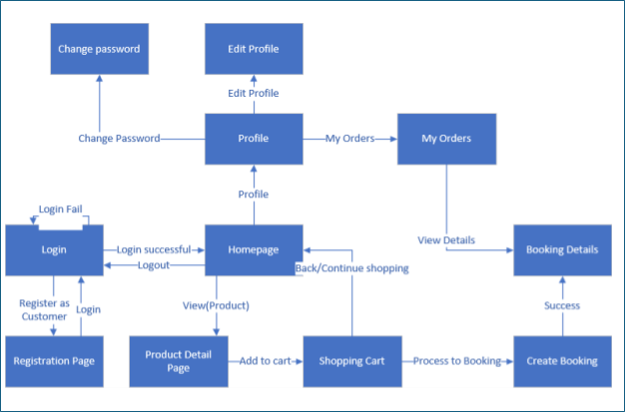

Figure 6: Screen flow of Customer

Seller
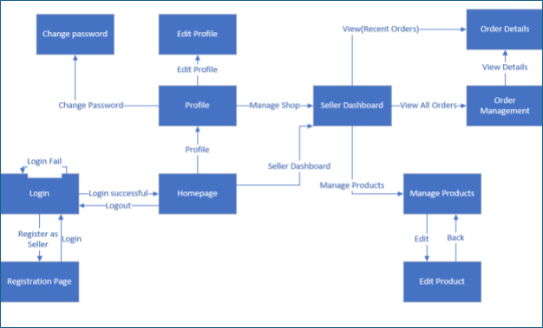

Figure 7: Screen flow of Seller

Admin
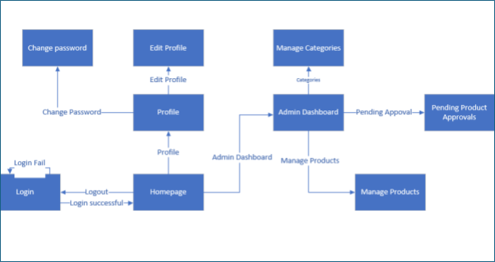

Figure 8: Screen flow of Admin

State Diagram
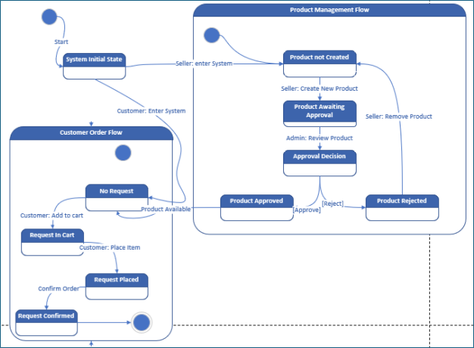

Figure 9: State transition diagram

Screen Design

3.0. Common UI Elements
Table 1: Detailed Navbar Components
Element Name | HTML Tag | Purpose | Description | Interaction | Event
Logo | <a> | Brand Identification | The store's logo, which links back to the homepage. | Click the logo. | Navigates to Homepage.
SHOP | <a> | Navigation | Links to the main shop page (product listings). | Click the link. | Navigates to the Shop page.
COLLABS | <a> | Navigation | Links to a page featuring collaborative products. | Click the link. | Navigates to the Collabs page.
CONTACT | <a> | Navigation | Links to the contact information page. | Click the link. | Navigates to the Contact page.
ABOUT US | <a> | Navigation | Links to the "About Us" page. | Click the link. | Navigates to the About Us page.
Search Input | <input> | Search | A text field for users to enter search keywords. | Enter keywords. | Enables the search button.
Search Button | <button> | Submit Search | A button to initiate a search based on entered keywords. | Click the button. | Submits the query and displays results.
Login Link | <a> | User Authentication | Links to the login page. Only visible to unauthenticated users. | Click the link. | Navigates to LoginPage.
Cart Icon | <a> | Cart Access | A cart icon that links to the shopping cart page. Often displays the item count. | Click the icon. | Navigates to ShoppingCartPage.
User Menu | <button> | User Account | A dropdown menu for logged-in users, containing links to Profile, Orders, and Logout. | Click the button (username). | Opens the dropdown menu.

Table 2: Presence of Common UI Elements Across Screens
Screen Name | Navbar | Footer | Notes
LoginPage | Yes | Yes | Navbar displays the "Login" button.
RegistrationPage | Yes | Yes | Navbar displays the "Login" button.
Homepage | Yes | Yes | The navbar for logged-in users includes a User Menu and Cart Icon.
ShoppingCartPage | Yes | Yes | The navbar displays the number of items in the cart.
ProductDetailPage | Yes | Yes
MyOrdersPage | Yes | Yes
ProfilePage | Yes | Yes
SellerDashboardPage | Yes (Seller variant) | No
AdminDashboardPage | Yes (Admin variant) | No

LoginPage
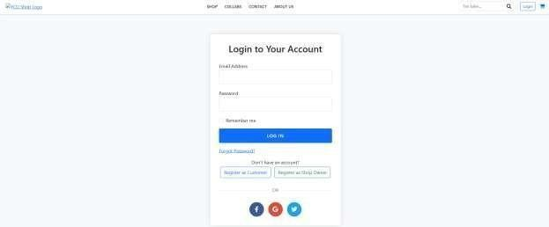
Figure 10: Login screen

Table 29: Elements of Login screen
Element Name | HTML  Tag | Purpose | Description | Interact | Event
Login Container | div | Container | Main container for the login form with styling | No | None
Login Title | h2 | Display | Shows "Login to Your Account" heading | No | None
Error Alert | div | Notification | Shows error message when login fails | No | None
Logout Alert | div | Notification | Shows success message after logout | No | None
Login Form | form | Container | Form that submits login credentials | Yes | submit
Email Field Label | label | Display | Label for email input field | No | None
Email Input | input | Input | Collects user's email address | Yes | input
Password Field Label | label | Display | Label for password input field | No | None
Password Input | input | Input | Collects user's password | Yes | input
Remember Me Checkbox | input | Input | Option to remember login session | Yes | change
Remember Me Label | label | Display | Label for remember me checkbox | No | None
Login Button | button | Action | Submits the login form | Yes | click
Forgot Password Link | a | Navigation | Link to password recovery page | Yes | click
Register Customer Link | a | Navigation | Link to customer registration page | Yes | click
Register Seller Link | a | Navigation | Link to seller registration page | Yes | click
Divider | div | Display | Visual separator with "OR" text | No | None
Facebook Login Button | a | Action | Social login via Facebook | Yes | click
Google Login Button | a | Action | Social login via Google | Yes | click
Twitter Login Button | a | Action | Social login via Twitter | Yes | click

Homepage
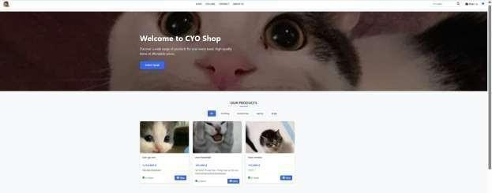

Figure 11: Homepage screen
Table 30: Elements of Homepage screen
Element Name | HTML  Tag | Purpose | Description | Interact | Event

Page Container | div | Container | Main content wrapper | No | None
Section Title | h2 | Display | "OUR PRODUCTS" heading | No | None
Category Pills Container | div | Container | Container for category filters | No | None
All Categories Link | a | Filter | Shows all products | Yes | click
Category Filter Links | a | Filter | Filters products by category | Yes | click
No Products Container | div | Display | Shows when no products available | No | None
No Products Icon | i | Display | Box icon for empty state | No | None
No Products Title | h3 | Display | "No Products Available" heading | No | None
No Products Text | p | Display | Description for empty state | No | None
Become Seller Link | a | Navigation | Links to seller registration | Yes | click
Products Grid | div | Container | Grid container for product cards | No | None
Product Card | div | Container | Individual product container | No | None
Product Badge | div | Display | Shows "New" or other badges | No | None
Product Image | img | Display | Product photo or placeholder | No | None
Product Info Container | div | Container | Contains product details | No | None
Product Name | h5 | Display | Product title | No | None
Product Price | p | Display | Product price information | No | None
Stock Status Container | div | Display | Shows stock availability | No | None
Stock Status Icon | i | Display | Check or X icon for stock | No | None
Stock Status Text | span | Display | "In Stock" or "Out of Stock" text | No | None
View Product Button | a | Navigation | Links to product detail page | Yes | click

ShoppingCartPage
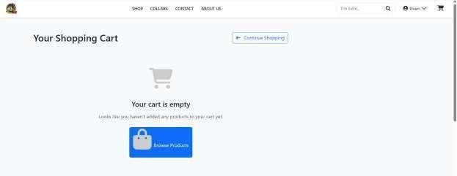

Figure 12: Screen of empty cart

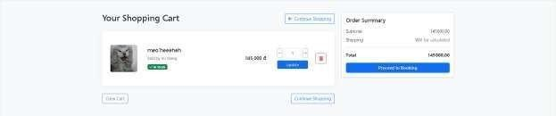
Figure 13: Cart with products screen
Table 33: Elements of cart with products screen
Element Name | HTML  Tag | Purpose | Description | Interact | Event
Page Title | h2 | Display | "Your Shopping Cart" heading | No | None
Continue Shopping Link | a | Navigation | Links back to homepage | Yes | click
Success Alert | div | Notification | Shows success messages | No | None
Error Alert | div | Notification | Shows error messages | No | None
Multiple Sellers Alert | div | Notification | Informs about multiple sellers in cart | No | None
Warning Alert | div | Notification | Shows warning messages | No | None
Empty Cart Container | div | Container | Displayed when cart is empty | No | None
Empty Cart Icon | i | Display | Shopping cart icon for empty state | No | None
Empty Cart Title | h4 | Display | "Your cart is empty" heading | No | None
Empty Cart Text | p | Display | Description for empty cart | No | None
Browse Products Button | a | Navigation | Links to homepage to browse products | Yes | click
Cart Container | div | Container | Main container for cart items | No | None
Cart Item | div | Container | Individual cart item wrapper | No | None
Product Image | img | Display | Product photo or placeholder | No | None
Product Name | h5 | Display | Name of the product | No | None
Seller Info | small | Display | Shows seller name | No | None
Stock Badge (In Stock) | span | Display | Green badge showing "In Stock" | No | None
Stock Badge (Out of Stock) | span | Display | Red badge showing "Out of Stock" | No | None
Stock Icon (Available) | i | Display | Check icon for available stock | No | None
Stock Icon (Unavailable) | i | Display | X icon for unavailable stock | No | None
Product Price | span | Display | Individual product price | No | None
Quantity Form | form | Container | Form for updating item quantity | Yes | submit
Product ID Hidden Input | input | Input | Hidden field with product ID | No | None
Quantity Control Container | div | Container | Wrapper for quantity controls | No | None
Decrement Button | button | Action | Decreases quantity by 1 | Yes | click
Decrement Icon | i | Display | Minus icon for decrement | No | None
Quantity Input | input | Input | Text field for quantity value | Yes | input, change
Increment Button | button | Action | Increases quantity by 1 | Yes | click
Increment Icon | i | Display | Plus icon for increment | No | None
Update Button | button | Action | Submits quantity update | Yes | click
Remove Form | form | Container | Form for removing item from cart | Yes | submit
Remove Product ID | input | Input | Hidden field with product ID | No | None
Remove Quantity | input | Input | Hidden field with quantity 0 | No | None
Remove Button | button | Action | Removes item from cart | Yes | click
Remove Icon | i | Display | Trash icon for remove action | No | None
Bottom Actions Container | div | Container | Container for cart-level actions | No | None
Clear Cart Form | form | Container | Form for clearing entire cart | Yes | submit
Clear Cart Button | button | Action | Removes all items from cart | Yes | click
Continue Shopping Link | a | Navigation | Links to homepage | Yes | click
Summary Card | div | Container | Card container for order summary | No | None
Summary Card Body | div | Container | Card body wrapper | No | None
Summary Title | h5 | Display | "Order Summary" heading | No | None
Subtotal Row | div | Container | Container for subtotal display | No | None
Subtotal Label | span | Display | "Subtotal" text label | No | None
Subtotal Amount | span | Display | Calculated subtotal amount | No | None
Shipping Row | div | Container | Container for shipping info | No | None
Shipping Label | span | Display | "Shipping" text label | No | None
Shipping Text | span | Display | "Will be calculated" message | No | None
Summary Divider | hr | Display | Horizontal line separator | No | None
Total Row | div | Container | Container for total amount | No | None
Total Label | span | Display | "Total" text label | No | None
Total Amount | span | Display | Final total amount | No | None
Proceed to Booking Button | a | Navigation | Links to booking creation page | Yes | click

ProductDetailPage

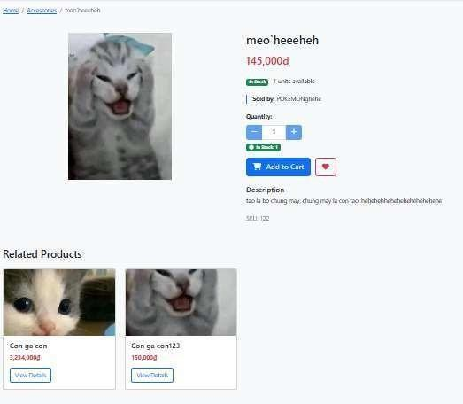

Figure 14 Screen of Product Detail

Table 34 Elements of Product's detail
Element Name | HTML  Tag | Purpose | Description | Interact | Event
Success Alert | div | Notification | Shows success messages with dismiss button | Yes | click (dismiss)
Success Message Text | span | Display | Success message content | No | None
Success Close Button | button | Action | Closes success alert | Yes | click
Error Alert | div | Notification | Shows error messages with dismiss button | Yes | click (dismiss)
Error Message Text | span | Display | Error message content | No | None
Error Close Button | button | Action | Closes error alert | Yes | click
Breadcrumb Navigation | nav | Navigation | Navigation breadcrumb container | No | None
Breadcrumb List | ol | Container | Ordered list for breadcrumb items | No | None
Home Breadcrumb | li | Navigation | Link to homepage | Yes | click
Category Breadcrumb | li | Navigation | Link to product category | Yes | click
Product Breadcrumb | li | Display | Current product name (active) | No | None
Main Image Container | div | Container | Container for main product image | No | None
Main Product Image | img | Display | Primary product image or placeholder | No | None
Thumbnail Container | div | Container | Container for thumbnail images | No | None
Thumbnail Image | img | Action | Clickable thumbnail to change main image | Yes | click
Product Name | h2 | Display | Product title/name | No | None
Price Tag | p | Display | Product price in Vietnamese Dong | No | None
Stock Status Container | p | Container | Container for stock information | No | None
In Stock Badge | span | Display | Green badge showing "In Stock" | No | None
Out of Stock Badge | span | Display | Red badge showing "Out of Stock" | No | None
Stock Quantity Text | span | Display | Number of units available | No | None
Seller Info Container | div | Container | Container for seller details | No | None
Seller Label | strong | Display | "Sold by:" label | No | None
Seller Name | span | Display | Shop name or seller's full name | No | None
Add to Cart Form | form | Container | Form for adding product to cart | Yes | submit
Product ID Hidden Input | input | Input | Hidden field with product ID | No | None
Quantity Label | label | Display | "Quantity:" label | No | None
Quantity Selector Container | div | Container | Input group for quantity controls | No | None
Decrement Button | button | Action | Decreases quantity by 1 | Yes | click
Decrement Icon | i | Display | Minus icon for decrement | No | None
Quantity Input | input | Input | Text field for quantity value | Yes | input, keypress
Increment Button | button | Action | Increases quantity by 1 | Yes | click
Increment Icon | i | Display | Plus icon for increment | No | None
Stock Status Badge (In Stock) | span | Display | Green badge with stock count | No | None
Stock Check Icon | i | Display | Check circle icon for available stock | No | None
Stock Count Text | span | Display | "In Stock: X" text | No | None
Stock Status Badge (Out of Stock) | span | Display | Red badge for out of stock | No | None
Stock X Icon | i | Display | Times circle icon for unavailable stock | No | None
Add to Cart Button | button | Action | Adds product to shopping cart | Yes | click
Cart Icon | i | Display | Shopping cart icon | No | None
Wishlist Button | button | Action | Adds product to wishlist | Yes | click
Heart Icon | i | Display | Heart icon for wishlist | No | None
Description Container | div | Container | Container for product description | No | None
Description Title | h5 | Display | "Description" heading | No | None
Description Text | p | Display | Product description or "No description available" | No | None
SKU Text | p | Display | Product SKU information | No | None
SKU Value | span | Display | Actual SKU code | No | None
Related Products Container | div | Container | Container for related products | No | None
Related Products Title | h3 | Display | "Related Products" heading | No | None
Related Products Grid | div | Container | Grid container for related product cards | No | None
Related Product Card | div | Container | Individual related product card | No | None
Related Product Image | img | Display | Related product image | No | None
Related Product Body | div | Container | Card body for related product info | No | None
Related Product Name | h5 | Display | Related product title | No | None
Related Product Price | p | Display | Related product price | No | None
View Details Link | a | Navigation | Links to related product detail page | Yes | click

MyOrdersPage
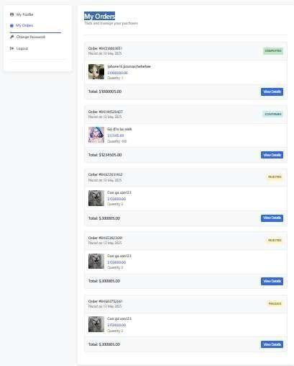

Figure 15 Screen of My Orders Table 35 Elements of My Orders

Element Name | HTML  Tag | Purpose | Description | Interact | Event
Success Alert | div | Notification | Shows success messages with dismiss button | Yes | click (dismiss)
Success Message Text | span | Display | Success message content | No | None
Success Close Button | button | Action | Closes success alert | Yes | click
Error Alert | div | Notification | Shows error messages with dismiss button | Yes | click (dismiss)
Error Message Text | span | Display | Error message content | No | None
Error Close Button | button | Action | Closes error alert | Yes | click
Info Alert | div | Notification | Shows info messages with dismiss button | Yes | click (dismiss)
Info Message Text | span | Display | Info message content | No | None
Info Close Button | button | Action | Closes info alert | Yes | click
Warning Alert | div | Notification | Shows warning messages with dismiss button | Yes | click (dismiss)
Warning Message Text | span | Display | Warning message content | No | None
Warning Close Button | button | Action | Closes warning alert | Yes | click
Sidebar Container | div | Container | Container for profile navigation menu | No | None
Profile Tabs Container | div | Container | Container for navigation tabs | No | None
My Profile Link | a | Navigation | Links to user profile page | Yes | click
Profile Icon | i | Display | User circle icon for profile | No | None
My Orders Link | a | Navigation | Links to orders page (active) | Yes | click
Orders Icon | i | Display | Shopping bag icon for orders | No | None
Change Password Link | a | Navigation | Links to password change page | Yes | click
Password Icon | i | Display | Key icon for password | No | None
Seller Dashboard Link | a | Navigation | Links to seller dashboard (if seller role) | Yes | click
Seller Icon | i | Display | Store icon for seller dashboard | No | None
Logout Link | a | Action | Triggers logout form submission | Yes | click
Logout Icon | i | Display | Sign out icon for logout | No | None
Logout Form | form | Container | Hidden form for logout submission | Yes | submit
Main Container | div | Container | Main content container | No | None
Profile Header | div | Container | Header section for page title | No | None
Profile Title | h1 | Display | "My Orders" main heading | No | None
Profile Subtitle | p | Display | "Track and manage your purchases" description | No | None
Empty Orders Container | div | Container | Displayed when no orders exist | No | None
Empty Orders Icon | i | Display | Large shopping bag icon for empty state | No | None
Empty Orders Title | h3 | Display | "No Orders Yet" heading | No | None
Empty Orders Text | p | Display | Description for empty orders state | No | None
Shop Now Button | a | Navigation | Links to shop page to start shopping | Yes | click
Orders List Container | div | Container | Container for orders when they exist | No | None
Order Card | div | Container | Individual order card wrapper | No | None
Order Header | div | Container | Header section of each order card | No | None
Order Info Container | div | Container | Container for order ID and date | No | None
Order ID | div | Display | Order number (e.g., "Order #BK123456") | No | None
Order Date | div | Display | Order placement date | No | None
Order Status Badge | div | Display | Status badge with dynamic styling | No | None
Order Body | div | Container | Body section containing order items | No | None
Order Product | div | Container | Individual product item in order | No | None
Product Image | img | Display | Product image or placeholder | No | None
Product Details Container | div | Container | Container for product information | No | None
Product Name | div | Display | Name of the ordered product | No | None
Product Price | div | Display | Price of the product | No | None
Product Quantity | div | Display | Quantity ordered | No | None
Order Footer | div | Container | Footer section of each order card | No | None
Order Total | div | Display | Total amount of the order | No | None
View Details Button | a | Navigation | Links to detailed order view | Yes | click

BookingDetailsPage

Figure 36 Screen of Booking Details
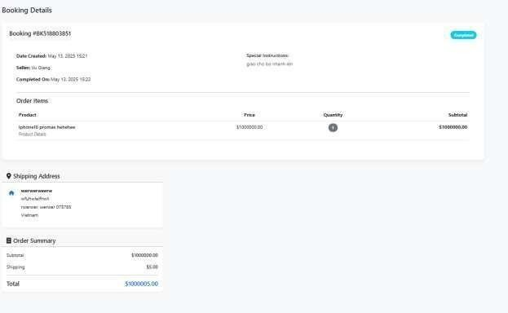

Table 37 Elements of Booking Details
Element Name | HTML  Tag | Purpose | Description | Interact | Event
Success Close Button | button | Action | Closes success alert | Yes | click
Error Close Button | button | Action | Closes error alert | Yes | click
Sidebar Toggle Button | button | Action | Toggles sidebar on mobile | Yes | click
Home Link | a | Navigation | Links to homepage | Yes | click
Profile Link | a | Navigation | Links to profile page | Yes | click
Bookings Link | a | Navigation | Links to bookings page | Yes | click
Cart Link | a | Navigation | Links to cart page | Yes | click
Wishlist Link | a | Navigation | Links to wishlist page | Yes | click
Back Button | a | Navigation | Returns to bookings list | Yes | click
Cancel Button | button | Action | Opens cancel booking modal | Yes | click
Modal Close Button | button | Action | Closes modal | Yes | click
Keep Button | button | Action | Cancels modal without action | Yes | click
Cancel Form | form | Container | Form for booking cancellation | Yes | submit
Confirm Cancel Button | button | Action | Confirms booking cancellation | Yes | click

ProfilePage
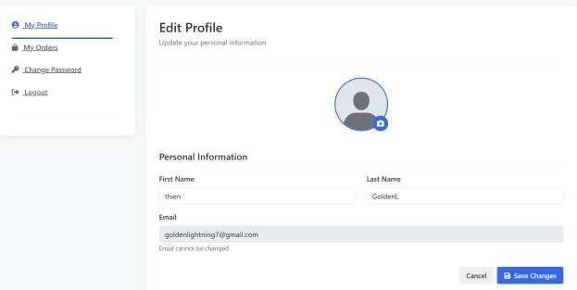

Figure 16 Screen of Edit Profile Table 38 Element of Edit Profile

Eleme nt Name | HTML  Tag | Purpose | Description
Profile Image Upload | input | Input | File input for uploading profile picture
Camera Icon/Label | label | Action | Clickable label to trigger file upload
First Name Input | input | Input | Text field for first name
Last Name Input | input | Input | Text field for last name
Email Input | input | Input | Text field for email address
Cancel Button | button | Action | Cancels form and returns to profile
Save Changes Button | button | Action | Submits the form to save profile changes

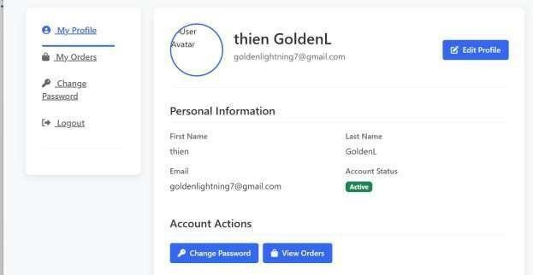

Figure 17Screen of Profile Table 39 Elements of Profile
Element Name | HTML  Tag | Purpose | Description | Interact | Event
Edit Profile Button | a | Navigation | Links to edit profile page | Yes | click
Change Password Button | a | Navigation | Links to password change page | Yes | click
View Orders Button | a | Navigation | Links to orders page | Yes | click

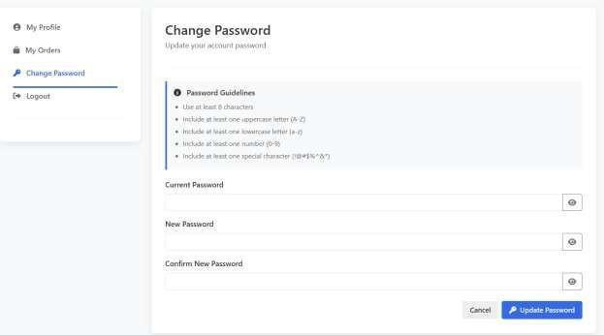

Figure 18 Screen of Change Password Table 40 Elements of Change Password
Element Name | HTM  L Tag | Purpose | Description | Interact | Event
Current Password Input | input | Input | Text field for current password | Yes | input
Current Password Toggle | button | Action | Shows/hides current password | Yes | click
New Password Input | input | Input | Text field for new password | Yes | input
New Password Toggle | button | Action | Shows/hides new password | Yes | click
Confirm Password Input | input | Input | Text field for password confirmation | Yes | input
Confirm Password Toggle | button | Action | Shows/hides confirm password | Yes | click
Password Form | form | Container | Form for password change submission | Yes | submit
Cancel Button | a | Navigation | Returns to profile page | Yes | click
Update Password Button | button | Action | Submits password change form | Yes | click

SellerDashboardPage
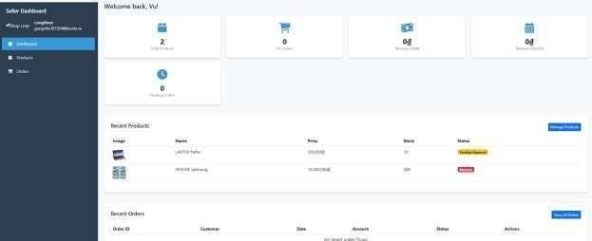

Figure 19 Screen of Seller Dashboard Table 41 ELements of Seller Dashboard

Element Name | HTML  Tag | Purpose | Description
Dashboard | a | Seller Dashboard Navigation | Links to the main SellerDashboardPage. (Currently active)
Products | a | Seller Dashboard Navigation | Links to the product management section of the seller dashboard.
Orders | a | Seller Dashboard Navigation | Links to the order management section of the seller dashboard.
Manage Product s | a | Action Button | Button to navigate to the product management or product creation page.
View All Orders | a | Action Button | Button to view the full list of orders for the seller.

ProductManagementPage[Seller]
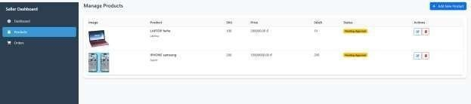
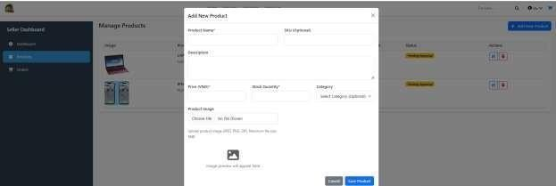

Figure 20 Screen of Manage Product[Seller] Table 42 Elements of Manage Product
Element Name | HTML  Tag | Purpose | Description
Dashboard | a | Navigation (Seller Dashboard) | Link to the main SellerDashboardPage.
Products | a | Navigation (Seller Dashboard) | Link to the product management section of the seller dashboard. (Active in this context)
Orders | a | Navigation (Seller Dashboard) | Link to the order management section of the seller dashboard.
Add New Product | button | Product Management | Opens a modal or form for adding a new product to the seller's inventory.
Edit Product (Icon) | a | Product Management | Link (icon-based) to edit the details of a specific product.
Delete Product (Icon) | button | Product Management | Icon button to trigger deletion of a specific product. Likely opens a confirmation modal.

Resubmit Product (Icon) | button | Product Management / Approval Flow | Icon button to resubmit a rejected product for approval.
View Rejection Reason  (Icon) | button | Product Management / Approval Flow | Icon button to display the rejection reason for a previously denied product.
Product Name Input | input | Product Name Field | Input field for entering the name of the product.
Product SKU Input | input | Product SKU Field | Input field for entering the Stock Keeping Unit (SKU) of the product.

Product Description | textarea | Product Description Field | Text area for entering a detailed description of the product.
Product Price Input | input | Product Price Field | Input field for entering the price of the product.
Product Stock Input | input | Product Stock/Quantity Field | Input field for entering the number of units currently in stock.
Product Category Select | select | Product Category Selection | Dropdown menu for selecting the product category.
Product Image Input | input | Product Image Upload | File input field for uploading an image of the product.
Cancel Add Product | button | Cancel Product Creation | Discards the entered product information and closes the “Add Product” modal.
Save Product | button | Save Product and Close Modal | Saves and submits the new product details, then closes the modal.

OrdersManagementPage

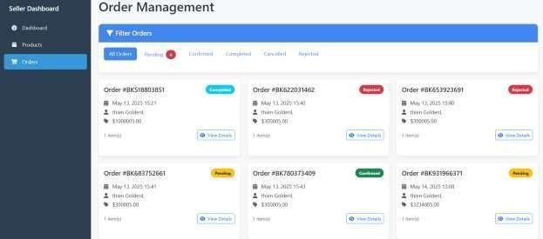

Figure 21 Screen of Order Management Table 43
Elements of Order Management

Eleme nt Name | HTML  Tag | Purpose | Description
Dashboard | a | Seller Dashboard Navigation | Navigates to the main SellerDashboardPage.
Products | a | Seller Dashboard Navigation | Navigates to the product management section of the seller dashboard.

Orders | a | Seller Dashboard Navigation | Navigates to the order management section of the seller dashboard. This is the active page (highlighted via class="nav-link active").
All Orders | a | Order Filter/View | Displays all orders. This is the active filter (highlighted).
Pendin g Orders | a | Order Filter/View | Displays orders with a “Pending” status. The number next to it (e.g., “4”) indicates the total count of pending orders.

Confirme d Orders | a | Order Filter/View | Displays orders with a “Confirmed” status.
Complete d Orders | a | Order Filter/View | Displays orders with a “Completed” status.

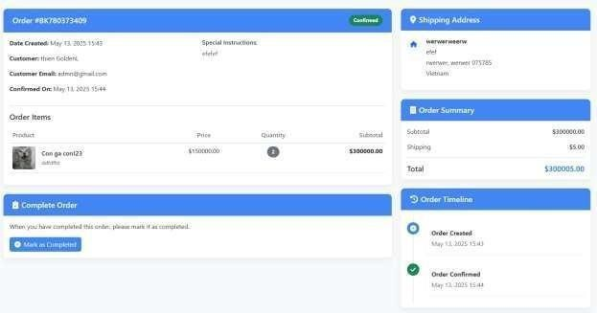
Figure 22 Screen of OrderDetailsPage
Table 44 Elements of Order Detail

Elemen t Name | HTML  Tag | Purpose | Description
Cancelle  d Orders | a | Order  Filter/View | Displays orders with a “Cancelled” status.
Rejecte d Orders | a | Order Filter/View | Displays orders with a “Rejected” status.
View Details | a | Order Action | Navigates to the OrderDetailsPage for a specific order. One per order entry.
Dashboard | a | Navigation | Navigates to the main dashboard page.
Products | a | Navigation | Navigates to the product management section.

Orders | a | Navigation | Navigates to the order management section. This is the currently active page.

Back to Orders | a | Navigation | Returns to the main order list view.
Mark as Complete d | button | Order Manageme nt | Button to mark the current order as completed. Corresponds to a green “Confirm Order” button.
Confirm Order | button | Order Manageme nt | Button to confirm the order. <button class="btn btn-success" type="submit">.
Reject Order | button | Order Manageme nt | Button to reject the order. Triggers a modal via data-bs- toggle="modal" and data-bs-target="#rejectOrderModal".

AdminDashboardPage
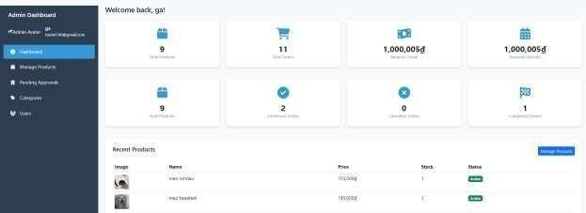
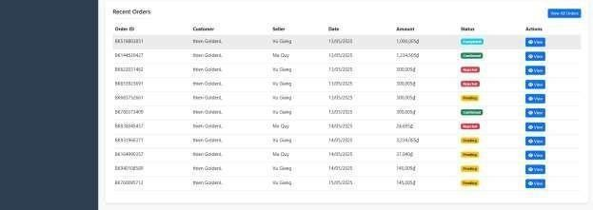

Figure 23 Screen of Admin Dashboard Table 45 Elements of Admin Dashboard
Element Name | HTML  Tag | Purpose | Description
Dashboard | a | Navigatio n | Link to the main AdminDashboardPage. The currently active page is highlighted.

Manage Product s | a | Navigatio n | Link to the product management section.
Pending Approval s | a | Navigatio n | Link to the pending product approvals section.
Categories | a | Navigatio n | Link to the product categories management section.
Users | a | Navigatio n | Link to the user management section.
Manage Product s | a | Action | Button-like link used to navigate quickly to the product management section.
View All Orders | a | Action | Button-like link to navigate to the full list of all orders.
View (Order) | a | Action | Appears multiple times in a table. Allows admin to view details of specific orders.

Admin ProductsManagePage

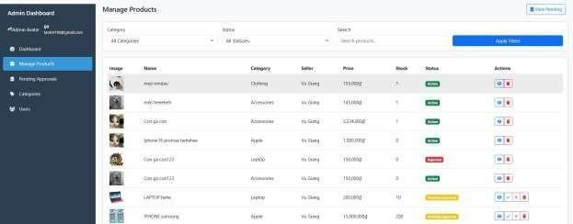

Figure 24 Screen of Admin ProductsManagePage
Table 46 Elements of Admin ProductsManagePage

Element Name | HTML  Tag | Category | Description
Dashboard | <a> | Admin Navigation | Link to the main AdminDashboardPage.
Manage Products | <a> | Admin Navigation | Link to the "Manage Products" section (currently active).
Pending Approvals | <a> | Admin Navigation | Link to the "Pending Approvals" page.
Categories | <a> | Admin Navigation | Link to the "Categories" page.
Users | <a> | Admin Navigation | Link to the "Users" page.

View Pending | <a> | Product Manageme nt | Button to view products with pending status.
Category Filter | <select> | Filtering | Dropdown to filter products by category (e.g., Clothing, Accessories, etc.).

Status Filter | <select> | Filtering | Dropdown to filter products by status (e.g., Active, Out of Stock, etc.).
Search Products | <input> | Filtering | Text input for searching products by name/description.
Apply Filters | <button> | Filtering | Button to apply all selected filters.
View Product (Action) | <a> | Product Manageme nt | Link to view product details (repeated per product, usually opens in new tab).
Delete Product (Action) | <button> | Product Manageme nt | Button to delete a product (repeated, opens confirmation modal).
Approve Product (Action) | <button> | Product Manageme nt | Button to approve a product (appears for pending items, opens modal).
Reject Product (Action) | <button> | Product Manageme nt | Button to reject a product (appears for pending items, opens modal).

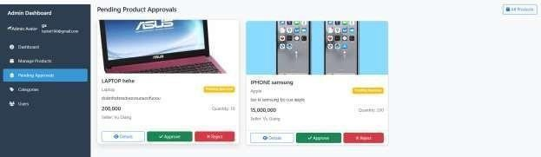
Figure 25 Screen of Pending Product Approvals Table 47 Elements of Admin products manage

Element Name | HTML  Tag | Category | Description
Dashboard | a | Admin Navigation | Link to the main AdminDashboardPage.
Manage Product s | a | Admin Navigation | Link to the product management section of the admin panel.

Pending Approval s | a | Admin Navigation | Link to the pending approvals section. (Currently active)
Categories | a | Admin Navigation | Link to the categories management section.
Users | a | Admin Navigation | Link to the user management section.
All Products | a | Link to All Products | Link to view all (likely approved) products.

Details | button | View Product Details | Button to open modal/popup for a product's details (e.g., "LAPTOP hehe", "IPHONE samsung").
Approve | button | Approv e Produc t | Button to approve a product (triggers approval process).
Reject | button | Reject Product | Button to reject a product (triggers rejection process).

CreateBookingPage
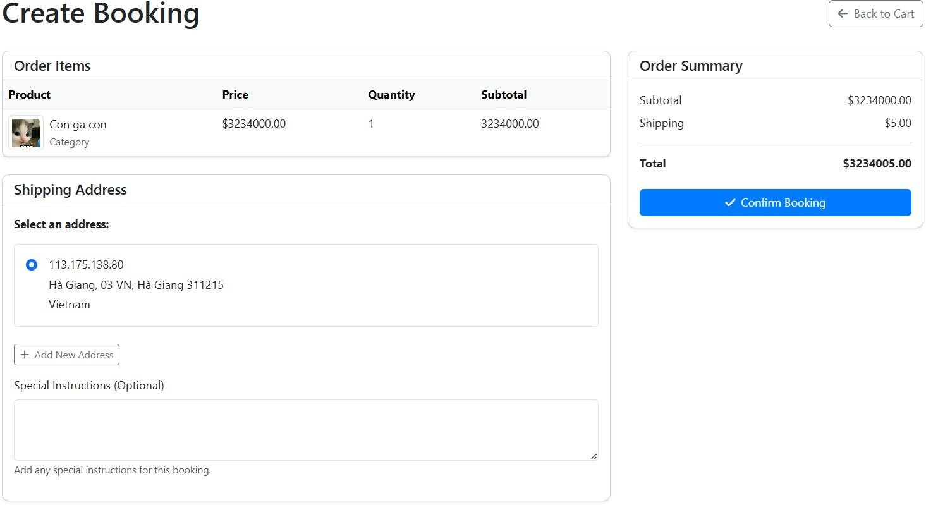
Figure 26 Screen of CreateBookingPage

Table 48 Elements of CreateBookingPage

Element Name | HTML Tag | Purpose | Description
Create Booking | <h1> | Page Title | Displays the title of the page.
Back to Cart | <a> | Navigation | Provides a link to navigate back to the cart.
Error message | <div> | Error Display | Displays error messages if any exist.
Order Items | <h5> | Section Title | Displays the title for the order items section.
Product | <td> | Table Header | Displays the product name in the order items table.
Price | <td> | Table Header | Displays the price of the product in the order items table.
Quantity | <td> | Table Header | Displays the quantity of the product in the order items table.
Subtotal | <td> | Table Header | Displays the subtotal of the product in the order items table.
Shipping Address | <h5> | Section Title | Displays the title for the shipping address section.
Street | <label> /  <input> | Input Field  Label and Field | Allows the user to input the street address.
Street Address (Optional) | <label> /  <input> | Input Field  Label and Field | Allows the user to input an optional street address.

City | <label> /  <input> | Input Field  Label and Field | Allows the user to input the city.
State/Provinc e | <label> /  <input> | Input Field  Label and Field | Allows the user to input the state or province.
Postal Code | <label> /  <input> | Input Field  Label and Field | Allows the user to input the postal code.
Country | <label> /  <input> | Input Field  Label and Field | Allows the user to input the country.
Select an address | <p> | Instruction Text | Informs the user to select an address.
Add New Address | <a> | Button | Allows the user to add a new address.
Cancel | <a> | Button | Allows the user to cancel adding a new address.
Special Instructions | <label> /  <textarea> | Input Field  Label and Field | Allows the user to input special instructions for the booking.
Order Summary | <h5> | Section Title | Displays the title for the order summary section.
Subtotal | <span> | Summary Value | Displays the subtotal of the order.
Shipping | <span> | Summary Value | Displays the shipping cost of the order.
Total | <span> | Summary Value | Displays the total cost of the order.
Confirm Booking | <button> | Button | Allows the user to confirm the booking.

RegistrationPage

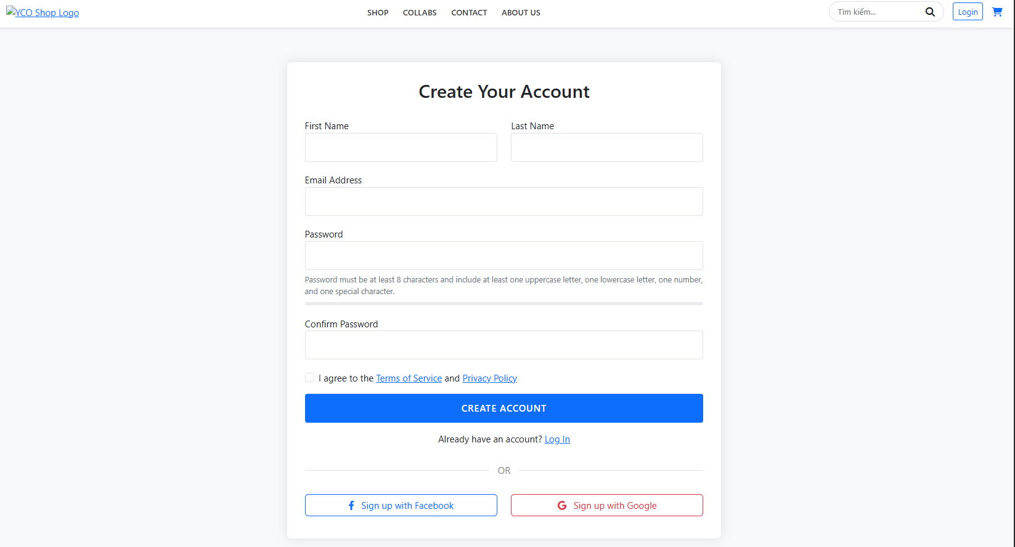
Figure 26 Screen of RegistrationPage [as customer] Table 49 Elements of RegistrationPage [as customer]
Element Name | HTML Tag | Purpose | Description
Create Your Account | <h2> | Page Title | Displays the title of the registration page.
Error message | <div> | Error Display | Displays error messages if any exist.
Success message | <div> | Success Display | Displays success messages if any exist.
First Name | <label> /  <input> | Input Field Label and Field | Allows the user to input their first name.
Last Name | <label> /  <input> | Input Field Label and Field | Allows the user to input their last name.
Email Address | <label> /  <input> | Input Field Label and Field | Allows the user to input their email address.
Password | <label> /  <input> | Input Field Label and Field | Allows the user to input their password.
Password Strength Bar | <div> | Visual Indicator | Displays the strength of the entered password.
Confirm Password | <label> /  <input> | Input Field Label and Field | Allows the user to confirm their password.
Terms of Service | <a> | Link | Provides a link to view the terms of service.

Privacy Policy | <a> | Link | Provides a link to view the privacy policy.
Create Account | <button> | Button | Allows the user to submit the registration form.
Log In | <a> | Link | Provides a link to navigate to the login page.
Sign up with Facebook | <a> | Button | Allows the user to sign up using their Facebook account.
Sign up with Google | <a> | Button | Allows the user to sign up using their Google account.
Terms Modal | <div> | Modal | Displays the terms of service in a modal.
Privacy Modal | <div> | Modal | Displays the privacy policy in a modal.
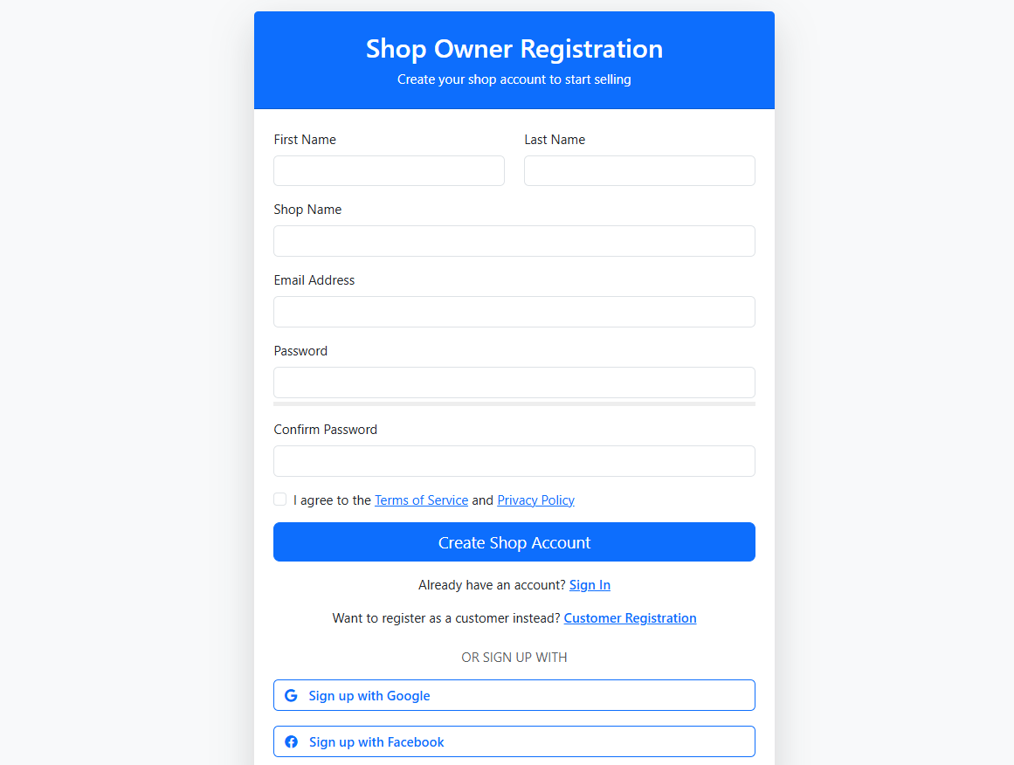
Figure 27 Screen of RegistrationPage [as seller]

Table 50 Element of RegistrationPage [as seller]
Element Name | HTML Tag | Purpose | Description
Shop Owner Registration | <h2> | Page Title | Displays the title of the shop owner registration page.

Error message | <div> | Error Display | Displays error messages if any exist.
Success message | <div> | Success Display | Displays success messages if any exist.
First Name | <label> /  <input> | Input Field Label and Field | Allows the user to input their first name.
Last Name | <label> /  <input> | Input Field Label and Field | Allows the user to input their last name.
Shop Name | <label> /  <input> | Input Field Label and Field | Allows the user to input their shop name.
Email Address | <label> /  <input> | Input Field Label and Field | Allows the user to input their email address.
Password | <label> /  <input> | Input Field Label and Field | Allows the user to input their password.
Password Strength Bar | <div> | Visual Indicator | Displays the strength of the entered password.
Confirm Password | <label> /  <input> | Input Field Label and Field | Allows the user to confirm their password.
Terms of Service | <a> | Link | Provides a link to view the terms of service.
Privacy Policy | <a> | Link | Provides a link to view the privacy policy.
Create Shop Account | <button> | Button | Allows the user to submit the shop registration form.
Sign In | <a> | Link | Provides a link to navigate to the login page.
Customer Registration | <a> | Link | Provides a link to navigate to the customer registration page.
Sign up with Google | <button> | Button | Allows the user to sign up using their Google account.
Sign up with Facebook | <button> | Button | Allows the user to sign up using their Facebook account.
Terms Modal | <div> | Modal | Displays the terms of service in a modal.
Privacy Modal | <div> | Modal | Displays the privacy policy in a modal.

