\=

Requirement & Design Specification
FIFA Football Field Booking Management System

Subject: SWP391
Version: 1.1

MEMBERS
Vũ Trường Giang- HE182222
Vũ Nguyễn Đức Dũng - HE181375
Nguyễn Trung Kiên - HE180700
Lê Việt Cường - HE191460
Đặng Đức Việt - HE161942

LECTURER
HoaiBM

– Hanoi, Jan 2026 –

Record of Changes
Version | Date | A*  M, D | In charge | Change Description
V1.0 | 13/1 | A | GiangVTHE182222, KienNTHE180700, CuongLVHE191460,  DungVNDHE181375 | Context Diagram, ERD, Booking Swimlane
V1.1 | 14/1 | M | GiangVTHE182222,  DungVNDHE181375 | Context Diagram, Booking Swimlane
 | 14/1 | A | GiangVTHE182222,  DungVNDHE181375 | Add UCs for Actors
 | 15/1 | A | VietDDHE161942 | Login Swimlane
 | 16/1 | M | GiangVTHE182222  ,CuongLVHE191460 | UCs, ERD modified
 | 16/1 | A | GiangVTHE182222, DungVNDHE181375,KienNTHE180700 | UCs Descriptions, Screen flow
 | 17/1 | A | GiangVTHE182222, CuongLVHE191460 | System Design
 | 19/1 | M | GiangVTHE182222, DungVNDHE181375,KienNTHE180700,  CuongLVHE191460, VietDDHE161942 | ERD, Database Description
 | 21/1 | A | GiangVTHE182222, DungVNDHE181375,KienNTHE180700 | State Machine Diagrams
 | 24/1 | M | GiangVTHE182222 | ERD, Table Description
 | 30/1 | M | CuongLVHE191460,  VietDDHE161942 | Login, Gmail Login Swimlane
 | 01/2 | M | GiangVTHE182222,KienNTHE180700, | Use cases Description, Context Diagram
 | 02/2 | M | GiangVTHE182222, DungVNDHE181375,KienNTHE180700,  CuongLVHE191460,  VietDDHE161942 | Use cases, ERD, Table Description, Context Diagram
*A - Added M - Modified D - Deleted

Contents
Record of Changes
I. Overview
1. System Context
2. External Entities
3. Business Processes
3.1 Sale Process
3.2 Customer Support
4. User Requirements
4.1 UCs for Guest
4.2 UCs for Student
4.3 …
5. System Functionalities
5.1 Screens Flow
5.2 Screen Authorization
5.3 Non-UI Functions
II. Functional Requirements
1. Feature Name1
1.1 SubFeature Name1.1
1.2 SubFeature Name1.2
2. User Authentication
2.1 User Register
3. System Administration
3.1 Master Data
3.2 User Management
III. System Design
1. Software Architecture
1.1 Overall Architecturural Diagram
1.2 Component Descriptions
2. Code Package Design
2.1. Package Diagram
2.2 Package Descriptions
3. Database Design
3.1 Database Schema
3.2 Table Descriptions

I. Overview

1. System Context
Fifa Field is a management system designed for operating a chain of sports fields under a single platform. The system enables customers to book fields, rent equipment, and make payments, while staff and managers manage schedules, inventory, and daily operations.
The platform uses a centralized equipment model with standardized rental prices and damage fees, combined with per-field inventory tracking to ensure accurate availability and consistency across all locations. It also supports scheduling management, vouchers, feedback collection, and revenue reporting.
Fifa Field provides a scalable and well-structured foundation for managing multi-location sports field businesses and can be extended into a full enterprise application.

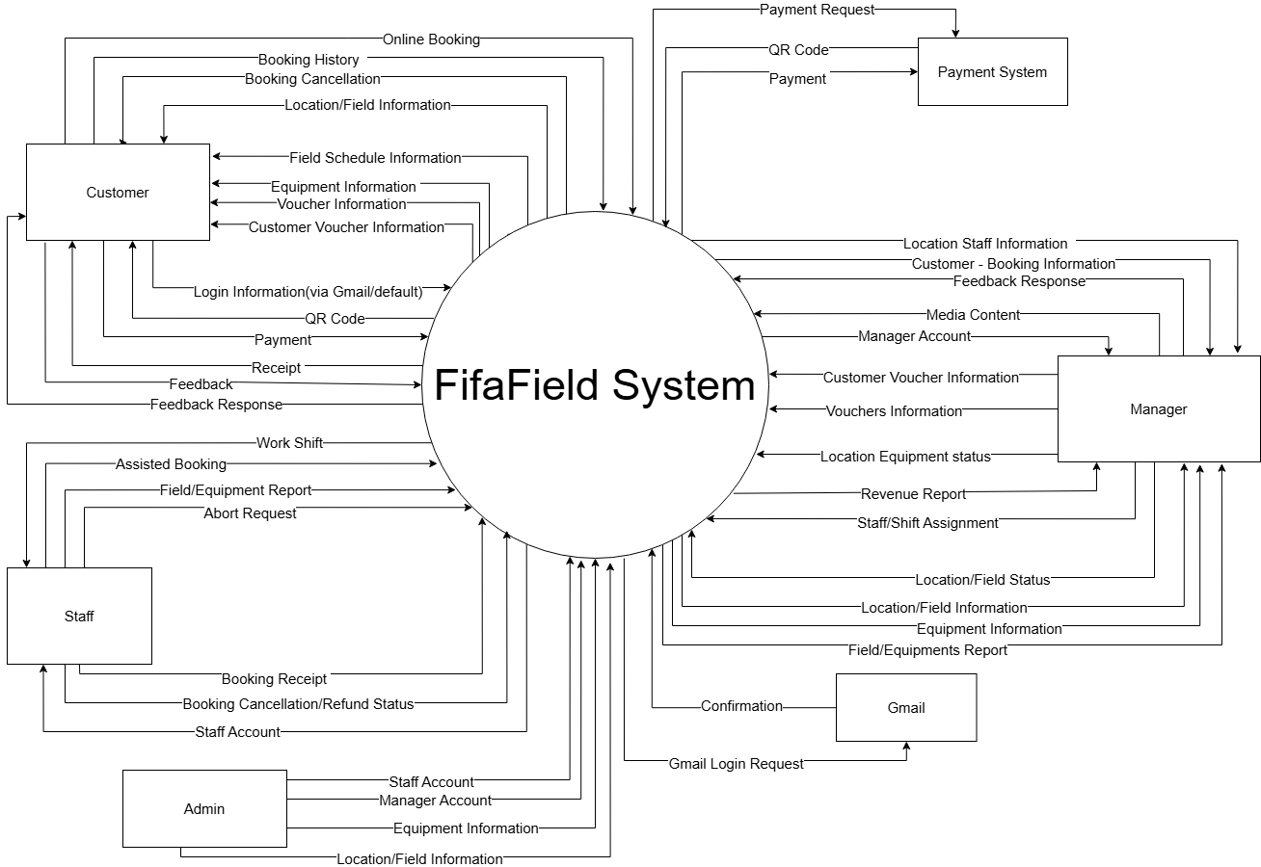
I-1.1 System Context Diagram

2. External Entities
# | Entity | Description
1 | Customer | The customer can booking field, order items from field, choose pack field to rent(pack normal field, pack tournament field,...), and payment through online payment system
2 | Manager | The manager manages a specific location which includes information of fields in the location, along with online content, staff and their shifts as well as resolving issue reports sent by staff. Manager can also response to customer feedbacks
5 | Staff | Staff manages offline booking for customer through hotline calls or direct ordering, working with their schedules and reporting equipments and field casualties
3 | Payment System | Payment system provide online payment method to rent field, and purchase items from field
4 | Admin | The admin manages staff and Manager accounts, reviewing revenues, field and equipment data
I-2.1 Table for External Actors

3. Business Processes

3.1 Sale Process
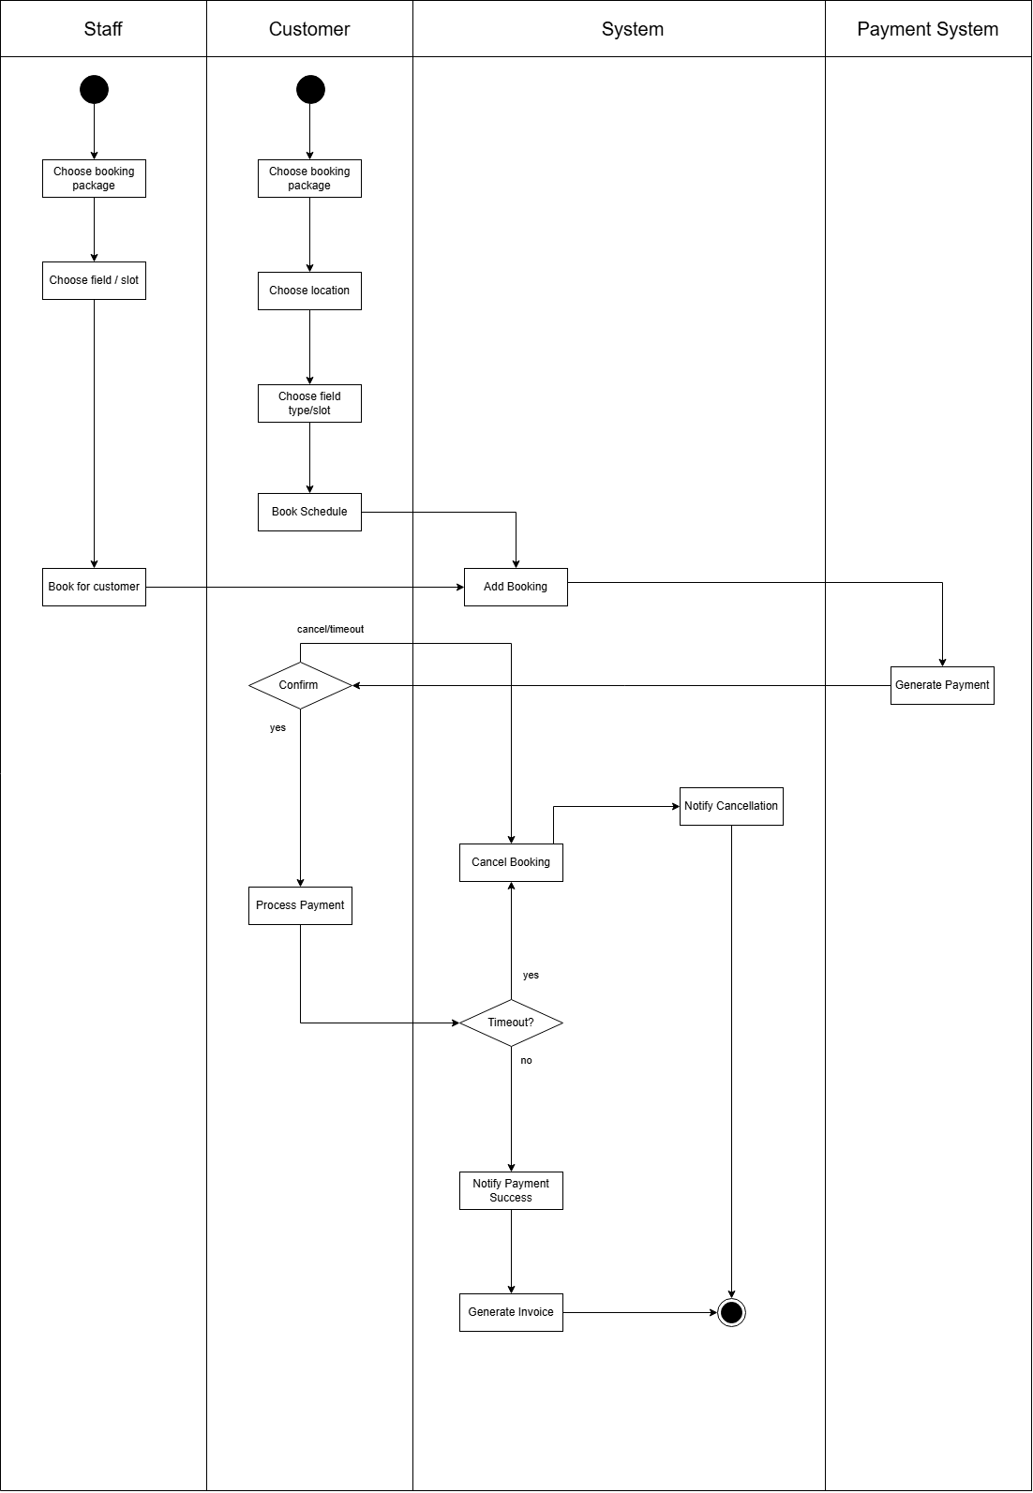
I-3.1.1 Swimlane for Booking flow
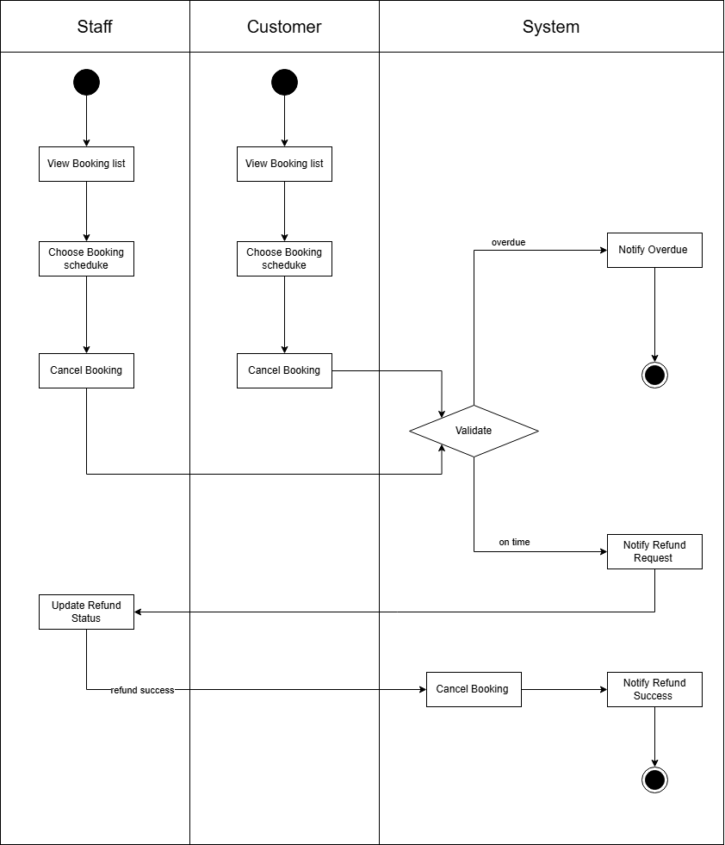
I-3.1.2 Swimlane for Cancel Booking Flow

3.2 Feedback Management
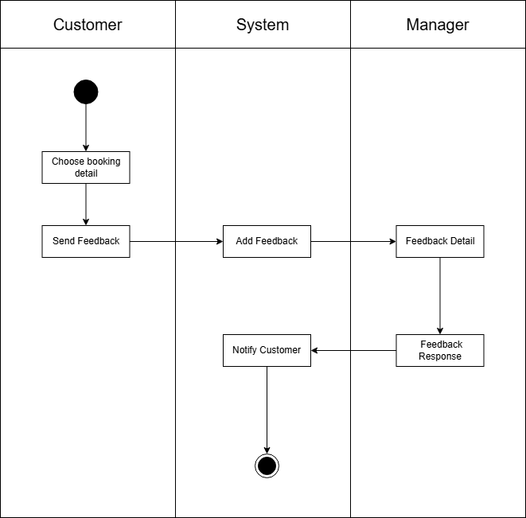
I-3.2.1 Swimlane for Feedback

3.3 Authentication
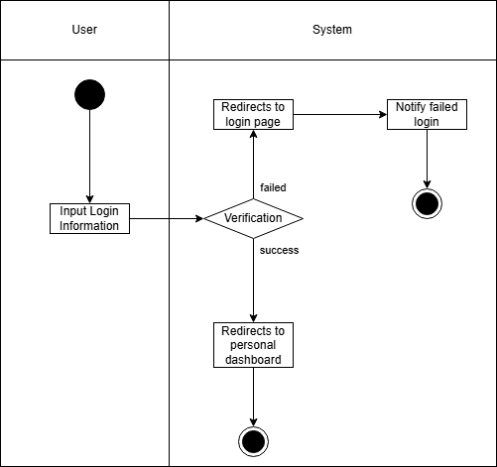
I-3.3.1 Swimlane for Login Flow
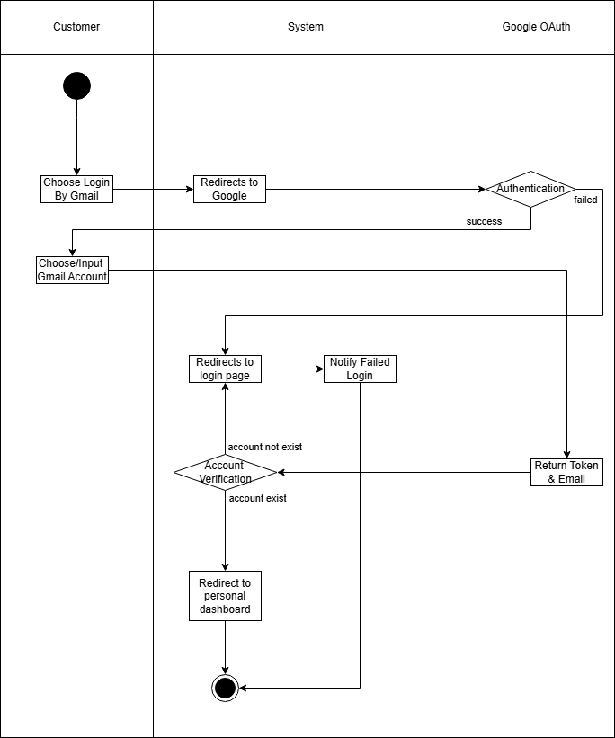
I-3.3.1 Swimlane for Gmail Login Flow

3.4 Staff - Shift
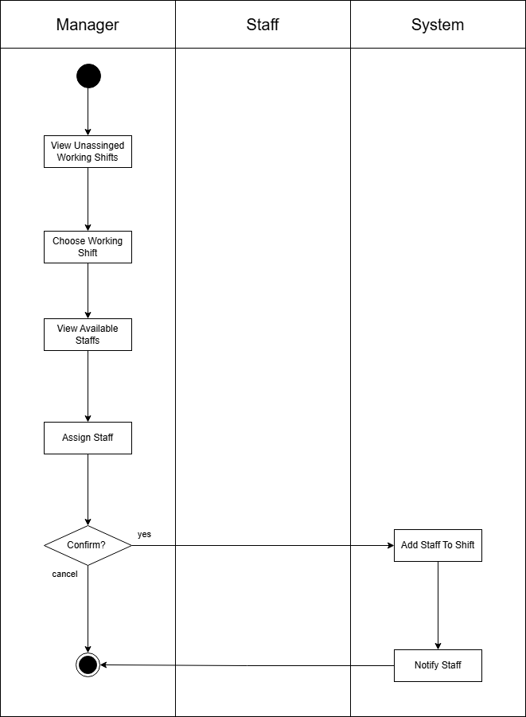
I-3.4.1 Swimlane for Assign Shift
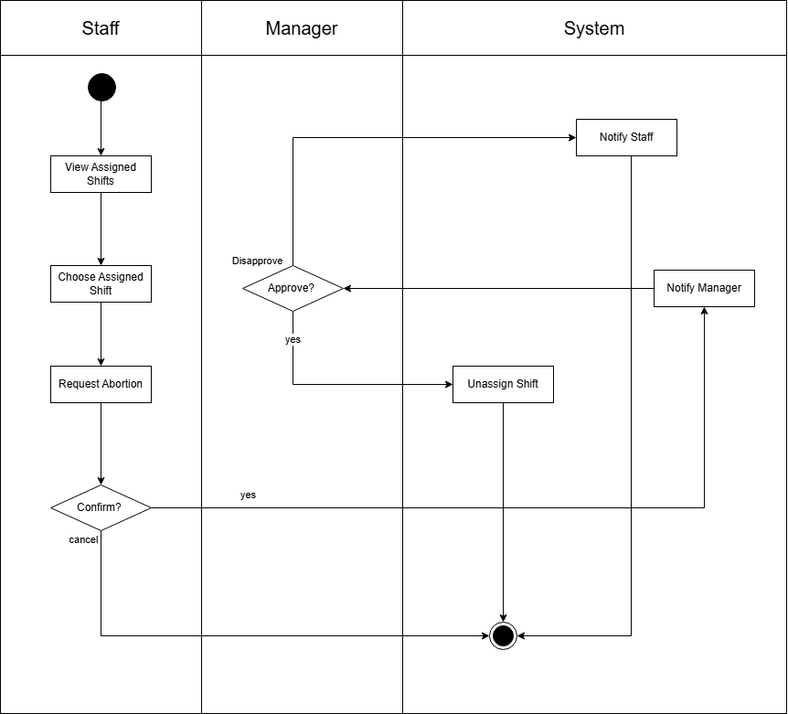
I-3.4.2 Swimlane for Abort Shift

3.5 Voucher Flow
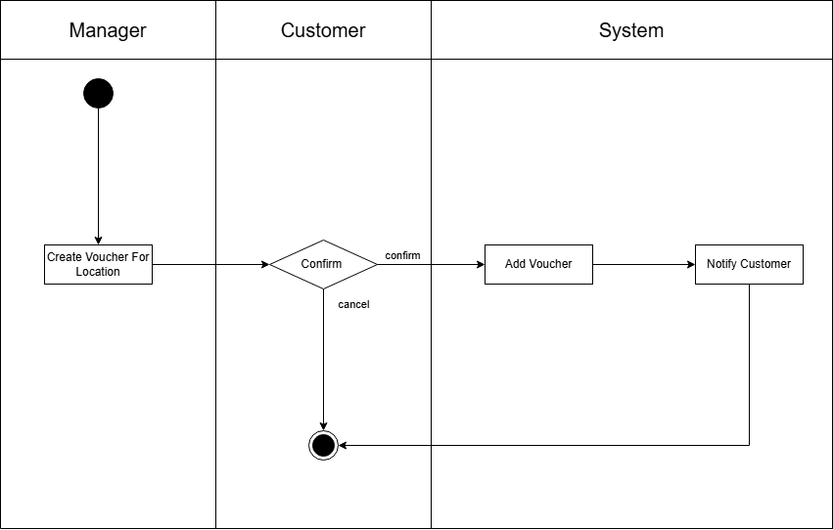
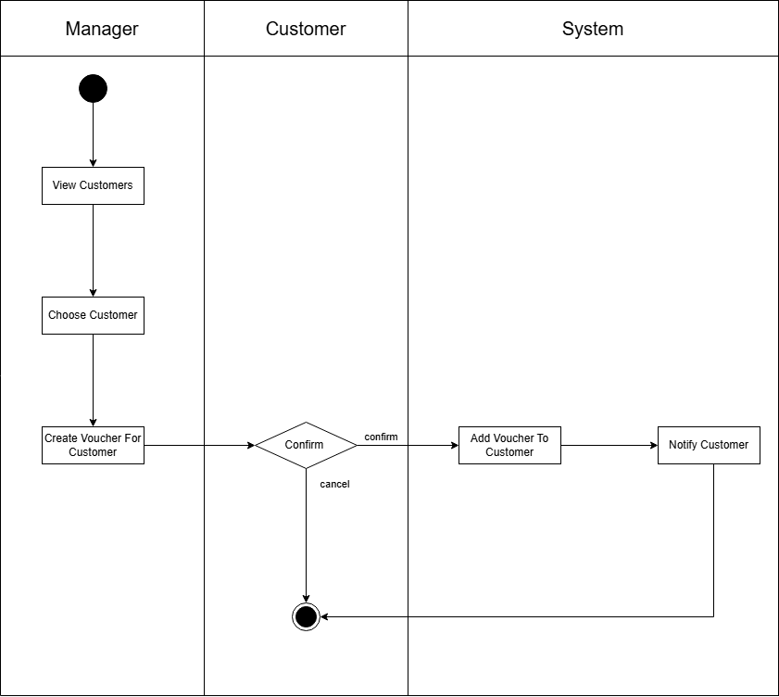
I-3.5.1 Swimlane for Adding voucher to customer

4. User Requirements
ID | Use Case | Feature | Main Actor | Use Case Description
UC-1 | Register an account | Create customer account | Guest | Guests can create their account to become customers
UC-2 | Login | Default Login, Gmail Login | Customer | Customers can login into their account via gmail or default login to access more feature of the web page
UC-3 | Forgot password | Change password with gmail or phone number | Customer, Guest | Customer, Guest can change their password using verification through their phone number or gmail account
UC-4 | Manage personal information | View profile, Edit profile | Customer | Customer can view and change their personal information
UC-5 | Change password | Change password | Customer | Customer can change password through gmail authentication
UC-6 | Forgot password | Reset password | Customer | Customer can reset password incase they forget
UC-7 | View Location | View Location List, View Location Detail | Customer, Guest | Customer, Guest can view location list and detail
UC-8 | View Field | View field list | Customer, Guest | Customer, Guest can view field list
UC-9 | View equipment list | View equipment list | Customer, Guest | Customer, Guest can view equipment list
UC-10 | View blog list | View blog list | Customer, Guest | Customer, Guest can view blog list
UC-11 | Book Field | view/choose package, field, available slots, equipments, voucher | Customer, Staff | Customer,Staff can view list available fields, items, and choose combos description, price, and turn to purchase
 | Book Default | Book default, Choose schedule | Customer, Staff | Customer,Staff can choose default booking and create default booking
 | Book Weekly | Book weekly,  Choose weekly schedule | Customer, Staff | Customer can choose weekly booking and book weekly
UC-12 | Cancel Booking | Cancel booking | Customer, Staff | Customer and staff can cancel initiated booking before or after payment if time is not overdue
UC-13 | Send Feedback | Create Feedback | Customer | Customer can create feedback to the service that has been served
UC-14 | View Bookings | View Booking | Customer, Staff | Customer, Staff can view their bookings and booking detail
UC-15 | View Receipt | View Receipt | Customer | Customer can view receipt after paying for their bookings
UC-16 | Pay online | Create online payment | Customer | Customer can pay for their bookings after confirmation
UC-17 | Receive notification | Receive notification | Customer | Customer can view service notification
UC-18 | View available vouchers | View voucher | Customer | Customer can view available vouchers
UC-19 | Login | Default Login | Staff, Manager, Admin | Staff, Manager, Admin login to their given accounts using their gmail and given password
UC-20 | Manage Field Schedule | View booked Slot, View available slot | Staff, Manager | Staff, Manager can view their field schedule
UC-21 | Book Field For Customer | Create Booking | Staff | Staff can create booking for customer,choose package, choose slot, rent equipment
UC-22 | Manage Booking Status | Edit booking status | Staff | Staff can edit customer’s booking status and their own booking for customer status.
UC-23 | View Field Schedule | View field schedule | Staff, Manager | Staff, Manager can view schedule of field
UC-24 | Report Field Issue | Create Field Issue Report | Staff | Staff can report field issues
UC-25 | Manage Location Equipment | Update location equipment quantity, status | Manager | Manager can update equipment quantity and status
UC-26 | Report equipment issue | Create equipment issue report | Staff | Staff can create equipment issue report in case the equipment is in damaged status
UC-27 | View work shift | View work shift | Staff | Staff can view work shifts
 | Request Abort Work Shift | Request Shift Abort | Staff | Staff can request manager to abort work shift
UC-28 | Manage Voucher | Add voucher, Edit voucher | Manager | Manager can add, edit voucher
 | Manager Customer Voucher | Add customer voucher, Edit customer voucher | Manager | Manager can add, edit voucher for specific customer
 | Manage Customers | View customer list, Edit customer detail, View customer booking, | Manager | Manager can view and edit customer status, view customer booking
UC-29 | Manage media content | View blog, Create blog, Edit blog, Delete blog | Manager | Manager can write blog, edit blog and delete blog
UC-30 | Manage revenue | View location revenue, View field revenue | Manager | Manager can view revenue monthly, entirely or daily
UC-31 | Manage location | View Location detail, Update location status | Manager | Manager can view their own location detail and update location status
UC-32 | Manage Location’s Field | View Location’s Field List, View Field Detail, Update Field Status | Manager | Manager can view their own location’s fields detail and update location status
UC-33 | View Field Report | View field report | Manager | Manager can view field report
UC-34 | View Location Equipment Report | View equipment report | Manager | Manager can view equipment report
UC-35 | Manage staff - shift | Add shift, View staff list, Edit staff status, Assign shift to staff | Manager | Manager can add shift and assign shift to certain staff
UC-36 | Mange Shift Abort Request | Deny/Approve shift abort request | Manager | Manager can approve or deny if staff request to abort shift assigned to staff
UC-37 | Manage Feedback | View feedback,  Response feedback | Manager | Manager can view and response to feedbacks from customers
UC-38 | Modify Roles | Modify account roles | Admin | Admin can change user’s role
UC-39 | Manage Manager Account | Create Manager account, edit manager’s information detail, edit manager status | Admin | Admin can supply account for manager and manage detail
UC-40 | Manage Staff Account | Create staff account, edit staff’s information detail, edit staff status | Admin | Admin can supply account for staff and manage detail
UC-41 | Revenue Management | View field revenue, View location revenue, View total revenue | Admin | Admin can review each location’s revenue
UC-42 | Manage Location | View location list, View location detail,  Add location,  Update location detail | Admin | Admin can view and manage location data
UC-43 | Manage field | View field list, Add field to location, View field detail, update field detail | Admin | Admin can view and manage field data
UC-44 | Manage Equipment | View list equipment, Add equipment, Edit equipment detail | Admin | Admin can view and manage equipment data
I-4. Table For Use Cases Description

4.1 UCs for User
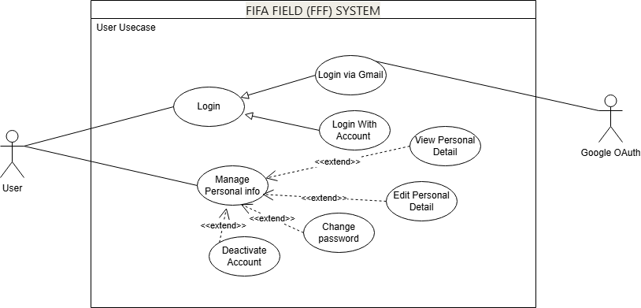
I-4.1 Use Case for User

4.2 UCs for Customer
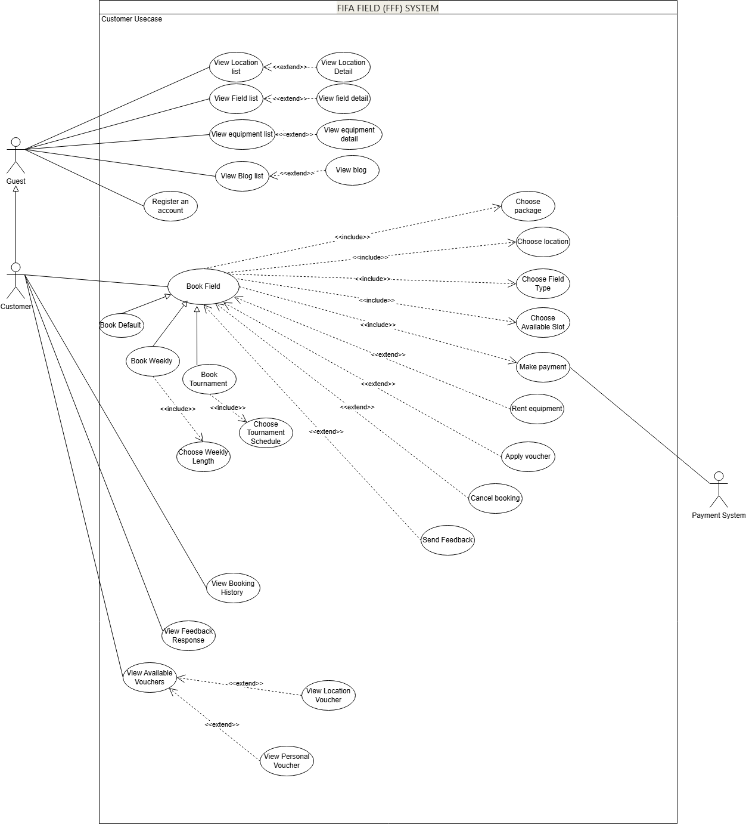
I-4.2 Use Case for Customer

4.3 UCs for Staff
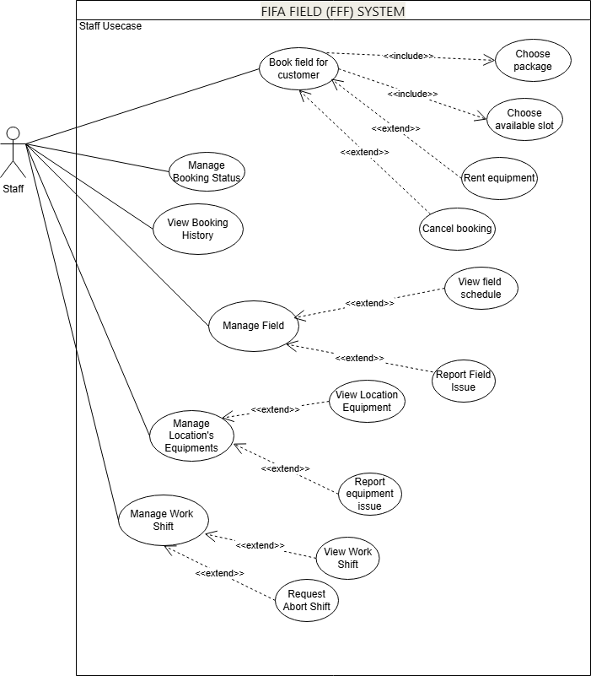
I-4.3 Use Case for Staff

4.4 UCs for Manager
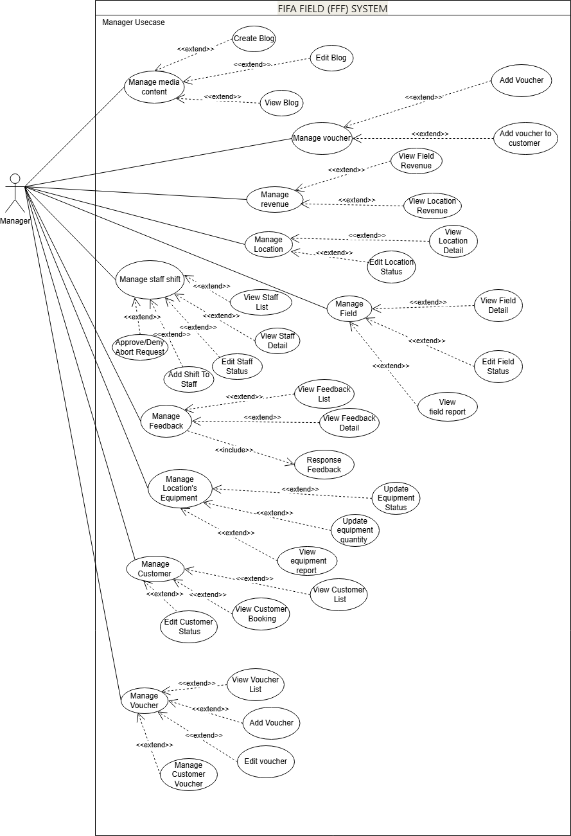
I-4.4 Use Case for Manager

4.5 UCs for Admin
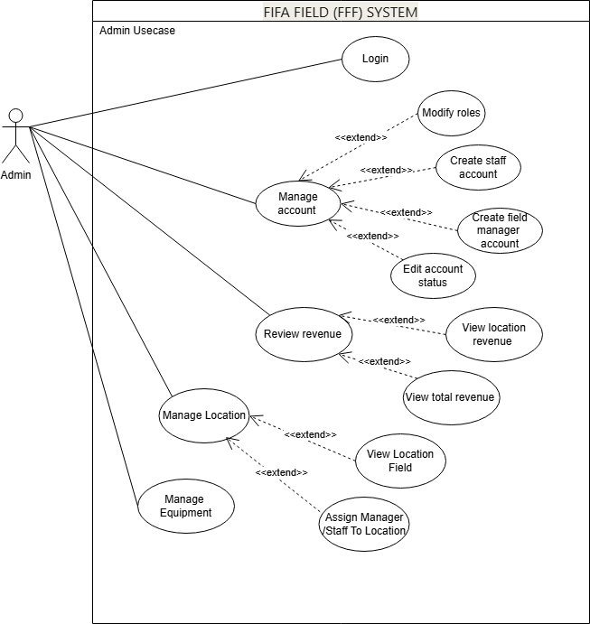
I-4.5 Use Case for Admin

5. System Functionalities

5.1 Screens Flow
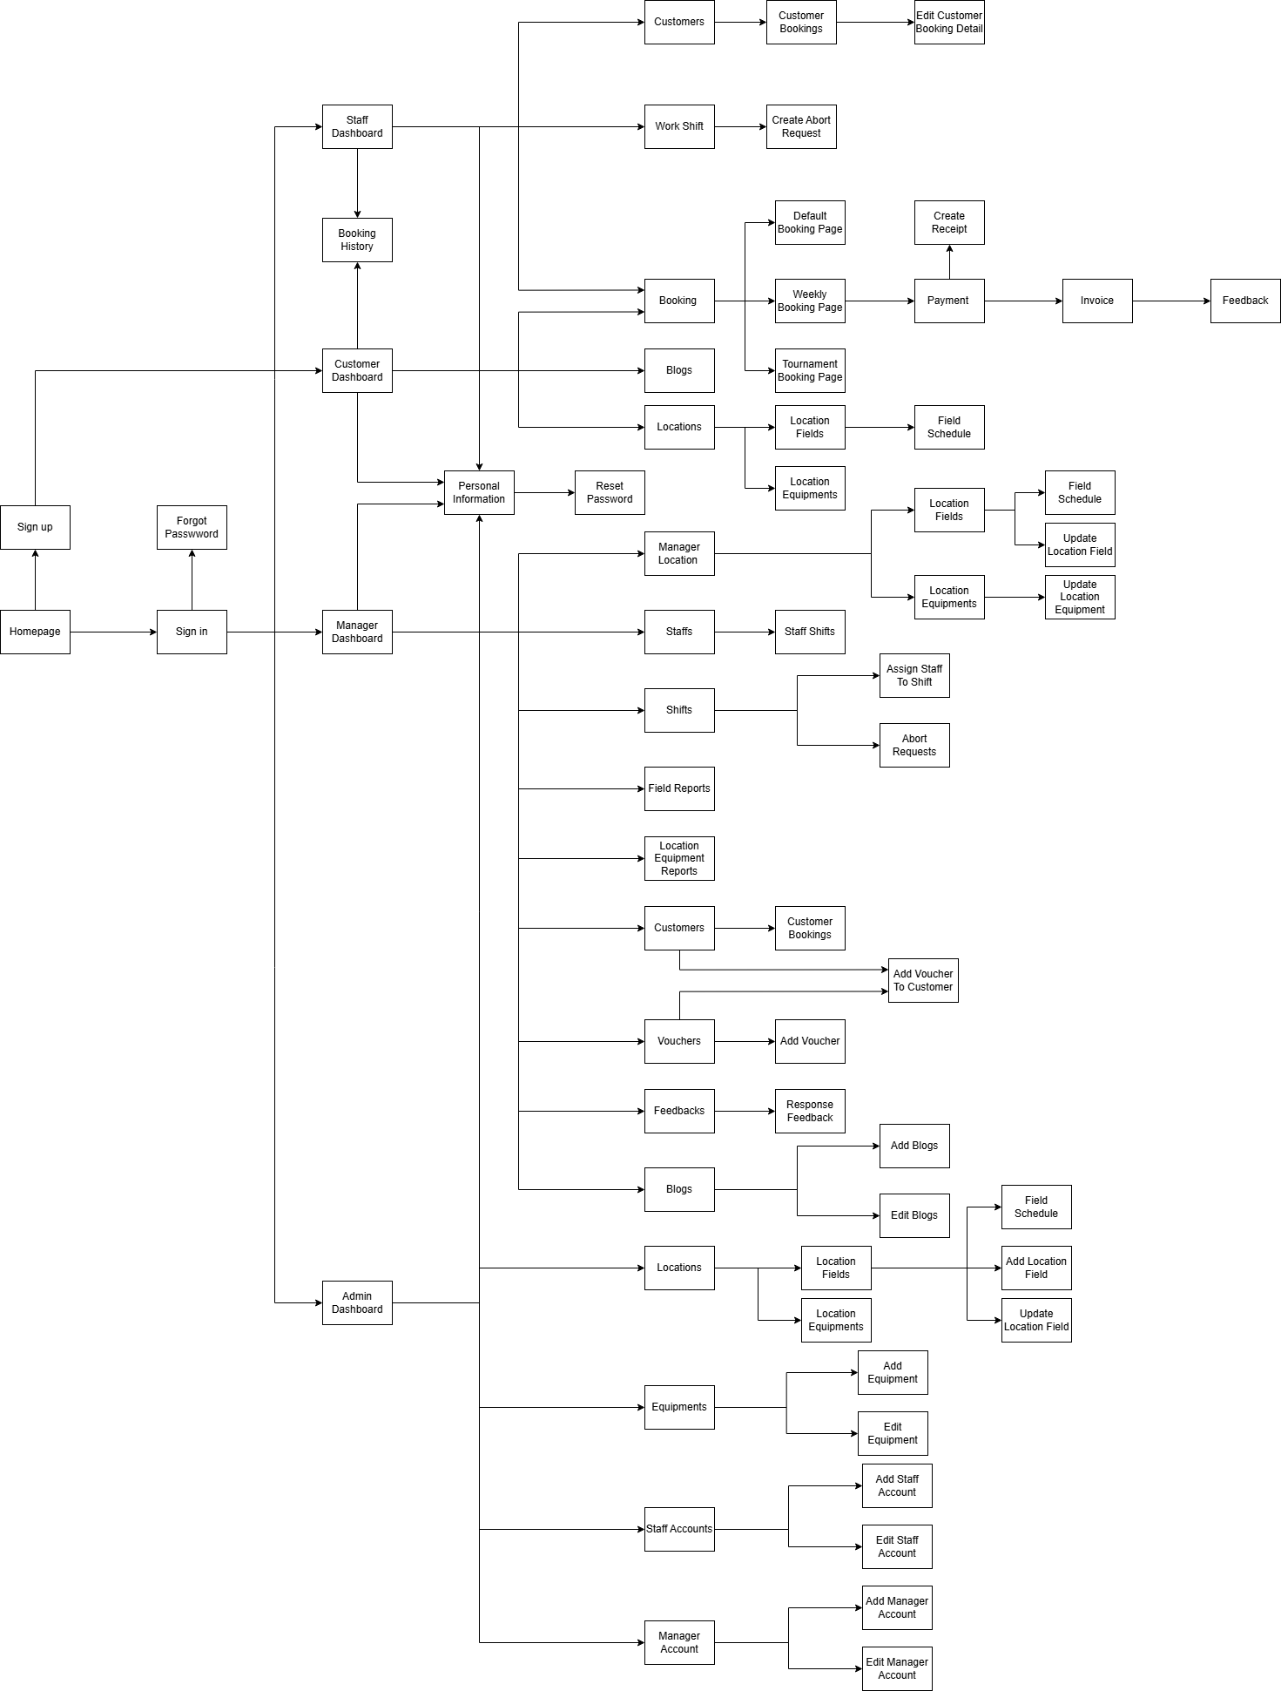
I-5.1. Screen Flow

5.2 Screen Authorization

Screen | Guest | Customer | Staff | Manager | Admin
Home Page | X | X | X | X | X
Sign up | X
Sign in | X | X | X | X | X
Forgot Password | X | X | X | X | X
Personal Information |  | X | X | X | X
Reset / Change Password |  | X | X | X | X
Customer Dashboard |  | X
Staff Dashboard |  |  | X
Manager Dashboard |  |  |  | X
Admin Dashboard |  |  |  |  | X
Booking |  | X | X
Default Booking Page |  | X | X
Weekly Booking Page |  | X | X
Tournament Booking Page |  | X | X
Payment |  | X | X
Create Receipt |  |  | X
Invoice |  | X | X
Feedback |  | X
Blogs | X | X |  | X | X
Add Blog |  |  |  | X
Edit Blog |  |  |  | X | X
Locations | X | X | X |  | X
Manager Location |  |  |  | X
Location Fields | X | X | X | X | X
Field Schedule | X | X | X | X | X
Update Field Schedule |  |  |  | X
Location Equipments | X | X | X | X | X
Update Location Field |  |  |  | X | X
Update Location Equipment |  |  |  | X
Booking History |  | X | X
Work Shift |  |  | X | X
Create Abort Request |  |  | X
Abort Requests |  |  | X
Customers |  |  | X | X | X
Customer Bookings |  |  | X | X | X
Edit Customer Booking Detail |  |  | X | X | X
Staffs |  |  |  | X | X
Staff Shifts |  |  |  | X
Assign Staff To Shift |  |  |  | X
Field Reports |  |  |  | X
Location Equipment Reports |  |  |  | X
Vouchers |  |  |  | X | X
Add Voucher |  |  |  | X
Add Voucher To Customer |  |  |  | X
Feedbacks |  |  |  | X
Response Feedback |  |  |  | X
Locations |  |  |  |  | X
Add Location Field |  |  |  |  | X
Equipments |  |  |  |  | X
Add Equipment |  |  |  |  | X
Edit Equipment |  |  |  |  | X
Staff Accounts |  |  |  |  | X
Add Staff Account |  |  |  |  | X
Edit Staff Account |  |  |  |  | X
Manager Accounts |  |  |  |  | X
Add Manager Account |  |  |  |  | X
Edit Manager Account |  |  |  |  | X

5.3 Non-UI Functions

# | Feature | System Function | Description
1 | Authentication | User Login | The system authenticates users based on email and password and grants access according to user roles.
2 | Authentication | Password Recovery | The system allows users to reset their password through email verification.
3 | User Management | Role Authorization | The system enforces role-based access control for Customer, Staff, and Manager.
4 | Customer Management | Store Customer Information | The system stores and manages customer personal information including address and contact details.
5 | Booking Management | Check Field Availability | The system validates field availability before allowing a booking to be created.
6 | Booking Management | Prevent Booking Overlap | The system prevents overlapping bookings for the same field and time slot using countdown method
7 | Booking Management | Create Booking | The system creates a booking record with selected field, schedule, equipment, and voucher information.
9 | Voucher Management | Validate Voucher | The system validates voucher codes based on expiry date, usage limit, and status.
10 | Voucher Management | Track Voucher Usage | The system tracks voucher usage globally and per customer to prevent reuse.
11 | Equipment Management | Check Equipment Availability | The system verifies equipment quantity availability before confirming rental.
12 | Equipment Management | Apply Damage Fee | The system applies damage fees when an equipment damage report is confirmed by staff.
13 | Payment Processing | Calculate Total Price | The system calculates total booking cost including field price, equipment, vouchers, and damage fees.
14 | Payment Processing | Confirm Payment | The system updates booking status only after successful payment confirmation.
15 | Invoice Management | Generate Invoice | The system generates an invoice for completed and paid bookings.
16 | Shift Management | Assign Staff Shift | The system allows managers to assign staff to shifts by date, field, and time period.
17 | Shift Management | Prevent Shift Overlap | The system prevents staff from being assigned to overlapping shifts on the same date.
18 | Feedback Management | Submit Feedback | The system allows customers to submit feedback only after booking completion.
19 | Revenue Management | Calculate Revenue | The system calculates revenue dynamically based on completed and paid bookings.
20 | Revenue Management | View Revenue by Period | The system supports revenue calculation by week, month, and year.
21 | Data Integrity | Restrict Data Deletion | The system prevents deletion of fields, equipment, or users that are referenced by active records.
22 | System Control | Activity Logging | The system logs critical actions such as booking confirmation, payment processing, and shift assignment.
23 | Equipment Addition | trg_AfterInsertEquipment | The database automatically adds equipment data to all locations after admin adds a new equipment
I-5.3. Table for Non-UI function

6. Business Rule

ID | Rule Definition
BR-01 | Only Staff assigned to a working shift at a specific field can handle bookings and customer support for that field during the assigned time slot.
BR-02 | A customer must be logged in to create, view, or cancel a booking.
BR-03 | A booking can only be created if the selected field schedule is available at the chosen date and time.
BR-04 | A booking cannot overlap with another confirmed booking for the same field and time slot, this is covered by a time countdown function
BR-05 | A voucher can only be applied if it is valid, not expired, and meets the usage conditions defined by the system.
BR-06 | A customer-specific voucher can only be used by the customer to whom it is assigned and only once.
BR-07 | Equipment quantity available for rental must be greater than or equal to the requested quantity before confirming a booking.
BR-08 | Equipment and field data must not be deleted if they are referenced in any booking, payment, or feedback records.
BR-09 | Payment must be successfully completed before a booking status is marked as “Confirmed”.
BR-10 | Only staff members can issue invoices for completed and paid bookings.
BR-11 | Only managers are allowed to assign staff shifts and manage field schedules.
BR-12 | Revenue statistics are calculated dynamically based on completed and paid bookings and can be viewed by week, month, or year.
BR-13 | A customer can submit feedback only after the booking has been completed.
BR-14 | A staff member cannot be assigned to multiple shifts that overlap on the same working date.
BR-15 | A field must be marked as active before it can be displayed and booked by customers.
BR-16 | Damage fees for rented equipment are applied only when a damage report is reported by staff.
BR-17 | Customer account information may not be deleted if the customer has existing bookings or payment history.
BR-18 | Only admins can view system-wide revenue and performance reports across all field locations.
I-6 Table for Business Rules

7. State Machine Diagram

7.1 Booking State
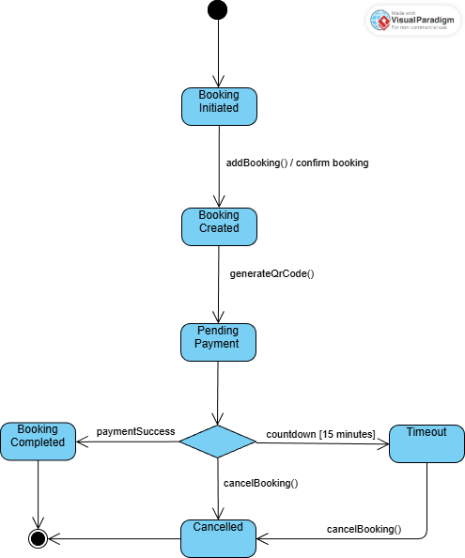
I-7.1.1 Booking State

7.1 Login State

II. Functional Requirements

1. Login

1.2 Login Screen
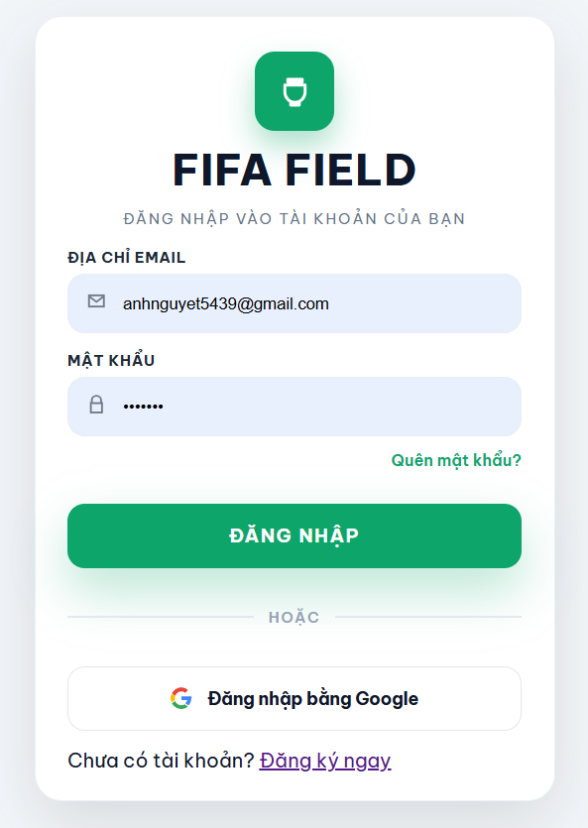
II-1.1.1 Login Screen
Screen description: This screen allows users to login to their accounts using their gmail or password or through gmail authentication

Field Name | Description
gmail | String, nvarchar[255]
password | String, nvarchar[255]
User
II-1.1.2 Field Description for login screen

1.2 Forgot password
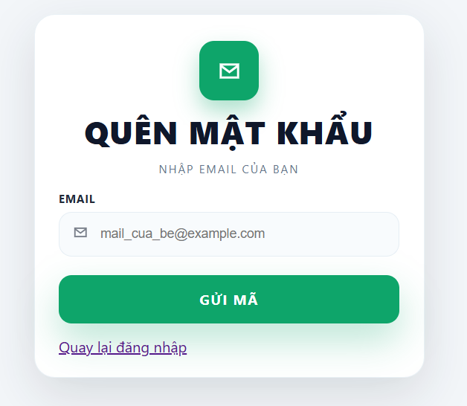
II-1.1.2 Field Description for login screen
Screen description: This screen allows users to get a new password through gmail authentication in case they forgot their original password

Field Name | Description
gmail | String, nvarchar[255]
User

1.3 Customer Register

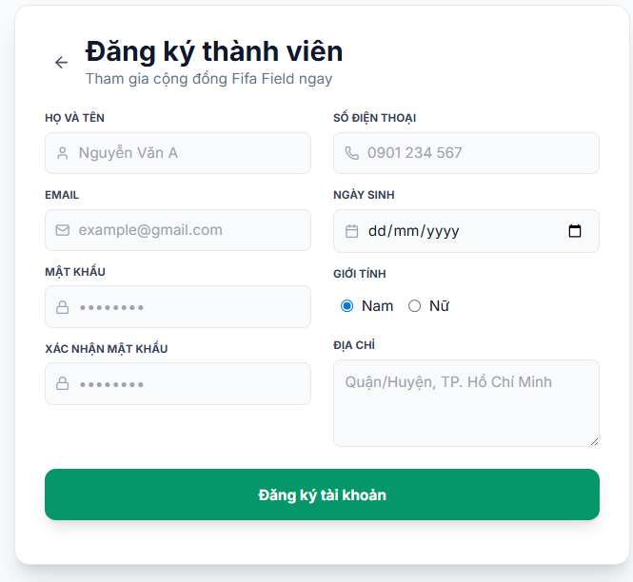
…
Screen description: This screen allows guests to register as a new customer by filling in the required fields or through gmail authentication.

Field Name | Description
name | String, nvarchar[255]
phone | String, char[20]
email | String, nvarchar[255]
password | String, nvarchar[20]
dob | Date
sex | String, nvarchar[20]
address | String, nvarchar[255]
User

2. Navigation/Dashboard

2.1 Landing page
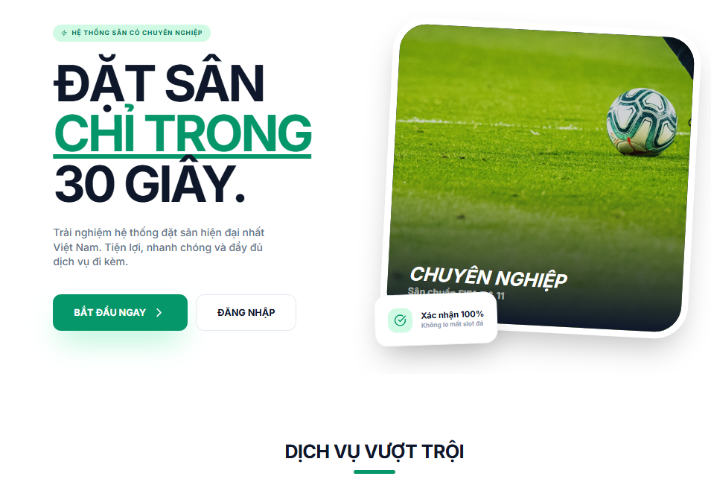
Screen description: This screen allows guests to view brief information about the webpage and chose to login as users or sign up

2.1 Landing page
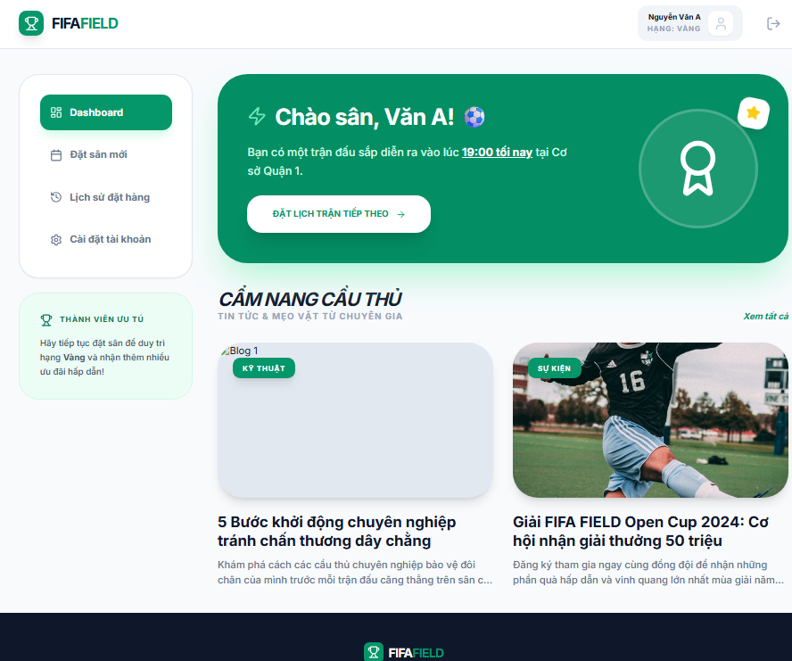
Screen description: This screen allows customers to navigate through the screens/functions they are authorized to.

3. Booking management

3.1 Booking Screen

3.1.1 Default Booking
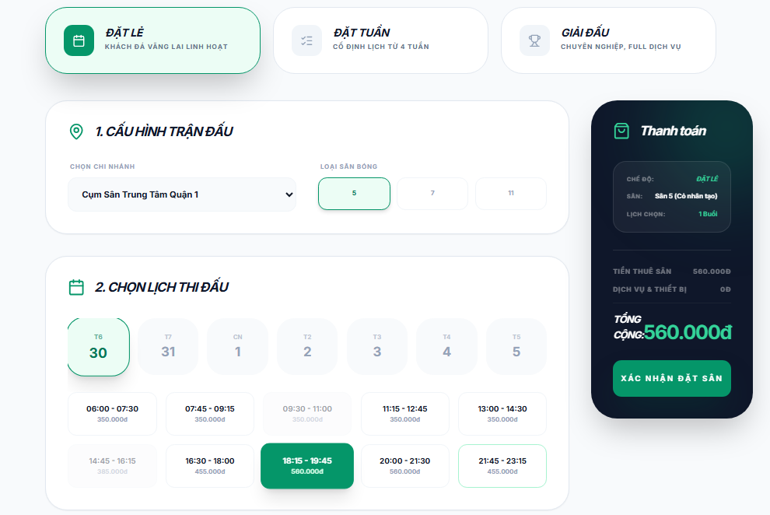

Screen description: This screen allows customers or staffs (book for customer) to book schedule on specific field

Field Name | Description
booking_id | String, nvarchar[20]
booker_id | String, nvarchar[20]
field_id | String, nvarchar[20]
schedule_id | String, nvarchar[20]
voucher_id | String, nvarchar[20] / Nullable
price | decimal
Booking

Field Name | Description
booking_id | String, nvarchar[20]
equipment_id | String, nvarchar[20]
quantity | int
Booking Equipment

3.1.2 Weekly Booking
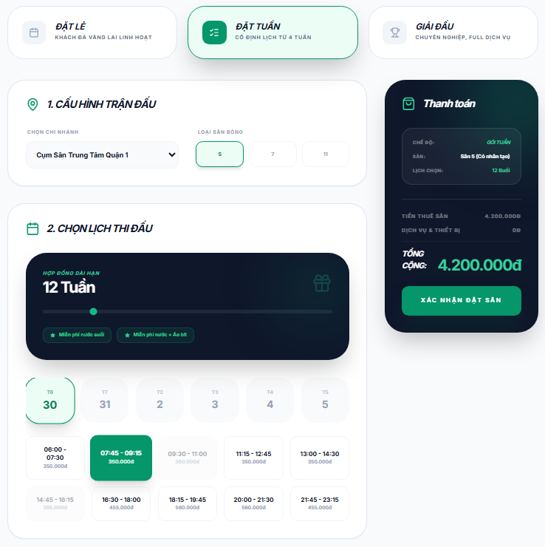

3.1.3 Tournament Booking
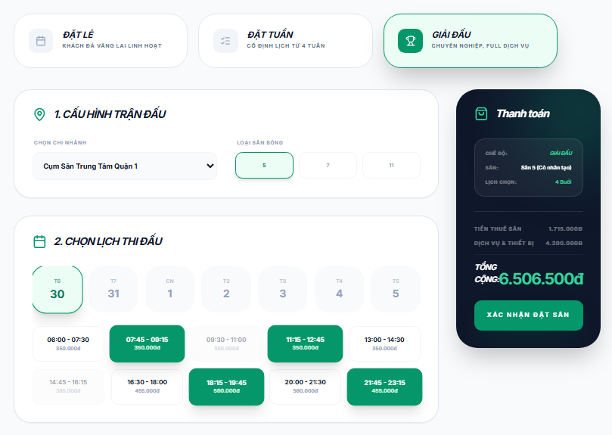

3.2 Payment

3.2.1 Payment Screen
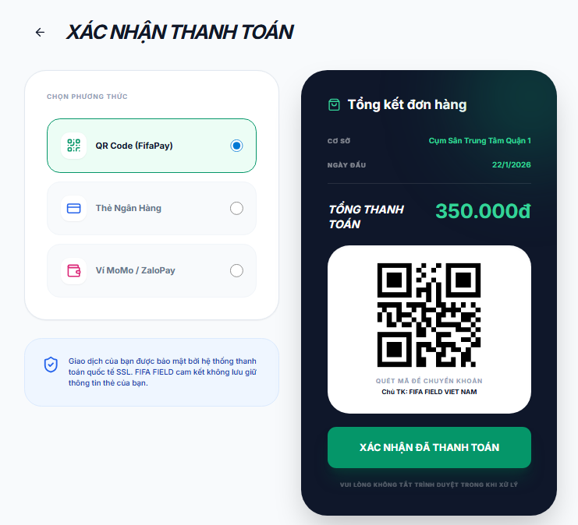
Screen description: This screen allows customers to create payment through QR banking code

3.2.2 Invoice
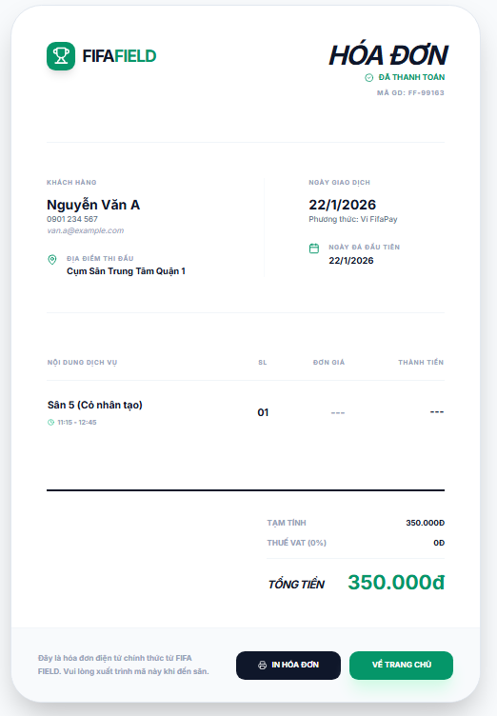
Screen description: This screen allows customers to view their successful payment

3. System Administration

3.1 Master Data

3.1.1 Equipment List
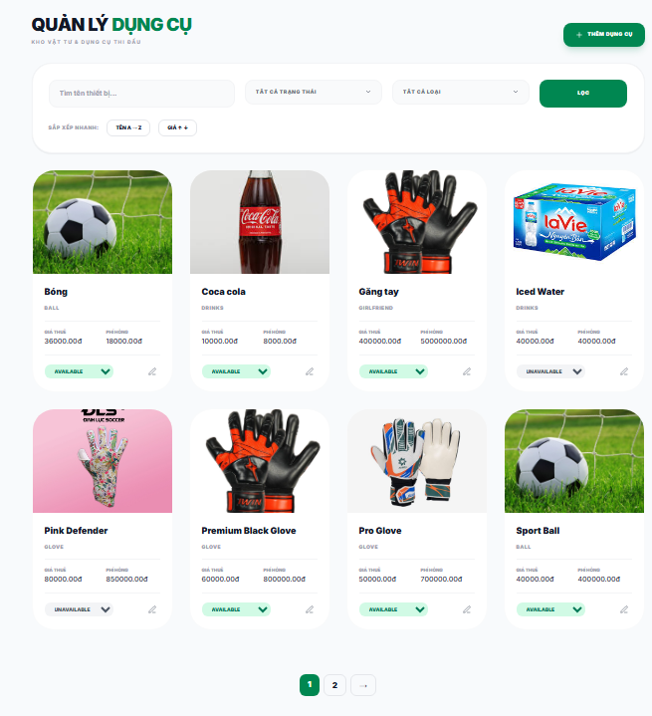

This screen allows the Administrator to:
· View Equipment List: view list of current master data.
· Filter Equipment List: filter master data by data types, statuses
· Search Equipment: enter keyword(s) to search master data by their names or values
· Sort Equipment List: sort master data list (ascending, descending) by clicking column headers
On the screen, admin can also
· Activate/Deactivate Setting: change status of a specific inactive/active master data
· Choose to go to the Setting Details screens for adding new or updating an existing master data by clicking the New Setting or Edit link.
Field Description
Field Name | Description
(1) | Initial values: all the active setting names with null or blank type  Hover the mouse to show the field name: “Setting Type”
(2) | Initial values: All Statuses, Active, Inactive (default value “All Status”)  Hover the mouse to show the field name: “Setting Status”
(3) | The change-status action is Activate or Deactivate depending on the current status of the relevant setting (Inactive or Active, respectively).

3.1.2 Equipment Details
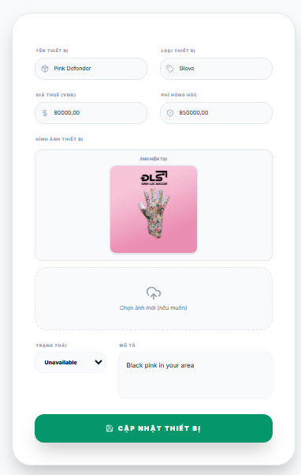
This screen allows the Administrator to:
· Update Details: update details of a specific equipment
Field Description
Field Name | Description
Name | Data type: non-digit string, max length of 20 characters
Type | Initial data values: all active setting names (with null or blank type)
Value | Data type: any string, max length of 100 characters
Priority | Data type: a positive integer
Description | Data type: any string, max length of 200 characters

3.1.3 Add Equipment
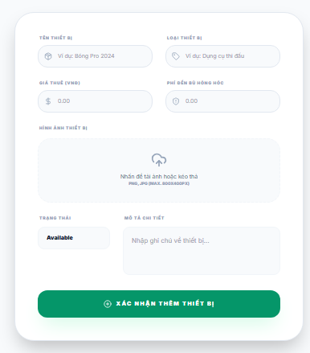
This screen allows the Administrator to:
· Add a new equipment
Field Description
Field Name | Description
Name | Data type: non-digit string, max length of 20 characters
Type | Initial data values: all active setting names (with null or blank type)
Value | Data type: any string, max length of 100 characters
Priority | Data type: a positive integer
Description | Data type: any string, max length of 200 characters

3.1.4 Location List
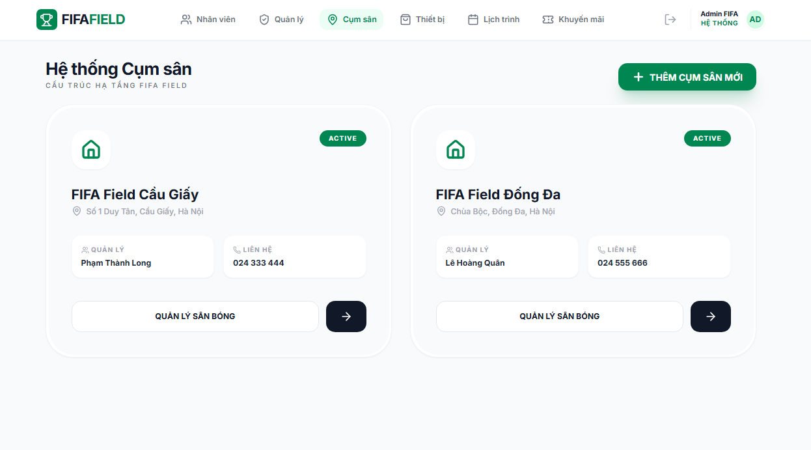

3.1.5 Location Equipment List
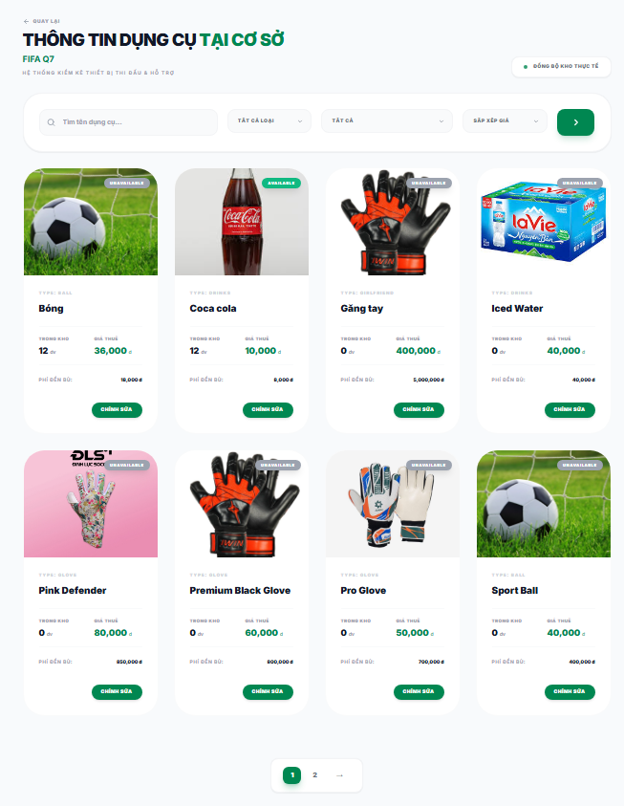

3.1.5 Location Equipment Edit
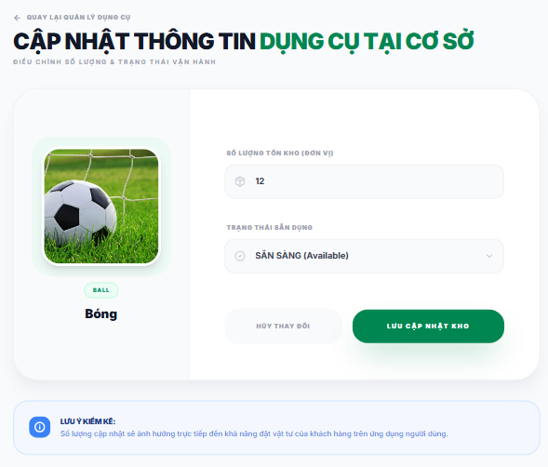

3.1.5 Field Schedule

3.1.6 Location Equipment List

3.1.7 Booking List
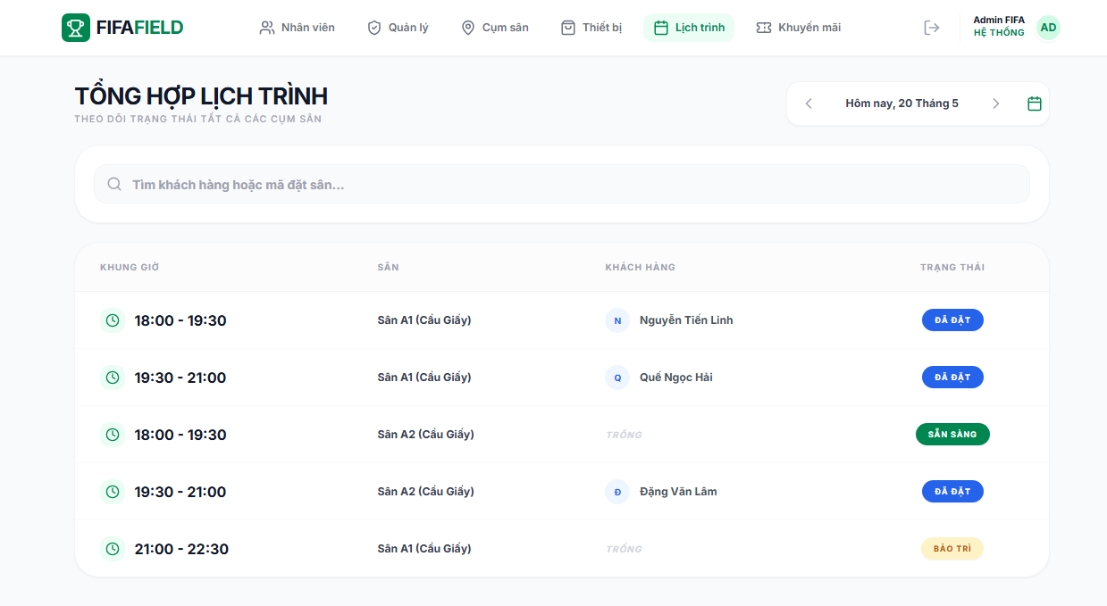

3.1.8 Voucher List5
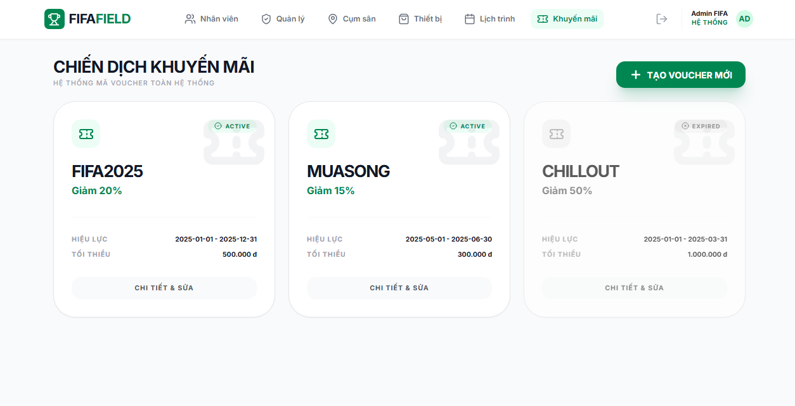

3.1.9 Add Voucher
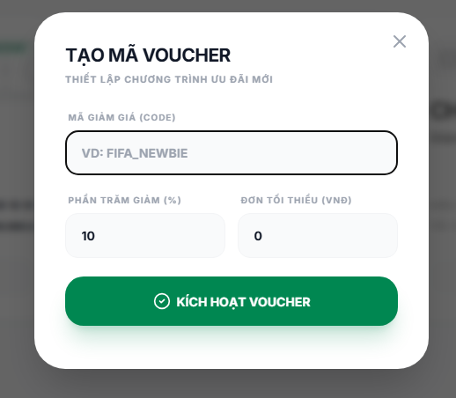
This screen allows the Admin to:
· Add Staff Information: add information of staff
Field Description
Field Name | Description
code | Data type: non-digit string, max length of NVARCHAR(50)
discount_value | Data type: a positive integer
used_count | Data type: a positive integer

3.2 User Management

3.2.1 Staff List
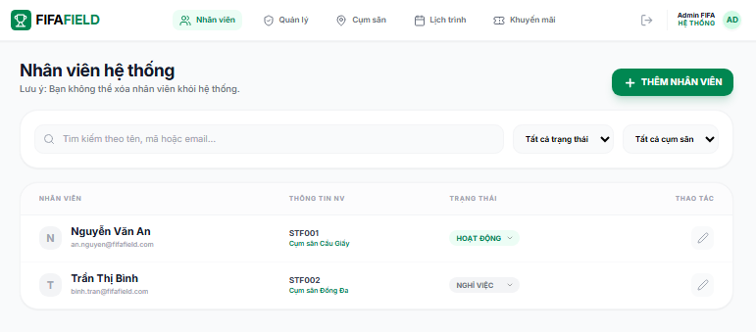

3.2.2 Update Staff Information
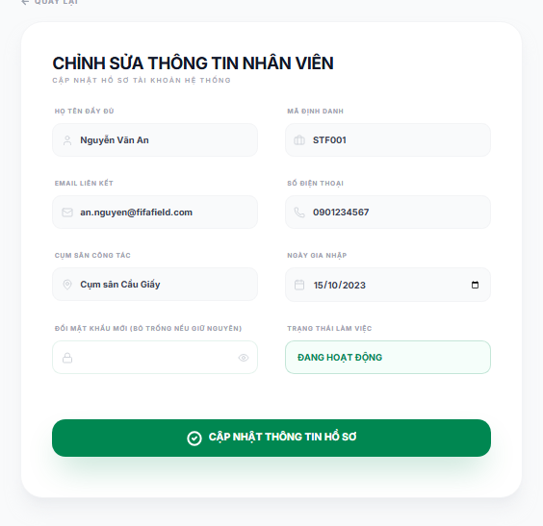
This screen allows the Staff to:
· Update Staff Information: update information of staff
Field Description
Field Name | Description
Name | Data type: non-digit string, max length of 20 characters
StaffID | Data type: any string, max length of 100 characters
Email | Data type: any string, max length of 100 characters
PhoneNum | Data type: a positive integer, length 10 characters
DateWork | Data type: date

3.2.3 Add Staff
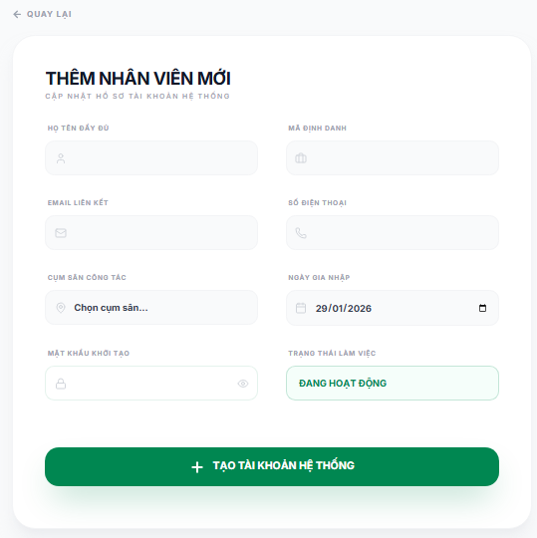
This screen allows the Admin to:
· Add Staff Information: add information of staff
Field Description
Field Name | Description
Name | Data type: non-digit string, max length of 20 characters
StaffID | Data type: any string, max length of 100 characters
Email | Data type: any string, max length of 100 characters
PhoneNum | Data type: a positive integer, length 10 characters
DateWork | Data type: date
Password | Datatype: NVARCHAR(20)

3.2.4 Manager List
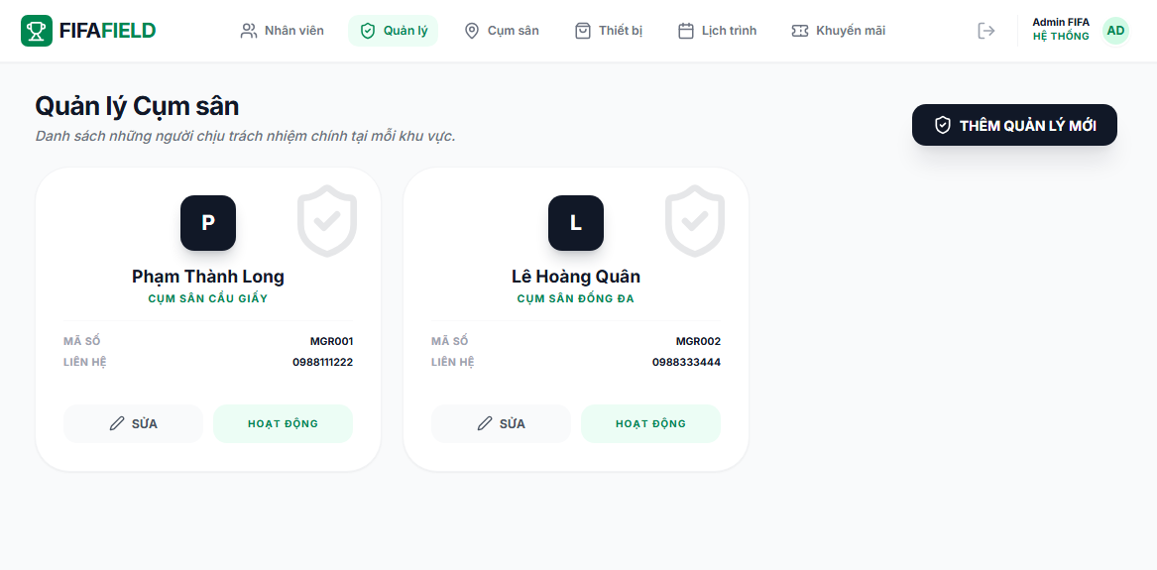

3.2.5 Add Manager
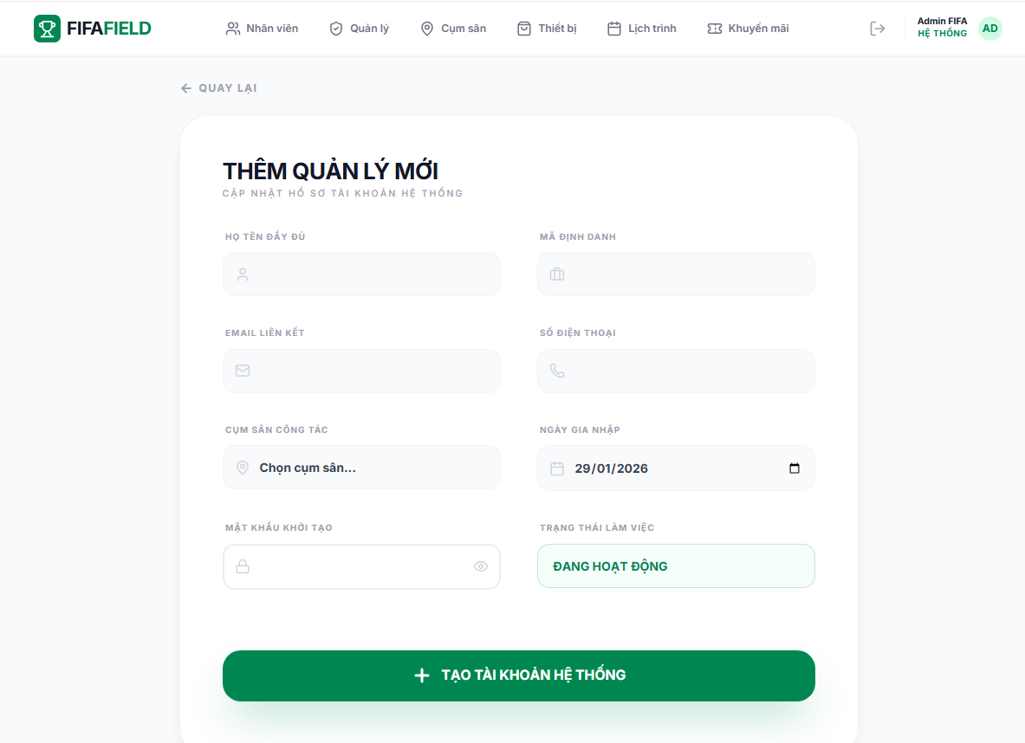
This screen allows the Admin to:
· Add Staff Account: add information of staff account
Field Description
Field Name | Description
Name | Data type: non-digit string, max length of 20 characters
StaffID | Data type: any string, max length of 100 characters
Email | Data type: any string, max length of 100 characters
PhoneNum | Data type: a positive integer, length 10 characters
DateWork | Data type: date
Password | Datatype: NVARCHAR(20)

3.2.6 Update Manager Information
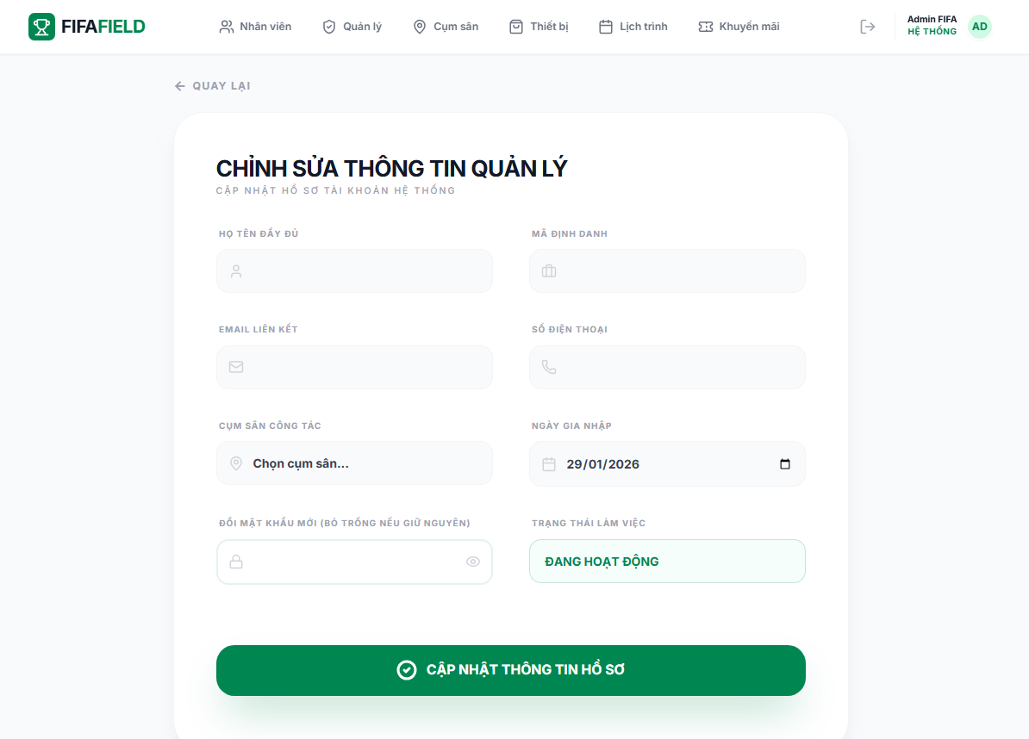
This screen allows the Admin to:
· Add Staff Information: add information of staff
Field Description
Field Name | Description
Name | Data type: non-digit string, max length of 20 characters
StaffID | Data type: any string, max length of 100 characters
Email | Data type: any string, max length of 100 characters
PhoneNum | Data type: a positive integer, length 10 characters
DateWork | Data type: date
Password | Datatype: NVARCHAR(20)

…

III. System Design

1. Software Architecture

1.1 Overall Architectural Diagram
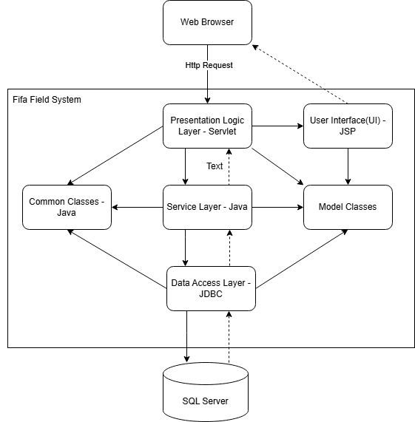
II-1.1 Architectural Diagram

1.2 Component Descriptions-

No | Component | Description
01 | Presentation Logic Layer | Manages the logic for displaying data, handling user navigation, and processing input before sending it to the deeper layers.
02 | User Interface | Provides the visual elements and layouts (HTML/CSS) that allow users to interact with the application.
03 | Service Layer | Encapsulates the core business logic and coordinates tasks between the UI and the data management layers.\\4
04 | Data Access Layer | Handles direct communication with the database, performing CRUD operations and executing SQL queries.
05 | Common Classes | Contains reusable utility classes, constants, and helper methods shared across multiple layers of the system.
07 | Model Classes | Defines the data structures and entities representing real-world objects used throughout the application.
08 | SQLServer | The relational database management system used for persistent storage and organization of application data.
09 | Web BR-ower | The client-side application used to render the interface and execute front-end scripts for the end-user.
II-1.2 Table for Component Description

2. Code Package Design
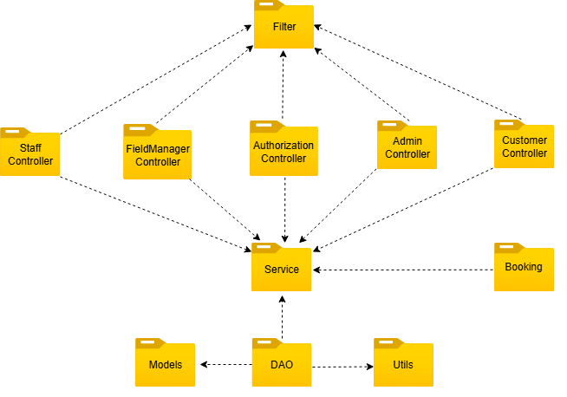
II-2 Code Package Design

2.1 Package Diagram

2.2 Package Descriptions
No | Package | Description
01 | Model | Contains data model classes (POJO/Entity) representing objects in the system.  These classes are used by the DAO to map data from the database and are processed by the Service in business logic.
20 | Dao | Responsible for database access (CRUD).  Executes queries, adds, modifies, and deletes data for the Models and returns results to the Service.
03 | Service | Handles the system's central business logic.  Receives requests from the Controller, checks data, applies business rules, calls the DAO to work with the database, and uses Utils when needed.
04 | AuthorizationController | Handles user authentication functions such as login, logout, and registration.  Works with the Service to verify account information and return authentication results.
05 | AdminController | Manages functions for administrators (Admin).  Sends requests to the Service to manage users, system data, and administrative tasks.
06 | FieldManagerController | Handles functions for Managers.  Coordinates management-related tasks and works with the Service to process logic.
07 | StaffController | Handles functions for field staff.  Coordinates customer booking service, field, equipment related tasks and works with the Service to process logic.
07 | CustomerController | Handles functions for customers/users.  Receives requests from users, calls the Service to process the task, and returns the results to the interface.
08 | Booking | Contains functions related to booking/registration/specific business operations.  Booking works with the Service to process data and related logic.
09 | Filter | Filters requests before they enter the Controller.  Checks login, assigns permissions (roles), and directs requests to the appropriate Controller (Admin, Manager, Customer).
10 | Utils | Contains utility classes shared across the entire system.  Includes database connection handling, password encryption, data validation, and other support functions.

II-2.2 Table for Package Description

3. Database Design

3.1 Database Schema

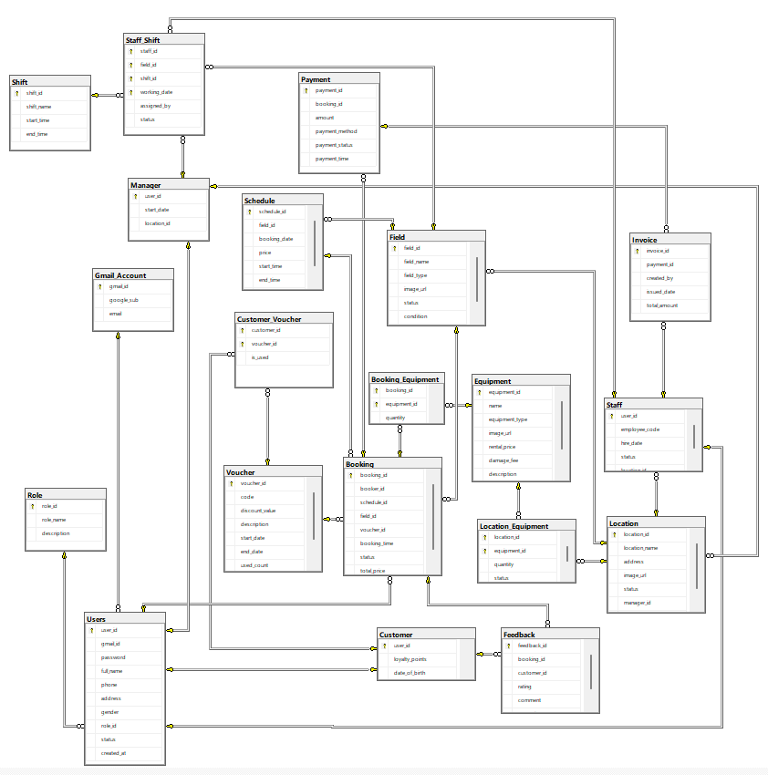

3.2 Table Descriptions

3.2.1 Role
This table defines user roles in the system to control authorization and access permissions.
No | Field | PK | FK | UN | NN | Description
01 | role_id | x |  |  | x | Unique identifier for each role
02 | role_name |  |  | x | x | Name of the role
03 | description |  |  |  |  | Role description

3.2.2 Gmail_Account
This table stores authentication information from Google Sign-In.
No | Field | PK | FK | UN | NN | Description
01 | gmail_id | x |  | x | x | Unique identifier of Gmail account
02 | google_sub |  |  | x | x | Google unique subject identifier
03 | email |  |  | x | x | Gmail email address

3.2.3 Users
This table stores common information for all users in the system.
No | Field | PK | FK | UN | NN | Description
01 | user_id | x |  | x | x | Unique identifier for user
02 | gmail_id |  | x |  | x | Linked Gmail account
03 | password |  |  |  |  | User password (for non-Google login)
04 | full_name |  |  |  |  | Full name of the user
05 | phone |  |  |  |  | User phone number
06 | address |  |  |  |  | User address
07 | gender |  |  |  |  | Gender of user
08 | role_id |  | x |  | x | Role assigned to user
09 | status |  |  |  |  | Account status (active, inactive)
10 | created_at |  |  |  |  | Account creation timestamp

3.2.4 Customer
This table stores customer-specific information.
No | Field | PK | FK | UN | NN | Description
01 | user_id | x | x |  | x | Reference to Users table
02 | loyalty_points |  |  |  |  | Loyalty points accumulated
03 | date_of_birth |  |  |  |  | Customer date of birth

3.2.5 Manager
This table stores manager-specific information.
No | Field | PK | FK | UN | NN | Description
01 | user_id | x | x |  | x | Reference to Users table
02 | start_date |  |  |  |  | Manager start date
03 | location_id |  |  |  |  | Location manager manages

3.2.6 Location
This table represents a group of football fields managed together.
No | Field | PK | FK | UN | NN | Description
01 | location_id | x |  | x | x | Unique identifier of location
02 | location_name |  |  |  | x | Name of the location
03 | address |  |  |  | x | Location address
04 | phone_number |  |  |  |  | Location hotline
06 | image_url |  |  |  |  | Location image
07 | status |  |  |  | x | open/closed
08 | manager_id |  | x |  |  | Manager responsible for the location

3.2.7 Staff
This table stores staff information.
No | Field | PK | FK | UN | NN | Description
01 | user_id | x | x |  | x | Reference to Users table
02 | employee_code |  |  | x |  | Unique employee code
03 | hire_date |  |  |  |  | Staff hire date
04 | status |  |  |  |  | Staff status
05 | location_id |  | x |  | x | Assigned working location

3.2.8 Field
This table stores football field information.
No | Field | PK | FK | UN | NN | Description
01 | field_id | x |  | x | x | Unique identifier of field
02 | field_name |  |  |  | x | Name of the field
03 | field_type |  |  |  | x | Field type (7-a-side, 11-a-side)
04 | image_url |  |  |  | x | Field image
05 | status |  |  |  |  | Open/closed status
06 | condition |  |  |  | x | Field condition information
07 | location_id |  | x |  | x | Location containing the field

3.2.9 Schedule
This table manages field availability time slots.
No | Field | PK | FK | UN | NN | Description
01 | schedule_id | x |  | x | x | Unique identifier of schedule
02 | field_id |  | x |  | x | Related field
03 | booking_date |  |  |  | x | Booking date
04 | price |  |  |  | x | Price of slot
05 | start_time |  |  |  | x | Slot start time
06 | end_time |  |  |  | x | Slot end time
07 | is_available |  |  |  |  | Availability status

3.2.10 Equipment
This table stores equipment definitions.
No | Field | PK | FK | UN | NN | Description
01 | equipment_id | x |  | x | x | Unique equipment identifier
02 | name |  |  |  | x | Equipment name
03 | equipment_type |  |  |  |  | Type of equipment
04 | image_url |  |  |  |  | Equipment image
05 | rental_price |  |  |  | x | Rental price
06 | damage_fee |  |  |  |  | Damage compensation fee
07 | status |  |  |  |  | Equipment status
08 | description |  |  |  |  | Equipment description

3.2.11 Location_Equipment
This table manages equipment inventory per field.
No | Field | PK | FK | UN | NN | Description
01 | location_id | x | x |  | x | Location identifier
02 | equipment_id | x | x |  | x | Equipment identifier
03 | quantity |  |  |  | x | Available quantity
04 | status |  |  |  | x | Equipment status
05 | condition |  |  |  | x | Equipment condition

3.2.12 Shift
This table defines work shifts.
No | Field | PK | FK | UN | NN | Description
01 | shift_id | x |  | x | x | Unique shift identifier
02 | shift_name |  |  |  |  | Shift name
03 | start_time |  |  |  | x | Shift start time
04 | end_time |  |  |  | x | Shift end time

3.2.13 Staff_Shift
This table assigns staff to shifts on specific fields and dates.
No | Field | PK | FK | UN | NN | Description
01 | staff_id | x | x |  | x | Staff assigned
02 | field_id | x | x |  | x | Working field
03 | shift_id | x | x |  | x | Assigned shift
04 | working_date | x |  |  | x | Working date
05 | assigned_by |  | x |  | x | Manager who assigned shift
06 | status |  |  |  |  | Assignment status

3.2.14 Voucher
This table stores discount vouchers.
No | Field | PK | FK | UN | NN | Description
01 | voucher_id | x |  | x | x | Voucher identifier
02 | code |  |  | x | x | Voucher code
03 | discount_value |  |  |  | x | Discount value
04 | description |  |  |  |  | Voucher description
05 | start_date |  |  |  |  | Voucher valid start date
06 | end_date |  |  |  |  | Voucher expiration date
07 | location_id |  |  |  | x | Voucher’s location
08 | used_count |  |  |  |  | Used count
09 | status |  |  |  |  | Voucher status

3.2.15 Customer_Voucher
This table links vouchers to customers.
No | Field | PK | FK | UN | NN | Description
01 | customer_id | x | x |  | x | Customer identifier
02 | voucher_id | x | x |  | x | Voucher identifier
03 | is_used |  |  |  |  | Voucher usage status

3.2.16 Booking
This table stores booking transactions.
No | Field | PK | FK | UN | NN | Description
01 | booking_id | x |  | x | x | Booking identifier
02 | booker_id |  | x |  | x | User who created booking
03 | schedule_id |  | x |  | x | Booked schedule
04 | field_id |  | x |  | x | Booked field
05 | voucher_id |  | x |  |  | Applied voucher
06 | booking_time |  |  |  |  | Booking timestamp
07 | status |  |  |  |  | Booking status
08 | total_price |  |  |  |  | Total price

3.2.17 Booking_Equipment
This table stores equipment rented per booking.
No | Field | PK | FK | UN | NN | Description
01 | booking_id | x | x |  | x | Booking identifier
02 | equipment_id | x | x |  | x | Equipment identifier
03 | quantity |  |  |  | x | Rented quantity

3.2.18 Payment
This table stores payment information.
No | Field | PK | FK | UN | NN | Description
01 | payment_id | x |  | x | x | Payment identifier
02 | booking_id |  | x |  | x | Related booking
03 | amount |  |  |  | x | Payment amount
04 | payment_method |  |  |  |  | Payment method
05 | payment_status |  |  |  |  | Payment status
06 | payment_time |  |  |  |  | Payment timestamp

3.2.19 Invoice
This table stores invoice information.
No | Field | PK | FK | UN | NN | Description
01 | invoice_id | x |  | x | x | Invoice identifier
02 | payment_id |  | x |  | x | Related payment
03 | created_by |  | x |  | x | Staff who created invoice
04 | issued_date |  |  |  |  | Invoice issue date
05 | total_amount |  |  |  |  | Total amount

3.2.20 Feedback
This table stores customer feedback.
No | Field | PK | FK | UN | NN | Description
01 | feedback_id | x |  | x | x | Feedback identifier
02 | booking_id |  | x |  | x | Related booking
03 | customer_id |  | x |  | x | Customer providing feedback
04 | rating |  |  |  |  | Rating (1–5)
05 | comment |  |  |  |  | Feedback content
06 | created_at |  |  |  |  | Feedback creation time

