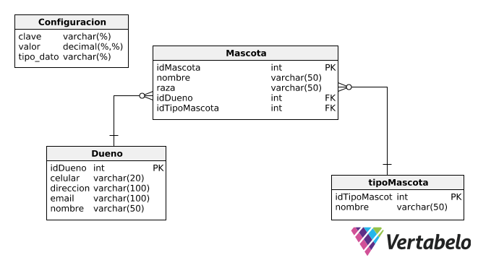

**create database Petshop;**

**use petshop;**

**create table configuracion(**

**clave varchar(10) primary key,**

**valor varchar(50),**

**tipo_dato varchar(10)**

**);**

**insert into configuracion values ("IGV","0.18","decimal");**

**Una vez creado nuestro proyecto Web Aplication**

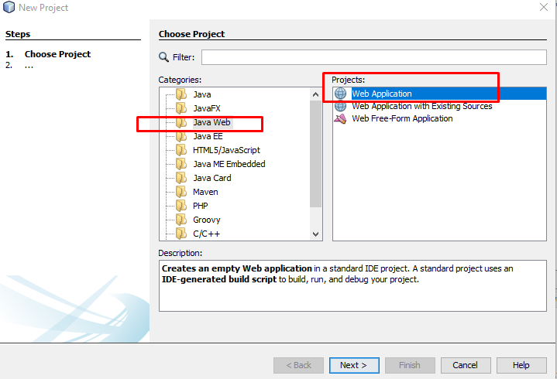

**Procedemos a crear nuestro JDBC y pool de Conexiones**

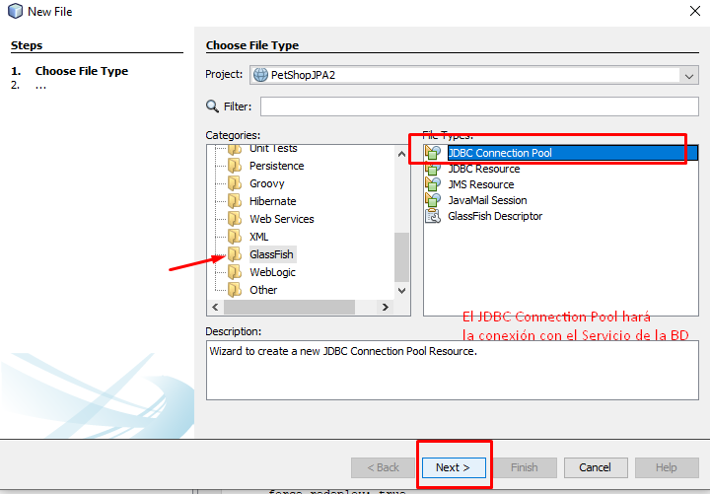

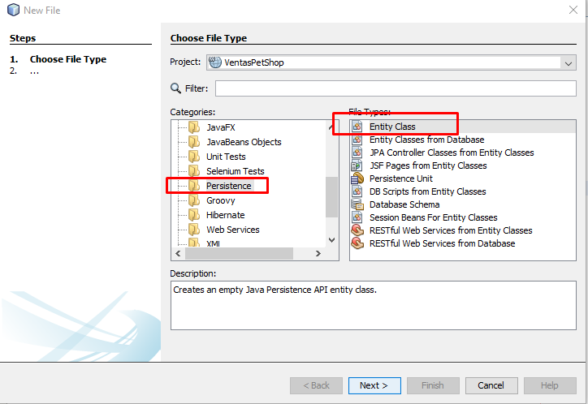

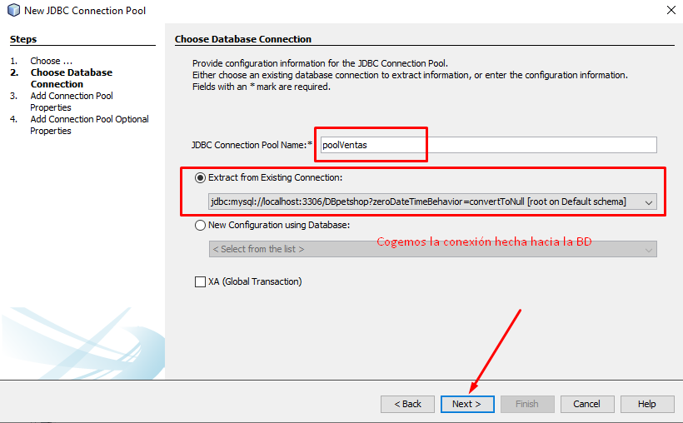

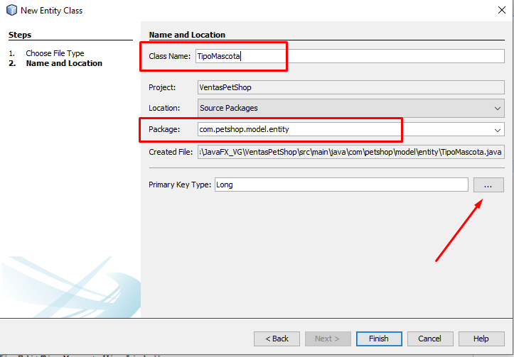

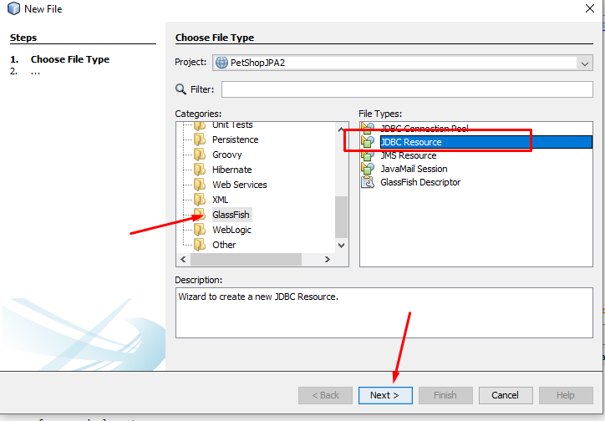

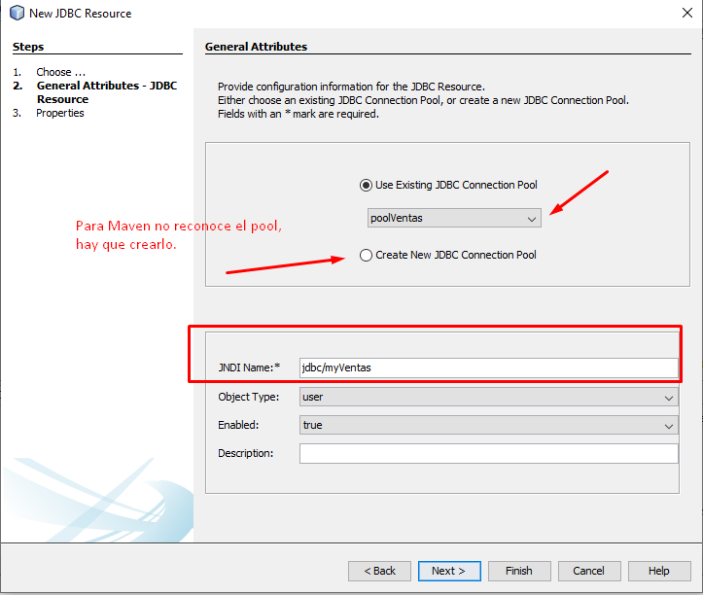

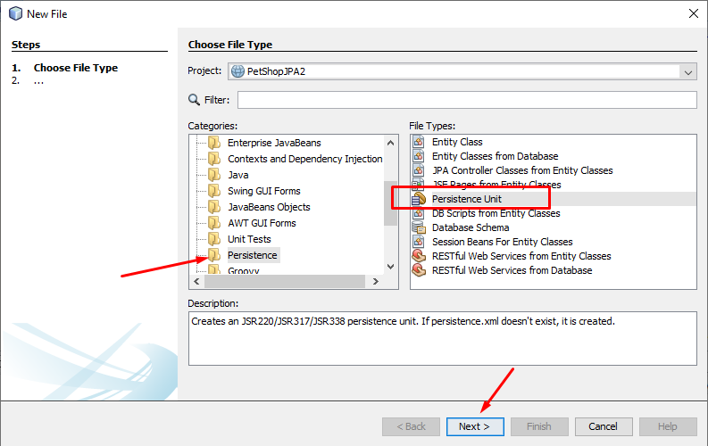

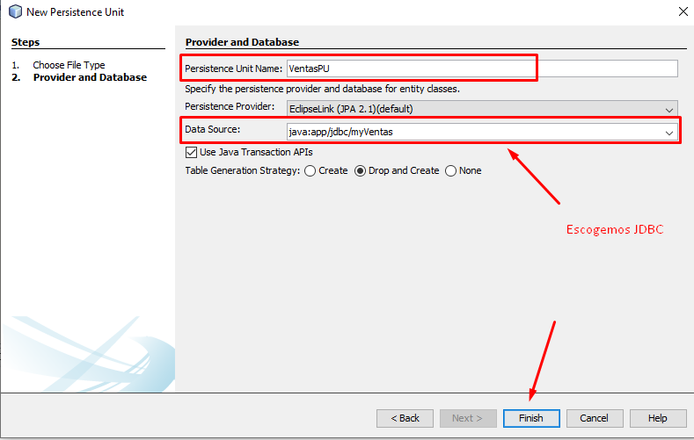

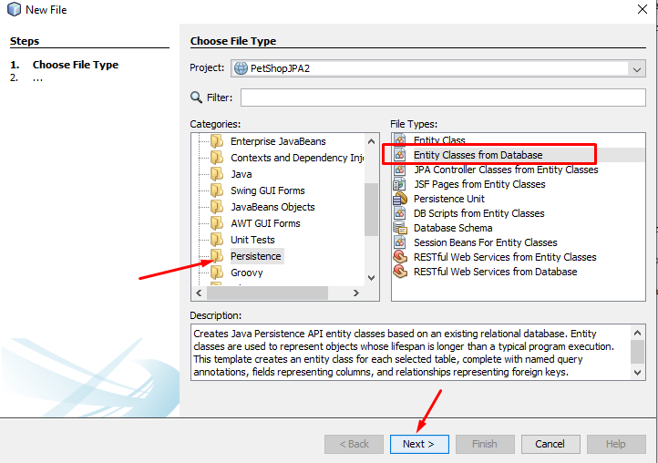

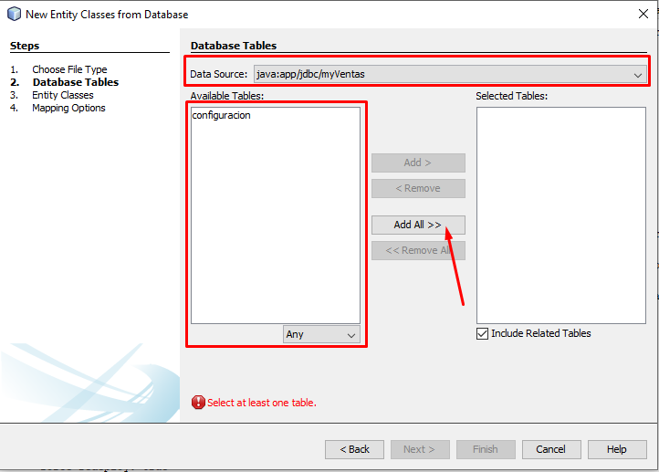

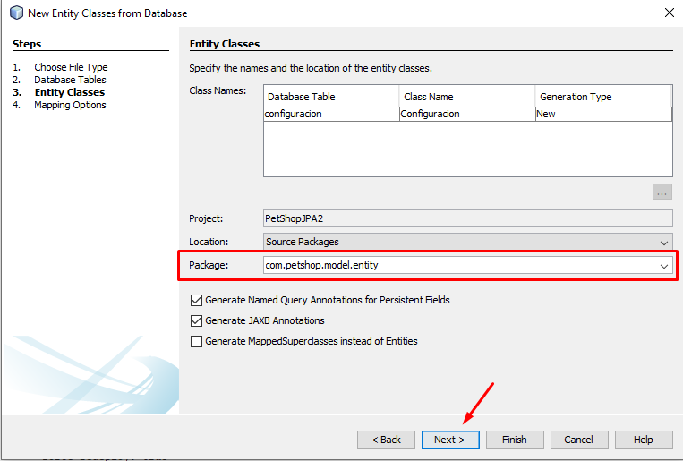

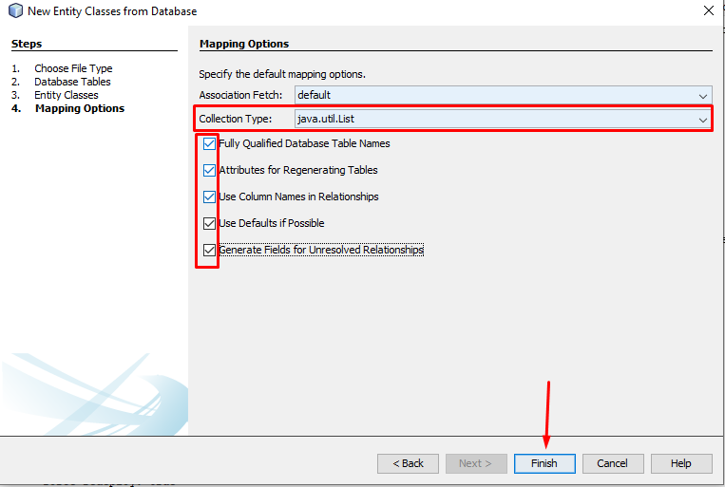

**Creamos una nueva Entidad: Mascota**

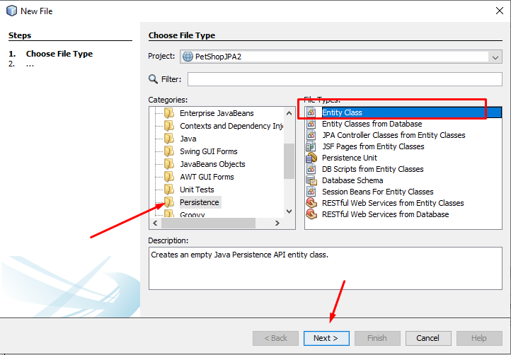

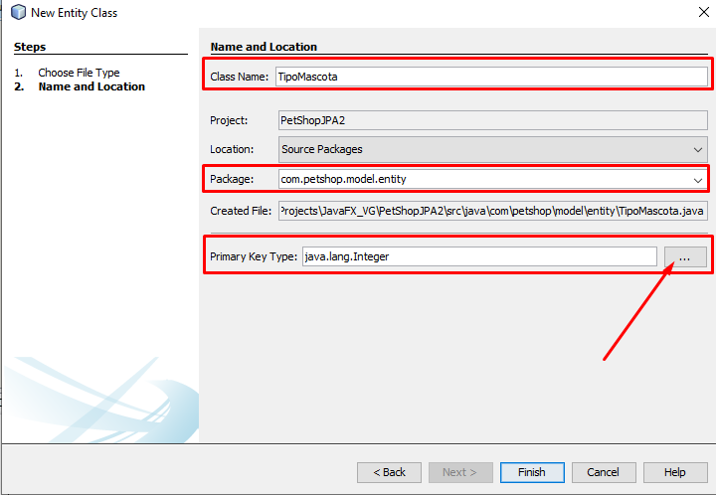

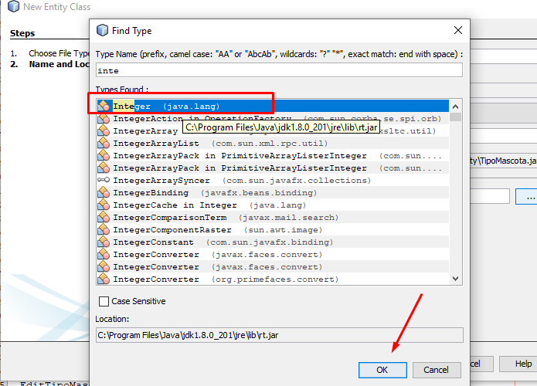

**Model Entity**

**Paquete: com.petshop.model.entity**

**Clase: TipoMascota**

@Entity

public class TipoMascota implements Serializable {

private static final long serialVersionUID = 1L;

@Id

@GeneratedValue(strategy = GenerationType.AUTO)

@Column(name = "idTipoMascota")

private Integer idTipoMascota;

@Size(min = 3, max = 50)

@Column(length = 50)

private String nombre;

@OneToMany(mappedBy = "tipo")

private List<Mascota> mascotas;

**Clase: Dueno**

@Entity

public class Dueno implements Serializable {

private static final long serialVersionUID = 1L;

@Id

@GeneratedValue(strategy = GenerationType.AUTO)

@Column(name = "id_dueno")

private Integer idDueno;

@Size(min = 3, max = 50)

@Column(length = 50)

private String nombre;

@Size(min = 9, max = 50)

@Column(length = 50)

private String celular;

@Size(min = 10, max = 100)

@Column(length = 100)

private String direccion;

@Size(min = 10, max = 100)

@Column(length = 100)

private String email;

@OneToMany(mappedBy = "dueno")

private List<Mascota> mascotas;

// Getter y Setter , toString, hashCode, equals

**Clase: Mascota**

@Entity

public class Mascota implements Serializable {

private static final long serialVersionUID = 1L;

@Id

@GeneratedValue(strategy = GenerationType.AUTO)

@Column(name = "id_mascota")

private Integer idMascota;

@Size(min = 3, max = 50)

@Column(length = 50)

private String nombre;

@Size(min = 3, max = 20)

@Column(length = 20)

private String raza;

@ManyToOne

@JoinColumn(name = "idTipoMascota")

private TipoMascota tipo;

@ManyToOne

@JoinColumn(name = "idDueno")

private Dueno dueno;

