Model Cheat-Sheet — “Signal Extraction in Hiring”
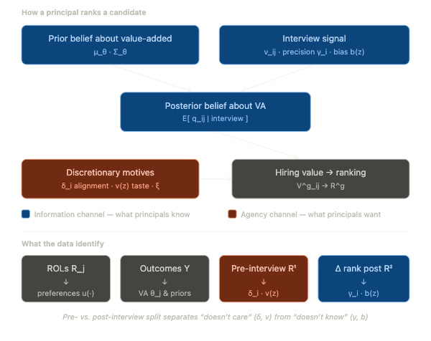
Parameters and objects to track when reading the model, grouped by the four building blocks (applicant preferences → productivity → beliefs → hiring decision) plus estimation.
Two notational collisions to keep in mind: - γ is used twice: γ (no subscript) is the coefficient vector on student controls Z_ℓ in the outcome equation; γ_i (with subscript) is the principal-specific signal precision in the beliefs block. Unrelated. - φ appears in both the productivity equation and the hiring-value equation — deliberately the same parameter, because it is what links a teacher’s unobserved productivity to their unobserved desirability (the selection channel).

0. Indices and sets
Symbol | Meaning
i = 1,…,N | principal / school (the hiring manager)
j = 1,…,J | applicant / teacher
ℓ | student
g = 1, 2 | screening stage: 1 = before interview, 2 = after interview
k = 1,…,K | discrete unobserved preference-type index
𝒥_i | principal i’s shortlist (≤10 applicants)

1. Applicant preferences (application stage) — identified from submitted ROLs
These govern which schools applicants apply to and rank, and are the raw material for the selection correction.
Symbol | Name | Interpretation
U_ij | indirect utility | utility applicant j gets from matching with school i
u(z_j, x_i, d_ij, τ_j) | systematic utility | flexible function of applicant traits, school traits, distance, and type
z_j | applicant observables | gender, ethnicity (Quechua), experience, test scores
x_i | school observables | amenity index, locality size/remoteness, student demographics/performance
d_ij | distance | teacher–school geographic distance; excluded from outcome eq (the instrument)
τ_j ∈ {1,…,K} | unobserved preference type | latent taste class (e.g. who values amenities vs. wages); unobserved to econometrician and principal
η_ij | preference shock | i.i.d. Type-I EV taste shock for the i,j match
R_j | rank-order list (ROL) | applicant j’s submitted ranking of schools — the observed choice data
π_k(z_j, d_j) | type probabilities | prior P(τ_j = k \| z_j, d_j)
P(τ_j=k \| z_j,d_j,R_j) | posterior type probs | updated type weights after seeing the ROL (Bayes)

2. Productivity / value-added — identified from student outcomes + ROL control function
The “ground truth” the model benchmarks beliefs against. θ_j is the object principals form beliefs about.
Symbol | Name | Interpretation
Y_ℓj | potential outcome | test score of student ℓ if taught by teacher j
α_j | ATE of teacher j | average effectiveness (value-added on a mean-zero-X student)
β_j | match/comparative-advantage effect | how teacher j’s returns vary with student traits X_ℓ
θ_j = (α_j, β_j) | teacher value-added bundle | the latent quality vector beliefs are about
X_ℓ | student traits (in match term) | lagged 2nd-grade score, gender (normalized mean-zero)
Z_ℓ | student controls | lagged score & its square, gender, ethnicity, age — at student/class/school level
γ | controls coefficient | returns to Z_ℓ (not the signal precision γ_i)
φ | selection-on-unobservables coefficient | loads the preference shock η into productivity: teachers are more productive in schools they prefer. Same φ reused in the hiring eq.
ε_ℓj | idiosyncratic error | mean-zero outcome noise
S_ℓ | realized assignment | which teacher student ℓ actually got
Y_ℓ | observed score | realized outcome Σ_j Y_ℓj·1{S_ℓ=j}
λ_i(ℓ)(R_j,z_j,d_j) | control-function term | E[η \| R,z,d] — corrects VA for sorting on unobserved match quality
q_ij := α_j + X_i′β_j | expected effectiveness at school i | teacher j’s VA evaluated at school i’s average student, net of the preference effect — the quantity principals try to learn

3. Priors and beliefs (information block) — the heart of the paper
Principals start with a common prior over θ_j/q_ij, then update on a private interview signal.
Symbol | Name | Interpretation
μ_θ(z_j,d_j,τ_j) | prior mean | average belief about VA given observables & type — how much weight observables get
Σ_θ | prior variance | residual VA dispersion not explained by observables → room to learn (large here)
μ_q(z_j,d_j,R_j,X_i) | prior mean of q_ij | school-specific implied prior mean
σ_q²(X_i) | prior variance of q_ij | school-specific prior uncertainty
ν_ij | interview signal | private noisy signal about q_ij received during interview/classroom obs
γ_i | signal precision (KEY) | principal-specific informativeness of the interview; exp(γ_i) = signal variance. Heterogeneity in ability to extract information
μ_γ, σ_γ² | distribution of γ_i | γ_i ~ N(μ_γ,σ_γ²); mean ≈ low learning, large σ_γ² ≈ a skilled right tail
b(z_j) | biased learning | systematic mis-interpretation of the signal by observable type (e.g. against women) — distinct from taste
E[q_ij\|S²] | posterior mean | updated belief = prior + (signal weight)×(signal − prior); weight = σ_q²/(σ_q²+exp(γ_i))
S¹_ij, S²_ij | information sets | S¹=pre-interview (z,d,R,X); S²=S¹ + ν (post-interview)

4. Hiring decision (payoff / ranking) — identified from rankings, pre vs. post interview
Governs how principals rank candidates. Pre-interview ranking → preferences; change in ranking → learning.
Symbol | Name | Interpretation
V^g_ij | hiring value | expected payoff to principal i from hiring j at stage g
δ_i | value-added weight / alignment (KEY) | how much principal i cares about productivity q_ij vs. other motives; the agency/alignment parameter
μ_δ, σ_δ² | distribution of δ_i | δ_i ~ N(μ_δ,σ_δ²); low/dispersed δ = weak or uneven alignment with maximizing VA
v(z_j) | taste for observable types | direct preference over candidate traits (potential taste-based discrimination)
ξ_ij | persistent discretionary motive | unobserved quality/preference component stable across stages (ξ ~ N(0,σ_ξ²))
σ_ξ² | variance of ξ | size of persistent unobserved discretionary motives
φ·η_ij | match term in value | same selection channel as in productivity, entering the payoff
ε^g_ij | choice shock | Type-I EV, i.i.d. across i,j,g — transitory discretionary noise
R^g_i | principal ranking at stage g | observed ranking; R¹ = pre-interview, R² = post-interview

5. Estimation / output objects
Symbol | Name | Interpretation
θ̂_j, φ̂ | VA estimates | unbiased, selection-corrected value-added
Ω̂_j | sampling variance | estimation noise in θ̂_j (small classes ⇒ noisy)
θ̂*_j | empirical-Bayes shrunken VA | MSE-optimal posterior of VA; used as the disclosed signal in the counterfactual

6. Identification map (which data pin down which block)
Primitive | Identified from
u(·) — applicant preferences | submitted ROLs (R_j)
μ_θ(·), Σ_θ — priors | selection-corrected VA estimates θ̂_j
δ_i (μ_δ,σ_δ²), v(z) — preferences/agency | pre-interview ranking R¹_i
γ_i (μ_γ,σ_γ²), b(z), ξ — learning/information | change in ranking after interview R²_i
The core identification idea: the interview is an information event observed in the data. Rankings before it reveal what principals want (preferences/alignment); how rankings move after it reveals what principals learn (signal precision + bias). This is what separates “doesn’t care” (δ_i, v) from “doesn’t know” (γ_i, b).

7. The two headline mechanisms in one line each
- Information friction ⇒ governed by γ_i (and Σ_θ): even well-meaning principals can’t tell good teachers apart because the interview signal is noisy. Estimated to be small on average, skewed.
- Agency friction ⇒ governed by δ_i (and v, ξ): principals rank on things other than value-added. Estimated to be substantial.
- b(z) sits across both: discrimination operating through biased learning rather than taste — which is why information disclosure (counterfactual) both raises VA and removes the gender penalty.

